
PFMA audit outcomes of the 2014-15 financial year
National Department of Human Settlements
October 2015

PC

CONTENTS
1. Introduction 1
2. Audit opinion history 4
3. Key focus areas 5
4. Other matters of interest 11
5. Drivers of internal control 12
6. Other AGSA reports 13
7. Combined assurance on risk management in the public sector 14
8. Minister’s commitments and progress on these commitments 16
9. Commitments from the portfolio committee/SCOPA 16

10. Entities included in the portfolio not audited by the Auditor-General
of South Africa (section 4(3) audit entities) 16

- Introduction
1.1 Reputation promise of the Auditor-General of South Africa
The auditor-general has a constitutional mandate, and as the supreme audit institution (SAI) of South Africa, it exists to strengthen our country’s democracy by enabling oversight, accountability and governance in the public sector through auditing, thereby building public confidence.
1.2 Purpose of document
The purpose of this briefing document is for the Auditor-General of South Africa (AGSA) to provide an overview of the audit outcomes and other findings in respect of the National Department of Human Settlements and its entities for the 2014/15 financial year.
1.3 Overview
Legislative mandate
The Department of Human Settlements determines the finances and promotes, communicates and monitors the implementation of housing programmes in South Africa.
In addition to the mandate derived from the Constitution, the Department of Human Settlements derives its responsibilities from section 3 of the Housing Act (1997). According to the act, the department must, after consultation with provinces and municipalities, establish and facilitate a sustainable national housing development process by:
- determining national policy, including national norms and standards, in respect of housing and human settlements development
- setting broad national housing delivery goals
- monitoring performance of provinces and municipalities against housing budgetary and delivery goals
- building the capacity of provinces and municipalities
- promoting consultation with all stakeholders in the housing delivery chain, including civil society and the private sector.
Vision
A nation housed in sustainable human settlements.
Mission and objectives
To facilitate the creation of sustainable human settlements and improved quality of household life.
Outcome 8 strategic goals
The following are the departmental strategic outcome-oriented performance indicators for the 2014-19 MTSF period:
- The number of households living in adequate housing settlements
- Improved housing conditions for households living in informal settlements
- The number of functional settlements that are spatially, socially and economically integrated (both new and revitalised)
- Fifty priority catalytic projects demonstrating comprehensive integrative mechanisms
- An increase in the volume of home loans granted by the private sector and DFIs to households in the affordable housing market and the creation of new units
- The percentage of sales transactions of properties worth less than R500 000
- Growth and distribution of value in the residential property market
- The number of metros accredited with the housing function
- The number of municipalities accredited with level 2 and provided with post-accreditation support
- Investment decisions in Human Settlements improving spatial efficiency
Human Settlements entities
The following active entities report to the minister of Human Settlements:

Name of entity | Legislative mandate
The Estate Agency Affairs Board (EAAB) | It regulates and controls certain activities of estate agents in the public interest.
Community Schemes Ombud Services (CSOS)* | CSOS is mandated to provide a dispute resolution service for community schemes, provide training for conciliators, adjudicators and other employees of the service, regulate, monitor and control the quality of all sectional title scheme governance documentation and take custody of, preserve and provide public access to scheme governance documentation.
Housing Development Agency (HDA) | The purpose of the agency is to identify, acquire, hold, develop and release state and privately owned land for residential and community purposes and for the creation of sustainable human settlements.
National Housing Finance Corporation (NHFC) | The corporation is mandated to make housing finance accessible and affordable to low- and middle-income households. It searches for new ways of mobilising finance for housing from sources outside the state, in partnership with the broadest range of organisations. It also provides wholesale finance and acts as a fund and risk manager.
National Home Builders Registration Council (NHBRC)* | The council provides housing consumers with warranty protection against defects in new homes and provides protection against any failure of builders to comply with their obligations in terms of the act. It provides an exclusive regulatory function in the home building environment.
The National Urban Reconstruction and Housing Agency (NURCHA) | The agency maximises options for financing the construction of housing and related facilities and infrastructure and to utilise the NURCHA’s loans to contribute to, and support, the emergence of new, successful, black-owned construction firms.
Rural Housing Loan Fund (RHLF) | It is mandated to empower low-income households in rural areas to access housing credit. It operates as a wholesale lender and, thus, attains its mandate by providing loans through retail intermediaries to its target market to be utilised for incremental housing purposes.
Social Housing Regulatory Authority (SHRA) | The SHRA regulates and supports the social housing sector in order to accelerate the delivery of sustainable and financially viable social housing projects. It is responsible for the disbursement of institutional investment and capital grants to social housing institutions.

* Audited by AGSA
1.4 Organisational structure
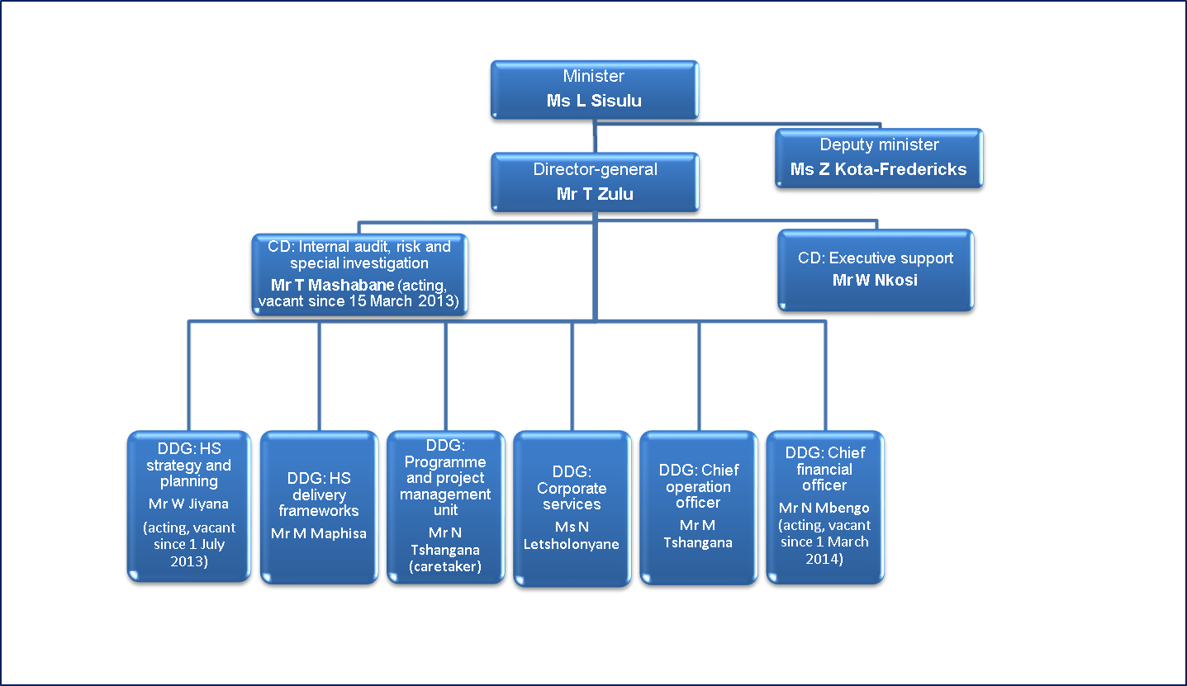

- Audit opinion history
Audit opinions | 14/15 | 13/14 | 12/13 | 11/12 | 10/11
- National Department of Human Settlements
- National Home Builders Registration Council
- Community Schemes Ombud Services
Qualification areas | 14/15 | 13/14 | 12/13 | 11/12 | 10/11
- Irregular expenditure |  |  |  | ü
Predetermined objectives | 14/15 | 13/14 | 12/13 | 11/12 | 10/11
- National Department of Human Settlements | ü | ü | ü | ü | ü
- National Home Builders Registration Council | ü | ü | ü | ü | ü
Compliance with legislation | 14/15 | 13/14 | 12/13 | 11/12 | 10/11
- National Department of Human Settlements | ü | ü | ü | ü | ü
- National Home Builders Registration Council | ü | ü | ü | ü | ü
- Community Schemes Ombud Services | ü |  | N/A | N/A | N/A

AUDIT OPINION LEGEND
 | Clean audit opinion: No findings on PDO and compliance
 | Unqualified with findings on PDO and compliance
 | Qualified audit opinion (with/without findings)
 | Disclaimed/adverse audit opinion
N/A | Entity not yet established
ü | Department/entity had findings (in the related matter)

2.1 Significant emphasis of matters
Department/entity | Emphasis of matter raised
National Department of Human Settlements | Material underspending of the vote by the department:  The department materially underspent its allocated budget as per the appropriation statement for programme 3: Programme Delivery Support. The allocated budget for programme 3 was R168 974 000, and only 70,6% of it was spent during the year. This had an impact on the department achieving its objectives.
National Home Builders Registration Council | Significant uncertainties:  With reference to note 25 to the financial statements, relating to pending cases that were disclosed as contingent liabilities, the ultimate outcome of the matters could not presently be determined, and no provision for any liability that might result was made in the financial statements.
Community Schemes Ombud Services | Material underspending of the budget:  As disclosed in the financial statements, the entity materially underspent the budget to the amount of R30 244 000 due to capacity constraints. As a result, the entity underachieved on some of its key performance indicators.  Funding of operations:  As disclosed in the chief executive’s report, the funding of the entity’s operations was in part reliant on the community schemes levies and other funding sources as provided for in section 22(1) of the Community Schemes Ombud Services Act (Act No. 9 of 2011). The delays in the approval process of the required regulations and promulgation of the relevant legal instruments that would allow CSOS to commence its income-generating activities might have an adverse impact on the entity achieving its planned objectives for the 2015/16 period.

- Key focus areas
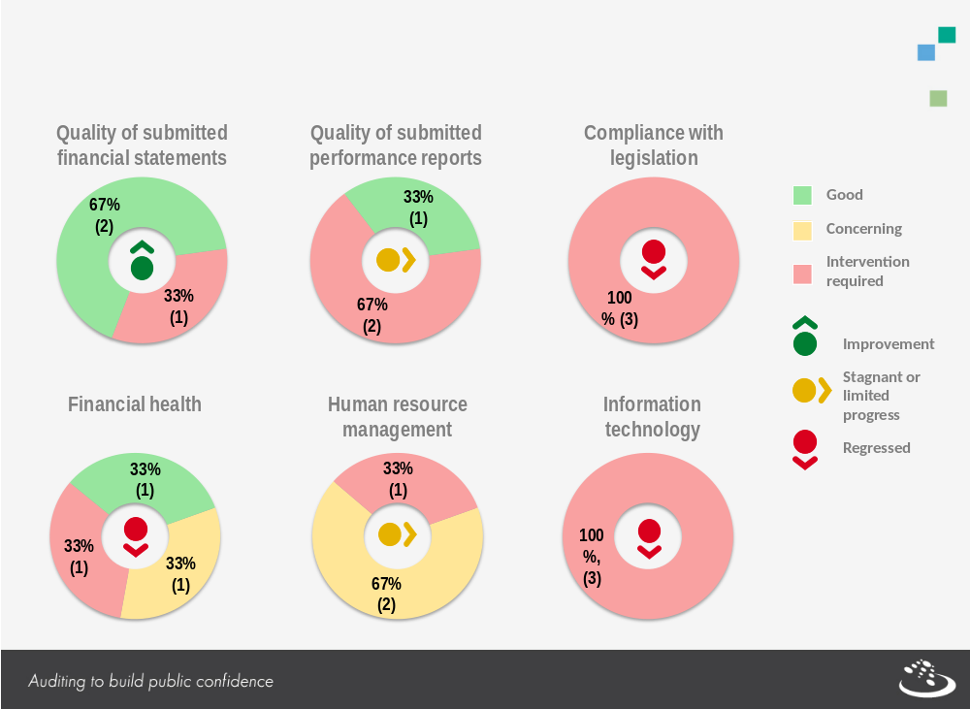

3.1 Material errors/omissions in submitted annual financial statements
Depart-ment/entity | Finding | Root cause | Recommendation
National Department of Human Settlements | The financial statements submitted for auditing were not prepared in accordance with the prescribed financial reporting framework as required by section 40(1)(b) of the Public Finance Management Act.  Material misstatements of current assets and disclosure items identified by the auditors in the submitted financial statements were subsequently corrected, resulting in the financial statements receiving an unqualified audit opinion. | Inadequate reviews by management of the financial statements as well as schedules, listings and registers that supported amounts in disclosure notes | Management should endeavour to compile monthly financial statements with all relevant disclosures. At a minimum, quarterly financials with all disclosure notes should be reviewed by governance structures, that is, management, internal audit and the audit committee.  The supporting schedules and listings to the prepared financial statements should be properly reviewed by management, and their accuracy, validity and completeness should also be verified.
3.1.1 Comments on additional AGSA interactions to help improve financial outcomes
Department/entity | Additional interaction/ service (for example, workshops, etc.) | Impact/outcome
The audit opinions of all three entities were unqualified in both the current and previous period; as such, no interventions were necessary.

  - Predetermined objectives
Department/entity | Finding | Root cause | Recommendation
National Department of Human Settlements | Reliability of reported performance information:  The FMPPI requires auditees to have appropriate systems to collect, collate, verify and store performance information to ensure valid, accurate and complete reporting of actual achievements against planned objectives, indicators and targets.  Significantly important targets were not reliable when compared to the source information or evidence provided. | This was due to the lack of standard operating procedures for the accurate recording of actual achievements and inadequate review to verify the validity of reported achievements against source documentation. | Management should develop and implement standard operating procedures to ensure that adequate and reliable supporting documentation is collected and stored as evidence of achievement of all reported performance information.  Reviews should be performed on the information or evidence provided to support achievement of targets.
National Home Builders Registration Council | Usefulness of reported performance information:  Treasury regulation 30.1.3(g) requires the annual performance plan to form the basis for the annual report – therefore, requiring consistency of objectives, indicators and targets between planning and reporting documents.  A total of 38% of the reported targets were not consistent with those in the approved annual performance plan.  Performance targets should be measurable as required by the FMPPI. A material number of targets could not be measured.  Performance indicators were not well defined as required by the FMPPI.  Reliability of performance information:  The FMPPI requires auditees to have appropriate systems to collect, collate, verify and store performance information to ensure valid, accurate and complete reporting of actual achievements against planned objectives, indicators and targets.  Information and explanations considered necessary to support the reliability of performance information could not be obtained. | This was due to reported and planned targets not being applied and measured consistently.  Performance indicators did not have a clear definition to enable consistent collection of data. | Management should perform frequent adequate reviews of consistency between planned and reported targets as well as ensure that performance indicators are clearly defined.  In addition, the reported performance information should be submitted to internal audit for review. Internal audit should review the performance information for consistency and reliability.  Internal audit must examine evidence files to ensure that evidence is available and appropriately filed for all reported achievements. Evidence in respect of reasons for variance should also be examined for its validity, accuracy and completeness.

3.2.1 Comments on additional AGSA interactions to help improve audit of predetermined objectives (AOPO) outcomes
Department/entity | Additional interaction/ service (for example, workshops, etc.) | Impact/outcome
National Department of Human Settlements | On an annual basis, we review the usefulness of the annual performance plans (APPs) of the department prior to approval by the minister and presentation to the portfolio committee. | The national department did not receive any material findings on the usefulness of its 2014/15 strategic and annual performance plan.

  - Compliance with legislation
Department/entity | Finding | Root cause | Recommendation
National Department of Human Settlements | The financial statements submitted for auditing were not in accordance with the prescribed financial reporting framework as required by section 40(1)(b) of the PFMA. There were material misstatements of current assets and disclosure items identified by the auditors in the submitted financial statements, which were subsequently corrected, resulting in the financial statements receiving an unqualified audit opinion. | Management did not perform adequate reviews of the submitted financial statements in order to ensure that they were free from material misstatements. | The preparation of financial statements should be performed on a monthly basis.  The monthly financial statements should be supported by accurate and valid support and reviewed timeously by management to ensure that errors are detected and corrected.  On a quarterly basis, the financial statements should be reviewed by internal audit and the audit committee.  The quarterly performance reports prepared should be reviewed by management and, furthermore, submitted to internal audit and the audit committee for final review. The review should include the verification of reported performance against supporting documentation that is accurate, valid and complete.
National Department of Human Settlements | Effective, efficient and transparent systems of risk management and internal control with respect to performance information and management were not maintained as required by section 38(1)(a)(i) of the PFMA.  The reported performance information was not reliable. | Management did not perform adequate reviews of the supporting documentation accompanying the reported performance information and financial statements in order to ensure that the reported performance information was reliable.
National Home Builders Registration Council | Effective, efficient and transparent systems of risk management and internal control with respect to performance information and management were not maintained as required by section 38(1)(a)(i) of the PFMA.  The reported performance information was not useful and reliable. | The performance information was not useful and reliable due to targets not being measurable and indicators not being verifiable and clearly defined. Management did not properly review the reported performance information to ensure its usefulness. | Management should perform frequent adequate reviews of consistency between planned and reported targets as well as ensure that performance indicators are clearly defined.
National Home Builders Registration Council | Goods and services with a transaction value below R500 000 were procured without obtaining the required price quotations as required by Treasury regulation 16A6.1 | Insufficient compliance monitoring | The NHBRC should utilise a supply chain management (SCM) compliance checklist to ensure that all applicable legislation has been adhered to prior to the procurement process being finalised for all contracts and transactions.  Condonation and, where applicable, disciplinary processes should be expedited, particularly with regard to multi-year contracts where irregular expenditure will continue to be incurred until such time as this process has been finalised.
National Home Builders Registration Council | Steps taken to prevent irregular expenditure as required by section 51(1)(b)(ii) of the PFMA were not effective in certain instances. | Insufficient compliance monitoring
Community Schemes Ombud Services | Effective, efficient and transparent systems of risk management and internal control with respect to performance information and management were not maintained as required by section 38(1)(a)(i) of the PFMA.  Quarterly reports for quarters 1 and 2 were not prepared and submitted to the minister of Human Settlements as required by Treasury regulation 30.2.1. | Management did not properly monitor compliance with applicable legislation. | Ensure that compliance with applicable legislation is regularly monitored, and implement steps to comply.
Community Schemes Ombud Services | The accounting authority did not ensure that the internal audit function was established as required by section 51(1)(a)(ii) of the PFMA and Treasury regulation 27.2, and consequently, the required functions and responsibilities of the internal audit function were also not complied with. | The entity was newly established and was still in the process of establishing its governance structures. | Management, with the assistance of the audit committee, should ensure that the internal audit function is established to perform its duties in order to ensure that the audit committee also fulfils its responsibilities.
Community Schemes Ombud Services | The audit committee did not review the effectiveness of the internal audit function as required by Treasury regulation 27.1.8 as internal audit had not yet been established.

  - Financial health
Department/entity | Concern
Community Schemes Ombud Services | Funding of operations:  The funding of the entity’s operations was in part reliant on the community schemes levies and other funding sources as provided for in section 22(1) of the Community Schemes Ombud Services Act (Act No. 9 of 2011). Delays in the approval process of the required regulations and promulgation of the relevant legal instruments that would allow CSOS to commence its income-generating activities might have an adverse impact on the entity achieving its planned objectives for the 2015/16 period.

  - Human resource management and consequence management
Department/entity | Finding | Root cause | Recommendation
National Department of Human Settlements | A human resource plan was not in place as required by PSR 1/III/B.2(d). | Management did not properly monitor compliance with applicable legislation. | Ensure that compliance with applicable legislation is regularly monitored, and implement steps to comply.
  - Information technology (control environment)
Department/entity | Finding | Root cause | Recommendation
National Department of Human Settlements | Adequate governance procedures had not been designed and implemented, including the development of a disaster recovery plan and the updating of the IT security policy. | Due to vacancies in the Security and Risk Directorate, the IT governance responsibilities were not adequately assigned. | Critical business functions should be identified through impact analysis, and the processes of drafting and revising key governance documents should be appropriately assigned.
National Home Builders Registration Council | Adequate governance procedures had not been designed and implemented, including the development of a disaster recovery plan, an IT continuity plan and the approval of the IT security policy. | Leadership had not prioritised the design of the IT governance framework and related IT strategy, policies and procedures due to prioritising the SAP implementation and related processes. | It is recommended that leadership should ensure that adequate governance procedures are designed and implemented to strengthen the IT environment.
National Home Builders Registration Council | Insufficient segregation of duties in the areas of user access control and program change management | These deficiencies could be attributed to the lack of monitoring of audit logs and appropriate review of the user administration policies. Resource constraints within the IT Department also contributed to the lack of segregation. | Leadership should prioritise the design of the IT governance framework and related IT strategy, policies and procedures in order to strengthen the NHBRC internal control environment.
- Other matters of interest
- Unauthorised expenditure (expenditure not in accordance with the budget vote)
No unauthorised expenditure was identified at any of the auditees in both the current and previous financial period.
- Irregular expenditure (expenditure incurred in contravention of key legislation)
Department/entity |  | Irregular expenditure
 |  | Movement | Amount  R  2014/15 | Amount  R  2013/14 | Root cause | Recommendation
1 | National Department of Human Settlements |  | - | 1 203 000 | Not applicable – the irregular expenditure was incurred in the previous year, with none in the current year.
2 | National Home Builders Registration Council |  | 53 969 000 | 130 400 000 | This was due to insufficient compliance monitoring. | The NHBRC should utilise an SCM compliance checklist to ensure that all applicable legislation has been adhered to prior to the procurement process being finalised for all contracts and transactions.  In addition, there should be consequence management for repeat non-compliance to ensure that transgressors are made aware of the consequences of their actions, and where appropriate, steps should be taken against them.
3 | Community Schemes Ombud Services |  | 639 000 | - | Compliance with the relevant legislation was not monitored. | It is recommended that proper controls be put in place by the entity to ensure that it adheres to the relevant legislation.
- Fruitless and wasteful expenditure: (expenditure that should not have been incurred/incurred in vain that could have been avoided, and no value for money received)
Department/entity |  | Fruitless and wasteful expenditure
 |  | Movement | Amount  R  2014/15 | Amount  R  2013/14 | Root cause | Recommendation
1 | National Department of Human Settlements |  | - | 36 000 | Not applicable – the fruitless and wasteful expenditure was incurred in the previous year, with none in the current year.
2 | National Home Builders Registration Council |  | 5 100 000 | 45 000 | Lack of monitoring of the implementa- tion of internal controls | Leadership should take immediate action and hold officials accountable for not adhering to the implemented internal controls.
Note: The fruitless and wasteful expenditure of the NHBRC for the year under review related to interest paid to SARS, amounting to R4,3 million, and penalties charged by SARS of R0.8 million.
- Drivers of internal control
Drivers of internal control
Department and entities | Leadership |  |  |  |  |  | Financial and performance management |  |  |  |  | Governance
Department and entities | Effective leadership culture | Oversight responsibility | HR management | Policies and procedures | Action plans | IT governance | Proper record keeping | Processing and reconciling controls | Reporting | Compliance | IT systems controls | Risk management | Internal audit | Audit committee
National Department of Human Settlements
National Home Builders Registration Council
Community Schemes Ombud Services

- Other AGSA reports
6.1 Performance audits
National Department of Human Settlements
On 29 November 2012, the Auditor-General of South Africa (AGSA) was requested by the previous minister to conduct a special audit into the procurement, implementation and performance of the Rural Housing Infrastructure Grant (RHIG).
The report was finalised and concerns raised with regard to overall management of the programme, monthly processes, oversight of service providers and quality of structures; it was communicated to management, the accounting officer, the chairperson of the portfolio committee as well as the current minister. The report was tabled in Parliament in August 2015.

- Combined assurance on risk management in the public sector

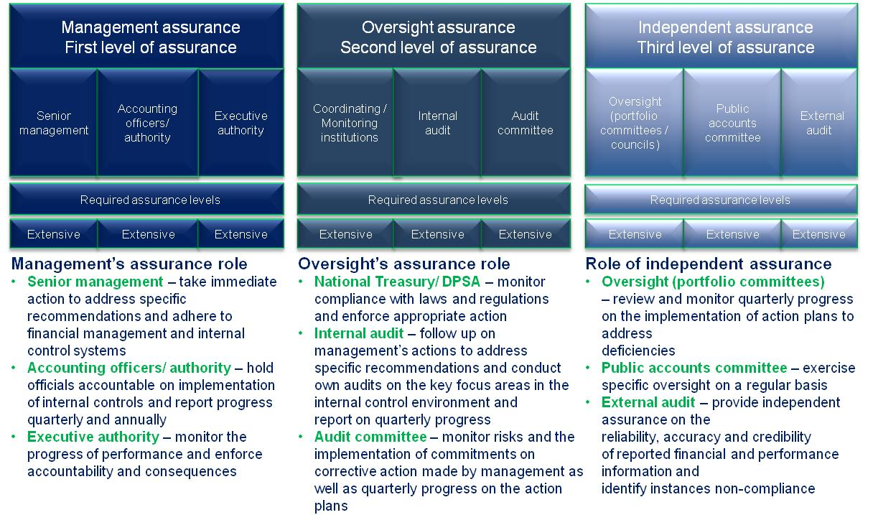
7.1 Assessment of assurance providers for the portfolio

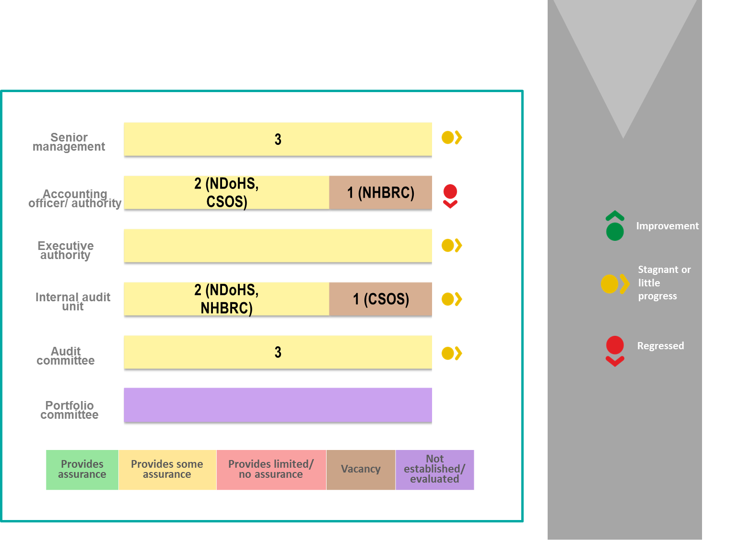

- Minister’s commitments and progress on these commitments
The following includes prior-year commitments and new commitments made:
Focus area | Commitment | Due date | Status
Key risk areas | The minister will quarterly monitor the progress on the preparation of proper monthly financial statements and the implementation of monthly key control assessments. | March 2015
Audit committee engagements | The minister will meet with the audit committee chairperson and the chairpersons of the public entities. | March 2015
STATUS LEGEND
Commitment has been implemented
Commitment in progress
Commitment has not been implemented
New commitment made in current year

- Commitments from the portfolio committee/SCOPA
The following recommended commitments are to be actioned by the committee:
- The portfolio committee should monitor progress against the annual performance plan and track the implementation of action plans to address previously identified audit findings on a quarterly basis.

- Entities included in the portfolio not audited by the Auditor-General of South Africa (section 4(3) audit entities)
Audit opinions | 14/15 | 13/14 | 12/13 | 11/12 | 10/11
- Estate Agency Affairs Board (EAAB)
- Housing Development Agency
- National Housing Finance Corporation Ltd
- National Urban Reconstruction and Housing Agency (NURCHA)
- Rural Housing Loan Fund
- Servcon Housing Solutions (Pty) Ltd
- Social Housing Foundation
- Social Housing Regulatory Authority (SHRA)
- Thubelisha Homes

Predetermined objectives |  |  | 14/15 |  | 13/14 | 12/13 | 11/12 | 10/11
- Estate Agency Affairs Board (EAAB) |  |  | ü |  | ü
- Social Housing Regulatory Authority (SHRA) |  |  |  |  |  |  | ü
- Housing Development Agency |  |  |  |  |  |  |  | ü
Compliance with legislation |  |  | 14/15 |  | 13/14 | 12/13 | 11/12 | 10/11
- Estate Agency Affairs Board (EAAB) |  |  | ü |  | ü | ü | ü | ü
- National Urban Reconstruction and Housing Agency (NURCHA) |  |  | ü |  | ü
- Servcon Housing Solutions (Pty) Ltd |  |  |  |  |  |  | ü | ü
- Social Housing Regulatory Authority (SHRA) |  |  | ü |  | ü | ü | ü
AUDIT OPINION LEGEND
 | Clean audit opinion: No findings on PDO and compliance
 | Unqualified with findings on PDO and compliance
 | qualified audit opinion (with/without findings)
 | disclaimed/adverse audit opinion
 | Audit not finalised at the time of reporting
 | Entity not yet established
ü | Department/entity had findings (in the related matter)

10.1 Findings related to section 4(3) entities
10.1.1 Predetermined objectives
Department/entity | Finding
Estate Agency Affairs Board | Usefulness of reported performance information:  Consistency: Treasury regulation 30.1.3(g) requires that the strategic/annual performance plan should form the basis for the annual report – therefore, requiring consistency of objectives and targets between planning and reporting documents. A total of 25% of reported objectives were not consistent with those approved in the strategic plan.  Measurability: The National Treasury framework for managing programme performance information (FMPPI) requires that performance targets be specific in clearly identifying the nature and required level of performance and, furthermore, should be realistic, given existing capacity. A total of 23% of planned targets did not meet these criteria.

10.1.2 Compliance with legislation
Department/entity | Findings
Estate Agency Affairs Board | - Supplier invoices were not settled within 30 days.  - The accounting officer did not submit the strategic plan for approval by the minister by 1 April 2014 as required by the PFMA.  - Debtors’ collection processes were ineffective in contravention of the PFMA and Treasury regulations.  - The composition of the board did not meet the requirements as set out in the Estate Agency Affairs Act.
National Urban Reconstruction and Housing Agency (NURCHA) | - The entity did not, in all instances, obtain three quotations for services procured with a value less than R500 000. Deviations in respect of these procurements were not documented and approved.
Social Housing Regulatory Authority (SHRA) | - The accounting authority did not take effective steps to prevent irregular expenditure/fruitless and wasteful expenditure as required by section 51(1)(b)(ii) of the Public Finance Management Act.  - The financial statements submitted for auditing were not prepared in accordance with the prescribed financial reporting framework as required by section 55(1)(a) of the Public Finance Management Act.  Material misstatements of liabilities and expenditure identified by the auditors in the submitted financial statements were subsequently corrected, resulting in the financial statements receiving an unqualified audit opinion.

