

PFMA audit outcomes of the 2014-15 financial year
Agriculture, Forestry and Fisheries

13 October 2015

PC

CONTENTS
1. Introduction 3
2. Audit opinion history 4
3. Key focus areas 6
4. Other matters of interest 22
5. Drivers of internal control 24
6. Other AGSA reports 24
7. Combined assurance on risk management in the public sector 25
8. Minister commitments and progress on these commitments 26

9. Commitments from the portfolio committee 28
10. Entities included in the portfolio not audited by the Auditor-General of South Africa (section 4(3) audit entities) 28

- Introduction
1.1 Reputation promise of the Auditor-General of South Africa
The Auditor-General has a constitutional mandate and, as the Supreme Audit Institution (SAI) of South Africa, exists to strengthen our country’s democracy by enabling oversight, accountability and governance in the public sector through auditing, thereby building public confidence.
1.2 Purpose of document
The purpose of this briefing document is for the Auditor-General of South Africa (AGSA) to provide an overview of the audit outcomes and other findings in respect of the Department of Agriculture, Forestry and Fisheries (DAFF) and its entities for the 2014-15 financial year.
1.3 Overview
The mandate, vision and mission of the department, as stipulated in the annual report (page 16), focus mainly on advancing food security and agrarian transformation in the agricultural sector.
The lack of improvement in the overall audit outcomes was caused by the DAFF, ARC, NAMC and OBP not addressing past material findings on their annual performance reports and/or compliance with legislation. The MLRF did however address prior year audit findings which resulted in an improvement on non-compliance matters.

1.4 Organisational structure
The organisational structure of the department is included in part A of the annual report (page 24).
The overall vacancy rate of the department increased from 9,8% (2013-14) to 13% (2014-15), which contributed to overall stagnation in the audit outcomes.

- Audit opinion history (excluding section 4(3) entities)
Audit opinions |  |  |  | Movement | 14-15 |  | 13-14 | 12-13 | 11-12 | 10-11
- Department of Agriculture, Forestry and Fisheries (DAFF)
- Agricultural Research Council (ARC)
- Marine Living Resource Funds (MLRF)
- National Agricultural Marketing Council (NAMC)
- Onderstepoort Biological Products (OBP)
Qualification areas |  |  |  |  | 14-15 |  | 13-14 | 12-13 | 11-12 | 10-11
- Current assets |  |  |  |  |  |  |  |  |  | ü
- Fixed assets |  |  |  |  |  |  |  |  |  | ü
Predetermined objectives |  |  |  |  | 14-15 |  | 13-14 | 12-13 | 11-12 | 10-11
- DAFF |  |  |  |  | ü |  | ü | ü | ü | ü
- MLRF |  |  |  |  |  |  |  | ü | ü
- NAMC |  |  |  |  | ü |  | ü
- OBP |  |  |  |  | ü |  | ü | ü | ü | ü
Compliance with laws and regulations |  |  |  |  | 14-15 |  | 13-14 | 12-13 | 11-12 | 10-11
- DAFF |  |  |  |  | ü |  | ü | ü | ü | ü
- ARC |  |  |  |  | ü |  | ü | ü | ü | ü
- MLRF |  |  |  |  |  |  | ü | ü | ü
- NAMC |  |  |  |  | ü |  |  | ü
- OBP |  |  |  |  | ü |  | ü | ü | ü | ü
 |  | AUDIT OPINION LEGEND
 |  |  | CLEAN AUDIT OPINION: No findings on PDO and compliance
 |  |  | UNQUALIFIED with findings on PDO and/or compliance
 |  |  | QUALIFIED AUDIT OPINION (with/without findings)
 |  |  | DISCLAIMER/ADVERSE AUDIT OPINION
ü |  |  | DEPARTMENT/ENTITY HAD FINDINGS (in the related matter)

 | Status improved from previous year (no material findings). |  | Same status as previous year (with material findings).
 | Same status as previous year (no material findings). |  | Situation has regressed from prior year.

2.1 Significant emphasis of matters
Auditee | Emphasis of matter raised
MLRF | Material underspending of budget  As per note 23.3 to the annual financial statements, the entity has materially underspent the budget on fisheries research and development; monitoring, control and surveillance; and aquaculture and economic development to the amount of R92 564 000 (17%).  This is as a result of the underspending on its conditional grant for vessel operating costs and on the working for fisheries programme by R35 451 000 and R60 797 000, respectively.  This was mainly due to the delay in appointment of the service providers.

- Key focus areas
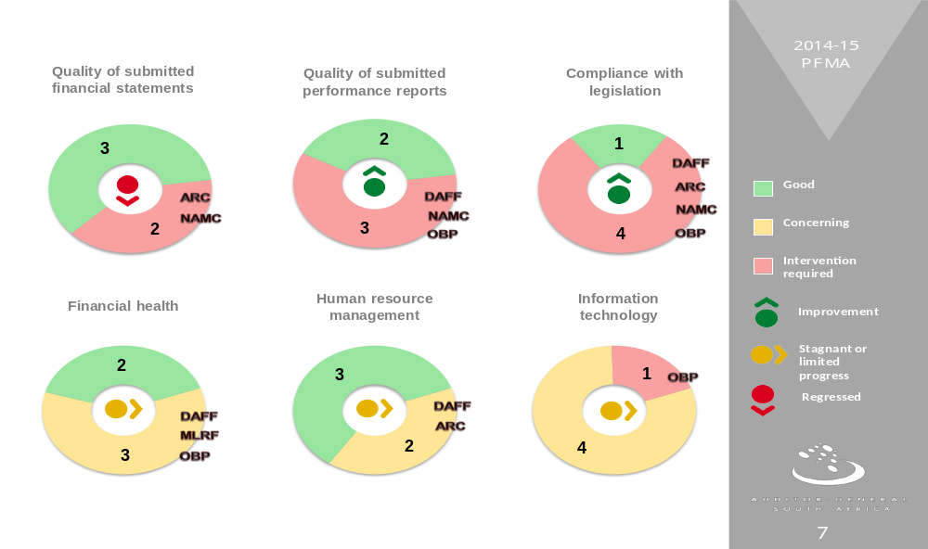
3.1 Material errors/omissions in submitted annual financial statements
Auditee | Finding | Root cause | Recommendation
ARC | Misstatements in various line items in the financial statements. | Management did not adequatly review the annual financial statements for completeness and accuracy prior to submission for auditing. | Management must ensure that:  - reliable, accurate and complete financial reports and financial statements are prepared on a continuous basis.  - a detailed review of the financial statements is performed before submission for auditing.
NAMC | Deferred revenue (grant received from the Department of Rural Development) on a new project was recognised without meeting the conditions of the contract with regard to project assets. | Management did not adequately apply the applicable financial reporting framework in compiling the financial statements. | Management must perform a verification against a GRAP checklist to ensure all accounting treatments are correctly disclosed in the financial statements.

3.1.1 Comments on additional AGSA interactions to help improve financial outcomes
Auditee | Additional interaction/ service (e.g. workshops etc) | Impact/ outcome
ARC and NAMC | Quarterly meetings with mangement and follow-up on prior year findings. | The auditee managed to maintain an unqualified audit opinion.  However, as reported in the pior year the ARC still materially adjusted it’s financial statements due to slow responses and a lack of ownership by employees and management
  - Predetermined objectives
Auditee | Finding | Root cause | Recommendation
DAFF | Programme 5: Usefulness  Planned and reported targets not in line with the ‘SMART’ principles.  - 20% of targets were not specific and measurable. The required level of performance were unclear.  - 40% of targets were not well defined in clearly stating where service delivery will take place (for example service delivery mainly takes place at provincial level) | This was due to inadequate systems and processes. For example the systems only included the processess to follow at the National department and not processess to ensure that all documents are received and reported on from provincial departments where applicable. | Management must ensure that proper systems and processes are in place to support the technical indicator descriptions.
DAFF | Programmes 3 and 5: Reliability  Significantly important targets in relation to the overall mandate of the department were not consistent to the source information or evidence provided making the reported achievements not reliable. | This was mainly due to inadequate monitoring of the completeness of source documentation received from provincial departments in support of actual achievements and lack of frequent review of the accuracy and validity of reported achievements against source documentation. | Management must prepare quarterly monitoring reports that are adequately reviewed by both the directorate: Organisational Performance and the internal audit unit.  Management must conduct site visits to provincial departments on a quarterly basis to ensure that all information was submitted to the national department for reporting.
DAFF | Adjustment of material misstatements  Material misstatements were corrected by management on the reported achievements in two programmes. However, the whole population was not corrected and therefore material findings were still reported in the audit report. | Management did not address weaknesses identified in relation to proper record keeping and monitoring of action plans over quarterly and annual reported predetermined objectives, resulting in repeat findings being raised. Evidence of this is that management submitted an incorrect version of the annual performance report for audit. | Management must:  - prepare quarterly monitoring reports that are adequately reviewed by both the directorate: Organisational Performance and the internal audit unit.  - hold staffl responsible for predetermined objectives accountable for the non-compliance identified.
NAMC | Programme 3 & 5: Usefulness  Planned and reported targets not in line with the ‘SMART’ principles.  - Targets and or indicators were not specific, verifiable and measurable. The required level of performance were not properly documented.  - Targets were not timebound. The date for the achievement of targets were not specified. | This was due to a lack of proper systems and processes for performance planning and management to provide for the development of performance indicators and targets included in the annual performance plan and technical indicator descriptions. | Management has already corrected the annual performance plan for 2015-16.
OBP | Strategic goals 2 and 5: Usefulness  Planned and reported targets not in line with the ‘SMART’ principles.  - Targets and or indicators were not specific and measurable. The required level of performance were not properly documented. For example the indicator for percentage business processes mapped, the target in the Annual Performance Plan is only ‘Process completed’.  - Targets were not timebound. The date for the achievement of targets were not specified.  - Some targets were not achieveable due to improper planning and setting of targets not within the budget. | The accounting authority and management did not have sufficient monitoring controls to ensure proper implementation of the overall process of implementation and reporting of performance information. Evidence of his was that performance indicators and targets included in the annual performance plan were not measurable (not specific and measurable and not time bound). | Management must ensure that the annual performance plan is in line with the ‘SMART’ criteria as required by the Framework for managing programme performance information (FMPPI).
OBP | Strategic goal 2: Reliability  Supporting documentation could not be obtained. | Due to lack of monotiring of the performance information processes, there was no link between what was reported and what management was attempting to report. As a result, they couldn’t provide supporting evidence to what was reported in the Annual Performance Report. | Management must ensure that reported performance information is supported by adequate and valid supporting information.
OBP | Strategic goal 5: Reliablity  Reported on target which was not in the Annual performance plan making the said target inconsistent with target in Annual performance plan. | This was mainly due to management not thoroughly reviewing and reconciling the annual performance report to the annual performance plan. | Management must perform a reconciliation of the information reported between the annual performance plan and the annual performance report.
3.2.1 Comments on additional AGSA interactions to help improve AoPO outcomes
Auditee | Additional interaction/ service (e.g. workshops, etc.) | Impact/ outcome
DAFF | Workshops on the audit of predetermined objectives (AoPO) were held with both internal audit and the directorate: Operational Performance in relation to the audit of predetermined objectives.  Various meetings were held to discuss audit findings.  Review of usefulness of the next year’s (2015-16) annual performance plan (APP). The 2014-15 APP was also reviewed during the 2013-14 interim audit.  The accounting officer has been very receptive to the recommendations made by the AGSA’s office and has undertaken to ensure a mindset change on the part of management responsible for AoPO. | No impact on the 2014-15 audit outcomes since interventions/corrective actions were implemented late in the 2014-15 financial year.
NAMC | Detailed discussions were held with management regarding the ‘SMART’ principles as required by National Treasury. | Management has already corrected the annual performance plan for 2015-16.
OBP | Review of the usefulness of the next year’s (2015-16) annual performance plan. The 2014-15 APP was also reviewed during the 2013-14 interim audit. | No impact on the 2014-15 audit outcomes. The 2015-16 annual performance plan has been corrected.

  - Compliance with legislation
Auditee | Finding | Root cause | Recommendation
DAFF | Strategic planning and performance management  Repeat control deficiencies were identified (material adjustments to the annual performance report and reported achievements for programmes 3 and 5 still not valid, accurate and complete). | Management did not address weaknesses identified in the controls over quarterly and annual reported predetermined objectives, resulting in repeat findings being raised. Evidence of this is that management submitted an incorrect version of the annual performance report for audit. | Management must:  - prepare quarterly monitoring reports that are adequately reviewed by both the directorate: Organisational Performance and the internal audit unit; and  - hold staff responsible for predetermined objectives accountable for non-compliance identified.
DAFF | Strategic planning and performance management  We were unable to verify whether quarterly monitorring reports were submitted to the minister. | Management did not ensure that proper systems and processes are in place to enable the minister to monitor progress made towards achieving the department’s goals and objectives. | Management must ensure that proper systems and processes are in place to enable submission of the quarterly monitoring reports to the executive authority for review and approval within 60 days after each quarter.
DAFF | Internal audit  The internal audit did not address the following areas as required in terms of the Treasury guidelines:  - assess the operational procedure and monitoring mechanisms for all transfers made and received, including transfers in terms of the annual Division of Revenue Act (DoRA).  - evaluate the reliability and integrity of operational information (in relation to reported performance information). | Critical components within performance information and compliance were not covered by internal audit due to inadequate guidance provided to the internal audit team as a result of instability in the chief audit executive position during the year. | - The accounting officer must ensure that internal audits are conducted in accordance with the standards set by the Institute of Internal Auditors.  - The accounting officer must ensure that internal audit operates effectively and assists management to maintain efficient and effective controls by evaluating management controls and providing recommendations for any deficiencies on a timely basis.  - The chief audit executive must provide guidance to the internal audit team and conduct a detailed review of all working papers as well as reports of findings issued to management.  - A workshop must be conducted where the principles of auditing operational information are explained.
DAFF | Expenditure management  Effective steps were not always taken to prevent irregular expenditure. | Compliance with laws and regulations relating to procurement and contract management was not properly reviewed and monitored at the regional offices of GADI and Limpopo. The same applied to the awarding of a contract at head office, because the line function only involved the supply chain management (SCM) directorate after the service had already been rendered. | - All goods and services must be procured in terms of all applicable laws and regulations.  - At least three quotations must be obtained for the procurement of goods and services.  - Directorates and regional offices must properly motivate the reasons why it was impossible or impractical to obtain three quotations.  - Reasons should be justifiable and accompanied by corroborating evidence.  - Management must plan in advance for big events to ensure that SCM processes are followed before the services are rendered.
DAFF | Transfer of funds  The expenditure for the programmes funded by the comprehensive agricultural support programme grant (CASP) was not monitored in accordance with the DoRA framework. | The accounting officer did not ensure that the CASP team had adequate human resources to adequately monitor the projects funded by this grant and to provide support to provinces on a monthly and quarterly basis. The monitoring framework for CASP was only implemented towards the end of the financial year, which did not allow for enough time to implement the planned corrective action. This was further due to the absence of a formal system or central database to keep track of the projects being monitored. | Management must ensure that:  - project-based grants are effectively monitored and adhere to the set business plan on a monthly and quarterly basis as well as provide support to the receiving parties.  - all project-based monitoring reports are received by the national office on a timely basis and that a formal system is implemented to keep track of monitoring of projects to allow for quick access to information.
ARC | Expenditure management  Although the accounting authority implemented controls to prevent irregular expenditure, these controls were not at all times effective in doing so. | Management did not review and monitor compliance with applicable laws and regulations. | Requests for quotations must always be sent when the entity needs to incur an expense as per the procurement process. If the goods/ services are to be procured by way of a deviation, a memo approving the deviation must be attached to the procurement.
OBP | Strategic planning and performance management  Effective, efficient and transparent systems of risk management and internal controls with respect to performance information and management were not in place. | The accounting authority and management did not have sufficient monitoring controls to ensure the proper implementation of the overall process of implementation and reporting of performance information. | Management must ensure that the annual performance plan is in line with the ‘SMART’ criteria as required by the FMPPI.
OBP | Internal audit  The internal audit function did not address the following areas as required in terms of the Treasury guidelines:  - evaluate the reliability and integrity of financial and operational information, and  - evaluate compliance with laws and regulations. | The accounting authority did not ensure that an adequately functioning and effective internal audit was in place to identify internal control deficiencies and recommend corrective action plans. | The accounting authority must ensure that internal audit operates effectively and assists management to maintain efficient and effective controls by evaluating management controls and making recommendations for any deficiencies on a timely basis.
  - Financial health
Auditee | Finding | Root cause | Recommendation
No material financial fealth findings have been reported for the DAFF portfolio.

  - Human resource management and consequence management
Auditee | Finding | Root cause | Recommendation
DAFF | Vacancies  - Six positions in senior management were vacant for more than 12 months.  - Five vacant positions in senior management were not advertised within six months. | Mainly due to lengthy recruitment processes caused by the unavailability of members to sit in on short listing and interview panels, as well as delays in finalising personnel suitability checks with the South African Qualification Authority and the State Security Agents. | Management must ensure that posts are advertised within six months of becoming vacant and filled within 12 months as required by the Public service regulations.
ARC | Overtime  Employees worked more than the maximum overtime hours allowed.  Written authorisation was not provided in advance for the overtime to be worked. | Overtime agreements were not updated regularly, resulting in overtime worked for periods not covered by the last approved overtime agreement. | Management must ensure that internal controls are effectively monitored and overtime is approved prior to being worked.
ARC | Leave administration  The required medical certificates were not submitted for sick leave. | Management did not effectively communicate to the personnel regarding the application of the leave policy, resulting in non-compliance with relevant applicable laws and regulations. | Management must ensure that:  - adherence to policy is regularly reviewed, control weaknesses are analysed, and appropriate follow-up actions are taken.  - the head of the humans resource department monitors implementation of procedures to ensure compliance with laws and regulations.  - all employees know and understand the application of the leave policy by possibly conducting a human resource workshop..

  - Information technology (control environment)
At DAFF an analysis of the audit outcomes indicated that some progress had been made in addressing previous findings. However, risks remained in the focus area of information technology service continuity regarding the design of controls. The entities still experienced challenges with the design and implementation of controls in all focus areas.

- Other matters of interest
- Unauthorised expenditure: Expenditure not in accordance with the budget vote
No unauthorised expenditure has been identified for the porttfolio.

- Irregular expenditure: Expenditure incurred in contravention of key legislation
Auditee |  | Irregular expenditure
 |  | Movement | Amount  R  2014-15 | Amount  R  2013-4 | Root cause | Recommendation
1 | DAFF |  | 3 093 000 | 7 808 000 | As reported under table 3.3 above – Expenditure management.  The reported irregular expenditure is still under investigation or disciplinary actions were taken against the responsible officials as disclosed in note 26.2 to the financial statements.  The goods and services relating to the irregular expenditure had been received by the department.
2 | ARC |  | 648 209 | 1 449 433 | As reported under table 3.3 above – Expenditure management.  The reported irregular expenditure is still under investigation or disciplinary actions were taken against the responsible officials as disclosed in note 29 to the financial statements.  The goods and services relating to the irregular expenditure had been received by the ARC.
3 | MLRF |  |   144 878 000 | 128 042 000 | During the 2013-14 financial year the entity entered into a long-term contract by way of deviation, even though it was not impracticable to invite competitive bids. Until such time that a new tender is awarded for the long-term manning, maintenance and management of the MLRF fleet, all expenditure incurred on the two contracts will be regarded as irregular expenditure. These contracts ended on 31 October 2014. The total expenditure for 2014-15 on the two contracts was R144 775 548. Also, during the current financial year the MLRF incurred irregular expenditure of R102 980. Three procurement transactions were found to be non-compliant with the PPPFA and PPR requirements. Investigations into these transactions are still ongoing. |  | Management must implement better demand management of procurement processes to limit the appointment of contractors by way of a deviation.
4 | NAMC |  | - | R833 000 | Not applicable.
5 | OBP |  | - | - | Not applicable.
Legends:
Decrease in incurred
expenditure
No change
Increase in incurred
expenditure
Fruitless and wasteful expenditure: Expenditure that should not have been incurred (incurred in vain, which could have been avoided, and receiving no value for money)
Auditee |  | Fruitless and Wasteful expenditure
 |  | Movement | Amount  R  2014-15 | Amount  R  2013-14 | Root cause | Recommendation
1 | DAFF |  | R199 000 | R6 000 | Management did not follow up with a supplier to pay back funds to the department for a payment incorrectly made to them. | The funds must be recovered from the supplier.
2 | ARC |  | R15 447 | R4 620 | Inadequate controls to ensure timeous payment of invoices. | Management must implement controls to ensure that invoices are received and paid on time.
3 | MLRF |  | R18 000 | R11 000 | Late payment of two suppliers. | Management must implement controls to ensure that suppliers are paid on time.
4 | NAMC |  | - | R40 000 | Not applicable.
5 | OBP |  | R26 992 | R101 580 | During the year under review, late VAT payments to the value of R26 992 were made to SARS due the bank clearing the amount the following day.  An alternative dispute resolution has been raised with SARS to object the R26 992 since clearing of the payment was not within the company's control. | The matter should be resolved with SARS.
- Drivers of internal controls
Drivers of internal control
Department and entities | Leadership |  |  |  |  |  | Financial & performance management |  |  |  |  | Governance
Department and entities | Effective leadership culture | Oversight responsibility | Human resource management | Policies and procedures | Action plans | IT governance | Proper record keeping | Processing and reconciling controls | Reporting | Compliance | IT system controls | Risk management | Internal audit | Audit committee
DAFF
ARC
MLRF
NAMC
OBP
- Other AGSA reports
6.1 Investigations
NAMC
- An independent consulting firm performed an investigation at the request of the NAMC in June 2014. The investigation was initiated based on a supplier’s banking details being changed, resulting in the public entity making payment to an unauthorised bank account. The alleged fraud was also reported to the South African Police Service and the fraudulent payment was recovered. This investigation was concluded in July 2014 and no disciplinary was taken due to a lack of evidence. The NAMC recovered the fraudulent payments from the bank on 30 October 2014.
MLRF
- The then minister of Agriculture, Forestry and Fisheries requested a forensic investigation into the procurement of goods and services for the manning of ships for the period 1 January 1999 to 28 February 2011. The investigation was completed on 16 April 2015 however no report has been issued to date.
- In December 2013 the then minister of Agriculture, Forestry and Fisheries announced that there will be an investigation into the allocation of fishing rights in the eight fishing sectors. This investigation was completed and the report was issued to the minister on 26 May 2014. The Hawks are investigating the matter further at the request of the accounting authority. The investigation by the Hawks is still in progress.
- Combined assurance on risk management in the public sector

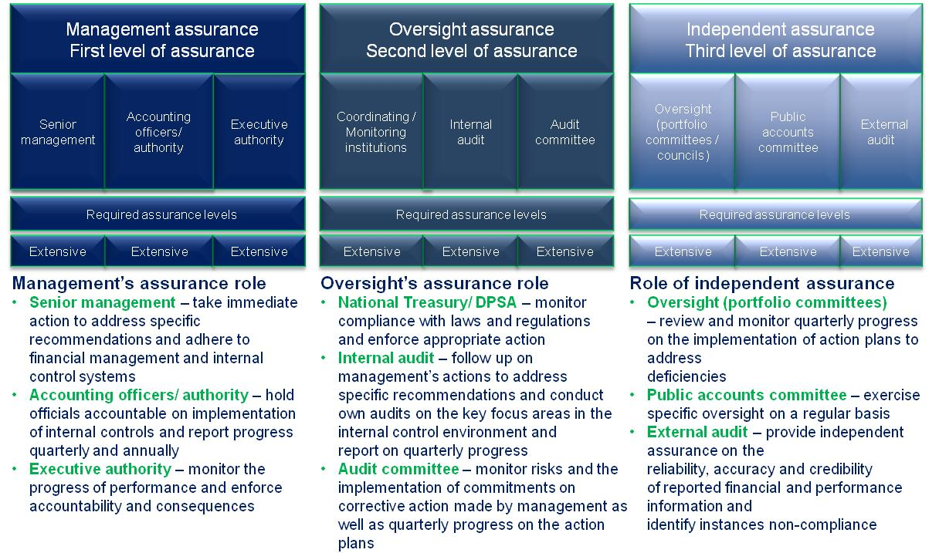
- Minister’s commitments and progress on such commitments
The following includes prior year commitments and new commitments made:
Focus area | Commitment | Due date | Status
Service delivery | The department will put a plan in place to identify and specify areas where service delivery will take place over a period of three to five years to be included in the department’s strategic plan.  This will assist the department to track and monitor service delivery and enhance planning and accountability to the citizens and will further ensure that targets not achieved are not removed from the strategic plan. Action plans to deliver services to the public are being developed and committed to. | 28 July 2014 | Material indicators and targets included in the operational plans of the department were not included in the strategic plan and annual performance plan (APP) for 2014-15.  These targets are also critical to achieving the 2030 targets as per the government’s national development plan.
Budget process | The department will ensure linkage of the budget to the targets as per the strategic plan.  This will make reporting on variances more relevant and easier to monitor. | 28 July 2014 | Based on the review of the 2015-16 APP the budget is still drafted per programme and not per indicator or target.
Credible reporting – financial statements | The department will implement daily, weekly and monthly checks and balances to ensure the credibility and completeness of financial and performance information presented to management and oversight committees. | 28 July 2014 | No material misstatements were identified.
Credible reporting – audit of predetermined objectives |  | 28 July 2014 | Material misstatements were still noted in the annual performance report submitted for audit on 31 May 2015.  All reasons for variances were not adequately recorded.
Reduction in use of consultants | The department will plan to support agricultural schools and encourage youngsters to study in the agricultural field.  This will assist in reducing the use of consultants in this field and ensure that the department achieves maximum return on investment made. | 28 July 2014 | The department has an approved consultancy reduction plan in place.  A reduction was noted in the amount spent on consultants from the 2013-14 (R33 953 000) to 2014-15 (R20 540 000) financial year.
Division of Revenue Act (DoRA) funds | The minister will collaborate with the provincial ministerial executive committees to ensure proper monitoring and evaluation of the use of DoRA funds. | 28 July 2014 | A monitoring framework for CASP funds was drafted in October 2014.  However, repeat findings were raised on material projects not monitored during the financial year under review due to insufficient human resources, as well as the absence of a formal system or central database to keep track of the projects being monitored.  The impact on the initiatives implemented should be visible in the 2015-16 financial year.
Internal audit | The department will strengthen its internal audit function to give assurance to oversight committees that information presented to these committees had undergone credibility and completeness checks. | 28 July 2014 | Internal audit was not operating effectively for the year due to insufficient guidance given by the acting Chief Audit Executive to the team resulting in the internal audit work performed not in accordance with the required IIA standards.  Progress has though been made in addressing prior year non-compliance identified.
Marine Living Resource Fund | The Marine Living Resource Fund (MLRF) will be merged with the department to ensure effective management of the entity. | 31 Aug 2015
Filling of vacancies | Vacant senior manager positions will be filled to build and maintain a positive culture. | 31 Aug 2015
Project plan | A project plan will be developed, setting out the timelines for review of the quarterly monitoring reports by the internal audit, audit committee, external audit and portfolio committee, to ensure the quality of reported predetermined objectives. | 31 Aug 2015
Ncera Farms | The Ncera Farms will be deregistered to ensure better management of the entity. | 31 Aug 2015
STATUS LEGEND
Commitment has been implemented
Commitment in progress
Commitment has not been implemented
New commitment made in current year

- Commitments from the portfolio committee
The following recommended commitments to be actioned by the committee:
- The department must maintain disciplines to ensure that quarterly performance reports produced are adequately signed off as accurate and credible by the responsible programme managers (deputy director-generals) and the directorate: Operational Performance. In addition, these reports must be subjected to the necessary quality review processes, including audit reviews, firstly by the department’s internal audit and the audit committee and, secondly, by external audit with the objective of obtaining some assurance on the quality and credibility of quarterly performance information reported. The review should also focus on indicators that are reported at national level, the implementation of which is at a provincial level.

- Action plans must be monitored to address repeat internal control deficiencies, ensuring that follow-up on action plans by the department is taken seriously and not seen merely as a tick-box exercise. Also, the department must ensure that not only the findings are addressed but also the internal control deficiencies that led to the audit findings of both internal and external audit.
- Entities included in the portfolio not audited by the Auditor-General of South Africa (section 4(3) audit entities)
Audit opinions |  | 14-15 |  | 13-14 | 12-13 | 11-12 | 10-11
- Ncera Farms
- Perishable Products Export Control Board (PPECB)
Qualification areas |  | 14-15 |  | 13-14 | 12-13 | 11-12 | 10-11
- None
Predetermined objectives |  | 14-15 |  | 13-14 | 12-13 | 11-12 | 10-11
- Ncera Farms |  |  |  |  |  | ü | ü
Compliance with laws and regulations |  | 14-15 |  | 13-14 | 12-13 | 11-12 | 10-11
- Ncera Farms |  | ü |  | ü | ü | ü | ü
AUDIT OPINION LEGEND
 | CLEAN AUDIT OPINION: No findings on PDO and compliance
 | UNQUALIFIED with findings on PDO and compliance
 | QUALIFIED AUDIT OPINION (with/without findings)
 | DISCLAIMER/ADVERSE AUDIT OPINION
ü | DEPARTMENT/ENTITY HAD FINDINGS (in the related matter)
10.1 Comments related to section 4(3) entities
Ncera Farms
The entity received a financially unqualified opinion with findings on compliance with legislation, which is the same as in the previous year. The entity’s financial resources are under strain and a turnaround strategy, including a request for funding, was submitted to the minister in 2014. No decision has yet been taken by the minister on the turnaround strategy.
PPECB
The entity has again achieved a clean audit outcome, but has been incurring increasing operating and net deficits in the past three years. The entity currently has large reserves and is unlikely to require government assistance in the foreseable future.

