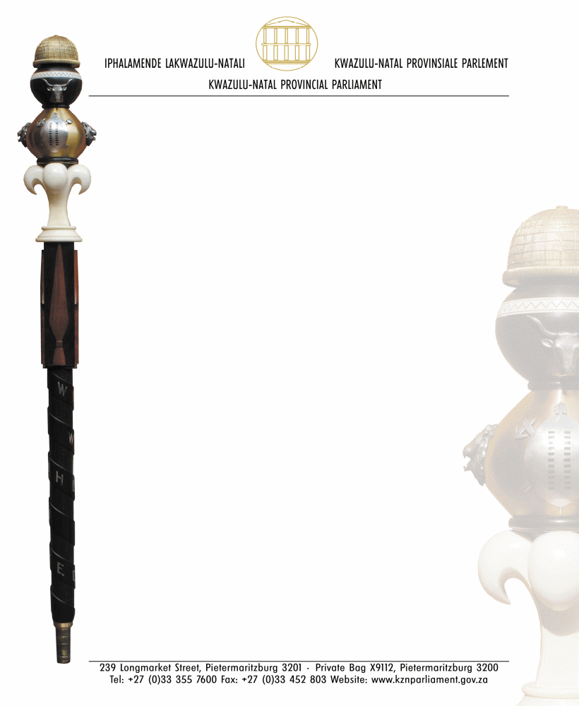

NEGOTIATING MANDATE

TO: HON DG MAHLANGU, MP
CHAIRPERSON OF SELECT COMMITTEE ON APPROPRIATIONS

NAME OF BILL: DIVISION OF REVENUE AMENDMENT BILL

NUMBER OF BILL: B33 – 2023

DATE OF DELIBERATION: 24 NOVEMBER 2023

VOTE OF THE LEGISLATURE:
The Portfolio Committee on Finance met today, Friday, the 24th of
November 2023, and agreed to mandate the KwaZulu-Natal delegation to support the Division of Revenue Amendment Bill [B33-2023].

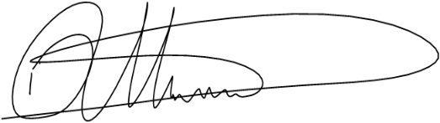
…………………………………….. 24 November 2023
HON TV XULU, MPL DATE
CHAIRPERSON: PORTFOLIO COMMITTEE
ON FINANCE

