**STATUS REPORT: BREEDE VALLEY MUNICIPALITY: NEW MANDELA SQUARE IN ZWELETHEMBA, WORCESTER, 652 IRDP SUBSIDISED HOUSES PROJECT- MAY 2023:**

Department of Infrastructure

**Louis Welgemoed**

Municipal Support: Human Settlement Planning

Louis.Welgemoed@westerncape.gov.za

1. **PURPOSE**

The purpose of this report is to provide a status update on the planning related matters associated with the New Mandela Square (652) IRDP Project in response to the Parliamentary Standing Committee for Human Settlements request to MEC Simmers dated 19 May 2023.

1. **EXECUTIVE SUMMARY**

Breede Valley Municipality received approval of approximately 1800 erven and units to be constructed in Zwelethemba, Worcester, dated 12 August 2002. The implementation of the project was phased in smaller and more affordable phases, namely**:**

* **Zwelethemba Phase 1 (384 houses),**
* **Zwelethemba New Mandela Square Phase 4** and
* **Cemetery Road**.

The Breede Valley Municipal Council resolved between 2007 and 2009 that the **Zwelethemba housing project: Phase 2** (368 erven and top structures) and the **Zwelethemba housing project: Phase 3** (285 erven and top structures) must be implemented. These phases were subsequently completed by 09 December 2008. However, the **Zwelethemba housing project: Phase 2** (368 erven and top structures) was reduced to 242 sites and services as the balance of 126 erven was occupied by informal settlers at the time. A total of 242 units were completed by 31 March 2015 under the 2013/14 subsidy quantum with Resolution 13/224 dated 05 November 2013. To date, the Municipality has serviced a total of 1800 erven and completed 626 top structures.

**The New Mandela Square Phase 4** is now in the implementation phase where new top structure opportunities will be provided on the existing serviced sites. This project will be funded through the IRDP program and will provide 852 top structure opportunities.

In February 2022, the Departmentally appointed NGO, People’s Environmental Planning (PEP), developed an Upgrading Plan (First Report: M3.2 Upgrading Plan) and a Relocation Strategy (Second Report: M3.3 Relocation Strategy) through community-based participatory planning process. This upgrading plan and relocation strategy will form the basis for the future decanting of New Mandela Square. The Breede Valley Municipality has proceeded to submit a PID application to the Department based on the Upgrading Plan and Relocation Strategy to unlock the development of New Mandela Square.

It should be noted that there is outstanding evidence to confirm that all statutory processes were followed, in addition to the qualifying beneficiaries; that needs to be resolved, to implement this project. This evidence must be provided by the Breede Valley Municipality in either an updated Project Implementation Readiness Report (PIRR) Application or by providing the outstanding information as annexure to the existing application to activate the project and to proceed with implementation.

To date the Western Cape Department of Infrastructure (DOI) has not received an updated project application or any additional information from the Breede Valley Municipality related to the New Mandela Project.

The Breede Valley Municipality submitted a Project Initiation Document (PID) Application for the upgrading of the North of Mandela Square and Aspad Informal Settlements to the Department of Infrastructure (DoI) in April 2023. The purpose of this PID Application is to initiate an upgrading project, of the indicated informal settlements, that will allow for the partial decanting of the New Mandela Square area thereby opening space to proceed with project 3255 or the construction of the remaining top structures in New Mandela Square.

The Directorates Planning and Implementation (Branch Human Settlements) undertook a site visit to the North of Mandela Square and Aspad Informal Settlements on 12 May 2023 as part of the review and assessment of the received PID Application (Project 3528).

The Directorate: Planning (Branch Human Settlements) completed the Planning Recommendation Report for the received PID Application on 17 May 2023 and submitted the completed report to the Chief Director: Human Settlement Planning (Branch Human Settlements) for review and approval on 18 May 2023. The Directorate: Planning identified two risks associated with the PID Application and the proposal therein, namely the current lack of sufficient bulk infrastructure capacity presently available for the project and the lack of a detailed explanation of the relocation and decanting strategy to be applied for this project.

The PID Application must still serve before the Departmental Project Assessment Committee (PAC) for final recommendation to the Head of Department (DoI) before funds can be released to the Municipality to proceed with the feasibility studies for this project.

1. **PROJECT BACKGROUND & LOCALITY**

The New Mandela Square (652) IRDP Project is in the northern extension of the neighbourhood of Zwelethemba in the settlement of Worcester in the Breede Valley Municipality. Figure 1 below depicts the location of the 2 pockets of the New Mandela Square (652) IRDP project. The proposed properties are owned by the Breede Valley Municipality. The northern most pocket is on the corner of Mtwazi Street and Yabo Street. The southern pocket is on the corner of Mayinjana Avenue and Isithintelo Street.

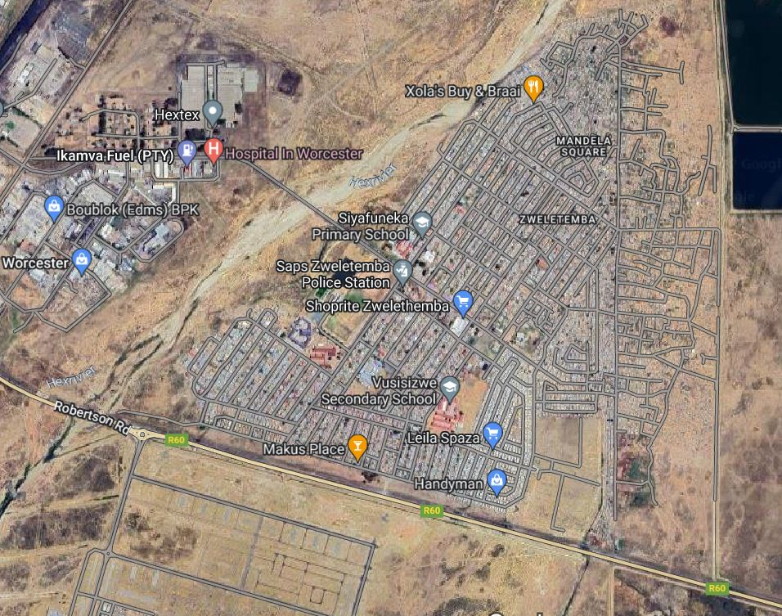

New Mandela Square (652) IRDP

Figure 1 Project Location



Figure 2: Site views of the New Mandela Square IRDP Project

The proposed site consists of Enhanced Services Sites with B-Grade services. The site is occupied by families living in informal structures, as depicted in Figures 2 and 3.

Figure 3: Enhanced serviced sites with core structures

The Breede Valley Municipality received overall approval for the Zwelethemba 1800 erven housing project by the Department on 05 November 2002. The project was approved as “services first and houses to follow” which was in accordance with approved guidelines at the time, to split services and top structures which would span over more than one financial year.

The implementation of the project was phased in smaller and more affordable phases, namely:

* Zwelethemba Phase 1 (384 houses),
* Zwelethemba New Mandela Square Phase 4 and
* Cemetery Road,

completed in previous financial years.

The Breede Valley Municipal Council resolved between 2007 and 2009 that the Zwelethemba housing project: Phase 2 (368 erven and top structures) and the Zwelethemba housing project: Phase 3 (285 erven only) must be implemented. These phases were subsequently completed by 09 December 2008.

However, the Zwelethemba housing project: Phase 2 (368 erven and top structures) was reduced to 242 top structures as the balance of 126 erven were occupied by informal settlers at the time. A total of 242 units were completed by 31 March 2015 under the 2013/14 subsidy quantum with Resolution 13/224 dated 05 November 2013.

To date, the Breede Valley Municipality has serviced a total of 1800 erven and completed 626 top structures.

1. **CURRENT PROJECT PLANNING STATUS**

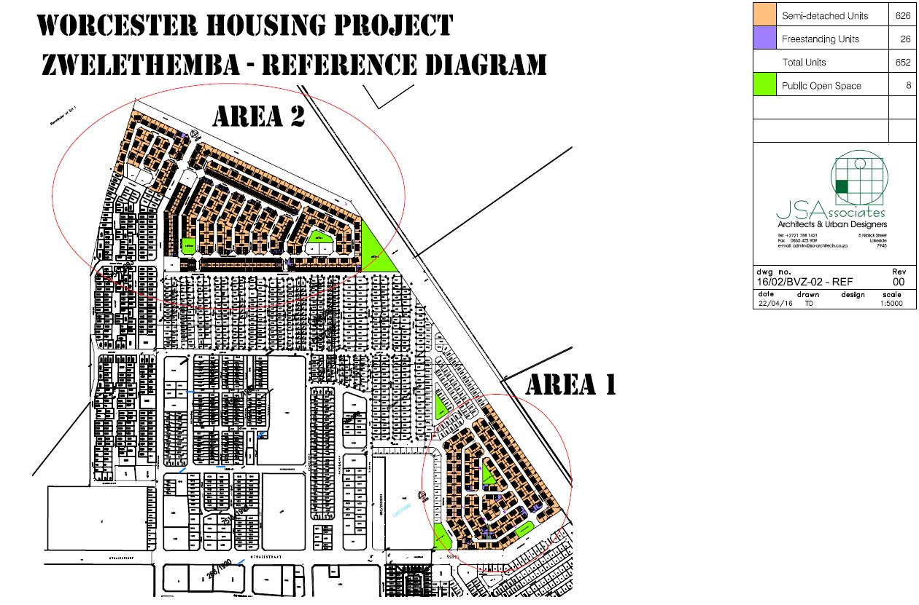The New Mandela Square (652) IRDP project is the conclusion of an older project that entailed the installation of services on the two affected sites. The Project Implementation Readiness Report (PIRR) application indicated that the project intends to construct new top structure opportunities on the already serviced sites. As shown in Figure 4 below, the layout includes housing typologies for semi-detached, three and four-row single-story houses as well as free-standing subsidy houses. In total 652 top structures are planned on two sites spread out in Zwelethemba.

Figure 4: Proposed Layout design of the New Mandela Square IRDP Project

The layout achieves increased urban efficiency as well as increased densities through the inclusion of three and four-row housing and semi-detached houses on the two sites. In addition to residential land uses, the layouts also make provision for public open spaces to increase the quality of this urban area.

Because the project entails infill development in an already established neighbourhood of Zwelethemba, the sites enjoy good access to various socio-economic facilities and amenities in this neighbourhood. Most facilities and amenities are located within walking distance of the two sites (less than 1km). As such, the following socio-economic facilities in Zwelethemba are within walking distance of the proposed development, namely:

* Schools: Siyafuneka Primary School, PJB Cona Primary School, Vusisizwe Secondary School, and creche’s as well.
* Library: Zwelethemba Municipal Library.
* Police Station: Zwelethemba Police Station.
* Commercial: Zwelethemba Shoprite and Xola’s Buy & Braai; and
* Cemetery: Zwelethemba South Cemetery.

When considering the list of socio-economic facilities located within walking distance of the proposed future project, the project can be considered as well located in the context of the Zwelethemba neighbourhood.

Additional services and economic opportunities can be accessed from the Central Business District (CBD) of Worcester itself, but these services and opportunities are not within easy walking distance of the proposed project and will require access to public transport.

The layout design does allow for increased urban densities, while still maintaining the residential character of the surrounding area. A circular road pattern with multiple gateways is included, and internal roads are of sufficient width to allow easy access, with the following benefits:

* Continuous route system promoting accessibility.
* A cost-effective design that optimises space and reduces costs through the inclusion of row housing.
* The design enables the provision of engineering services cost-effectively.

The two sites are in an existing neighbourhood of Zwelethemba and as such do fall within the latest urban edge and adhere to the spatial proposals as contained in the latest Municipal Spatial Development Framework (SDF 2019).

The table below depicts the status of the statutory processes involved with the New Mandela Square (652) IRDP Project and has been derived from the Project Implementation Readiness Report (PIRR) Application that was submitted in 2019 to the Western Cape Department of Infrastructure (DoI).

| Statutory process | Yes | Date of approval | No | Comment if “No” | Not applicable |
| --- | --- | --- | --- | --- | --- |
| LUPA | **X** |  |  |  |  |
| NEMA | **X** |  |  |  |  |
| NHRA | **X** |  |  |  |  |
| WULA | **X** |  |  |  |  |
| National Forest Act | **X** |  |  |  |  |
| General Plan | **X** |  |  |  |  |
| Other |  |  |  |  |  |

As can be seen from the table above all necessary development rights have already been obtained for this project according to the PIRR Application. Although this confirmation was stated in the PIRR Application, **copies of the actual approvals were not included in the PIRR Application, despite numerous follow-ups with the Municipality.**

1. **CURRENT STATUS**

Through the PIRR Application received in 2019, the Breede Valley Municipality has applied for a total of 652 IRDP subsidized houses in New Mandela Square in Zwelethemba, Worcester, which is the penultimate phase of the Zwelethemba 1800 subsidized housing project. Upon completion of this phase, it will bring the total houses constructed to 1 278 IRDP units. The municipality indicated that they still intend to apply for the final phase of 522 IRDP subsidy houses, in a separate future application to the Department.

The future development will integrate effectively with the existing town as well as with the bulk services networks. This would reduce the costs of engineering services.

Although the project inception meeting was held in mid-December 2018, SMEC SA (Pty) Ltd (the contractor the municipality appointed) only began pre-planning and feasibility work in earnest in February 2019.

The site was inspected by the Department’s regional and project managers on 13 February 2020, and they confirm the findings of the geotechnical report. The proposed sites are currently occupied by families living in informal dwellings. The proposed site is characterized by B Grade civil services at present.

1. **FUNDING APPROVAL**

The subsequent application for a top structure phase in 2015 was not approved by the Department, due to various outstanding issues, including a lack of qualifying beneficiaries at the time.

The Department requested a revised application, and, upon receipt, a meeting was convened with the Municipality to resolve further outstanding annexures, including the Site Development Plan, Traffic Impact Assessment, and Township Establishment information.

Internally, the Department’s Engineer’s report was completed and a site inspection with municipal officials took place on 13 February 2020. Also, the Department’s Project Administration Directorate further indicated that the application for top structures is currently being assessed by the provincial Department of Environmental Affairs and Development Planning for comments in their evaluation report.

1. **CONSTRUCTION PROGRAMME**

A proposed construction programme was submitted (dated, the year 2019), but this is to be further amended by the construction firm, taking the supporting documentation and statutory processes into consideration. This will also be made available to the DoHS.

1. **BUDGET**

Figure 5 below shows the most recent draft Departmental Business Plan extract for the Breede Valley Municipality, dated January 2023. This figure indicates that at present no funding has been allocated for the New Mandela Square (652) IRDP project. Funding will only be committed to this project once all the outstanding issues have been addressed and approval for the PIRR Application has been approved. **A key outstanding issue is the provision of proof that all necessary statutory processes have been completed and that all development rights have been obtained.**

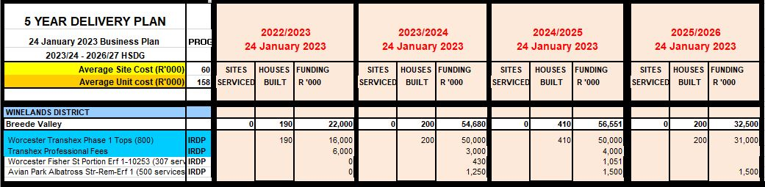Figure 5: Business Plan extract for the Breede Valley Municipality (January 2023)

1. **BENEFICIARY ADMINISTRATION**

According to the Department’s Beneficiary Approvals Directorate, beneficiaries have been screened for submission to the Department by the municipality, but there are still some issues that need to be addressed such as the following:

* Some applicants residing on the plots are under the age of 35 years old and this issue remains unresolved by the municipality.
* Several applicants do not conform to the three years on the waiting list, and some applicants are not on the waiting list.
* Some applicants are earning above R3500.00 per month.

According to the latest beneficiary screening list, as submitted by the municipality, a total of 37 beneficiaries are provisionally approved for the project.

1. **APPOINTMENT OF NON-GOVERNMENTAL ORGANISATION (NGO)**

The Breede Valley Municipality requested the assistance of an NGO through the Departments NGO Framework Agreement to conduct community-based planning and enumeration in the New Mandela informal settlements. The overall intention of the appointment is to ensure broad community participation in the implementation of the upgrading plan and any other initiatives directed towards the community of New Mandela informal settlements in the Breede Valley Municipality.

The appointment of a service provider was concluded on the 16th of February 2022 with the following milestones delivered by the service provider:

* Milestone 1: Scoping, site establishment and aerial survey;
* Milestone 2: Establishment and formalisation of community

participation structures;

* Milestone 3:   Community based planning;
* Milestone 4:   Continuity Plan and Close-out Report.

As of 1 November 2022, the service provider has fully completed Milestone 1 and 2 of the Service Level Agreement (SLA). This has been provided through the submission of the latest Drone Aerial Imagery illustrating the exponential growth and number of households in the New Mandela Informal Settlements as well as a fully signed Social Compact between the Municipality and Community Structures. The service provider has successfully completed and submitted the Upgrading Plan as well as the Relocation Strategy (Milestone 3 of the SLA). The Sustainable Livelihood Plan and the Close-Out Report were completed in December 2022 in line with the project plan.

On 01 February 2023 the Department received a request from the Breede Valley Municipality to extend the NGO’s contract to include the following, namely:

* Co-produce a toilet and tap layout for Emagwaleni;
* A co-design re/unblock section of North-Mandela with trained EPWP workers;
* Assist BVM to submit a UISP application for the upgrading of Emagwaleni;
* Assist BVM to submit an application for funds for land acquisition;
* A team of 20 trained EPWP workers that can continue to work after the NGO’s departure.

Presently the Department is considering this request and a meeting between the stakeholders was held on 02 March 2023. The table below depicts a proposed program of activities.

| **No** | **Activity/ Action:** | **Responsible Party:** | **Time Frame:** |
| --- | --- | --- | --- |
| 1. | Drafting of Emagwaleni UISP Application | Breede Valley Municipality | **Completed** |
| 2. | Submission of Emagwaleni UISP Application to DoI | Breede Valley Municipality | **Completed** |
| 3. | PAC (DoI) review & approval of Emagwaleni UISP PID Application | Dept. of Infrastructure (WC) | **In process Site Visit Undertaken and Planning Report completed. PAC review to be undertaken (to August 2023)** |
| 4. | Project budget allocation during adjustment budget process (GAAC) | Dept. of Infrastructure (WC) | 3 Month Process (to October 2023) |
| 5. | Release of Tranche 1.1 Planning Funding | Dept. of Infrastructure (WC) | Immediate with gazetting of ISUPG BP |
| 6. | Undertaking of detailed feasibility studies and preparation of Project Feasibility Report (PFR) Application | Breede Valley Municipality | 6 Month Process (to May 2024) |
| 7. | PAC (DoI) review & approval of Emagwaleni UISP PFR Application | Dept. of Infrastructure (WC) | 4 Month Process (to August 2024) |
| 8. | Release of Tranche 1.2 Feasibility Funding | Dept. of Infrastructure (WC) | Immediate with gazetting of ISUPG BP |
| 9. | Obtaining all necessary development rights for Emagwaleni UISP Project and preparation of Project Implementation Readiness Report (PIRR) Application | Breede Valley Municipality | 12 to 24 Month Process (to August 2025) |
| 10. | PAC (DoI) review & approval of Emagwaleni UISP PIRR Application | Dept. of Infrastructure (WC) | 4 Month Process (to November 2025) |
| 11. | Detailed Engineering Designs and Contractor Appointment | Breede Valley Municipality | 4 Month Process (to March 2026) |
| 12. | Project implementation and start of installation of services | Breede Valley Municipality & Dept. of Infrastructure (WC) | Construction potentially commences from March 2026 onwards |
| 13. | Beneficiaries relocated onto serviced sites according to Emagwaleni Relocation Plan, opening space in New Mandela Square Project area allowing for the construction of top structures | Breede Valley Municipality & Dept. of Infrastructure (WC) | To be determine |

The work outlined above will contribute toward allowing the BVM to de-densify the informal settlements of Emagwaleni and Zwelethemba and in so doing allow space to address the construction of houses in New Mandela.

1. **RECENT ACTIONS**

The Breede Valley Municipality submitted a Project Initiation Document (PID) Application for the upgrading of the North of Mandela Square and Aspad Informal Settlements to the Department of Infrastructure (DoI) in April 2023. The purpose of this PID Application is to initiate an upgrading project, of the indicated informal settlements, that will allow for the partial decanting of the New Mandela Square area thereby opening space to proceed with project 3255 or the construction of the remaining top structures in New Mandela Square.

The Directorates Planning and Implementation (Branch Human Settlements) undertook a site visit to the North of Mandela Square and Aspad Informal Settlements on 12 May 2023 as part of the review and assessment of the received PID Application (Project 3528).

The Directorate: Planning (Branch Human Settlements) completed the Planning Recommendation Report for the received PID Application on 17 May 2023 and submitted the completed report to the Chief Director: Human Settlement Planning (Branch Human Settlements) for review and approval on 18 May 2023. The Directorate: Planning identified two risks associated with the PID Application and the proposal therein, namely the current lack of sufficient bulk infrastructure capacity presently available for the project and the lack of a detailed explanation of the relocation and decanting strategy to be applied for this project.

The PID Application must still serve before the Departmental Project Assessment Committee (PAC) for final recommendation to the Head of Department (DoI) before funds can be released to the Municipality to proceed with the feasibility studies for this project.

1. **CONCLUSION**

This report has attempted to provide a summary of the New Mandela Square (652) IRDP project, the context and status of this project as well as the status of the planning processes related to this project. The report indicates that according to the PIRR Application received by the DOI all development rights have been obtained and the project can proceed to implementation once the decanting and beneficiary issues are resolved. It is important to note that evidence of the obtaining of development rights has not been presented to the DOI and the PIRR Application cannot be approved until this evidence is provided.

**KAHMIELA AUGUST**

**CHIEF DIRECTOR: HUMAN SETTLEMENT PLANNING**

**WESTERN CAPE GOVERNMENT: DEPARTMENT OF INFRASTRUCTURE**

**DATE: 19 MAY 2023**