Report of the Portfolio Committee on Cooperative Governance and Traditional Affairs on the 2023/24 Annual Performance Plans, Strategic Plans and Budgets of the Departments of Cooperative Governance and Traditional Affairs and the Entities Reporting to them, Dated 21 April 2023

Having engaged the Departments of Cooperative Governance and Traditional Affairs, and their associated entities, on their 2023/24 Annual Performance Plans (APPs), Strategic Plans and Budgets, the Portfolio Committee on Cooperative Governance and Traditional Affairs reports as follows:

- INTRODUCTION

Rule 227 of the National Assembly Rules mandates the Portfolio Committee on Cooperative Governance and Traditional Affairs to oversee the Departments of Cooperative Governance (DCoG) and Traditional Affairs (DTA) - Votes 3 and 15 respectively - and their associated entities. The associated entities are the Municipal Infrastructure Support Agent (MISA), the Municipal Demarcation Board (MDB), the Commission for the Promotion and Protection of the Rights of Cultural, Religious and Linguistic Communities (CRL Rights Commission) and the South African Local Government Association (SALGA). The diagram below is a schematic representation of the cooperative governance and traditional affairs portfolio:
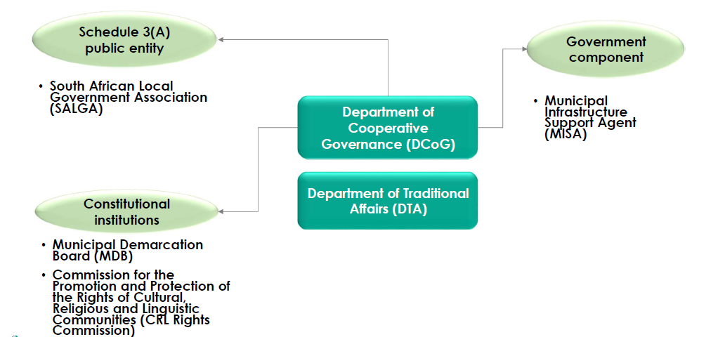

Between 18 and 19 April 2023, the Portfolio Committee considered the 2023/24 APPs, Strategic Plans and Budgets of the above Departments and entities. These were duly tabled in Parliament in accordance with the relevant legislative prescripts. These documents outline the outputs, indicators and targets, which the Departments and entities envisage achieving by 31 March 2024 given the resources made available in the 2023/24 budget.

- KEY POLICY AND RESOURCE CONSIDERATIONS FOR 2023/24

Department of Cooperative Governance

- Policy overview

The Department is primarily responsible for improving cooperative governance across the three government spheres. As stipulated in Section 154 of the Constitution, it must also support and strengthen municipal capacity to manage their own affairs, exercise their powers, and perform their allocated functions. One the Department’s key interventions in this financial year relates to reducing audit qualifications and Material Irregularities (MIs) in respect of the Community Work Programme (CWP).

Over the years, the CWP has been the Department’s predominant qualification area and the main source of irregular expenditure, which amounted to half a billion rand in 2023/24. Over the last decade, the CWP has incurred a cumulative R3.3bn in irregular expenditure. For several years, the Portfolio Committee has been raising concerns to the effect that the CWP does not seem to be serving its intended purpose, and that its investment return does not justify the billions of rand allocated to it.

In this regard, the Department has, as of 31 March 2023, temporarily taken over the administration of the CWP from the implementing Non-Profit Organisations (NPOs) in bid to address the compendium of previously experienced problems. The Programme’s budget allocation remains unchanged as to assist with maintaining implementation capacity in the NPOs’ absence. Part of the budget is also earmarked for the payment of NPO retention fees that have not yet been reconciled.

The Department has also introduced a new programme and organisational structure to address previous problems relating to optimal staff placement, and misalignments in the Strategic Plan. This is among the performance targets, which the Department had failed to achieve in the past. Another critical intervention, through the National Disaster Management Centre (NDMC), is to ensure that municipalities have disaster risk management plans in place, as to improve climate protection and reduce loss of human life, livestock and infrastructure. The Portfolio Committee has previously noted that the NDMC has inadequate disaster response capacity, which is characterised by haphazardness, poor organisation and poor planning.

Finally, in cognisance of the fact that municipal coalition governments have caused political instability in some of the councils that have been forced to form them, the Department will be working on legislation and stakeholder engagements to address the issue. The Portfolio Committee has previously welcomed the development of a municipal coalition framework by SALGA and encouraged further deliberation on whether this framework should remain voluntary or become an institutionalised coalition policy.

- Resource considerations

In the context of the recent flooding incidents, which have led to the declaration of a National State of Disaster, the funding reduction to the NDMC from R4.2bn in 2022/23 to R932.2m in 2023/24 is unjustifiable. The APP notes that the Programme is severely underfunded and that this will significantly affect the Department’s ability to fully execute its mandate in terms of the Disaster Management Act (2022). However, the Portfolio Committee was assured that National Treasury will avail the funds when the need arises. The diagram below encapsulates the Department’s resource considerations for the 2023 Medium Term Expenditure Framework (MTEF) period:

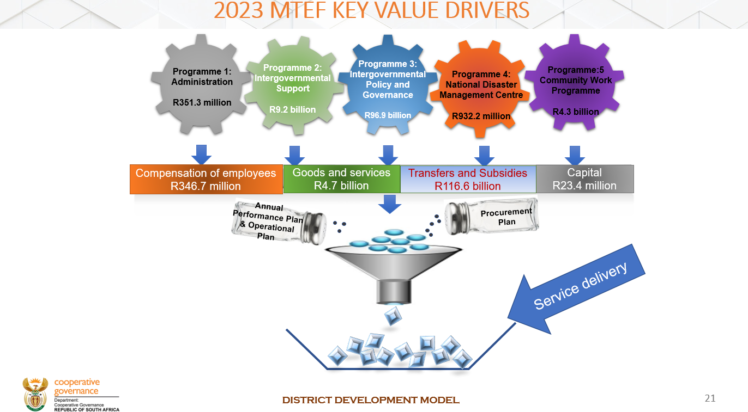
Source: Department of Cooperative Governance (2023).

Municipal Infrastructure Support Agent

- Policy overview

MISA is mandated to render technical advice and support to municipalities by undertaking a broad range of functions to optimise municipal infrastructure provisioning. During the period under consideration, the organisation will be placing more emphasis on utilising the DDM as to involve other critical stakeholders in the fulfilment of its mandate. This is in cognisance of the cross-cutting nature of the organisation’s policy mandate and the limitations of working in isolation. The Portfolio Committee has previous raised a concern around MISA’s unclear engagement with the problem of ageing infrastructure, especially as it relates to potable water access.

- Resource considerations

In its 2020/21 Preliminary Budgetary Review and Recommendations Report, the Portfolio Committee recommended that MISA must re-examine its funding model to ensure that it is aligned to the responsibilities expected of the organisation. During the 2021/22 budget vote process, the Portfolio Committee once again observed that the organisation’s funding model was not optimal, given the responsibilities it is expected to fulfil.

In response to the Portfolio Committee’s observation and recommendation, MISA indicated that it had prepared a business case, which estimated that the organisation will require approximately R2.9bn over the MTEF period to implement key initiatives to strengthen the Agent’s role and capacity to support municipalities towards improved delivery of municipal infrastructure and basic services. However, as the Table below illustrates, MISA’s funding requirements are still far from realisation:

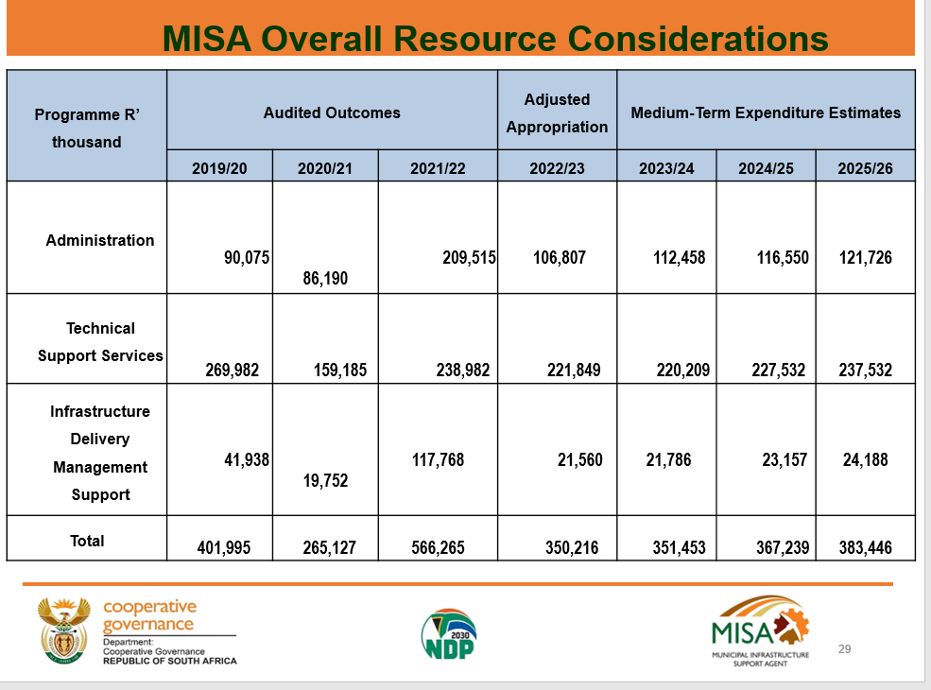
Source: Municipal Infrastructure Support Agent (2023).

Department of Traditional Affairs

- Policy overview

As in the previous financial years, the DTA continues emphasizing coordinating the participation of Local House of Traditional and Khoi-San Leaders in the District Development Model (DDM) to ensure that they are afforded a meaningful role in the process. Based on its oversight findings and engagements with traditional leaders on the ground, the Portfolio Committee has previously identified challenges around the involvement of traditional leaders in the DDM. The Department’s APP also draws attention to the issue of strained working relations between councillors and traditional leaders, which needs to be addressed.

- Resource considerations

The Portfolio Committee previously noted that funding to the National House of Traditional and Khoi-San Leaders (NHTKL) is insufficient to reaffirm the institution’s role as a key player in cooperative government. It has also noted provincial inconsistencies and discrepancies in the remuneration of traditional leaders and funding of traditional councils. However, the DTA’s own budget of R193.1m, from where the allocation to the NHTKL proceeds, is itself constrained from providing the required funding augmentation, as the Table below illustrates:

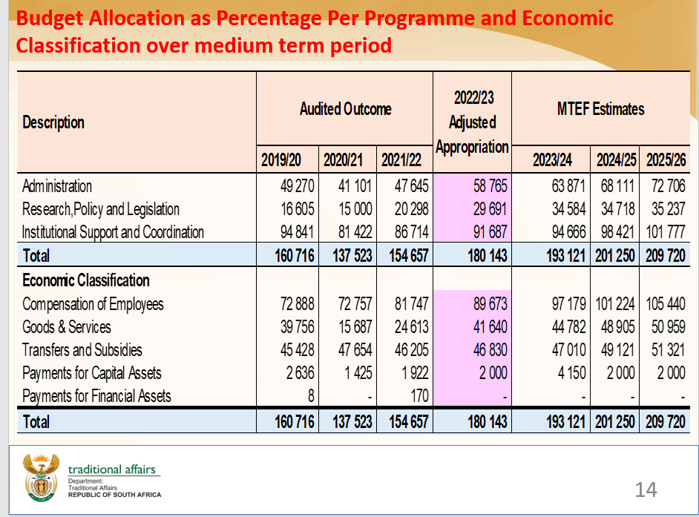
Source: Department of Traditional Affairs (2023).

The Table below illustrates the funding allocation percentage and amount (R24.1m in 2023/24) to the NHTKL, among others, from the DTA’s main budget:
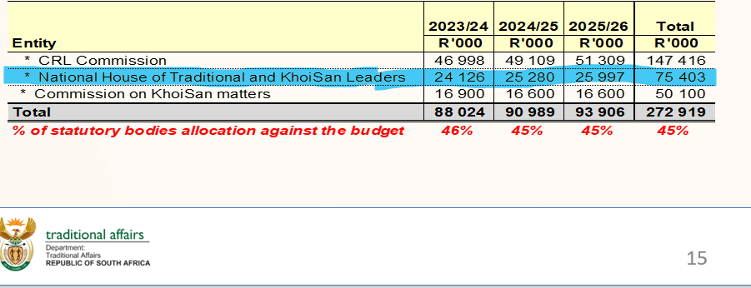
Source: Department of Traditional Affairs (2023).

The funding constraints also prevent the Department from providing tools of trade to local houses of traditional and Khoi-San leaders. The provision of tools of trade remains a burning question for many traditional leaders, and the Portfolio Committee has observed little traction in this regard despite more than a decade of traditional leadership transformation.

CRL Rights Commission

- Policy overview

The Commission is statutorily tasked with promoting and protecting cultural, religious and linguistic rights. In response to the Portfolio Committee’s previous concerns, the Commission will continue striving to enhance its footprint at the local level, particularly in rural areas where its existence remains largely unknown. An agreement is set to be concluded with SALGA to utilise its municipal offices as the Commission does not have its own local and provincial offices. The Commission will also prioritise capacitating CRL Community Councils and equipping them to champion CRL Rights issues at the local level. There are currently approximately 300 Community Councils in existence, which the Commission is working on capacitating, through it public education programme.

- Resource considerations

On several occasions, the Portfolio Committee has noted that the funding allocation to the Commission is incommensurate with the magnitude of the organisation’s mandate and needs urgent review. As many of the country’s deep-seated racial problems inevitably revolve around matters of culture, language and religion, there needs to be proper investment in the Commission as the key structure tasked with addressing these problems. However, the Committee has also noted instances where the Commission has not fully utilised the budget allocated to it. As tabulated below, the Commission receives a budget of R47m in 2023/24 as a transfer from the DTA:

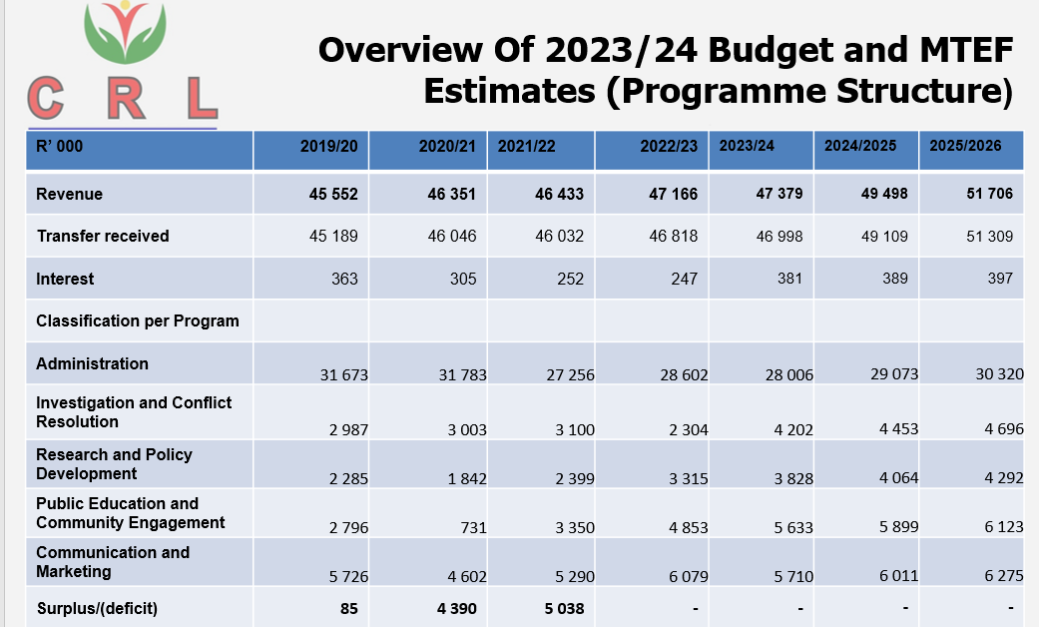
Source: CRL Rights Commission (2023).

Municipal Demarcation Board

- Policy overview

The Board is an independent authority responsible for determining municipal boundaries, declaring District Management Areas (DMAs), delimiting wards for municipal elections, and assessing municipal capacity to perform their constitutional functions. During the period under consideration, the Board continues striving to improve its public awareness and stakeholder education in relation to the municipal outer boundary determination and ward delimitation processes. This is in response to the Portfolio Committee’s persistent appeals around these matters, including advising the organisation to invest more of its resources on public participation, as its processes remain little understood and the extent of its consultation with affected communities remains inadequate. The Board tendered an apology for those instances where the Portfolio Committee’s requests have not been honoured.

All the demarcation proposals currently serving before the Board have been received from outside the organisations. Since inception, the Board has not made any determination proposals of its own despite being legally empowered to do so. As already alluded, one of the Municipal Demarcation Board’s key performance areas during the period under discussion relates to the municipal outer boundary determination and re-determination process, where inputs from research studies, public meetings, and investigation hearings are being considered. The closing date for these inputs was 31 March 2022. Valid inputs were classified into four different classes:

- Class 1 relates to technical and minor boundary re-determinations, which entail small-scale boundary adjustment and alignment with a minor impact on the geographic area, a negligible or no impact on the number of voters, and no impact on the capacity of the affected municipalities. All Class 1 municipal boundary re-determinations have been considered, and final determinations were published in February 2023.

- The second re-determination Class pertains to consolidation and annexations and is a medium scale boundary re-determination that may impact on a sizeable geographic area, and number of voters in one or all the affected municipalities. Although this may affect ward arrangements, it will not materially impact municipal capacity to deliver services. One hundred and seventy-two proposals were received in respect of Class 2 determinations.

- Class 3 re-determinations relate to amalgamations, which entail major and large-scale municipal boundary re-determination and a significant impact on geographic areas, the number of voters, and municipal capacity. Twenty-two proposals were received in this regard.

- The last Class of re-determinations pertains to the categorisation of any new metropolitan, district or local municipality with or without boundary changes. Eight proposals were received in this regard.

The Board last undertook the municipal outer boundary determination and re-determination process in 2018, in preparation for the November 2021 local government elections. The municipal outer boundary determination and re-determination process for Classes 2 – 4 redeterminations is set to be concluded during the current financial year, after which planning for the ward delimitation process will commence.

- Resource considerations

As in the previous years, the Board continues expressing frustration around the limited financial resources allocated to it, and the resultant inability to fully execute the organisational mandate. The Portfolio Committee has also previously expressed concern around the Board’s projected budget reduction over the medium term, and its negative impact on organisational operational stability, especially in relation to public participation. The cost element also makes it impossible for the Board to advertise its public notices everywhere, although every effort is made to reach all critical stakeholders and ensure that the affected areas are prioritised. The table below summarises the Board’s resource considerations in the period under review.

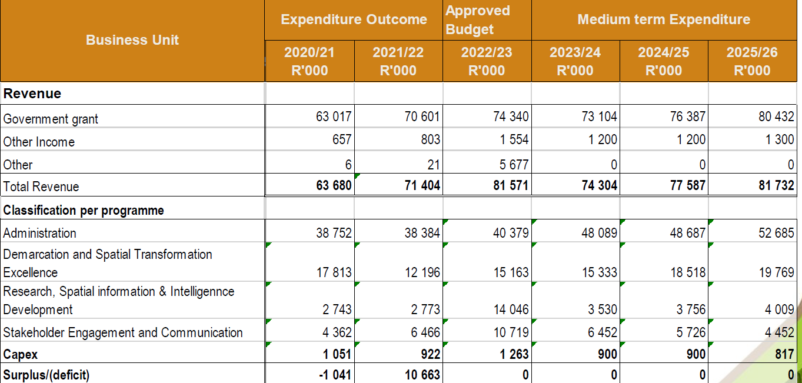
Source: MDB (2023)

South African Local Government Association

- Policy overview

SALGA has a constitutional mandate to assist in the transformation of local government. A critical issue emanating from SALGA’s APP relates to the organisation’s internal diagnostic analysis, which concluded that SALGA’s functional role and influence is inadequate, and thus unable to bring about the necessary change required to improve local government’s image. The organisation intends enhancing its operating model to better serve its members, ensure value for money and improve its image, and that of local government as a whole.

Political factors outside SALGA’s locus of control and the inadequate national fiscal allocation to local government are some of the key constraints to the fulfilment of the organisation’s constitutional mandate. The inability of many households to pay for municipal services negates the assumption that local government can rely on raising its own revenue. SALGA’s capacity building initiatives also continuously experience high attrition, as 7 out of 10 trained councillors do not return after an election. Consequently, the organisation must start from the beginning after every five years. This does not assist the effective execution of SALGA’s capacity building initiatives.

On the political front, the organisation has identified, among other things, the need to regulate municipal coalition governments as to abolish the prevailing coalition bargaining practice. Political parties are also enjoined to put forward candidates of the right calibre to ensure that there are quality people making the right decisions. The organisation strives to partner and collaborate with the other role players in the local government space as to avoid duplication of efforts. The APP is a product of a far and wide consultation with these role-players.

- Resource considerations

SALGA indicated to the Portfolio Committee that it is not requesting new financial resources. Being cognisant of the risk associated with relying predominantly on municipal levies for the organisation’s sustenance, SALGA is exploring alternative revenue generating opportunities. Tabulated below is SALGA’s resource considerations, reflecting the continued reliance on membership levies:

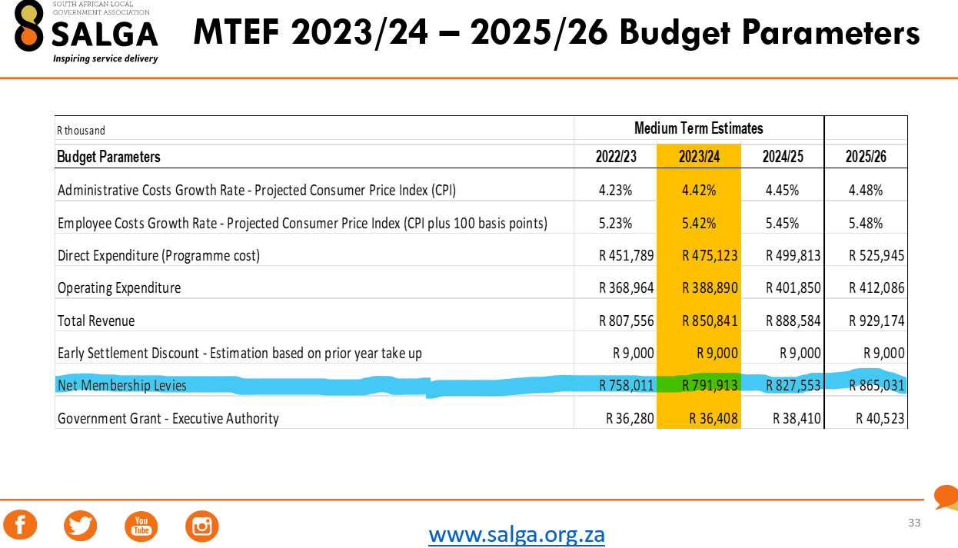
Source: SALGA (2023).

- IMPLEMENTATION OF 2022/23 BUDGETARY REVIEW RECOMMENDATIONS

Recommendation | Implementation progress
The Auditor-General (AG) and DCoG should strive to find common ground regarding the potential irregularities identified in the process of appointing the latest cohort of Implementing Agents. In the next BRRR report cycle, both the AG and DCoG should update the Portfolio Committee on how this matter has been resolved. | The Department has, as of 31 March 2023, temporarily taken over the administration of the CWP from the implementing NPOs, which obviates the point of contention with the AG.
The Portfolio Committee should, at the earliest convenience, convene a workshop with DCoG to discuss the CWP in more detail. | The workshop is scheduled for 05 May 2023.
The DTA should furnish the Portfolio Committee with a report on the killing of traditional leaders, particularly in KwaZulu-Natal where the problem has become systemic. | The report is still outstanding.
The Portfolio Committee should, at the earliest convenience, engage SALGA on the role it ought to play in the constitutional intervention process in municipalities. | The engagement is still outstanding.

- COMMITTEE OBSERVATIONS

  - Department of Cooperative Governance. The Department has provided no clear sense as to the consequences that would follow should targets not be achieved. More details on the Department’s revised organisational structure are needed as to enable Committee members to know exactly who to contact in relation to a particular municipality. As noted previously, the Department’s capacity to intervene in the problems of local government leave much to be desired. The indicator relating to the number of municipalities earmarked for future disaster intervention is not reliable as it is not possible to know in advance which municipalities will be affected. The Department has issued no formal communication regarding its moratorium on the contracting of CWP implementing NPOs. This has generated much uncertainty, speculation and confusion. The DDM results are not yet perceptible, and there is little indication as to how the Model is being implemented.

  - Municipal Infrastructure Support Agent. MISA cannot adequately address the problem of aging infrastructure single-handedly. It needs support and collaborative interaction with other relevant stakeholders.

  - Department of Traditional Affairs. Despite more than ten years of traditional leadership transformation, no adequate tools of trade have been provided to traditional leaders. The Department has earmarked only 23 NHTKL members for tools of trade provision and omitted provincial and local houses. The Department has also not attended sufficiently to the Spatial Land Use Management Act, 2013 (SPLUMA), which is spewing conflict between traditional leaders and municipalities. Traditional leaders’ non-representation in the tribunals provided in the legislation is among the chief causative factors.

  - South African Local Government Association. The organisation is failing to deliver on its constitutional mandate to assist in the transformation of local government. SALGA’s own internal diagnostic analysis concluded that the organisation’s functional role and influence is inadequate, and thus unable to bring about the necessary change required to improve local government’s image. SALGA continues to be unresponsive to matters of nepotism and sexual abuse in the labour Bargaining Council where the organisation is also represented. More activity around the organisation’s plans, beyond just presenting them to the Portfolio Committee, is likely to bring the requisite change. So far, the same questions have been raised and the same responses have been provided, which has brought a sense of futility to the whole exercise. SALGA’s presentation is disconnected from the lived reality of municipalities.

  - CRL Rights Commission. The Commission’s APP does not have a programme addressing the history of languages.

  - Municipal Demarcation Board. The Board has been unresponsive to the demarcation matter previously raised with it in relation to Ward 52 in the City of eThekwini. Instead of convening a consultative meeting with the affected residents, the Board has opted to alert the security cluster about possible community unrests. The reliance on policing is a disproportionate response as communities are often satisfied to see a government functionary coming to address them, even if their issue is not well-argued. Some of the publication platforms the Board currently uses to publish Section 26 notices do not meet the relevant public notice criteria. Certain published demarcation maps are inaccessible or entirely missing from the Board’s website.

- COMMITTEE RECOMMENDATIONS

  - Department of Cooperative Governance. The Department’s revised organisational structure should be furnished to the Portfolio Committee immediately. The Department should further furnish the Committee with a Memorandum relating to the employment and remuneration of the personnel replacing the CWP Implementing Agents.

  - Department of Traditional Affairs. The Department should, as soon as possible, furnish the Portfolio Committee with the details of the traditional leadership disputes and claims currently underway and those serving before it. The Department should also furnish the outstanding report requested in the 2022 BRRR process in connection with the killing of traditional leaders, particularly in KwaZulu-Natal where the problem has become systemic.

  - Municipal Demarcation Board. The Portfolio Committee should consider undertaking oversight visits to the areas proposed for demarcation, as to better understand the proposals’ rationale. The Board should, at a convenient time, brief the Portfolio Committee in more detail on the demarcation proposals that could trigger community unrest in the run-up to the 2026 local government elections. The Board should also attend to demarcation matter previously raised with it in relation to Ward 52 in the City of eThekwini. The Board should further pay more careful attention to the media platforms used for publication of critical public notices.

  - CRL Rights Commission. The Commission should consider including in its APP a deliverable relating to the history of languages.

  - South Africa Local Government Association. The Portfolio Committee should follow-up on its 2022 BRRR recommendation regarding engaging SALGA on the role it ought to play in the constitutional intervention process in municipalities. SALGA should further furnish the Portfolio Committee with an update on the matter raised in relation to wrong-doing in the labour Bargaining Council. The organisation must also infuse more activity on its plans rather than just present them to the Portfolio Committee.

  - Municipal Infrastructure Support Agent. Within the next 14 days, MISA should furnish the Portfolio Committee with the list of municipalities prioritised for intervention in relation to Municipal Infrastructure Grant (MIG) expenditure, and water and sanitation provision.

Report to be considered.

