**ADDITIONAL REPORTING OF THE PORTFOLIO COMMITTEE ON COMMUNICATIONS AND DIGITAL TECHNOLOGIES TO THE BUDGETARY REVIEW AND RECOMMENDATIONS REPORT (BRRR): POSTBANK ANNUAL REPORTS FOR 2019/20, 2020/21; AND 2021/22 FINANCIAL YEARS AND BROADBAND INFRACO DATED 7 MARCH 2023**

The Portfolio Committee on Communications (PCC), having considered the financial and non-financial performance for the years 2019/20, 2020/21 and 2021/22 of the Postbank on 15 November 2022 and of Broadband Infraco (BBI) for the year 2021/22 on 17 February 2023 reports as follows:

1. **Introduction**

For the period under review, the Committee, in exercising its oversight role, considered for Postbank 2019/20, 2020/21 and 2021/22 Annual Reports and Financial Statements of Postbank. For BBI, the Committee considered the 2021/22 Annual Report and Financial Statements. The Auditor-General of South Africa (AGSA) also presented the audit outcomes of the Entities for the above-mentioned Financial Years.

The annual reports of both entities were not available to be processed during the BBBR process in 2022, hence this addition reporting.

1. **Postbank**

**History of Postbank**

* First Savings bank was established in 1822.
* Became a State-owned savings bank in 1875.
* Banking was first conducted in 100 SAPO branches initially.
* Eventually, the services were available at every Post Office.
* In 1910 Post Office Savings bank amalgamated to form the Post Office Bank of the Union of South Africa.

Product offerings: Union loan certificate, national savings certificate, Saving Books, Banks Cards, Investments

The Postbank Act was promulgated in 2010 to create Postbank as a stand-alone Entity.

On 1 April 2019, Postbank was created as a separate legal entity and assets and liability split from SAPO. Postbank is in the process of applying for a full banking license and currently has a Section 13 approval to establish a bank obtained in 2016. There is a need to establish a Bank Controlling Company once the Postbank amendment bill has been promulgated.

The Section 16 license will be updated and submitted to the SARB once the amendments to the Postbank’s Act have been promulgated and the appointment of the key management staff is finalised.

The entity’s mandate is to drive financial inclusion on a cost-effective basis.

The transition milestones to a State bank are composed of:

1. Finalisation of the amendment to the Postbank Act
2. Update and submission of the Section 16 license application envisaged for the fourth quarter of FY2023.
3. Finalisation of the modernisation of the Bank's IT platforms to comply with banking legislation and regulatory requirements.
4. Implementation of the channel strategy.
5. Provide expanded services on a cost-effective basis to benefit its customer base.

**Performance Summary as at 31 March 2020**

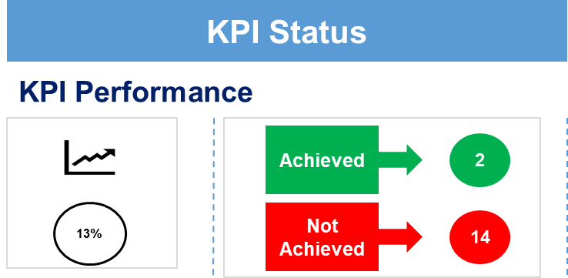

There was a high vacancies and instability in the leadership position which impacted the execution of the strategy.

**Operational Highlights: 2019/20**

As at the end of March 2020, the Postbank had 19.7 millionindividual and group savings accounts that were predominantly for the bottom of the pyramid and previously financially excluded customers and further awarded the Department of Environmental Affairs (DEA) Waste Bureau business.

A total of 8.4 millionSASSA beneficiaries were paid via Postbank accounts to the amount of R122.5 billionduring the 2019/20 financial year. Despite initial payment IT challenges, Postbank attained improved systems stability in the 2019/20 financial year, significantly improving its adherence to the industry SLA. Postbank implemented grant payments and biometric systems.

Partnered with the Eastern Cape Department of Public Works and Department of Roads and Transport to provide banking accounts to over 23 000 workers.

The transfer of the operations of the Postbank division, including staff and assets & liabilities, to Postbank was Gazetted with an effective date of 1 April 2019, in line with the provisions of the Postbank Amendment Act 44 of 2013.

Updates to Section 16, banking license application and Section 43 related to establishing a bank controlling company are in progress. In HR, Postbank Commenced HR capacity building in key areas of IT, Operations, Project Office, and Product development.

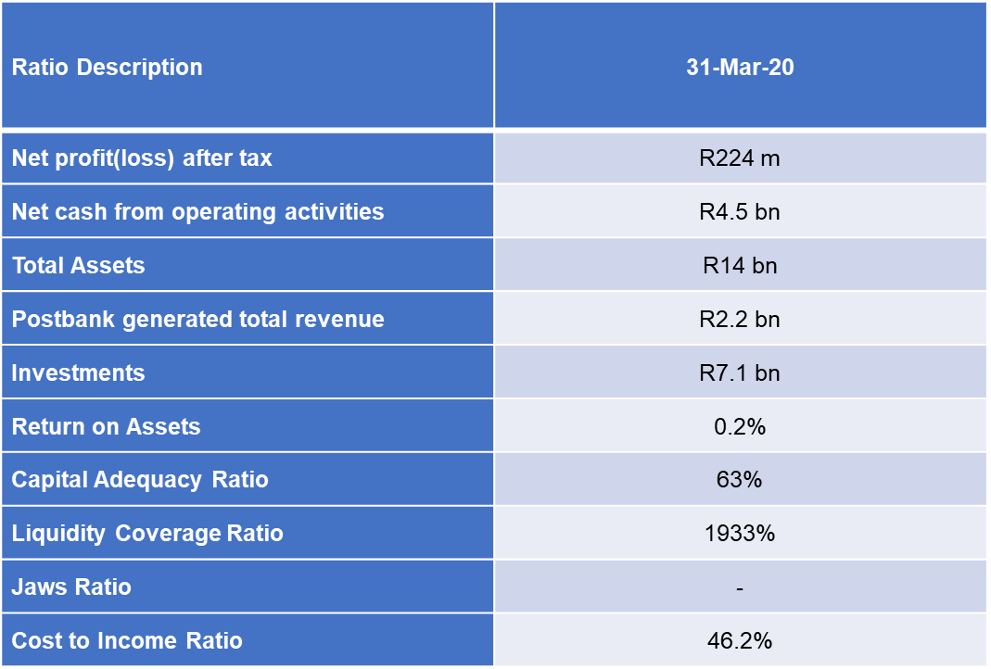

**Key Financial Highlights: 2019/20**

The profit after tax for the financial year ended 31 March 2020 amounted to R211 million. Net Cash from Operating Activities amounted to a cash basis figure of R5.3 billion; this is the amount of cash generated by Postbank from the revenue that was generated. Total assets amount to R14.2 billion in 2020 financial year, which exceeds total liabilities by R3.7 billion. This means that Postbank has sufficient cash to pay its debts.

Postbank generated total revenue of R2.3 billion during the year ending 31 March 2020. Return on Assets amounted to 2.05 per cent during the 2019/20 financial year. This return shows the profitability of Postbank’s assets in generating revenue and earnings. Investments amounted to R7.065 billion in the 2019/20 financial year despite slow growth in deposits due to customers.

**Auditor-General’s Report: 2019/20**

The Postbank received an outcome of a **Qualified Opinion** for the year under review.

**Other Reserves and Other Deposits (grants)**: The AGSA could not obtain sufficient and appropriate audit evidence that the other reserves and other deposits had been adequately accounted for. This resulted from Postbank's inability to reconcile IGPS records to SAP (reporting

system). Other reserves were determined after deducting the liability of the other deposits (grants) transferred to Postbank from SAPO.

The Postbank has developed an Integrated Audit Action Plan:

1. **Short-term measures to address the reconciliation** - Postbank is appointing a service provider through Supply Chain Management by the 31st of January, 2023. The Service Provider will perform the reconciliation, present the result to Management and Management correct and report the Annual Financial Statements by the 15th of May 2023.
2. **Long-term measures to address the reconciliation** – Postbank will develop a Business Case; facilitate the procurement of a solution and implementation of the reconciliation solution/system by the 31st of October 2023. Management will ensure the reconciliation solution/system is implemented by the 30th of October, 2023 and ensure credible reporting in the Annual Financial Statements going forward.

**Performance Summary as at 31 March 2021**

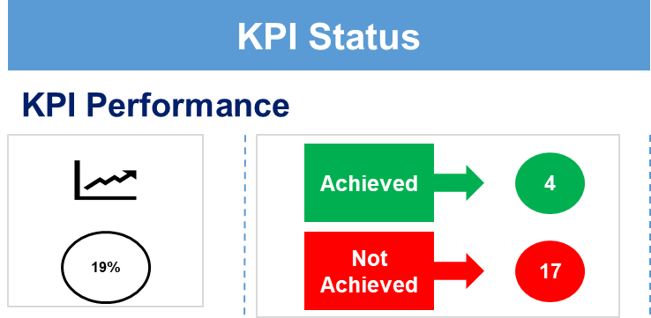

**Key Challenges:**

* The 2020/21 financial year was a difficult trading period across the markets due Covid-19 pandemic. The restrictions and lockdown significantly impacted the bank’s overall performance and revenues.
* High vacancies and instability at the leadership position impacted the execution of the strategy.

**Operational Highlights: 2020/21**

The Postbank holds 19.8 million (2019/20: 19.7 million) individual and group savings accounts, with grant accounts making up a significant number. The SARB designates Postbank as a clearing system participant in terms of Section 6(3)(a) of the NPS Act. The Banks Act Amendments promulgated enabling Postbank to start the process of finalising the incorporation of a Bank Controlling Company. The entity awarded the SRD grants business and paid R13.33 billion to 5.2 million SRD grant beneficiaries for the period under review.

**Key Financial Highlights: 2020/21**

The Postbank presented their financial results on the back of the Covid-19 pandemic, which left a distraction and major onslaught on our economy and, most importantly, our customers. Besides its negative impacts on economic activities, the Covid-19 pandemic caused harm to the South African economy in various ways, closure of businesses, massive damage to tourism and the hospitality sector and a significant number of job losses.

The financial results as at 31 March 2021 are reflective of the challenging operating environment that Postbank has experienced. The Bank’s revenue declined from R2.2 billion as at 31 March 2020 to R2.09 billion in the period under review. This was mainly due to expected credit losses which increased from R521 million to R798 million.

The impairment charge for the period under review was significantly high, primarily due to the increase in credit risk on some of our investments and the adjusted overlay for the Covid-19 pandemic impact. The Net Interest Income (NII) declined from R555 million in the prior year to R406 million as at 31 March 2021 as a result of the decline in interest rates.

The bank generates its revenue mainly from two income sources: the NII and Non-Interest Revenue (NIR). During the year ending 31 March 2021, the NIR contributed 80% (70%: 31 March 2020) of total revenue whilst Net Interest Income.

The NII accounted for only 20 per cent (25%: 31 March 2020) of total revenue. Diversifying the bank’s revenue sources is part of their management focus in the short-to-medium term.

**Auditor-General’s Report: 2020/21**

The Postbank received a **Disclaimer** audit opinion for the reporting year.

**Other Reserves and Other Deposits (grants)**: The AGSA could not obtain sufficient and appropriate audit evidence that the Other reserves and Other deposits had been adequately accounted for. This resulted from Postbank's inability to reconcile IGPS records to SAP (reporting system). Other reserves were determined after deducting the liability of the other deposits (grants) transferred to Postbank from SAPO.

The Postbank has developed an Integrated Audit Action Plan:

1. **Short-term measures to address the reconciliation** - Postbank is appointing a service provider through Supply Chain Management by the 31st of January, 2023. The Service Provider will perform the reconciliation, present the result to Management and Management correct and report the Annual Financial Statements by the 15th of May 2023.
2. **Long-term measures to address the reconciliation** – Postbank will develop a Business Case; facilitate the procurement of a solution and implementation of the reconciliation solution/system by the 31st of October 2023. Management will ensure the reconciliation solution/system is implemented by the 30th of October 2023 and ensure credible reporting in the Annual Financial Statements going forward.

**Performance Summary as at 31 March 22**

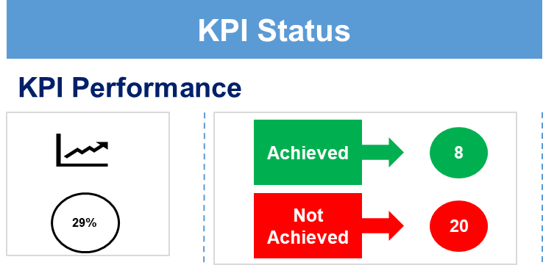

**Key Challenges:**

* The South African Reserve Bank (“SARB”) variation notice prevented Postbank from issuing new bank cards and launching products that integrate into the National Payment System (NPS) until the bank complies with the conditions outlined in the variation notice.
* Ministerial Moratorium around Postbank entering into long-term procurement contracts and the appointment of executives also impacted the activation of several strategic initiatives during FY2021/22.

**Operational Highlights 2021/22**

The Postbank holds 21 million (31 March 2021: 19.8 million) individual and group savings accounts, with most of the account holders from previously financially disadvantaged (underbanked) and excluded (unbanked) customers.

The entity partnered with additional retail merchants to disburse SRD grants in the period under review. At least 7 million (31 March 2021: 5 million) SRD grant recipients were paid via Postbank accounts to the value of R15 billion in the period under review (31 March 2021/2021: R13 billion).

More than 71 financial literacy campaigns were conducted in 2021/2022 compared to the previous Financial Year. In Financial Year 2020/2021, SARB designated Postbank as a clearing system participant in terms of section 6(3)(a) of the NPS Act.

**Key Financial Highlights: 2021/22**

The Postbank’s net profit improved significantly to R324 million in the year under review, rising from a loss of R443 million in the prior year. The improvement from the preceding year is mainly due to lower expected credit losses in the year under review, mainly due to reduced Covid-19 overlay adjustment. Although the Bank’s profitability has improved, the effects of Covid-19 still negatively impacted the overall performance of the Bank. This was evident in the flat revenue numbers reported in the year under review. The Bank reported revenue of R2 billion in the period under review. The revenue was impacted by a 16 per cent decline in NII from R405 million in the prior year to R335 million during the year ending 31 March 2022.

The main driver of the decline in the NII was the reduction in the Interest income from R436 million in the prior year to R367 million in the period under review as a result of the low interest rates.

**Auditor-General’s Report: 20221/22**

The Postbank received a **Disclaimer** audit opinion for the reporting year.

**Other Reserves:** AGSA could not obtain sufficient and appropriate audit evidence that the Other reserves had correctly been transferred and accounted for.

**Other Deposits:** AGSA was unable to obtain sufficient appropriate audit evidence for deposits due to customer due to the limitations imposed by the information systems to manage the related transactions.

**Fee and Transactional income**: AGSA was unable to obtain sufficient and appropriate audit evidence for Fee and Transactional income due to the inadequate status of accounting records and lack of required reconciliations between supporting information systems not being conducted

**Intercompany Receivables:** The issues resulting from the carving out of Postbank’s Assets and liabilities from SAPO were resolved, and Postbank successfully migrated to a new environment.

However, AGSA qualified this line item because the balance included SASSA-related transactions where we normally settle transactions with SAPO.

**Material losses:** Material losses could not be verified for completeness due to the significance of internal control deficiencies identified on key systems and cyber security incidents resulting in a loss of R89 million.

Postbank has developed an Integrated Audit Action Plan:

1. **Short-term measures to address the reconciliation—**Postbank is appointing a service provider through Supply Chain Management by the 31st of January 2023. The Service Provider will perform the reconciliation, present the result to Management and Management correct and report the Annual Financial Statements by the 15th of May 2023.
2. **Long-term measures to address the reconciliation** – Postbank will develop a Business Case; facilitate the procurement of a solution and implementation of the reconciliation solution/system by the 31st of October 2023. Management will ensure the reconciliation solution/system is implemented by the 30th of October, 2023 and ensure credible reporting in the Annual Financial Statements going forward.

The service provider, KPMG has been appointed to investigate the root causes of material losses. The investigation will also assist in quantifying the total value of material losses incurred, which will be reported in the Annual Financial Statements.

1. **Broadband Infraco (BBI)**

BBI is a Schedule 2 Entity in terms of the Public Finance Management Act No. 1 of 1999 (PFMA) (as amended) and is mandated through the Broadband Infraco Act, No. 33 of 2007 (the Act), amongst other key pieces of legislation.

The Company has two Shareholders - the Department of Communications and Digital Technologies (DCDT), representing the South African Government (owning 74 per cent of the shares), and the Industrial Development Corporation (IDC), which owns 26 per cent of the shares.

The legislative mandate is set out in the Broadband Infraco Act No. 33 of 2007 (the Act). Its objectives are to expand the availability and affordability of access to electronic communications, including, but not limited to, under-developed and under-serviced areas. The objects of the Act are aligned with the Electronic Communications Act No. 36 of 2005 and commensurate with international best practices and pricing through the provision of electronic communications network services and electronic communications services, expand the availability and affordability of access to electronic communications, including (but not limited) to underdeveloped and underserviced areas.

**Performance Summary as at March 2022**

The Company has achieved fourteen (14) out of nineteen (19) targets, which represents 74 per cent of its annual targets. Fourteen of the nineteen targets were achieved. Four financial sustainability targets and one socio-economic target were not achieved.

The Company could not commence the process of raising funds in the market due to the delay in the approval of the network investment plan. BBI also has low cash flow levels and a lack of debt repayment history. These factors contributed significantly to the non-achievement of the financial sustainability targets of the Company. The revenue is impacted in the main by the dropping of contracted links, price pressure due to fierce competition in the market, long outstanding debts, and self-provisioning by major customers. Due to some long outstanding debts, the debtors’ collection period has increased to 58 days compared to 28 days in the previous financial year. Low procurement levels and low spending on training and development due to financial constraints contributed significantly to the regression of the B-BBEE Level.

The Company has survived by using the cash generated from operations since 2012. This has resulted in very low levels of network investment and has impacted the ability to expand and upgrade the current infrastructure, including being unable to replace the obsolete ADLash fibre. This and load shedding has increased the network's instability, impacting customer satisfaction during the year under review.

The new normal that was caused by the outbreak of the COVID-19 pandemic altered working from physical locations (offices) to home offices, with meetings held virtually and learning for school pupils conducted digitally. Many children in rural and underserviced areas were left out of the e-learning process due to the widening digital divide in our country. Broadband Infraco is poised to expand broadband connectivity to ensure the inclusivity of all citizens in e-government, e-health, e-commerce, digital economy, and e-learning.



**Operational Highlights 2021/22**

* A total of five customers were acquired in the year under review.
* Strategic Partnerships – BBI recently signed a partnership agreement with a local Cloud and IT services company which has started to yield results with the one of BBI’s customers who are interested in the hosted cloud service. This will enable us to extend our offerings to include Cloud Services to exiting backhaul services – adding additional revenue.
* Channel Partner Training – BBI provided training to one of the strategic partners on its products and services. Additionally, the process training was conducted to ensure a seamless introduction to BBI’s internal processes.
* BBI concluded a letter of agreement with one of the provinces on the Intergovernmental Framework. This was for the continuation of services following the existing contract's expiration. The opportunity is to replace a private contract with a government-to-government deal.
* BBI has been selected as one of the preferred Service Providers for IT Infrastructure at Dube Trade Port in KZN. Dube Trade Port has already sent requests for quotations on 1Gbps IP Transit and 10Gb Layer 2 connectivity from Teraco Durban to Dube Trade Port Offices.
* C4IR – BBI was selected by CSIR to partner with the Centre for the Fourth Industrial Revolution (C4IR) to accelerate the adoption of the implementation of the Internet of Things (IoT) by the SMMEs Project. BBI’s role will be to provide Backhaul on its NLD Network from the region to Teraco Isando.
* KZN DoE – BBI has successfully deployed 10Mbps Internet to 36 of the 38 Schools in the KZN Region. We are currently in discussions to set up support processes with the selected contractors to address post-installation support services.

**Key Financial Highlights 2021/22**

Company revenue decreased by 5.47 per cent from R463 million in the prior year to R 437 million for the year ended 31 March 2022 and against a target of a 36 per cent increase.

Company cash generated from operations decreased from R45 million in the prior year to R7 million for the year ended 31 March 2022. A total of 136 per cent Debt to Equity was achieved against a target of 107 per cent.

There was an R27 million positive cash balance maintained against a target of R15 million and a total of R323 million new sales contracts against a target of R400 million. There was a decline in operating profit by R69 million against a target of R37 million. Non-current liabilities decreased by 2.3 per cent.

Other costs as a percentage of revenue increased to 26 per cent from 12 per cent in the prior year. The total capex as a percentage of revenue is 20 per cent at a rand value of R86 million.

**Auditor-General’s Report: 20221/22**

The statement of profit and loss and other comprehensive income indicates that the Company incurred a net loss of R118.561 during the year ended 31 March 2022 due to lower revenue raised against the cost to revenue and other operating expenses. The Company’s current liabilities exceeded its current assets by R339.535. The Company had accumulated losses of R1.556.687, and that the Company’s total assets exceeded its liabilities by R272.843. This indicates a material uncertainty and casts significant doubt on the ability of the company to continue as a *Going Concern.*

1. **Observations and recommendations**

**4.1 Observations for the Postbank**

In relation to Postbank, the Committee noted:

1. and thanked the Postbank for the presentation made;
2. that it required clarity from the AGSA on steps to be taken by AGSA when entities ignore the recommendations of the Committee. AGSA responded that the Public Protector and Hawks could be approached in such cases. AGSA noted that an element of collusion was identified in this matter, and it was referred to the Hawks for investigation regarding the SASSA grant. AGSA meets regularly with the Hawks, and a Steering Committee has been set up to deal with these issues. AGSA had met with the Board to discuss a forensic investigation and would avail their findings to ensure an efficient investigation. Regular meetings with the Reserve Bank have also been undertaken.;
3. its concern that the Postbank has received two disclaimers in a row and that this is the worst possible audit outcome an entity can receive;
4. its concern in respect of irregular expenditure of the Postbank;
5. its concern that the Board is to be appointed by the Cabinet and not the Committee. The Deputy Minister responded that the Board was appointed by the Minister in consultation with Cabinet as was required by legislation;
6. its concern with respect to record-keeping and Information Technology (IT) capabilities which were inadequate;
7. that the failure to maintain internal control issues was identified by AGSA and needed to be addressed;
8. its concern in respect of the internal controls and internal audits of the Postbank;
9. its concern as to how the Postbank will finance itself with? the establishment of the State Bank;
10. its concern in respect of the IT systems required and whether these updated systems can be afforded;
11. concern in respect of the sustainability of the Postbank;
12. that it required clarity to determine if the current revenue available could sustain the Postbank;
13. that the unfavourable (more likely adverse that unfavourable?) audit outcome speaks to the lack of proper systems within Postbank;
14. that it recognised that the Postbank is in a transition process, which is not expected to be without challenges;
15. that the Bank has enough capital and is above Reserve Bank requirements, which is a positive sign;
16. that it required clarity in the case the Postbank does not get the licence and what would be the consequence of this. The AGSA responded that Postbank was allowed to participate in the national payment system, almost like a bank. In the absence of the Postbank complying with the variation order by the Reserve Bank, the Bank would be exposed and not be able to conduct its work;
17. its concern that Board members and several Executives are yet to be appointed, which is likely to cause instability in leadership. AGSA responded that this might have been the cause of unfavourable (adverse?) audit outcomes. The situation was exacerbated in that there were governance challenges at both the Executive and Board levels;
18. that AGSA noted that it met with the Minister, the Entity’s Executive and the Board frequently to address the audit queries;
19. that AGSA noted the importance of established governance structures in supporting the Board;
20. that it was evident that the initial spin-off stage from SAPO to Postbank was not managed correctly;
21. concern that there were vacancies at the Board and Executive level that impacted the functioning of the Postbank;
22. that the Postbank indicated that it was well capitalised and had sufficient reserves to function;
23. that Postbank can sustain itself without requesting assistance from the fiscus to function;
24. they indicated that the Card Management System was part of the legacy issues and that they will undertake a complete card replacement process in a secure environment; and
25. that the current Board appointees were competent and were appointed with the involvement of the Auditor General and Reserve Bank;

**4.2 Recommendations for the Postbank**

In relation to the Postbank, the Committee resolved that the Minister should:

1. ensure that processes are in place to address all issues raised by AGSA;
2. ensure that the Postbank submits regular reports and updated quarterly reports to update the Committee on its capacity and service providers, amongst others;
3. ensure that the oversight function of the Department on the Postbank is improved;
4. ensure that the Committee receive further information on the sustainability of the Postbank;
5. ensure that the issue of the banking licence be finalised;
6. ensure that the high risk of cyber security, capacity issues, project management and card management needs, are addressed;
7. ensure that all vacancies on Board and Executive levels are filled urgently;
8. ensure the Committee arranges a joint committee meeting with Standing Committee on Finance;
9. ensure that the AGSA provide pointers that the Committee look at when doing oversight over entities;
10. ensure that processes are in place to strengthen internal controls measures; and
11. ensure that processes are in place to fill all vital vacancies.

**4.3 Observations for BBI**

In relation to Broadband Infraco (BBI), the Committee noted:

1. and thanked the BBI for the presentation made;
2. that BBI achieved fourteen (14) out of nineteen (19) targets, which represents a 74 per cent achievement rate;
3. that of the five targets not met, four (4) are for financial sustainability, and one (1) for socio-economic transformation;
4. that an unqualified audit outcome, with findings, was achieved by the entity;
5. that the going concern status of BBI remains an ongoing challenge;
6. that access to funding by the entity was a challenge and needed to be addressed;
7. that network expansion to create redundancy and capacity in the network was a challenge;
8. that BBI would, in the future, deal with the expansion of service offering through partnerships and collaborations;
9. that BBI would have to fill critical vacancies;
10. that it required clarity on the process of conclusion of the merger between BBI and Sentech;
11. that it required the need to understand the rationale to have the BBI incorporated with Sentech. The Department responded that the rationale for the merger was proclaimed in the 2013 Presidential Review on state entities and SOE reforms;
12. that it required clarity as to how the merger would improve the entity's results. The Deputy Minister responded that the issue of SA Connect had a phase 1, a pilot which connected 1000 sites. The implementation of phase 2 would be more detailed and would include the connectivity of the entire country, including schools, clinics, and traditional authorities, amongst others;
13. that the Deputy Minister indicated that the merger between BBI and Sentech would impact legislation the Companies Act and that, therefore, there would be a need to amend legislation governing these entities;
14. concern and requested clarity about why the Gauteng and Western Cape provinces did not receive connectivity. BBI responded that there was a concentration in areas that were not as effectively connected, however in the future, all provinces will be catered for;
15. concern and required clarity on the entity’s debt to Telkom. BBI responded that R150 million was owed to Telkom;
16. that it needed clarity as to the challenges experienced in reaching the deadline date for the merger. Sentech indicated that the process would be concluded at the end of the financial year;
17. that it also required clarity on the impact of the merger on the market;
18. concern on how load shedding has impacted the infrastructure of BBI and wanted to know if it was mitigating the damage caused;
19. concern that the merger may result in job losses. The Deputy Minister indicated that this merger would not result in job losses, although positions at top management would have to be managed;
20. that the Deputy Minister noted that the ultimate idea is to have one entity with one functioning role as one digital state company. The Department indicated that the creation of one company was in the long term, but at the end of this year, Sentech will take over 74% of the government, and BBI will control the rest. The integration of the two companies would still need to be confirmed by the Companies Act; and
21. that the Deputy Minister noted that Sentech and SABC (one of its biggest clients) had taken the matter for rates for signal distribution to the Competition Commission. The matter was ongoing, but Committee was assured that Sentech was not a going concern as a functioning Entity and therefore not threatened.

**4.4 Recommendations for BB1**

In relation to the BBI, the Committee resolved that the Minister should:

1. ensure that processes are in place to address all issues indicated by the Auditor General;
2. that processes are in place to address the going concern challenges of the entity;
3. that processes are in place to deal with the challenge of access to funding by the entity;
4. that network expansion challenges be addressed; and
5. that critical vacancies be filled.

***Report to be considered.***