Report of the Portfolio Committees: Mineral Resources and Energy, Home Affairs and Police on the Joint Oversight visit on Illegal Mining to Five South African Provinces, Dated 25 November 2022.

Introduction

The Portfolio Committees on Mineral Resources and Energy, Home Affairs and Police (hereafter, “the Committees”) undertook a joint oversight visit from 10 to 11 September 2022 to the Limpopo Province. The two-day joint oversight visit stemmed from an earlier joint oversight visit by the Portfolio Committees on Mineral Resources and Energy, and Police to establish facts regarding the gang-rape and robbery incident that had taken place on 28 July 2022 in West Village, Krugersdorp. The incident took place at a mine that holds a mining right, issued by the Department of Mineral Resources and Energy (DMRE). It was alleged that the perpetrators are illegal miners, mostly foreign nationals. This mine incident highlighted a bigger challenge, that is illegal mining. For this reason, the visit by the Committees was broadly on illegal mining.

Subsequent to the Gauteng/Krugersdorp oversight, the Committees resolved that a much broader fact finding oversight on illegal mining be conducted jointly by the Committees on Mineral Resources and Energy, Home Affairs and Police. The Committees resolved to visit five provinces where illegal mining is taking place.

The five provinces that were selected for the fact finding oversight were Gauteng, Limpopo, Mpumalanga, Free State and North West. Initially, the Committees had planned to conduct oversight in areas where illegal mining of gold was rife. However, it was later decided that, areas where illegal mining of chrome occurs should be included. Therefore, the oversight focussed on the illegal mining of gold and chrome in the country.

Table 1: Dates and Venues of the Provincial Fact Finding Oversight
Province | Area/Venue | Dates
Mpumalanga | - Barberton, Witbank | 7 and 8 October
Gauteng | - Roodepoort, Florida, Soweto  - JHB CBD, Kimberly reef Outcrop, Alberton, Roodekop, Spring Gold 1 Gedex, Benoni Snake road | 18 September  09 October
Free Sate | - Welkom | 17 September
Limpopo | - Burgersfort and Steelpoort  - Polokwane(Bergnek) | 10-11 September
North West | - Klerksdorp, Orkney, Steelfontein, Haartebeespoort, Rustenburg | 15-16 October

1.1 Report Writing Methodology

This report provides a comprehensive overview of the five provinces, as mentioned above. It is important to note that, this is a consolidated report, meaning that the reporting is not per province, but issues that came up in the provinces are grouped in themes. However, there are individual reports of the provinces, which could be made available when a need arises. In a situation, where something that was raised is unique to a particular province, this will be acknowledged in this report. It is also important to note that, the provincial reports are a basis for this consolidated report – information used is derived from those reports.

DEFINING ILLEGAL mining

This section provides an overview of illegal mining, such as defining the concept, outlining the criminal value chain of illegal mining, causes and impact of illegal mining.

Illegal mining means any prospecting or mining operations undertaken by any person in any area without holding any mineral concession, permit or any other permission granted or permitted under these rules or without any lawful authority, as the case may be. In South Africa, illegal mining takes place in both abandoned and operating mines, with illegal miners often operating under extremely dangerous conditions. Illegal mining can be categorised into two types namely, underground mining and surface mining. Underground illegal mining is a method that involves mining of hard rocks from underground. The activities are mostly in old and abandoned mines accessed mainly by shafts. Labour is intensive and high risk due to the possibility of rock collapse/fall. Most of the illegal miners are recruited to go underground for periods ranging from three weeks to six months. Illegal surface mining, on the other hand, is commonly known as cast mining where soil and rocks overlying the minerals are removed. This practice includes open-pit mining and strip mining. The illegal mining market is a well-managed 5-tier syndicate system.

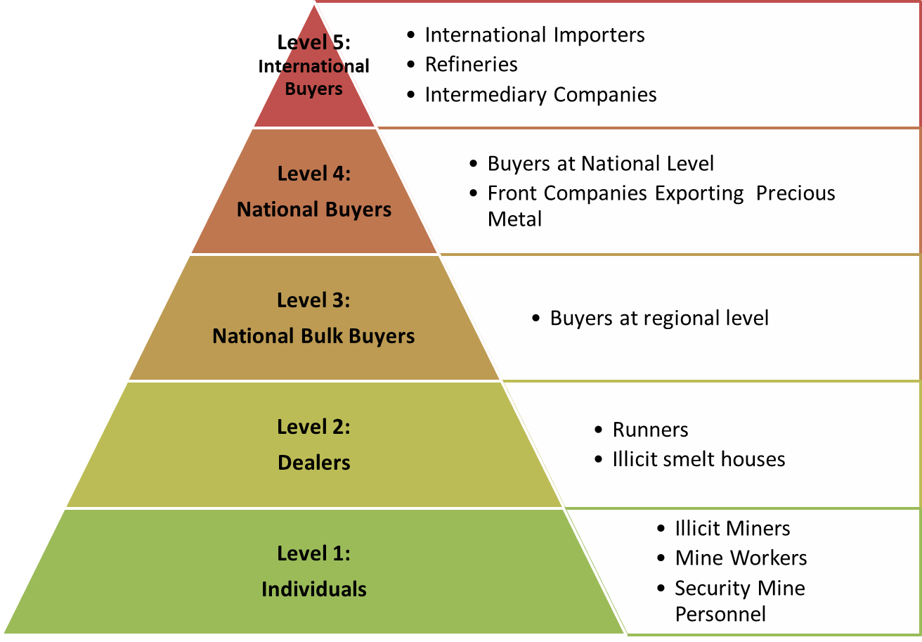
Figure 1: The Criminal Value Chain Relating to Illegal Mining
Source: South African Police Service (Gauteng) presentation, (2022)

As summarised in Figure 1 above, in the First Tier one would find underground workers, including many illegal immigrants, who do the physical mining. Many have worked in mines previously. They use chemical substances to primitively refine the product. The Second Tier are the buyers on the surface around the mines who also organise the First Tier illegal miners and support them with food, protection and equipment. In the Third Tier there are regional bulk buyers, who are usually entities with, in most cases, permits issued in terms of the Precious Metals Act (No. 37 of 2005) to trade in precious metals. The Fourth Tier are distributors, nationally and sometimes internationally, that work through front companies or legitimate exporters. The Fifth Tier are the top international receivers and distributors that usually work through international refineries and intermediary companies.

According to the Department of Mineral Resources and Energy (DMRE) in South Africa, illegal mining is conducted in respect of Chrome, Precious Metals (gold), Platinum concentrate, Iron Ore and Manganese, Coal, Diamonds, Aggregate Sand and other Industrial minerals. Limpopo, Gauteng, Free State, North West, Mpumalanga and Northern Cape have been identified as hotspots. Chrome, Coal and other bulk commodities are transported by trucks and exported from South Africa’s seaports or via Maputo Harbour in Mozambique as alternatives to Durban and Richards Bay Sea ports. The minerals are transported via rail and road, placing additional burden on public infrastructure.

2.1 Causes and impact of illegal mining

A number of factors contribute to illegal mining, some of the causes of illegal mining are discussed below.

2.1.1 Causes of illegal mining

In South Africa there are over 6 100 abandoned mines, these mines were left unrehabilitated as there was no legislative requirements for the rehabilitation of the mines prior the promulgation of the Mineral and Petroleum Resources Development Act in 2002. Rehabilitating these mines became the responsibility of the Government. With the current pace and small budget allocation for the closure and rehabilitation of these mines, it would take Government over 16 years to close these mines. In the meantime, these mines are used by the illegal miners for illegal mining. As explained above, illegal mining also occurs in legal mines – an example being the Harmony which shared its experiences with the Committees on how illegal mining impacted on the company and the measures the company had taken to combat illegal mining.

Mines that are under ‘care and maintenance’ and those that are under ‘business rescue’ can become enablers for illegal mining. Care and maintenance is often referred to as temporary closure of a mine where the mine is said to be in a state where it has temporarily stopped production for various technical, environmental, financial or labour related reasons. For instance, in Limpopo, the Committees were informed that, of the 177 mining rights which the DMRE had issued in the province between 2011 and 2022, 20 were reported to be under care and maintenance. Whilst mines are under care and maintenance, illegal miners see such gaps as an opportunity to engage in illegal activities. In Limpopo, the Committees visited Eersteling Gold Mine, which has been under care and maintenance since 1977 when production was suspended due to the prevailing low gold prices at the time. The community of Bergnek, Capricorn District, in Limpopo reported to the Committees that, because of the long period that Eersteling Gold remained non-operational or under care and maintenance, it has since been occupied by illegal miners. As a consequence, illegal miners are said to be terrorising the community of Bergnek.

Similar to the above, mines that are under business rescue may encourage illegal mining. The common interpretation of ‘business rescue’ is that it involves an independent intervention by a ‘business rescue practitioner’ to save a company from collapse when it is in severe financial trouble. Business rescue efforts can also fail and lead to provisional and then final liquidation.
Business rescue effectively allows the owners of a mine to delay a decision on when to liquidate and close. The owners hope that conditions will improve over time, and they will get profits from the operation. The unions and government also hope that jobs will be saved if closure is delayed and the company is rescued from liquidation. Business rescue can drag on, even for years, and in the process a mine can remain un-operational and therefore a hotspot for illegal miners.

Lastly, porous borders are often cited as one of the root causes for illegal mining. As it will be explained in the subsequent sections, the majority of illegal miners turned out to be un-documented foreign nationals.

2.1.2 Impact of illegal mining

Illegal mining often has dire and severe structural damages to the ground, leading to permanent road closures due to sinkholes, cracking and caving-in of the surface ground as a result of uncontrolled underground digging and mining.

Terrorisation of the communities by illegal miners is one of the sensitive and unacceptable consequence of illegal mining. Illegal mining has been associated with kidnapping, human trafficking, child labour and forced labour. Moreover, illegal mining gangs are directly involved with violent crimes associated with illegal firearms, rape, murder, intimidation, house breaking, theft, assault and corruption in nearby communities. Added to the challenge is the fact that unfortunately some communities sympathise with the syndicate leaders and illegal miners who may provide food, money and business to them.

Illegal mining also impacts on South Africa’s national security since the country’s infrastructure, territorial integrity, state authority, mineral sovereignty, economic security, safety and security get threatened. As a result, South Africa’s reputation/image is under threat and this directly threatens the formal economy as the cost of conducting mining business increases due to constant threats. This also impacts on foreign investor confidence as the ability of the State to control and manage the extent of illicit mining and trafficking in precious metals and diamonds is questioned. Furthermore, economic growth and development is adversely affected by the looting of national strategic assets and resources which in turn leads to losses in government and business revenue; threatening the long term sustainability of mines and their secondary industries.

3. key emerging issues across provinces

This section provides a comprehensive overview of the key issues which emerged during the oversight visits, across the five provinces. To a large extent, issues are grouped according to the respective Portfolio Committees, although mindful of the fact that issues do cut across the Committees.

3.1 Illegal Mining: A Home Affairs Perspective

Across the five provinces, it was reported that the illegal miners are predominantly from Lesotho and Zimbabwe, followed by other countries such as Mozambique, the Kingdom of eSwatini and Malawi. Notwithstanding the fact that illegal miners are predominantly foreign nationals, it was acknowledged that there are some South Africans who are involved in illegal mining activities.

It was reported that, the majority of illegal miners (at least from statistics of those who were arrested), are undocumented foreign nationals. This is a big challenge for the country, and is attributed to the country’s porous borders. Foreign nationals do enter the borders easily, and when they are deported, some are reported to return to the country on the same day. It was reported that this challenge is posed by Section 34 (1)(b) and (d) of the Immigration Act (13 of 2002) which was ruled by the Constitutional Court of South Africa to be unconstitutional. The judgment meant that when foreign nationals are arrested for immigration offenses, the Department of Home Affairs (DHA) should present them to a Magistrate Court in person within 48 hours. The unconstitutionality was suspended for 24 months to allow Parliament to amend the Act to ensure that undocumented foreign nationals must appear in court in person for the magistrates to confirm their deportation. Since section 34 of the Immigration Act was not amended, some Magistrates refuse to confirm the deportation which leads to the release of undocumented foreign nationals.

It was also pointed out that, besides the capacity issues at the borders, corruption by the DHA was rife as well. An example of a corruption case was cited wherein the DHA official at the Beitbridge Port of Entry solicited a R300 bribe to extend the number of days for a foreign national to stay in the country. The DHA official was arrested and convicted for four (4) years and suspended for five (5) years. This is just an illustration of many more possible such cases, the majority of which are likely not reported.

In response to some of the above challenges, the DHA and the DHA Minister, stated that measures such as the the Border Management Authority (MBA) Act 2 of 2020 are yielding positive results such as the appointment of MBA Commissioners who set in motion the appointment of Border Guards. The deployment of the 200 Border Guards was regarded as too little by some of the community members. The DHA agreed with that those 200 Border Guards were not sufficient. The DHA was in the process of advertising for the second round of Border Guards.

Additionally, in his presentation to the Portfolio Committees on Police, Mineral Resources and Police on 2 August 2022, the Minister of Home Affairs, Dr. Motsoaledi, stated that the Director General (DG) of the DHA and the Deputy Director General (DDG) of Immigration Services met with the permanent Secretary of Lesotho to discuss the migrants’ role in illegal mining activity and areas of co-operation including the issues of deportation. On 10 August 2022, a meeting was held between the ministers and other officials to discuss the issues of Zimbabwean Exemption Permit (ZEP) termination, conveyers’ transportation of illegal immigrants’ without any documents and illegal miners. The Minister stated that there were buses and taxies fined for transporting illegal immigrants to the country. Furthermore, a Botswana immigration border technical meeting was held on 10 and 11 August 2022 and a Mozambique immigration technical meeting was scheduled to take place in Maputo on 22 and 23 August 2022.

3.2 Illegal Mining: A South African Police Service Perspective

As discussed above, countrywide, illegal mining leads to the secondary informal syndicate market that supplies commodities such as firearms, liquor and prostitution. The syndicate leaders mainly employ undocumented foreign nationals and bribe police, security officers, prosecutors, lawyers and magistrates. The modus operandi for illegal mining remains largely the same due to the fact it remains the only source of income of the illegal dealers, refiners, smelters and receivers.

Illegal mining is an extremely dangerous undertaking as those who participate in this enterprise are often heavily armed and in possession of explosives which they normally use to set booby traps for mine employees, including security personnel and rival groups of illegal miners. It is argued that turf wars are on the rise because different illegal mining syndicates/ groups are fighting for mining space. Illegal miners are heavily armed with anything from a handgun and hunting rifles to heavy assault rifles. Ex-soldiers and the military-trained members, mainly from Zimbabwe, Lesotho and Mozambique, are used as snipers.

During the visits, it became clear that illegal miners are linked to a number of criminal activities including mass shootings and killings; gang/mass rapes; tampering with infrastructure, including the theft of copper cables; Illegal connection of electricity; which all result in the loss of human lives. Offences include illegal dealing in diamonds and precious metals, illegal firearms, undocumented persons, possession of stolen property, trespassing and offences related to the Explosives Act.

Illegal mining and organised crime are inter-related and often illegal mining is spearheaded by globally connected criminal syndicates. Of concern is the growing involvement of organised criminal groups, as well as the substantial increase in the volume and rate of transnational dimensions and a range of offences related to illegal mining of precious metals.

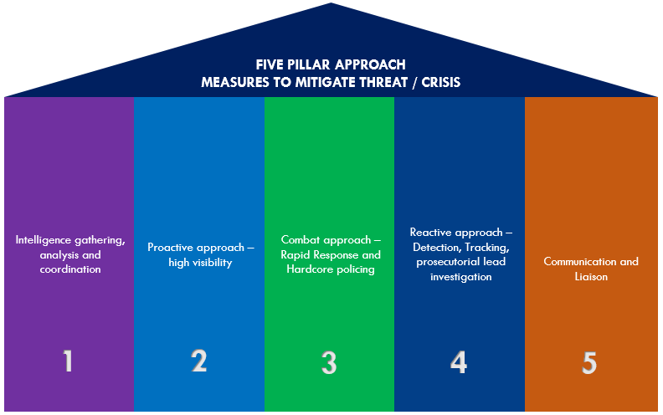
The SAPS has adopted and implemented a Five Pillar Intervention Plan to deal with illegal mining countrywide, which focusses on stabilization of identified hotshots and is based on the following:
Source: SAPS (2022)

SAPS has deployed several specialised multi-disciplinary task teams to deal with illegal mining activities, compromising of members from Crime Intelligence, Public Order Policing (POP), Tactical Response Team (TRT), National Intervention Unit (NIU), Air wing, Organised Crime Division, the Directorate for Priority Crime Investigations (DPCI/Hawks), Local Criminal Record Centre (LCRC) and communication. Moreover, SAPS highlighted various operational and strategic challenges to the policing of illegal mining.

Operational policing challenges include:
- Policing of Illegal mining activities in respect of:
  - SAPS members level of training in identification of raw materials.
  - Inherent risk of members going underground in search of perpetrators.
  - Knowledge and skills of Detectives to investigate cases relating to illegal mining.
- Law enforcement and security personnel are expected to respond to incidents in an unfamiliar terrain, exposing their personal safety and vulnerability to armed attacks.
- Public violence associated with Illegal mining requires diversion of resources from classical policing functions.
- Storing of bulky and toxic exhibit materials: the 13 SAPS evidence stores are generally small in size and not equipped to store large machinery.
- Inadequate coordination in the Criminal Justice System relating to prosecution and conviction of perpetrators.
- Increase in specific crimes stemming from, or in connection with illegal mining.
- Inadequate enforcement of mining legislation by Department of Mineral Resources and Energy.
- Neglect by mining houses/companies in securing property where mining activities ceased.

Strategic policing challenges include:
- Reputational damage for SAPS surrounding the manner of dealing with illegal mining and its consequences.
- Increased levels of corruption in all spheres of Government relating to this matter.
- Increase in children in conflict with the law due to the number of youth involved.
- Increase in illegal trade of equipment, explosives etc. utilised in illegal mining.
- Destruction of the social fabric of communities leading to increased levels of crime.
- Increase in expenditure relating to deployment of specialised SAPS capacities in the combating and investigation of illegal mining activities.
- Impaired relations with Southern African Development Community (SADC) countries whose citizens are involved in illegal mining and bearing the brunt of local communities.
- Porous borders leading to an increased influx of undocumented foreign nationals.

From a policing perspective, it is essential that various legislative gaps (identified in section 5) must be addressed and closed to enable a more efficient and effective policing approach to combat illegal mining.

3.3 Illegal Mining: A Mineral Resources Perspective

The mandate of the DMRE “is to regulate, transform and promote the minerals and energy sectors… and ensuring that all South Africans derive sustainable benefit from the country’s mineral wealth”. As a regulator of the mining sector, the issue of illegal mining becomes a key responsibility for the Department. However, as indicated earlier, in the past, there was no law that obliged mining companies to rehabilitate the mines upon completion of their mining activities. The DMRE, unfortunately has to address those legacy issues, where mines remain abandoned. Annually, the DMRE receives a budget of about R140 million, to close about 40 open holes (holings) per year, which are being exploited by illegal miners. According to the DMRE, with the current budget allocations, it would take about 17 years to close all the remaining holes. During the oversight visit, it became evident that, even in areas where the DMRE had closed the mine openings or shafts, illegal miners dug around the sealed shaft or mine opening. In fact, the sealing design assisted the illegal miners in identifying areas where mines had existed.

As was evident during oversight, a number of factors which encourage illegal mining fell within the purview of the DMRE. As explained in Section 2 above, these included, the failed or prolonged business rescue processes, mines that are under care and maintenance, poor management and monitoring of the mining rights issued to traditional leaders. The latter was raised more in the Limpopo and North West provinces, where Traditional Authorities allegedly gave letters to people to conduct mining illegally on land that belonged to Traditional Leaders. This being done outside the legislative framework – such as done without obtaining the necessary mining rights / authorisation from DMRE. The Committee emphasised the fact that the mineral resources that are beneath the surface belong to the State and therefore, under no circumstances, can Traditional Leaders confer this state property. It was reemphasised that Traditional Leaders own the land but not the mineral resources.

In contrast, in Rustenburg, Witrantjies Village, there were instances where land that belonged to a Traditional Leader was completely taken over by the illegal miners. The area is a hotspot for illegal chrome mining. The Chief indicated that the DMRE promised to come back to him but never did. He also pointed out that two (2) DMRE officials came to the area before extensive damage was done in the area. The damage could have been stopped at that time. The mining is conducted just 50 metres from people’s homes. Within the village, there were a number of excavators and trucks parked that were allegedly used by illegal miners.

3.3.1 Rehabilitation of old mines to combat illegal mining

As explained above, Council for Geoscience (CGS) and Mintek are tasked with the responsibility of implementing the mine closure programme, including closing of holings, on behalf of the Department. Apart from the closing of holings, the entities also conduct research on mine closure. Some of the mine closure research projects that the CGS has done include repurposing mine tailings for backfilling of shallow under-mines areas, asbestos air quality monitoring, ground stability studies, development of the national mine closure strategy, and the development of illegal mining monitoring tool. According to CGS, the illegal mining tool is the first in South Africa, it has never been attempted before. The tool includes the Illegal Miner Mapper (IMM). The IMM incorporates Remote Sensing data and machine learning to detect map the spatial patterns of illegal mining activities. Areas currently being monitored include illegal gold mining in Benoni, illegal coal mining in Emalahleni, and illegal sand mining in Durban. Other programmes aimed at rehabilitating the mines that were reported in Gauteng included the following projects.

Johannesburg CBD Anderson Street Iprop Property Development: The DMRE reported that mining, at this site, had been done from around 1910. The site was being repurposed as a housing development on an outcrop to rehabilitate the land and stop illegal mining. This rehabilitation/development is done by Iprop Property Development. In closing the holes or tunnels, the DMRE, together with Iprop Development, decided for a residential development rather than just concrete slabs which are less effective in preventing illegal mining. The DMRE showed the delegation a big tunnel, which the DMRE and the IProp Property Development were in the process of closing. This tunnel was reported to have been in existence for more than 100 years. The DMRE indicated that this was one of the positive stories of dealing with illegal mining.

Goundrand/Sol Plaatjies: In this area, there is a property development and it was reported that it took seven years to rehabilitate the place. The development in this area would join Dobsonville in Soweto and it would take about 15 years to complete the project. The area would have facilities such as private schools, clinics, shopping centres and the Committees suggested a police station. The plan is to integrate the Groundrand with Soweto and Roodepoort. As a result of this development, there were no more than a few illegal activities taking place. The developers also take responsibility to secure the place.

Solar Farm: Near Florida, the Committees were shown a piece of land where illegal mining was taking place and there is a plan to build a solar farm to supply Eskom with electricity and to curb illegal mining. It would be 10 square kilometres of solar panels connected to the local substation. It was reported that Eskom was planning to move the power lines to the other side of the Main Reef road because the poles were not stable anymore due to illegal mining underground. The place is damaged and it is not suitable for human settlement.

3.4 Vulnerable Communities

Community Police Forums (CPFs) are established through section 18 of the South African Police Service Act, 1995 (Act No. 68 of 1995) with the objective of establishing a liaison between SAPS and communities as contemplated in section 215 of the Constitution.

These structures play a crucial role in South Africa’s community-orientated policing approach that was adopted post-Apartheid to build trust and cooperation between the police and communities. These structures are intended to -

- establish and maintain a partnership between the community and the Service;
- promote communication between the Service and the community;
- promote co-operation between the Service and the community in fulfilling the needs of the community regarding policing;
- improve the rendering of police services to the community at national, provincial, area and local levels;
- improve transparency in the Service and accountability of the Service to the community; and
- promote joint problem identification and problem-solving by the Service and the community.

Based on the above, CPFs were identified as a key Government (and elected) structure for engagements during oversight visits to provide a perspective on the impact of illegal mining on communities, and to speak to the relationship between SAPS and communities and whether the police are, in their view, effectively addressing illegal mining. The Committees also met mining stakeholders such as the Mining Affected Communities United in Action (MACUA) and Women Affected by Mining United in Action (WAMUA). The Committees also met communities that were directly affected by illegal mining.

During the various oversight visits it became clear that illegal mining has a devastating impact on communities, especially in terms of violent crime. Specific categories include contact crime such as murder, attempted murder, assault with the intent to cause grievous bodily harm (GBH) and sexual offences, predominantly rape. Another prominent crime category affecting communities are property-related crime, including house robbery, house breaking and stock theft.

Communities raised significant concern about the seeming ineffective response from the police to deal with illegal mining in affected areas. Inadequate police resourcing was raised as another concern, such as the contact point established in Bergnek that is staffed by one police officer. CPF structures are not sufficiently resourced and supported by the police in terms of transport, equipment such as torches, reflective vests and telecommunication capabilities.

Communities indicated that illegal miners are heavily armed with high calibre firearms which exacerbate the proliferation of illegal firearms in local communities, and the country as a whole. Residents indicated that shootouts between illegal miners and the police often spill into residential areas and that residents are fearful of stray bullets from high calibre firearms that can easily penetrate walls.

A key concern raised by communities is the perceived collusion between illegal miners and officials from the SAPS, DMRE and DHA. It was alleged in several communities that many officials, especially police officers, are corrupted and offer protection and transport illegal goods for illegal miners.

A common thread running across community engagement is a seeming lack of trust between communities and the police, largely due to suspicions of complicity by the police and a lack of effective response by local police stations to reports of illegal mining (and related crimes). It was stated that there is a breakdown between the police and communities which prevent the community to work together with the police in fighting crime. Another aspect therein is that communities are fearful to report crime to the police as they are scared that police members working with (or for) illegal miners, will leak this information which will lead to the community members being targeted by illegal miners.

The impact on vulnerable groups, including women and children, and the elderly, were emphasised by all communities that were engaged. Women run a constant risk of being raped, children are too scared to play outside and the elderly are living in constant fear of illegal miners. Community members indicated that illegal miners are destroying the social fabric of communities and breaking families apart. Large groups of local residents are displaced from informal settlements due to illegal miners simply taking over their homes. Community members stated that illegal mining effectively keeps them hostage, robbing them of their freedom of movement.

A significant concern remained the fact that illegal miners get bail too easily and just return to their activities as soon as released. It was further pointed out that persons convicted of illegal mining received inadequate (or lenient) sentences, which do not deter persons from returning to illegal mining activities once released. This impacts further on the already significant challenge faced with recidivism in South Africa.

Community members raised significant concern about South Africa’s porous borders and the influx of undocumented (illegal) foreign nationals who are believed to be heavily involved in illegal mining activities. Community members indicated that foreign nationals from Lesotho (called Basotho’s or Magomosha) are the most dangerous and violent grouping. It was further alleged that human rights based organisations, including the South African Human Rights Commission (SAHRC) are too concerned about the rights of illegal foreigners, neglecting the rights of South African citizens.

Community members raised concerns about structural damages caused to their homes and business due to uncontrolled blasting with illegal explosives. This is coupled to significant damage caused to public infrastructure, including water supply, electricity supply, collapsing of roads (due to sinkholes), cable theft, destruction of street lights, and damage to sewer and drainage systems. These have a significant impact on local and district municipalities to repair these damages. Municipalities are also facing significant challenges with land grabs. Community members alleged that illegal miners had become so prominent and organised that they control municipal access to the areas, including services such as Telkom.

Community members indicated that they are deprived of mining rights and that these rights are dominated by large companies. Communities indicated that joint ventures with large mining companies should be set up to uplift and enrich communities. Community members alleged that some mine owners are the ones employing zama zamas and are intrinsically involved in illegal mining activities. Especially, mining stakeholders stated that the DMRE should legalise small-scale mining.

Community members raised concern about the safety and welfare of the people who are working underground especially women who can be raped whilst working. It was stated that many workers are forced to work underground against their will and they are working under very poor conditions that are not conducive to health.

Community members raised concerns about the environmental impact of illegal mining in their local areas, especially the large scale of water wastage in illegal mining operations, and the pollution of rivers and streams. The gasses from unrehabilitated mines and illegal mining are causing serious health risks and residents are regularly treated in hospital for respiratory illnesses.

During the very first oversight visit, in Gauteng, Krugersdorp, the Residents of West Village, where illegal mining is rife and where the rape incident had occurred said that “communities are scared for their lives…we are under siege by the Basotho nationals… West Village is at war, it was a hub of illegal miners. The Basotho have threatened that they would come for revenge.” Similarly, during engagement in Bergnek, the Ward Councillor stated that illegal miners are terrorising the community, and it is suspected that the illegal miners are working with some members of the community as informants. Moreover, the community indirectly supports or sponsors this illegal mining behaviour because illegal miners rent houses within the community.

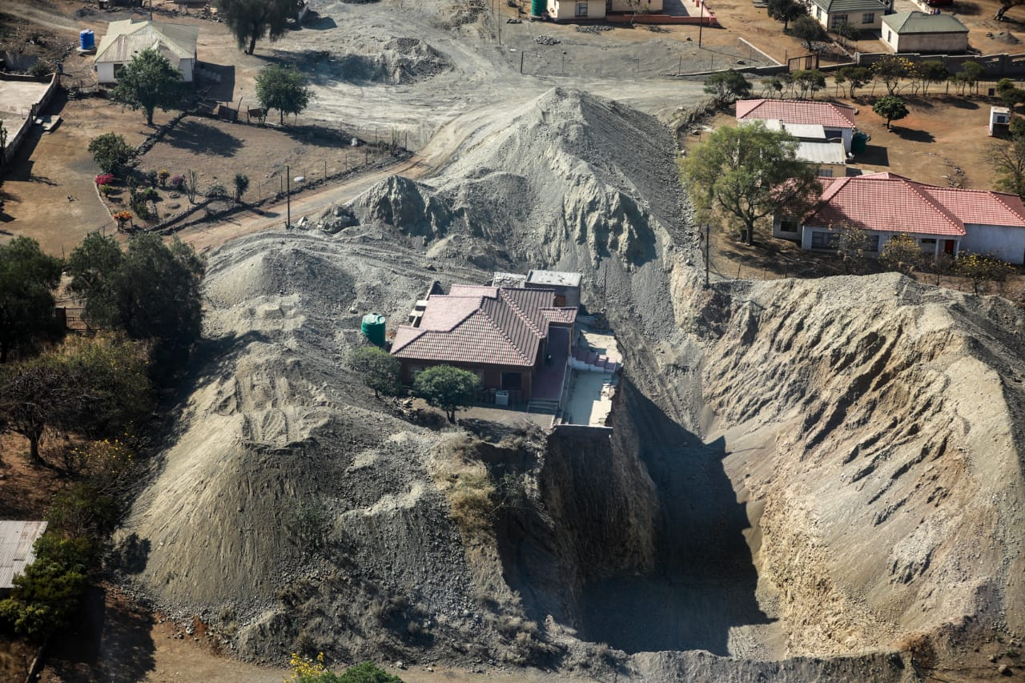
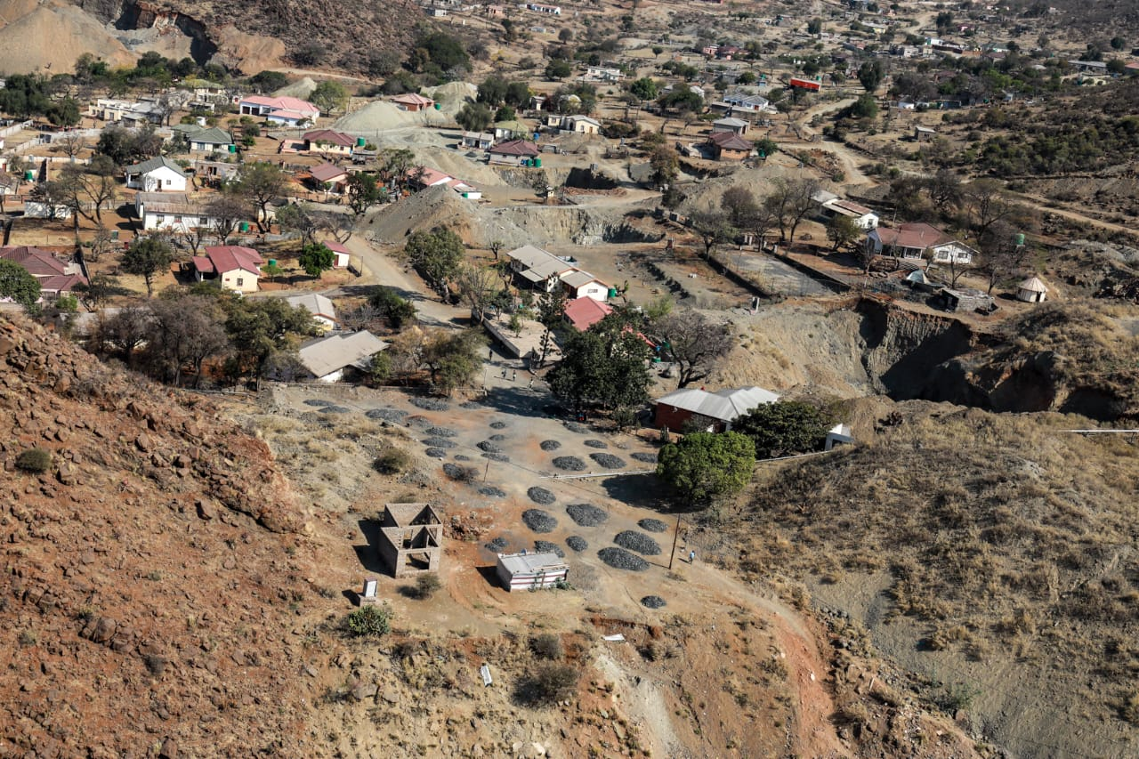
Photo: 1: Illegal Mining within a Residential Area in Limpopo

4. The Free State PROVINCE: case study to combat illegal mining

A joint presentation by the three departments on 17 October 2022 in Welkom, Free State, painted a clear picture of what illegal mining is, its impacts and practical solutions to the challenge. The response of the province to illegal mining could be used as a benchmark by all the provinces experiencing illegal mining.

Illegal mining activities were rife in the Free State ten (10) years ago. Syndicate Leaders employ mainly illegal foreigners, recruit Police, Security, Lawyers and Magistrates. They smuggle gold from underground, do surface mining and assassinate rival groups. They smuggle foodstuff underground via closed shafts, operating shafts and surroundings. They attack and intimidate mine employees, security and community. Illegal miners are transported by syndicate leaders under the impression that they are going to work legally underground, upon their arrival they are kept in safe houses. Their passports get taken away and kept by the syndicates before they are forced underground to work for that specific syndicate. Miners found underground in the province are mainly from Zimbabwe. The Committees were informed that Lesotho nationals are recruited to work under ground, and this group believes that it is an honour because their ancestors worked on the mines. Most illegal firearms found underground during disruptive operations are found in possession of Lesotho nationals.

Mine shafts are used by illegal miners to access minerals and for ventilation and getting supplies. Moreover, shafts are interlinked underground, thereby allowing illegal miners to move from one shaft to another. Illegal miners operated in territories and groups and therefore killing of each other was rife. A number of attacks on mining plants and kidnappings by illegal miners were reported in the province between 2013 and 2018. Between 2012 and 2015, a lot of illegal miners’ dead bodies were found in one of the mine shafts in Welkom. It was also reported that, between 2012 and 2022, about 10 000 illegal miners in the province were arrested. It is estimated that about 1000 illegal miners had died, some falling into shafts and never returned.

On 2 April 2013, Harmony Gold plant employees and security were attacked by two armed robbers, demanding to enter the smelt house. One robber was caught, arrested and was convicted and sentenced to 7 years’ imprisonment, wholly suspended for 5 years. On 12 February 2014, a Security Manager at Harmony Gold Investigations was kidnaped together with his family. The kidnappers assaulted the Security Manager, demanding keys of the safe in which gold exhibits were stored. All the victims were later released by the kidnappers, and no suspects arrested in relation to this kidnapping. On 28 September 2017, a Regional Mine Manager was fatally shot in his vehicle on the road between a mine shaft and the main road. There are several cases of this nature in the province.

A provincial intervention to combat illegal mining was sought and granted. The SAPS started a multi-disciplinary approach to deal with illicit mining by establishing joint Tactical Teams, a joint Operational Centre was established, and Harmony Gold Mine covered accommodation costs for SAPS members. During this operation, the main Syndicate Leader and two of his accomplices were convicted of murder and sentenced to life imprisonment on 21 October 2021.

It was found that the Syndicate Leader had two South African Identity Documents and he was not a South African citizen. It was reported that, during the court process, SAPS had to protect the judge, and the prosecutor and there was a threat to explode the court. The witnesses were put in a safe house in Mpumalanga and later removed to Cape Town. The safe house in Mpumalanga was attacked and fortunately, the witness was already in Cape Town.

One of the SAPS members misled the court relating to the Syndicate Leader’s identity to get him released on bail. The SAPS member was arrested and sentenced to three (3) years imprisonment. SAPS reported that 10 kingpins were identified during the arrests of runners. On 15 November 2015, the project called “Pappa G” was registered and 9 kingpins were arrested and R3 million was recovered. SAPS reported that 26 luxury vehicles, firearms, 2 gas bottles and the cutting torch were confiscated at the end of the project. Including the arrest of the Syndicate Leader and 10 kingpins.

Operation Knock-Out started on 1 July 2019 and ended on 31 August 2022. The operational and tactical concepts employed by this operation included the following:

- Closing the unused shafts such as ARM 7 that was used to facilitate food to the illegal miners who are working underground.
- Sweeping surface areas, shafts and underground areas of runners, illegal miners and undocumented foreign nationals.
- Securing plant areas and transportation of Gold Bearing Materials (GBM).
- Dedicated investigation teams and disruptive investigations.
- Security of the High Court, protection of prosecutors and judges.
- During Operation Knock Out, 4 985 arrests were made and 2 026 of those arrested were people from Lesotho, followed by South African citizens, Zimbabwe, Mozambique, Malawi, Senegal, Congo, Nigeria, Ghana, Pakistan and Bangladesh.

A corrupt SAPS member also recruited four (4) SANDF to protect the Kudu Plant Sump from the syndicate leaders and these SANDF members were arrested. The SANDF used their official uniform to protect the Plant. These SANDF members were not from the Free State. SAPS also confiscated six (6) excavators and two (2) low-beds that were used for illegal mining on mine premises. Operation Knock Out at Vierfontein started on January 2021 and it was ongoing.

It was also reported that section 34(1)(b) and (d) of the Immigration Act favoured illegal immigrants, as they were released back into the communities after being issued with a notice to leave South Africa. It was stated that some Magistrates who are colluding with syndicates or fearing the syndicates, tend to use this section to release the arrested foreign nationals.

5. Legislative Framework and Legislative Gaps

The purpose of this section is to highlight key legislative framework and legislative gaps which have an impact on the effectiveness of the efforts to fight against illegal mining.

5.1 Legislative Framework

Legislation applicable in dealing with the phenomenon of illegal mining are, inter alia, the following:
- Second-Hand Goods Act, 2009 (Act No. 6 of 2009)
- Minerals and Petroleum Resources Development Act, 2002 (Act No. 28 of 2002)
- The Mine Health and Safety Act 29 of 1996
- Immigration Act, 2002 (Act No. 13 of 2002)
- Firearms Control Act, 2000 (Act No. 60 of 2000).
- Prevention of Organised Crime Act, 1998 (Act No. 121 of 1998)
- National Environment Management Act, 1998 (Act No. 107 of 1998)
- Explosives Act, 1956 (Act No. 26 of 1956)
- Precious Metals Act, 2005 (Act No. 37 of 2005)
- Companies Act, 2008, (Act No.71 of 2008)

Further legislation applicable include the following:
- Constitution of the Republic, Act 108 of 1996;
- The Criminal Procedure Act 51 of 1977,
- The South African Police Service Act 68 of 1995,
- National Water Act 36 of 1998;
- Mining Titles Registration Act 16 of 1967;
- Critical Infrastructure Act 8 of 2019;
- Criminal Matters Amendment Act 18 of 2015;
- National Environmental Management Waste Act 59 of 2008;
- Labour Relations Act 68 of 1995; and
- Spatial Planning and Land Use Act 16 of 2013.
- The Draft Policy on artisanal and small scale mining 2021: GN 258 of 2021

5.2 Legislative Gaps

Existing legislation to combat illegal mining is fragmented and lacks substantive measures to effectively deal with these activities. The ambit of illicit mining cuts across different legislation which are administered by different departments. The following are examples of legislation that impact on the regulation of illicit mining:

- Hazardous Substance Act, 1973 (Act No. 15 of 1973);
- Prevention of Organised Crime Act, 1998 (Act No. 121 of 1998);
- Mineral and Petroleum Resources Development Act, 2002 (Act No 28 of 2002);
- Precious Metals Act, 2005 (Act No 37 of 2005);
- Customs and Excise Act, 1964 (Act No. 91 of 1964); and
- Diamonds Act, 1986 (Act No. 56 of 1986).

In 2020, the SAPS embarked on a legislative review of the above legislation to identify various shortcomings in the legislation dealing with illegal mining from a policing perspective. Ministerial engagements have taken place and engagements are continuing with the responsible Departments to enable the strengthening of policing and the combatting of illicit mining.

One of the serious gaps in the mining law lies in the Mineral and Petroleum Resources Development Amendment Act, 2008 (Act No 49 of 2008) in terms of the criminalisation of illegal mining. Previously, section 5(4) of the Mineral and Petroleum Resources Development Act, 2002 (Act No 28 of 2002) read with section 98 of the Act (the penalty clause), criminalised mining, exploration, production etc. of any mineral or petroleum, subject to certain requirements. Section 5(4) was repealed by the Mineral and Petroleum Resources Development Amendment Act, 2008 (Act No 49 of 2008) and replaced by section 5A. However, the new section 5A prohibits, inter alia, mining for any mineral or petroleum without compliance with certain conditions. Unfortunately, the prohibition has not been criminalised in the amended section 98 of that Act. As a result, illicit mining is currently not criminalised, despite the fact that it was previously, before the Amendment Act came into operation on 7 June 2013. This lucuna is a substantial shortcoming in the existing legislative framework and limits policing operations on this matter severely. The amendment of the relevant legislation and effective co-ordination between the responsible Departments will enable a more effective regulatory framework to combat the scourge of illegal mining.

The DMRE, as the main functionary of the Acts listed above, is encouraged to process amendments and facilitate the introduction thereof in Parliament as a matter of urgency.

The summary of the legislative gaps identified in the legislative framework to effectively combat illegal mining was identified by the SAPS Legislation Management Division.

Mineral and Petroleum Resources Development Act No. 28 of 2022
- Persons who render assistance (directly or indirectly) to miners who are engaged in illegal mining acts are not covered in the Act.
- Contraventions of section 5A are not criminalised in the Act. Section 98 to be amended to criminalise contraventions of section 5A and to delete the reference to section 5(4), which subsection has since been repealed.
- Penalties to be prescribed for contraventions of section 5A in the Act should reflect the seriousness of the contraventions.
- Sections 91 and 92 of the Act permit authorised persons designated by the Minister to enter prosecuting areas, mining areas or retention areas. These authorised persons are entitled to execute warrants and to obtain evidence for purposes of a criminal offence.
- Section 93 of the Act provides for circumstances where an authorised officer can suspend or terminate activities such as prospecting, exploration, mining, etc. Section 93 should also provide for police officials to suspend or terminate such activities where there is non-compliance with the legislation.

Diamonds Act, 1986 (Act No. 56 of 1986)
- The definition in section 1 of the Act in respect of “sell” is incomplete.
- Section 18(e) of the Act allows a person to be in possession of an unpolished diamond if such a person is in possession of that diamond in implementing a written agreement entered into by him or her with a person referred to in sub-sections (a) to (d) of this section.
- Section 37 of the Act does not allow for the suspension of the licence of the licence holder by the Regulator where a criminal case involving dishonesty is pending against the licence holder.
- Section 78 of the Act limits the power to direct persons to furnish information and submit registers, documents and books to the Regulator.
- The Act does not require dealers in polished diamonds to keep registers.
- There is no specific regulatory framework in respect of jewellers granting inspection, search and seizure powers to police officials.
- The wording of the Diamonds Act, 1986, and the Precious Metals Act, 2005, relating to the search and seizure powers of police officials is not aligned. The Diamonds Act, 1986, provides in section 81 for the functions of inspectors and police officials to search and seize for certain articles. The provision contains no reference to a warrant. The Precious Metals Act, 2005, provides in section 16 for powers of search and seizure. This provision provides for a warrant issued in terms of section 16(5) of the Act.
- The penalties created by section 87 of the Act appear to be outdated.

Precious Metals Act, 2005 (Act No. 37 of 2005)
- The possession, transport and disposal of chrome is not regulated.
- Certain definitions in section 1 of the Act need to be amended.
- Section 3 of the Act is unclear and is inadequate.
- Section 7 of the Act contains an incorrect reference.
- Section 8 of the Act needs to be amended in order to ensure that the precious metal beneficiation licence is used only for beneficiation and not for trading.
- Section 11 of the Act provides for cancellation of licences, etc. No provision is made for disqualification before a licence or permit is issued.
- Section 12 of the Act, –
- needs to be amended in order to allow for applicants for Export Approvals for both gold and platinum-group metals to commit to local beneficiation as a condition to export and to prevent the export of un-beneficiated precious metals; and regulations 23 and 24 of the Precious Metals Regulations need to be brought in line with section 26 of the Mineral and Petroleum Resource Development Act, 2022 and the Export Approval validity period needs to be set at a minimum of 5 years for security of tenure and policy certainty.
- A limited compliance function is allocated to the SAPS in terms of section 15(2)(b) of the Act.
- Sections 16 – 18 of the Act are to be repealed.
- Section 20 of the Act to be amended.
- Section 21 of the Act provided for the disposal of precious metal and further provides that precious metals be delivered to the owner thereof.
- The Regulatory framework in respect of precious metals in relation to the transportation and conveyance thereof must be amended.
- Precious Metal Regulations are to be amended.
- Precious Metals Regulation 29 and Section 22 of the Precious Metals Act are to be amended, to align the requirement to provide samples to the Forensic Laboratory.

Hazardous Substances Act, 1973 (Act No. 15 of 1973)

Mercury is to be brought within the ambit of sections 3 and 4 of the Hazardous Substances Act, 1973 (Act No. 15 of 1973) and amendments to the Act are required to cover mercury. Mercury is presently categorised as a Group II Hazardous Substance. The Hazardous Substances Act, 1973 contains sufficient measures pertaining to the selling, acquisition, disposal and licensing of Group I, III and IV Substances but not in relation to Group II Substances.

Non-Ferrous Metals: No Legislation
Absence of legislation dealing with all non-ferrous metals.

Customs and Excise Act, 1964 (Act No. 91 of 1964)
The in-transit areas at airports within the Republic of South Africa (RSA) are exploited to circumvent declarations and used to smuggle illicit goods through the RSA and the Customs and Excise Act, 1964 (Act No. 91 of 1964) does not cover these areas.

Immigration Act, 2002 (Act No. 13 of 2002)

The Immigration Act 13 of 2002, particularly section 34(1)(b) and (d) must be reviewed to urgently address that undocumented foreign nationals must appear in court in person within 48 hours for the magistrates to confirm their deportation. The DHA has approached the Portfolio Committee on Home Affairs to address this single Amendment and Parliament legal section has advised that the DHA must initiate the amendment themselves. Since section 34 of the Immigration Act was not amended, some Magistrates refuse to confirm deportations and undocumented migrants are released.

6. OBSERVATIONS

The Committees made the following observations:

- Illegal mining is happening in derelict and ownerless mines, active mines, mines under business rescue and mines under care and maintenance.
- The Committees noted the efforts of the DMRE and welcomed the rehabilitation of old mines in the Gauteng Province.
- The Committees were concerned that the DMRE has not been firm on the “use it or lose it” principle provided in the MPRDA. A lot of people are sitting on the mining rights that are not used.
- The role of the South African Diamond and Precious Metals Regulator (SADPMR) came under the spotlight. The need for the Regulator to come into the discussion as it is responsible for regulating the sector, such as licensing refineries.
- The work of the CGS and Mintek on the mine closure programmes was welcomed. However, it is concerning that the budget allocated to the programme is limited, to an extent that it would take about 17 years to complete the programme.
- The Committees welcomed the innovation shown by CGS in developing an illegal mining tool – a system to track illegal miners.
- In more than two instances, the Committees entered in mines that were operating legally without pre-authorisation or arrangements with the mining houses. This had put the Committees in an unpleasant and awkward situation.
- The Committees applauded the approach that the Free State SAPS, in partnership with various stakeholders employed in dealing with illegal mining. The multidisciplinary approach used, yielded positive results.
- The Committees noted with concern the improper procedures of the courts and their impact on illegal mining cases. This relates to the lenient sentences that illegal miners receive.
- It was noted with concern that, since Section 34 of the Immigration Act was not amended, some magistrates refuse to confirm the deportation of foreign nationals which leads to the release of undocumented foreign nationals often without bail due to S34 (1b) being declared unconstitutional.
- The Committees noted that communities live in constant fear of the illegal miners, as these miners often commit criminal activities, and are heavily armed.
- A possible need for the army to be deployed was observed by the Committee, in order to deal with the issue of illegal mining permanently.
- The Committees observed with concern that illegal miners erode pillars of old mine shafts, therefore endangering lives of many people on the surface of these old mines.
- In Limpopo and more so in the North West Province, Members were extremely concerned about the statement that was made by the DMRE that indicated that mining rights, in the form of a letter, are given by Traditional Leaders. The Committee emphasised the fact that the mineral resources that are beneath the surface belong to the state and therefore, under no circumstances, can Traditional Leaders own State property.
- Linked to the above, in the North West Province, Members were concerned about the mining rights that were issued by farm owners/Traditional Leaders to the ‘so called investors’ allowing them to mine without proper authorisation. This action or practise was strongly condemned by the Committee for allowing people to utilise the mining rights without complying with the laws and prescripts.
- Members expressed dismay with the DMRE in the North West province and complained that they were not getting satisfactory responses. This was particularly concerning when answers were not provided for who had the mining rights for some of the mining operations that were taken place in Vogelstruisnek/Witrantjies and Moloagane Village, where illegal mining of chrome was rife.
- It was clear from the presentations and engagements that the Department of Police and the Department of Mineral Resources in the North West Province were not working together sufficiently to address the challenges of illegal mining. The Departments were encouraged to work together more closely in fighting this crime so as to improve the current situation.
- In some areas in Gauteng, it appeared that there is a possible relationship between the people who are praying as part of outdoor churches and the illegal miners both of which have connections to neighbouring countries.
- In Limpopo, the Committees noted that, the community conducted illegal mining because of the monopoly in terms of mining rights being granted to big companies.
- There is insufficient collaboration between SAPS, DHA, DMRE and the Department of Justice and Correctional Services when it comes to addressing the issue of illegal mining.
- Members commended the construction of buildings and related economic activity as rehabilitation of mines which creates employment. This was regarded as a good solution.
- There is a need for the harmonisation of legislation, particularly, the Companies Act and the MPRDA.
- There is no profiling of illegal mining in South Africa in terms of the role-players such as the beneficiaries, kingpins to better address the crime.
- Business rescue practitioners are not closely investigated enough in terms of their role in adding to illegal mining.
- The Committees observed with concern the failure by the DMRE to flatten all the structures that are being used as seedbed to conduct illegal mining activities.
- The Committees noted an oversight on their part not to include the Committees on Justice and Correctional Services.
- In North West Province, in the three sites that were visited, the Committees noted with concern the excavators that were allegedly being used by illegal miners. The SAPS needed confirmation of the mining rights holders in the areas, to be able to confiscate the excavators and equipment.
- In all areas, the Committees noted the allegations of corruption against the officials of the DMRE, DHA, SAPS, amongst others.
- There is no plan to address environmental impacts and infrastructure damage caused by illegal mining.

7. RECOMMENDATIONS

Having conducted the oversight on illegal mining, the Committees recommends as follows:

- Urgent amendment of the mentioned sections of the following pieces of legislation in response of the challenge of illegal mining:
- Immigration Act, 200 (Act No.13 of 2002)
- Mineral and Petroleum Resources Development Act No. 28 of 2022
- Diamonds Act, 1986 (Act No. 56 of 1986)
- Precious Metals Act, 2005 (Act No. 37 of 2005)
- Hazardous Substances Act, 1973 (Act No. 15 of 1973)
- Customs and Excise Act, 1964 (Act No. 91 of 1964)
- The Department of Home Affairs should increase the capacity of Immigration Services dealing with undocumented illegal miners.
- Police capacity, training and the skills of members dealing with illegal mining must be strengthened at local, provincial and national level.
- Specialised policing resources to target illegal mining at the local policing structures must be strengthened to neutralise illegal mining.
- The Civilian Secretariat should address the resourcing of CPFs effectively in the amendment to the SAPS Act, 1995.
- The Private Security Industry Regulatory Authority (PSIRA) should implement a campaign focusing investigations on private security providers employed by mines, especially in terms of training, registration and firearm compliance.
- There needs to be an intervention which will deal with the judiciary granting lenient sentences to accused persons convicted on such offences as this is now a priority crime.
- The success of the multidisciplinary approach in tackling illegal mining in Free State should be replicated in other provinces experiencing the same challenge.
- The DMRE should submit to Parliament a report on the status of all the mining rights/permits granted in the Vogelstruisnek farm or between Vogelstruisnek/Witrantjies village and Moloagane Village, in Rustenburg.
- The DMRE should intensify the training of Traditional Leaders regarding land ownership versus mining rights. The purpose of the workshops/training sessions would be to capacitate Traditional Leaders on what they can and what they cannot do, relating to mining activities.
- The DMRE need to address the monopoly of mining rights in the Burgersfort area relating to Samancor Chrome Ltd, Glencore and Anglo American.
- Linked to the above, the DMRE should expedite the implementation of its Small Scale and Artisanal Mining Policy.
- Regulations on gold as a market should be strengthened, and there should be a consideration to make gold a strategic resource mineral.
- CGS and Mintek should collaborate with the SAPS to use the technologies developed to track illegal miners as a prevention measure.
- Budget allocation for the closure of Derelict and Ownerless mines should be increased in order to address the pull factors.
- The DMRE, in collaboration with relevant stakeholders, should ensure that old mine shafts are demolished and rehabilitated. The DMRE, to summit progress report on this by the end of January 2023, particularly in relation to a commitment that was made in the North West Province.
- A follow-up oversight by the Committee on Mineral Resources and Energy needs to conducted, particularly to the North West Province, to ensure that recommendations on collaboration are being addressed and proper closure of mines.
- All provinces should consider construction and economic activity as rehabilitation of mines which creates employment.
- There needs to be far better collaboration between the Department of Justice and Correctional Services, SAPS, and DMRE, in order to better address illegal mining.
- There should be consequence management for the Government officials who are found to be involved in corrupt activities relating to illegal mining.
- There should be profiling of illegal mining roles in terms of the role-players such as the beneficiaries, kingpins to better address the crime.
- Business rescue practitioners must be more closely investigated in terms of their role in adding to illegal mining.
- The DMRE should do an assessment of the extent of the damage caused by illegal mining activities and put measures in place to fix the problem.

Report to be considered.

Law Insider, (2022)
South African Police Service, (2022)
Ibid
Mineral Council South Africa, and South African Police Service (2022)
Department of Mineral Resources and Energy, (2022)
Minerals Council South Africa (n.d)
Department of Mineral Resources and Energy, (2022)
Ibid
Department of Mineral Resources and Energy, (2022)

