Report of the Ad Hoc Joint Committee on Flood Disaster Relief and Recovery, Dated 17 November 2022
Table of Contents

EXECUTIVE SUMMARY 2
1. Introduction and background to the ad hoc joint committee 5
1.1. Establishment and mandate 5
1.2. Committee membership 5
2. Committee programme of action 7
3. Part one: Formal briefings 9
3.1. Section A: Briefings by National Departments and Entities 9
3.2. Section B: Briefing by Provincial Departments 23
3.3. Section C: Briefing by Municipalities 28
4. Part two: committee site visits to flood-affected areas 34
4.1. Section A: KwaZulu-Natal 34
4.2. Section B: Eastern Cape 41
4.3. Section C: North-West 42
5. Part three: committee observations and recommendations 43
5.1. Observations 43
5.2. Recommendations 48
6. Part four: matters for referRal to relevant committees 52
7. acknowledgements 53
8. annexures 54

EXECUTIVE SUMMARY

The Ad Hoc Joint Committee on Flood Disaster Relief and Recovery (hereinafter the ad hoc joint committee) was established as per the Announcements, Tablings and Committee Reports (ATC) No. 68 of 11 May 2022. Its main objective was to assess the extent of and response to the damages incurred in the provinces of KwaZulu-Natal, North-West and the Eastern Cape following the severe floods experienced in April and May 2022. On 18 April 2022, a national state of disaster was declared in response to the severity and magnitude of these floods.

The declaration was, in the main, meant to facilitate the release of the resources required to respond effectively to the disaster and to enable better disaster response coordination. Subsequently, the ad hoc joint committee engaged relevant sector departments, the affected municipalities and other relevant state organs to assess the interventions instituted in the aftermath of the floods.

In line with its mandate of overseeing the disaster response and implementation of disaster relief measures by the various spheres of government, the ad hoc joint committee convened and received briefings from the relevant national and provincial departments, municipalities and other state organs. Inputs were received from the Premiers and the relevant Ministers of the Executive Councils (MECs) of the three affected provinces. The ad hoc joint committee undertook fact-finding oversight visits to the three affected provinces, starting in KwaZulu-Natal from 27 to 30 May 2022, followed by the Eastern Cape from 08 to 10 June 2022, and culminating in the North-West on 30 June 2022.

Since the impact of the flood damage was most severe in KwaZulu-Natal, the ad hoc joint committee undertook a follow-up visit to the province from 23 to 25 August 2022. The main objective of the follow-up visit was to engage the province on matters raised during the committee’s oversight visit from 27 to 30 May 2022. The ad hoc joint committee supplemented all its engagements in the three provinces with in loco inspections of the damage caused and an assessment of the current rehabilitation and reconstruction efforts.

Summary of findings
The floods of April and May 2022 caused the most extensive devastation in KwaZulu-Natal, with 448 reported fatalities. Subsequently, the ad hoc joint committee spent more time in that province. The Eastern Cape was the second most affected, but mainly in the local municipality of Port St Johns in the Oliver Reginald (OR) Tambo District, with seven fatalities reported for the whole province. The North-West was the least affected with zero fatalities, but with the most damage seen in some parts of the Deelpan Village under the Tswaing Local Municipality in the Ngaka Modiri Molema District.

The floods disproportionately affected marginalised communities, with particular devastation in informal settlements, especially those in flood-prone areas, such as flood plains. Flood warnings had a limited reach, and those communities who received the warning notices did not seem to know what to do under the circumstances.

In terms of funding resources, much confusion existed around the R1 billion national emergency response fund announced by the President as a measure to provide immediate relief in the wake of the flood disaster. The initial impression was that this amount was exclusively earmarked for KwaZulu-Natal. Subsequent briefings to the ad hoc joint committee revealed that the R1 billion was envisaged as a national emergency response. Treasury has, as at 12 August 2022, approved a total of R429.8m in provincial and municipal disaster response grants (R87.4m), provincial emergency housing grant (R325.8m), and municipal emergency housing grant (R16.6m). National Treasury also indicated that expenditure by provinces and municipalities was lagging behind these approved funds.

The total funding required to address the aftermath of the flood disaster is substantially more than the R1 billion announced as the national emergency response fund. In KwaZulu-Natal alone, the total amount required for post-disaster recovery is estimated at R17.8 billion, against an available national contingency reserve fund of R5 billion. Although some of the funding estimates presented were inclusive of backlogs and flooding incidents that occurred before April and May 2022, which are outside the scope of the ad hoc joint committee’s terms of reference, many presenters stressed that this does not diminish the enormity of the funding that will be required to deal effectively with the aftermath of the disaster.

While the declaration of a national state of disaster was supposed to facilitate the release of the resources required to respond effectively to the disaster and to enable better disaster response coordination, many presenters stressed that none of these objectives were satisfactorily achieved. The affected municipalities and provinces still need to comply with stringent conditions and requirements before disaster relief funding can be released. There has also been a strong call for the affected state organs to reprioritise their funds to deal with the aftermath of the disaster. Many presenters, however, stressed that some of the affected state organs had virtually nothing left to reprioritise, as for some organs of state the disaster struck towards the end of their financial year, with funds already spent or committed.

Some donations paid into the National Revenue Fund had also not been released to the intended beneficiaries, pending the finalisation of some fiscal processes and procedures. With exceptions, inter-departmental coordination and coordination among the three spheres of government have also been, in the main, poorly executed.

The response by the relevant sector departments to the national state of disaster lacked the expected urgency and agility. This was evident in, among other things, the extraordinary delays in the provision of land for the construction of Temporary Residential Units and the permanent relocation of the families rendered homeless in the aftermath of the floods. The most common reason cited for these delays relates to the general reluctance by traditional authorities to release land and adhere to the prescripts of the Spatial Planning and Land Use Management Act 16 of 2013 (SPLUMA) and its regulations. However, this is mainly relevant in the affected rural areas and does not explain the delays experienced in the affected informal settlements, primarily located in cities and towns.

Permanent relocation of households away from compromised locations has also not always been the most favoured option by some communities, as this would ostensibly entail the loss of access to ancestral land in the case of rural communities, and reduced access to public amenities in the case of urban residents. Some provincial governments and municipalities also had differing views on this matter and had, therefore, not managed to agree on a common approach, thus contributing to the delay of interventions.

In certain instances, the impact of the floods, as highlighted by many presentations, could have been mitigated by relatively inexpensive proactive measures, such as regular cleaning and unblocking of waterways and culverts, and stricter implementation of municipal by-laws in respect of erecting settlement structures in unsuitable habitats. The general dilapidation of infrastructure due to ageing and poor maintenance also exacerbated the flood impact.

While some psycho-social support was provided to families and individuals adversely affected by the floods, its effectiveness was constrained by a definitive shortage of social workers, which diminished the potential capacity of the Department of Social Development to provide comprehensive psycho-social support.

The impact of the support provided to municipalities to enable them to comply with the conditions and requirements for access to disaster relief funding has not been decisive. As a result, several municipalities experienced delays in accessing funding due to inadequate technical capacity or ability to complete the requisite forms. The improvement needed in this regard is not only ensuring sufficient technical municipal capacity to complete the forms, but also to relax the stringent regulatory environment in cognisance of the declaration of a national state of disaster.

From its first sitting on 13 May 2022, to its last sitting, the ad hoc joint committee has undertaken substantial work and successfully concluded its assignment before 30 November 2022, the stipulated deadline by which it must table its final report in both the National Assembly and the National Council of Provinces.

Introduction and background to the ad hoc joint committee

Establishment and mandate

The National Assembly and the National Council of Provinces agreed that Parliament has a constitutional obligation to oversee the implementation of Government relief measures (financial and non-financial) to address the impact of the devastating floods witnessed in early to mid-2022 in KwaZulu-Natal, some parts of the Eastern Cape and the North-West province. With the concurrence of both Houses of Parliament, and in accordance with Joint Rule 138 of the Joint Rules of Parliament, Parliament established the Ad Hoc Joint Committee on Flood Disaster Relief and Recovery.

The main objectives of the Ad Hoc Joint Committee are to:

- Engage the relevant government departments and entities to assess the overall impact of the damage, responses and relief measures by the national departments;
- Oversee the response and implementation of the relief measures by the government;
- Confer with those committees who have a direct interest in the events to facilitate coordinated oversight activities;
- Consist of 11 members from the National Assembly (ANC 6, DA 2, EFF 1 and other parties 2) and nine members from the National Council of Provinces; and
- Report by 30 November 2022.

Committee membership

As per the ATC No.68 of 11 May 2022, the following Members were nominated by their parties to serve on the Ad Hoc Joint Committee:

National Assembly
African National Congress
Frolick, Mr CT; Lesoma, Ms RMM; Direko, Ms DR; Mangcu, Mr LN; Mbinqo-Gigaba, Ms BP; Mashego, Mr | Malatji, Mr T [Alternate]; Masiko, Ms FA [Alternate]; Joemat-Petterssen, Ms TM [Alternate]; Magaxa, Mr KE [Alternate]
Democratic Alliance
Macpherson, Mr DW; Hoosen, Mr MH
Economic Freedom Fighters
Mente, Ms V
Inkatha Freedom Party
Hlengwa, Mr M
African Transformation Movement
Zungula, Mr V
United Democratic Movement
 | Kwankwa, Mr NLS [Alternate]
Freedom Front Plus
 | Groenewald, Mr IM [Alternate]

National Council of Provinces
African National Congress
Nyambi, Mr AJ; Rayi, Mr MI; Dodovu, Mr TSC; Bebee, Ms LC; Shaikh, Ms S.
Democratic Alliance
Brauteseth, Mr TJ; Bara, Mr M.
Economic Freedom Fighters
Zandamela, Mr S
Freedom Front Plus
Du Toit, Mr F

At the first sitting of the ad hoc joint committee on 13 May 2022, Hon. Mr. Frolick and Hon. Mr. Nyambi were nominated and elected as committee co-chairpersons. As per the ATC No. 124 of 24 August 2022, the final list of members serving on the ad hoc joint committee was as follows:

Party | Main Member | Alternate
African National Congress | - Hon. Mr A J Nyambi, MP | Hon. Mr M E Nchabeleng, MP
 | - Hon. Mr M I Rayi, MP | Hon. Ms M L Moshodi, MP –
 | - Hon. Mr TSC Dodovu, MP | Hon. Ms B M Bartlett, MP –
 | - Hon. Ms LC Bebee, MP | Hon. Ms M L Moshodi, MP –
 | - Hon. Ms S Shaikh, MP | Hon. Mr M E Nchabeleng, MP
Democratic Alliance | - Hon. Mr T J Brauteseth, MP | Hon. Ms C Labuschagne, MP – alternate
 | - Hon. Mr M R Bara, MP | Hon. Ms C Labuschagne, MP – alternate
Economic Freedom Fighters | - Hon. Ms S A Luthuli, MP | Hon. Ms M O Mokause, MP – alternate
Freedom Front Plus | - Hon. Mr F Du Toit, MP | Hon. Mr M A P De Bruyn – alternate

The parliamentary support team consisted of the following members of staff:
Committee Secretaries
Ms N Matinise; Adv P Gwebu
Committee Assistants
Mr L Ben; Ms Y Cele-Ntshika; Ms Yvonne Manakaza
Researchers
Mr T Manungufala; Mr M Molo
Content Advisors
Ms S Dawood; Ms P Mbude-Mutshekwane; Mr A Sokomani

Committee programme of action

As part of its parliamentary oversight mandate, the Ad Hoc Joint Committee received a series of formal briefings by the respective departments and entities, as well as conducting oversight visits to observe first-hand the devastation caused by floods in the KwaZulu-Natal, Eastern Cape and North-West provinces. The formal briefings entailed presentations from the most affected departments, provinces and municipalities, as tabulated below:

Department/Entity | Date/s of formal briefing
Planning, Monitoring and Evaluation | 23 May and 12 August 2022
Office of the Auditor-General | 25 May 2022 and 31 August 2022
National Treasury | 08 June and 12 August 2022
Public Works and Infrastructure | 01 July 2022
Human Settlements | 01 July 2022
Water and Sanitation | 01 July 2022
Social Development | 11 August 2022
Transport | 11 August 2022
Small Business Development | 11 August 2022
Public Enterprises | 11 August 2022
KwaZulu-Natal Provincial Government | 30 May, 01 July and 23 August 2022
Eastern Cape Provincial Government | 08 June and 01 July 2022
North-West Provincial Government | 30 June and 01 July 2022
uMlalazi Local Municipality | 27 May 2022
KwaDukuza Local Municipality | 28 May 2022
uMgungundlovu District Municipality | 30 May 2022
uGu District Municipality | 29 May 2022 and 24 August 2022
eThekwini Metropolitan Municipality | 23 August 2022
Port St Johns Local Municipality | 09 June 2022
OR Tambo District Municipality | 10 June 2022
King Sabatha Dalindyebo Local Municipality | 10 June 2022
Council for Geoscience | 23 August 2022
South African Human Rights Commission | 12 September 2022

Selected site visits to the affected provinces took place from 27 to 30 May 2022 in KwaZulu-Natal, 8 to 10 June 2022 in the Eastern Cape, and 30 June to 1 July 2022 in the North-West. The impact of the flood damage was most severe in KwaZulu-Natal, thus a follow-up visit to the province was undertaken from 23 to 25 August 2022. The main objective of the follow-up visit was to engage the province and the relevant municipalities on matters raised during the committee’s initial oversight visit from 27 to 30 May 2022. The table below encapsulates the visited sites and the dates of the visits.

Site name | Date/s of visit
Valley Road Bridge | May and August 2022
Crescent Street Bridge | May and August 2022
N2 Freeway, Amanzimtoti (Adams Road) | August 2022
uMlazi/Lamontville Interchange | August 2022
Mount View Shelter, Verulam | August 2022
KwaNdengezi Hall Shelter | May 2022
Umdloti | May and August 2022
Durban Port Terminal | May 2022
Bayhead Road | May 2022
Temporary Residential Unit in Ward 1, uMlalazi | May 2022
Yellowwood Drive Bridge | May 2022
Brettonwood High School, uMlazi | May 2022
M70 Road, Mvudlweni, Pietermaritzburg | May 2022
Nagle Dam | May 2022
MR551 Road to eShongweni | May 2022
Tongaat Water Treatment Plant | May 2022
Green Farm Informal Settlement, Port St Johns | June 2022
KwaNonyevu Informal Settlement | June 2022
Chief Ngwesizwe Great Place, Mqanduli | June 2022
Mbizane Village | June 2022
Deelpan Village, Tswaing | June 2022

Part one: Formal briefings

Section A: Briefings by National Departments and Entities

- Cooperative Governance and Traditional Affairs

The initial briefing by the Department of Cooperative Governance and Traditional Affairs on 23 May 2022 provided an overview of the response of the Kwazulu-Natal provincial government to the flood disaster. The response entailed collaborating with respective national departments to implement Government’s three-phased approach (immediate humanitarian relief, stabilisation and recovery, rehabilitation and reconstruction) to interventions in the province. The provincial government managed to place more than 7 000 affected families and individuals in temporary shelters around the province. As part of the emergency maintenance management, city engineers worked on repairing road infrastructure damaged in the floods. The estimated damages amount to R25 billion, but with the reprioritisation of funds, allocation of national disaster grants and other donations, the provincial government hopes to reconstruct and recover infrastructure damaged in the province. Municipalities and sector departments submitted funding applications to the National Disaster Management Centre (NDMC) through the Provincial Disaster Management Centre (PDMC).

On 1 July 2022, the ad hoc joint committee received another briefing from the Department of Cooperative Governance and Traditional Affairs, emphasising the Department’s flood disaster response and recovery interventions following its last appearance on 23 May 2022. The Department’s briefing was informed by reports from provincial and national government stakeholders, received between 27 and 30 June 2022. Further information provided was an update on immediate humanitarian relief, including service provision at the shelters, burial support to assist the families of the 132 deceased people, restoration of electricity and assessments by social workers. The Department also reported on progress with support to businesses (based on input received from the Small Enterprise Development Agency (SEDA) – an entity of the Small Business Development Department) including economic support packages and trade relief funds consisting of formal (R50 million) and informal (R10 million) components.

At a follow-up meeting on 12 August 2022, the Department stressed that a significant amount of work was completed during the first phase of Government’s disaster response and recovery approach. Most of the disaster response work is currently focused on the second phase, namely stabilisation and recovery, including people that lost homes, and restoring the provision of services. The Department maintains the role of coordinating response and recovery efforts by all stakeholders in accordance with the legislated mandate.

On matters of funding, unforeseen and unavoidable expenditure incurred relates to two additional funding requests – the replenishment of the Municipal and Provincial Disaster Relief Grants (MDRG and PDRG), which have been depleted. The request amounts to R344.5 million, with R247.6 million earmarked for the MDRG and R96.8 million for the PDRG. The second request pertains to shortfalls that could not be funded through the reprioritisation of budgets. This amounts to R3 billion, of which R2.96 billion will be allocated to Kwazulu-Natal and R50.5 million to the Eastern Cape. The Department maintained that through this process of supporting the flood disaster in Kwazulu-Natal and Eastern Cape, several gaps and weaknesses were revealed in the current disaster management system. This points to the need to overhaul the system. A commitment to work and conclude this process was set for 31 March 2023.

- Presidency: Planning, Monitoring and Evaluation

The Department of Planning, Monitoring and Evaluation (DPME) was requested to support integrated monitoring and evaluation and integrate the disaster response within the planning and monitoring frameworks, which included a matrix of outcomes and responses by affected departments at a national, provincial and local government level. In its initial assessment and presentation to the ad hoc joint committee on 23 May 2022, the DPME presenters stressed that irrespective of the limitations under which all interventions are to be coordinated, the three-phased interventions would be implemented concurrently to ensure swift recovery within the Kwazulu-Natal and Eastern Cape provinces.

As part of its responsibility, the Department forms part of the Oversight Committee on the National State of Disaster, dealing with the impact of severe weather events and ensuring transparency and accountability in respect of the emergency funds allocated to the disaster to ensure that funds are utilised for the intended purposes. Additional funding for further interventions must first go through an adjustment budget process. However, existing disaster management grants will be provided for relief.

The initial challenges noted related to planning issues, including a lack of targets, indicators and timeframes in departmental plans. Furthermore, aspects of interdependencies and collaboration between departments are managed on an ad hoc basis. The development of a planning template or matrix with information from respective departments was agreed upon to ascertain interventions and measurable targets to enable the Government to monitor and communicate progress on the flood disaster in affected communities.

The initial direct assistance to government departments entailed providing relevant support and guidance in planning, monitoring and evaluating flood disasters in the affected provinces. A critical meeting convened by the DPME with the National Disaster Management Centre (NDMC)reflected on the effectiveness of the disaster management system in South Africa, the NDMCs institutional capacity, and related challenges. A case was made for the review of the country’s current disaster management model, given the silence of the disaster management legislation on the role of institutions such as the Development Bank of Southern Africa (DBSA), the Council for Scientific and Industrial Research (CSIR), Infrastructure South Africa (ISA), and the DPME. The Government also needed to upgrade the existing information system and work towards integrated data platforms that foster a seamless exchange of information across relevant institutions.

In its follow-up meeting with the DPME on 12 August 2022, the presentation focused on the matrix, as requested by the ad hoc joint committee on 23 May 2022. The matrix, which was appended to the presentation, highlighted the information provided by the respective departments in terms of contribution to the disaster management efforts, planning, budgeting and funding-related matters, and an assessment of progress made in attaining the objectives of Government’s three-phased disaster response. The matrix is a tool to monitor and evaluate departmental responses to the three-phased approach proposed by the President.

The matrix covered 12 intervention areas with approximately 45 indicators to monitor the outcomes of interventions. Key intervention areas included humanitarian relief, human settlements and housing, school facilities, electricity infrastructure, water and sanitation, landfill sites, roads and bridges, rail infrastructure, public buildings and support for business planning and resource mobilisation. The matrix followed a result-based approach adopted by the National Joint Flood for organising interventions.

- National Treasury

The initial briefing by National Treasury on 8 June 2022 indicated that the release of funds to affected provinces and municipalities is subject to the fulfilment of specific conditions and requirements of the Division of Revenue Act. The emergency disaster funds amount to R1 billion for immediate relief and are structured as follows: R145 328 million from the Provincial Disaster Relief Grant, R324 764 million from the Provincial Emergency Housing Grant, R371 420 million from the Municipal Disaster Response Grant, and R175 412 million from the Municipal Emergency Housing Grant.

During this briefing, National Treasury noted that none of the affected provinces submitted the required applications for specific funds from the four grants. No submissions or assessment reports of damages and costs thereof were received by National Treasury, although technical advice on the completion of forms aligned to regulations was provided by it. The follow-up briefing on 1 July 2022 reiterated that compliance with legislation was a condition on which the release of funds by Treasury depended. The fundamental principles in the Disaster Management Act, some of which were considered unpopular, were highlighted – particularly Sections 56 and 57, which deals with funding of post-disaster recovery and relief.

The previous assumption that the R1 billion was exclusively for Kwazulu-Natal was corrected, and this amount was meant for the entire national disaster. The second assumption that none of the R1 billion had been released was also corrected. At the time of reporting, National Treasury approved a total of R429.8 million in provincial and municipal response grants. The remaining constraints to releasing the rest of the funds relate to grant conditions and the signing of the 2022 Appropriations Bill into law. For example, the provincial and municipal emergency housing grants require the province and the municipality to spend at least 80 per cent of the grant before a second tranche can be disbursed.

The signing of the Appropriations Bill will allow the lifting of restrictions imposed by section 27 of the Division of Revenue Act, which limits spending to 45 per cent of grants and equitable share. National Treasury raised concern that the expenditure by provinces and municipalities was lagging behind the funds already disbursed. The provincial government of Kwazulu-Natal was reported to have received several donations. However, these could only be accessed after being captured in an Adjusted Appropriations Act for the province. The Kwazulu-Natal provincial government contested the statement that provincial and municipal expenditure was lagging behind the funds already disbursed by National Treasury. A strong recommendation by the provincial department stressed the importance of clarifying the disbursement of R1 billion to the public. This amount was not solely earmarked for interventions in Kwazulu-Natal.

Insurance claims on affected State institutions are also being released slowly, and there was a recommendation that National Treasury should advance immediate funds that would be reimbursed once insurers paid the affected institutions. There are still shortages of funds in respect of humanitarian support and provision of meals. Several donations were pledged for the province but were not yet received. Furthermore, there was a lack of quick response from National Treasury, especially in light of the revelation that donations were paid into the national fiscus but not yet disbursed to the province. The Eastern Cape provincial government also echoed the sentiments that National Treasury was not as agile as expected when dealing with a national state of disaster. The North-West provincial government criticised the National Treasury’s emphasis on reprioritisation.

On 12 August 2022, a progress report submitted by National Treasury highlighted the current disbursement of funds. The allocation process for immediate response grants required a series of legislation-related processes. The authority to grant approvals did not only rest with National Treasury but also with accounting officers as per Section 43 of the Public Finance Management Act. Thus far, R5.2 billion was made available for disaster response, of which R674 million relates to disaster relief grants, while R4.5 billion relates to reprioritised funds. The funding requests currently before National Treasury relate to the conversion of the Municipal Emergency Housing Grant to the Provincial Emergency Housing Grant, the conversion of the Provincial Disaster Response Grant to the Municipal Disaster Response Grant, and the tabling of an adjustment budget for unforeseen and unavoidable expenditure. The conversion request amounts to R185 million and relates to the eThekwini metro.

National Treasury’s dashboard indicated possible under-reporting on procurement, which they argued could be symptomatic of underperformance by national and provincial departments, as well as municipalities. For example, national and provincial departments reported total orders amounting to R669 million against payments amounting to R44.3 million, while municipalities reported payments of R3.8 million against total orders of R29.1 million. The total expenditure for both national and provincial departments stood at R359.5 million at the end of July 2022, while municipal expenditure stood at R153.1 million at 30 June 2022. Spending of disaster grants was not appropriately related to the prescripts of classification. This was reflected in respect of R228 million of municipal disaster response grant and R723 284 relating to Vote 41: Water and Sanitation.

- Public Works and Infrastructure

The briefing by the Department of Public Works and Infrastructure on 1 July 2022 focused on the immediate response and interventions as at 22 June 2022. The critical issues raised related to the Department’s collaboration with national, provincial and local government structures to repair flood-damaged state-owned buildings in the shortest possible time; the development of a database of volunteer built-environment professionals comprising 304 specialists and professionals to form part of teams to assess, scope, cost, design and implement critical reconstruction and building work associated with damaged critical infrastructure; and identification of suitable land parcels to be used for the resettlement of households that have been left homeless. The Department also identified the importance of the need to construct modular steel bridges in Kwazulu-Natal, Eastern Cape, and North-West.

In summary, the Department’s interventions centre around the following work streams – the rehabilitation of the Durban Air Force Base, which is 98 per cent complete; emergency services relating to public works assets in Kwazulu-Natal and the Eastern Cape; identification and verification of land parcels to determine suitability for resettlement; assignment of built environment professionals to assist with expediting expenditure; and identification of bridges for disaster intervention. The national state of disaster was an opportunity for Infrastructure South Africa to assist by developing a technology-based system to improve reporting on currently impacted areas.

- Department of Human Settlements

During a briefing to the ad hoc joint committee on 1 July 2022, the Department of Human Settlements provided a progress update on the provision of temporary residential units (TRUs), and advances in implementing Phases 1 and 2 of the recovery phases. The approach to address relief operations consisted mainly of expediting access to funding, implementing support to establish a Joint Coordinating Committee that serves as an accountability and advice forum, and monitoring and oversight that involved continuous site visits.

The main challenges experienced in Kwazulu-Natal related to availability of and access to land for residential purposes; residents that continued to live in mass care centres, particularly in eThekwini; the slow pace of delivery of TRUs in urban areas due to legislative processes around pre-planning for land development and business forums that demanded to be paid 30 to 40 per cent; community reluctance to accept TRUs with the perception that TRU beneficiaries were receiving preferential treatment over those who were on the waiting list for houses; as well as some councillors that interfered with beneficiary lists. Other issues pertaining to the human settlements sector are the emergency housing programme, the emergency grant framework and the requirements for establishing transitional residential areas (TRAs).

Unlike Kwazulu-Natal, the Eastern Cape did not have to construct TRUs, as the April disaster occurred mainly in rural areas. However, the province received assistance in the form of R105 million in human settlements development grants for accelerated eradication of mud houses in flood-prone areas. The primary interventions in the North-West province are around reprioritising the Human Settlements Development Grant to the value of R54.9 million, providing TRUs to destitute communities, and securing land for relocation. The main challenge relates to the lack of progress in relocating displaced community members in Deelpan.

Interventions in the provinces were beset by challenges around poor coordination between the provincial and local government; a lack of urgency and administrative capacity to respond to the disaster; bad terrain and inaccessible sites that resulted in delays in the erection of shelters; long travel distances between the affected villages; resistance to relocation; and theft of TRU construction material that also contributed to the slow pace of construction.

- Department of Water and Sanitation

The KwaZulu-Natal (KZN) province was most affected, with extensive damage to its bulk water supply. The system has since been stabilised following the involvement of Water Boards, particularly in eThekwini. However, in the north of KZN, some areas remained without water, mainly due to collapsed bulk infrastructure. Water carting was provided as an alternative, although several challenges were noted at the onset of this project.

Before the disaster, municipalities, including metros, were struggling to fulfil their responsibility as Water Services Authorities and Water Service Providers. Municipalities experienced substantial non-revenue water losses resulting from ageing infrastructure. Billions of rands are needed to replace the ageing infrastructure. The maintenance of Wastewater Treatment Works has also been neglected. The floods exacerbated these challenges. Infrastructure replacement must not only consider existing conditions but must also factor in population growth to accommodate the increased demand for services.

The presentation by the Department of Water and Sanitation on 1 July 2022 detailed the Department’s interventions in the three provinces, including raising of the Hazelmere Dam wall, impending repairs to two Umgeni Water Aqueducts at an estimated cost of R1 billion, establishment of a War Room, and the hiring of 82 water tankers for 90 days. Progress with regard to the restoration of water supply in eThekwini’s five regions was reiterated, as previously outlined in the national CoGTA submission. The conclusion, as far as KZN was concerned, was that most of the water services had been restored, but that the restoration of sanitation services was still lagging. The storm that occurred during the month of May set back restoration efforts for waste water works. Although the NDMC had approved the first round of funding applications, there was an urgent need to expedite further rounds of disaster funding.

In the Eastern Cape province, the Department has conducted site verification to assess the extent of the damages in Amathole, OR Tambo, and Joe Gqabi Districts. The Department concluded that the floods were not as severe as in KZN, although the Port St Johns area was severely affected. All verifications have been completed and requests for funds were being processed at the time of the briefing. In the North-West Province, the Department conducted a site visit to the Deelpan Village on 28 June 2022 and found that none of the households were flooded at the time and that people had returned to their houses after the water had subsided.

However, one of the boreholes was still flooded and inaccessible. To alleviate the water challenge, 15 water tanks have been provided and serviced by two water tankers. In the long term, the Department plans to implement hydro-geological monitoring network infrastructure to understand and monitor the pans, and relocate the two boreholes to avoid future flooding.

- Social Development

The Department of Social Development provided a briefing on 11 August 2002 on responses to the flood disaster relief efforts. While many stakeholders were eager to assist the provinces at the beginning of the disaster, donor fatigue had set in, and many stakeholders stopped providing relief, further exposing the vulnerabilities of communities currently housed in shelters. The Department and Entities supporting its work continue to provide humanitarian support to flood victims.

Four months after the flood disasters, shelters, mainly in Kwazulu-Natal, were still operational. Although approximately 28 per cent of people left the shelters, some have returned, whilst others who were not victims of the flood gained access to the shelters, as food security and housing remain critical factors, particularly in eThekwini. Emphasis was placed on the Department of Human Settlements to fast-track its efforts in providing temporary residential units, as this challenge puts more pressure on sustaining shelters.

The Department’s role in the National Joint Flood Coordinating Committee is to take the lead in ensuring humanitarian relief efforts are provided. The main focus of the departmental presentation related to the role of the Department in respect of its psycho-social support services, and social relief of distress interventions through the South African Social Security Agency (SASSA). The Department, through SASSA, provided a total of 9 250 social relief of distress grant vouchers to the value of R1 980 per person, at an estimated cost of R16.5 million; 4 045 hot meals to the affected families and individuals; 898 blankets; 888 mattresses; 676 dignity packs for the people housed in shelters; 1 231 school uniforms at an estimated cost of R3.2 million; and serviced approximately 72 shelters at a cost of R8.4 million. The core of interventions was in Kwazulu-Natal, the worst hit province. The challenges encountered during the Department’s provision of psycho-social services revealed that many children were displaced from their families, with some experiencing sexual abuse in shelters.

- Department of Transport

The briefing by the Department of Transport on 11 August 2022 highlighted the work that had been completed by the Department to date and that is still in the process of completion. The Acting Director-General detailed the extent of flood damages and progress made to date. For the Passenger Rail Agency of South Africa (PRASA), the cost estimate around the resumption of service and flood damage repair amounts to R2.8 billion. Road network assessment by the South African National Road Agency Limited (SANRAL) in respect of the Eastern Cape indicated an estimated cost of R1.360 billion to repair the damage seen across the five districts in the province. The funds available due to reprioritisation amounted to R158m, leaving a shortfall of R1.202bn.

In KwaZulu-Natal where the damage to transport infrastructure has been most extensive, the estimated repair costs amount to R5.7bn. The province’s reprioritisation exercise yielded an amount of R2.9bn. After receiving an additional allocation of R220m, the remaining shortfall amounts to R2.6bn. Assessment of damage in the North-West indicated that the rehabilitation of the damaged infrastructure would cost approximately R4bn. The Department’s interventions to date include waiver of toll road fees at Thongathi and Umvoti Toll Plazas on the N2, to afford relief to those communities whose alternative roads had been damaged.

Further challenges highlighted by the Department are the pre-construction consultations with Business Forums (such as taxi associations), a constraint that kept delaying the work of PRASA and SANRAL. This element needs to be appropriately managed, as it has the potential to induce further delay and jeopardise recovery. Nevertheless, the Department envisages that by July 2023, SANRAL would have completed permanent repairs to all failures arising from the floods.

- Small Business Development

The Department updated the ad hoc joint committee on its flood relief programme in respect of KwaZulu-Natal and the Eastern Cape. The Department received a total of 457 applications for assistance, amounting to R224.7 million. Of the 457 applications, 408 or 89 percent were received from KwaZulu-Natal, amounting to approximately R200 million, with the eThekwini metro area accounting for 212 (out of 457) of the applications amounting to R123.5 million. The remaining 49 applications, to the value of R24.2 million, were received from the Eastern Cape.

Forty-seven per cent or 213 of the applications were lodged by women-owned businesses, whilst 33 per cent or 154 were submitted by youth-owned businesses. The agricultural and services sectors accounted for 311 or 68 per cent of the applications, to the value of R157 million. Applications relating to manufacturing, construction and tourism amounted to 14 per cent, seven per cent and four per cent, respectively, to the amount of approximately R67 million.

At the time of briefing the Committee, the Department had assessed 169 (37 per cent) of the received applications. From this assessment, 32 applications were declined, as it could not be verified whether the items claimed for had existed before the floods; items were found to be in working order and did not need repair or replacement; there were fictitious or inflated amounts on items claimed for; the scheme did not cover items such as damaged buildings; items were already covered by insurance; and beneficiaries and suppliers that were not tax compliant. One hundred and twenty-seven applications have been recommended for approval and 99 of these have been approved, amounting to R33.5 million. Thirty-eight per cent of the approved applications were from eThekwini and mostly related to the agricultural, manufacturing and services sectors.

The Department further highlighted that on 25 July 2022 it opened its Informal Trader Floods Relief Programme for applications, with the closing date set for 12 August 2022. The Programme was allocated R10 million and is expected to support approximately 1 333 informal traders. A detailed report will be submitted to the ad hoc joint committee once applications are received from the relevant municipalities.

- Public Enterprises

The Department of Public Enterprises’ briefing on 11 August 2022 focused on the adverse impact of the floods on Transnet and Eskom infrastructure. eThekwini had been spared from load shedding to ensure that recovery from the floods was not interrupted. The Transnet Group Chief Executive (CE) was then delegated to deliver the Transnet part of the Department’s report. The Group CE indicated that rubble from the Durban Port had been cleared less than two weeks after the floods.

However, the Port struggled to cope with debris from 54 municipal storm-water outfalls discharging into it. The Transnet National Ports Authority was engaging the eThekwini metro on the implementation of measures to prevent waste from encroaching on the storm-water system. The Bayhead Road was envisaged to have three lanes inbound and three lanes outbound within the next 18 months. The reconstruction of the Bayhead Canal is set for completion by December 2022. In terms of Transnet freight rail rolling stock, it was indicated that a total of 433 wagons and 100 electric and diesel locomotives were damaged.

Transnet was still finalising the assessment of overall flood damage costs. Preliminary indications show that, as at 30 June 2022, the damage (including asset damage, business interruption and clean-up costs) amounts to R6.4 billion. The Group CE commended the presence and activity of critical decision-makers at the coalface of the damage, which facilitated a smooth operation of restoration initiatives. The need for the entity to build more resilient infrastructure, including the lifting of equipment to higher platforms, was also emphasised. Transnet was also working, as a matter of urgency, towards finding alternative routes out of the Bayhead area.

In respect of the Montclair Lodge issue that had been on the news, and also raised during the Committee’s engagement with Social Development and Transport, the Group CE indicated that the Lodge is a property of Transnet. Transnet had resolved to extend the occupation of the Lodge by vulnerable groups, in exchange for a commitment by the eThekwini metro to take responsibility for the upkeep of the facility. In this regard, Transnet and the metro will enter into a term lease agreement. While the Lodge has already been advertised in the open market for disposal, the metro will be granted first right of refusal to purchase it. If this right was not exercised by the end of the agreed lease period, the metro will return the Lodge to Transnet Property and ensure that all occupants are orderly evacuated. A subsequent briefing by the City of eThekwini indicated that the Lodge had been returned to Transnet and alternative accommodation for the occupants was found.

A short presentation from Eskom was also received, the main highlight being that most of Eskom’s infrastructure was not affected by the floods, as most of it is on the outskirts of eThekwini. Eskom assisted eThekwini’s recovery, including the suspension of load shedding. However, it has been agreed that when Eskom reaches stage four of load shedding, eThekwini will also load shed. Other municipalities being assisted include the uGu and iLembe Districts, and the Ray Nkonyeni Local Municipality.

- Auditor-General of South Africa

In the current disaster a common concern was the need to protect public funds and to ensure that the response initiatives are not only designed to respond to the need, but are also implemented appropriately. The Auditor-General of South Africa (AGSA) briefed the ad hoc joint committee on 25 May 2022 on its intervention to prevent and detect weaknesses in controls and report on findings within a short time.

To respond to the key risks relating to procurement and contract management, the AGSA designed a series of real-time audits to respond to risks, which would look at compliance with laws and regulations, and consider matters relating to value for money. The AGSA would look at whether goods and services were delivered at the right place, at the right time and with the right quality, and if the benefits reached the intended beneficiaries. The AGSA assured the ad hoc joint committee that it would report on work that enhanced transparency, accountability and good governance. The fundamental mechanisms in the audit process were prevention, detection and reporting. The AGSA would look at the three spheres of government – national, provincial and local in Kwazulu-Natal and Eastern Cape, respectively.

On 31 August 2022, the AGSA briefed the Committee on the outcomes of its first round of real time audits as at 31 July 2022. The briefing focused predominantly on KwaZulu-Natal, as the Eastern Cape post-disaster initiatives were lagging. The Eastern Cape has not yet dealt adequately with previous disasters dating as far back as 2013. Disaster response capability, planning and coordination were emphasised as critical issues that need to be addressed in the province, as natural hazards, such as the current disasters, are likely to become the norm in future.

The lessons learnt during the real time audits of COVID-19 social relief initiatives enabled AG audit teams to handle the current real time audits with better experience. In the first round of real-time audits, spending on education infrastructure rehabilitation and social relief was found to be consistent with the budgets allocated to these sectors. Few invalid transactions were found, as the accounting officers and executive authorities were responsive and receptive to the AG’s call for an effective accountability ecosystem. The provincial government of KwaZulu-Natal has rendered the required and expected support to municipalities, with the Provincial Treasury introducing the innovation of conducting pre-assessment awards for all transactions above R1 million.

The provincial internal audit unit has also been active, providing much-needed assurance and pre-empting many of the AG’s post-disaster audit findings. National Treasury has provided guidance on the various funding mechanisms available to address post disaster recovery. In this sense, the capacity for monitoring and oversight over disaster relief interventions has been well established. Social relief interventions, through the South African Social Security Agency, were also commended as they, in the main, reached the right people.

However, the AG stressed the need for more emphasis on driving the efficiency and effectiveness of these monitoring and oversight initiatives. The process of identifying needs and monitoring deliverables, delivery of equipment and learning material, and assessing education infrastructure damage were also identified as areas for future improvement. The real-time audit also found very little movement on transactions relating to initiatives around water and sanitation, as well as railway and road infrastructure. Of the 198 water tankers made available in KZN, a sample of 30 was audited. Delivery of water by the selected water tankering services reportedly experienced many delays due to poor coordination between the province and the City of eThekwini. Water tankers were also not all well maintained. Other areas of weakness were also identified around quality problems in the construction of TRUs. From a sample of 30 TRUs, the audit verified and confirmed that most of the reported TRUs were in existence.

However, the needs assessment regarding identifying appropriate beneficiaries was poorly managed. None of the audited TRUs complied with the minimum construction specifications. Instances of poor workmanship were also identified, and instances where TRUs were located in flood-prone areas. Provision of related services, such as electricity connection, was reportedly not always factored.

In summary, the Government’s overall responsiveness to the national disaster was very slow when measured against its plans. The first real-time audit findings confirmed most of the ad hoc joint committee’s observations during its post-disaster assessments. The presenters stressed that outstanding matters would be addressed in the second special audit report scheduled for tabling in Parliament in October 2022.

- Council for Geoscience

The Council for Geoscience provided details on the geotechnical aspect of the flood disaster to afford the ad hoc joint committee a more holistic understanding of the country’s vulnerability to geo-hazards. The Chief Executive Officer, Mr Mabuza, led the Council’s delegation and delivered the bulk of its presentation. The briefing emphasised the importance of science as a basis for policy decision-making and bringing value to social development issues. The 2010 amendments to the Institution’s founding legislation expanded its mandate to include additional responsibilities. such as providing advice to state organs regarding geo-hazards and environmental pollution.

However, the Council’s funding arrangements remain incommensurate with this expanded mandate. This has constrained the Institution’s ability to implement projects that would contribute to the full exploitation of the country’s natural resources potential, including the complete mapping of its oceans economy and geological potential. It was advised that much of the geo-hazards could be avoided if geotechnical reports were a prerequisite for infrastructure-related developments across the country. The Council does not have the legislative authority to enforce its recommendations, as it is mainly an advisory body.

Mr Mentjies outlined the projects and activities undertaken to fulfil the Council’s legislative mandate. Regarding geo-hazards, the Council is pursuing a multi-year mapping programme incorporating seismic hazard, risk and impact analysis; dolomite hazard and impact analysis; mine seismology; landslide mapping and erosion; tsunamis; geotechnical characterisation; and development planning. The development of a concept as a basis for a disaster early warning system is also underway, in collaboration with Infrastructure South Africa. In 2021/22, the Council distinguished itself by undertaking the first-ever endeavour in South Africa to map landslide susceptibility at a municipal scale.

In relation to the floods of April 2022, Council personnel were deployed to Port St Johns and eThekwini to conduct geotechnical assessments. Preliminary findings indicated that these areas needed serious attention if future disasters are to be avoided. The first report will soon be tabled. Although the Council’s profile has been growing, the municipal uptake of its services is not yet at the desired level. The Council continues striving to implement its full legislative mandate.

- South African Human Rights Commission
The South African Human Rights Commission (SAHRC) focused its briefing on its flood disaster response and monitoring observations with respect to the flood-affected provinces. In the immediate flood aftermath, the Commission developed an action plan and a discussion paper to guide and inform institutional response to the disaster. The Commission has observed insufficient emphasis on the impact of the disaster on the Eastern Cape, as much focus is on KwaZulu-Natal. In the North-West, the Deelpan community has not received adequate details on the temporary structures to be provided, including size, capacity and the building material to be used. The Commission will be calling on the Government to provide these details.

The Commission has engaged with KwaZulu-Natal on regular basis, as the most acutely affected province. In addition to monitoring and assessing the rights to clean drinking water, adequate housing and education, the Commission has also started investigating potential violations of environmental rights as enshrined in Section 24 of the Constitution. The Commission generally found red-tape and lack of political will to implement disaster relief measures as the main characteristics in all the areas visited in the flood disaster aftermath.

The Commission’s observations on access to funding through National Treasury, capacity for disaster management, the water crisis and the living conditions at some shelters in KZN, housing delivery, the search and rescue of missing persons, the flood impact on schooling, the poor coordination among the three spheres of government, the lack of disaster readiness, and the provision of psycho-social support to flood victims, were mostly consistent with the ad hoc joint committee’s observations and findings.

Section B: Briefing by Provincial Departments

- KwaZulu-Natal
At the initial briefing of May 2022 and subsequent briefing on 1 July 2022, the province’s presentation reiterated the extent of damage in Kwazulu-Natal, specifically in the eThekwini Metropolitan Municipality. It also provided details of interventions being undertaken, reporting and institutional arrangements, security and emergency search and rescue, risk and early warning, humanitarian relief, donations and shelter support, infrastructure interventions, economic recovery, community and communication mobilisation, and finance and funding requests.

During the Committee’s third formal engagement with the province on 24 August 2022, it received a consolidated report from the newly elected Premier, Honourable Nomusa Dube-Ncube, regarding progress made since the previous interactions with the province. The Committee was assured that the search and rescue mission for the 80 people still reported as missing was ongoing, albeit at a lesser scale. A progress report received in October 2022 indicated that this number has reduced to 72. Social development efforts by the Department of Social Development are also ongoing, but have been hampered by Treasury’s substantial reductions to the Department’s Compensation of Employees’ budget.

Despite the difficult circumstances, the Department will continue to provide an acceptable level of services to the mass care centres, and mitigate the inhumane conditions in some shelters. The Palm Ridge Hotel has been secured to provide temporary accommodation for more than 200 people displaced by the floods, who will thereafter be decanted to permanent housing. Maintaining communication with people in the shelters, as well as with flood-impacted people that were not necessarily accommodated in shelters, has been part of the Province’s disaster response strategy. Unfortunately, as presenters noted, these interventions have also tended to attract people who are not necessarily victims of the flooding incidents.

The Committee’s recommendation regarding the construction of retaining walls around those houses that had suffered partial flood damage was noted. However, the province was re-evaluating the use of retaining walls, as they tend to pose a safety hazard, particularly in the context of the difficult topography in which some of the human settlements have been erected. The province is in constant liaison with the Chapter Nine Institutions, including the Office of the Auditor-General, which is undertaking real-time audits of the disaster relief funds, as well as the Human Rights Commission on the matter of some Non-Governmental Organisations (NGOs) that had received government funding to assist with disaster mitigation efforts but were not visible on the ground.

A research study conducted by the Province’s climate change committee, in collaboration with the University of Cape Town, indicates that more coastal habitats are approaching the redline zone due to global warming and rising sea levels. The province is looking at drawing best practice lessons from the case of the Netherlands, which has dealt successfully with rising sea levels. Water spills resulting from the tilt in the Shongweni Dam were identified as a consequence of an overdue upgrade on the dam, which was built in the 1880s. The province is considering reclaiming the land on which the dam is located to effect the necessary upgrades to protect the affected communities from the impact of the spills. Although the province is doing its best to respond to the state of disaster, financial constraints have thwarted its efforts to provide the desired level of response.

An update was provided on progress on matters previously raised about uMlalazi, uMgungundlovu and uGu District municipalities. Section 3.3 of this report highlights these matters. The MEC for Human Settlements emphasised the provision of permanent structures, not just TRUs, as the Department’s ultimate objective. Although some progress had been made in moving people out of shelters, the process remained slow due to scarcity of suitable land and uncooperative property owners.

Further input was provided on progress made to date in delivering TRUs and reducing the number of mass care centres. One thousand and fifteen TRUs have been erected across the province, with the iLembe District accounting for the bulk of the completed structures. A subsequent progress report indicated that this number had increased to 1 046 completed TRUs, of which 1 325 are occupied. Those not yet occupied are awaiting services. The number of mass care centres has reduced to 92, with the eThekwini metro registering a decrease from 80 to 71. As at 07 October 2022, mass care centres in eThekwini had decreased further to 65 and the total number for the province reduced to 75. Many mass care centres have been linked to land parcels, which are at different stages of preparation as a permanent solution. Other accommodation options, such as a rental assistance scheme, and transitional emergency accommodation using existing buildings, are also under consideration to ensure that families are moved out of shelters before the end of November 2022.

An update in terms of assistance provided to small businesses was also received from the Small Enterprises Development Agency. Apart from the extension of the funding application deadline from 12 August to 26 August 2022 and the receipt of 767 applications, most of the information provided had already been presented to the Committee during the briefing of 11 August 2022, as indicated under section 3.1 of this report. The province could not contribute to the SEDA report as it was not shared with it.
In October 2022, the provincial government submitted to the ad hoc joint committee a consolidated progress report on its flood disaster interventions. Highlights include the observation that families of the deceased have stopped responding to the telephone number Government had provided for submission of details for claiming re-imbursement for funeral costs. The Motsepe foundation has approved 103 applications for payment, with 54 having been paid to Funeral Parlours, 18 paid directly to beneficiaries and 31 being still processed for payment.
- Eastern Cape
Ongoing assessments have revealed that more than 4 317 households had been majorly affected, with cases of homelessness and damage to properties. More than 55 villages have been left without domestic water supply, and approximately R30 million is required to repair the damaged water and sanitation systems. The damage to agricultural infrastructure in some municipalities will affect the 2022 harvest. More than 190 roads have been damaged. Twelve health facilities were damaged, mainly in Port St Johns, Nyandeni and Ingquza Hill Local Municipalities. The interim plan is to provide alternative measures to ensure business continuity.

On human settlements infrastructure, a total of 1 841 households were affected. The Department of Human Settlements has appointed a contractor to erect 435 temporary shelters in Alfred Nzo and 565 in OR Tambo District Municipality. The completion date for the 1 000 units was 30 June 2022. The Housing Development Agency has appointed contractors to erect temporary shelters in OR Tambo, Chris Hani, Alfred Nzo and Joe Gqabi Districts, with work commencing in the week of 6 June 2022.

The effects of flood disasters require short, medium and long-term interventions from the education, health, human settlements, water and sanitation and transport (or road infrastructure) sectors. The Department of Social Development has, as part of its immediate intervention, provided support in the form of food parcels amounting to R1 960 for each family who lost family members, with SASSA providing R3 960 for families who lost more than one family member.

In a subsequent briefing on 1 July 2022, the Committee received the latest update regarding the damages caused by the severe weather events of April 2022; the interventions implemented by provincial and municipal spheres on the damaged infrastructure; as well as on the additional costs required to address the damages after reprioritisation and funding requests from national government.

Interventions by other sector departments were emphasised, including interventions by the Departments of Education, Health, Human Settlements, Water and Sanitation, Transport, Agriculture and Rural Development, Economic Development and the Development Bank of Southern Africa. Most of these interventions are already covered in the section that deals with Human Settlements, Water and Sanitation, Public Works and Infrastructure and Cooperative Governance and Traditional Affairs. The province submitted applications to the NDMC for disaster relief funding. These amounted to R1.8 billion against an available amount of R516 million.

The Eastern Cape Premier highlighted the need for coordination to be strengthened and noted that interventions in this province by the Department of Small Business Development can improve. The Premier noted that the presentations did not cover the Chris Hani District, which was also adversely affected by the floods, and further stressed that it was odd that the Department of Transport could not cover the damage to bridges due to the disaster of 2021. However, the Premier welcomed the reports and looked forward to working with national government to resolve some of the challenges experienced in the province.

On 21 October 2022, the provincial Government submitted an updated report indicating that, almost five months after the flood disaster, most flood victims still live with neighbours and relatives, and that only about 757 of the 2 959 temporary structures needed have been erected. The 757 temporary structures are only in the Alfred Nzo (379) and OR Tambo (378) Districts. The provincial Department of Transport has to date completed repairs to 60 roads to the value of R53.3 million. Despite reprioritisation, the provincial Government has been unable to amass enough resources to address the flood damages.

- North-West
The Province’s existing vulnerability and propensity towards natural and anthropogenic hazards was highlighted. These hazards can be categorised as geophysical (earthquakes, dolomite, sinkholes, and landslides); hydrological (floods); climatological (droughts, veld fires, and extreme temperatures); or meteorological (cyclones and storms). One of the worst hit areas in the North-West is the Deelpan Village, which experienced flooding in December 2021 and from January to March 2022. The village is situated in a low-lying area/wetland surrounded by water pans.

The flooding on 6 March 2022 was one of the worst, as more than 75 per cent of the village was submerged in water. Approximately 1 083 houses and 4 506 people were affected. Water sources were polluted due to overflowing and stagnant water. There were difficulties in accessing villages due to muddy roads. Patients and the deceased could not be moved to hospitals or mortuaries. Learners and workers struggled to leave their homes, with livestock drowning and crops being washed away.

The role of the Department of Cooperative Governance, Human Settlements and Traditional Affairs (COGHSTA) in the province was characterised as coordinating the disaster intervention of the various sectors and collaborating with the South African Weather Services (SAWS) to broadcast severe weather early warnings. Communication by the Provincial Disaster Management Centre of early warnings issued by the SAWS to all role-players and stakeholders ensured that there was no loss of lives during the current flooding incident, as the previous flooding disaster had resulted in the loss of seven lives.

As part of the medium-to-long term interventions, future developments must consider prospective and compensatory disaster risk management strategies aligned to the District Development Model and Integrated Development Plan. The immediate/urgent matters include additional policing resources for Deelpan (SAPS), identification of suitable land for human settlement development (Bogosi/municipalities/state), access and internal roads repairs and maintenance to be prioritised, provisioning of water and sanitation in Deelpan and opening of the Deelpan Park Home Clinic.

The funding for disaster management will be available from the departmental/organisational operational budget, budget reprioritisation/repurposing, obtaining grants from national departments, applying for provincial and municipal disaster relief grants, and departments/sectors setting aside 1.2% from their budget for disaster management (per national and provincial disaster management frameworks).

The expenditure for disaster interventions in Deelpan amounts to R649 880 for humanitarian relief from the operational expenditure; an amount of R54.9 million for emergency housing grant allocation; R76 700 (diesel, culverts and cement), an amount of R18.9 million for business plans to support 303 emerging and subsistence farmers; an amount of R7.9 million from Ngaka Modiri Molema District for food parcels, blankets, mattresses, rain boots, sanitary packs and R288 382 for humanitarian relief.

Section C: Briefing by Municipalities

- uMlalazi
The uMlalazi Local Municipality reported that its disaster unit had assessed 26 wards comprising 508 families. Approximately 3 371 people were affected by the floods. One fatality, due to drowning, was reported. There were also seven reported fatalities of its residents that resided in eThekwini. Immediate social relief to the affected families was provided in the form of food parcels (450), mattresses (150), blankets, stoves, and other basic amenities amounting to R325 000. In terms of humanitarian support from donors, the municipality has received 400 food parcels and 200 foam mattresses as a donation from the Lotto Foundation (Ithuba), which had been distributed to the beneficiaries. In partnership with the Department of Home Affairs, the municipality assisted families and individuals who lost their identity documents and certificates.

The Department of Human Settlements visited the affected families and approved provision of temporary residential units to 114 households. A contractor had been identified by the Housing Development Agency (HDA), and has begun constructing 30 TRUs in Wards 1 and 5. At the time of reporting, 209 families were verified by the Department of Human Settlements. Ten housing projects are planned for implementation in partnership with the Department of Human Settlements. However, the municipality was facing challenges in land provision by traditional authorities. A recommendation was made that the traditional authorities be engaged regarding the prescripts of the Spatial Planning and Land Use Management Act (SPLUMA), Act No. 16 of 2013 and its regulations to ensure that traditional authorities allocated land to communities in line with the legislation.

The impact of the flood disasters resulted in serious damage to roads, bridges, storm water pipelines, water causeways, and water and sanitation infrastructure, at an estimated cost of more than R52 million to repair. During a follow-up visit to KwaZulu-Natal, the Committee received an update on TRU construction and repair of flood-damaged road infrastructure in uMlalazi. It was confirmed that the assessment and verification of TRU beneficiaries had been completed, and that 33 TRUs were completed. The causeway bridges were repaired, except for the P518 in ward 23, Nteneshana. However, the contractor was reportedly on site as at August 2022. Support has been received from the engineers of the Municipal Infrastructure Support Agent regarding the technical assessment of municipal damages to assist the municipality in applying for disaster relief funding. The assessment did not find any affected bridge across the uThukela River, including in Ward 16.

- KwaDukuza
The KwaDukuza Local Municipality reported that the iLembe District Municipality was one of the most affected in terms of road infrastructure. The impact of the flooding incident in the local municipality resulted in a total number of 2 492 affected people, 315 houses totally damaged, with 239 houses partially damaged. As a result, more than 363 families were left homeless and 231 people displaced. The municipality recorded 10 fatalities.

On 14 April 2022, the municipal manager established a Social Relief Task Team to coordinate social relief interventions for victims of the flood disaster, shelters for displaced people and provision of social relief packages containing mattresses, blankets, food parcels and hot meals, burial costs to affected families, as well as coordinating and guiding donor relief to the respective identified communities. The municipality provided a list of donors, and offered bereaved families financial support amounting to R15 000.

The Kwazulu-Natal Department of Human Settlements has allocated 200 TRUs for the entire iLembe District Municipality. The construction company, Stedone was appointed to construct the units in KwaDukuza and Mandeni Local Municipalities. The housing officers have contacted ward councillors to establish the number of beneficiaries since the assessment has to be carried out by the province first before vouchers are issued.

A preliminary assessment report indicated that road, electricity, housing, and water infrastructure was severely damaged. A total estimated R1.156 billion was required to address the following affected infrastructure – electricity, housing, civil engineering, public amenities, local council buildings, compound buildings, and old age homes.

- uGu
The uGu District Municipality noted that all the local municipalities were affected by the adverse weather between 8 and 12 April 2022. Approximately 7 437 people were affected, including 1 779 households, with 722 houses destroyed completely, and seven people lost their lives. Umzumbe and Umuziwabantu registered one fatality each. Three people were injured and 288 people were left homeless. The district estimated that approximately R25 million was needed to rebuild the damaged infrastructure, and provide social relief to the affected households and individuals. Waterworks, with interruptions of water supply was also highlighted. The most damaged road infrastructure was in Ward 6 (Margate), R102 (Scottsbug), Ward 15 (Mahlongwa), Wards 3 and 16 in Ezenbeni, and N2 North bound road and Qoloqoto (Ndwalane) access road in Umzumbe.

The district uses the District Disaster Management Forum to manage and respond to the disaster. A database to communicate new developments has been created, with information being disseminated through emails and various social media platforms. Nine temporary shelters were provided to accommodate displaced people, but these have since been closed. The Department of Human Settlements had completed five temporary residential units in the district, with only 70 being built in the entire province. The slow pace of building temporary residential units was reportedly due to non-availability of land.

All mass care centres had been closed by the time the Committee undertook a follow-up visit to the district in August 2022. The main issues remaining relate to outstanding repairs to the Valley Road and Crescent Street Bridges, and the provision of reliable access to water. The district has been experiencing years of water shortages even before the floods. Funding constraints remain the main impediment to the district’s recovery efforts, as the R2m received thus far has been incommensurate with the damage incurred. The Ray Nkonyeni Local Municipality, on the other hand, has to date received R19.9m against an initial funding request of R1.1bn, which was later revised downwards to R800m.

- uMgungundlovu
The uMgungundlovu District Municipality reported that more than 5 714 people and 1 091 households in the district were affected. The flood totally destroyed 253 homes, whilst more than 1 258 were partially damaged. More than 208 people were left homeless, with one fatality and three people who sustained injuries. In partnership with non-governmental organisations, the municipality provided a total of 132 blankets, 106 mattresses, and 27 food parcels, and is supported by the National Lottery Commission, NGOs, SASSA, and Social Development, at both the district and local level. Trauma counselling and psycho-social services are provided by a team of social workers from the Department of Social Development. In the aftermath of the disaster, the district established four shelters to accommodate the homeless, but currently only one shelter remains operational. Others were de-commissioned and occupants reintegrated into their communities.

Road infrastructure was also damaged, and road infrastructure rehabilitation has been provided. The Department of Transport is responsible for approximately 164 road projects, at an estimated cost of R291 million. SANRAL is responsible for 76 road projects at an estimated cost of R293 million. The municipality has exhausted its Municipal Infrastructure Grant funding and is unable to reprioritise these grants. Although the district received an allocation of R85 million for the 2021/22 financial year for the Water Services Infrastructure Grant, an adjustment of R40 million increased the allocation to R81 million.

During a follow-up visit to KwaZulu-Natal, the ad hoc joint committee received an update on the status of mass care centres in the District. Only the Truro Hall shelter in Msunduzi was not yet de-commissioned. The shelter accommodates eight families with one death, which occurred in June 2022, being reported. Land has been identified and a service provider appointed to clear the site where the families will be relocated. However, community protests have delayed the process. A subsequent progress report indicated that the Truro Hall shelter was the first to close, following the introduction of a Rental Assistance Scheme on 01 October 2022. In Mpofana, the requisite assessments have been concluded and the construction of TRUs is expected to commence in the course of August 2022. In Richmond, the identification of suitable land and the associated assessments are still underway. Thus not much has happened in these municipalities regarding the provision of temporary residential units.

- eThekwini
Led by the Mayor, Councillor Kaunda, eThekwini’s briefing highlighted the metro’s key interventions in the aftermath of the floods. While significant milestones have been registered, the provision of decent accommodation for flood victims remains a critical challenge. There is now contestation around the distribution of TRU construction material, as the communities’ preference for permanent structures is growing stronger, as the time spent in shelters becomes indefinite. The resistance to building material used is slowing down the distribution and contributes to even more delays. The City has issued a letter of award for the construction of 167 TRUs to accommodate the occupants of the Montclair Lodge. The search and rescue mission remains incomplete, as 26 bodies are still unidentified, and 80 people remain missing.

According to the City’s CFO, Mr Sandile Mnguni, the total financial impact of the flood damages will be known by December 2022, when verification is expected to be finalised. Preliminary indications suggest that R5.7bn worth of damages has been incurred, including R1.8bn relating to human settlements. Applications for disaster relief funding are still being processed. Water and sanitation- related challenges also remain prevalent, including contamination of static water tanks, sewer pump failures that have resulted in the contamination of water tables, and a high concentration of E. coli that has seen fish dying. A budget of R100m has been provided to fix all non-functional pump stations by September 2022.

The rehabilitation of the Tongaat Water Treatment Works is also underway and estimated to be completed by 5 November 2022. In the meantime, water is being provided from a packaged water treatment plant donated by Emitas Water Solution. In addition, water tankers, storage water tanks and boreholes are used to supply water to the communities. The City intends purchasing a fleet of water tankers to save on water tanker hiring costs.

- OR Tambo and King Sabatha Dalindyebo
The OR Tambo District Municipality is a disaster-prone area, and has been hit by natural disasters between 2011 and 2022. The April 2022 disaster is the third within a space of five months. Of the 37 municipal wards in the district, 25 were affected, with a total of 786 households. Of this amount, 359 homes were completely damaged and 427 homes partially damaged. The impact of the disaster on roads and bridges comprised damages to 590 kilometres of gravel roads and 14 bridges affected by the floods.

There was no notable impact on the district’s electricity network, but areas serviced by ESKOM were affected. No fatalities and injuries were reported. The frequency of these disasters is of concern to the municipality, as communities that settle in disaster-prone areas remain vulnerable, with most disasters occurring in Wards 15 and 17. In respect of interventions, the assessment and verification for the housing-related damages were completed in May 2022. The Department of Human Settlements appointed the Housing Development Agency as the service provider to build temporary residential structures.

As per the National Treasury communication, reprioritisation of funding by the municipality was undertaken. The worst affected roads were reprioritised for the Municipal Infrastructure Grant, whereby R15 million was allocated toward the damaged roads and bridges. This emergency intervention has impacted the already assigned funds for existing projects, as planned roads will now be shifted for completion in the outer years.

- Port St Johns
In the Port St Johns Local Municipality in the OR Tambo District Municipality, the presentation highlighted the topography of the area, which is a seaport in the lowest area of the region surrounded by mountainous topography. Other factors exacerbating the municipality’s vulnerability to flooding include the non-desilting of the Mzimvubu River, and loose soil that resulted in land and mudslides, which blocked the road and storm-water channels of the main road. The landslide also blocked the Second Beach Road that connects the Central Business District.

Other infrastructural damages include damages to 12 Department of Transport roads, 103 municipal access roads whose repair costs are estimated at R377 million, and the collapse of the R61 main road. Eleven bridges were also severely affected and will cost approximately R82.4 million to repair. Five clinics were damaged. One fatality with three injuries was reported. The economic impact of the flood disaster included the closure of some businesses, damage to goods and produce in retail shops, flooding and destruction of farm produce and dairy. The preliminary indication is that 423 people were left homeless, and 1 180 homes partially damaged. Seven schools were damaged.

The municipality’s short-term infrastructure requirements to deal with the aftermath of the flood are estimated to cost R37.7 million in direct costs associated with a detailed flood line and mitigation study (R5 million) and emergency housing amounting to R32.7 million. In the medium-term, the municipality anticipates that it will need R15.6 million in direct costs and indirect costs of R1 million. The municipality acknowledged that it needed to take steps to protect its current and future development against flooding incidents. The municipality has undertaken a climate change vulnerability assessment to assist municipal planners in their decision-making processes.

The assistance needed by the municipality relates to: desilting of the Mzimvubu River, clearance of the Creek ravine, implementation of a storm-water project, construction of wastewater treatment works and water treatment plants, South African National Defence Force (SANDF) support for the construction of some bridges, assistance with temporary shelters, especially for the destitute and homeless, repair of provincial roads, funding relocation of the town to Military Base, decentralisation of some services to retail nodes, and provision of bulk services.

- Ngaka Modiri Molema
The District Executive Mayor emphasised that the residents of Deelpan are not in favour of relocation, and that relocating communities of Deelpan would entail relocation of other villages as well. New settlements with associated infrastructure will have to be built. The experience in the municipality has shown that communities will take ownership of the new houses but will move back to previous residences with the inevitable cycle of movement occurring when disaster strikes. Rain in the area is not the only problem. Water flowing from high-lying areas is also a major issue. An engineering solution to deal with water levels in the area was a better option than relocating people. The municipality has a geotechnical report that proposes a more feasible engineering solution to the flooding situation. Members indicated a need for more information on the position of the national and provincial organs of state with respect to the engineering solution.

Part two: committee site visits to flood-affected areas

Section A: KwaZulu-Natal

- Temporary Residential Unit in Ward 1, uMlalazi
The Committee visited a family in Bongela Village (WARD 1), uMlalazi, where a Temporary Residential Unit was being erected. The household was affected by the recent floods wherein their house collapsed. The family has about 21 children who are part of the household; hence it was prioritised for a TRU. The site project manager stated that the Department of Human Settlements is responsible for the procurement process for the building of the TRU structures and provides a voucher of R65 000 per structure. The structure visited by the Committee was 80 per cent complete and would be completed by the end of May 2022. The municipality was advised to build, as a matter of urgency, a retaining wall around the TRU to protect it from flooding.
- Yellowwood Drive Bridge
The floods upstream of the Yellowwood Drive bridge swept debris (tree trunks, tarmac layers, papers), blocked the culverts, and scoured the bridge along the river banks and eventually swept it away. This damage cut off the water, electricity and internet fibre, as these services were anchored on the bridge. The floods also swept a woman and her baby in a car, which was recovered downstream. The woman and her baby were recovering in hospital. The ad hoc joint committee recommended that the municipality embark on a programme to regularly unblock and clean water ways and culverts. This would mitigate against flooding in the future.
- Tongaat Water Treatment Plant
The ad hoc joint committee visited the Tongaat Waste Water Treatment Plant (WWTP). However, there was no presentation on site. The plant is completely damaged and landslides have shifted the ground around it. The unavailability of water from this plant affects the entire Durban North region. As a result, this region entirely depends on water tankers. The Committee recommended that the municipality consider public private partnerships (PPPs) in the process of rebuilding the plant, as it appears to be complex work requiring specialised skills that may not be available in the public sector. The Department of Water and Sanitation should also provide a briefing on the plant and its plans for restoring it to a functional state. A planned follow-up visit to the plant did not materialise due to community protests that coincided with the ad hoc joint committee’s visit date. In October 2022, a progress report was submitted to the ad hoc joint committee indicating that work on restoring the plant to a fully functional state is due for completion at the end of October 2022. The plant is scheduled for commissioning in mid-November 2022.
- Durban Port Terminal
The ad hoc joint committee visited the Port of Durban, also known as Durban Harbour, the largest and busiest shipping terminal in Sub-Saharan Africa. The incidents of the recent floods damaged approximately 30 meters of the Bayhead, which provides for the transportation of containers and petroleum products. A large part of the Durban Harbour was also damaged and flooded with debris and sediments, which reduced its depth. The damage included the power station, which was submerged and would have to be lifted 600m above water to avoid further flooding. The damage led to the suspension of operations for 36 hours. The repair work would require an estimated R80 million. The repair work was done urgently to ensure that the harbour does not run out of fuel, as there was 30 hours’ worth of fuel stock at the time of the flooding. The repair work managed to secure 80% of the fuel requirements.

The road is currently fixed and has two lanes leaving and one lane entering the harbour, providing transport for food, medicines and fuel. Dredging is done regularly, as it is an essential part of port maintenance and operation. The Ports Master Plan (PMP) for Durban Port outlines a number of interventions that would improve the harbour’s resilience to disasters and competitiveness. The plan intends to expand the access road to three lanes both ways and transport 11 million containers by 2030. The old airport would be used as the logistical hub to support the new expansion of the port.

A plan is also underway to provide an alternative road that would be a collaboration between the City of eThekwini and Transnet, which is estimated to cost around R3 billion. In addition, Transnet intends opening the railway lines between Durban and Ashburton, thus opening the line from Johannesburg to Durban. This would reduce the number of trucks on the road and improve containers delivered at the port, as trains are more efficient in transporting containers than trucks.

A Climate Change Unit has been established to develop adaptation and mitigation plans for the port. To improve efficiency, the port is planning to generate electricity from waves (hydropower). In this regard, a concept is already finalised and will take 4 to 5 years to fully develop. Work outside the harbour area to protect the port infrastructure is hamstrung by regulations, which prohibit any work related to the port from being done outside of the harbour areas without approval, such as Environmental Authorisations and Municipal permits.

The loss that businesses have suffered due to the flooding is not yet known, partly because the harbour accommodates a number of independent companies that still have to determine the quantum of damage. Transnet reported that cooperation from other government institutions, such as departments and municipalities, is commendable, as some approvals are given immediately upon request, thus expediting the emergency work.

- Brettonwood High School, Umlazi
The ad hoc joint committee visited Brettonwood High School in UMlazi. However, there was no presentation on site. Based on observations, the school was severely damaged by the flooding incidents. The ablution facilities, swimming pool and the entire sports field were flooded and the water was still stagnant. Four container classrooms on site were being used. It appeared that the Umbilo River that runs along the school is full of silt and floods into the school yard. To prevent further flooding, the school placed sand bags along the fence, which was ineffective.

- Valley Road Bridge, Port Shepstone
The Bridge sustained damages during the April/May 2022 flooding incidents, as well as the flooding of 2019. The funding for the latter was never adequate to ensure proper reconstruction. On a follow-up visit to the bridge three months later, the Committee noted no significant progress made on repairs, apart from the erection of some concrete bollards a few days before the Committee’s arrival. The lack of progress was attributed to lack of funding, which is expected to be available in the next financial year. The estimated cost to repair the damages is R2.2m. The Committee recommended that the bridge be rehabilitated without delay using all available resources, including the assistance of community members.

- Bridge on Crescent Street, Port Shepstone
The damage to the bridge mostly stemmed from the April 2022 floods. Although partial repairs to the bridge had been effected at the time of the Committee’s follow-up visit, the causeway was still barricaded and the road was not accessible to pedestrians. Bollards have been installed to facilitate the movement of pedestrians. However, it was unclear what intervention efforts were underway to address the debris that comes from upstream every time flooding occurs. A contractor was reportedly refused his offer to fix the bridge for less than the required R4.5m. However, the Ray Nkonyeni municipal leadership denied receiving such an offer. The municipality stressed that the offer would have had to undergo the normal procurement process even if it was received.

Raw sewage was also flowing freely in the stream, as a contractor blocked manholes with sand. A contractor was reportedly on site rehabilitating the wastewater treatment plant. The contact details of the contractor that blocked the manholes was requested so that he could be held liable. The lack of technical capacity and resources, such as plumbers and honey suckers, exacerbates the sewage pollution in the area. The Committee resolved to find a way of motivating further budget allocation during the Medium Term Budget Policy Statement to address challenges in this municipality, and to protect its status as a great tourist destination. The municipality has six blue flag beaches, the Blue Flag being one of the world’s most recognised voluntary awards for beaches, marinas and sustainable tourism operators.

- uMdloti
There were no officials to brief the ad hoc joint committee on the damage and the impact caused by the floods in the uMdloti area. However, one of the uMdloti residents who was on site on the day of the visit informed the ad hoc joint committee that the rains, which lasted more than 30 hours, caused millions of rands worth of damages. Houses and apartments, worth millions, will have to be entirely demolished.

Water and sanitation, telecommunication and electricity infrastructure had also been severely damaged. This was a significant loss to the small town, which is a tourist destination. Members observed two substantial crevices in the uMdloti residential area. The resident believes the developers, the Devmco Group, were to blame for the mudslides that destroyed their houses and apartments. The new residential area built above uMdloti was also believed to have worsened the floods, as the vegetation was destroyed to make way for the new development.

Members further enquired about insurers’ role in terms of compensation for the damage caused by the floods. Insurers were still assessing the situation. The resident had lodged a complaint regarding Devmco Group. The committee noted that the Government should also play its part in ensuring that the people of uMdloti receive water and sanitation services, and any other essential services during this period. Public private partnerships were recommended as a possible approach to resolving the issues in uMdloti.
A follow-up visit to the area on 25 August 2022 noted significant progress in the rehabilitation of the area compared to the last visit three months earlier. The Committee was particularly encouraged by the City of eThekwini’s utilisation of internal resources, and relaxing of Supply Chain Management processes in recognition of the national state of disaster. The need for a plan to prevent further flooding in the future was emphasised.
On 25 October 2022, the ad hoc joint committee Co-Chairpersons undertook an unannounced visit to the site and found that the progress observed previously has been sustained.

- M70 Road – Mvudlweni, Pietermaritzburg
This is an arterial road, which is very important for daily commuting. The road started eroding around February 2022. The damaged part of the road is 40 meters long, with a depth of 35 meters. Geotechnical studies revealed clay material moving under the road towards the railway line. The road was then closed as a precautionary measure, but the community opened it as they could not afford to use a detour which is a further 15km long.
The assessment of the damage and concomitant cost for rehabilitation has been determined and a report was used to develop tender specifications. The rehabilitation will involve piling, including underground drainage, which is highly specialised work. To this end the procurement, which includes the preferred bidders process, is complete and has been submitted to National Treasury for approval. The total cost is estimated at approximately R65 million and construction, which will take four to five months to complete, was planned to start in June 2022.

- Nagle Dam
This site visit was cancelled due to the unavailability of the officials from eThekwini. Nevertheless, the security officer on duty reported that there is no reported damage to the dam and its associated infrastructure.

- MR 551 Road to Shongweni
There were no officials from the provincial Department of Transport and the municipality to address the ad hoc joint committee. The delegation had a discussion with the farmers that were onsite. Information received stated that the road is under the jurisdiction of the provincial department. However, there are conflicting views as to who is responsible for the repairs of the road. The community residing on the other side of the road is completely cut off, especially during heavy rains. More than a thousand households reside on the other side of the road.

The community has been trying to get assistance from the Government to repair the road without success. The farmers providing services to the community took it upon themselves to fix certain parts of the road. With help from Hillcrest municipality, the farmers were able to construct a temporary road to allow for movement. The bridge is completely destroyed. As a result, there is no access for vehicles coming from the community that live on the other side of the road. The farmers have been engaging with the Taxi Associations operating on this road to develop a plan that can ensure that vehicular movement is restored. Government will request SANRAL to take over the repairs of the road. Once there is an agreement between SANRAL and the provincial department, a memorandum will be signed, and SANRAL will repair the road on behalf of the provincial department.

There was an acknowledgment of the initiative taken by the farmers and the community to provide alternative means to ensure movement on the damaged MR 551 Road. The site visit to the road was a practical experience of how flood damage hampered people’s daily activities. Subsequent engagements with the Department of Transport and the City of eThekwini yielded no tangible outcomes, as each shifted the responsibility for the road’s maintenance to the other.

- KwaNdengezi Hall Temporary Shelter
A briefing by the volunteers at the shelter highlighted that there are four other shelters around the area, and it is estimated that more than 380 people lost their houses. The KwaNdengezi Hall is being used as the main shelter. The volunteers reported on services provided at the shelter and the challenges faced.
The Departments of Social Development, Education and Home Affairs; SASSA and non-governmental organisations, such as Doctors without Borders, Gift of the Givers, and the Red Cross, are providing social relief of distress services such as food, water, blankets, mattresses, and school uniforms for children. Social workers visit the shelter to provide the required services. The Department of Education has provided two Wendy houses that are being used for children to do their school work and also function as a nursery.
The Department of Human Settlements visited the shelter to profile the families and individuals for the temporary residential units. However, the Department only selected ten families for profiling. This was raised as a concern by the ad hoc joint committee, which recommended that the Department profile all the families accommodated in the shelters. The people accommodated in the shelters should be prioritised for the temporary residential units, as the condition of the shelters was not conducive for women, children and persons with disabilities.
There are challenges regarding safety and security in the shelters. Some members of the community who are not staying at the shelter come and go as they please because there is no security. Some even come at night whilst the people are sleeping, which poses a risk for women and children. The food at the shelter is not always enough to cater for everybody. The shelter always runs out of gas, as there is no money to refill it. The volunteers pleaded with Members of the ad hoc joint committee to advocate for gas and more food.

- uMlazi/Lamontville Interchange
The heavy rains washed the interchange away in April 2022. The storm-water, sewage, water pipes and cable ducts were damaged. A combined effort to restore Umlazi major access was successfully displayed by the Roads and Stormwater Maintenance Department, and the Road Provision Department (Roads Rehabilitation Branch) of eThekwini Municipality. Reconstruction and repairs of damaged road section on South Coast North require outsourcing to external service providers, and is subject to a memorandum of understanding (MOU) and memorandum of agreement (MOA) between eThekwini Municipality and KwaZulu-Natal Department of Transport (KZN DOT). The delay in the signing of the MOA is derailing rehabilitation work. Preliminary designs have been carried out, with a road reconstruction cost estimate of R32 million. A subsequent progress reported submitted to the ad hoc joint committee in October 2022 indicated that engagements to resolve the MOU matter are still ongoing.

- N2 Freeway, Amanzimtoti (Adams Road)
This particular route, namely S24 Adams Road, is along the N2 in KwaZulu-Natal. Minor repair work on embankment failure was envisaged to commence in July 2022. According to SANRAL DDG, Mr Chuene, funding has been reprioritised for permanent repairs. The project, which is estimated to take a maximum of three months to complete, is at the contractor procurement stage, with construction expected to start on 28 September 2022. The construction commencement date has been shifted, against previous promises. Traffic on this route congests up to 8km, as one lane is currently closed. Although the required repair is relatively minor and was envisaged to be completed in two months, it is taking far longer than initially estimated.
On 25 October 2022, the ad hoc joint committee Co-Chairpersons undertook an unannounced visit to the site and noted that no work had yet commenced. Compared to the Committee’s last visit to the area in August 2022, the only noticeable difference was the erection of concrete barriers along the failed embankment. All else remained the same.

- Mount View Shelter (Verulam)

On 25 August 2022, the ad hoc joint committee visited Mount View Shelter (Verulam) to assess the living conditions. These were found unacceptable and inhumane, as the shelter was overcrowded and lacked privacy. The shelter housed more than 200 people, including 60 children. An undertaking was made that the people will be relocated to temporary residential units by the end of October 2022. A suitable land parcel in Cotton land has been secured from Tongaat Hullet to be used for this purpose. Access to this land will ensure proximity to amenities, including schools and places of employment for residents. The commitments made regarding the relocation of the people housed in shelters were appreciated. The Committee undertook to monitor these commitments. The visit to the shelter would enable the Committee to speak to the upcoming Medium Term Policy Budget Statement with authority regarding the areas in which funds could be directed to alleviate the aftermath of the disaster in the province.
On 25 October 2022, the ad hoc joint committee Co-Chairpersons undertook an unannounced visit to the Mount View Community Hall Shelter and observed that the living conditions had deteriorated and had become unsanitary. A foul stench enveloped the place as toilets are no longer cleaned regularly. There are fewer toilets than before. The Co-Chairpersons spoke to one of the occupants, a young woman named Ms Ntombothando Mthwana, who indicated that government officials had not yet returned to fulfil their promise of moving people out of the shelter by end of October 2022. The officials were last seen when the ad hoc joint committee visited the shelter two months earlier.
Government has stopped providing food and people are cooking their own food or receive meals from community church leaders. However, the plug points in the community hall are no longer functional, which makes cooking impractical. People have resorted to dangerous connection methods, which pose electrocution risks. There is still no privacy as people have to take baths in full view of others. The shelter still houses 158 adults, and an unspecified number of children. There is transport available to take children to school during the weekdays. This was the only sense of comfort derived from the unannounced visit.

Section B: Eastern Cape

- Green Farm Informal Settlement – Port St Johns
The settlement was created in 2005 with two houses built on the valley wetland and, over time, it grew with houses being built on the hills and wetlands. The settlement expanded in the 2016/17 financial year due to the collapse of governance at the municipality caused by protracted strikes. The area is prone to flooding and associated processes, such as mudslides and landslides. The soil is highly slippery, with high risk of flooding.

The April 2022 floods severely affected the settlement, with some houses being swept away and people losing their belongings. SASSA provided relief in the form of blankets, food parcels and mattresses. Although the municipality has attempted to move people from these areas, people refuse to move away as the area is close to town. The municipality has since included decentralisation of amenities from the town to Ntafufu and Tombo as retail nodes and Bambisana and Isilimela as service nodes, which are away from flood-prone areas.

- KwaNonyevu Informal Settlement (Cnr. Military Base Road and Airport Road)

At midnight on 12 April 2022, residents in the area were awakened by a mudslide that swept through their houses. Houses built on the slopes pushed down other homes in their path. There were no fatalities, as residents managed to escape. One account by a resident who lived in the area for 14 years noted that this was the first time they experienced a flood of this magnitude, with some residents losing everything. Residents are however grateful for food parcels, blankets, school uniforms and temporary housing units.

There is an urgent need to provide an access road for people trapped on the other side of the hill, as the area is prone to mudslides. Communities are open to move to alternative locations if consulted, but these locations should have all the amenities currently utilised. The report from the Port St Johns Local Municipality provided no adequate profiling of the informal settlement, which was not conducive to the planning and swift provision of social relief interventions.

- Great Place of Chief Ngwesizwe (Mqanduli)

The area is one of poorest areas in the district. The village does not have a clinic, which was promised since 2012. There is no high school in the area, and children attend high schools in surrounding villages. Houses were completely destroyed by the recent floods, with no available shelters. People rely on neighbours and relatives to accommodate them. There is an urgent need for a shelter.

- Mbizane Village

The heavy rains completely damaged two rondavels. There were no fatalities, with affected residents seeking accommodation with neighbours and relatives. On this particular site, the owner of the homestead is a pensioner with disabilities who lives with more than five grandchildren. No temporary housing was provided to the family. Observations show that the house appears to have been damaged 6 to 12 months ago, which was confirmed by children playing in the yard. However, the municipality and community members claim the heavy rains in April 2022 damaged the houses.

Section C: North-West

- Deelpan Village

The village is situated in a low lying area, surrounded by permanently wet pans. Topographically, the village is located in a waterlogged area that can be classified as a wetland without a channel. The houses were flooded in December 2021 and the subsequent floods that occurred in March and April 2022 exacerbated the situation. At the time of the visit, there were inhabitable houses that were submerged one metre deep in the water.

The delegation assessed the alternative land identified to construct TRUs and to accommodate the displaced communities. The geotechnical study conducted has confirmed that the identified land is suitable for human settlements. However, there is no consensus reached with the communities as yet. The consultation process will continue until all affected communities are amenable to relocation.

Part three: committee observations and recommendations

Observations

Members of the ad hoc joint committee, having engaged the presentations, and observed at site visits the achievements and challenges, highlighted the following:

- Humanitarian relief

- While some psycho-social support was provided to families and individuals adversely affected by the floods, its effectiveness was constrained by a definitive shortage of social workers, which diminished the potential capacity of the Department of Social Development to provide comprehensive psycho-social support. In KwaZulu-Natal, approximately 2000 trained but unemployed social workers could be utilised to address the social worker shortage in the province, thus improving the psycho-social support provided to flood victims.

- Sustained follow-up by the relevant State departments in the aftermath of the flood disaster has not been forthcoming. This, coupled with the poor communication of Government’s disaster relief programmes, tends to overshadow the instances where positive gains have been made.

- The provincial government of KwaZulu-Natal, including the former premier and current MEC for COGTA, is commended for the consistent and thorough presentations delivered to the Committee and for actively providing leadership. The MEC’s intervention in the matter of the Buthelezi family, whom a funeral parlour fraudulently denied burial support, is particularly praiseworthy. The parlour’s negative reaction to the family’s successful redress is regrettable.

- The involvement of non-governmental organisations in providing humanitarian support to flood affected families and individuals is commendable, but the lack of coordination with Government is of concern. A further concern is the case of those NGOs that have not been visible on the ground despite having received government funding.

- The response by the relevant sector departments to the national state of disaster lacked the expected urgency. By the end of the first three months of the declaration of a national state of disaster there should have been some reasonable movement, but this was not always the case. The national state of disaster exposed the Government’s inability to move quickly to address post-disaster recovery. At times, there has been a discrepancy between the favourable impressions portrayed during formal briefings vis-à-vis the reality on the ground.

- A shift of emphasis towards the service delivery and performance impact of audited interventions is becoming more evident in the work of the Auditor-General, as demonstrated in her first real-time audit report of Government’s flood relief initiatives. This is an encouraging development, as it displays the AGSA’s responsiveness to Parliament’s feedback.

- The Auditor-General’s first real-time audit report confirms most of the ad hoc joint committee’s observations in conducting its post-disaster assessments in the affected areas of KwaZulu-Natal.

- The South African Human Rights Commission’s observations on access to funding through National Treasury, capacity for disaster management, the water crisis and the living conditions at some shelters in KZN, housing delivery, the search and rescue of missing persons, the impact of the flood on schooling, the poor coordination among the three spheres of government, the lack of disaster readiness, and the provision of psycho-social support to flood victims, are mostly consistent with the ad hoc joint committee’s observations and findings.

- Human settlements and housing

- There have been delays in the provision of land for the construction of TRUs and the permanent relocation of the families left homeless in the aftermath of the floods. The fact that many people are still housed in shelters, months after the flooding incidents, indicates that there is still much to be done.

- The singular focus on providing TRUs for people currently accommodated in shelters is understandable but risks neglecting and side-lining those currently housed by family members. Government’s communication with the latter group has been almost non-existent.

- The erection of human settlements on unsafe locations, such as flood plains and steep slopes, has exacerbated the adverse impact of the disaster, with marginalised communities being disproportionately affected, especially those in rural areas and informal settlements. Compliance with existing legislative mechanisms to prevent this, such as the Spatial Planning and Land Use Management Act, 2013 (SPLUMA), has been poor, especially on land that is under traditional authorities’ jurisdiction.

- Permanent relocation of households away from compromised locations has not always been the most favoured option by some communities, as this would entail a loss of access to ancestral land, in the case of rural communities, and reduced access to public amenities in the case of urban residents. Some provincial governments and municipalities also had differing views on this matter and had therefore not managed to agree on a common approach, thus contributing to the delay of interventions.

- Communication with people in the shelters regarding where Government is moving them, and the relocation timeframe, has not been prioritised sufficiently.

- The living conditions in the Mount View Community Hall shelter in eThekwini are appalling and have worsened instead of improving.

- Water and sanitation infrastructure

- While the City of eThekwini has made commendable progress in its post-disaster recovery efforts, the issue of sanitation remains a crisis point. Approximately 80 per cent of the City’s sewage plants are dysfunctional, leading to contamination of rivers and oceans due to large volumes of untreated waste water. The City’s Water and Sanitation Department is on the verge of collapse, as it takes approximately two weeks to fix a burst pipe. This contributes to massive non-revenue water losses, a problem that has not been resolved despite being known to the national Department of Water and Sanitation’s (DWS) political leadership for at least five years.

- Even before the floods, the country already experienced ageing water and sanitation infrastructure, mainly due to lack of maintenance and delayed replacement of infrastructure that had exceeded its design lifespan. The floods have exacerbated the problem. The acknowledgment of a sanitation backlog by the political leadership of the DWS provides little comfort in the absence of a clear solution and a way forward to address the problem.

- The interim measures instituted to ensure uninterrupted water supply in the aftermath of the disaster are noteworthy, but need to be balanced with more emphasis on the question of permanent water security. In this regard, little has changed around the Tongaat area regarding permanent water provisioning, even though nearly five months have elapsed since the April/May disaster. It is disappointing that community protests prevented the joint ad hoc committee from visiting the Tongaat Water Treatment Plant to assess the reported progress made in its reconstruction.

- Roads and bridges

- In certain instances, the impact of the floods could have been mitigated through relatively inexpensive proactive measures, such as regular cleaning and unblocking of waterways and culverts.

- The Department of Transport has not paid adequate attention to rebuilding of damaged roads in the Eastern Cape, even though some schools remain inaccessible due to damaged roads. There was also no information on the provincial roads equitable share and maintenance grant disbursed to the province, despite the indication by SANRAL that it had spent funds in the Eastern Cape.

- The work on the R61 road in the Eastern Cape has not been completed, with SANRAL indicating that further repairs will only be considered in the project’s second phase. This is cause for concern as, in the event of a disaster striking again, areas such as Port St Johns will again be severely affected.

- The R4 billion estimate required for repairing damaged roads in the North-West province most likely relates to historical damage before the floods of 2022.

- Four months after the flooding incidents, the Department of Transport had not yet confirmed the reprioritisation of budgets to fund road damage repair in KwaZulu-Natal. This lacks the sense of urgency expected in a disaster situation.

- It is also problematic that the repair to the Illovo River Bridge was still at a proposal stage, with structural assessments and geotechnical and hydrological investigations not having yet commenced.

- The situation around the MR551 road to Shongweni has not yet changed for the better, as people remain cut off and have to pay double taxi fares to use alternative routes. Between the province and the municipality, no organ of state is willing to take responsibility for fixing the road, as each is of the view that this a competence of the other. This is not helpful, and urgent action is required, even if it means construction of bailey bridges.

- The progress made regarding Valley Road Bridge and Crescent Street Bridge repairs is unsatisfactory, as completion time frames have not been provided. The amounts quoted for repairs to the two bridges are excessive.

- The delays in the repairs to the N2 Freeway (Amanzimtoti) are concerning, as they impact the free flow of traffic on the affected part of the road.

- Support for business

- It is doubtful whether the available funds are sufficient to provide adequate support to affected businesses, as the Department of Small Business Development received 457 applications for assistance to the value of R224m, while the available funds amounted to R60m.

- It is of concern that applications for Informal Trader Relief Funds only opened on 25 July 2022, nearly four months after the national state of disaster was declared in April 2022.

- Resource mobilisation

- There has been a strong emphasis on the affected organs of state to reprioritise their funds to deal with the aftermath of the disaster, with no cognisance taken that some of the affected state organs have virtually nothing left to reprioritise since, for some, the disaster struck towards the end of their financial year. Reprioritisation also takes money away from other critical service delivery projects, resulting in backlogs. This system is not tailored for the type of relief required in times of disaster.

- While the declaration of a national state of disaster was supposed to facilitate the release of the resources required to respond effectively to the disaster and to enable better disaster response coordination, none of these objectives have been satisfactorily achieved. The affected municipalities and provinces still need to comply with stringent conditions and requirements before disaster relief funding can be released. Some donations paid into the National Revenue Fund had also not been released to the intended beneficiaries, pending the finalisation of some fiscal processes and procedures.

- While the Public Finance Management Act and Municipal Finance Management Act are important and necessary financial regulatory instruments, these need to be revisited in times of national states of disaster and readjusted accordingly. A special dispensation for national disaster situations needs to be considered.

- With exceptions, inter-departmental coordination and coordination among the three spheres of government has been, in the main, poorly executed. One of the symptoms of this lack of coordination relates to the pricing of the temporary residential units where the North-West province had dedicated a budget of R54.9m to construct approximately 250 units, which translates to a cost of more than R100 000 each. In contrast, other provinces spent a maximum of R68 000 per temporary structure.

- The impact of the support provided to municipalities to enable them to comply with the conditions and requirements for access to disaster relief funding has not been decisive. This has resulted in the submission of poor-quality documents, including funding requests that went beyond the current state of national disaster to incorporate backlogs from previous financial years. A number of municipalities consequently experienced delays in accessing post-disaster relief funding.

- Significant confusion existed around the R1 billion announced by the President as a measure to provide immediate relief in the wake of the flood disaster. The initial impression was that this amount was exclusively earmarked for KwaZulu-Natal, but subsequent briefings revealed that it was conceived as a national emergency response. While it was agreed that a statement should be issued to clarify the R1 billion, this should come from the Presidency as the perceived misinformation emanated from the Office of the Presidency.

- The total funding required to deal with the aftermath of the flood disaster is substantially more than the R1 billion announced as the national emergency response fund. In KwaZulu-Natal alone, the total amount required for post-disaster recovery is estimated at R17.8 billion, against an available national contingency reserve fund of R5 billion. However, some of the funding estimates include backlogs and flooding incidents that occurred before April and May 2022.

- The establishment of the ad hoc joint committee on flood disaster relief and recovery inspired the hope that Government would move with speed, rise to the occasion and improve municipal disaster response capacity, including assisting municipalities to submit claims to the insurers. However, the revelation that funding for the 2019 KZN disaster was only disbursed in March 2022 dampens this hope.

- The under-reporting and under-performance by national and provincial departments and municipalities on the funds that have already been disbursed is cause for concern, as it is indicative of insufficient capacity to spend.

Recommendations

- National Treasury should consider re-evaluating the budget reduction effected in respect of Compensation of Employees in the Department of Social Development, particularly in light of the shortage of social workers, which has hampered departmental capacity to provide psycho-social support in times of national crises. This would also ensure that provincial governments, such as that of KwaZulu-Natal, can employ more social workers to provide much-needed psycho-social support during disasters of this magnitude.

- National Treasury should further consider regulating the price of Temporary Residential Units, including putting a price cap, to ensure that it is standardised across all provinces. This would achieve a similar objective as regulating the prices of Personal Protective Equipment at the height of the COVID-19 pandemic.

- National Treasury and the National Disaster Management Centre (NDMC) should improve the support provided to disaster-impacted organs of state to facilitate timely and accurate submission of funding requests, and ensure the quality of submitted information is satisfactory. The improvement needed in this regard is not only in respect of ensuring sufficient technical capacity to complete the forms, but also to relax the stringent regulatory environment in cognisance of the national state of disaster that has been declared. The NDMC, in particular, should also equip municipalities with the requisite skills to develop credible disaster management plans, as well as with mechanisms to ensure that they are disaster-capacitated and disaster-ready.

- The NDMC should further strive to ensure that all provinces meet a minimum set of requirements in terms of disaster response readiness to address the current unevenness in provincial disaster response capabilities.

- The national Department of Cooperative Governance should improve its coordination of disaster relief efforts and demonstrate the usefulness of the District Development Model. A proper coordination plan should also be devised to ensure order in the shelters that house hundreds of people.

- All the relevant role players in the disaster response value chain should act with a sense of urgency befitting a national state of disaster and improve communication with the affected communities to raise awareness of initiatives embarked upon to assist. The communication should be packaged and tailor-made to suit the target communities. Provinces, civil society organisations and municipalities should work closely together to ensure clear lines of communication. The State should make use of social media platforms to disseminate information to communities, families and individuals regarding the provision of services.

- In the context of a national disaster, the processes that usually apply under normal circumstances should be reviewed. Organs of state should not be prevented from considering the local support offered to assist with infrastructure reconstruction. This support however should be regularised to avoid unlawful conduct. In this regard, the Ray Nkonyeni Local Municipality must formalise the offer made for the reconstruction of the Valley Road Bridge, but ensure that this is done correctly.

- Funding for disaster relief is hamstrung by legislative requirements for prudent financial management outlined in the Public Finance Management Act, the Municipal Finance Management Act and the Disaster Management Act. National Treasury and CoGTA should work together to reconsider certain provisions in these pieces of legislation to ensure that funds are released immediately whenever a state of national disaster has been declared.

- COGTA MECs should improve the methods of cascading severe weather warnings to municipalities, as it is doubtful whether the forecasts around the April/May 2022 events were adequately communicated. Weather warnings should be communicated to the people timeously and through all available communication channels. This should include ensuring that warning notices are posted on the Departments’ official websites.

- The KZN Department of Human Settlements should balance its singular focus on providing TRUs for people currently accommodated in shelters by also considering those currently housed by family members. Communication with the latter group should be improved. The Department should also ensure that all temporary residential units have a timeframe, as they should be a temporary intervention.

- The Port St Johns Local Municipality should properly profile the people living in the KwaNonyevu informal settlement to ensure that social relief interventions can be planned and provided without delay. The ad hoc joint committee should also consider conducting a follow-up site visit to the municipality.

- Municipalities should enforce stricter implementation of by-laws to prevent the erection of human settlement structures in unsuitable habitats, and inculcate preventative infrastructure maintenance measures, such as regular cleaning and unblocking of waterways and culverts. In future, they should also consider circumventing the shortage of land by utilising abandoned buildings in the central business districts to accommodate victims of floods.

- Custodians of mass care centres should reconsider the mixing of people in one space irrespective of age, sex and gender, as this arrangement poses a number of hazards, including crime and the spreading of contagious diseases.

- The Department of Social Development should invest more in training of social workers currently in the system to enhance sensitivity to people’s needs in times of crisis.

- The Department of Transport should submit a supplementary report that provides a more detailed breakdown of figures relating to the repair of damaged road infrastructure in the Eastern Cape and the North-West. The North-West report, in particular, should include the average road resurfacing cost per square metre.

- The non-governmental organisations that received funds to assist in social relief interventions for affected families and individuals should account for their activities.

- The relevant provincial legislatures should enhance their oversight and monitor the disaster relief efforts in their provinces, as the ad hoc joint committee cannot regularly visit the affected provinces.

- The ad hoc joint committee should engage further around the Tongaat area, including the management of the Section 36 award for the Tongaat Water Treatment Plant, and request a Special Report from the Auditor-General. The Department of Water and Sanitation should also provide a detailed report with timeframes and budgets pertaining to the rehabilitation of the bulk water infrastructure, which includes the Tongaat Water Treatment Plant.

- Transnet should provide an analysis of the net economic loss on rail and ports in the three provinces affected by floods. This should also include mitigation strategies to deal with, and prevent future loss.

- The Department of Rural Development, Land Reform and Agriculture should monitor the implementation of the Spatial Land Use Management Act as land parcels distributed by tribal authorities fail to consider the vulnerability of land areas to disasters. Traditional leaders/councils should be trained on the purpose of SPLUMA and its implementation, as this would assist with placing people on suitable land not prone to disasters.

- The estimated costs of post-disaster reconstruction and rehabilitation should only consider damages relating to the 2022 national state of disaster and exclude unrelated infrastructure backlogs and severe weather incidents.

- The Auditor-General should probe SANRAL around contract management in connection with the repair work on embankment failure in S24 Adams Road along the N2 Freeway (Amanzimtoti) in KwaZulu-Natal.

- The Departments of Transport, Water and Sanitation and the flood-affected municipalities should furnish the ad hoc joint committee with a clear roadmap on the restoration and maintenance of dilapidated roads, water and sanitation infrastructure.

- The National Council of Provinces and the National Assembly should finalise the establishment of the Joint Steering Committee on Climate Change.

- The Council for Geoscience should cultivate good working relations with all disaster-prone municipalities, as well as the Departments of Human Settlements at national and provincial levels.

- In processing the Climate Change Bill, the Portfolio and Select Committees on Environmental Affairs, Forestry and Fisheries should draw lessons from the experiences of KwaZulu-Natal, Eastern Cape and the North-West in the wake of the April/May 2022 flooding incidents.

Part four: matters for referRal to relevant committees

Issue | Relevant Lead Committees
Access to a reliable supply of drinking water, with emphasis on Tongaat and uGu in KwaZulu-Natal | Portfolio Committee on Cooperative Governance and Traditional Affairs, Portfolio Committee on Water and Sanitation and Select Committee on Cooperative Governance and Traditional Affairs, Water and Sanitation and Human Settlements
Impact of the flood disaster on schooling | Portfolio Committee on Basic Education and Select Committee on Education and Technology, Sports, Arts and Culture
Psycho-social and humanitarian support in the aftermath of April/May 2022 flood disaster | Portfolio Committee on Social Development and Select Committee on Health and Social Services
Follow-up with North-West Provincial Government and the Ngaka Modiri Molema District Municipality regarding the geotechnical report that proposes a more feasible engineering solution to the flooding of pans, compared to relocating households | Portfolio and Select Committees on Environmental Affairs, Forestry and Fisheries
Housing provision in the aftermath of the April/May 2022 flood disaster and specific follow-up with the provincial government of KwaZulu-Natal on its promise of decanting the occupants of the Mount View Community Hall Shelter by end of October 2022 | Portfolio Committee on Human Settlements and Select Committee on Cooperative Governance and Traditional Affairs, Water and Sanitation and Human Settlements

acknowledgements

The Ad Hoc Joint Committee wishes to convey sincere appreciation to the multiple stakeholders and role-players that made it possible to deliver on the mandate conferred upon it by Parliament. Robust but cordial engagements with these stakeholders and role-players provided a practical understanding of the challenges on the ground and informed the formulation of relevant recommendations.
Particularly important are insights gained from interactions with the Presidency (including the Department of Planning, Monitoring and Evaluation); the Department of Cooperative Governance and Traditional Affairs (including the National Disaster Management Centre); the Office of the Auditor-General; National Treasury; Department of Water and Sanitation; Public Works and Infrastructure; Human Settlements; Council for Geoscience; Human Rights Commission; provincial Departments of Cooperative Governance and Traditional Affairs in KwaZulu-Natal, Eastern Cape and North-West; the Premiers of KwaZulu-Natal and the North-West, as well as all the MECs, Mayors, Accounting Officers and other public officials of the affected provinces that appeared before the Committee.
Finally, the extensive contributions of the ad hoc joint committee Members and the assistance from the committee and research support staff is gratefully acknowledged.

annexures

Annexure 1:

Annexure 2:

Annexure 3:

Annexure 4:

Annexure 5:

Annexure 6:

Annexure 7:

Annexure 8:

Annexure 9:

Annexure 10:
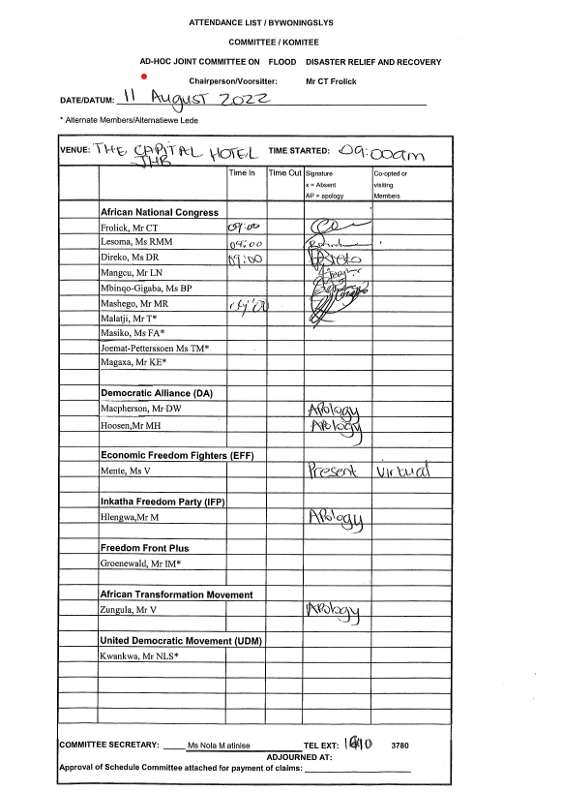

Annexure 11:
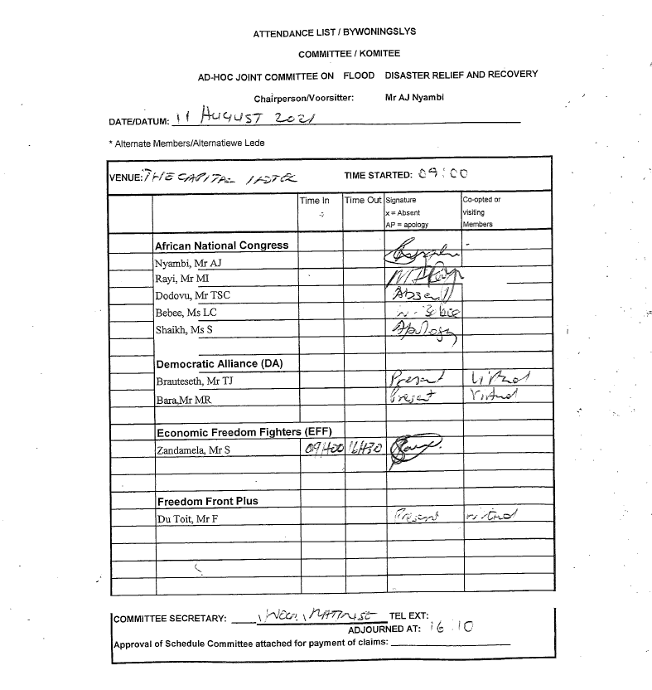

Annexure 12:

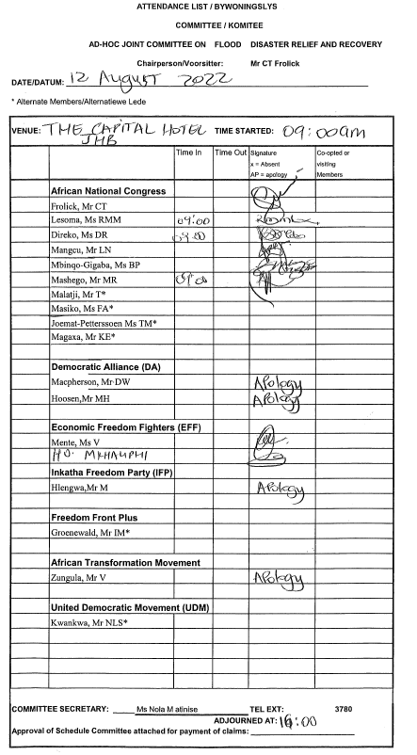

Annexure 13:
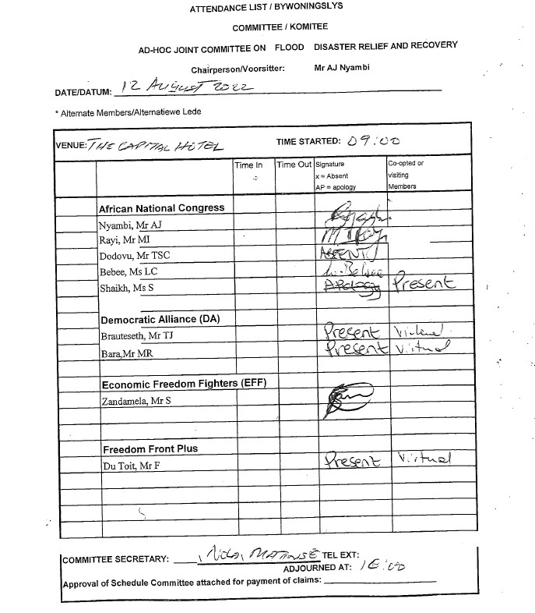

Annexure 14:
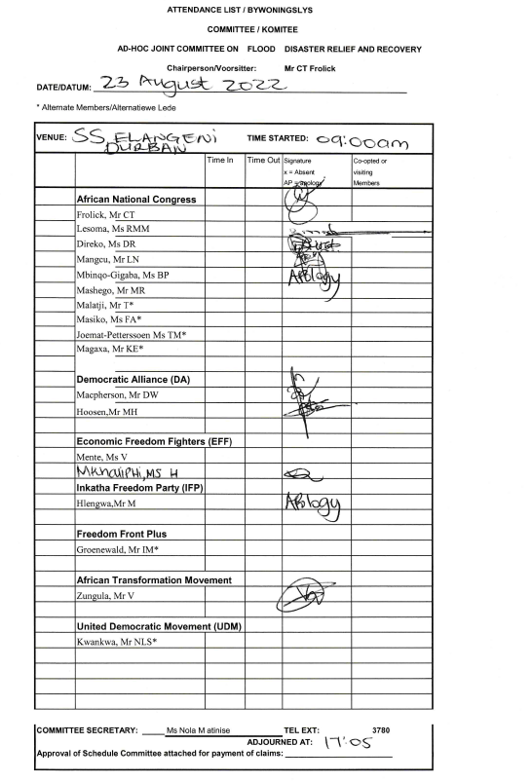

Annexure 15:
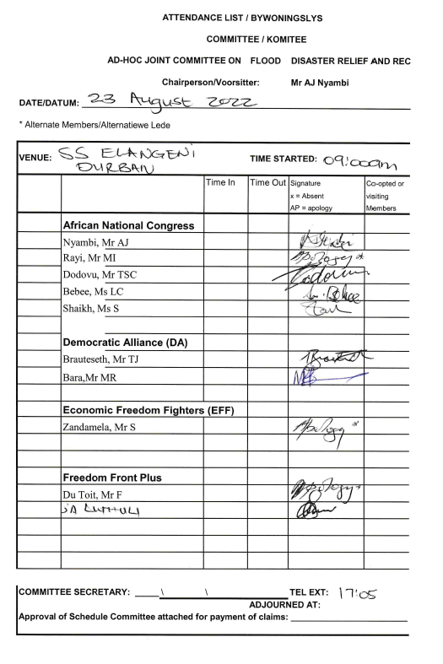

Annexure 16:

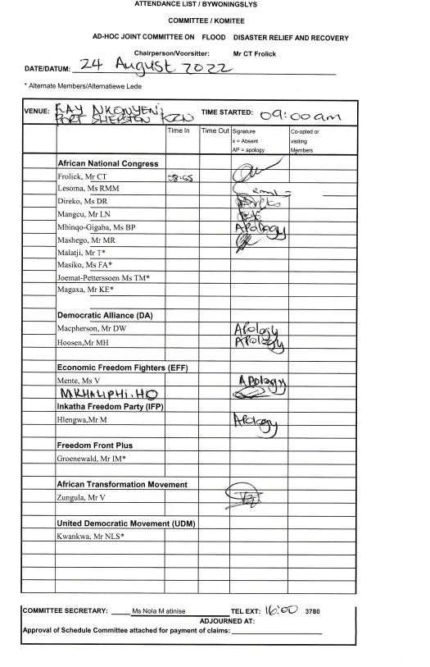

Annexure 17:

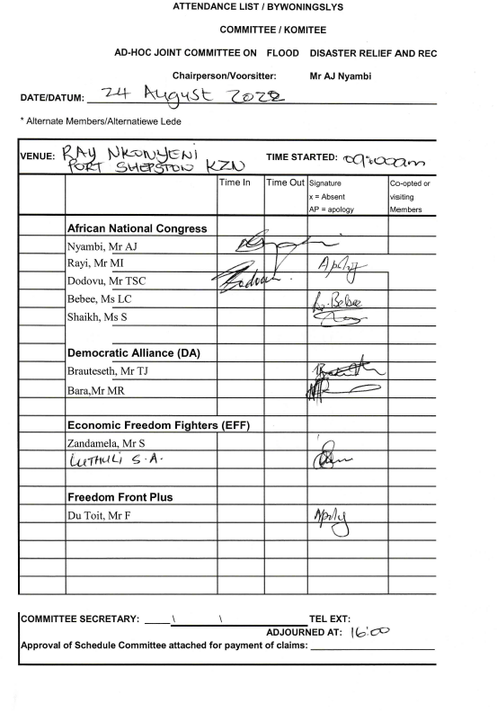

Annexure 18:

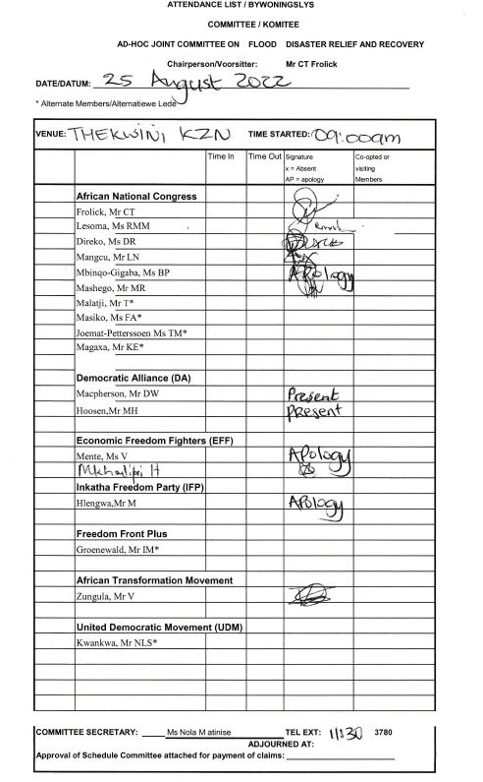

Annexure 19:

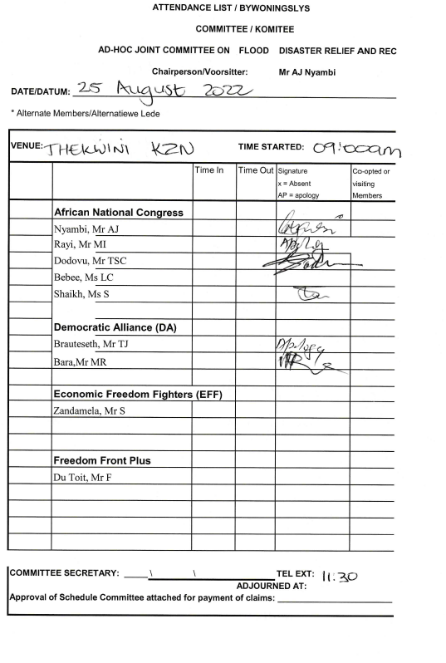

Annexure 20:

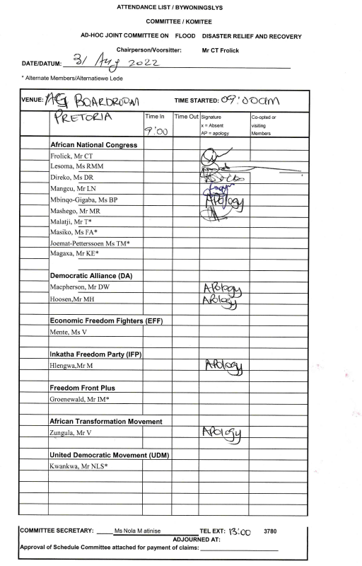

Annexure 21:
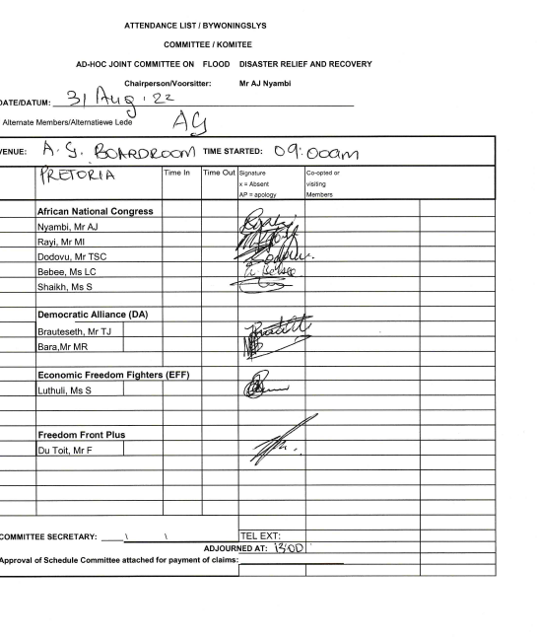

Annexure 22:
