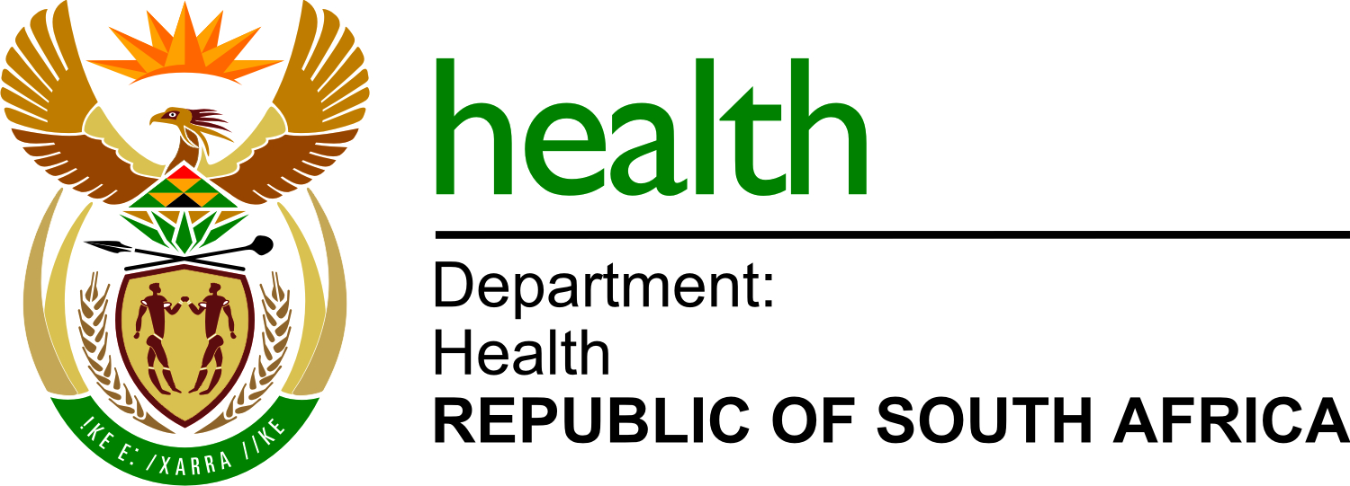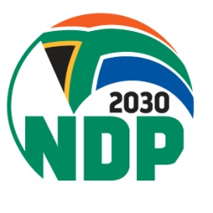
Private Bag X828, PRETORIA, 0001, Dr AB Xuma Building, 1112 Voortrekker Road, Pretoria, Townlands 351-JR, PRETORIA, 0187, Tel (012) 395 8000, Fax (012) 395 8918

Mr Yunus Ismail Carrim
To the Chairperson of Select Committee on Finance

For attention Mr Nkululeko Mangweni
Email: nmangweni@parliament.gov.za

Dear Mr Carrim,
WRITTEN SUBMISSION FOR THE: 2022 DRAFT TAX ADMINISTRATION LAWS AMENDMENT BILL - VAPING: TAXATION OF ELECTRONIC NICOTINE AND NON-NICOTINE DELIVERY SYSTEMS

WHO am I?
Department of Health
Represented by:
Dr Lynn Moeng-Mahlangu: Chief Director: Health Promotion and Nutrition.
Responsible for Nutrition and Health Promotion policies and regulations, programme monitoring and evaluation. My current responsibility is the development of the proposed draft Tobacco products and electronic delivery systems Control Bill. Also the focal point person for Tobacco Control in South Africa.
Contact Details:
Tel: (012) 395 8287
Cell No.: 082 490 8977
Email: Lynn.moeng@health.gov.za

What are the Department of health’s concerns
- The Draft tax Administration laws Amendment Bill is supporting the Department of health to protecting public health, the new generation products (vapes) are introducing new health harms increasing the burden to an already compromised health system.
- Tax measures are important strategy to reduce consumption and demand for these products.
- The products contain nicotine which is addictive.
- They are mainly marketed as harm reduction by the industry which is misleading and has additional health harms.
- While these are marketed as cessation tools from the tobacco products, they are marketed to all age groups and mainly targeting youth and non-smokers. The cessation approach and the nicotine dispensing are not compliant with medicinal protocols.
- If the products are not controlled or regulated, they will be used used by more young people and increase the burden.

The Department would like to present
To make a detailed PowerPoint presentation to the committee.

Does the Department have support
Yes, the Department has support
Partners that are pro tobacco control, including: The SA Tobacco Control Advocacy Alliance members under the National Council Against Smoking (NCAS). The NCAS has over the years advocated for tobacco control in the country, which is its sole mandate.

NGOs:
The Advocacy Alliance Tobacco
Alcohol and Gambling Advisory (TAAG)
The Cancer Association for South Africa (CANSA)

Academia:
Africa Centre for Tobacco Industry Monitoring and Policy Research (ATIM)
UCT: Research Unit on the Economics of Excisable Products (REEP)
University of Pretoria

Research Institution:
SA Medical Research Council (SAMRC),
International stakeholders such as The Campaign for Tobacco Free kids (CTFK)

