Report of the Portfolio Committee on Women, Youth and Persons with Disabilities to identify suitable candidates for the filling of vacancies in the Commission for Gender Equality dated 26 October 2022

The Portfolio Committee on Women, Youth and Persons with Disabilities (herein referred after as the Committee) in fulfilling its Constitutional mandate identified and recommended suitable candidates for the filling of vacancies of commissioners in the Commission for Gender Equality (CGE), as per the Commission for Gender Equality Act No. 39 of 1996, reports as follows:

- Introduction

  - The Commission for Gender Equality is a Chapter 9 Institution established with a view to strengthen constitutional democracy with a focus on the attainment of gender equality in all spheres of life. Section 187(1) of the Constitution of the Republic of South Africa Act 108 of 1996 states that the “Commission for Gender Equality must promote respect for gender equality and the protection, development and attainment of gender equality.”
  - Furthermore, Section 187 (2) grants the Commission “the power, as regulated by national legislation, necessary to perform its functions, including the power to monitor, investigate, research, educate, lobby, advise and report on issues concerning gender equality.”
  - In addition to the constitutional mandate assigned to the Commission, it is assigned further powers, duties and functions through its founding legislation. This is encapsulated in section 11 of the Commission for Gender Equality Act, No. 39 of 1996,
  - Section 3 (1) of the Act provides that “the Commission shall consist of a chairperson and no fewer than seven and no more than 11 members who shall -
- have record of commitment to the promotion of gender equality; and
- be persons with applicable knowledge or experience with regard to matter connected with the objects of the Commission.”
  - Section 3(2) further provides that “the President shall, when it becomes necessary, appoint as a member of the Commission a person —
(a) nominated by a committee in the National Assembly proportionally composed of members of all parties represented in the Assembly;
(b) approved by the National Assembly by a resolution adopted with a supporting vote of a majority of the members of the National Assembly; and
(c) on the recommendation of the Assembly”
  - According to the Act, Commissioners can serve up to two terms and are appointed by the President, on the recommendation of Parliament. To this end, S3 (7) provides that “any person whose term of office as a member of the Commission has expired, may be reappointed for one additional term.”
  - In compliance with provisions of section 193 (5) of Constitution Act 108 of 1996, on the 3rd June 2022, the Portfolio resolved to identify suitable candidates for the filling of vacancies in the CGE.
  - The Committee executed its duties in terms of the Rules of the National Assembly.

- Committee Process and Procedure

  - The Committee was composed of eleven members as follows:

AFRICAN NATIONAL CONGRESS
- Ms CN Ncube-Ndaba
- Ms F Masiko
- Ms T Masondo
- Ms B Marekwa
- Ms A Hlongo
- Ms C Phiri
DEMOCRATIC ALLIANCE
- Ms N Khan-Sharif
- Mr L Mphithi
INKATHA FREEDOM PARTY
- Ms M Hlengwa

ECONOMIC FREEDOM FIGHTERS
- Ms N Hlonyana

AFRICAN TRANSFORMATION MOVEMENT
- Ms T Marawu (only attended the meeting of 3 June 2022 and has not participated in other Committee meetings related to the filling of Commissioner vacancies in the Commission for Gender Equality)

- Committee meetings

The Committee held meetings as follows:
  - The Committee Chairperson Ms CN Ncube-Ndaba, informed the Committee in a meeting on 31 May 2022 that the Committee was requested by the Office of the Speaker of the National Assembly to initiate the process of filling vacancies in the Commission for Gender Equality (CGE). To this end, the Committee was requested to fill the 2 outstanding vacancies that are currently in the CGE and the 4 vacancies of Commissioners whose term will end on 31 October 2022.
  - The Committee adopted a committee programme, the draft advertisement and the Google-form online application form on 3 June 2022.
  - On the 23rd and 24th August 2022, the Committee met for shortlisting of candidates. The Committee received information about the number of applicants and/or nominations received - 158 in total. The Committee unanimously agreed on the twenty-four candidates shortlisted to be interviewed. The Committee was satisfied with the shortlisting process and considered it fair and just. The Committee also agreed to request the State Security Agency (SSA) to conduct the security screening of the twenty-four shortlisted candidates and Parliament’s Human Resources to undertake a process for verifying candidate’s qualifications.
  - A short list of candidates’ names with their qualifications were uploaded on the Parliamentary website for public commentary on 2 September 2022 until 16 September 2022. This was in keeping with Parliamentary processes and procedures in addition to legal advice received from the Office for the Institute Supporting Democracy (OISD) regarding compliance with the Protection of Personal Information (POPI) Act (No. 4 of 2013).
  - The Committee met on the 20 to 23 September 2022 to conduct interviews for the shortlisted candidates.
  - On the 25th October 2022, the Committee deliberated on the outcome of the interviews and made decision about preferred names to recommend to the President for appointment. The Committee also adopted the committee report on the 26th October 2022in order to report to the National Assembly.
.
- Legal framework and process

  - The Committee’s process was guided by the Constitution, Act 108 of 1996; Commission for Gender Equality Act 39 of 1996, as amended and the Rules of the National Assembly.
  - The standard guidelines for appointment of commissioners for the CGE as approved by Parliament in 2018 also was of great assistance to the Committee.
  - The Committee also agreed to replicate some of the successes of the previous Ad Hoc Committees on CGE.
  - The legal advisor from OISD, outlined the legal framework and process to the Committee on 23 August 2022.

- Advertisement

  - In fulfilment of its mandate, the Committee issued an advertisement requesting nominations and/or applications for the positions of commissioners for CGE from members of the public.
  - The advertisement appeared in all official languages in various newspapers throughout the country as well as on Parliament’s website.
  - The advertisements placed on 26 June 2022 stipulated a closing date of 18 July 2022. A set of qualifying criterion based on the legislative framework as stipulated in section 193 of Constitution and section 3 of the CGE Act 39 of 1996, as amended was set out as follows:
- The candidates must be South African citizens.
- Candidate to be fit and proper persons for appointment to the Commission.
- Candidates to broadly representative of South African community.
- Candidates to have a record of commitment to the promotion of gender equality.
- Candidates to have applicable knowledge of and experience in matters connected with the objects of the Commission.
  - The advertisement also clearly stated that the appointment by the President of commissioners on recommendation of Parliament would be for a term of office not exceeding five years either on a full-time or part-time basis.
  - The advertisement also made provisions to consider those candidates who had served a term as commissioner at CGE in terms of section 3(7) of CGE Act 39 of 1996 as amended.
  - The advertisement also informed applications and/or nominations about publishing of names on the Parliamentary website to allow members of the public to comment on the suitability of candidates.
  - The Committee received 168 applications in response to the advertisement.

- Overview of Applications
  - Of the 168 applications, 10 duplications were noted as certain applicants with the same identity number applied on more than one occasion. Thus when removing the 10 duplications it brings to a total of 158 applications.
  - The demographic profile of applicants was as follows:
    - The Committee noted as reflected in the graph below, of the 158 applicants, 33 were males (21.1%) of which 1 identified as gay, 124 females (78.4%), of which 4 indicated that they were transgender and 1 non-binary person.
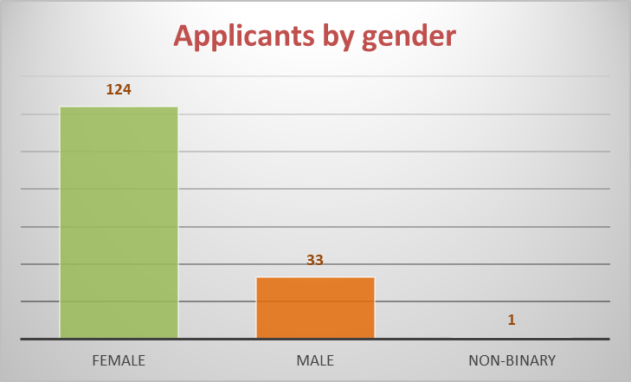
    - The Committee noted as reflected in the graph below, of the 158 applicants the majority (52.5%) reside in the Gauteng Province. The largest cohort of males and females were from Gauteng Province.
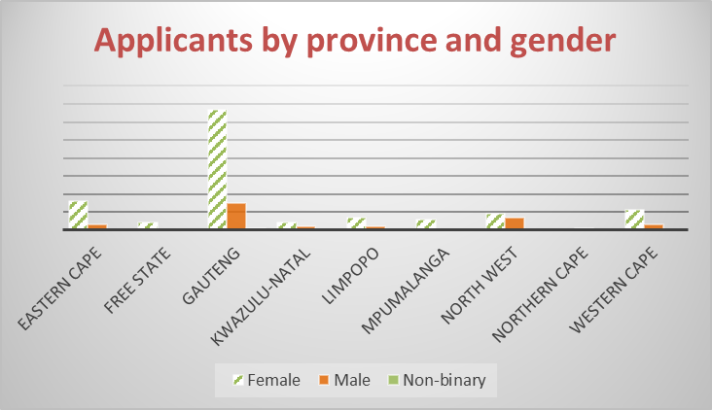

Applicants by Province and Gender
Province | Female | Male | Non-binary | Total
Eastern Cape | 16 | 3 |  | 19
Free State | 4 | 0 |  | 4
Gauteng | 67 | 15 | 1 | 83
KwaZulu-Natal | 4 | 2 |  | 6
Limpopo | 7 | 2 |  | 9
Mpumalanga | 6 | 0 |  | 6
North West | 9 | 7 |  | 16
Northern Cape | 0 | 1 |  | 1
Western Cape | 11 | 3 |  | 14
Total | 124 | 33 | 1 | 158
    - The Committee noted as reflected in the graph below, of the 158 applicants, the majority were Black African females (67.7%) and males (20.5%). Coloured applicants constituted 5% of applicants, while Indian/Asian and White applicants accounted for 2.5% and 3.8%
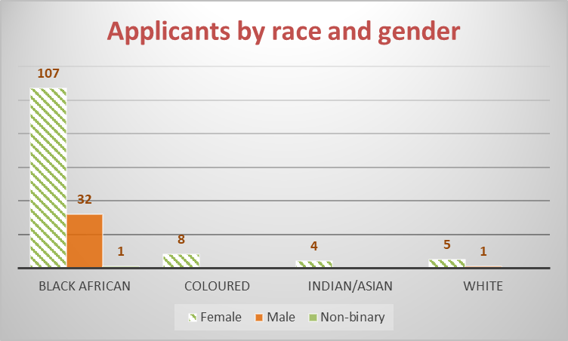

Applicants by Race and Gender
Race | Female | Male | Non-binary | Total
Black African | 107 | 32 | 1 | 140
Coloured | 8 |  |  | 8
Indian/Asian | 4 |  |  | 4
White | 5 | 1 |  | 6
Total | 124 | 33 | 1 | 158
    - The Committee noted as reflected in the graph below, of the 158 applicants, 18 applicants (11.5%) noted having a disability - 4 males and 14 females.
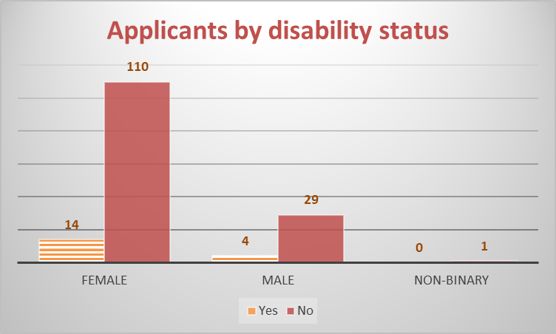
    - The Committee noted as reflected in the graph below, of the 158 applicants, 69 were employed, 42 were self-employed and 5 were students. A total of 41 applicants indicated that they were unemployed.
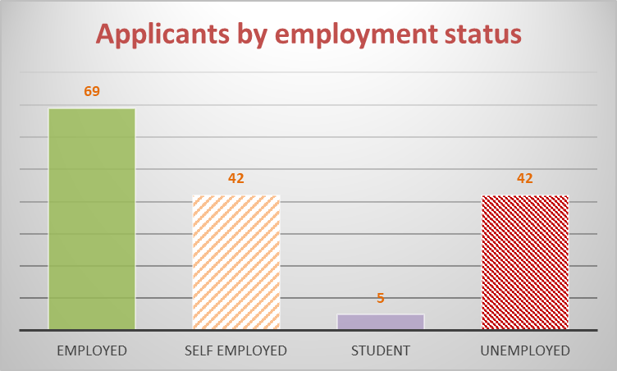
6.2.6 The Committee noted as reflected in the graph below, of the 158 applicants, 62 or 39% were nominated and 96 or 61% were self-nominees - in other words applicants who still applied but without a nomination.
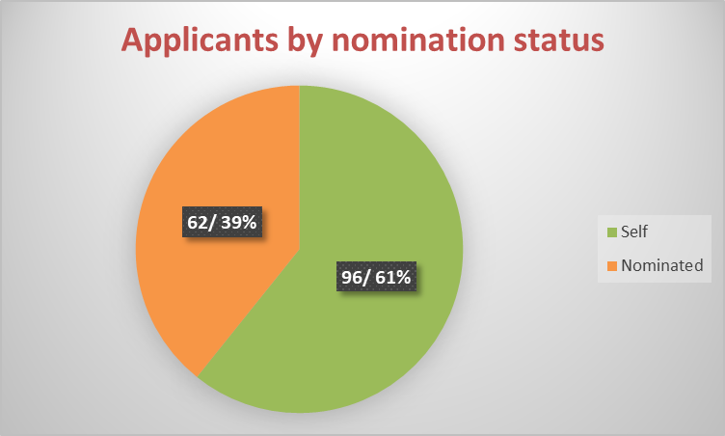

- Public Participation

  - In line with Constitutional imperatives as outlined in section 59 (1) of the Constitution Act 108 of 1996, the Committee agreed to an open and transparent process that caters for public involvement and participation.
  - The Committee also being aware of public interests on gender equality issues provided a platform for civil society to comment on all candidates.
  - To facilitate public participation, the Committee published the names of all candidates with their qualifications on Parliament’s website to allow the public to comment. The closing date for public comments was 16 September 2022.
  - The Committee received an overwhelming response to the call for public comments. A total of 656 comments were received. These comments related to 22 of the 24 shortlisted candidates. The comments per candidate ranged with 1 comment for a candidate being the least to 99 comments the most a candidate received.

- Shortlisted Candidates

On 24 August 2022, the Committee shortlisted twenty-four (24) candidates to be interviewed. The shortlisted candidates were:

- Adv. Thando Gumede
- Ms Pontsho Pilane
- Ms Candice Chirwa
- Adv. Nthabiseng Sepanya-Mogale
- Mr Itumeleng Gareth Mmusi
- Dr Nthabiseng Moleko
- Ms Bernadine Bachar
- Ms Mulalo Nemataheni
- Ms Emily Makosha Maditsi
- Leonasha Leigh-Ann van der Merwe
- Ms Lebogang Fataha
- Ms Santel Wilhemia van Zyl
- Ms Theresa Eulanda Mabusela
- Ms Pulane Noko Thobejane
- Mr Bongani Ngomane
- Ms Lindiwe Khonjelwayo
- Ms Susan Charity Mokwebo
- Ms Nonhlanhla Gretta Govender
- Ms Fundiswa Barbara Skweyiya-Gusha
- Ms Magdalene Moonsamy
- Prof. Nokuthula Mazibuko
- Ms Joy Janita Lange
- Ms Leelambal (Prabashni) Subrayan Naidoo
- Ms Zoleka Susan Ponoane
After the Committee had published the short listed candidates, the Committee was informed in writing by Dr Nthabiseng Moleko that she had withdrawn from the process. As such the Committee interviewed a total of 23 candidates.

- Interviews

  - The Committee agreed on structured questions for the interviews and that interview questions should be relevant to the objects of the CGE. Furthermore, the Committee ensured uniformity of questions during all interviews except for a current serving Commissioner. The Committee acknowledged the importance of institutional memory and continuity within the Commission and therefore questions were posed in relation to that.
  - The Committee agreed that interview questions should be about ascertaining the candidate’s knowledge about gender equality practises, legislative framework and principles; and to determine the candidate’s commitment to promotion of gender equality.
  - The Committee agreed on posing questions aimed at identifying the behavioural attributes and skills of candidates. The Committee agreed on leadership, interpersonal, conflict management, team building, motivation and innovation as preferred behavioural attributes and skills.
  - The candidates were each allocated a minimum of forty-five (45) minutes to answer all questions posed.
  - The Committee afforded those candidates with negative public commentary to respond to issues raised and to clarify any matter the candidate deemed important to bring the attention of the panel.
  - On the 20th September 2022, the Committee interviewed the following candidates:
• Ms Joy Janita Lange
• Prof. Nokuthula Caritus Mazibuko
• Ms Leelambal (Prabashni) Subrayan Naidoo
• Ms Gretta Nonhlanhla Govender
  - On the 21st September 2022, the Committee interviewed the following candidates:
• Ms Bernadine Bachar
• Ms Candice Chirwa
• Ms Pulane Noko Thobejane
• Ms Lindiwe Khonjelwayo
• Ms Magdalene Moonsamy
• Ms Sarah Charity Mokwebo
• Ms Leonashia Leigh-Ann van der Merwe
• Ms Zoleko Susan Ponoane
• Ms Pontsho Pilane
• Mr Itumeleng Mmusi
  - On the 22nd September 2022, the Committee interviewed the following candidates:
- Ms Mulalo Nemataheni
- Ms Fundiswa Barbara Skweyiya-Gushu
- Ms Santel Wilhemia Van Zyl
- Ms Lebogang Fataha
  - On the 23rd September 2022, the Committee interviewed the following candidates:
• Mr Bongani Glenton Ngomane
• Adv. Olave Nthabiseng Sepanya-Mogale
• Ms Makosha Emily Maditsi
• Ms Theresa Eulanda Mabusela
• Adv. Thando Gumede

- Deliberations

  - The Committee met on the 25th October 2022 to deliberate on the interviewed candidates and select preferred candidates to fill the six vacancies within the CGE.
  - The Committee having conducted all the interviews and taken into consideration the application form with all the relevant documentation of which Parliament’s Human Resources verified candidate’s qualifications and the State Security Agency undertook security screening agreed to the candidates to be recommended to the President for consideration.
  - The Committee also agreed to recommends as follows –
    - (04) candidates half term; and
    - (06) candidates full term.

- Recommendations

  - Having considered the request of the National Assembly for the Committee to nominate and recommend candidates for appointment as Commissioners for CGE, the Committee recommends the following candidates:
    - Half Term – Part Time Commissioners
- Mr Bongani Glenton Ngomane
- Ms Leelambal (Prabashni) Subrayan Naidoo
- Ms Sarah Charity Mokwebo
- Ms Fundiswa Barbara Skweyiya-Gushu
In the event that a vacancy arises due to a resignation or death, the President will be able to choose from the aforementioned list. The half term in this instance refers to a period of two-and-a-half years to fill the existing vacancies within the Commission.

    - Full Term - Full Time and Part-time Commissioners
- Adv Olave Nthabiseng Sepanya-Mogale
- Adv Thando Gumede
- Ms Leonashia Leigh-Ann van der Merwe
- Ms Lindiwe Khonjelwayo
- Ms Bernadine Bachar (person with a disability)
- Ms Mulalo Nemataheni
In the event that a vacancy arises due to a resignation and or death, the President will be able to choose from the aforementioned list.
  - Taking into consideration that Adv. Olave Nthabiseng Sepanya-Mogale is currently serving as a part-time Commissioner, the Committee recommends that Adv. Mogale be appointed as a full time Commissioner so as to ensure continuity and preservation of institutional memory.
  - The Committee further recommends that:
    - The House adopts the report as a matter of urgency as the term of office of 4 Commissioners comes to an end 31 October 2022. In addition, to the two existing vacancies the Commission will not quorate by 1 November 2022.
    - The Committee strongly recommends that the appointments are attended to as a matter of urgency in light of the aforementioned (11.3.1).
    - In order to strengthen the independence of the CGE and its reach, the National Assembly should revise the funding of this chapter nine institution.

- Appreciation

  - The Committee would like to thank all Members for making themselves available and working long hours to ensure success in carrying out the mandate of the Committee.
  - The Committee would also like to thank all candidates for making themselves available to be considered for appointment to the Commission for Gender Equality.
  - Furthermore, the Committee wishes to convey appreciation to the support staff for their contribution to the success of the Committee.

The majority of the political parties represented in the Committee adopted the report.

Report to be considered.

Commission for Gender Equality Act (No. 39 of 1996) As Amended by Public Service Laws Amendment Act, No. 47 of 1997 [with effect from 1 July, 1999] and the Commission on Gender Equality Amendment Act, No. 17 of 2013.

