Prevention and Combating of Hate Crimes and Hate Speech Bill
Research Note

Introduction
The Chairperson of the Portfolio Committee on Justice and Correctional Services posed a question during a Committee Meeting on 21 September 2022 regarding the efficacy and impact of similar legislation in other countries. The Department of Justice and Constitutional Development’s (the Department) response is set out below.

The Department has conducted a search and made efforts, in as far as possible, to answer that question. Given time and resource constraints, as well as the general shortage of detailed information in this regard, only a few countries were chosen as comparators, and these were also informed by the availability of academic text and research on those countries.

This Research Note is split into two parts. Part A provides a high-level snapshot and summary of a limited selection of foreign jurisdictions and their hate crimes and/or hate speech legislation. The purpose of Part A is to illustrate the disparity between this type of legislation across countries and regions – there is no uniform definition of the offences of “hate crime” and “hate speech”, no uniform category of victim and victim selection/identity/characteristics, no uniform penalty for the offences and no uniform recording, data collection or analysis of the offences.

Part B of the Research Note contains excerpts from academic text which assess the offences of hate crimes and/or hate speech in foreign legislation and the “efficacy” thereof. These academic texts speaks to the disparities identified in the discussion on Part A set out above, and address the difficulty in answering to the efficacy of such legislation.

Summary Finding
This has proved to be a difficult question to answer for a number of reasons, not least of which is how to properly interpret and understand the question itself.

The “effectiveness” of hate crimes legislation is dependent on what we define as “effective”, and this requires a much broader understanding and perspective of the entire criminal justice system in South Africa and what is understood by the “effectiveness” of legislation which criminalises conduct or which creates a criminal offence.

The issue of the interpretation and understanding of “effectiveness” aside, the next leg of the question requires an interpretation of data relating to hate crimes in jurisdictions where it is criminalised. When studying this area of the law, it became apparent that this area of law is, in itself, a difficult and complex. This is, in most part, due to the fact that each jurisdiction defines a “hate crime” quite differently. There is no universal definition of a hate crime, and these definitions, can, in fact, vary within a region (see Schweppe, J., Haynes, A. and Walters, M.A. (2018) Lifecycle of a Hate Crime: Comparative Report. Dublin: ICCL.)

Not only do definitions of a “hate crime” vary across countries, but so too do victim categories and methods of selection of victim categories.

Some jurisdictions criminalise this conduct through different means and not necessarily through legislation (such as the Netherlands, for example).

Taken together, this mean that understanding the data emanating from each of these jurisdictions (if there is any data at all) will require understanding their policy approach to the conduct which we seek to criminalise in this Bill; understanding the legislation in the foreign jurisdiction; and, finally understanding and interpreting the data (if any) of the offences in that context.

There is no baseline or control against which we can measure the effectiveness of legislation criminalising hate crimes and hate speech. So varied are the policy approaches and data of each country that this research would be required to transcend into the realm of expert academia in order to answer it properly. For that reason, we have excerpted the relevant portions of academic text by experts in this field, instead of restating it, for ease and efficacy.

Part A
Excerpts – snapshot of foreign jurisdictions with hate crimes and/or hate speech legislation

Taken from: The Department’s “Hate Speech Legislation in other Jurisdictions” (2018)

CANADA:
The Canadian Criminal Code, 1985, in section 319, deals with public incitement of hatred. It criminalises the communication of “statements” (as defined), in any “public place” (as defined) which incites hatred against any “identifiable group” (as defined), where the incitement is likely to lead to a breach of the peace. The maximum penalty is imprisonment for a period not exceeding 2 years. It also criminalises the wilful promotion of hatred against an identifiable group by communicating statements, the maximum period of imprisonment also being 2 years. Section 319(3) sets out certain limitations on the application of section 319, for instance if–
(a) the “offender” establishes that the statements communicated were true;
(b) in good faith, the offender expressed an opinion on a religious subject or an opinion based on a belief in a religious text; or
(c) the statements were relevant to any subject of public interest, the discussion of which was for the public benefit, and if on reasonable grounds, the offender believed them to be true.

AUSTRALIA:
The Racial Discrimination Act of 1975 deals with “Offensive behaviour because of race, colour or national or ethnic origin” in section 18C. It provides that it is unlawful for a person to do an act, otherwise than in private if–
“(a) the act is reasonably likely, in all the circumstances, to offend, insult, humiliate or intimidate another person or a group of people; and
(b) the act is done because of the race, colour or national or ethnic origin of the other person or of some or all of the people in the group.”. (Our emphasis)
Section 18D sets out exemptions and reads as follows:
“Section 18C does not render unlawful anything said or done reasonably and in good faith–
(a) in the performance, exhibition or distribution of an artistic work;
(b) in the course of any statement, publication, discussion or debate made or held for any genuine academic, artistic or scientific purposes or any other genuine purpose in the public interest; or
(c) in making or publishing–
(i) a fair and accurate report of any event or matter of public interest; or
(ii) a fair comment on any event or matter of public interest if the comment, is an expression of a genuine belief held by the person making the comment.”.

IRELAND:
Section 2 of the Prohibition of Incitement to Hatred Act, 1989, dealing with “Actions likely to stir up hatred” provides as follows:
“It shall be an offence for a person–
(a) to publish or distribute written material;
(b) to use words, behave or display written material–
(i) in any place other than inside a private residence; or
(ii) inside a private residence so that the words, behaviour or material are heard or seen by persons outside the residence; or
(c) to distribute, show or play a recording of visual images or sounds,
if the written material, words, behaviour, visual images or sounds, as the case may be, are threatening, abusive or insulting and are intended, or having regard to all the circumstances, are likely to stir up hatred.”.

NEW ZEALAND:
Hate speech is prohibited under the Human Rights Act, 1993. Section 61 makes it unlawful to publish or distribute “threatening, abusive, or insulting matter or words likely to excite hostility against or bring into contempt any group of persons on the ground of the colour, race or ethnic or national origins of that group of persons”. Of greater relevance is section 131 which criminalises incitement of “racial disharmony” and provides, among others, as follows:
“Every person commits an offence and is liable on conviction to imprisonment for a term not exceeding 3 months or to a fine not exceeding $7 000 who, with intent to excite hostility or ill-will against, or bring into contempt or ridicule, any group of persons in New Zealand on the ground of the colour, race, or ethnic or national origins of that group of persons–
(a) publishes or distributes written matter which is threatening, abusive or insulting, or broadcasts by means of radio or television words which are threatening, abusive or insulting; or
(b) uses in any public place (as defined in section 2(1) of the Summary Offences Act, 1981), or within the hearing of persons in any such public place, or at any meeting to which the public are invited or have access, words which are threatening, abusive or insulting,
being matter or words likely to excite hostility or ill-will against, or bring into contempt or ridicule, any such group of persons in New Zealand on the ground of the colour, race, or ethnic or national origins of that group of persons.”.

FRANCE:
France prohibits by its penal code and by its press laws public and private communication which is defamatory or insulting or which incites discrimination, hatred or violence against a person or group of persons on account of place of origin, ethnicity or lack thereof, nationality, race, specific religion, sex, sexual orientation or handicap.

THE NETHERLANDS:
The Dutch Penal Code prohibits both insulting a group and inciting hatred, discrimination or violence, as set out below:
Article 137c: “He who publically, orally, in writing or graphically, intentionally expresses himself insultingly regarding a group of people because of their race, their religion or their life philosophy, their heterosexual or homosexual orientation or their physical, psychological or mental disability, shall be punished by imprisonment of no more than a year or a monetary penalty of the third category”.
Article 137d: “He who publically, orally, in writing or graphically, incites hatred against, discrimination of or violent action against persons or belongings of people because of their race, their religion or their life philosophy, their gender, their heterosexual or homosexual orientation or their physical, psychological or mental disability, shall be punished by imprisonment of no more than a year or a monetary penalty of the third category”.

KENYA:
The hate speech offence in the National Cohesion and Integration Act (Act No. 12 of 2008), provides that a person who uses threatening, abusive or insulting words or behaviour or displays any written material, publishes or distributes written material, presents or directs the public performance of a play, distributes, shows or plays a recording of visual images or provides, produces or directs a programme “which is threatening, abusive or insulting or involves the use of threatening, abusive or insulting words or behaviour” is guilty of an offence if such person intends thereby to stir up “ethnic hatred”, or having regard to all the circumstances, ethnic hatred is likely to be stirred up. The penalty is a fine or imprisonment not exceeding 3 years. The limitations to the application of this provision in Kenya are different from the limitations usually found in legislation of this nature and are “Kenya-specific”.

SUDAN:
Section 25 of the Sudanese Criminal Act prohibits insulting religion, inciting hatred and showing contempt for religious beliefs. The penalties for contravention of this section include imprisonment and fine.

Taken from: The Department’s “Concept Paper on Combating Hate Crimes and Hate Speech” dated 31 May 2016
A comparison of grounds used in other jurisdictions is set out in the footnote.
Part B
Excerpts from academic text – assessing the offences of hate crimes and/or hate speech in foreign legislation and the ‘efficacy’ thereof

Taken from: Jennifer Schweppe (2021) “What is a hate crime?” Cogent Social Sciences, 7:1, 1902643, DOI: 10.1080/23311886.2021.1902643
Though the term “hate crime” is used across jurisdictions, disciplines, and contexts, it is perhaps surprising that there is no uniform understanding of the term. For this reason, scholars, policy makers, and legislators can often speak at odds when discussing the issue, even within practice silos. This poses perhaps a unique problem for scholars, policy makers and analysts. Across other manifestations of criminality, there is typically general agreement in the academy and across policy domains as to what the constructs mean. Whilst between jurisdictions, there will be differing legal definitions as to what, for example, constitutes a rape, there are agreed definitional boundaries as to what that term means across contexts. This allows, for example, for scholars across disciplines and jurisdictions to explore and problematize the concept, as well as for policy makers and analysts to understand the phenomenon cross-jurisdictionally. This allows for comparability of data, and for learning between jurisdictions as to how best to address this social ill. The same is not true for hate crime. There is no accepted definition at an international level as to what constitutes a hate crime, from organisations such as the United Nations, the Council of Europe or the European Union. Not only that, but there is no agreed conceptualisation of the term across jurisdictions.

From a policy perspective, this is problematic as we cannot begin to compare data across jurisdictions when such fundamentally different definitions of a term are utilised. From a scholarly perspective, it is problematic as we are seeking to compare explore, understand, and problematise fundamentally different phenomena using the one umbrella term.

European understandings of hate crime
There is no common definition of hate crime across Europe, either formal or informal, within the European Union or the Council of Europe. Across Member States of the EU generally, a range of interpretations of the concept of hate crime are in evidence.
Glet notes that in Germany, for example, the historical context has dictated a conceptualisation of hate crime in that country which is markedly different to that in the United States (and thus, the definition adopted by the OSCE):
“In Germany, hate crimes are considered politically motivated offences because they present a threat to the human and constitutional rights of the victim and undermine the democratic, pluralistic directive of the country. In this regard, the German approach towards recording hate incidences is based on an offender-oriented system of classification, which focuses primarily on the political motive of the alleged perpetrator.”.

Member States’ divergent conceptualisations of hate crime are reflected in wide-ranging inter- jurisdictional variation in the construction of hate crime laws. Perry notes that the same position applied across the United States in the early 1990s following the passage of the federal Hate Crime Statistics Act:
‘The limits of the federal government’s commitment to hate crime data collection are immediately apparent in [the Act] itself. Efforts are constrained by the narrow definition of both the protected groups and the enumerated offences . . . Moreover, this brings to mind the problem of inconsistency between reporting agencies. Not all states recognise the same categories of bias in their legislation. Some states do not include gender in their hate crime legislation; some do not include sexual orientation; yet others include such anomalous categories as “whistle blowers”. (Perry, 2010, p. 349)’.

Ten years following the passing of the Framework Decision, in Europe we are faced with very similar issues as the definitions of hate crime vary across jurisdictions. For the purposes of monitoring and policy analysis, OSCE/ODIHR (2009, p. 6) proposes a generalised definition applicable across boundaries. Hate crimes, it suggests, are “criminal acts committed with a bias motive.” Perry (2016, pp. 610–619) notes that the approach of the OSCE in coming to its definition was to use one which excluded those offences “on which there is no international consensus on their criminalization:”
“For example, while several countries criminalize discrimination, or membership of ‘extremist’ groups, and include these acts within their national concepts of hate crime, most do not. Similarly, although all European countries criminalize hate speech, to some extent, there is a diverse approach to the threshold of ‘hate’ above which freedom of expression is no longer protected. (Perry, 2016: 610, p. 619)”.

The consequences of the absence of a common conceptualisation and construction of hate crime, emanating either from the EU or the Council of Europe, are numerous. First, as Perry notes, disparate legislation produces methodological differences with respect to data collection.

Direct impacts can range from physical injury to emotional and psychological harm. We now know that there is a qualitative difference to the impact of hate crime as compared to non-hate motivated incidents. For instance, data from the Crime Survey for England and Wales showed that victims of hate crime were more likely than victims of crime overall to say they were emotionally affected by the incident (92% and 81% respectively) (Corcoran et al., 2015, p. 22), while 36% of hate crime victims stated they were “very much” affected compared with just 13% for non-hate crime victims. The data also showed that twice as many hate crime victims suffer a loss of confidence or feelings of vulnerability after the incident compared with victims of non-hate crime (39% vs. 17%). Hate crime victims were also more than “twice as likely to experience fear, difficultly sleeping, anxiety or panic attacks or depression compared with victims of overall CSEW crime (Corcoran et al., 2015, p. 22).”.

Paterson et al conducted a study involving over 3,000 LGBT and Muslim people which found that knowing other people who have been the victim of hate crime increases the perception of threat in those indirect victims. This in turn is linked to heightened feelings of vulnerability, anxiety and anger (Paterson et al., 2018; Walters et al., 2020). These heightened emotions are evidence of the terrorising effects of hate crime, on the broader community of which the victim is part.

It is vitally important however, to understand in this context that, at least from a legal perspective, hate speech and hate crime are two separate concepts and are constructed differently. Indeed, hate speech offences have a much longer statutory pedigree, dating back to “reconstruction-era civil rights statutes and early 20th-century state statutes aimed at the activities of white supremacist (Phillips & Grattet, 2000: 567, p. 572).” Similarly, the British Race Relations Act 1966 criminalised incitement to racial hatred, as did the Irish Prohibition of Incitement to Hatred Act 1989. Goodall observes that one of the key differences between hate speech offences and hate crime is what she refers to as the “audience” of the crime “which does not necessarily include the victim, but is rather a separate audience who can be stirred up”, and it is this distinction, and the extent to which hate speech can and should be criminalised, which is perhaps one of the more contentious issues in the field of hate studies (Goodall, 2010).

From a legal perspective, the criminalisation of hate speech is not unproblematic, being seen as in direct conflict with rights to freedom of expression (Kiska, 2012, pp. 107–151). Pejchal and Brayson (2016, p. 257) note that attempts to limit free speech are sometimes seen as an “attack on the foundations of Western society, where freedom of expression has been considered a developmental cornerstone.” This argument was successful in the US Supreme Court case of RAV v City of St Paul (1992). That said, while in the United States there are few limitations on the freedom of speech (Waldron, 2012), this is not the case in other jurisdictions. Through the operation of both Article 10 of the European Convention on Human Rights (which sets out both the protection for and limitations on the freedom of expression) as well as Article 17 of the Convention (which was stated in Glimmerveen and Hagenbeek v The Netherlands (1978) as having a general purpose of preventing “totalitarian groups from exploiting in their own interests the principles enunciated by the Convention”) the Court has upheld laws which criminalise hate speech in, for example, Norwood v United Kingdom (2004).

In his articulation of how hate can be conceptualised globally, Brudholm observes that there are four “constitutive features” of hate crime globally (Brudholm, 2016, pp. 34–35):
(1) If there is no crime, there can be no hate crime;
(2) There is general agreement that the proof of the hate crime lies in the answer to the question why the crime was committed;
(3) Implied in the definition is a requisite relation between the hate and the crime; and
(4) There is also an implication that there is a specification of a list of protected characteristics: the hate must be directed towards categories of group identity.

Taken from: “Recording Hate Crime: Technical solutions in a training vacuum” by Haynes and Schweppe in European Law Enforcement Research Bulletin - Innovations in Law Enforcement at 227-238
In Ireland, police record hate crime as part of their operational duties and their remit in collecting crime data. This article addresses the impact on the quality of official hate crime statistics of a technical change to the manner in which the hate element of a crime was recorded in Ireland in 2015. The primary data were collected via two research projects conducted in 2015 and 2017. Both projects addressed the treatment of hate crime in the criminal justice process in Ireland. This article draws on interviews with members of the police and employees of the national Garda Information Services Centre (GISC) conducted for these studies.

While technical advancements were made in the recording of hate crime, by 2017 awareness of hate crime recording categories had not been mainstreamed among police officers and little support had been provided to them in interpreting the meaning of categorical labels. While technical training had begun to be rolled out, training on the substantive issues involved had not been mainstreamed and did not address the recording of discriminatory motivations. The technical changes to the police recording of hate crime in Ireland evidence a progressive ethos with respect to:
• Recording the hate element of a crime beyond the limits of legislation.
• Identifying victims of hate crime.
• Including a wide range of identities.
However, in the absence of agreed definitions and training, the impact of this technical change will, we argue, be limited.

Taken from: “Reality versus rhetoric: Assessing the efficacy of third-party hate crime reporting centres” by Wong et al in International Review of Victimology 2020, Vol. 26(1) 79–95
The underreporting of hate crime is recognised as problematic for jurisdictions across Europe and beyond. Within the UK, the landmark inquiry report into the murder of Stephen Lawrence 25 years ago has seen governments faithfully adhering to a policy of promoting the increased reporting of hate crime. An enduring legacy of the inquiry, third-party reporting centres (TPRCs) have been equally faithfully promoted as the primary vehicle for achieving such increases. While the nations of the United Kingdom have pioneered the development of TPRCs, their function and form have been adopted in other jurisdictions, including Victoria, Australia. Nevertheless, despite their reliance on TPRCs, policymakers have given limited attention to their efficacy. The evidence from a plethora of small scale studies has consistently found that TPRCs have been limited by public awareness, capability, capacity and poor oversight difficulties.

Taken from: “The Origins of Hate-Crime Laws” by K Naidoo in Fundamina Volume 22 | Number 1 | 2016 pp 53-66
In South Africa, civil-society organisations have made several submissions to the Department of Justice which have recommended the enactment of hate-crime legislation. It is lamentable that these calls have not been heeded given post-apartheid South Africa’s status as a constitutional state and its commitment to equality. While hate-crime laws will not eradicate crimes motivated by bias and prejudice, the imposition of the criminal sanction and an aggravated penalty to such conduct may be considered as the ultimate “symbolic message” that a government has at its disposal to try and change prejudiced attitudes and the manifestations thereof.

Taken from: Prof Jennifer Schweppe, School of Law and Prof Amanda Haynes, Dept of Sociology at University of Limerick – Presentation to the European Centre for the Study of Hate
- Your definition of effectiveness should drive your legislative decision-making
- Determine your priorities and build a legislative model
What is effective hate crime legislation?

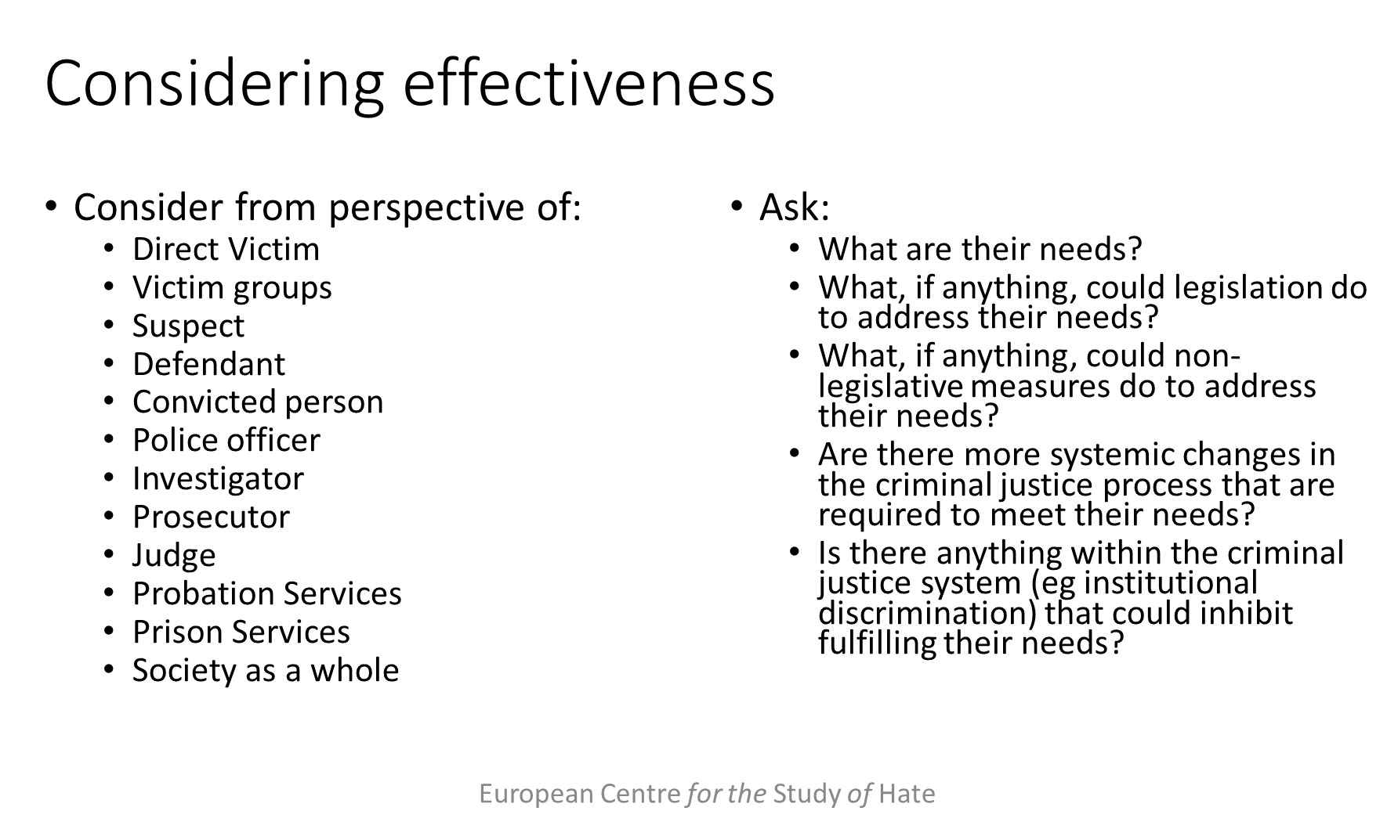
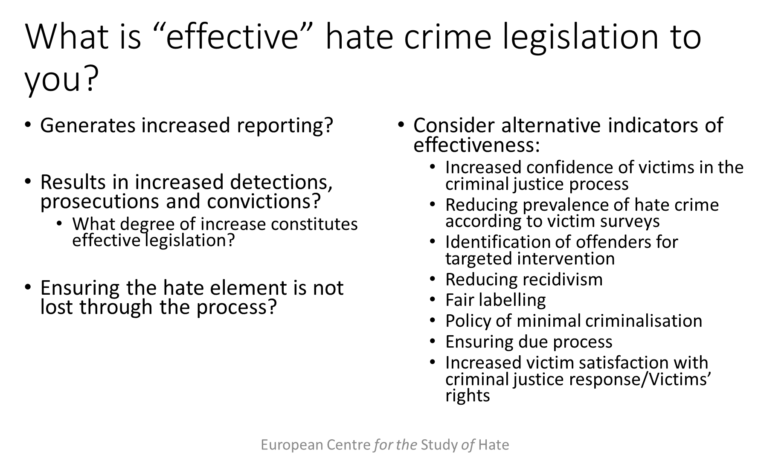

Taken from Schweppe, J., Haynes, A. and Walters, M.A. (2018) “Lifecycle of a Hate Crime: Comparative Report” Dublin: ICCL at pp 121 -144
Hate crime is a problem affecting the lives of minoritised communities across Europe on a daily basis. Addressing hate crime through the criminal justice system, while not the only mechanism available to states, is arguably the most direct means of responding to hate crime at our disposal. The effectiveness of punishment in addressing offending behaviour is a matter of debate, but there is ongoing evidence of the potential of alternative approaches such as restorative justice. The Victims’ Directive is founded in an appreciation of the needs of victims of crime to have their experiences addressed appropriately by the legal process. It is accepted that the criminal justice process is an imperfect tool, but the flawed nature of the system does not mitigate the requirement of victims of hate crime for access to the established means of addressing issues of social control and infringements of personal safety and security within the state. Failures on the part of the legal process to appropriately address hate crime have deleterious implications for direct victims’ trust in the system, but may also reduce their trust in the state and in majority society. These effects also manifest among the minoritised communities which share the characteristics targeted. The detrimental impacts of a failure to appropriately address hate crime through the criminal justice process are therefore experienced at the level of the individual, community and society.

Hate crime legislation has a “symbolic” purpose, emphasising the wrongfulness of hate motivated crimes: in criminalising hate, society is sending a message that it will not tolerate this type of behaviour. Across the five jurisdictions party to this project, this message is sent in different ways due to the construction of legislation, and also its operation. The criminal justice system is, of course, not the only mechanism by which hate crime can be addressed and combated, but it is has an important place among the resources at Members States’ disposal.

This Report has shown that the extent to which a hate element is recognised by individual actors in the criminal justice process largely depends on first, the legislative approach to addressing hate crime, secondly, the existence of policies on the issue, thirdly, the extent to which these policies are shared across the process, and finally, the extent to which those policies are embedded in practice.

At the point of recording, this Report has identified divergent practices across jurisdictions, with a minority utilising the “perception test” as recommended by ECRI; a minority making it mandatory for police officers to address whether the case was hate motivated or not; and some still lacking any policy regarding the recording of a hate element. This Report has found that the absence of clear and common recording protocols has deleterious implications for the quality of hate crime statistics and the capacity of both the State and the EU to monitor progress in addressing hate crime through the criminal justice system.

In the following stages of the criminal justice process, disparities widen. At the point of investigation, England and Wales and Sweden have addressed all of the Commission’s recommendations to support the implementation of Article 4. However, neither the Czech Republic nor Ireland have addressed any of the Commission’s Recommendations with respect to the establishment of specialised units, guidelines and training for investigators, and Latvia has established only guidelines. We have found that shortfalls in these regards detrimentally impact the knowledge, comprehension and resources that investigators can bring to bear on evidencing the presence of a hate element.

At the stage of prosecution, this report finds that Ireland and Latvia have addressed none of the Commission’s Recommendations with respect to prosecutorial specialisms, guidelines and training, while only England and Wales have instituted specialist training for prosecutors. We find that the lack of supports available to prosecutions contributes to the idiosyncratic approaches to the prosecution of a hate element in evidence in some jurisdictions.

Enactment of the Recommendations is most limited at the point of sentencing. Specifically, three States have enacted none of the recommendations with respect to sentencing guidelines, data and training, and no state has addressed the recommendation that judges be trained in relation to hate crime. In practice, we have found that the hate element may already have been lost to the court at the stage of prosecution, through the manner in which it is presented in the courtroom, but it may also simply not be addressed by the judge. This presents two problems: first, the “message element” of the crime is lost; and second, in the context of recidivistic behaviour, it is not possible to track reoffending.

At all stages of the process, what we refer to as the “forward communication of the hate element” is vital to ensuring that slippage and filtering out does not occur. We believe that in order to prevent the “filtering out” or “disappearing” of a hate element, the EU and its Member States should implement the following policies and practices across criminal justice processes.

Haynes and Schweppe have observed that, in the absence of hate crime legislation, the hate element of an offence can be “disappeared” from the criminal justice process. However, even the presence of what might be considered the most robust legislation in operation in the European Union does not necessarily result in the hate element being captured across the process. As Part 4 of this Report has observed, the hate element of a crime is often “filtered out” by the police, the prosecution or judiciary in England and Wales.

Requirements at EU level
The combating of hate crime through the criminal justice system is key to realising a safe society for Europe’s marginalised and minoritised communities, in turn addressing the societal fissures and fractures to which targeted hostility contributes. Chakraborti observes:
“... the value of hate crime laws and their enforcement can be significant, whether in terms of their capacity to express our collective condemnation of prejudice, to send a declaratory message to offenders, to convey a message of support to victims and stigmatized communities, to build confidence in the criminal justice system within some of the more disaffected and vulnerable members of society, and to acknowledge the additional harm caused by hate offences.”
However, the mere presence of such laws on statute books is not sufficient to achieve such impact: such laws must be effective, and appropriately enforced, both, as Chakraborti states, “for individual freedoms and for cohesive communities.”

Article 2 of the African Charter on Human and Peoples’ Rights provides that “every individual shall be entitled to the enjoyment of the rights and freedoms recognised and guaranteed in the present Charter without distinction of any kind such as race, ethnic group, colour, sex, language, religion, political or other opinion, national and social origin, fortune, birth or other status.”. In the US hate crime acts can be committed on the basis of race, colour, religion or national origin. In Belgium the grounds are sex, supposed race, colour, descent, national or ethnic origin, sexual orientation, civil status, birth, fortune, age, religious or philosophical beliefs, current or future state of health and handicap or physical features. In France they are actual or perceived ethnicity, nation, race, religion or sexual orientation. In Ireland they are race, colour, nationality, religion, sexual orientation, ethnic or national origins or membership of the Traveller community or an indigenous minority group. In Sweden they are race, colour, nationality, ethnicity, sexual orientation and religion. In Italy they are race, sex, gender ethnicity, nationality and religion. The Additional Protocol to the Convention on Cybercrime (the Budapest Convention), concerning the criminalization of acts of a racist and xenophobic nature committed through computer systems, in Article 2 refers to the grounds of race, colour, descent or national or ethnic origin and religion.

