**Budgetary Review and Recommendations Report of the Portfolio Committee on Communications, dated 18 October 2022**The Portfolio Committee on Communications (the Committee), having considered the performance and submission to National Treasury for the medium-term period of the Government Communication and Information System (herein referred to as the Department) and Media Development and Diversity Agency (herein referred to as the Agency); reports as follows:

1. **Introduction**

In terms of Chapter 4 of the Constitution of the Republic of South Africa, Act 108 of 1996 (the Constitution), gives a mandate to Portfolio Committees to legislate, conduct oversight over the Executive Authority and also facilitate public participation.

* 1. **The mandate of the Department**

The mandate of the Government Communication and Information System is derived from section 195(g) of the Constitution, which stipulates that the public should be provided with information that is timely, accurate and accessible. This is in support of the constitutional principles of freedom of expression, and transparent and open governance. The Department is responsible for providing strategic leadership and coordinating government communication to ensure that the public is informed, and has access to government programmes and policies that benefit them.

* 1. **Purpose of the Report**

The Money Bills Amendment Procedure and Related Matters Act (Act 9 of 2009) sets out the process that allows Parliament to make recommendations to the Minister of Finance as well as the cabinet Minister responsible for the vote to ensure the effectiveness and efficiency of the use of resources to ensure optimal service delivery.

According to Section 5 of the Money Bills Amendment Procedure and Related Matters Act, the National Assembly, through its Committees, must annually assess the performance of each national Department. The Committee must submit an annual Budgetary Review and Recommendation Report (BRRR) for the Department as it falls under its oversight responsibilities, for tabling in the National Assembly. This process happens every October of each year when the Committee assesses service delivery performance given available resources, evaluates the effective and efficient use and forward allocation of resources, and may make recommendations on the forward use of resources.

The BRRR also sources documents from the Standing/Select Committees on Appropriations/Finance when they make recommendations to the Houses of Parliament on the Medium-Term Budget Policy Statement (MTBPS). The comprehensive review and analysis of the previous financial year’s performance, as well as performance to date, form part of this process. The Standing Committee on Appropriations (SCOA) should consider these when it is considering and reporting on the MTBPS to the National Assembly.

Lastly, this performance report is also in line with Section 195 of the Constitution and other legislative prescripts that guide performance management in the public sector to display and promote transparency and accountability to stakeholders and the public concerning matters under their control.

1. **Role and Mandate of the Committee:**
2. Consider legislation referred to it;
3. Exercise oversight over the Department and it entities;
4. Consider International Agreements referred to it;
5. Consider the Budget Vote of the two Departments;
6. Facilitate public participation process; and
7. Consider all matters referred to it in terms of legislation, the Rules of Parliament and resolutions of the House.
8. **Expenditure Overview**

Over the medium term, the Government Communication and Information System continue to focus on providing and facilitating strategic government communication and encouraging active citizen participation. It supported all government departments in conceptualising cohesive campaigns, developing communications strategies and content, disseminating information, and engaging stakeholders. The Department enhances its delivery of these core services by harnessing various communications structures, such as social media, to reach and provide information to more South Africans.

Expenditure for these activities within the medium term with the allocations to the Content Processing and Dissemination programme (R1.3 billion) and Intergovernmental Coordination and Stakeholder Management programme (R375.4 million), which together accounted for 75.6 per cent of the Department’s budget over the medium term. Transfers to the Department’s entities accounted for 34.6 per cent (R751.9 million) of its total budget.

The Department kept communities and stakeholders abreast of the government’s progress with the implementation of the district development model, which aimed to improve the coherence and impact of development in 44 districts and eight metropolitan municipalities across the country. To this end, the Department held community and stakeholder liaison visits and a number of development communication projects per year over the MTEF period. Spending for these activities was primarily driven by goods and service items, which was allocated 16.9 per cent (R62.4 million) of the total budget in the Intergovernmental Coordination and Stakeholder Management programme.

The Department’s outreach programme used talk shows on community radio and television stations, activations at taxi ranks and malls, commuter train blitzes, imbizos, and door‐to‐door campaigns. These activities allow the Department to interact with communities and often provide an early warning for any societal issues or discontent. The outreach programme was allocated R6.3 million for the year under review of the medium term in the Provincial and Local Liaison subprogramme in the Intergovernmental Coordination and Stakeholder Management programme. R50 million was further allocated to the Products and Platforms subprogramme in the Content Processing and Dissemination programme for the COVID‐19 Vaccine rollout campaign in 2021/22.

To make the public aware of the opportunities created by the government, in line with its key priorities, the Department had planned to publish 15.3 million copies of the Vuk’uzenzele newspaper per year over the medium term at an estimated cost of R75 million in the Products and Platforms subprogramme in the Content Processing and Dissemination programme[1].

**Strategic Overview of the Department**

In the 2021/22 financial year, communication was again at the forefront of the fight against the Coronavirus Disease (COVID-19) pandemic. Our nation’s communications, led by the Government Communication and Information System (GCIS), were called on to support our massive national vaccine roll-out. Government communication played an instrumental role in drawing in all South Africans to be part of our massive vaccination campaign. GCIS empowered citizens with the necessary information that enabled them to take control of their health and fight the spread of the deadly virus.

Communication in the national vaccine roll-out was guided by a progressive communications strategy based on scientific evidence and shaped by key research on how South Africans view the COVID-19 vaccines. During the year under review, the GCIS was allocated an additional R50 million to drive communication on COVID-19 vaccinations. It demonstrated how a funded communication campaign could raise awareness, expand reach and make substantial inroads into changing public perceptions.

To respond to the rapid changes in the communication landscape with the convergence of media and technology, the GCIS developed a Draft Media Development and Diversity Agency (MDDA) Amendment Bill during the 2021/22 financial year. GCIS work at the MDDA and Brand South Africa (Brand SA) encompassed quarterly performance review sessions, Director-General (DG)/Chief Executive Officer (CEO) engagements, Chief Financial Officer (CFO) meetings and company secretary’s meetings to guide this entity in the key sectors they operate.

**4. Methodology**

For the period under review, the Committee, in exercising its oversight role, considered the 2021/22 Annual Reports and Financial Statements of the Department and the Agency on Tuesday, 11 October 2022. The Annual Reports presentations were preceded by the Auditor-General of South Africa (AGSA), which presented the audit outcomes of the Department and MDDA.

The Committee also considered the 2022 State-of-the-Nation Address (SoNA), National Development Plan (NDP), Committee meetings, oversight reports and the 2020/21 Estimates of National Expenditure (ENE). There was no report from the Standing Committee on Appropriations (SCOA) nor was there a report from the Standing Committee on Public Accounts (SCOPA).

**4.1 Outcomes of the Report**

This report is aligned with the broader government policy framework, New Growth Path (NGP), NDP and the governing party’s priorities (job creation, poverty alleviation, combating crime and corruption, rural development, education and health). It reviews the initiatives taken by the Department to ensure that the priorities of the plan are realised.

The report also assesses the financial performance against service delivery performance to ascertain whether the budget allocated to the Department was spent as envisaged in annotated in the Annual Performance Plan (APP). Finally, it summarises the observations made by the Committee after considering quarterly reports, all other necessary documents, and presentations generated using oversight instruments, before making service delivery recommendations.

1. **The Department**

Section 195 (g) of the Constitution (1996) - Public should be provided with timely, accurate and accessible information. Deepen democracy and sustain nation-building and patriotism by ensuring that the citizenry is informed about government programmes and that they are able to influence and participate in such programmes. In 1998, the South African Communication Service was dissolved, and the Department was established by Cabinet, largely based on recommendations contained in the report of the Task Group on Government Communications (ComTask).

The priority of the Department and its entities is to ensure that the public is provided with timely, accurate and accessible information. Part of the focus has been on information dissemination on Covid-19 as well as access to economic opportunities and social-relief packages. The Department enjoys a footprint in all nine provinces in line with its mandate.

* 1. **Mandate and Legislative Framework**

The Department was formally established in terms of Section 239 of the Constitution of the Republic of South Africa of 1996 and as a strategic unit in The Presidency in terms of Section 7 of the Public Service Act, 1994 (Act 103 of 1994). The Department is mandated to coordinate, guide and advise on government communications, including media liaison, development communication and marketing. Its goal is to achieve integrated, coordinated and clear communication between the government and South African citizens to enable the public’s involvement in the country’s transformation.

The work of the GCIS is further informed by:

* The Constitution of the Republic of South Africa of 1996.
* PFMA of 1999, as amended.
* MDDA Act, 2002 (Act 14 of 2002).
* Electronic Communications Act, 2005 (act 36 of 2005).
* The revised 2019-2024 MTSF.
* The Government Communication Policy, was approved by Cabinet on 22 August 2018.
* National Treasury’s Framework for Strategic Plans and Annual Performance Plans.
* Public Service Act of 1994.

**5.2 Organisational Environment**

The GCIS staff complement is recognised as the biggest asset of the organisation. In response to changes in communication practice and delivery, the need for capacity development will ensure the maintenance of a skilled, capable and relevant workforce that is representative of the country's demographics. More than 95 per cent of staff completed a Personal Development Plan (PDP) for the financial year.

Budget constraints impeded the full implementation of the Workplace Skills Plan (WSP), but the priority was given to training needs in high-pressure areas. Through the Directorate: of HR Development (HRD), thirty-six (36) senior managers attended training as outlined in their PDPs during the year under review. The prescribed vacancy rate threshold is 10 per cent, as set by the DPSA. By the end of the 2021/22 financial year, the vacancy rate of the GCIS was 6.74 per cent. By 31 March 2022, the GCIS managed to fill three (3) critical executive posts of DDGs that had been vacant for more than three years: DDG: Corporate Services, DDG: Content Processing and Dissemination and DDG: Intergovernmental Coordination and Stakeholder Management.

During the year under review, the GCIS’s management deemed it necessary for the Chief Directorate: HR to scope the conduct of an organisational review exercise for implementation in the 2022/23 financial year. This was informed by, amongst other elements, the following:

* It is a requirement that organisational structures should be reviewed every five years in line with Regulation 25(2) of the Public Service Regulations (PSR) of 2016.
* The increased communication demand across three spheres of government.
* Aligned entities’ mandates that were transferred to the GCIS in the 2020/21 financial year with the mandate of the GCIS, namely the MDDA and Brand SA.

It is a common cause that change in an organisation’s environment often compels a change in strategy, which in turn may require the department to assess the internal/external environment, organisational capacity and current business processes to determine if it is well positioned to support the strategy. A well-designed structure makes it easier to identify inefficiencies and new problems as the organisation evolves and matures. Thus, reviewing the structure regularly will ensure that the GCIS is set up for optimal growth and service delivery well into the future.

Financial disclosures form part of the government’s Ethics and Integrity Management Framework. In compliance with the PSR of 2016 and the DPSA directives, all Senior Management Service (SMS) members disclosed their financial interests, and the department maintained the achievement of 100 per cent throughout the financial year under review. This was further cascaded to all designated employee categories and sections.

The department submitted all quarterly performance reports (QPRs) against predetermined objectives within the prescribed 30 days. Internal processes and approvals have been streamlined to accommodate the need for Internal Audits to verify reported performance before submission to external oversight bodies. The Executive Authority adhered to all invitations to appear before the Portfolio Committee on Communications.

In October 2021, Cabinet approved the revised 2019- 2024 MTSF. This revision incorporated an indicator that measures the effectiveness of government communication to bridge the trust deficit between the government and the citizenry. The MTSF targets on the Government Communication Policy necessitated a change to the GCIS Strategic Plan, which was finalised as part of the 2022/23 planning cycle.

The APP was developed, reviewed by the Department of Planning, Monitoring and Evaluation (DPME) and National Treasury and tabled in Parliament by the end of March 2022. The 2022/23 APP demonstrates maturity in planning practice for the GCIS and better alignment with the Revised Framework on Strategic and Annual Performance Plans (APP) issued by the DPME in 2019. The GCIS commenced the revision of its internal Planning and Performance Monitoring Framework.

**5.3 Overview of Performance Highlights**

The mandate of the GCIS is enshrined in Section 195(g) of the Constitution of the Republic of South Africa of 1996. The GCIS ensures that citizens are informed about the government’s policies, programmes and projects in a manner that enables informed decision-making to improve the quality of their lives. This mandate is given effect through the GCIS’s outcome of an informed and empowered citizenry. Adhering to this mandate, the department plays a pivotal role in securing a democratic society, building social cohesion and enabling economic transformation through information on access to opportunities.

Despite the unprecedented experience of COVID-19 and its impact on our economy and society, the GCIS remained resilient and ensured that it leads and coordinates government communication through the media, using its platforms and limited physical interactions. The address by the President on key matters has become a prominent feature of the South African communication landscape.

Information dissemination and communication practice have evolved significantly over the last few years. Digital platforms and social media have overtaken traditional means of communication such as print media. The placement of opinion pieces, media statements and daily government messaging in various print, broadcast and social media platforms enhanced communication of government messages covering multiple topics on key government programmes and opportunities. Despite these changes and owing to the history and make-up of South Africa, media remains a strategic key partner in advancing the mandate of the GCIS.

Whilst many of these engagements have been migrated to virtual platforms, the easing down of lockdown regulations has seen a return to face-to-face interaction and limited mass gatherings. Between 1 April and 31 March 2022, thirty-five (35) media briefings were conducted to ensure that the public was informed about government decisions. Nineteen (19) post-Cabinet media briefings were held to engage the media and journalists on Cabinet matters. This demonstrated the GCIS’s commitment to delivering services to the citizens, irrespective of any circumstances that may bring about risks of non-delivery of services to the citizens.

During the unfortunate July 2021 unrest, government messaging was ramped up to restore a sense of calm and demonstrate a responsive government that handled the situation and responded to people’s needs. Citizens were informed about the total cost of the damages to properties, the impact on the economy, the availability of food supplies, the impact on social services and most importantly, the consequences for people who had broken the law in any way during this period. These messages gave the people hope that the government acted in the interest of the people, their safety, economy and social welfare.

While the GCIS is tasked to ensure that government messages are coherent, accurate and timeously delivered to citizens, the government continues to encounter the challenge of conflicting messages and disseminating false information. GCIS has a huge responsibility to ensure that there is accurate and effective Government communication.

Government communication is competing for attention with prominent voices and at times, alluring with falsehood and misinformation. This is in the main perpetuated through social media platforms. During this period, a concerted effort was directed towards ensuring relevance, accuracy and timeous of platforms such as SAnews and *www.gov.za.* Daily updates were done to these online platforms and GCIS-managed social media accounts, primarily Facebook and Twitter.

Community engagements through the Provincial and Local Liaison (PLL) unit saw nearly 32 million South Africans accessing information either directly or indirectly through the work of the GCIS provincial and district offices. The primary mode of interaction was community radio, with a total of 528 community radio programmes in the 2021/22 financial year.

The radio programmes were used to profile messaging and information on COVID-19, GBVF, ERRP, crime and corruption, job creation and service delivery interventions using localised messengers, including municipal leadership. Overall, the organisational target of 400 radio products and services provided was overachieved by 75 per cent.

A total of 699 radio products and services were provided. The overachievement builds on the gains of the 202/21 financial year where, due to the lockdown restrictions and a limit on gatherings, radio services proved a viable alternative to face-to-face interaction and an effective communication channel. During the 2021 Local Government Elections (LGE) held on 1 November 2021, the GCIS increased government messages between October and November 2021, by educating and informing people about their rights, the meaning of democracy, and location of voting stations, processes of voting and subsequently, results of the elections.

Millions of South Africans turned up at voting stations across the country. It was evident that democracy depends on the active participation of citizens, and voting remains the most tangible way for citizens to bring about change and renewal.

*Vukuzenzele* newspaper is the flagship publication of the GCIS. For the period under review, 22 online editions of the community newspaper were published, and a total of 15,3 million copies were distributed. The discrepancy between online editions and printed editions is part of exploring the transition towards digital platforms informed by the GSM and Census studies. *Vukuzenzele* newspaper remains the most significant print circulation in South Africa and is also available in a Braille version. The GCIS continues to promote the advertisement of government vacancies in *Vuk’uzenzele* newspaper as the publication is strongly slanted towards capacity-building and job creation.

Although the GCIS wishes to increase the number of printed copies of the newspaper, financial constraints remain a challenge. The GCIS will continue to engage National Treasury for additional funds to increase the print run of the *Vuk’uzenzele* newspaper to reach even the most remote parts of the country.

**5.4 Performance per programme**

The Department achieved 89 per cent performance (34 targets achieved out of 38 planned targets) for the 2021/22 financial year. The Department spent 99.7 per cent of the allocated budget for the 2021/22 financial year. Moreover, the Department received an unqualified audit opinion with a material finding for the 2021/22 financial year.

The increase in the annual appropriation from 2020/21 to 2021/22 is mainly due to the nett effect of a once-off allocation of R50 million for the COVID-19 communication campaign and reductions by the National Treasury in respect of the communication of employees and goods and services. The department spent 99.7 per cent of its final appropriation in the 2021/22 financial year. The variance of R2.426 million comprises R752 000 in CoE due to the attrition of staff and vacant posts; R713 000 in Goods and Services due to lesser recovery of self-financing expenditure in respect of the advertising of vacant positions in the *Vuk’uzenzele* newspaper, lower cost on Subsistence and Travelling, lower communication-related expenditure (telephones, data lines) and lower cost on operating payments; a saving of R58 000 in Transfers and Subsidies due to lesser payments in respect of leave gratification as a result of resignations and retirement of former employees as well as lesser payments than projected in respect of TV licences; an underspending of R1.017 million under capital assets due to non-delivery of equipment from suppliers. Theft and losses of R114 000 are funded from Goods and Services. In the 2020/21 financial year, the department spent 98 per cent of its allocated budget and realised variance of R13 million (2 per cent). Most of the variance related to CoE was due to vacant posts and staff attrition.

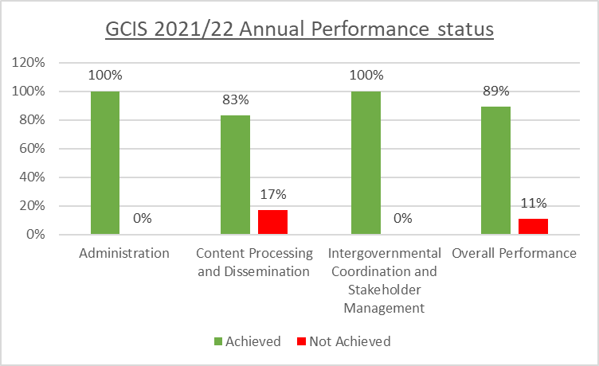

A detailed explanation of performance per programme is outlined herewith below:

The Administration programme had about 3 targets and managed to achieve 100 per cent. The Content Processing and Dissemination had a total of 23 targets with 83 per cent of the targets achieved. The Intergovernmental Coordination and Stakeholder Management programme had 12 targets and managed to achieve 100 per cent. Thus, there were 34 non-financial targets which were achieved.



**Programme 1: Administration**

The purpose of this Programme is to provide overall management and support for the Department. The Strategic Objective is to provide adequate and effective Corporate Services functions in pursuit of good governance.

*Key achievements under this programme include:* The GCIS compiled and submitted four QPRs in 2021/22 in line with the DPME's guidelines for the preparation of the QPRs (issued May 2021). All four QPRs were finalised within 30 days of the end of the quarter and presented actual performance information as validated by Internal Audit. The Annual Report for 2020/21 was completed and tabled in Parliament in September 2021. All reports against the APP and the approved annual operational plans (per Branch) are compiled using the Organisational Performance Management System (OPMS). The department managed to keep the vacancy rate below 10 per cent during the 2021/22 financial year and reduced the Top Management vacancy rate from 75 per cent in the 2020/21 financial year to 0 per cent in the 2021/22 financial year. The turnover rate decreased from 6.09 per cent in the 2020/21 financial year to 5.9 per cent in the 2021/22 financial year.

The department designated a number of posts to promote representativity to enhance the achievement of Employment Equity (EE) targets. This is achieved through targeted recruitment and partnership with institutions for persons with disabilities, youth organisations and institutions of higher learning. Nine (9) employees from designated groups were recruited during the reporting period. The national target of 2 per cent was achieved at 3.16 per cent, exceeding the national target by 1.16 per cent. Women's representation at the SMS level was achieved at 56 per cent.

It must be emphasised that the future GCIS will require a large capital budget to expedite digital transformation technologies and ensure that the department stays relevant, nimble and productive in the face of the 4IR regime and other shocks. To expedite digitisation/digital transformation and guarantee the GCIS remains relevant, flexible and effective under the 4IR regime, a digitised GCIS requires a significant capital input of roughly R39,9 million during the MTEF period.

The procurement plan quarterly progress reports were presented to National Treasury within the time frame. According to the GCIS manual B-BBEE figures, R250,155 million went to black-owned businesses, R76,278 million went to women-owned businesses, and R51, 693 million went to youth-owned companies out of total spending of R446, 774 million. The rural economy received R12, 225 million, and the township economy received R32, 010 million, respectively. After the year, 6 333 invoices to the value of R423,21 million out of the 6 607 invoices received were paid within 30 days, a rate of 95 per cent versus the aim of 100 per cent.

The GCIS IT Infrastructure was available in line with the required service levels maintained by the State Information Technology Agency. However, some incidents of downtime were experienced due to load shedding and vandalism. Some end-of-life servers and computers were also replaced during this period. The IM&T unit also ensured that all software licences were renewed, including the Microsoft Enterprise Agreement, security software, virtual meeting tools and the electronic forms design and workflow tool.

**Programme 2: Content Processing and Dissemination**

This Programme aims to provide strategic leadership in government communication to ensure coherence, coordination, consistency, quality, impact and responsiveness of government communication. The Strategic Objectives are (i) to produce government communication products and provide services to grow the share of voice of government messages in the public arena; (ii) to provide strategic leadership and support in government communication through public opinion research and analysis of media coverage to understand the communication environment and inform government messages; and (iii) to provide efficient and effective communication services.

*Key achievements under this programme include:* The Branch achieved annual targets under challenging conditions, which included increased workloads as the content focus broadened, financial constraints which threatened to morph from “more with less” to “less with less”, and shifts in staff levels as lockdown regulations governed office attendance. Coverage from the government news agency *www. sanews.gov.za* has been strategically focused on disseminating information related to the COVID-19 pandemic during the reporting period, keeping the public informed every step of the way on developments related to the pandemic.

*Vuk’uzenzele* is a government newspaper that focuses on communicating government programmes and policies, including socio-economic opportunities created by government programmes and how to access these opportunities. The newspaper is partly published in all official languages. It is a free publication published twice a month on the 1st and the 15th of each month, with the exception of December and January, which is published as one combined edition. It now carries paid-for public sector vacancies, tenders and notices. The newspaper is also published in Braille for visually impaired groups and individuals, with the web version of the newspaper available through the website catering to those with access to the internet. The newspaper can also be accessed by downloading the VukApp on a mobile phone.

The GCIS has adopted scientific communication methods to ensure that government messages resonate with South Africans. Research, media analysis, monitoring, and evaluation are part of a suite of tools used to inform communication strategies and campaigns. This includes providing content analysis reports for The Presidency, which has been at the forefront of communicating on the global pandemic.

During the period under review, the GCIS’s Research unit conducted a nationally representative quantitative research study in support of the COVID-19 integrated communication efforts. The study was conducted from 28 May to 30 June 2021 amongst 2 000 South Africans across all nine provinces. Findings from the research enabled the National COVID-19 Communication Committee (NCCC) to adopt the COVID-19 communication strategy based on identified needs and communication gaps of South Africans.

During the period under review, the Directorate: of Media Production continued to provide critical audio-visual support to The Presidency by documenting the work done by the two political principals per the Programme of Action (PoA). In addition, the unit was instrumental in extending the efforts by The Department of Health in the fight against COVID-19 through the implementation of a vaccine roll-out campaign encouraging citizens to get vaccinated.

48 clients approved 311 media-buying campaigns for various programmes and services in the 2021/22 financial year. The cost of advertising was R338 092 669,96, of which clients paid R269 329 596,69 and benefitted from R68 763 073,27 savings (average saving achieved was 20 per cent). Out of the 311 approved campaigns, 265 were implemented (85 per cent), 23 ongoing campaigns (7 per cent), 16 approved campaigns (5%) and six campaigns were cancelled (2 per cent).

The campaigns focused on the government’s response to COVID-19 and the benefits of getting vaccinated and various other initiatives and programmes/projects that promoted the ERRP, the fight against GBVF, recruitment and various other awareness campaigns focusing on educating citizens about government programmes.

Through the support given by Entity Oversight in the form of holding QPR sessions, DG/CEO engagements, CFO meetings and company secretaries’ meetings, the department seeks to ensure that there is governance and accountability; that boards are increasingly accountable for the financial and operational performance and repositioning of SOEs through governance agreements. The chief directorate has been monitoring the implementation of marketing, branding, and community media plans.

The engagements included holding QPR sessions, DG/CEO engagements, CFO meetings and company secretaries’ meetings. The purpose of these forums was to strengthen the oversight of the entities. These forums assisted in regulating the relationship between the Executive Authority and the entities, in particular outlining the principles and structures of how the Minister exercises oversight over the entities and how the entities comply with governance prescripts.

During the 2021/22 financial year, the Minister in The Presidency appointed and launched the inaugural B-BBEE MAC Sector Council. The primary function of the council is to ensure that transformation in the MAC sector (including JSE- listed companies) is promoted, monitored and reported through the Annual Transformation Report tabled before the Minister in The Presidency, the Department of Trade, Industry and Competition (the DTIC), the B-BBEE Commission and the Presidential Advisory Commission on B-BBEE.

**Programme 3: Intergovernmental Coordination and Stakeholder Management**

This programme aims to provide strategic leadership in government communication to ensure coherence, coordination, consistency, quality, impact and responsiveness of government communication.

*Key achievements under this programme include:*

The chief directorate managed to sustain weekly proactive media engagement activities focused on the thematic areas of GBVF, ERRP, anti-corruption and youth opportunities. In the period under review, intensive media engagement focused on preventing the spread of the COVID-19 virus and promoting the uptake of vaccines as the best preventative measure to fight the virus. Members of the media across both commercial and community sectors, as well as broadcast, print and online, made an immeasurable contribution to raising awareness of Vooma Vaccination weekends and covering numerous events of government and social partners, including webinars, in this national effort.

The Department established a solid partnership with the South African National Editors Forum (SANEF) and the National Press Club to promote COVID-19 awareness, ensure access for the media fraternity to vaccination and above all promote the importance of vaccination through various media channels. These included sustained and regular media briefings as well as themed Webinars which also attracted coverage from across the continent.

The Department coordinated initially daily but thereafter thrice weekly of the Communications Command Council (CCC on COVID-19) of all government communicators nationally and provincially reporting to the NCCC on the implementation of the communication strategy to fight COVID-19 and promote vaccination. Furthermore, prepared the development of all Communication Work stream reports to the Inter-Ministerial Committee (IMC) on Vaccination chaired by the Deputy President of the Republic Mr David Mabuza.

The Department provided ongoing media liaison services to the government by providing government information; establishing, strengthening and maintaining working relationships with foreign media and independent media; and establishing relations with South African missions and parliamentary stakeholders with the view of disseminating government information and key targeted messages. The department has successfully implemented a joint project to host the historic SoNA 2022 at the Cape Town City Hall following the devastating fire in Parliament.

The Department led the development of a comprehensive local Government Election (LGE) strategy and monitored its implementation thus resulting in the holding of a peaceful, free, fair and democratic LGE. GCIS has also coordinated and played an instrumental role in ensuring that issues of GBVF, the coordination of National Days for Nation Building and Social Cohesion were always on the radar. The Directorate has also strengthened the management of issues that have reputational implications on government work. This was achieved by mobilising all communicators in the government communication system. Through the adoption of online communication platforms such as Zoom or MS Teams daily, there is a significant increase in participation where robust discussions unfold. Integration of social media platforms to media engagement has increased reach as the Domestic Media Engagement directorate has live-streamed the majority of webinars and hosted Twitter spaces to expand the audience's reach of government messages.

**5.5 Overview of Financial Performance Information**

The GCIS was initially allocated R749.7 million for the 2021/22 financial year. During the 2021 Adjusted Estimates of National Expenditure (AENE), the appropriation was increased from R7.7 million to R757.4 million, with additional funds (R6.9 million) allocated for the improvement of conditions of service on levels 1-12 as well as a further R800 000 as self- financing expenditure in respect of the sale of advertising space in the *Vuk’uzenzele* newspaper.

Of the adjusted allocated budget, the GCIS spent R755 million (99.7 per cent) by 31 March 2022. An underspending of around R2.426 million (0.3 per cent) was realised. The underspending comprises of:

1. R752 000 in Compensation of Employees (CoE) due to the attrition of staff and vacant posts;
2. R713 000 in Goods and Services due to lesser recovery of self-financing expenditure in respect of the advertising of vacant posts in the *Vuk’uzenzele* newspaper; lower cost on Subsistence and Travelling; lower communication-related expenditure (telephones, data lines) and lower cost on operating payments;

R58 000 in Transfers and Subsidies due to lesser payments in respect of leave gratification as a result of resignations and retirement of former employees, as well as lesser payments than projected in respect of television (TV) licences; R1.017 million under capital assets due to non-delivery of equipment by suppliers; Theft and losses of R114 000 is funded from Goods and Services.

The GCIS continues to adhere to sound financial management principles stipulated in the PFMA of 1999 and National Treasury Regulations. To ensure that the GCIS maintains sound financial governance that is client-focused and responsive to the overall operating environment, the financial policies are reviewed at least every second year to ensure that they comply with the PFMA of 1999 and National Treasury Instructions and prescripts. When required, updates are made from time to time within the two years.

Financial policies and related amendments are made available to all GCIS staff. In between, financial circulars are issued to staff from time to time as guided by the National Treasury and the Department of Public Service and Administration (DPSA).

**5.6 Program Expenditure**

**The spending trend per programme is as follows:**

|  |  |  |  |  |
| --- | --- | --- | --- | --- |
| **Programme Name** | **2021/22** | | | |
| **Final Budget** | **Final**  **Expenditure** | **% Variance (Underspending)** | **Variance (Underspending)** |
| **R’000** | **R’000** | **%** | **R’000** |
| **Administration** | 190 122 | 189 482 | 99,7% | 640 |
| **Content Processing and Dissemination** | 441 387 | 440 069 | 99,7% | 1 318 |
| **Intergovernmental Coordination and Stakeholders Management** | 125 921 | 125 453 | 99,6% | 468 |
| **Total** | **757 430** | **755 004** | **99,7%** | **2 426** |

Part of the budget which was not spent was due to the non-delivery of the computers because of the delays as they were being shipped from overseas. There was also part for the money which could not be spent due to lack of traveling during the pandemic. The Department continues to adhere to sound financial management principles as stipulated in the PFMA of 1999 and National Treasury Regulations. To ensure that the Department maintains sound financial governance that is client-focused and responsive to the overall operating environment, the financial policies are reviewed at least every second year to ensure that they comply with the PFMA and National Treasury instructions and prescripts.

**5.7 AGSA Report**

According to AGSA, GCIS regressed in terms of material non-compliance in SCM, which affected the audit report (Extension and expansion of panels of service providers). As confirmed by National Treasury, management should have followed a competitive bidding process. AGSA indicated that management should adhere to SCM principles and processes, a good review of SCM processes and proper recording keeping to ensure documents are easily accessible and available when requested. GCIS had set 38 annual targets, of which 34 (89 per cent) targets were achieved. The programme's scope was programme 2: Content Processing and Dissemination, of which (19/23) 83 per cent of the planned targets were achieved or over-achieved. No material findings were identified.

**5.8 MDDA**

The Agency was set up in terms of the MDDA Act of 2002 to enable historically disadvantaged communities and individuals to access the media. The mandate of the agency is to encourage access to media by Historically Diminished Groups as well as by historically diminished indigenous language and cultural groups; encourage the development of human resources and training and capacity building, within the media industry, especially amongst historically disadvantaged groups; encourage channelling of resources to the community and small commercial media sector, and raise awareness about media development and diversity issues and support initiatives which promote literacy and a culture of reading.

The enabling legislative environment and the positioning of the Agency in the Ministry in the Presidency have strengthened the relevance of its value proposition. The new democratic South Africa recognises the urgent and critical need for transforming the media environment based on the key principle of freedom of expression, a right enshrined in our new Constitution.

In addition, media diversity and the invaluable role of the media in ensuring access to information were, from the start, cornerstones of our democracy. The importance of community media cannot be underestimated. Though they usually reach a smaller audience/readership, their capacity to offer a targeted platform for under-represented groups is a valuable tool for social participation. Despite all the challenges the community media sector faces, civil society, government, and stakeholder groups still see the need to build a thriving community and small commercial media sector.

**5.8.1 Performance Highlights**

The MDDA reports against the Annual Performance Plan of 2021/2022 as tabled in Parliament on 24 March 2021. The Annual Performance Plan was developed to effect the MDDA Five-Year Strategic Plan for 2020/2021 - 2024/2025, which was tabled on 18 March 2020. The Strategic Plan and Annual Performance Plan have been developed in terms of the Revised Framework for Strategic Plans & Annual Performance Plans as per National Treasury Instruction No 5 of 2019/2020. The 2021/2022 MDDA Annual Performance Plan has five programmes, with a total of twenty-two output indicators. There following are programmes as part of the mandate of the entity:

* Programme 1 - Governance and Administration;
* Programme 2 - Grant and Seed Funding;
* Programme 3 - Partnerships, Public Awareness and Advocacy;
* Programme 4 - Capacity Building and Sector Development; and
* Programme 5 - Innovation, Research and Development.

The graph below is the graphical highlights the performance of the entity for the year under

review:

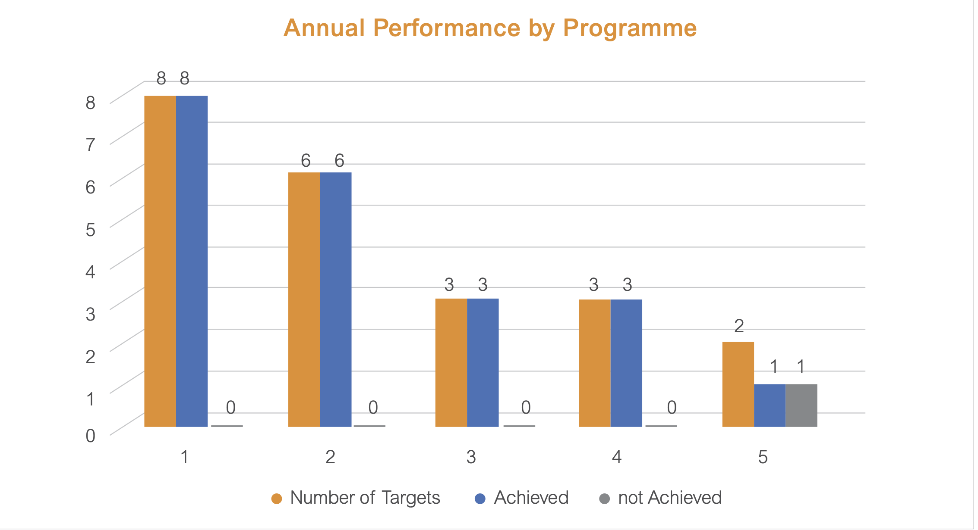

The MDDA achieved the targets for twenty-one (95 per cent) of the twenty-two output indicators included in its Annual Performance Plan for 2021/2022, with one target not achieved. The output indicator that was not achieved fell under. Programme 5 - Innovation, Research and Development - Output Indicator No 21: Number of Research projects funded on key trends/developments impacting the community media sector. There was a procurement delay which resulted in the project starting late. The unit met with Redflank on the 24th of March 2022, and after that, the service provider commenced with a mapping exercise and engagements with stakeholders. Currently, the service provider is preparing data collection instruments. The unit requested the service provider to expedite data collection and assign more human resources for this assignment to complete the project in time. This project will be achieved during the 2022-23 financial year.

**5.8.2 Service Delivery Environment**

The Strategic Plan of the MDDA is informed by the following:

* The socio-political and economic environment prevailing in South Africa
* The National Development Plan (NDP) and macro environment
* The community media sector and the broader media environment in the print, broadcast, and digital platforms
* Relevant legislation: direct and indirect

A Glass Ceilings study in 2018, jointly conducted by Gender Links and SANEF and supported by the MDDA, highlights that inequality and inequity persist while the media industry is changing with more women in senior roles. While South Africa does boast notable media exceptions, it cannot be denied that women are still under-represented in the media, both at senior levels, from ownership and Board level to station management and editors, and in the newsroom. Supporting women-owned and managed community media projects must be a focus area of the MDDA in delivering its mandate.

The COVID-19 pandemic brought digital inequality into stark relief, highlighting the urgency with which digital inequality needs to be addressed to improve economic participation by the majority of South Africans (especially in rural areas) and prepare the country for the next inevitable disaster or pandemic. South Africa still has an urban-rural divide on media consumption, particularly as many people remain offline due to high data costs. A current key challenge for the MDDA’s community and small commercial media is how to harness the advantages of both the digital era and, going forward, 4IR and how to lessen the impact of the digital dividend on communities. The MDDA’s role is vital before, during, and after migration to ensure that community media’s interests are identified, fought for, and maintained. This means that traditional forms of community media (print and broadcast) need more support in an ever-changing landscape that includes stiff competition from online media, including social media. But online media is not the all-encompassing panacea for exclusion from the information.

In the period in review, the economic environment was characterised by low levels of GDP growth. This was further exacerbated by the COVID-19 pandemic and its devastating effect on all economic sectors. A lack of economic growth impacted the community media revenue as some of its major customers were affected by a decline in sales revenue and the need to cut costs and retrenchment a current reality. The MDDA’s role is to assist the community media sector in finding more affordable means of broadcasting/publishing by, for example, moving to self-transmission or digital platforms.

The NDP Five Year Implementation Plan for the priorities outlined in the Electoral Mandate targets a just transition to a low carbon economy and reducing climate change costs to the GDP to less than 5 per cent by 2024; reduced vulnerability of key sectors to climate change; and reduction of total greenhouse gas (GHG) emissions in South Africa. The MDDA has a major role in promoting and supporting these global and national initiatives in its messages and technologies and those of its beneficiaries, promoting recyclable and environmentally friendly technologies and discouraging unfriendly environmental practices.

The Universal Declaration of Human Rights provides a fundamental guarantee of the right to freedom of expression, which encompasses the freedom of the media, while, at the national level, the South African Constitution (1996) represents some of the most progressive modern constitutional thinking on media freedom. However, for a truly enabling environment to be provided in which community-based media can flourish, other statutory instruments are required. The MDDA, therefore, has a vital role in ensuring that such statutory instruments are passed, for example regulating the 30 per cent advertising spent by Government on community-based media and providing input into regulations for digital radio and online media in general.

The MDDA expected its beneficiary projects to adhere to the Press Code and includes it as a focus area in its capacity-building and training initiatives. The advent of social media has also brought about the threat of cyberbullying and, acutely felt by women, cyber misogyny. While media literacy has been a focus area of the MDDA in the past, digital media literacy is a growing concern. The MDDA and the community-based media sector must play a more significant role in educating and sharing knowledge with communities on the ethics of social media.

**5.8.4 Financial Performance**

The Agency reported against the APP of 2021/2022 as tabled in Parliament on 12 May 2021. The APP was developed to effect the Agency’s 5-Year Strategic Plan for 2021/2022 - 2024/2025, which was also tabled on 18 March 2020. Both the Strategic Plan and APP have been developed in terms of the Revised Framework for Strategic Plans & Annual Performance Plans as per National Treasury Instruction No 5 of 2019/2020.

The table below describes the revenue versus expenditure patterns of the Agency during the financial year under review.



The 2021/22 funding was sourced as follows: (i) broadcasters funded 58 per cent of the budget; government grant was 38 per cent; and interest on investments of 4 per cent. There was a rollover of R14 million which was approved by the National Treasury and therefore the entity managed to break even.

**5.8.5 Auditor-General**

MDDA attained an unqualified audit opinion in the 2021/22 financial year. Material findings were on: Noncompliance with laws and regulations. It's currently in contestation with the office of the Auditor General. The Audit Improvement Plan is in place to correct the audit findings and improve internal controls.

The AGSA expressed that the financial statements submitted for auditing were not fully prepared in accordance with the prescribed financial reporting framework, as required by section 55(1)(a) and (b) of the PFMA. Material misstatements of current liabilities and revenue from non-exchange identified by the auditors in the submitted financial statement were corrected, resulting in the financial statements receiving an unqualified audit opinion.

AGSA further noted that management did not implement proper record-keeping promptly to ensure that complete, relevant and accurate information is accessible and available to support financial and performance reporting. Management did not prepare regular, accurate and complete financial and performance reports supported and evidenced by reliable information.

The agency had 16 planned targets and managed to achieve 95 per cent (16) of the annual targets for its key performance indicators for 2021/22. This is an increase of 6 per cent over the previous year and the best performance of the Agency over the past seven financial years. The remaining target of the sustainability model could not be completed due to delays in procurement.

The Agency achieved a clean audit; see the chart below:

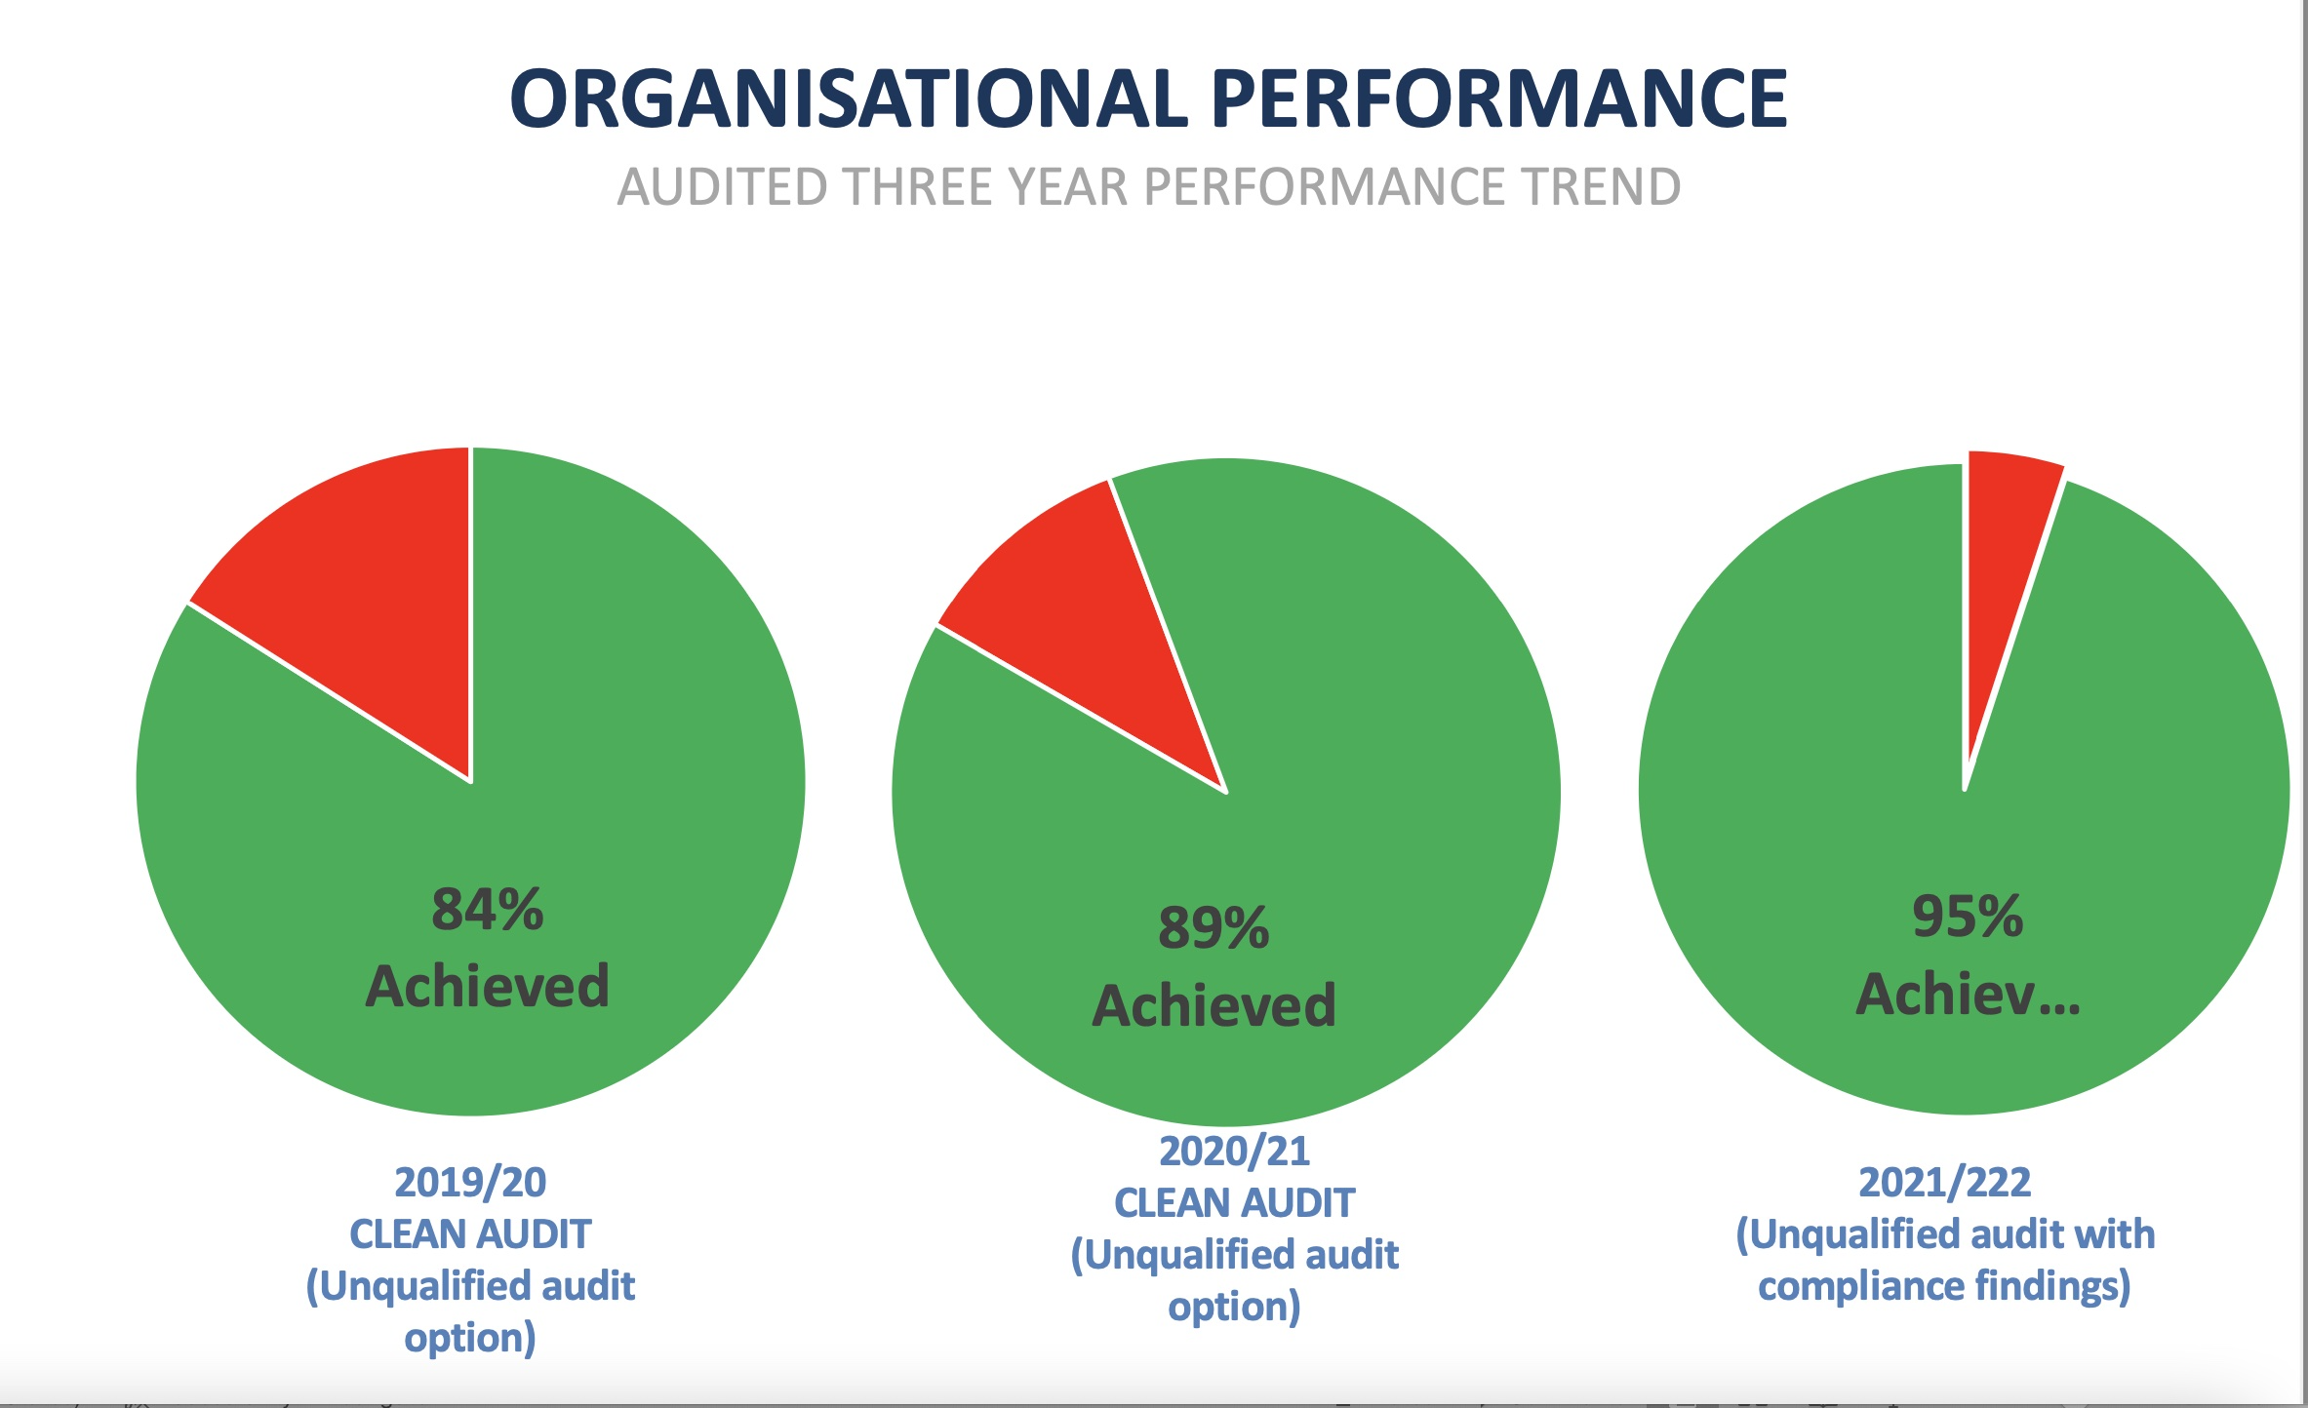

**6. Standing Committee on Appropriations (SCOA)**

The Department did not appear before SCOA.

**7. Standing Committee on Public Accounts (SCOPA)**

The Department did not appear before SCOPA.

**8. Committee observations**

**8.1 The Department**

The Committee noted and commended the Department:

1. it commended the performance of the Department for the good work done in the period under review;
2. the Department achieved an 89 per cent performance which amounts to 34 targets achieved out of 38 planned targets, and spent 99.7 per cent of the allocated budget for the 2021/22 financial year;
3. the Department received an unqualified audit opinion with a material finding;
4. the Department played a key role during the COVID-19 pandemic, which must be commended.
5. the Department included a total increase of women employed in the Department;
6. the vacancy rate was at 6.7 per cent, and that the Department had reduced the Top Management vacancy rate from 75 per cent in the 2020/21 financial year to 0 per cent in the 2021/22 financial year;
7. women’s representation at the SMS level was achieved at 56 per cent;
8. the Department has an ageing IT infrastructure which affects the performance of the entity;
9. its appreciation that the Department won an award for vaccine information and commended the Department for playing a key role during the beginning of COVID-19;
10. that it required clarity on the position of non-operational equipment in respect of its studios within Parliament precincts;
11. it is expected that the Department achieve a clean audit in the next year; and
12. that the Department noted its concern in respect of the resources and funding and requested that the Committee assist in the process of ensuring that funding was obtained.

**8.2 MDDA**

The Committee noted and commended the Agency for the following:

1. it commended the MDDA for the presentation and its performance;
2. the MDDA attained an unqualified audit in the financial year under review;
3. the material findings were on non-compliance with how the EDF money came from the competition commission which was allocated to MDDA as an implementation agency;
4. it congratulated MDDA for celebrating 20 years of operation and noted that the entity should ensure they its work does not become obsolete;
5. that it was also vital for the entity to move with the times and become relevant within the market;
6. it required clarity in respect of the role of Sentech and MDDA to aid in the community radio payment of fees;
7. its concern that approximately R33 million was spent on overhead costs for employees; and
8. that there was a need to ensure that community radio stations become self-sustainable.

**9. Recommendations**

In relation to the Department and MDDA, the Committee resolved that the Minister should:

1. ensure that the internal controls are in place to meet the requirements as laid out by the Auditor General;
2. ensure that the Department IT infrastructure is upgraded for accurate record-keeping and ensure effective communication with the rest of the citizens;
3. ensure that the Draft Media Development and Diversity Agency (MDDA) Amendment Bill is finalised;
4. ensure that processes are in place for radio stations to become self-sustainable;
5. ensure that the outstanding transmission cost between Sentech and Community Radio Stations is addressed;
6. ensure that the Department and MDDA comply with all findings made by the Auditor General;
7. that the Committee ensures that the Department receives funding assistance to prevent the collapse of the Department; and
8. that members of the Committee take the issue of funding to their caucuses and request assistance for the Department.

**Report to be Considered.**

1. *National Budget 2021 – Estimates of National Expenditure*