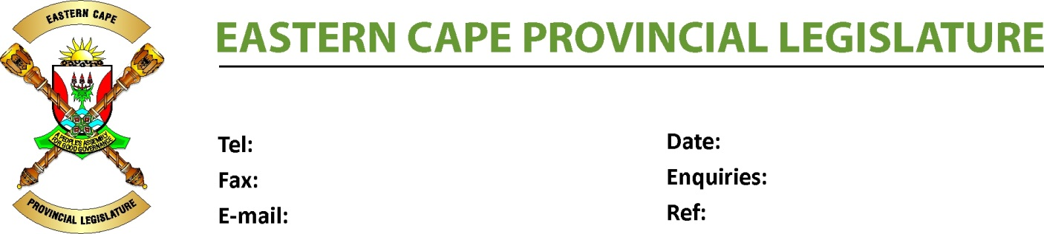
PORTFOLIO COMMITTEE ON RURAL DEVELOPMENT AND AGRARIAN REFORM
Ms N. Stuurman
nstuurman@ecleg.gov.za

STAB, 2020

29 August 2022

086 645 9143
040 609 1638

NEGOTIATING MANDATE

To : The Chairperson
Select Committee on Land Reform,
Environment, Mineral Resources&Energy

Name of Bill : Sectional Titles Amendment Bill

Number of Bill : [B31B -2020]

Date of Deliberation : 29 August 2022
_____________________________________________________________________________________

- Vote of the Legislature

The province votes in favour of the Bill, with no proposed amendments and therefore mandates the Permanent Delegate to the NCOP to negotiate in favour of the Bill.

- General Comments

The report of the Portfolio Committee attached hereto highlights other issues raised by the stakeholders, relating to the Bill before the Portfolio Committee and are matters that ought to be given serious consideration by the Department of Agriculture, Land Reform and Rural Development.

29 August 2022
_________________ ________________
FD.BESE (MPL) DATE
CHAIRPERSON OF THE PORTFOLIO COMMITTEE ON RURAL DEVELOPMENT AND AGRARIAN REFORM

