Report of the Portfolio Committee on Higher Education, Science and Innovation on the consideration of the Financial and Non-Financial Performance of the 2021/22 Second and Third Quarters of the Department of Science and Innovation, Dated 15 June 2022

The Portfolio on Higher Education, Science and Innovation, having considered the Financial and Non-Financial Performance of the 2021/22 Second and Third Quarters of the Department of Science and Innovation, reports as follows:

- Introduction

Section 5 of the Money Bills Amendment Procedure and Related Matters Act (9 of 2009) (hereafter, the Money Bills Act), as amended by Act 13 of 2018, requires the National Assembly, through its committees, to annually assess the performance of each national department. This culminates in a committee submitting a Budgetary Review and Recommendation (BRR) Report where the committee may make recommendations on the forward use of resources to address the implementation of policy priorities and services, as the relevant department may require additional, reduced or re-configured resources to achieve these priorities and services.

To give effect to the requirement of Section 5 of the Money Bills Act, the Portfolio Committee on Higher Education, Science and Innovation (hereafter, the Committee), on 4 March 2022, considered the financial and non-financial performance of the 2021/22 second and third quarters of the Department of Science and Innovation (hereafter, the Department or DSI).

- 2021/22 Budget Allocation to Vote 35: Science and Innovation

The 2021/22 consolidated government expenditure for innovation, science and technology was R17.4 billion (R15.4 billion in 2020/21, revised estimate), which was 1% of the total Medium Term Expenditure Framework (MTEF) allocation and 8.4% of the consolidated economic development expenditure of R207.5 billion.

The Department’s 2021/22 budget allocation increased from R7.3 billion in the 2020/21 financial year to R8.9 billion. This represented, when adjusted for inflation, a real increase of 17.8% and closely returned the Department’s allocation to what it was in 2020 (R8.8 billion) before the budget cuts to meet the needs of the national COVID-19 response. In terms of economic classification, the apportionment of the Department’s 2021/22 budget allocation of R8.9 billion remained the same as in previous years and comprised Current payments of R566.5 million (6.3%), Transfers and subsidies of R8.4 billion (93.6%), which increased from R6.8 billion in 2020/21, and Payments for capital assets of R2.9 million (0.03%). The Department’s budget funds five major programmes, namely:

  - Programme 1 – Administration
  - Programme 2 – Technology Innovation
  - Programme 3 – International Cooperation and Resources
  - Programme 4 – Research, Development and Support
  - Programme 5 – Socio-economic Innovation Partnerships

These programmes fulfil the Department’s mandate of realising the full potential of STI in social and economic development. The percentage budget allocation to the Programmes remained essentially the same as in previous financial years and Programmes 2, 4 and 5 that are responsible for the Transfers to the Department’s entities, received 94.7% of the Department’s total budget allocation.

Notable changes in the allocations to Transfers and subsidies from 2020/21 to 2021/22 included:

  - The allocation for Innovation Projects research increased from R171.4 million to R503.3 million. This allocation supports innovation activities that aim to increase, commercialise and use publicly funded intellectual property.
  - The allocation for Science awareness and initiatives to encourage youth participation in science increased from R33.5 million to R91.6 million.
  - The allocation for the Square Kilometre Array’s (SKA) capital contribution to research increased from R456.6 million to R802.4 million. This is for the 20 antennae that will be added to the MeerKAT.
  - The allocation to the Council for Scientific and Industrial Research (CSIR): Mining research and development (R&D) increased from R41.7 million to R63.5 million.
  - The allocation to the CSIR: Cyberinfrastructure R&D increased from R60.2 million to R272.1 million. This is the next tranche of funding to enhance the National Integrated Cyberinfrastructure System, which is allocated R3.6 billion over the medium term.

The 2021/22 budget allocation seemed to restore partially, through these increased budget allocations, funding to some of the areas most affected by the COVID-19 budget cuts.

  - 2021/22 Adjusted Estimates of National Expenditure

The 2021 Medium-Term Budget Policy Statement (MTBPS) stated that the Department had reprioritised funds over the MTEF period to support technology localisation, beneficiation, advanced manufacturing and research by the National Research Foundation (NRF). The 2021/22 Adjusted Estimates of National Expenditure (AENE) showed that the Department’s budget allocation increased by R72.3 million to equal R9 billion. This increase comprised R67 million for Transfers and subsidies, R2.8 million for Current payments and R2.5 million for Payments for capital assets (Table 1).

Table 1: 2021/22 Adjusted Budget Summary for Vote 35: Science and Innovation
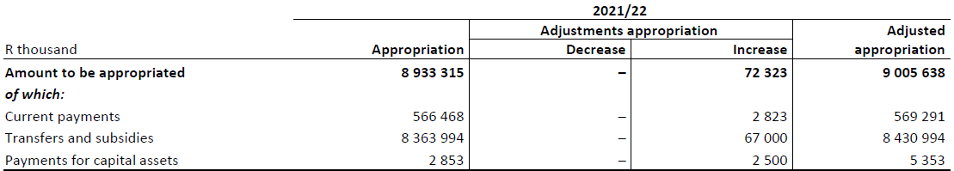
Source: National Treasury, 2021 Adjusted Estimates of National Expenditure.

The R67 million allocated for Transfers and subsidies formed part of the Presidential Youth Employment Intervention. Of this:

- R25 million was to provide training to 450 graduates and 50 community mentors as environmental champions to conduct door‐to‐door community education and awareness campaigns in partnership with the Duzi Umngezi Conversation Trust;
- R32 million was to appoint 900 unemployed graduates through the Water Research Commission’s water graduate employment programme, aimed at improving employment readiness in the water sector; and
- R10 million was to provide training to 250 graduates at the CSIR, to support the Council in various fields.

The remaining R5.3 million of the R72.3 million increase was allocated for higher salary increases than what the main budget provided for.

Significant virements and shifts were effected to meet South Africa’s obligations for the Square Kilometre Array’s capital contribution to research. These totalled R215.7 million and included:

- From Programme 2: R70 million from the Technology Innovation Agency (TIA) and R5.7 million from the Green Nano Chemistry and Nano Medicine Platforms; and
- From Programme 4: R105 million shifted within the NRF and R35 million from the CSIR’s Cyberinfrastructure R&D.

Other significant virements and shifts included:

- R33.9 million shifted from the Medical Research Council to the Network for Genomic Surveillance and mRNA technology transfer hub within Programme 2;
- R30.9 million shifted from TIA to the South African National Space Agency for the Space Weather Centre;
- R20 million shifted within the NRF for human resource development at the Centres of Excellence;
- R25.9 million from the NRF to Programme 5 for Innovation for inclusive development; and
- R38.6 million from the CSIR to the Technology Stations Programme.

The 2021/22 AENE stated that the Department’s entities spent more of their ring‐fenced funds in 2021/22 for projects undertaken on behalf of the Department than they did in 2020/21, resulting in fewer surplus funds being surrendered to the Department.

  - 2021/22 Second Quarter (July to September 2021) Financial Performance

At the end of the second quarter, the Department had spent R4.6 billion (51.6%) of the available budget of R8.9 billion (Table 2). The Department planned to spend R5.7 billion. The R1 billion variance was mainly due to the slow processing of transfer payments and delays in project payments due to administrative delays and the late submission of progress reports by the Department’s entities and various service providers. All Programmes spent less than they planned to. The Department spent R5.1 million on COVID-19 related initiatives, comprising mostly consumables such as sanitisers, sanitiser dispensers and masks.

At the end of the second quarter, the Department had 384 staff against 457 funded posts, resulting in 73 vacancies. Spending on compensation of employees amounted to R163.5 million against projected expenditure of R179 million.

Table 2: Vote 35: Science and Innovation – Budget and expenditure summary at end-September 2021
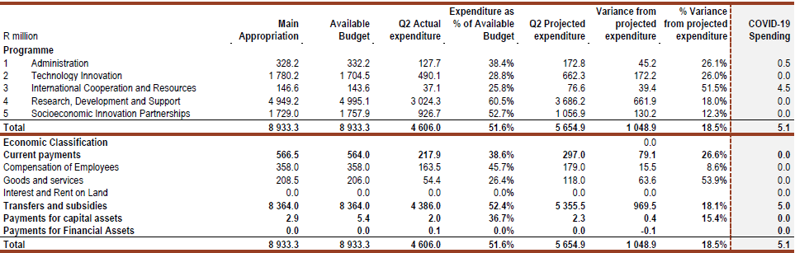
Source: National Treasury, 2021/22 2nd Quarter Expenditure Report to the Standing Committee on Appropriations.

Programme 1: Administration: Expenditure amounted to R127.7 million of the available budget of R332.2 million. The lower than anticipated spending was mainly on goods and services, particularly on items such as travel and subsistence, and venues and facilities.

Programme 2: Technology Innovation: Expenditure amounted to R490.1 million of the available budget of R1.7 billion. The lower than anticipated spending was mainly due to delayed payments on transfers and subsidies for the Bio-Economy Strategy that emanated from the late submission of supporting documents and financial statements by the implementing body.

Programme 3: International Cooperation and Resources: Expenditure amounted to R37.1 million of the available budget of R143.6 million. The lower than anticipated spending was mainly due to delayed payments on transfers and subsidies for Africa multilateral agreements and global science international resources because contracts were still being finalised.

Programme 4: Research, Development and Support: Expenditure amounted to R3 billion of the available budget of R5 billion. The lower than anticipated spending was mainly due to delayed payments on transfers and subsidies for research and development infrastructure.

Programme 5: Socioeconomic Innovation Partnerships: Expenditure amounted to R926.7 million of the available budget of R1.8 billion. The lower than anticipated spending was mainly due to delayed payments on transfers and subsidies for the Technology Localisation Implementation Unit (TLIU) and the Technology Stations Programme (TSP) because the implementing agency did not submit, within the stipulated timeframe, an annual financial report for the funds to be disbursed.

  - 2021/22 Second Quarter (July to September 2021) Non-Financial Performance

During the period under review, the total number of planned output targets was 31. The Department achieved 81% (25) and did not achieve 19% (6) of the planned output targets.

Programme 1 with 4 targets achieved 75% (3) and did not achieve 25% of these targets.
Programme 2 with 2 targets achieved 100% of these targets.
Programme 3 with 8 targets achieved 88% (7) and did not achieve 12% of these targets.
Programme 4 with 10 targets achieved 80% (8) and did not achieve 20% of these targets.
Programme 5 with 7 targets achieved 71% (5) and did not achieve 29% of these targets.

During the second quarter, the Department mainly ascribed the non-achievement of targets to:

Process delays – 4 targets – where the achievement of targets are dependent on factors that are outside the control of the Department;
Target formulation deficiencies -1 target - where targets were not achieved because of variables that were not foreseen during the target formulation phase; and
Ineffectiveness of implementers – 1 target – where targets were not achieved due to deficiencies during the implementation phase.

  - 2021/22 Third Quarter (October to December 2021) Financial Performance

At the end of the third quarter, the Department had spent R6.7 billion (75%) of the available revised budget of R9 billion (Table 3). The Department planned to spend R7 billion. The R264.8 million (3.8%) variance was mainly due to lower spending on transfers and subsidies within the Administration and Technology Innovation programmes. The Department spent R41.1 million on COVID-19 related initiatives, comprising mostly consumables such as sanitisers, sanitiser dispensers and masks.

At the end of the second quarter, the Department had 383 staff against 457 funded posts, resulting in 74 vacancies (16% and one more vacancy than the second quarter). Spending on compensation of employees amounted to R247.8 million against projected expenditure of R363.3 million.

Programme 1: Administration: Expenditure amounted to R203.9 million of the available budget of R334.7 million. The lower than anticipated spending was mainly on goods and services, particularly on items such as travel and subsistence, and venues and facilities.

Programme 2: Technology Innovation: Expenditure amounted to R1.2 billion of the available budget of R1.7 billion. The lower than anticipated spending was mainly due to delayed payments on transfers and subsidies for services regarding the replacement of the billboard screen at the Department’s offices and for the relocation of officials from Belgium back to South Africa.

Programme 3: International Cooperation and Resources: Expenditure amounted to R72.9 million of the available budget of R144.4 million. The lower than anticipated spending was mainly due to delayed payments on transfers and subsidies under the Global Science Project - Africa Multilateral Agreements flagship project, as some contract agreements were still at the drafting stage.

Table 3: Vote 35: Science and Innovation – Budget and expenditure summary at end-December 2021
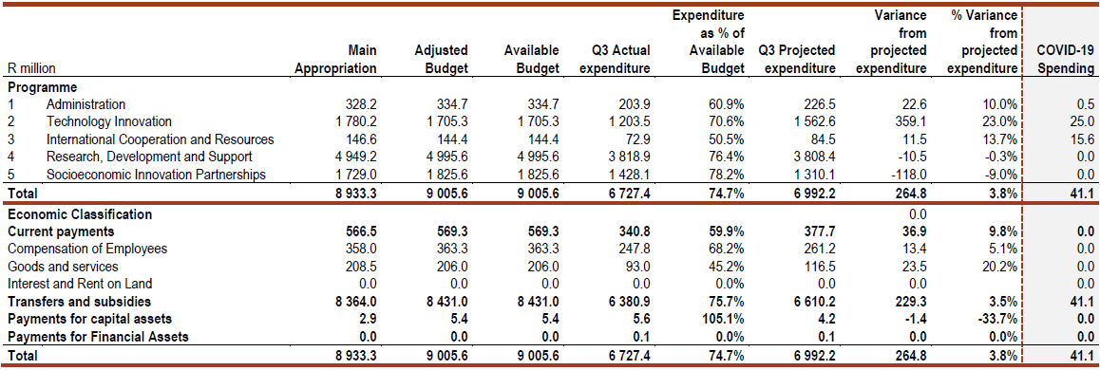
Source: National Treasury, 2021/22 3rd Quarter Expenditure Report to the Standing Committee on Appropriations.

Programme 4: Research, Development and Support: Expenditure amounted to R3.8 billion of the available budget of R5 billion. The slight increase in spending was mainly due to delayed payments on transfers and subsidies for the Southern Ocean Carbon and Climate Observatory project, as the implementing agency’s deliverables did not meet the 90% threshold on spending as required by the Department to disburse funds for the continuation of the project.

Programme 5: Socioeconomic Innovation Partnerships: Expenditure amounted to R1.4 billion of the available budget of R1.8 billion. The increase in spending was mainly due to transfers and subsidies for the Local Manufacturing Capacity, Resource-based Industries and the Science and Technology Indicators projects. These were paid later due to contracting processes that were not finalized on time and because the financial reports did not reflect a 90% threshold on spending as required by the Department to disburse funds for the continuation of the project.

  - 2021/22 Third Quarter (October to December 2021) Non-Financial Performance

For the period under review, the total number of planned output targets was 32. The Department achieved 69% (22) and did not achieve 31% (10) of the planned output targets.

Programme 1 with 3 targets achieved 67% (2) and did not achieve 33% of these targets.
Programme 2 with 5 targets achieved 80% (4) and did not achieve 20% of these targets.
Programme 3 with 9 targets achieved 67% (6) and did not achieve 33% of these targets.
Programme 4 with 8 targets achieved 75% (6) and did not achieve 25% of these targets.
Programme 5 with 7 targets achieved 57% (4) and did not achieve 43% of these targets.

To summarise, the Department achieved 73% of its targets during the first quarter, 81% of its targets during the second quarter and 69% of its targets during the third quarter. During the third quarter, acknowledging the negative trajectory of its non-financial performance, the Department mainly ascribed the non-achievement of targets to:

Process delays – 9 targets – where the achievement of targets are dependent on factors that are outside the control of the Department; and
Target formulation deficiencies -1 target - where targets were not achieved because of variables that were not foreseen during the target formulation phase.

- Committee Observations

  - The Committee noted the DSI’s input on their non-achievement of targets and expressed concern about the increased number of targets that were not met during the third quarter.
  - The Committee was concerned about the underexpenditure in certain Programmes, especially since the Committee constantly advocates for increased funding for the DSI.
  - The Committee cautioned against the constant use of virements across Programmes and stated that it was an indication of poor planning.
  - The Committee noted the DSI’s invitation to visit BIOVAC where the Committee would also receive an update briefing on the current developments with the programme to manufacture locally vaccines.
  - The Committee expressed interest in DSI’s Indigenous Knowledge Bioprospecting and Product Development Platform.
  - The Committee raised concern about the slow and or non-uptake of DSI innovations by other government departments and the private sector.
  - The Committee expressed interest in the assistance available to inventors in taking products to market (commercialisation).
  - The Committee enquired about the challenges at the Technology Innovation Agency and what had been resolved to date.
  - The Committee enquired about the DSI’s vacancy rates, as well as the current recruitment plan.

- Recommendations

Having considered the Department’s financial and non-financial performance for the 2021/22 second and third quarters, the Committee recommended that:

  - The Department submit written responses to the questions that were not adequately answered. These included the:
    - Plan of action regarding performance, as well as the repeat offenders in terms of targets not being met due to the unavailability of verification documentation.
    - Audit Action Plan, with timeframes and mitigation actions.
    - Vacancies and recruitment plan.
    - Details of irregular expenditure, as well as consequence management actions.
    - The Youth and Women Procurement Strategy and the challenges experienced therewith.
    - The decline from quarter’s two to three in the number of postgraduate students supported.

  - The Department provide the Committee with the outstanding responses from previous engagements as a matter of urgency.

Report to be considered

