**Report of the Select Committee on Health and Social Services on Budget Vote 19, the Annual Performance Plans of the Department of Social Development and its entities for 2022/23 Dated 03 May 2022**

The Select Committee on Health and Social Services (henceforth, the Committee) having considered and deliberated on the Budget Vote, the Annual Performance Plans of the Department of Social Development (henceforth, the Department), the South African Social Security Agency (SASSA) and the National Development Agency (NDA) on 26 April 2022 and 03 May 2022, wishes to report as follows:

1. **INTRODUCTION**

Section 5(2) of the Constitution of South Africa (No. 108 of 1996) and Section 27(4) of the Public Finance Management Act (No.1 of 1999) set out the role of Parliamentary Committees in conducting oversight over government departments and entities.

As part of conducting Parliamentary oversight, Committees have the constitutional mandate to scrutinise and approve the budgets of the Executive. In this regard, the Committee considered the Annual Performance Plans (APPs) and budget allocation of the Department of Social Development and its entities.

This report summarises a presentation received from the Department and its entities on the Annual Performance Plans and Budget for the 2022/23 financial year and allocations over the Medium-Term Expenditure Framework (MTEF) period. The report entails the deliberations, observations and recommendations made by the Committee relating to Budget Vote 19.

1. **DEPARTMENT OF SOCIAL DEVELOPMENT ANNUAL PERFORMANCE PLAN (2022/2023)**

**2.1 The Mandate, Vision, Mission, of the Department**

The Department aims to help improve the lives of the poor and vulnerable by fulfilling the following:

* Reducing the levels of poverty, inequality, vulnerability and social ills;
* Empowering individuals, families and communities; and
* Having a functional, efficient and integrated sector.

The Department envisions a “caring and self-reliant society”.

The mission of the Department is to transform society by building conscious and capable citizens through the provision of comprehensive, integrated and sustainable social development services.

**2.2 Policy Priorities for 2022/23 Financial Year**

The policy priorities of the Department are aligned with Section 27(1)(2) of the Constitution of the Republic of South Africa. The Constitution gives effect to the right of everyone to have access to: *(a) health care services, including reproductive health care; (b) sufficient food and water; and (c) social security, including if they are unable to support themselves and their dependents, appropriate social assistance.*

In addition, the policy priorities of the Department are in line with the aspirations of the National Development Plan (NDP): Vision 2030, Medium Term Strategic Framework (MTSF), United Nations (UN) Sustainable Development Goals (SDGs), African Union (AU) Agenda 2063, and 2022 State of the Nation Address (SONA). As shown in Figure 1, these entail the following:

Priority 2 – Economic transformation and job creation;

Priority 3 - Education, skills and health;

Priority 4 – Consolidating the social wage through reliable and quality basic services; and

Priority 6 – Social cohesion and safe communities.

**Figure 1: Selected MTSF 2019-24 priorities related to Social Development sector**

The Department has a direct responsibility of realising or ensuring the following:

* Implementing the National Strategic Plan to eradicate Gender-Based Violence and Femicide (GBVF).
* Improving the optimisation of social welfare services.
* Optimising the social security legislative framework and develop appropriate norms and standards for service delivery.
* Optimising the non-profit organisations legislative framework to promote good governance and accountability.
* Promoting vibrant and sustainable communities.
* Improving household food security.

## BUDGET ANALYSIS FOR 2022/23

## The Social Development sector provides social protection services and leads government efforts to forge partnerships through which vulnerable individuals, groups and communities become capable and self-reliant participants. This mandate is realised through the following five (5) budgeted programmes: Administration (Programme 1); Social Assistance (Programme 2); Social Security Policy and Administration (Programme 3); Welfare Services Policy Development and Implementation Support (Programme 4); and Social Policy and Integrated Service Delivery (Programme 5).

The total budget allocation of the Department is R257.0 billion for the 2022/23 financial year, which is a nominal increase of R23.27 billion (or 10 per cent) compared to the R233.7 billion adjusted budget for 2021/22.

**Table 1: Overall budget allocation to the Department and its programmes for the 2022/23 financial year**

|  |  |  |  |  |  |  |
| --- | --- | --- | --- | --- | --- | --- |
| PROGRAMME | BUDGET | | NOMINAL ↑ OR ↓ | REAL ↑ OR ↓ | NOMINAL % CHANGE | REAL % CHANGE |
| R million | **2021/22** | **2022/23** | **2022/23** | **2022/23** | **2022/23** | **2022/23** |
| Programme 1 | 417,9 | 423,6 | 5,7 | - 12,5 | 1,36% | -3,00% |
| Programme 2 | 224 542,2 | 248 294,6 | 23 752,4 | 13 060,3 | 10,58% | 5,82% |
| Programme 3 | 8 077,5 | 7 614,5 | - 463,0 | - 790,9 | -5,73% | -9,79% |
| Programme 4 | 304,0 | 309,1 | 5,1 | - 8,2 | 1,68% | -2,70% |
| Programme 5 | 385,9 | 359,6 | - 26,3 | - 41,8 | -6,82% | -10,83% |
|  |  |  |  |  |  |  |
| TOTAL | 233 727,5 | 257 001,4 | 23 273,9 | 12 206,9 | 10,0% | 5,22% |

Figure 1 illustrates how the Department’s budget allocation is affected by the inflation rate of 4.5% for 2022/23 financial year.

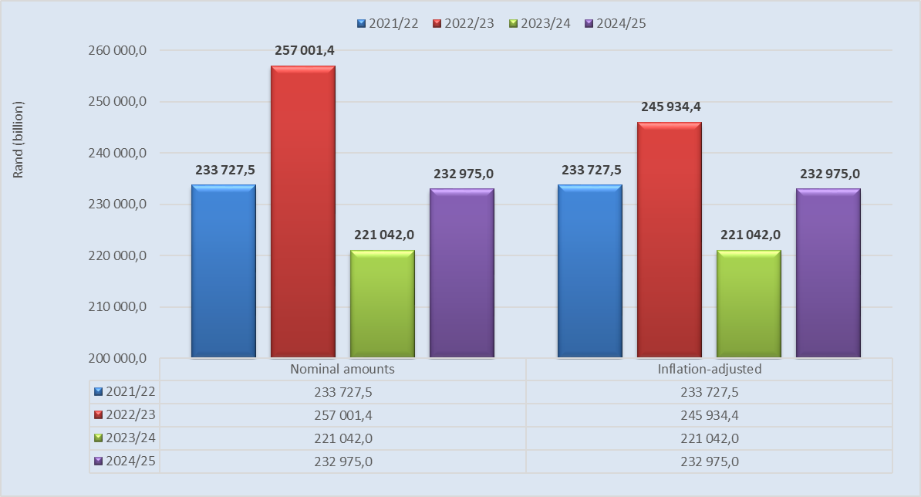**Figure 1: Department’s budget over the medium term in nominal and real (Inflation Rate: 4.5%)**

Figure 2 compares the Department's budget allocation on specific line budget line items according to economic classifications. As shown in Figure 2, a large proportion of the Departmental budget goes to transfers and subsidies to the value of R232.79 billion (which is 99.6 per cent of the total departmental budget). This is followed by current payments to the value of R922.3 million (0.36 per cent of the total departmental budget) and payment of capital assets to the value of R12.5 million (0.01 per cent).

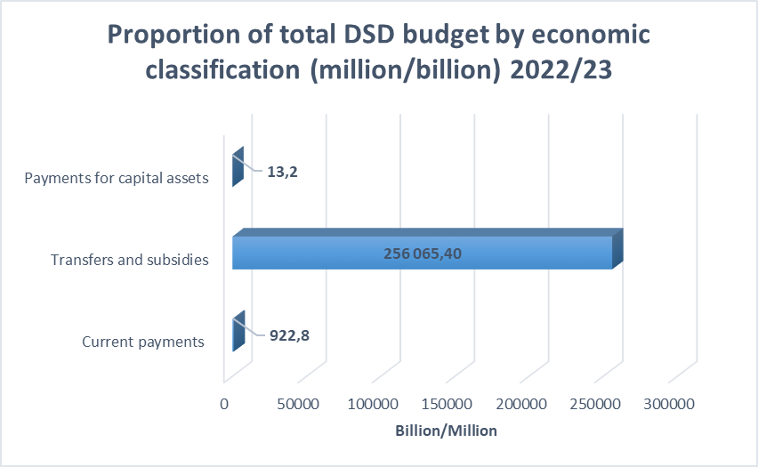**Figure 2: Proportion of the Department’s budget spent on specific line items according to economic classification**

The *current payments* budget shows a real increase half a million rand between 2021/22 and 2022/23 financial years. The current payments totals R922.3 million, of which:

* Compensation of Employees receives R507.3 million, compared to R516.7 million previously. It declines with -1.8% from the previous year, whist Goods and Services increase in real terms with 2.4%.
* Goods and Services receives R415.5 million in 2022/23 compared R405.6 million previously.

The *payment of capital assets* budget shows a nominal increase of R700 thousand (5.60%). It increases from R12.5 million in 2021/22 to R13.2 million 2022/23 financial year. Of this amount, R12.5 million (96.2% of the total budget of this line item) is allocated to machinery and equipment, with the remaining allocated to software and other intangible assets.

There is a notable increase in both nominal and in real rand value for transfers and subsidies line item. It increases from R232.79 billion in 2021/22 to R256 billion in 2022/23 year. The budget increases in this line item are driven by the following:

* *Households:* there is a notable real budget increase from an adjusted R224.54 billion in 2021/22, to R248.3 billion in 2022/23.
* *Non‐profit institutions:* payments to this line item show a real increase from an adjusted R29.7 million in 2021/22, to R44 million in 2022/23.

1. **BUDGET AND ANNUAL PERFORMANCE TARGETS PER PROGRAMME**

**4.1 Budget allocations per programme**

The proportional allocations per main programme between the 2021/22 adjusted budget and 2022/23 voted funds are shown in Figure 3. This excludes Programme 2 (Social Assistance), which is managed by the South African Social Assistance Agency (SASSA) in paying out social grants.

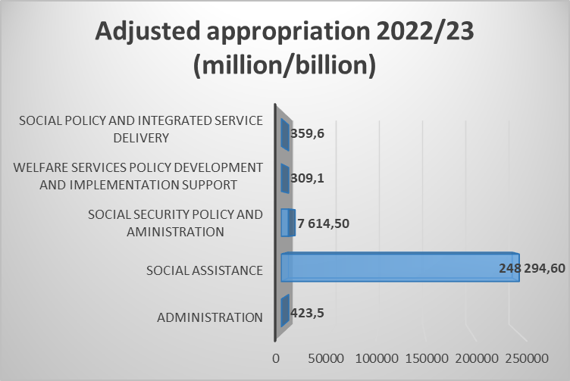**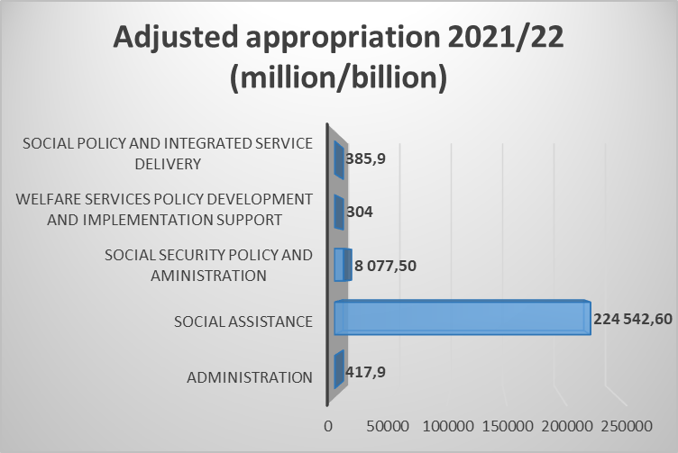Figure 3: Comparison of budget allocation between the Departmental programmes**

*Programme 1: Administration* receives a budget allocation of R423.5 million for 2022/23, which shows nominal increase of R5.7 million compared to the adjusted budget of R417.9 million in 2021/22 financial year. However, when the inflation is considered, the programme’s budget shows a real decline of R12.5 million (or -3.00 real percent change). This programme only consumes 0.2 per cent of the total budget of the Department. Over the medium term, the programme’s budget shows an average growth rate of 1.6 per cent.

*Programme 2: Social Assistance*, is the only programme that achieved a positive budget in both nominal and in real rand terns. The total budget allocation for the programme is R248.2 billion for 2022/23 financial year, up from an adjusted budget of R224.5 billion in 2021/22 financial year. This programme shows a nominal increase of R23.75billion (10.58%) or a real increase of R13.0 billion (5.82%). It consumes about 96.2 per cent of the total departmental budget. Over the medium term, the programme’s budget shows an average growth rate of -0.1 per cent.

*Programme 3: Social Security Policy and Administration* is the second largest budget of the Department and receives an allocation of R7.6 billion for 2022/23 financial year. This is a decline compared to the adjusted budget allocation of R8.0 billion in 2021/22 financial year. The programme’s budget shows a nominal decrease of R463 million and a real decrease of R790.9 million. The programme consumes about 3.3 per cent of the total departmental budget. Over the medium term, the programme’s budget shows an average growth rate of 3.3 per cent.

*Programme 4: Welfare Service Policy Development and Implementation Support* budget increases from R304 million in 2021/22 to R309.1 million in 2022/23 financial year. This shows a nominal increase of R5.1 million (1.68 per cent) and a real decrease of R8.2 million (-2.70 per cent) between 2021/22 and 2022/23 financial years. However, over the medium term, the programme’s budget shows an average growth rate of 2.0 per cent.

*Programme 5: Social Policy and Integrated Service Delivery* experiences significant budget cuts compared to other programmes of the Department, i.e., its budget decreases from R385.9 million, to R359.6 million. Therefore, the programme’s budget shows a nominal decrease of R26.3 million (-6.82 per cent) and a real decrease of R41.8 million (-10.83 per cent). The notable decrease in this programme is the transfer to the National Development Agency (NDA) from R246.0 million in 2021/22, to R 219.3 million in 2022/23 financial year. Over the medium term, the programme’s budget shows an average growth rate of -1.0 per cent.

* 1. **Performance targets per programme**
     1. *Programme 1: Administration*

The purpose of this programme is to provide leadership, management and support to the department and the social sector. The programme budget is allocated across 6 sub-programmes as listed below:

**Table 2: Budget allocation for the sub-programmes**

|  |  |  |
| --- | --- | --- |
| SUB-PROGRAMMES | 2021/22 BUDGET ALLOCATION | 2022/23 BUDGET ALLOCATION |
| Ministry | R42.6 million | R43.7 million |
| Department Management | R71.7 million | R73.5 million |
| Corporate Management | R164.1 million | R168.2 million |
| Finance | R73.5 million | R75.4 million |
| Internal Audit | R16.5 million | R16.6 million |
| Office Accommodation | R44.9 million | R46.6 million |
| TOTAL | R413.2 million | R423.5 million |
| Compensation of Employees | R210.8 million (51.0%) | R210.7 million (49.9%) |
| Goods and Services | R196.8 million (47.6%) | R206.9 million (48.7%) |

The Department reports that it will utilise its budget to pilot the Electronic Monitoring and Evaluation (M&E) System for Social Development in three (3) provinces, and obtain an unqualified audit opinion. It will also implement the National Integrated Social Protection Information System (NISPIS). Furthermore, the Department is planning to submit a government wide strategy on the employment of social services professionals to the Cabinet during this financial year.

This programme is a strategic partner to the core business of the Department and is regulated by a myriad of legislation. It is responsible for ensuring effective and efficient governance systems are in place to create an enabling environment to deliver on its mandate. Thus, during the 2022/23 financial year, the Department is planning to:

* Submit the Draft SASSA Amendment Bill.
* Draft Regulations on Children’s Amendment Bill submitted to the Minister for approval.
* Refine and validate the Draft Social Development Bill.
* Draft Regulations on Older Persons Amendment Bill.
* Submit the Victim Support Services Bill to Cabinet for approval.
* Table the Non-Profit Organisation (NPO) Amendment Bill to Cabinet/Parliament.
* Produce a Draft Amendment NDA Bill.

The realisation of the targets set in this programme will contribute to the achievement of government priorities, particularly, priorities 3 and 6.

* + 1. *Programme 2: Social Assistance*

The purpose of this programme is to ensure the provision of social assistance to eligible beneficiaries in terms of the Social Assistance Act (No.13 of 2004) and its regulations.

The programme consists of payments made to beneficiaries for the provision of social grants as administered and paid by SASSA on behalf of the Department:

**Table 3: Payments for provision of social grants**

|  |  |  |
| --- | --- | --- |
| SUB-PROGRAMMES/SOCIAL GRANTS | 2021/22 PAYMENTS | 2022/23 PAYMENTS |
| Old Age | R86. 487 billion | R92 .146 billion |
| War Veterans | R1.197 million | R962 thousand |
| Disability | R23. 579 billion | R24.704 billion |
| Foster Care | R4.338 billion | R4.057 billion |
| Care Dependency | R3.658 billion | R3.875 billion |
| Child Support | R73.318 billion | R77.224 billion |
| Grant-in-Aid | R1.6 billion | R1.901 billion |
| Social Relief of Distress | R31.561 billion | R44.386 billion |
| TOTAL | R195.516 billion | R204.295 billion |
| Households (transfers) | R195.516 billion (100%) | R204.295 billion (100%) |

Over the medium-term, the Department will continue to transfer funds to beneficiaries for the provision of social grants for the provision of social grants to the elderly, children, war veterans and persons with disabilities. Social grants account for an estimated 94.3 per cent (R175.3 billion per year on average) of the Department’s total budget over the MTEF period.

SASSA is mandated to pay social grants to 19.1 million beneficiaries in 2022/2023, up from 18.6 million in 2021/2022 (in line with the National Treasury's final projection). Spending on grants is expected to increase at an average annual rate of 7.5 per cent over the medium term. This is mostly due to inflationary adjustments to the value of the grants and growth in the number of beneficiaries. The elderly population, is growing by 3% per year. As the elderly population grows, the number of beneficiaries who receive the old age grant is expected to increase. Likewise, as the child population grows, the number of beneficiaries who receive the child support grant is expected to increase. The high levels of unemployment and poverty in the country, combined with high wage inequality and low labour market participation, contribute to the growth of social grants to children. Therefore, the social assistance programme will continue to be an important lever in government’s arsenal to tackle poverty and inequality.

* + 1. *Programme 3: Social Security Policy and Administration*

The purpose of this programme is to provide for social security policy development, administrative justice, the administration of social grants, and the reduction of incorrect benefit payments. The programme budget is allocated across 5 sub-programmes as listed below:

**Table 4: Budget allocation for five sub-programmes**

|  |  |  |
| --- | --- | --- |
| SUB-PROGRAMMES | BUDGET 2021/22 | BUDGET 2022/23 |
| Social Security Policy Development | R66.0 million | R68.8 million |
| Appeals Adjudication | R40.5 million | R40.7 million |
| Social Grants Administration | R7.393 billion | R7.427 billion |
| Social Grants Fraud Investigations | R70.8 million | R72 million |
| Programme Management | R5.4 million | R5.5 million |
| TOTAL | R7.576 billion | R7.615 billion |
| Current payments | R104.4 million (1.3%) | R109.6 million (1.4%) |
| Transfers and subsidies | R7.469 billion (98.5%) | R7.502 billion (98.5%) |
| Payments for capital assets | R2.8 million (0.03%) | R2.9 million (0.03%) |

The programme aims to amend the Social Assistance Act, SASSA Act and the Fund-Raising Act to address existing gaps and inconsistencies in the legislation. It also plans to develop critical policy documents:

1. Draft policy for integrating children’s grants beneficiaries with government services;
2. Draft policy on maternal support for vulnerable pregnant women and children;
3. Draft policy for income support to 18–59-year-old; and 4) draft policy on voluntary cover for retirement and risk benefits for atypical and informal sector workers.
   * 1. *Programme 4: Welfare Services Policy Development and Implementation Support*

The purpose of this programme is to create an enabling environment for the delivery of equitable developmental welfare services through the formulation of policies, norms and standards and best practices and support to implementing agencies.

The programme budget is allocated across nine sub-programmes as listed in Table 5.

**Table 5: Budget allocation for sub-programmes**

|  |  |  |
| --- | --- | --- |
| SUB-PROGRAMMES | BUDGET 2021/22 | BUDGET 2022/23 |
| Service Standards | R31.7 million | R30.9 million |
| Substance Abuse | R21.9 million | R20.7 million |
| Older Persons | R20.2 million | R19.1 million |
| People with Disabilities | R13.7 million | R13.6 million |
| Children | R85.4 million | R82.9 million |
| Families | R10.8 million | R10.5 million |
| Social Crime Prevention and Victim Empowerment | R73.4 million | R75.4 million |
| HIV and AIDS | R13.6 million | R12.6 million |
| Youth | R25.5 million | R42.4 million |
| Social Worker Scholarships | *R3.4 million* | *-* |
| Programme Management | R4.5 million | R4.7 million |
| TOTAL | R304.6 million | R313.1 million |
| Compensation of Employees | R142.0 million | R142.8 million |
| Goods and Services | R121.8 million | R115.6 million |

Only three of the 11 sub-programmes under this programme show positive budget increases in nominal terms. That is, Social Crime Prevention and Victim Empowerment, Youth and Programme Management.

Importantly, this programme aims to do the following:

* Train 270 social workers on Adoption Policy Framework and Strategy;
* Present the revised White Paper on Families to the Technical Working Group;
* Monitor the implementation of the Guidelines for Community Based Prevention and Early Intervention Services to vulnerable children;
* Monitor the implementation of the Inter-sectoral Protocol on Management of Violence Against Children, Child Abuse and exploitation;
* Monitor the implementation of the programme of action on foster care in provinces;
* Capacitate 7 public treatment centres on the implementation of the Universal Treatment Curriculum for substance use;
* Capacitate (15) GBVF hotspot districts on the provision of psychosocial services policy and Inter-sectoral Policy on Sheltering Services in implementing the NSP; and
* Capacitate four provinces on the Guidelines on Respite Care Services for Families of Children and Persons with Disabilities.
  + 1. *Programme 5: Social Policy and Integrated Service Delivery*

The purpose of this programme is to support community development and promote evidence-based policymaking in the department and the social development sector. The programme budget is allocated across 8 sub-programmes as listed below.

**Table 6: Budget allocation for sub-programmes**

|  |  |  |
| --- | --- | --- |
| SUB-PROGRAMMES | BUDGET 2021/22 | BUDGET 2022/23 |
| Social Policy Research and Development | R6.5 million | R6.5 million |
| Special Projects and Innovation | R12.2 million | R12.8 million |
| Population Policy Promotion | R38.4 million | R38.7 million |
| Registration and Monitoring of Non-Profit Organisations | R41.5 million | R41.9 million |
| Substance Abuse Advisory Services and Oversight | R6.9 million | R7.0 million |
| Community Development | R30.5 million | R29.8 million |
| National Development Agency | R246.0 million | R219.2 million |
| Programme Management | R3.8 million | R3.8 million |
| TOTAL | R385.9 million | R359.6 million |
| Current payments | R136.8 million | R137.4 million |
| Transfers and Subsidies | R248.2 million | R221.2 million |
| Payments for capital assets | R1.0 million | R1.0 million |

Of the eight (8) sub-programmes in this programme, only two (2) have experienced budget cuts, namely: *Community Development* and the *National Development Agency (NDA)*. The notable budget cut is that of the transfer to the *NDA* to the value of R26.8 million.

Importantly, under this Programme, the Department plans to do the following:

* Create 176 474 Expanded Public Works Programme (EPWP) work opportunities through Social Sector EPWP Programmes;
* Capacitate stakeholders to implement the NPO Mentorship Model;
* Build capacity of provinces on the implementation of the Department Sector Funding Policy;
* Implement NPO sector payment system in all provinces;
* Develop an annual report on the implementation of the National Food and Nutrition Security Plan;
* Link 20 000 social protection beneficiaries to sustainable livelihood opportunities; and
* Train 92 municipalities on the Integrating Migration issues into Integrated Development Planning (IDP).

1. **SOUTH AFRICAN SOCIAL SECURITY AGENCY (SASSA) ANNUAL PERFORMANCE PLAN 2022/2023**

**5.1 Introduction**

The mandate for South African Social Security Agency (SASSA) is to ensure the provision of comprehensive social security services against vulnerability and poverty within the constitutional and legislative framework.

SASSA’s work for the Medium Term Expenditure Framework (MTEF) period will be streamlined towards achieving the four outcomes as identified and detailed in its strategic plan 2020 – 2025. These outcomes include:

* Reduced poverty levels.
* Economic transformation - empowered individuals and sustainable communities.
* Improved customer experience.
* Improved organisational efficiencies.

In line with the aforementioned, for the 2022/23 financial year, SASSA has set to achieve the following interventions:

* Business Process Reengineering,
* Digitization and automation of business processes to position SASSA within the developing technological topography,
* Strengthening the management of SASSA’s payment partnerships in order to ensure that social grants beneficiaries receive their grants at the right time and place,
* Building management capacity for efficient and effective organizational environment and improve organizational efficiency and governance.

**5.2 Budget Analysis for the 2022/23 Financial Year**

The overall budget allocation of SASSA for 2022/23 financial year in comparison with the previous financial year is shown in Table 6.

**Table 7: SASSA budget allocation for 2022/23 financial year**

SASSA has a budget allocation of R7.504 billion for 2022/23 financial year. This shows a nominal decrease of R1.034 billion (or -12.1 nominal per cent) compared to the adjusted budget allocation of R8.538 billion in 2021/22 financial year. When the inflation rate of 4.5 per cent is factored in, the budget of the Agency is further reduced by R1.357 billion (or -15.90 real per cent) between 2021/22 and 2022/23 financial years. When comparing the two programmes of the Agency, the bulk of the total budget is allocated to Programme 2: Benefits Administration Support to the value of R4.575 billion in 2022/23 financial year. The budget for this programme shows a nominal decrease of R668.6 million (- 12.75 per cent), from R5.243 billion in 2021/22 financial year.

**5.3 Budget and Annual Performance Targets Per Programme**

The Agency functions through two main programmes, namely, Programme 1: Administration and Programme 2: Benefits Administration and Support.

**Table 8: Number of performance targets for 2022/23 financial year**

|  |  |
| --- | --- |
| PROGRAMME | NO. OF TARGETS IN THE 2022/2023 APP |
| Programme 1 | 17 |
| Programme 2 | 17 |
| **Total** | **34** |

*5.3.1 Programme 1: Administration*

The purpose of the administration program is to provide leadership, management and support services to SASSA. This program aims to realize the three SASSA outcomes that are economic transformation, improved customer experience and improved organizational efficiency. In the year under review, some essential interventions for the program will include:

* Linking social grant beneficiaries to developmental opportunities through existing relationship between the Department and the National Student Financial Aid Scheme (NSFAS).
* Modernising business processes to position SASSA within the developing technological topography.
* Utilising SASSA database as a strategic asset to improve decision-making and effective integration with other government institutions.
* Considering various options towards migration from legacy system to modern solutions.
* Improving organisational efficiency and governance.
* Intensifying the fight against fraud and corruption.

The Administration programme plays a crucial role in ensuring that SASSA is capable to deliver efficiently on its mandate of administering, managing and payment of social grants. Essential to the identified priorities within the programme are the organizational transformation interventions, which deal with capacity of the Agency to deliver on its mandate. This includes a skills audit which is aimed at proper placement of staff for optimal utilization. The modernization of business processes also remains a priority for SASSA in the MTEF period. The programmes compensation of employees is R1, 114 995 billion in 2022/23. The increase in compensation of employees to R1,182,686 is expected to accommodate the outcomes of the planned initiatives, for example, the Business Process Reengineering Programme.

To improve the quality of SASSA’s financial reporting, the Agency will invest in a business intelligence solution which will verify that all payments to grant recipient banks accounts were successful and match the claims from the SAPO. This solution will allow data to be profiled comprehensively and effectively to support transactional, operational and analytical workloads regardless of it source, volume or latency.

*5.3.2 Programme 2: Benefits Administration and Administration and Support*

The purpose of the Administration and Support Programme is to provide a grant administration service, which will ensure that operations within SASSA are integrated. This programme manages the entire function of grant administration from application to approval and beneficiary maintenance. The programme also provides income support to South Africans that are unable to provide for themselves and their dependents. This programme is responsible for the core business of SASSA and it provides an efficient and effective grant administration service for the implementation of the social assistance program across the country. It also monitors and evaluates improvements, innovations, and service delivery networks. Strategic guidance and support is also provided to ensure that an effective and efficient social security customer service is provided to beneficiaries in a dignified manner.

Some of the interventions for 2022/23 financial year include:

* Increasing the number of grants in payment including grant-in-aid to an estimated 18.8 million at the end of March 2023.
* Implement the extended Child Support Grant (CSG), which is CSG Top-Up for orphans. A total of 191 200 applications in payment.
* Process 100% applications for the coronavirus (COVID-19) special grant (or Special Relief of Distress grant).
* Develop the Service Delivery Improvement Plan (SDIP).
* Implement the System Interface with government institutions where Memorandum of Agreements (MOUs) were completed to improve validation of beneficiaries.
* Reduce the turnaround time for processing social grant applications from 10 days to 5 days and gradually to 1 day at the end of the MTSF period.
* Improve time spent in resolving customers’ enquiries and disputes.
* Roll out the queue management system to 18 local offices – 2 offices per region.
* Strengthen the management of SASSA’s payment partnerships in order to ensure that social grants beneficiaries receive their correct grants at the right time and place.
* Explore the possible value that can be added to the SASSA beneficiaries using the economies of scale and the improvements in the payment landscape.

On its resource allocations, the core business of SASSA is placed within the Benefits and Administration Programme. While the business processes of SASSA have been automated, it can be noted that some of the activities are still manual and labour intensive. The scanning of beneficiary records takes place at a central place in each region which means that records are physically transported from local offices to the central regional registry on a regular basis. The planned improvements including the finalisation of the automation process for the grant applications may yield some positive rewards translating into fewer resources propelled into human resources and equipment (vehicles).

The compensation of employees for this programme was R2, 431,509 billion in 2022/23. The rollout and upgrade of the beneficiaries’ biometric solution that is aimed at reducing fraud by strengthening beneficiary verification mechanisms and authentication is prioritised in the MTEF period. The planned upgrades will include facial recognition as an additional biometric identifier, and high performance search and matching capabilities to efficiently scan an estimated 220 million beneficiary fingerprints in the database to identify potential duplicates.

1. **NATIONAL DEVELOPMENT AGENCY (NDA) ANNUAL PERFORMANCE PLAN 2022/2023**

**6.1 Introduction**

The National Development Agency (henceforth the NDA) is an agency of government that reports to Parliament through the Department of Social Development. The NDA is classified as a public entity under Schedule 3A of the Public Finance Management Act (Act No. 1 of 1999). The NDA was established in November 1998 as government’s response to the challenge of poverty and its causes in South Africa. The NDA has a two-fold legislative mandate consisting of a primary mandate and a secondary mandate.

Its primary mandate is to contribute towards the eradication of poverty and its causes by granting funds to civil society organisations (CSOs) for carrying out projects or programmes aimed at meeting development needs of poor communities and strengthening the institutional capacity of CSOs involved in direct service provision to poor communities. The secondary mandate is to promote consultation, dialogue and sharing of development experience between civil society organisations and relevant organs of state; debate on development policy; and undertake research and publications aimed at providing the basis for development.

In line with the NDP and the MTSF, for the year under review, the NDA has set to achieve the following priorities:

* Increase funding to CSOs programmes that are creating job opportunities, skills development and sustainable livelihood.
* Create 3 000 job opportunities.
* Provide capacity-building interventions to CSOs supported by the NDA on organizational management and technical training to improve quality of service and sustainability.

**6.2 Budget Analysis for the 2022/23 Financial Year**

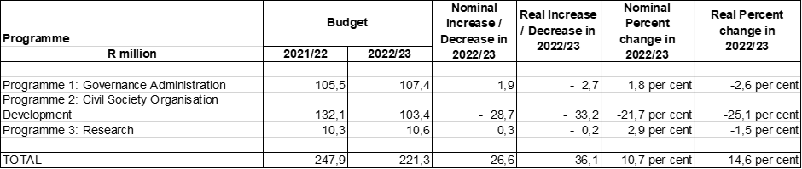**Table 9: NDA budget allocation for 2022/23 financial year**

The NDA received a budget allocation of R221.3 million for 2022/23 financial year, down from R247.9 million in 2021/22. This illustrated a nominal decrease of 10.7 per cent and a real decrease of 14.6 per cent (when inflation is considered). The real decrease is R36.1 million.

* 1. **Budget and Annual Performance Targets Per Programme**

* + 1. *Programme 1: Administration*

The focus of this programme is on promoting and maintaining organisational excellence and sustainability through effective and efficient administration that includes performance, employee wellbeing, cost containment as well as brand enhancement and recognition. These will be achieved within a sound governance and administration environment.

This programme has an allocation of R107.4 million for 2022/23, up from a revised budget allocation of R105.3 million for 2021/22 financial year. For the 2022/23 financial year, the NDA is planning to achieve the following four (4) performance targets it set for itself:

**Table 10: Indicators and annual performance targets for Programme 1**

|  |  |
| --- | --- |
| OUTPUT INDICATOR | ANNUAL TARGET |
| Percentage (%) reduction of non-compliance resulting in irregular, fruitless and wasteful expenditure (IFW) expenditure reported | Reduce by 80% the cumulative balance of IFW expenditure reported in prior year annual financial statements. |
| ICT strategy and architecture aligned to NDA business model approved and implemented | Approve and implement the ICT strategy and architecture to be aligned to NDA business model. |
| |  | | --- | | New organisational structure aligned to NDA business model approved and implemented | | Approval and implementation of new organisational structure aligned to NDA business model. |
| |  | | --- | | NDA Strategic Partnership Model aligned to NDA business model approved | | NDA will be approving the NDA Strategic Partnership Model to be aligned to NDA business model . |

* + 1. *Programme 2: Civil Society Organisation (CSO) Development*

The purpose of this programme is to focus on elevating the NDA to become the lead coordinator of development initiatives. The programme will also focus on creating effective poverty eradication impact through the utilisation of key mechanisms and channels of poverty eradication, including, but not limited to the support of CSOs.

The budget allocation for this programme declines from R132.1 million in 2021/22 to R103.4 million in 2022/23 financial year. This represents a 21.7 per cent nominal and 25.1 per cent real decrease in the budget for this programme compared to the previous year.

This programme has a total of five (5) performance targets for 2022/23 as opposed to the four (4) targets for the 2021/22 financial year. SONA 2022, indicated that the Social Employment Fund will create a further 50,000 work opportunities using the capability of organisations beyond government, in areas such as early childhood development, and tackling gender-based violence among others. In addition to expanding public employment, Government is providing support to young people to prepare them for work and link them to opportunities. The NDA is planning to align itself with this target by creating jobs because of CSO development interventions.

**Table 11: Indicators and annual performance targets for Programme 2**

|  |  |
| --- | --- |
| OUTPUT INDICATOR | ANNUAL TARGET |
| |  | | --- | | Rand value of resources raised from NDA partnerships to fund CSO development interventions | | During the year under review, the NDA plans to raise R35 million to fund CSOs |
| Number of work opportunities created as a result of CSO development interventions | NDA intends to create 3000 work opportunities as a result of CSOs development interventions. |
| Number of CSOs capacitated to strengthen their institutional capacity | NDA also plans to capacitate 2000 CSOs during the year under review. |

* + 1. *Programme 3: Research*

This programme will focus on development policy research and NDA programmes evaluative studies to be used to inform programme planning and policy development and debates in the social, economic and development sectors of the economy. The outcome is to inform national development policy debates and engagements on issues relating to development and poverty alleviation in general. It will also produce publications and standards for effective best practice in the development sector to promote sharing of lessons and good practice.

This programme has a total number of three (3) targets for 2022/23, the same as targets set for the previous financial year.

**Table 12: Indicators and annual performance targets for Programme 3**

|  |  |
| --- | --- |
| OUTPUT INDICATOR | ANNUAL TARGET |
| Number of research publications produced to provide a basis for development policy. | The Agency is planning to release three research publications and three evaluation reports for the year under review. |
| Number of dialogues held with external stakeholders to inform development policy. | It is also planning to have five (5) external dialogues to engage on the NDA research outputs during this period under review. |
| Number of evaluations conducted to inform programme design and implementation | NDA will conduct 3 evaluations for the year under review. |

1. **COMMITTEE DELIBERATIONS**

* The Committee wanted to know how the Department will process 80% of NPO Annual Reports and how many it expecting to receive in the current financial year.

*The Department stated that in terms of the NPO Act, Sections 1 and 2, all NPOs must report to the Department of Social Development. There are currently over 250 000 NPOs, not all of them report within a year. Due to COVID-19 there has been delays, targets have been reviewed (2 years), some reports were submitted online and there were technical issues thus targets were lowered. Under normal circumstances, 50 000 reports are received. The expectation is that more than 50 00 reports will be received seeing the situation has normalised. These reports must be scrutinised to give NPOs compliance certificates. Therefore, the Department wants to do 80% of these reports.*

* The Committee noted with concern that across Provinces there has been a reduction in funding. The Committee wanted to know how the Department will counter the impact of budget cuts. An example, was made of the budget cuts in North West and Northern Cape provinces.

*The Department indicated that it has been underfunded, historically. However, it has always managed to do a lot with very little money. The allocation is not adequate for all the responsibilities the Department has. However, there are no drastic cuts from National Treasury in this financial year. The Department that it is important to note that there is better co-operation between itself, SASSA and NDA to assist with this by creating a stronger impact with the small budget. In addition, the Department has strategies in place to deal with the reduction in funds. It was also mentioned that the shift of the ECD function to the Department of Basic Education may be partially attributed to the reduction in funding.*

* The Committee noted with concern, the discontinuation of the Social Worker grant as well as lack of absorption of qualified social workers. The Committee wanted to know what the impact of this is, if there is a strategy to absorb social workers in the Department nationally, provincially as well as in the NPO sector. In addition, the Committee cautioned that not addressing this may be wasteful expenditure and a contributor to youth unemployment and rising social ills. The Committee wanted to know how the Department is planning to address this.

*The Department stated that unfortunately it does not have the money to absorb social workers. However, there is a plan and strategy in place to remedy this. It was acknowledged that a strategy is needed to combat this, though it should not only be the Department’s responsibility. The Department agreed with the Committee that social workers are needed in various sectors and institutions including schools and correctional services. Hence, the Department is looking at an integrated strategy on how best to remedy this. It is important for other departments (and the private sector) to collaborate with the Department on this aspect. There is a draft sector strategy, which is broadly addressing the employment of social workers in provinces, in the private sector as well as nationally. The idea is to work towards a joint bid by the Department and submit this to National Treasury in June. The intention is to get funding for social workers. In terms of contracting social workers, provincial departments have been advised to consider continuing with the contracts with what is available in their own budgets in the meantime.*

* The Committee asked about the period and process of reapplication for the R350 grant. In addition, the Committee wanted to know about the impact will it have on poor and vulnerable communities, considering the devastation in KwaZulu-Natal (KZN) and Eastern Cape (EC), Northern Cape (NC) transport issues, and winter. Further, the Committee noted the increase in the grant to KZN victims, and wanted to know if victims from other Provinces are also eligible for the increase.

*SASSA clarified that the new R350 grant application requirement stems from the new legislation. In addition, it has opened the application process and it is a once-off application that will be scrutinised every 3 months to make sure those eligible are recipients of the grant to rule out any fraudulent behaviour. SASSA reported that applications for the R350 grant were steadily streaming in. Besides KZN, other Provinces victims are also eligible for the grant increase. More details will be communicated to the public directly. It was reported that long queues will be curbed with reference to this grant, as everything will be done electronically.*

* The Committee wanted to know how the community-based programmes will be rolled out. An example was cited about the co-operation of departments regarding teenage pregnancy.

*The Department acknowledged that teenage pregnancy is a crosscutting issue. There will be no success on the issue by working in silos. The Department stated that it has to start where the challenge is - child protection and the need for strengthening families, empowering families and instil values. Working with the community is very important as to empower communities and take ownership of their own children. Integration and collaboration is imperative, and an accountability structure. There are programmes in place – there is a package of services (from the Department of Health, Department of Basic Education etc.) The implementation of an integration model will assist with the intervention model.*

* The Committee was concerned about the delays in finalising investigations on irregular, fruitless and wasteful expenditure, particularly at SASSA and the NDA. The Committee wanted to know the reasons for the delays. In addition, the Committee wanted to know if the implicated employees are still working for the Department or the entities; and if so, what the risks of that are. The Committee asked what the Department is doing in real time to address the delays in investigations on irregular, fruitless and wasteful expenditure and what progress was made on outstanding cases. Lastly, the Committee wanted to know about the key performance indicators for senior management regarding finalisation of these investigations.

*The Department indicated that in all the performance agreements of senior managers, there are aspects on how issues raised by the Auditor-General will be responded to. With regard to challenges at SASSA, the Department holds regular entity oversight meetings. Importantly, it is in the process of finalising amendment of the SASSA Act, which will include provisions for the establishment of the Board. With the NDA, a control committee has been appointed on the 11 contracts that have been identified as being irregular. Determination tests are underway.*

*The NDA explained that the irregular and fruitless expenditure dates back from previous financial years and at the time it never applied for condonation. For it to obtain a condonation there should be some requirements that have to be met, such as a determination of financial loss, through the Board and National Treasury. Some of the cases involved procurement of office space without following proper supply chain management (SCM) prescripts. At the time, the SCM unit was under-resourced and not well capacitated. Subsequently, these areas are gradually being addressed. The Agency is investigating and conducting a determination test, which will to a binding consequence management outcome.*

* The Committee raised concern about the (critical) vacancies (at the Department and NDA).

*The NDA explained that the process for the filling of the Chief Executive Officer and Board vacancies was underway.*

* The Committee raised concern about the NDA budget cuts, and the impact of that set targets and timeframes.

*The NDA stated that historically it has been having budget cuts. The NDA explained that its budget structure is line with the NDA Act. Section 3(1) of the Act provides that the NDA should raise funds for CSOs funding, which it has been able to fulfil through donors.*

1. **RECOMMENDATIONS**

Having considered the budget and the annual performance plans of the Department and its entities the Committee makes the following recommendations:

**8.1 Department of Social Development**

* The Minister should ensure that the Department within the 2022/23 financial year fills the vacancies of critical positions, particularly that of the Director-General.
* The Minister should ensure that the Department within the 2022/23 financial year puts in place secure information communication and technology management (firewall) systems to protect it from cybercrime, which has proved to be a serious threat globally. In addition, with the advent of the COVID-19 pandemic, the Department and its entities should implement most of their services digitally.
* The Minister should ensure that there is a viable strategy to address the challenge of social work services in the country, that it is tabled in Parliament and implemented.

**8.2 South African Social Security Agency (SASSA)**

* The Minister should also ensure that SASSA implements or strengthens its human resource policies on vetting and academic clearance of its employees as one of the measures to prevent fraud and corruption. The Minister should also engage with the Minister of Communication and Digital Technologies on the same matter for those employees who work within the social grants payment system.
* The Minister should also ensure that SASSA within the 2022/23 financial year finalises all the appeals on the SRD grant, including those dating back to August 2021.
  1. **National Development Agency (NDA)**
* The Minister should ensure that the NDA Board is appointed within the 2022/23 financial year and that the position of the Chief Executive Officer is filled.
* The Minister should ensure that the NDA Board conducts and finalises the investigation on the allegations of fraud and corruption against the previous Chief Executive Officer within the 2022/23 financial year.

Report to be considered.