REPORT OF THE PORTFOLIO COMMITTEE ON COOPERATIVE GOVERNANCE AND TRADITIONAL AFFAIRS ON THE 2022/23 ANNUAL PERFORMANCE PLANS AND BUDGETS OF THE DEPARTMENTS OF COOPERATIVE GOVERNANCE AND TRADITIONAL AFFAIRS AND THE ENTITIES REPORTING TO THEM, DATED 10 MAY 2022

Having met with the Departments of Cooperative Governance and Traditional Affairs, and their associated entities, on their 2022/23 Annual Performance Plans (APPs), Strategic Plans and Budgets, the Portfolio Committee on Cooperative Governance and Traditional Affairs reports as follows:

- INTRODUCTION

  - Section 77 (3) of the Constitution stipulates that an Act of Parliament must provide for a procedure to amend money Bills before Parliament. This Constitutional provision resulted in Parliament passing the Money Bills Amendment Procedure and Related Matters (Act No. 9 of 2009) (the Money Bills Act). The Money Bills Act sets out the process that allows Parliament to make recommendations to the Minister of Finance to approve, reject or amend the budget of a National Department.

  - From 03 - 04 May 2022, the Portfolio Committee met and considered the 2022/23 Annual Performance Plans, Strategic Plans and Budgets of the Departments and Entities reporting to it. These consist of the Departments of Cooperative Governance and Traditional Affairs, the Municipal Infrastructure Support Agent, the CRL Rights Commission, the Municipal Demarcation Board and the South African Local Government Association.

- KEY POLICY AND RESOURCE ALLOCATION CONSIDERATIONS FOR 2022/23

  - Department of Cooperative Governance.

    - A key matter of concern in the 2022/23 APP of the Department of Cooperative Governance relates to the tabling in Parliament of the Monitoring, Support and Interventions Management Bill. The Committee has, on numerous occasions, heard of the abuse and misuse of the intervention process, particularly by Provincial Governments, due to the lack of a legislative instrument that clarified and regulated it. The Bill is therefore needed as a matter of urgency.

    - However, the Department keeps shifting the goal posts for the submission of the Bill to Parliament. During the 2021/22 APP process, the Department stated that the Bill would be tabled by 31 March 2022. In the meeting of 22 March 2022, where the Portfolio Committee considered the Department’s financial and non-financial performance in relation to the Third Quarter of 2021/22, the Committee was promised that the tabling of the Bill could be expected in July 2022.

    - The 2022/23 APP now shifts the deadline again to 31 March 2023. Since this Bill has been on the Department’s APP since the Fourth Parliament, the concern is that the Department may shift the tabling of this Bill perpetually, thus making a mockery of the parliamentary accountability process.

    - As in many previous years, the Portfolio Committee remains concerned (see section 4.1) that the Community Work Programme does not seem to be serving its intended purpose, and its investment return does not justify the large sums of money allocated to it. In 2022/23, this allocation amounts to R4.3bn. As the Table below indicates, the allocation to the CWP constitutes 85,1 percent of the funds directly administered by the Department, excluding transfers to municipalities, the South African Local Government Association, the Municipal Demarcation Board, the Municipal Infrastructure Support Agent, and the South African Cities Network.

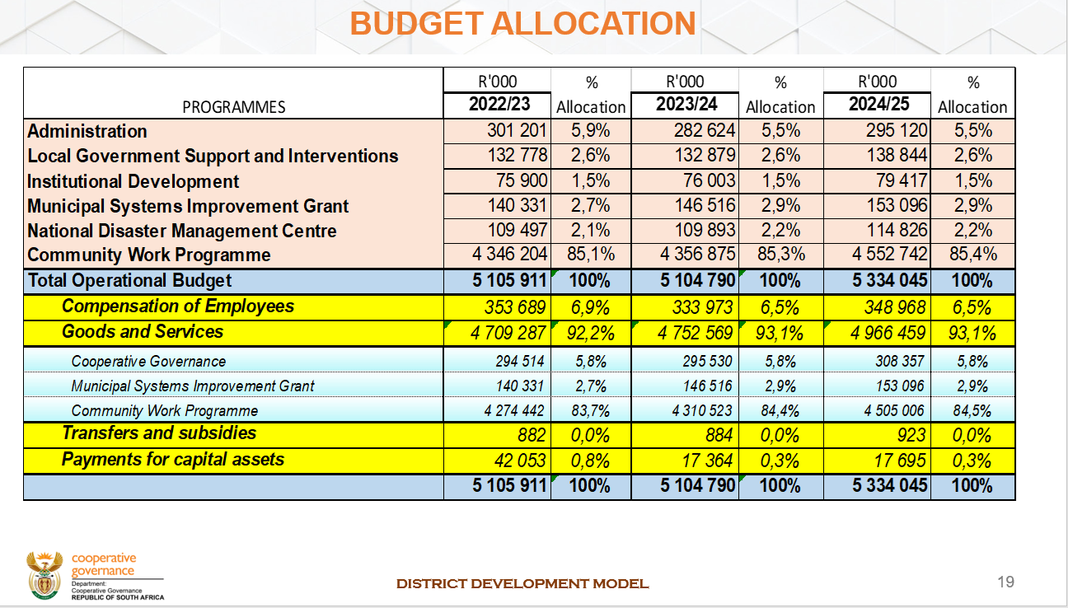
Source: Department of Cooperative Governance (2022).

  - Municipal Infrastructure Support Agent

    - For the most part, the entity’s 2022/23 APP is similar to the APP presented in 2021/22 except for a noticeable increase in output targets for Programme 3: Infrastructure Delivery Management Support. These have increased from seven in 2020/21 to 11 in 2022/23, following the addition of new responsibilities.

    - During the 2021/22 Budget Vote process, the Portfolio Committee noted that the funding model of the MISA was not optimal, given the responsibilities which the organisation is expected to fulfil. This observation followed a recommendation issued by the Committee in its 2020/21 Preliminary Budgetary Review and Recommendations Report, which stated that MISA must re-examine its funding model to ensure that it is aligned to the responsibilities expected of the organisation.

    - In response to the Portfolio Committee’s observations and recommendations, MISA indicated that it had prepared a business case, including full costing, setting out the key initiatives aimed at strengthening the agency’s role and capacity to support struggling municipalities towards improved delivery of municipal infrastructure and basic services. This business case was approved by the Minister in September 2019 and submitted to National Treasury as the basis for seeking additional funding.

    - The estimated amount requested based on the business case was R2.9 bn over the three-year MTEF period. National Treasury did not approve the request for funding to implement the initiatives in the business case. MISA has since initiated a process of developing a Long-Term strategy that seeks to clearly define its key focus areas, operational approach and funding model in the future. It is envisaged that the strategy will pave a way for further exploration of various options for funding MISA in the future. The appointment of a service provider to assist the agency in the development of this strategy was envisaged to be concluded by the end of February 2022.

    - Thus, as the Table below illustrates, the funding allocation to MISA still falls far below the R2.9bn needed to strengthen the agency’s role and capacity to fulfil its mandate.

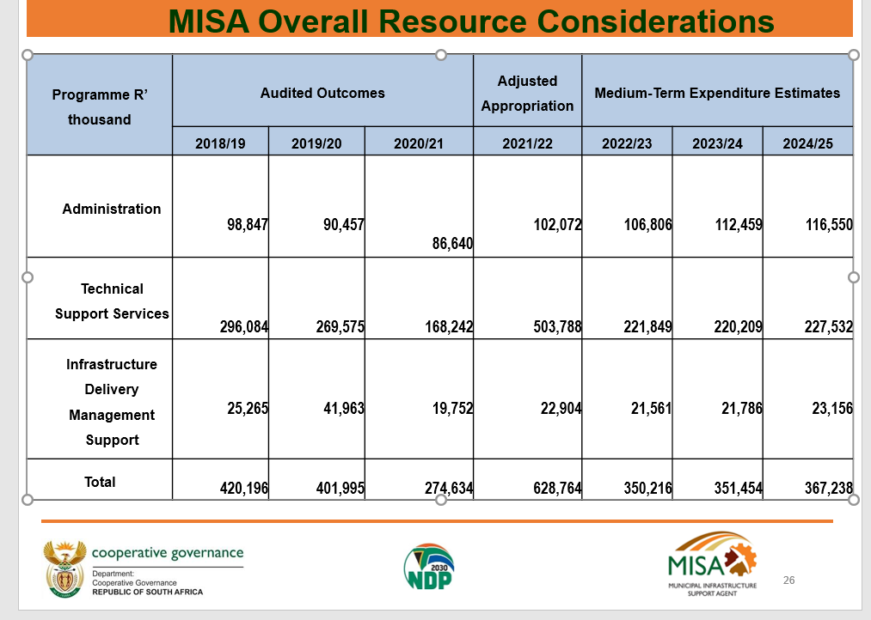

Source: Municipal Infrastructure Support Agent (2022).

  - Department of Traditional Affairs.

    - As in the previous financial year, the Department’s 2022/23 APP reiterates emphasis on the role of the institution of traditional leadership in terms of fighting Gender Based Violence and Femicide. The Department continues envisaging using structures of traditional leadership to create awareness of GBVF in traditional communities.

    - However, some traditional leaders are concerned that government seemed intent on conferring this role and responsibility without any attempt to create an enabling environment for its execution. Consequently, the Department is likely to receive limited cooperation in this regard, unless it ensures that traditional leaders are adequately resourced to execute the policy directives of government. The Department has previously informed the Portfolio Committee that this is the responsibility of the Province. However, the Committee did not find this argument convincing, as it was the national Department’s responsibility to oversee the Province, and see to it that it was fulfilling its mandate.

    - Previously, the Portfolio Committee has submitted that the funding allocation to the CRL Rights Commission is pitiful considering the magnitude of the Commission’s mandate, and needs urgent review. It was noted that there was no proper investment in the structure supposed to address the country’s deep-seated problems of racism, which inevitably related to culture, language and religion. In the same Report, the Committee further noted that the funding allocated to the National House of Traditional Leaders falls short of the goal of reaffirming the role of the institution of traditional leadership as a key player in cooperative government.

    - Both the CRL Rights Commission and the National House of Traditional Leaders receive their budget allocations as transfers from the Department of Traditional Affairs. Increasing funding to these institutions would entail augmenting the DTA’s baseline. However, as indicated in Table below, the Department’s budget allocation of R177m in 2022/23 is itself constrained, and does not provide much room for augmenting the funding to the two institutions.

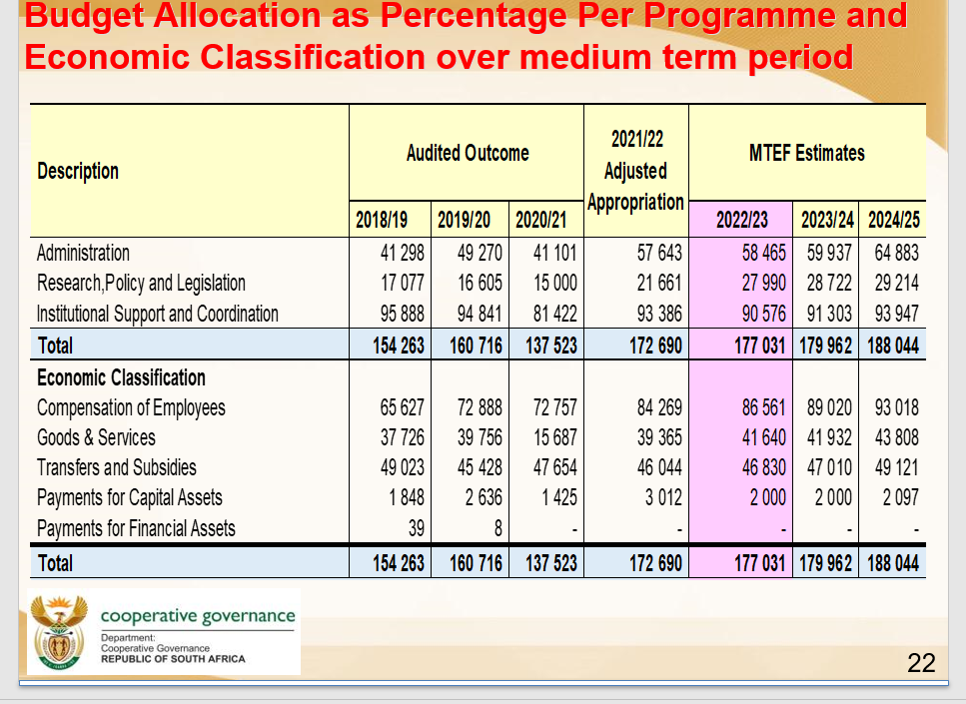
Source: Department of Traditional Affairs (2022).

  - Municipal Demarcation Board

    - Over the years, the Portfolio Committee has been emphasizing the need for the Board to improve on its public awareness and stakeholder education process. In response, the Board has repeatedly expressed its commitment to address this matter. Even in the 2022/23 APP the Board raises the lack of understanding of the municipal boundary red-determination process as a matter of concern, and affirms its intention to continue with its education and awareness programme.

    - It is therefore of concern that the 2022/23 APP drastically reduces the number of public awareness and education activities completed, from 10 in 2020/21 to only four in 2022/23. This is inconsistent with the Board’s expressed commitment to improve on its public awareness and stakeholder education process.

    - As in the previous financial years, the Board continues to express frustration with regard to the limited financial resources allocated to it, which constrains its ability to fulfil its mandate. Specific mention is made of the imperative to conduct municipal boundary re-determination that will require significant funding in 2022/23. Previously, the Portfolio Committee noted that the Board’s projected budget reduction over the medium is a concern, as it has negative implications for the Board’s operational stability, especially in relation to public participation. At the same time, there is a concern (see section 4.6) the that compensation of employees consumes an excessive portion of the entity’s allocated budget, as seen in Table below.

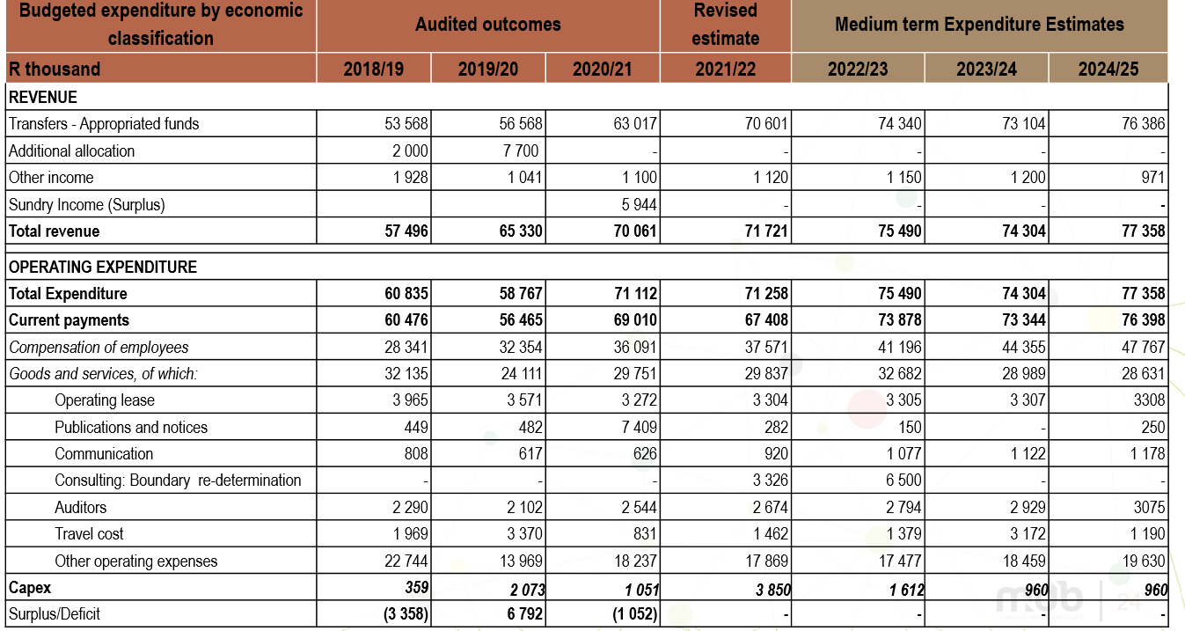
Source: Municipal Demarcation Board (2022).

  - South African Local Government Association

    - The South African Local Government Association has just emerged from its elective conference of 2022, which ushered in a new Five-Year Strategic Framework that, among other things, outlines the strategies, which the organisation will be pursuing over the next five years. Among the envisaged strategies will be a movement towards a focus on the impact of the organisation’s work, as to address the concern around the fact SALGA has been obtaining consecutive clean audits for nearly a decade, but this has not been translating to its member municipalities.

    - It is also worth noting that while the Constitution, the Municipal Systems Act, the Intergovernmental Relations Framework Act and the White Paper on Local Government provide a clear role for SALGA, the Municipal Finance Management Act omits to do so despite being one of the key legislative prescripts governing the financial affairs of local government for which SALGA has a central stake. The lack of a legislated function for SALGA in regulating the financial affairs of municipalities is a missed opportunity in terms of enhancing oversight over municipal financial reporting obligations.

    - One of the findings emerging from the Portfolio Committee’s recent oversight visit to the Free State province was that many of the municipalities in the visited Districts of Lejweleputswa, Thabo Mofutsanyana and Fezile Dabi had woeful revenue collection rates and had little to non-existent revenue enhancement strategies. One would have expected that SALGA’s Municipal Financial Support sub-programme would have a plan of action around this matter.

    - SALGA has submitted that, for the 2022/23 financial year, it will have a shortfall of R112.5m as the national fiscus is not funding its legislated participation in Intergovernmental Relations (IGR) and mandatory governance costs. However, as in the case of the MDB, there is a concern that, were SALGA provided this shortfall, it would be consumed by administrative overheads (see section 4.6). As seen in Table below, 66.7 percent of the organisation’s anticipated expenditure in 2022/23 is geared towards administration.

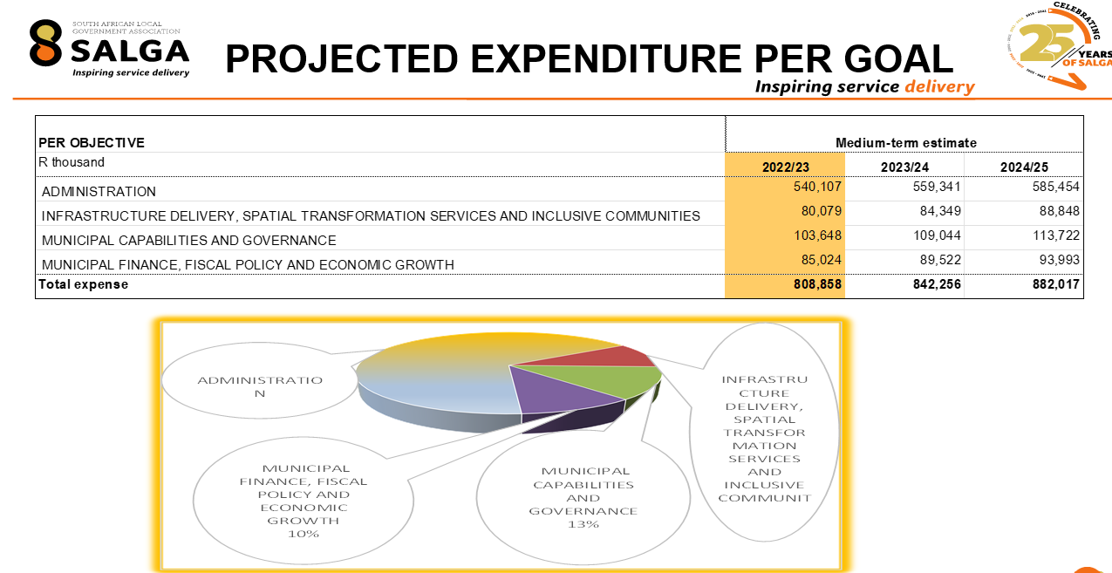
Source: South African Local Government Association (2022).

  - CRL Rights Commission

    - As noted under section 2.3.3, the Portfolio Committee has previously submitted that the funding allocation to the CRL Rights Commission was incommensurate with the magnitude of the Commission’s mandate, and needed urgent intervention. There was a need to ensure that Government invests adequately in the structure supposed to address the country’s deep-seated problems of racism, which inevitably related to culture, language and religion.

    - However, there is also a concern (see section 4.6) that R30.5m of the Commission’s R47m budget allocation is earmarked for internal administrative overheads, as seen in Table below. This means that approximately 65 percent of the Commission’s budget is geared towards payment of organisational overheads, rather than service delivery deliverables. This needs to be interrogated, otherwise the Commission risks existing primarily for the payment of salaries and other overheads.

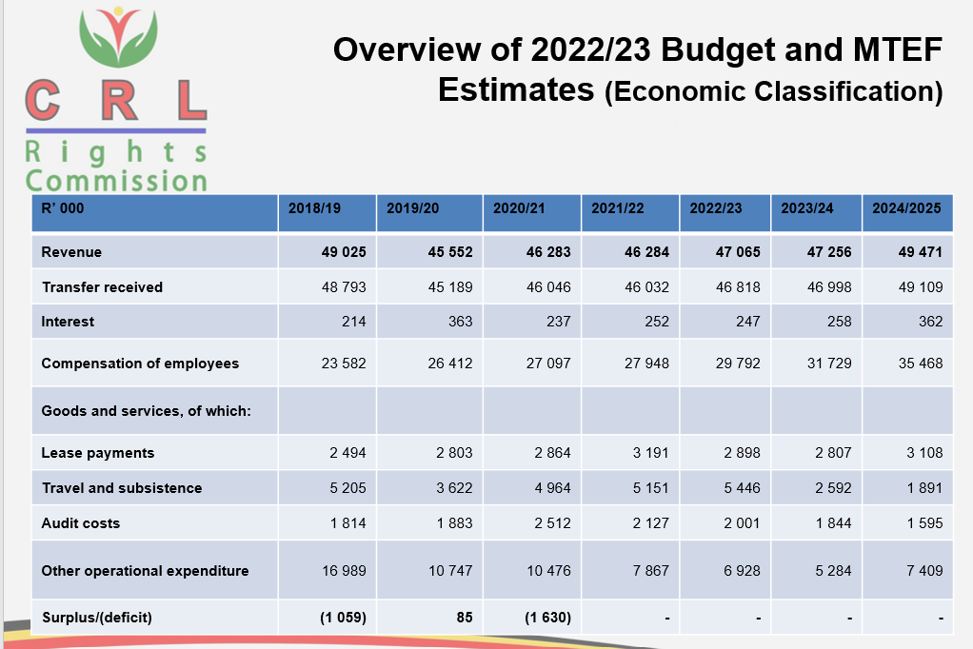

Source: CRL Rights Commission (2022).

    - As in the previous years (going as far back as the Third Administration), the Commission continues to decry inadequate funding, which reportedly hinders it from deploying all the resources necessary to enable it to deliver on its mandate. At the same time, the Commission has no clear resource mobilisation strategy. Previously, the Commission had indicated to the Portfolio Committee that it had a draft resource mobilisation strategy, but this had not yet been finalised. An update on this draft strategy is now overdue.

- IMPLEMENTATION OF 2021/22 BUDGETARY REVIEW RECOMMENDATIONS
2021/22 BRR RECOMMENDATIONS | PROGRESS IN 2022/23
- The Committee must demand a clear plan and timeframes from the Department of Cooperative Governance with regard to resolving the legacy issues in the Community Work Programme. This will enable the Committee to deal with specifics, rather than talk in general terms. | The Department introduced a new CWP Implementation Policy with effect from 01 October 2021. The policy clarifies the role of Implementing Agents and significantly strengthens procurement and financial practices. The policy is currently being updated to incorporate learnings form the first 6 months of implementation.  The Department is currently finalising the CWP Policy Framework to ensure that the new CWP model will have a greater impact on poor communities. This process is expected to be completed by end March 2022. The new model will ensure that useful work is designed to support key priorities as identified in DDM One Plans and ensure that targeted training support real skills development that would enable participants to become self-employed or find more sustainable income opportunities.  The framework introduces a shift in focus from Implementing Agents to Implementing Partners, based on shared goals aims at improved public goods and services. The Department presented the above progress to Portfolio Committee on 01 February 2022.
- The Committee must engage the Department of Cooperative Governance on developing a clear plan that responds to the issue of unreliable water supply and sanitation. This should be a broad plan that also responds to roads maintenance. | Ongoing.  The report detailing plans to respond to unreliable water supply and sanitation has been developed and will be shared with the Portfolio Committee and further discussed upon receipt of invitation from the Committee. The report detailing plans was attached as Tag A – from page 26 - 35
- The Department must, as a matter of urgency, finalise and table to Parliament the Bill relating to intergovernmental interventions in terms of Sections 100 and 139 of the Constitution. | Ongoing.  i) The Department has concluded on the consultations undertaken with all national sector departments, provincial treasuries, Premiers Offices, NW Section 100 Administrators’ Forum, MuniMECs/TROIKAs and office-bearers in all nine provinces, and National Economic Development and Labour Council (NEDLAC) was also engaged.  ii)The Bill has been submitted to Department of Planning Monitoring and Evaluation (DPME) to obtain the obligatory “socio-economic impact assessment,” certificate. Feedback was received from DPME and the revised “socio-economic impact assessment and draft plan has been resubmitted to DPME in December 2021.  iii)The Bill was also submitted to Office of the State Law Advisor to obtain a Cabinet Compulsory State Law Advisor’s constitutional compliance certificate. Feedback was received from the State Law Advisor (SLA) during an engagement held on 02 December 2021. The revised IMSI Bill has been resubmitted to SLA in December 2021. A pre-certification note has been obtained from the SLA.  iv)Next step is to present the Bill to the Cabinet clusters for inputs and comments before processing it further  v)Based on the Department’s Annual Performance Plan for 2022/2023 financial year the Bill will be tabled in Parliament by 31 March 2023.
- The Minister of Cooperative Governance and Traditional Affairs should brief the Committee in relation to the charges against the Chief Executive Officer of the Municipal Infrastructure Support Agent in connection with the supply of Ventilated Improved Latrines in the Amathole District. In its next audit, the Office of the Auditor-General should also look into this matter. | Ongoing.  The Department takes charges levelled against the Chief Executive Officer of MISA very seriously. Without prejudicing the merits of the case, the Hawks provided information as follows.  Herewith updated progress:  Cambridge Cas 260/06/2018 – Fraud & Corruption  Prejudice: +/- R 631 MILLION  Accused:  1. Ntsokolo Chris Magwangqana  2. Vincent Mpumelelo Shezi  3. Nkosinathi Rooseveld Soga  4. Lulama Lancelot Taleni  5. Goodman Ntandazo Vimba  6. Ongama Mahlawe  7. Bongani Mpeluza  8. Eddison Vuyani Gaga  9. Helen Busisiwe Kwinana- Boadi  10. Lovemore Sinbara Kativhu  CURRENT STATUS OF INVESTIGATION  Investigation complete  INVESTIGATION CONDUCTED SINCE THE LAST REPORT  Case was transferred to Grahamstown High Court and postponed to the 04 April 2022 for the observation of accused 02 to appear and outcome of observation whether accused 2 will be fit to stand trial.  The case for the rest of the accused persons is postponed to 03 May 2022.
- The Committee should convene a separate meeting with the Municipal Demarcation Board to discuss its internal governance matters, including the Report on the unfounded allegations against the Chief Executive Officer. The Minister and Deputy Ministers of Cooperative Governance and Traditional Affairs should lead the discussion and provide a way forward. | Recommendation implemented.  The Portfolio Committee had engagement with the MDB and COGTA on 7 December 2021. The Department provided the Committee with an update on this matter.  As a way forward, the Minister recommended to the President to establish an Investigation Tribunal in accordance with the Municipal Demarcation Act. This is an ongoing process, and we will apprise the Portfolio Committee in due course.
- The Municipal Demarcation Board should develop and present to the Committee a strategy of dealing with demarcation hotspot areas, including those areas that have challenges going back as far as 2016. The Board must also clarify the rationale behind amalgamation of certain municipalities in the Eastern Cape, which has exacerbated the problems in these municipalities. | The Board was scheduled to present to the Portfolio Committee a strategy of dealing with demarcation hotspot areas and rationale behind amalgamation of certain municipalities in December 2021. Due to changes in Committee programme, these could not materialise however the report was submitted to the Committee. A detailed report on the above matter was enclosed as Tag B 1 & Tag B 2.

- COMMITTEE OBSERVATIONS

  - The Portfolio Committee noted that large sums of money (in billions) are being allocated to the CWP, but there seemed to be no tangible return on this investment. Some CWP participants still do not receive stipends, despite assurance from the Department of Cooperative Governance that it will address this matter. There are still participants who have no uniforms or sharing a set of uniform with several other people. Overall, the CWP appears to be money wasted. There needed to be an evaluation of whether the CWP is serving its purpose, as cursory evidence suggests that the system is abusing people rather than serving them.

  - The Committee further observed that the Department of Cooperative Governance’s proposal to build new smart cities is a priority that can best be addressed after adequate focus has been given on providing infrastructure to the previously disadvantaged who still drown in pit toilets, and get eaten by crocodiles while fetching water. The infrastructural gaps resulting from past racial imbalances needed to be narrowed first before the undertaking of more ambitious projects.

  - It was noted that the South African Local Government Association had once again presented a moving account of the problems engulfing local government, as well as clear proposals on how to address these. However, SALGA’s plan will be difficult to sell in the current municipal environment, which is characterised by poor political leadership, non-understanding of legislation, and councillors who do not fully understand their role and fear the involvement of citizenry in ward committees. SALGA’s proposals are likely to remain on paper if the political leadership does not make them a priority. The Portfolio Committee needs to determine the exact role it should play in this regard.

  - The Portfolio Committee is concerned that the footprint of the CRL Rights Commission in rural communities, particularly in the Western Cape, remains invisible. The existence of the Commission is still unknown among these communities.

  - Committee members advised that the Municipal Demarcation Board should be investing more of its resources on public participation, as many people still do not know about the Board. There is an outcry among some communities that the Board does not consult them. To prove that these complaints are unfounded, the Board needs to keep a portfolio of evidence on public participation and provide this when requested.

  - Finally, the Committee is concerned that more than half of the allocated budgets of SALGA, MDB and the CRL Rights Commission seem dedicated to the compensation of employees rather than on delivering on the core service delivery mandates of these entities. This creates the impression that these entities mainly exist to pay salaries. The entities’ presented budgets also do not provide details regarding expenditure on contracted services.

- COMMITTEE RECOMMENDATIONS

  - The Department of Cooperative Governance must conduct an evaluation and cost-benefit analysis of the Community Work Programme to assess whether it was serving its intended purpose and to determine whether the cost incurred on the Programme is consistent with the benefit derived.

  - The South African Local Government Association, the Municipal Demarcation Board, and the CRL Rights Commission must provide addenda to their 2022/23 Annual Performance Plans that will assist the Portfolio Committee to better understand why personnel costs and other administrative overheads absorb more than half of the entities’ budget allocations.

- APPRECIATION
The Committee wishes to thank the Departments of Cooperative Governance and Traditional Affairs, CRL Rights Commission, SALGA, Municipal Demarcation Board, and MISA for their fruitful, cordial and constructive engagements. The contributions of Committee members, as well as Committee support staff is highly appreciated.

Report to be considered

