**2021**

Financial Sector Conduct Authority

3rd Quarter Performance Report



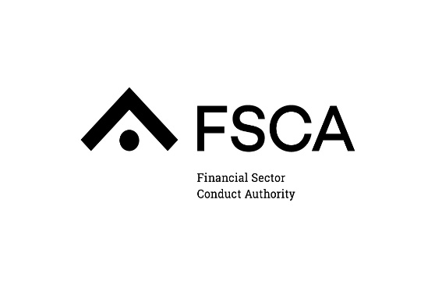

Table of Contents

1. EXECUTIVE SUMMARY 3

1.1 INTRODUCTION 3

1.2 SUMMARY OF PERFORMANCE 4

1.2.1 BUILDING A NEW ORGANISATION 4

1.2.2 AN INCLUSIVE AND TRANSFORMED FINANCIAL SECTOR 10

1.2.3 A ROBUST REGULATORY FRAMEWORK THAT PROMOTES FAIR CUSTOMER TREATMENT 11

1.2.4 INFORMED FINANCIAL CUSTOMERS 22

1.2.5 STRENGTHENING THE EFFICIENCY AND INTEGRITY OF OUR FINANCIAL MARKETS 22

1.2.6 UNDERSTANDING NEW WAYS OF DOING BUSINESS AND DISRUPTIVE TECHNOLOGIES 24

2. PERFORMANCE MONITORING 27

2.1 PERFORMANCE AGAINST STRATEGIC GOALS 27

3. HUMAN RESOURCES 43

3.1 EMPLOYMENT EQUITY 43

3.2     TRAINING 43

3.3 ENTITY ORGANOGRAM 44

4. OCCUPATIONAL HEALTH AND SAFETY 44

4.1   EMERGENCY READINESS 45

5. GOVERNANCE 45

5.1 LEGISLATIVE COMPLIANCE 45

5.2 REPORTS 45

5.2.1 MOVEMENT OF COMMITTEE MEMBERS 45

6. BUSINESS RISK REGISTER 46

7. FINANCIAL OVERVIEW 47

7.1 OVERVIEW OF FINANCIAL PERFORMANCE AND KEY RATIOS 47

7.2 STATEMENT OF FINANCIAL PERFORMANCE FOR THE PERIOD ENDED 28 FEBRUARY 2021 48

7.3 STATEMENT OF FINANCIAL POSITION AS AT 28 FEBRUARY 2021 51

7.4 STATEMENT OF CASH FLOW FOR THE PERIOD ENDED 28 FEBRUARY 2021 54

7.5 CAPITAL EXPENDITURE SUMMARY 55

APPENDIX A – FSCA ORGANOGRAM 56

APPENDIX B – FSCA STRATEGIC RISK REGISTER 57

# EXECUTIVE SUMMARY

## INTRODUCTION

The mandate of the FSCA is to:

* Enhance the efficiency and integrity of financial markets;
* Promote fair customer treatment by financial institutions;
* Provide financial education and promote financial literacy; and
* Assist in maintaining financial stability.

The organisation’s operational focus is on regulating and supervising the conduct of entities within the financial sector. These entities provide financial services and products set out in the FSR Act.

The FSCA is well on its way to meeting its legislative mandate. The strategy has been shifted to activity-based operations.

The FSCA’s Strategic and Annual Performance Plans are based on the following six strategic priorities, which are utilised as performance drivers for the year:

* Building a new organisation;
* An inclusive and transformed financial sector;
* A robust regulatory framework that promotes fair customer treatment;
* Informed financial customers;
* Strengthening the efficiency and integrity of our financial markets; and
* Understanding new ways of doing business and disruptive technologies.

## SUMMARY OF PERFORMANCE

A summary of the performance activities of the entity is provided under each of the six strategic priorities.

### *Building a New Organisation*

In the first three years, the FSCA’s strategic focus was centred around the strengthening of internal structures. This is to ensure that the organisation is adequately resourced and possesses skills needed to achieve its expanded mandate.

On 1 December 2021, Ms Badat assumed her role as Deputy Commissioner, completing the structure of the Executive Committee (Exco). Following her joining, executive oversight over all FSCA divisions was finalised and communicated with all FSCA staff.

The FSCA continues with its regulatory and supervisory mandate ensuring that service delivery and bedding down its new functional business operational structure remains on track.

### *Stakeholder Management*

Effective Stakeholder Management plays a critical role in the execution of the FSCA’s mandate. Through the strategic management of relationships between the FSCA and, its internal and external stakeholders, the organisation will be able to exercise its authority in ensuring that the sector’s conduct is fair for all customers. A critical component of the organisation’s engagement plan is keeping all stakeholders abreast of developments as it transitions into a dedicated market conduct authority.

The FSCA through the Communication and Language Service department deployed various communication channels and platforms to disseminate key messages about the work of the Authority. This included hosting consultative engagements with customers, media, and the financial sector industry players, establishing a social media presence, and producing publications such as the FSCA e-Newsletter and Our Voice. These efforts are aimed at keeping stakeholders informed; building confidence in the organisation capability; and ensuring stakeholder buy-in of regulatory reforms.

The activities below highlight some of the initiatives undertaken in the period under review.

2. **FSCA e-Newsletter (External Publication)**

The FSCA e-Newsletter is a quarterly publication which provides the financial services industry with an update of regulatory developments. The third quarter edition was published on 23 December 2021.

1. **Digital and Social Media**

The FSCA’s social media platforms in the 3rd quarter performed well. With a total reach or "Opportunities to See" of over **84.7 million** *(OTS* a measure of reach developed by[*BrandsEye*](https://www.brandseye.com/)that is calculated by the overall number of mentions multiplied by the followership of the authors that posted. This will give the minimum number of potential views of the conversation online). There was good growth on FSCA pages on all social media for Q3, driven by regulatory updates such as:

* 1. Consumer Education Department’s *Financial Literacy Speech Competition moving to the district and provincial finals phase.*
  2. The Fintech *(Digital Banking)* and Retirement Funds supervision *(Economies of Scale)* teams).

The pages have continued to grow, with the current community now standing at a combined 50 000. As for the social media pages, the below key metrics were recorded:

1. The Facebook page gained 417 followers on the platform. It also had over 9 433 post engagements (posts that are seen or engaged with by users);
2. “The FSCA Twitter page gained 199 new followers for a total follower count of 6 806 (a 3% rise) while having over 70 000 post impressions in the reporting period.; and
3. LinkedIn saw 1 169 followers gained and 108 025 post impressions from the previous quarter.

|  |  |
| --- | --- |
| **Risks/Challenges or Gaps Identified** | **Mitigation Strategies Adopted** |
| The main risk remains in the proactive dissemination of information in a changing environment that includes the COVID-19 pandemic. | * The FSCA continuously engages with all stakeholders, including the public, to ensure that all changes are communicated timeously and accurately. * The FSCAs virtual media interviews, media engagements, thought leadership industry workshops, social media engagements and press releases are some of the vehicles through which the FSCA communications initiatives are employed to manage this risk. |

### *Information and Communication Technology (ICT)*

In carrying out its mandate, the FSCA engages financial service providers intensively to ensure the market is functioning as it should, and users are protected. This is done through various tools of information collection and analysis. The Information & Communication Technology (ICT) Division partnered with business and adopted a Data Driven Digital (DDD) strategy to support the enablement and achievement of the organization’s objectives.

The DDD strategy was adopted with a vision to transform the FSCA into a next generation, insight-driven regulator. Through this transformation, the FSCA will be able to leverage the value of data it collects, complement it with non-traditional data to support evidence-driven business decision making. The FSCA began implementing the first year of our DDD strategic plan in 2019/2020 with a focus on establish the right foundation for a data driven organization. Through this digital strategy, the ICT aims to partner with business and enable the organization to deliver quality market conduct services. This will be achieved through deep insights and business decisions that arise from the analysis of consumer/ customer data, embedded culture of business insight and analytical decisions supported by Artificial Intelligence, Machine Learning, Natural Language Processing capabilities and tools.

The ICT Division held its annual strategy planning session in an effort to reflect on previous financial year’s performance and revised the year 3 (FY2021/2022) deliverables of the Data Driven Digital (DDD) Strategy to confirm alignment to the FCSA Strategic objectives set out in the Regulatory strategy. The following key programs were still confirmed to be relevant for the pursuit of the DDD strategy:

* + - * 1. Digital Optimization - to digitise core and support processes of the business through provision of simple, integrated seamless services supported by strong ICT capabilities to achieve operational efficiency.
        2. Digital Transformation - to embed culture of business insight and analytical decisions supported by evidence from advance analysis of consumer and customer data.
        3. Technology Optimization - to optimize the IT technical environment to support the digital organisation and its transformation.
        4. Cyber Security - to ensure a cyber resilient digital platform for the FSCA through a multi-level defence mechanism,
        5. Digital Office - to take advantage of current and emerging technologies to achieve holistic customer experience of all FSCA stakeholders and ensure consistency.

With input from many across the business and in particular Licensing and Business Centre, ICT is supporting the operationalization of the Business Centre through business process redesign and rationalization of the complaints and queries for a more transparent and efficient complaints and query management as well as embarking on a customer experience program, and Market Abuse to realise the objectives of the Data and Analytics vision by tapping into third party data sources for a more holistic approach in managing conduct risks. This is over and above the continued effort to deliver other DDD strategy targets.

* 1. **Digital Optimisation programme**

1. The Enterprise Resources Planning (ERP) project: Project execution work is currently on hold; the focus continues to be on completing the procurement process to appoint service providers to complete the Phase II work.
2. The Integrated Regulatory Systems (IRS) TOR: Received executive approval for commencement with the procurement process.
3. Trustee Toolkit: The project requires specialist skillsets, and it was agreed that the resourcing be brought on through outsourcing of this work to an external service provider.
   1. **Digital Transformation programme**
4. Business Intelligence and Analytics (BIA): Demonstrations of the data set for the Fit & Proper and Pension Unclaimed Benefits use cases were done and feedback was received from Business. Necessary updates will be implemented to conclude and obtain sign off. Sessions to demonstrate the Single View Data Set to the Business have been scheduled with respective Business units. Following these demos, data requirements definition for the 360 View use cases will commence in the sessions and in follow up sessions. The Micro Insurance data requirements were handed over to the development and testing teams. Test cases were defined for this data set.
5. Technical Stream continues to focus on building the Self-Service Use Cases for the remaining business units.
6. Several digitization initiatives have been completed, and this includes MS Teams for Collaboration and meetings with complete additional features like calendar integration and task management and Employee Wi-Fi for all FSCA employees who are working from the office. Microsoft Teams Softphones functionality will be rolled out to all FSCA employees from 14 to 17 January 2022; this will enable employees to make and receive telephone calls using their existing desk phone extension number on Microsoft Teams.
   1. **Technology Optimisation programme**
7. WAN and Internet Service: On-track and in progress
8. The DFA link configurations are completed, and cutover was done on 22 October 2021.
9. The FSCA Disaster Recovery site was successfully moved from Growth Point to Waterfall.
10. The DR link was configurations were tested by both Dimension Data and the FCSA and it is up and running at the new DR site.
11. The project is planned for completion by end of March 2022.
12. Integration Platform: This project is in analysis, planning and design.
13. The landscape architecture has been defined; setup of the environment was completed, and it is ready for development.
14. Procurement of the software license has been completed and the installation of the software is in progress.
15. Service Provider domain user and System service accounts have been created.
16. Planning of project activities is in progress.
    1. **Cyber security programme**

The cyber security strategy implementation plan initiatives which focus on cyber security risk management and resilience planned for implementation in the current financial year.

1. The draft project charter is completed and is in the final review stages.
2. The Hardware requirements were reviewed with the technical team and final inputs were incorporated by the service provider and resubmitted to the FSCA team.
3. Employee Password Self-Service is planned for delivery in Q4 of FY2021/2022.
   1. **Enterprise Information Management**

**POPA Phase III:** The implementation of the POPIA business and universal controls for Phase III of the project is completed. The approval of the project closure was obtained at the Steering Committee that was held on 01 December 2021.

1. The completion of the Compliance report and the validation by the Governance Risk and Assurance (GRA) Department is in progress.
2. The report will be presented to Information Governance Council (IGC) and Information Stewards Board (ISB) once the validation is completed.
3. 100% training completion rate has been achieved and newly hired employees are trained on an ongoing basis as part of the onboarding process.
4. **ICT Strategic Risk Management**

ICT continues to identify and manage emerging risks by reviewing and updating the operational risk register on a quarterly basis. This is to maintain the correct posture of the department’s risk landscape. The following strategic risks are constantly being monitored for tracking and implementation of the necessary controls.

|  |  |
| --- | --- |
| **Risks/Challenges or Gaps Identified** | **Mitigation Strategies Adopted** |
| **Cyber Risk** - The risk of financial and data loss as result of unauthorized and illegal access to the FSCA ICT infrastructure. | * Managed Security Operations Center (CSOC) services – The control has been successfully implemented. * Implement employee password self-service – The project is planned for implementation in Q4 of FY2021/2022. * Identity driven security – planned control. * Data centric security – planned control. * Proactive threat management – a continuous and yearly mitigation control. |
| **ICT** **Projects Risk** – Potential failure of strategic ICT project (IRS).  The Integrated Regulatory Systems (IRS) TOR: There was a recommendation to analyse the impact of the PA/FSCA Shared Services Business Case project to the IRS Project. | * Entrenchment of project governance throughout the project – effective once procurement process is concluded. * Business Case Review – Completed. * Vendor Management Risk Assessment – Planned. |

### *An inclusive and transformed financial sector*

The FSCA’s three-year regulatory strategy, in line with one of its functions in the FSR Act, requires it to promote financial inclusion in the financial sector. The FSR Act defines financial inclusion to mean that all persons have timely and fair access to appropriate, and affordable financial products and services. The FSCA has developed its financial inclusion strategy, identifying six pillars to achieve the deepening of access to financial products and services, the usage of financial products and services and the quality of financial products and services. An implementation plan will identify actions of the FSCA to achieve these seven pillars:

1. Promote financial inclusion through financial education.
2. Collect and monitor data on financial inclusion to monitor progress.
3. Support technological innovation that enables financial inclusion.
4. Support small financial service providers who typically serve lower income customers with simple and affordable products.
5. Promote the supply of appropriate financial products and services to Small, Medium and Micro Enterprises (SMMEs).
6. Create a regulatory and supervisory framework that promotes financial inclusion.
7. Effectively cooperate with other stakeholders and participate in broader financial inclusion initiatives.

The FSCA also supports transformation of the financial sector. There is a signed MOU with the Financial Sector Transformation Council (FSTC) to improve cooperation, co-ordination, and information-sharing between the regulator and the FSTC in support of transformation.

| **Risks/Challenges or Gaps Identified** | **Mitigation Strategies Adopted** |
| --- | --- |
| Delays in finalisation of the Financial Sector Code at the Financial Sector Transformation Council. The FSCA participates in various sub-committees and has contributed to the work in those committees. However, there is an overall lack of strategic focus and guidance in the process which has resulted in lengthy delays in finalisation of a new FS Code. | The issue has been communicated to the National Treasury and has been noted by the FSCA at the FSTC subcommittees. |

### *A robust regulatory framework that promotes fair customer treatment*

1. **Regulatory Policy Division**

The Regulatory Policy Division is responsible for the ongoing development of the regulatory frameworks over which the FSCA has oversight responsibilities, as well as its financial inclusion and consumer education mandates, as required by the FSCA’s statutory mandate and Government policy objectives. The Division conducts research into broader domestic and international developments and emerging conduct risks, including technological innovations (FinTech) necessary to inform such frameworks. The Division is also tasked with co-ordinating the FSCA’s interaction with other regulatory and supervisory authorities and standard setting bodies and ensuring that adequate internal and external stakeholder consultation takes place in relation to the development of regulatory frameworks.

On 13 December, the FSCA published the Regulatory Strategy to be effective 14 December 2021 until 31 March 2025.

The Division focused on the risks and mitigating strategies in the 3rd Quarter 2021/2022 set out in the table below:

| **Risks/Challenges or Gaps Identified** | **Mitigation Strategies Adopted** |
| --- | --- |
| Turnaround times when FSCA submits draft Standard to National Treasury to facilitate tabling in Parliament are resulting in significant delays in implementing critical legislation. | * Making provision for delays in project timelines. * Having regular meetings with National Treasury. * Agree with National Treasury on a coordinated and streamlined process for tabling draft Standards in Parliament. |
| Uncertainties regarding the intention and timing of the Financial Sector Regulation Act (FSRA) insofar it relates to the various mandates of the different financial sector regulators and legislative architecture. | * A Committee has been established led by National Treasury to co-ordinate (Financial Regulation Reform Steering Committee (FRRSC)). * A Task Team consisting of National Treasury, FSCA, PA and CMS were established to consider overlapping objectives and information sharing measures and to make recommendations on future conduct and prudential delineation. The FSCA will contribute to these discussions as part of its participation on the Task Team. * PA/FSCA established working groups to facilitate the smooth transition of the prudential regulation of Collective Investment Schemes, Pension Funds and Friendly Societies from the FSCA to the PA. * Regular quarterly meetings have been set up between the NPS department of the SARB and the FSCA to discuss areas of overlap, coordination, and development. In addition, special workstreams are set up to discuss mandate and development matters as they arise with regards to, development of the COFI Bill and the NPS Act review. * Internal FSCA working groups have been set up to further refine the perimeter and scope of the FSCA mandate with regards to credit, debt collection, various markets activities and payment services. This work will be used to inform COFI Bill developments as well as to inform discussions with the NCR, CDC, SARB and PA. * Considerations with regards to services related to forex are taking place through the development of the COFI Bill. |
| Legislative framework not adapting quickly enough to financial sector trends, emerging risks, and international developments. | * Carrying out proactive research into and monitoring of financial sector trends, emerging risks, and international developments. * Ensuring regulatory instruments are timeously developed to address emerging risks. * Participate in the work of international financial sector principle/standard setting bodies (IAIS, IOPS, IOSCO). |
| Under capacitation and inefficiency of research function, resulting in an inability to deliver on mandate, and a lack of new insights to support the work of the regulator, and of required new skills (e.g., behavioural economics approaches) including from industry. | * Training existing staff on new skills (behavioural economics). * Leveraging on partnerships with external stakeholders to undertake research where possible (e.g., CGAP). * Evaluation of FSCA structures to ensure efficacy of its intended functions, including the research function. |
| Lack of readiness for the COFI Bill framework.   * Under the future legislative framework all sectoral laws will be collapsed into the COFI Bill. There is therefore a significant body of existing subordinate legislation that must be facilitated through Standards under the COFI Bill. If COFI is passed and the body of subordinate legislation is not ready, it could lead to a significant delay in the implementation of the COFI framework and/or gaps in legislation. | * Development of a financial sector law Harmonisation and Transition Plans with the purpose of ensuring a smooth transition into the COFI Framework. |
| The outbreak of COVID-19 Pandemic and subsequent Lockdown. | * Issuing of Directives in terms of the Disaster management Act for essential services. * Issuing of Guidance to Industry. * Provision of regulatory relief . * Issuing measures to provide customer relief. * Issuing of exemptions to allow for rapid response to crisis. * Regular meetings with NT and the PA. * Weekly engagements with sector. * Communication and guidance to customers. * Assessment of systemic impact and response. * Tracking relief measures and responses by sector. |

1. **Conduct of Business**

The Conduct of Business Supervision Division is responsible for the ongoing supervision of the business conduct of all supervised entities, with an emphasis on promoting fair treatment of financial customers, other than retirement funds (supervised by the Retirement Funds Supervision Division) and market infrastructures and certain other participants in the financial markets (supervised by the Market Integrity Supervision Division). The focus of the division is supervision throughout the relevant product lifecycle, including product design and customer targeting, and all stages of pre- and post-sale services.

The division consists of the following departments:

1. Banks and Payment Providers;
2. Insurers and Retirement Fund Administrators;
3. Micro and Access Product Institutions;
4. Financial Advisors & Intermediaries;
5. Investment Providers; and
6. FICA Supervision.

The FSCA continues to focus on achieving strategic targets in line with the risk-based supervisory plans, compliance with legislative requirements and relevant principles of regulation as recommended by the international standard setting bodies.

Matters highlighted in the Regulatory Strategy relevant to this objective include:

1. Working towards an overarching supervisory framework, including overarching conduct of business reporting for financial institutions.
2. Incremental embedding of Treating Customers Fairly (TCF) in existing supervisory frameworks.
3. Ongoing work to build capacity and capability in new areas for supervision like banking and payment services.

The FSCA has continued with its programme for risk-based supervision of the various sectors in the financial services industry. The results of these activities are detailed in Section 2 of this report under Performance Monitoring.

Risks and challenges together with mitigation actions/strategies are summarised below:

| **Risks/Challenges or Gaps Identified** | **Mitigation Strategies Adopted** |
| --- | --- |
| ***Gaps in the conduct of business supervisory framework:***  The supervisory framework needs to continue to transition towards a more robust, intensive, intrusive, and risk-based conduct of business regulatory regime. This also entails the development of a more mature risk rating methodology that needs to be applied. | * Continuously reviewing and updating the supervisory framework by drawing on input from the IAIS and other overseas financial regulators. * Increased focus on level of engagement with regulated entities, particularly insurers, to enhance the robustness of the supervisory framework. * Thematic reviews will be focused on gaps identified through the data we receive to assist us in being more proactive in our supervision. * Engagements with World bank to assist the division with the development of uniform Risk Mitigation Methodology. |
| ***Inadequate data to identify key conduct risks****:*  Insurers do not consistently have access to or maintain reliable, complete, and accurate data of appropriate quality to provide sufficient insight into the level of customer outcomes across the industry. | * Development of conduct of business returns (CBR’s). Information received from the CBR’s will enable the proactive identification of key conduct risks. * Development of reports to assist in the analysis of the data received to enable the division to use the data in its supervisory approach and risk rating of entities. * Need Suptech programmes to assist with the analysis of big data and eventually do predictive analysis. * Legislative interventions (through further Policyholder Protection Rules and Regulations in Tranche 3 Amendments). * Secured data analysis services which scans media to identify potential areas of conduct risk. |
| ***Lack of capacity and skills to deal with enhanced approach to supervision:***  The Conduct of Business division and industries need to enhance the capacity and competency levels of their resources to ensure that they are able to appropriately manage compliance requirements while also being able to align their thinking and approach to the enhanced approach to supervision in accordance with the Twin Peaks regulatory regime. | * Enhanced HR job profiling and recruitment processes. * Increased exposure of Conduct of Business division team members to international frameworks and understanding of business models and processes. * Increased focus on Conduct of Business division training. * Introduction of Business Centre to reduce the volumes of complaints that are submitted to the Division. |

1. **Retirement Funds Supervision**

The Retirement Funds Supervision Division (RFD) is mandated by the Pension Funds Act, 1956 (PFA) and the Financial Sector Regulation Act, 2017 (FSRA) to regulate and supervise retirement funds, members of their boards, principal officers and others fulfilling statutory functions in terms of the PFA and FSRA. The Division continues to focus on achieving strategic targets in line with the risk-based supervisory plans, compliance with legislative requirements and adherence to agreed turnaround times with Retirement Funds. A draft Conduct Standard has been submitted to National Treasury for onward submission and tabbing at Parliament, to address short comings currently contained in Regulation 33 requiring additional member data to be provided by employers in respect of its employees to enable the Fund to maintain adequate member records. This information will enable Funds to inform members of non-payment of contributions by their employer, improve general communication and will enable Funds to trace members who became entitled to a benefit.

Risks and challenges together with mitigation actions/strategies are summarised below:

| Risks/Challenges or Gaps Identified | Mitigation strategies to address identified shortcomings |
| --- | --- |
| Regulatory information not provided timeously, which inhibits pro-active and pre-emptive supervision. | * + - * A Conduct of Business Return (“the Return”), incorporating a Fund Governance Return, has been drafted to be issued for comment to the industry during the first quarter of 2022. It is anticipated that industry workshops will be held in the first quarter of 2022 in order to familiarise the role players with the Return. The aim is to issue the final Return in April 2022. It addresses an array of issues from, *inter alia,* board composition (compliance with rules and sections 7A or 7B of the PFA), compliance with Default Regulations, the Trustee Training Toolkit, pursuant to Conduct Standard 4 of 2020, payment of contributions, transformation and ESG. The return is currently in the ICT development phase which is being done in conjunction with the ICT and Actuarial Departments. * Quarterly returns for the top 200 funds are being developed to support the Proactive Pre-emptive Intrusive and Intensive (PPII) supervisory framework. |
| Poor governance and management of Funds by Trustees. | * A Governance Conduct Standard is in the process of being developed which, *inter alia,* seeks to convert PF Circular 130 into a Conduct Standard, and which further incorporates Board Notice 3 of 2016, Directive PF No.8 of 2018, King IV and Treating Customers Fairly principles. * The Retirement Funds Supervision Division (“RFSD”) is planning to host various online workshops to assist with the training of trustees on legislative developments and regulatory requirements. |
| Non-compliance with section 13A – Arrear contributions. | * + - The draft Conduct Standard on the requirements in terms of section 13A (Arrear Contributions) of the Pension Funds Act, 24 of 1956 (“the Act”), has been submitted to National Treasury for onward submission and tabling at Parliament.       * For the 2022/2023 financial year the RFSD endeavours to hold workshops with commercial umbrella funds, municipality funds and bargaining council funds on issues around section 13A of the Act. The workshops will include stakeholders in the various sectors, prosecuting authorities and boards of funds. Preparations are underway to start with municipal funds.       * Letters will be issued to funds for distribution to all employers participating in the fund, reminding them of their statutory obligation to pay contributions as per the rules of the fund. A draft document has been prepared for review and distribution. |
| Strengthening of the liquidations process | * During recessions and economic hardships of employers participating in funds due to Covid-19, it has become increasingly important to ensure that the liquidations process is cost-effective and expeditious. A draft liquidations standard has been developed that will dovetail with the proposed changes to section 28 of the Pension Funds Act setting clear timelines, revised prescribed fees, etc. |
| Lack of understanding the importance ESG | * After successfully hosting a 3-day introductory training course on ESG integration in March 2021, meetings were held with the HoDs from the RFSD, Actuarial Services Department and Insurers and Retirement Fund Administrators Department to establish their needs on the integration of ESG into the supervisory framework, in respect of which the International Finance Corporation (IFC) is assisting the Financial Sector Conduct Authority (“the Authority”). These discussions yielded good progress for the next steps. The initial proposal on the plan, which is primarily focusing on capacity building, commenced with in-depth training in October 2021, which included hosting workshops with other regulators in the form of peer-to-peer reviews as well as working on case studies relating to existing retirement funds which participants were familiar with. * IFC and World Bank – The Authority was approached by the IFC and World Bank wherein the Authority was offered other opportunities for assistance with capacity building and supervisory framework guidance based on international standards and best practice. A meeting was held to discuss the needs of the RFSD (and to an extent the Authority) focusing on Climate Risk. The proposals for the opportunities, scope and duration of the partnership were provided during the month of August 2021 for approval. * The capacity building and awareness training on ESG related matters continued and 4 workshops were held over October and November 2021. A report on the workshops and key considerations for the Authority is being drafted with the aim of submitting the report by 6 December 2021. * The IFC Team has indicated that further funding is available to continue the work with the Authority specifically within the RFSD for the next few years. A new co-operation agreement will have to be entered into and approved by the Authority. A meeting was held with the IFC representatives on 24 November 2021 to discuss how best to continue the work. A formal plan will be provided by the IFC in due course. |

1. **Licensing and Business Centre**

The Licensing and Business Centre (LBC) division houses the FSCA’s licensing, information management, business process improvements and query resolution functions. The LBC division has three departments namely:

* Licensing;
* Business Centre; and
* Business Process Improvements.

The Licensing Department is responsible for the processing of all FSCA license applications in terms of the various financial sector laws. The Business Centre is the FSCA’S information management hub. The Business Process Improvements unit is responsible for the development, implementation and maintenance of appropriate procedures and processes and quality assurance across the organization. Business process improvement and quality assurance is critical in ensuring operational efficiency across the FSCA.

The division continues to focus on the following:

1. Capacitation in the division in terms of resource appointments, skills, and expertise build-up in order to address the imminent licensing framework in respect of the following:
   1. Crypto assets;
   2. Financial benchmarks; and
   3. New financial services categories as prescribed in terms of the FSR act (credit services, payment services, debt collection, medical schemes).
2. Necessary support provided to new entrants (funeral insurance business) on the licensing requirements and process.
3. Intensifying understanding of financial technology driven business models and impact on legislation and policy and considering appropriate regulatory response.
4. Improving the operational efficiency through the continued review of business processes across the division and FSCA.

The challenges, risk or gaps identified together with the mitigation strategies have been summarized below:

| Risks/Challenges or Gaps Identified | Mitigation strategies to address identified shortcomings |
| --- | --- |
| * An increase in the provision of highly innovative financial products and services (crypto assets) | * The development of licensing framework to cater for the regulation and licensing of these products and services. |
| * Lack of framework to cater for the following:  1. Independent verification of criminal convictions, sanctions, and other relevant checks at licensing 2. Fit and proper assessment for beneficial owners at licensing. | * The development of the licensing risk model to enable criminal checks and intensive vetting and screening of all beneficial owners, significant owners, and other key persons responsible for management, oversight, and control of financial institutions. |
| * Lack of processes to collect data and information required to support our regulatory mandate and functions (transformation data, beneficial ownership). | * The development of processes to enable the collection of data and reporting on the transformation progress and the beneficial ownership of financial institutions. |
| * Lack of stakeholder centricity. | * The development of the Business Centre Strategy to effectively perform its function as the FSCA information management hub. * The development of the Business Process Management framework and roadmap to improve operational efficiency. |

### *Informed financial customers*

1. **Consumer Education**

During Q3, the Consumer Education Department resumed some face-to-face activities and conducted 8 exhibitions. No media activities were conducted, but the National Schools Speech Competition’s District and Provincial finals were successfully completed virtually. The visitors to the website for the period was 2656.

The Department focused on the risks and mitigating strategies in the 3rd Quarter 2021/2022 set out in the table below.

| **Risks/Challenges or Gaps Identified** | **Mitigation Strategies Adopted** |
| --- | --- |
| Poor quality of reports and other documents submitted by appointed service providers delays project finalisation. This results in reports and documents having to be returned multiple times before finalisation. | To mitigate the poor level of reports delivered, the Consumer Education Department (CED) built into bid requirements that a professional editor was to sign-off on the report. This, however, has not provided the mitigation required. The CED is currently looking at ways to improve the delivery of reports by service providers. |
| Delivery in the appointment of service providers due to delayed supply chain processes still threatens the Consumer Education Department (CED) in achieving its business objectives which risks reputational damage to the FSCA. | The CED continues to list this as a critical risk on the FSCA Risk Register and the matter continues to be raised at executive level. As the supply chain function is a separate unit, the CED has limited ability to mitigate. |

### *Strengthening the efficiency and integrity of our financial markets*

Effective Stakeholder Management will play a critical role in the execution of the FSCA’s mandate. Through the strategic management of relationships between the FSCA and its internal and external stakeholders, the Authority will be able to achieve an efficient financial sector that treats customers fairly. A critical component of the FSCAs engagement plan is keeping our stakeholders abreast of developments as we transition into a dedicated market conduct authority.

1. **Financial Benchmarks & Credit Rating Agencies**

| **Findings/Risks/Challenges or Gaps Identified** | **Mitigation strategies to address identified shortcomings** |
| --- | --- |
| **Sovereign Africa Ratings (Pty) Ltd (SAR)**  On 5 November 2021, the Authority sent a letter to SAR requesting the following in relation to its application as a registered credit rating agency:   * a demonstration of SAR’s approach to developing a clientele that will sustain the financial viability of the entity, * clarity on the employment status of critical staff, in particular whether analysts will be full-time or part-time employed by SAR along with its major shareholder, Plus 94 Research including mechanisms that will be in place to manage any potential conflicts of interest that may arise, and * a demonstration that SAR’s board has sufficient financial expertise which should include knowledge of the debt capital markets, investment markets, credit and risk analysis. | **Sovereign Africa Ratings (Pty) Ltd (SAR)**  SAR indicated that it was considering board appointments to ensure compliance with the requirement for sufficient financial expertise which should include knowledge of the debt capital markets, investment markets, credit and risk analysis.  SAR clarified that the Plus 94 Research will not share any resources other than financial and human capital to ensure that independence is maintained, and no conflicts of interest arises. SAR undertook to ensure that separate employment and confidentiality agreements are entered into with the relevant employees.  SAR explained that in terms of its approach to developing a clientele, SAR will initially source clients on an unsolicited basis to establish a foothold in the market, which will hopefully act as a catalyst for further business. The directors of SAR have knowledge and experience of consolidating subscription-based services and therefore plan to focus on a subscription-based business model, with the option of post-rating report releases for a fee for solicited credit ratings.  The Authority will finalise the application for consideration by the License Committee once all the information has been submitted by SAR. |

1. **Market Infrastructures & OTC Derivative Markets**

The South African financial markets continue to be impacted by the Covid 19 pandemic. The relatively muted performance of the South African markets has exacerbated the operational and financial difficulties experienced by the South African Market Infrastructures. Whilst the South African financial markets have generally held up much better than expected and the FSCA did not experience any events that threatened the integrity of the markets thus far. The FSCA will continue to monitor the markets and take appropriate action where necessary.

The FSCA is in the process of considering JSE Clear’s application for the Independent Clearing House and Central Counterparty licences. This application will be finalised in the new calendar year.

The FSCA continues with remote supervisory inspections. The inspections are augmented with regular engagements that cover a wider range of issues that arise on an ad hoc basis. The Market infrastructures are responding positively by addressing the concerns raised by the FSCA through the supervisory inspections and continue to be forthcoming with their concerns and operating challenges.

| **Risks/Challenges or Gaps Identified** | **Mitigation strategies to address identified shortcomings** |
| --- | --- |
| * The inability to conduct in depth onsite reviews. * New operating and market risks emerging as participants develop new ways of addressing performance declines. * Insufficient governance arrangements and lack of segregation of key functions by the Market Infrastructures. * Smaller and newer infrastructure experiencing operational and financial challenges. | * The Authority has issued various guidelines and has engaged extensively with the industry to provide guidance with interpretation of legislation. * A revised onsite review methodology that enables a review of activities remotely promotes proactive escalation of regulatory issues being experienced by the market infrastructures and OTC derivative providers. * Increased dialogue with industry across all levels so that we remain abreast of developments that potentially impact on our regulatory objectives. |

### 

### *Understanding new ways of doing business and disruptive technologies*

Considering FSCAs efforts to proactively monitor and regulate fintech activity, the Fintech department was established to focus on five key strategic areas including:

1. Providing regulatory guidance to FinTech’s.
2. Testing new Fintech innovations in a Sandbox.
3. Conducting research on latest Fintech developments in order to influence policy change.
4. Providing subject matter expertise within FSCA and to external stakeholders.
5. Engaging with the Fintech ecosystem (incubators, venture capitals, academics, incumbents).

Over the coming three years the Fintech department will be focused on guiding even more Fintech’s on regulatory matters, conducting Sandbox tests by introducing further cohorts, and carrying out research focused on Digital platforms, Non-traditional data, Regtech and Suptech, Open Banking, and Artificial Intelligence in order to develop new policies. The department will also host a number of industry workshops as a means to drive collaboration between regulators and the Fintech ecosystem. The Department focused on the following risks and mitigating strategies in the 3rd Quarter 2021/2022 as set out in the table below.

| **Risks/Challenges or Gaps Identified** | **Mitigation Strategies Adopted** |
| --- | --- |
| New ways of doing business and disruptive technologies resulting in the legislative framework becoming outdated and inappropriate. | Fintech Unit to actively and continuously monitor Fintech trends, unpack their implications for the financial sector, and develop proposals to address the associated emerging risks. |

Additionally, in fulfilment of the abovementioned strategic objectives and risk mitigation objectives, several focus areas have been undertaken in line with Fintech developments and emerging risks.

| **Fintech Emerging Trend/ Theme/ Focus area** | **Progress made** |
| --- | --- |
| Digital Platforms | The FSCA Fintech department is conducting research on Fintech Digital Platforms and Crowdfunding and working with regulators and industry through workshops on making sense of trends and assembling recommendations to address risks around Fintech Digital Platforms. |
| Open Finance | The FSCA Fintech department is conducting research on Open Finance and is currently collaborating with regulators and the financial sector in unpacking research findings and establishing recommendations to address risks around Open Finance in South Africa. |
| Alternative Finance | The FSCA Fintech department is conducting research on Alternative Finance with the view of sharing insights with industry and facilitating a dialogue around risks and benefits. |
| Alternative Data | The FSCA Fintech department is conducting research on Alternative Data with the view of sharing insights with industry and facilitating a dialogue around risks and benefits. |
| Supervisory Technology (Suptech) | The FSCA Fintech department is conducting research on Suptech with the view of sharing insights with regulators and facilitating a dialogue around how regulators can enhance their capabilities leveraging on Suptech. |
| Digital Banking | The FSCA Fintech department is conducting research into Digital Banking with the view of sharing insights on trends with regulators and industry players and facilitating a dialogue around risks and benefits. |

## Actual performance against targets for Q3 is set out in section 2 under Performance Monitoring.

## 2. PERFORMANCE MONITORING

## 2.1 PERFORMANCE AGAINST STRATEGIC GOALS

| **Outcome** | **Output** | **Output Indicator** | **Target 2021/22** | **Q3** | | | **Year-to-date** | | | **Comment / Reason for variance** | **Corrective actions (measures in place to ensure improvement for under-achievement)** |
| --- | --- | --- | --- | --- | --- | --- | --- | --- | --- | --- | --- |
| **Target** | **Actual** | | **YTD Target** | **YTD Actual** | |
| **Programme: Administration** | | | | | | | | | | | |
| A modern organisation that is financially sustainable and efficient. | Paid suppliers’ valid invoices within 30 days. | Percentage suppliers’ invoices paid within 30 days. | Pay 100% of valid supplier’s invoices within 30 days. | Pay 100% of valid supplier’s invoices within 30 days. | | **Not - Achieved**  93% of valid supplier invoices paid within 30 days. | Pay 100% of valid supplier’s invoices within 30 days. | **Not – Achieved**  94% of valid supplier invoices paid within 30 days. | | Delays on settlement due to queries on supplier invoices. | Following up with service providers and relevant Cost Center Managers to resolve queries timeously. |
| Achieved FSCA Employment Equity Targets. | Percentage achievement of FSCA EE Targets. | 50% female  50% male  2% employees with disabilities  90% employees from black group  10% from white group. | 50% female  50% male  2% employees with disabilities  90% employees from black group (79% African, 7% coloured, 4% Indian)  10% from white group. | | **Not – Achieved**  55% female  45% male  0.7% employees with disabilities  88% employees from black group (79% African, 6% coloured, 3% Indian)  12% from white group. | 50% female  50% male  2% employees with disabilities  90% employees from black group (79% African, 7% coloured, 4% Indian)  10% from white group. | **Not – Achieved**  55% female  45% male  0.7% employees with disabilities  88% employees from black group (79% African, 6% coloured, 3% Indian)  12% from white group. | | The FSCA experienced a resignation and a retirement in the colored population group. The target for African population group has been met. The male and female ratios have stayed at 45/55 as most appointments are internal. In addition, for those appointments that were external, the appointments were based on merit and where female employees fared better the best person was appointed. | Focus is being directed at recruiting people with disabilities, Coloured and Indians. The overrepresentation of the white population group can only be achieved through natural attrition.  EXCO has approved a bursary policy to recruit people with disabilities which will assist in meeting the disability target in the long-term. |
| Achieved media engagements conducted. | Number of media engagements conducted. | 8 broadcast media interviews. | 2 broadcast media interviews  . | | **Achieved** - 2 broadcast media interviews. | 6 broadcast media interviews. | **Achieved** - 6 broadcast media interviews. | | N/A | N/A |
| 8 community radio interviews. | 2 community radio interviews. | | **Achieved** - 2 community radio interviews. | 6 community radio interviews. | **Achieved** - 6 community radio interviews. | | N/A | N/A |
| 4 media monitoring reports. | 1 media monitoring report. | | **Achieved –** 1 media monitoring report. | 3 media monitoring report. | **Achieved –** 3 media monitoring reports. | | N/A | N/A |
| 4 FSCA newsletters. | 1 FSCA newsletter. | | **Achieved –** 1 FSCA newsletter | 3 FSCA newsletter. | **Achieved –** 3 FSCA newsletter. | | N/A | N/A |
| 4 FSCA “Our Voice”. | 1 “Our Voice. | | **Achieved –** 1 FSCA “Our Voice”. | 3 “Our Voice. | **Achieved –** 3 FSCA “Our Voice”. | | N/A | N/A |
| **Programme: Licensing and Business Centre** | | | | | | | | | | | |
| Effective and efficient licensing processes that ensures fair treatment of customers by financial institutions. | Completed licence applications within 90 days. | Percentage of licence applications completed within the SLCs- 90 days (where all the information has been received). | Complete 80% of licence applications received within - 90 days (where all the information has been received). | Complete 80% of licence applications received within - 90 days (where all the information has been received). | | **Achieved** - Licenced 86.5% of all received applications within 90 days. | Licence 80% of all received applications within 90 days. | **Achieved**  80.13%. | Improved processes resulted in the department being able to attend to more applications. | | N/A |
| **Programme: Regulatory Policy** | | | | | | | | | | | |
| Improved brand awareness, financial literacy, customer awareness and understanding of their rights and responsibilities when making financial decisions.  A Regulatory environment that better enables innovation in the interest of financial customers. | Implemented Consumer Education initiatives. | Number of Financial literacy and consumer education initiatives conducted. | 55 workshops conducted | 14 workshops conducted. | | **Achieved** - 60 workshops conducted | 50 workshops conducted | **Achieved - 144** workshops conducted | | Additional Expanded Public Works Programme (EPWP) workshops could be conducted due to lifting of some COVID-19 restrictions. | N/A |
| 15 media activities. | 3 media activities. | | **Not -Achieved** - 2 media activities. | 11 media activities. | **Achieved** - 755 media activities. | | Only two of the 3 media activities could be achieved as the third one was cancelled by the media house. | Ensure confirmation of interviews with media house in advance. |
| 16 exhibitions | 2 exhibitions | | **Achieved** 8 exhibitions. | 12 exhibitions | **Not – Achieved** 8 exhibitions | | Started implementing face-to-face activities when lockdown measures were reduced to level 1 and additional exhibitions due to implementation of postponed exhibitions. | Exhibitions will continue in Q4, should face-to-face activities be able to be conducted safely. Planned and postponed exhibitions and stakeholders’ invitations will be considered in Q4, taking lockdown measures into account. |
| 83 Speech Competition activities. | 1 Speech Competition activity. | | **Achieved –** 75 Speech Competition activities. | 83 Speech Competition activities. | **Achieved –** 84 Speech Competition activities. | | Speech competition was changed to on-line format and uploading of videos by learners. Adjudication of District and Provincial finals were completed in Q3 as per agreement with Provincial education departments. The National final will take place in Q4. | N/A |
| 3 Resources developed | 1 Resource developed | | **Achieved**  2 Resources developed | 2 Resources to be developed | **Achieved**  3 Resource developed | | Additional resource developed as an update to Make the Most of Your Money, Booklet 1. | N/A |
| 5 research and M&E reports/case studies. | 1 research and M&E reports/case studies. | | **Achieved** - 1 research and M&E reports/case studies. | 4 research and M&E reports/case studies. | **Achieved** - 5 research and M&E reports/case studies. | | N/A | N/A |
| 4 reports on online activities. | 1 report on online activities. | | **Achieved** - 1 report on online activities. | 3 reports on online activities. | **Achieved** - 3 reports on online activities. | | N/A | N/A |
| Responded to Fintech queries received by FSCA from the Regulatory Guidance Unit. | Percentage response Rate to Fintech Queries submitted to RGU related to FSCA mandate within 28 days of receipt. | Respond to 90% of queries received by the FSCA within 28 days of receipt. | Respond to 90% of queries received by the FSCA within 28 days of receipt. | | **Achieved –**  Responded to 98% of queries received by the FSCA within 28 days of receipt. | Respond to 90% of queries received by the FSCA within 28 days of receipt. | **Achieved –**  Responded to 95.67% of queries received by the FSCA within 28 days of receipt. | | Team overachieved target due to query management efficiencies on the part of administrators and swift resolution on the part of regulatory subject matter experts. | N/A |
| Resolved Fintech Sandbox Cohorts test cases within six months after parameters were defined. | Percentage of RSB Sandbox Cohorts test cases completed within six months after defining parameters. | Resolution of 90% of RSB test cases within six months after defining parameters. | Resolution of 90% of RSB test cases within six months after defining parameters. | | **Not - achieved**  Resolution of 66% of RSB test cases within six months after defining parameters. | Resolution of 90% of RSB test cases within six months after defining parameters. | **Not - achieved**  Resolution of 49.67% of RSB test cases within six months after defining parameters. | | Testing still underway for one more case which is scheduled to run for 18 months from May 2021 until Nov 2022. | Going forward, targets are being adjusted to take account of certain test cases being more complex and requiring a longer test period. This is the consequence of learning experience, as this is a new activity for the FSCA, and the RPD specifically. |
| **Programme: Conduct of Business Supervision** | | | | | | | | | | | |
| Improved brand awareness, financial literacy, customer awareness and understanding of their rights and responsibilities when making financial decisions. | Completed awareness programmes to educate communities utilising banking services. | Number of awareness programmes held with communities utilising banking services. | Hold 5 awareness programmes to educate Communities utilising banking services. | Hold 1 awareness programme to educate Communities utilising banking services. | | **Achieved**  1 – awareness program held. | Hold 3 awareness programme to educate Communities utilising banking services. | **Not achieved**  1 – awareness program held. | | 1 Awareness program could be conducted for Q3 due to the limitations brought by the Covid-19 regulations. These workshops can only be held face to face due to the identified population who are not digitally savvy and illiterate. | 4 awareness programmes will be held in Q4 while monitoring and observing the Covid-19 pandemic related regulations to meet the target of 5. |
| Completed up-skill training for small financial services providers | Number of workshops conducted to provide up-skill training for small financial service providers | Conduct 9 workshops to provide up-skill training for small financial services providers | Conduct 5 workshops to provide up-skill training for small financial services providers (FAI 3 and Micro 2) | | **Not Achieved**  Conducted 3 workshops to provide up-skill training for small financial services providers (FAI 3 and Micro 0) | Conduct 5 workshops to provide up-skill training for small financial services providers (FAI 3 and Micro 2) | **Not Achieved**  Conducted 3 workshops to provide up-skill training for small financial services providers (FAI 3 and Micro 0) | | Micro: The workshops were supposed to be conducted in a face-to-face manner, as this works best for the target audience (small Financial Services providers). Due to the impact of Covid-19, the workshops were not conducted. | The workshops will resume in Q4 if possible, with the Covid-19restrictions |
| Increased prioritisation by the financial sector on transformation and inclusion. | Completed empowerment workshops held with small business enterprises (SMMEs). | Number of empowerment workshops conducted with SMMEs. | Conduct 18 empowerment workshops with SMMEs. | Conduct 5 empowerment workshops with SMMEs. | | **Not Achieved** -  Conducted 4 empowerment workshops with SMMEs. | Conduct 13 empowerment workshops with SMMEs. | **Achieved** -  Conducted 41 empowerment workshops with SMMEs. | | Micro: Due to the implementation of the POPI Act, the workshops conducted on Teams were stopped to find a better online platform to comply with the POPI Act provisions. Micro only conducted 4 of the 5. | The workshops will resume in Q4 via Teams Events.  The Teams registration methods included information that was not required in terms of the POPI Act. The department has to redesign their registration process to make sure it is POPI compliant and give ICT development time to amend the online registration form. |
| Improved market conduct through risk-based and pro-active supervision of financial institutions. | Completed on-site inspections conducted on regulated entities. | Number of virtual on-site inspections conducted on regulated entities. | 122 onsite (physical or virtual) inspections. | 42 onsite inspections   * BPP 5 * IRF 0 * Micro institution 10 * FAI 15   Investment providers 12 | | **Not - Achieved**  39 onsite inspections  Banks and Payment Providers (BPP) 2  Insurance and Retirement Funds (IRF) 2  Micro institution 9  Financial Advisors and Intermediaries (FAI) 15  Investment providers (IP) 11 | 81 onsite inspections   * BPP 15 * IRF 5 * Micro institution 14 * FAI 25   Investment providers 22. | **Achieved**  95 onsite inspections  Banks and Payment Providers (BPP) 31  Insurance and Retirement Funds (IRF) 5  Micro institution 13  Financial Advisors and Intermediaries (FAI) 25  Investment providers (IP) 21 | | BPP: 3 Thematic reviews on termination of accounts/relationships that were planned for Q3, were canceled to cover 12 months of the implementation of Section 9 and 10 of the Conduct Standard 3 of 2020 (Banks) came into effect on 01 July 2021.  IRF managed to execute more than planned for the quarter, as the team could set up more meetings. Some of the client base was available for meetings as opposed to previous declines.  Micro: 2 virtual onsite inspections for Q3 were moved to Q4 at the request of insurers (Hollard & AUL). 1 unplanned virtual inspection was conducted with a co-op bank (Ziphakamise) subsequent to the Conduct Standard for Banks becoming fully effective in July 2021  IP: Unable to conduct due to critical people for the inspections contracting Covid-19. | BPP: No action, currently exceeding the year-to-date target.  Micro: The 2 outstanding inspections for Q3 will be conducted in Q4.  IP: The remaining inspection (1), to be conducted in Q4. |
| Completed off-site analysis of statutory returns from registered financial services providers. | Percentage of statutory returns analysed for FSPs. | Perform 80% off-site analysis on statutory returns received from registered Financial service providers (FSP). | Perform 80% off-site analysis on statutory returns received from registered Financial service providers (FSP). | | **Achieved** -  Perform 93.35% off-site analysis on statutory returns received from registered Financial service providers (FSP). | Perform 80% off-site analysis on statutory returns received from registered Financial service providers (FSP). | **Achieved** -  Perform 94% off-site analysis on statutory returns received from registered Financial service providers (FSP). | | Focus was on assessing the financial statements, in this period before the next series of onsite visits started. The objective was to have minimal financial statements not analysed. | N/A |
| Completed off-site analysis of Conduct of business returns from insurers earmarked for review in the current financial year. | Percentage of insurer conduct of business returns analysed. | Perform offsite analysis on 80% of the conduct of business returns submitted by insurers earmarked for review in the 2021/22 financial year. | Perform offsite analysis on 80% of the conduct of business returns submitted by insurers earmarked for review. | | **Achieved** -  Performed offsite analysis on 104% of the conduct of business returns submitted by insurers earmarked for review in the 2021/22 financial year. | Perform offsite analysis on 80% of the conduct of business returns submitted by insurers earmarked for review. | **Achieved** -  Performed offsite analysis on 105% of the conduct of business returns submitted by insurers earmarked for review in the 2021/22 financial year. | | IRF team prioritised conduct of business returns submitted by insurers therefore overachieving on the target. | N/A |
| Completed desktop reviews on statutory returns from investment providers. | Percentage of desktop reviews conducted for investment providers. | Conduct desktop reviews on statutory returns of 80% of investment providers. | Conduct desktop reviews on statutory returns of 80% of investment providers. | | **Achieved** -  Conducted desktop reviews on statutory returns of 86% of investment providers. | Conduct desktop reviews on statutory returns of 80% of investment providers. | **Achieved** -  Conducted desktop reviews on statutory returns of 92% of investment providers. | | Fewer inspections were carried out in the quarter; therefore, the available capacity was utilised to analyse returns that were received. | N/A |
| **Programme: Market Integrity Supervision** | | | | | | | | | | | |
| **Improved regulation and supervision processes to strengthen the efficiency and integrity of our financial markets.** | Completed inspections conducted to Market Infrastructures and Self-Regulating Organisations (SROs). | Number of inspections conducted for Market Infrastructures and SROs (virtual or physical). | Conduct 3 inspections for Market Infrastructures and SROs (virtual or physical) by 31/3/2022. | Conduct 1 inspection for Market Infrastructures and SROs (virtual or physical). | | **Achieved** - 1 inspections conducted for Market Infrastructures. | Conduct 3 inspection for Market Infrastructures and SROs (virtual or physical). | **Achieved** - 4 inspections conducted for Market Infrastructures. | | N/A. | N/A |
| **Programme: Retirement Funds Supervision** | | | | | | | | | | | |
| **Enhanced supervision to promote sound management of retirement funds thereby protecting and safeguarding retirement benefits and rights of beneficiaries** | Completed on-site inspections conducted per Risk-based Supervision Plan (On-site, desktop or virtual). | Percentage of inspections (on-site, desktop or virtual) conducted relating to Retirement Funds. | 80% of inspections conducted as per the risk-based supervisory plan (on-site, desktop or virtual). | 80% of inspections conducted as per the risk-based supervisory plan (on-site, desktop or virtual). | | **Achieved** – 82.35% of virtual or desktops on-site inspections conducted. | 80% of inspections conducted as per the risk-based supervisory plan (on-site, desktop or virtual). | **Achieved** – 90.36% of on-site inspections conducted. | | Planning and conducting desktops on-site inspections improved as a result of lessons from the past year. | N/A |
| Completed analysis of returns from Registered Funds (off-site reviews). | Percentage of returns received from registered funds analysed (off-site reviews) within agreed timeframes. | 80% of returns received from registered funds analysed (off-site reviews) within agreed timeframes. | 80% of returns received from registered funds analysed (off-site reviews) within agreed timeframes. | | **Achieved –**  100% of returns received from registered funds analysed (off-site reviews). | 80% of returns received from registered funds analysed (off-site reviews) within agreed timeframes. | **Achieved –**  89.27% of returns received from registered funds analysed (off-site reviews). | | There were improvements in time management because of the learning curve experienced in the past year. | N/A |
| **Programme: Enforcement** | | | | | | | | | | | |
| **Effective, impartial investigation and enforcement processes to maintain transparency and integrity of our financial sector.** | Executed administrative sanctions within relevant timeframes. | Percentage of administrative sanctions executed. | 90% of administrative sanctions executed within 60 business days of decision (permitted there is no appeal, review, or reconsideration). | 90% of administrative sanctions executed. | | **Achieved** - 100% of administrative sanctions executed. | 90% of administrative sanctions executed. | **Achieved** - 100% of administrative sanctions executed. | | The procedures in place are such that once a decision has been made, the process of execution starts immediately. | N/A |
| Executed warrants from a Judge or magistrate within relevant timeframes. | Percentage of warrants obtained from a magistrate or a judge executed within 10 days. | 100% of warrants obtained from a judge or magistrate executed within 10 days of receipt. | 100% of warrants obtained from a judge or magistrate executed within 10 days of receipt. | | N/A  No warrants were obtained. | 100% of warrants obtained from a judge or magistrate executed within 10 days of receipt. | N/A  No warrants were obtained. | | N/A – (Fulfilment of target depends on department obtaining warrants – no warrants were obtained in Q3). | N/A |
| assistance provided for all requests from the South African law enforcement agencies. | Percentage of requests from South African law enforcement agencies where assistance was provided. | Provide assistance to 100% of requests received from South African law enforcement agencies within the requested date. | Provide assistance to 100% of requests received from law enforcement agencies within the requested date. | | **Achieved –**  Provided assistance to 100% of requests received from law enforcement agencies. | Provide assistance to 100% of requests received from law enforcement agencies within the requested date. | **Achieved –**  Provided assistance to 100% of requests received from law enforcement agencies. | | N/A | N/A |
| Assistance provided for all requests received from international regulators. | Percentage of requests received from international regulators where assistance was provided. | Provide assistance to 100% of requests received from international regulators within the requested date. | Provide assistance to 100% of requests received from international regulators within the requested date. | | **Achieved -** Provided assistance to 100% of requests received from international regulators within the requested date. | Provide assistance to 100% of requests received from international regulators within the requested date. | **Achieved -** Provided assistance to 100% of requests received from international regulators within the requested date. | | Please note that in Q2 this target erroneously included a request from Jersey. This was regulatory intelligence report, rather than a request for assistance. This has now been rectified and the target has consistently achieved 100% in Q1, Q2 and Q3. | N/A |

## HUMAN RESOURCES

## 3.1 EMPLOYMENT EQUITY

### *3.1.1* *FSCA Staff Complement*

The table below indicates the staff complement as of 31 December 2021, by gender, race, and employee band (% representation)

Table 1: Staff complement as at 31 December 2021

|  |  |  |  |  |  |  |  |  |  |  |  |  |  |
| --- | --- | --- | --- | --- | --- | --- | --- | --- | --- | --- | --- | --- | --- |
| **BAND** | **Total** | **Total staff disabled** | **Total EE (includes white females)** | **Non-citizens** | **AFRICAN** | | **INDIAN** | | **COLOURED** | | **WHITE** | | **Total** |
| **M** | **F** | **M** | **F** | **M** | **F** | **M** | **F** |  |
| A | 11 | 0 (0) | 10 (91) | 0 (0) | 4 (36) | 3 (27) | 0 (0) | 1 (9) | 0 (0) | 0 (0) | 1 (9) | 2 (18) | 11 |
| B | 37 | 0(0) | 32 (86) | 0 (0) | 9 (24) | 11 (30) | 2 (5) | 1 (3) | 1 (3) | 3 (8) | 5 (14) | 5 (14) | 37 |
| C | 294 | 0 (0) | 278 (95) | 6 (2) | 116 (39) | 106 (36) | 5 (2) | 9 (3) | 6 (2) | 6 (2) | 16 (5) | 30 (10) | 294 |
| D | 175 | 2 (1) | 175 (100) | 2 (1) | 70 (40) | 90 (51) | 1 (1) | 1 (1) | 2 (1) | 7 (4) | 0 (0) | 4 (2) | 175 |
| E | 89 | 3 (3) | 89 (100) | 2 (2) | 30 (34) | 42 (47) | 1 (1) | 0 (1) | 1 (1) | 8 (9) | 0 (0) | 7 (8) | 89 |
| **Totals** | **606** | **5 (1)** | **584 (96)** | **10 (2)** | **229 (38)** | **252 (42)** | **9 (1)** | **12 (1)** | **10 (2)** | **24 (4)** | **22 (4)** | **48 (8)** | **606** |
| **Percentage** | | | | | **79%** | | **3%** | | **6%** | | **12%** | | **100%** |

### *3.1.2    Gender Profile*

Table 2: Gender per band as at 31 December 2021

|  |  |  |  |
| --- | --- | --- | --- |
| **Band** | **Total staff** | **Total Male (%)** | **Total Female (%)** |
| A | 11 | 45 | 55 |
| B | 37 | 46 | 54 |
| C | 294 | 49 | 51 |
| D | 175 | 42 | 58 |
| E | 89 | 36 | 64 |
| **Overall Total** | **606** | 45 | 55 |

### *3.1.3    Disability Profile*

The FSCA currently has five employees (0.8%) who have declared their disability status.

Table 3: Employees living with disabilities

|  |  |  |  |  |  |  |  |  |
| --- | --- | --- | --- | --- | --- | --- | --- | --- |
| **TOTAL** | **MALE** | | | | **FEMALE** | | | |
| **AFRICAN** | **COLOURED** | **INDIAN** | **WHITE** | **AFRICAN** | **COLOURED** | **INDIAN** | **WHITE** |
| **5** | **1** | **0** | **0** | **0** | **3** | **0** | **0** | **1** |

## 3.2     TRAINING

A total of two hundred and eighty-seven (47%) employees (excluding contractors) attended various training initiatives as per the table below.

Table 4: Training

|  |  |  |  |  |  |  |  |  |
| --- | --- | --- | --- | --- | --- | --- | --- | --- |
| **TOTAL** | **MALE** | | | | **FEMALE** | | | |
| **AFRICAN** | **COLORED** | **INDIAN** | **WHITE** | **AFRICAN** | **COLOURED** | **INDIAN** | **WHITE** |
| 287 | 97 | 4 | 6 | 8 | 120 | 13 | 9 | 30 |
| 47% | 34% | 1.4% | 2.1% | 2.8% | 42% | 4.5% | 3% | 10% |

A total of one hundred and thirty-five (22%) employees attended various conferences and seminars (webinars & workshops) as per the table below.

Table 5: Conferences and Seminars (Webinars & Workshops)

|  |  |  |  |  |  |  |  |  |
| --- | --- | --- | --- | --- | --- | --- | --- | --- |
| **TOTAL** | **MALE** | | | | **FEMALE** | | | |
| **AFRICAN** | **COLOURED** | **INDIAN** | **WHITE** | **AFRICAN** | **COLOURED** | **INDIAN** | **WHITE** |
| 135 | 49 | 4 | 4 | 8 | 50 | 6 | 5 | 9 |
| 22% | 36% | 3% | 3% | 6% | 37% | 4% | 4% | 7% |

## 3.3 ENTITY ORGANOGRAM

See attached Organogram (refer to *Appendix A – FSCA Organogram*).

## OCCUPATIONAL HEALTH AND SAFETY

In terms of the OHS Act (Act 85 of 1993) and Regulations the FSCA must ensure and maintain a safe working environment for employees.

The FSCA is committed to complying with health and safety standards.

No injuries on duty were reported during the Q3 period.

On-going inspections, in-house and external training as well as induction of all new employees are done on an ad-hoc basis. Pre-work assessment of contractor's OHS management and approval to undertake work for the FSCA is ongoing.

The FSCA also have regular OHS and Covid-19 awareness initiatives.

Training of OHS reps took place during this quarter.

The Occupational Health and Safety Act, Act 85 of 1993, as well as the Covid-19 Government Notices published in terms of the Disaster Management Act, 2002 was adhered to and no contraventions were reported.

All Covid cases are reported on the NIOH as required.

## 4.1   EMERGENCY READINESS

An unannounced emergency evacuation drill will take place in quarter four.

## GOVERNANCE

## 5.1 LEGISLATIVE COMPLIANCE

There were no non-compliance issues reported in this reporting period.

**5.2** **REPORTS**



### *Movement of Committee Members*

During the reporting period two movements were noted in respect of the following committees: audit, risk, human resources, and remuneration committees. These were in relation to the financial sector conduct authority (FSCA), office of the pension funds adjudicator (OPFA) and financial advisory and intermediary services office (FAIS Ombud).

Table 6Audit Committee members

|  |  |  |
| --- | --- | --- |
| **Name** | **Designation** | **Tenure of Office** |
| Mr Sathie Gounden | Chairperson | Resigned 31 July 2021 |
| Dr E Phasoane Mokgobu | Member | Resigned from 30 June 2021 |
| Mr Nico Esterhuizen | Chairperson | 13/09/2021 -31/07/2023 |
| Ms Lebogang Senne | Member | 13/09/2021 -31/07/2023 |
| Ms Jabu Mogadime | Member | 1/08/2020 -31/07/2023 |
| Mr H Ratshefola | Chairperson of Risk Committee | 1/08/2020 -31/07/2023 |
| Ms Precious Mvulane | Member | 1/11/2020 -31/07/2023 |

Table 7 Human Resource committee members

|  |  |  |
| --- | --- | --- |
| **Name** | **Designation** | **Tenure of Office** |
| Ms Dudu Msomi | Chairperson | 1/08/2020 -31/07/2023 |
| Dr Les Winston Matlhape | Member | Deceased in January 2021 |
| Dr E Phasoane Mokgobu | Member | 1/07/2021 – 31/07/2023 |
| Mr H Ratshefola | Member | 1/08/2020 -31/07/2023 |
| Ms Jabu Mogadime | Member | 1/08/2020 -31/07/2023 |
| Prof P Sutherland | Chairperson of Remuneration | 1/08/2020 -31/07/2023 |

Table 8 Remuneration committee members

|  |  |  |
| --- | --- | --- |
| **Name** | **Designation** | **Tenure of Office** |
| Prof Philippus Johannes Sutherland | Chairperson | 01/07/2020 – 30/06/2023 |
| Ms Hilaren Lerato Molebatsi | Member | 01/07/2020 – 30/06/2023 |
| Ms Tracy Lea Randall | Member | 01/07/2020 – 30/06/2023 |
| Ms Vanisha Balgobing | Member | 01/07/2020 – 30/06/2023 |
| Ms Dudu Msomi | Chairperson of HR Committee | 01/08/2020 – 31/07/2023 |

Table 9 Risk committee members

|  |  |  |
| --- | --- | --- |
| **Name** | **Designation** | **Tenure of Office** |
| Mr Hamilton Mmaugabo Ratshefola | Chairperson | 01/07/2020 – 30/06/2023 |
| Adv Stephen Matsatsi Malatji | Member | 01/07/2020 – 30/06/2023 |
| Mr Peter Raymond Koch | Member | 01/07/2020 – 30/06/2023 |
| Prof Tania Ajam | Member | 01/07/2020 – 30/06/2023 |
| Mr Sathie Gounden | Chairperson of Audit Committee | Resigned 31 July2021 |
| Mr Nico Esterhuizen | Chairperson of Audit Committee | 13/09/2021 -31/07/2023 |

1. **BUSINESS RISK REGISTER**

See attached Risk Register (refer to *Appendix B – FSCA Strategic Risk Register*).

1. **FINANCIAL OVERVIEW**

**7.1 Overview of Financial Performance and Key Ratios**

The Financial Sector Conduct Authority reported a surplus of R157.694 million for the period ended 31 December 2021, compared to a budgeted surplus of R218.113 million. The forecasted and budgeted surplus for the financial period ending 31 March 2022 is R0.567 million.

**Liquidity of FSCA**

The FSCA is maintaining sufficient cash resources in order to meet its short-term liabilities as and when they fall due. The FSCA also maintains adequate resources by monitoring the forecast of the cash and cash equivalents on the basis of expected cash flows.

As at 31 December 2021 current assets amounted to R926.179 million (including cash and cash equivalents of R749.675 million) and current liabilities at R335.969 million. The positive cash position will enable the FSCA to meet its short-term liabilities as they fall due.

The FSCA is also maintaining a contingency reserve amounting to R86.636 million to protect the FSCA’s operating capacity against the effects of unforeseen events.

**7.2 Statement of Financial Performance for the period ended 31 December 2021**

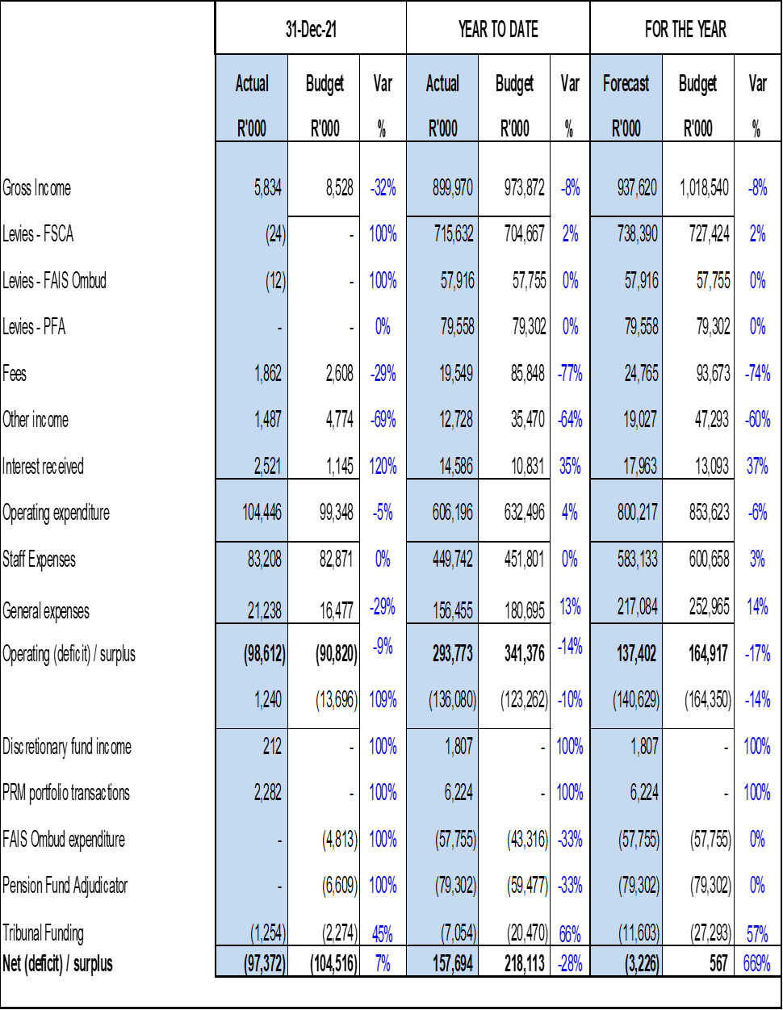

7.2.1 Staff Expenses

The table below lists staff expenditure items.

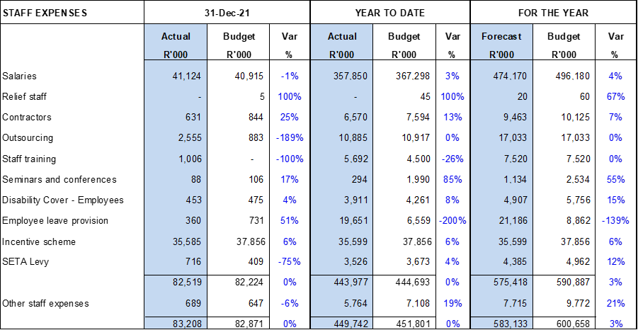

7.2.2 General Expenses

The table below lists general expenditure items.

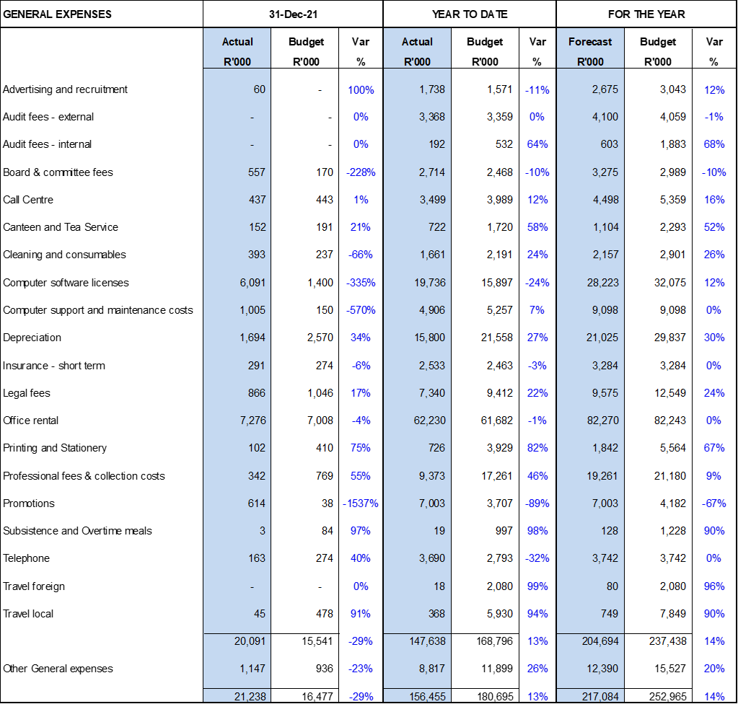

## Statement of financial position as at 31 December 2021

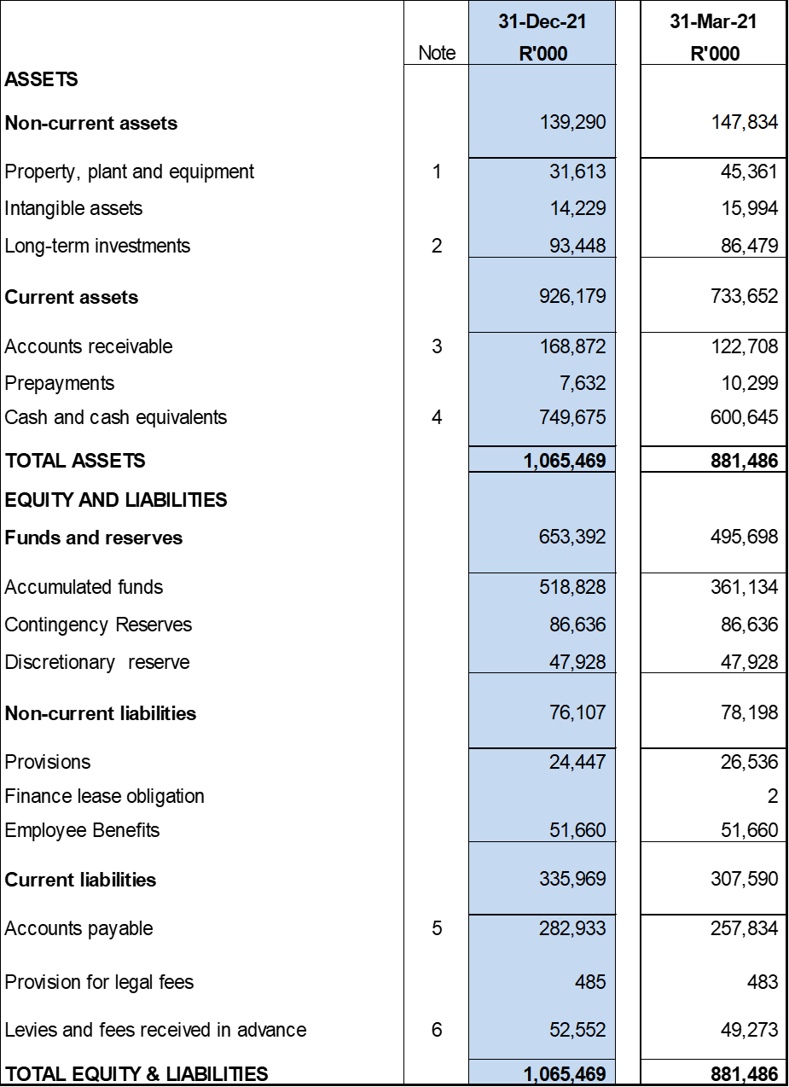

7.3.1 Notes to the Balance Sheet

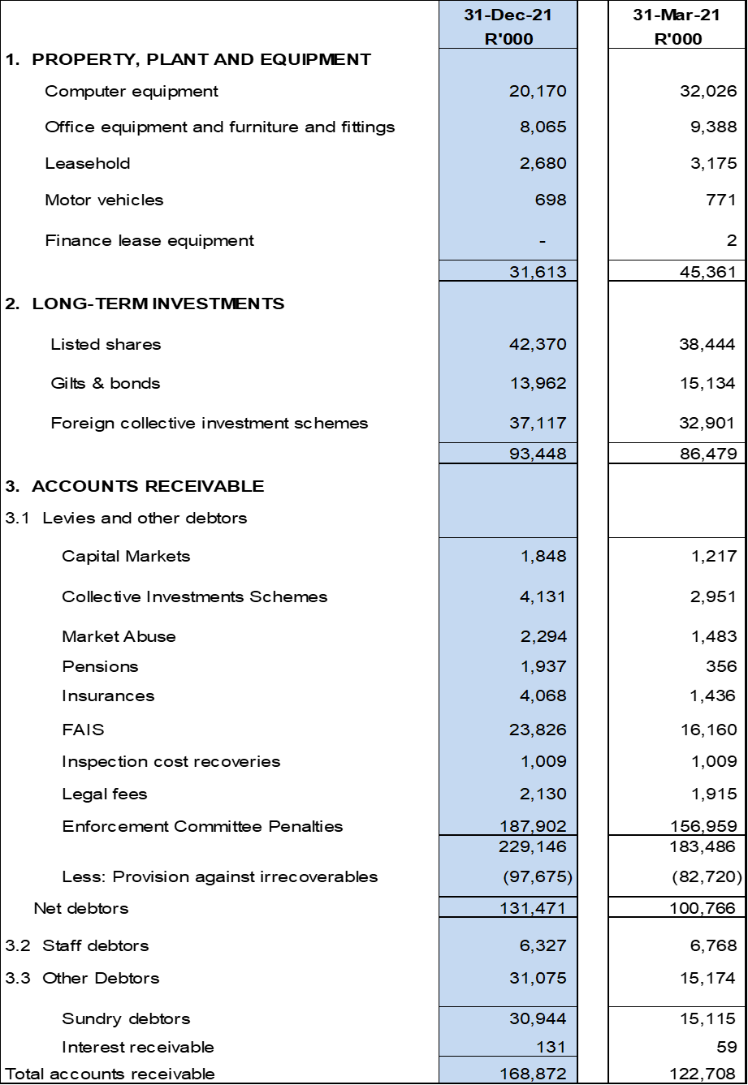

Notes to the Balance Sheet (Continued)

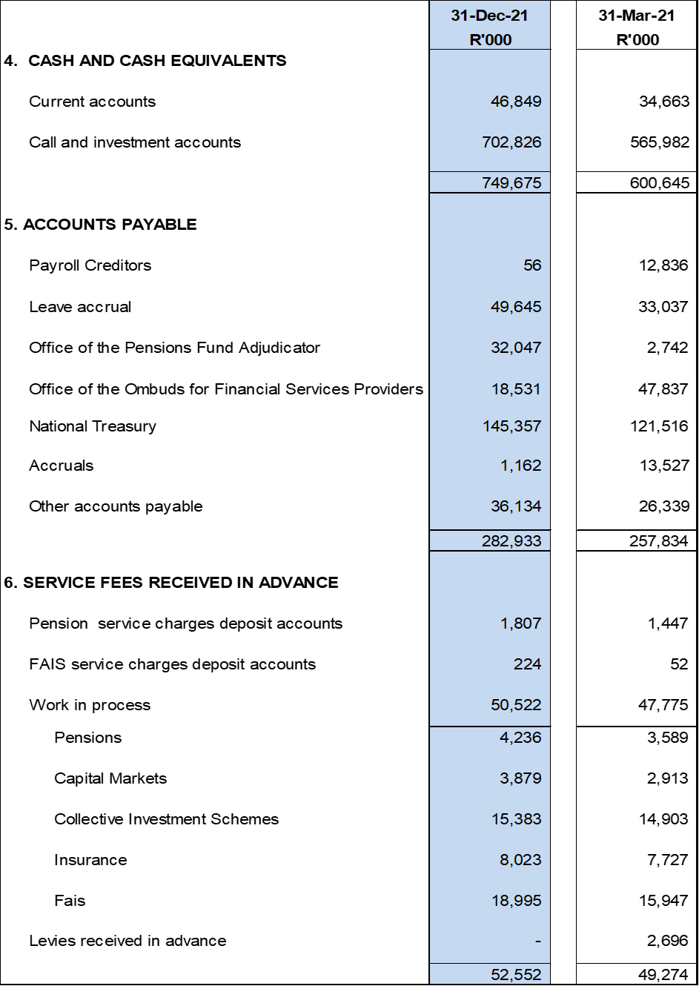

## Statement of cash flow for the period ended 28 September 2021



## Capital Expenditure Summary

A significant portion of the capital expenditure budget is allocated to computer equipment and computer software. The rebuilding of ICT infrastructure is well in progress. Also included in the budget is replacement of laptops and PCs that will be reaching the end of their useful lives in the current year.

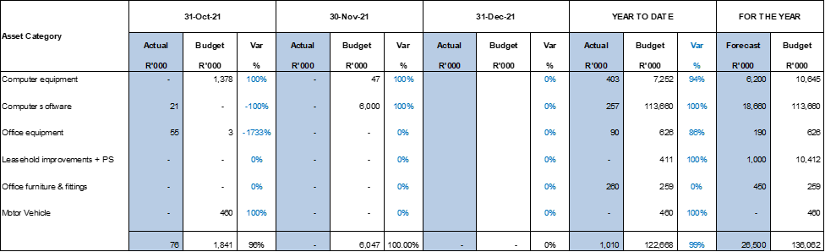

**Appendix A – FSCA Organogram**

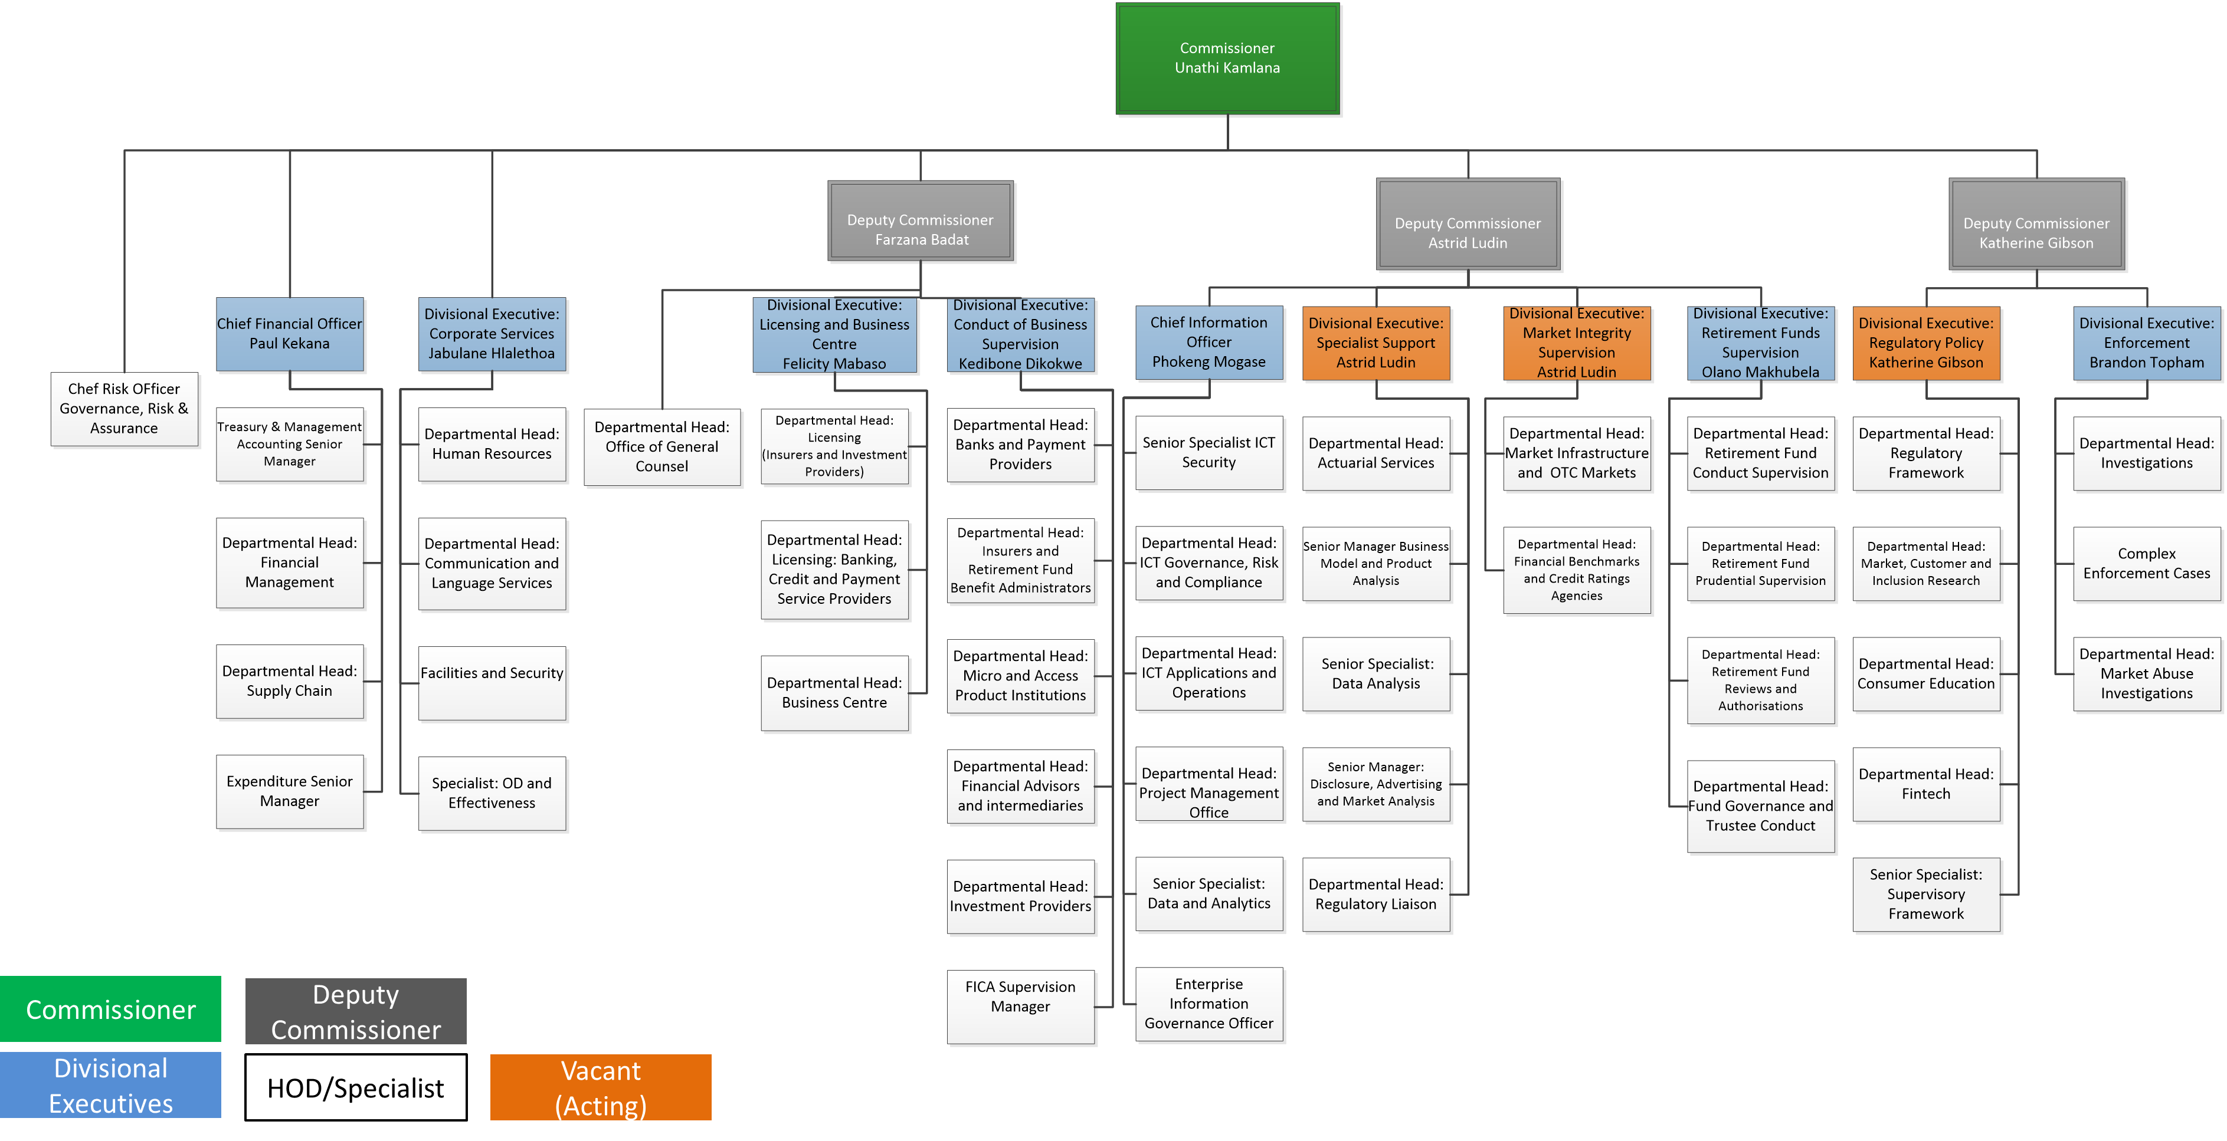

**Appendix B – FSCA Strategic Risk Register**







