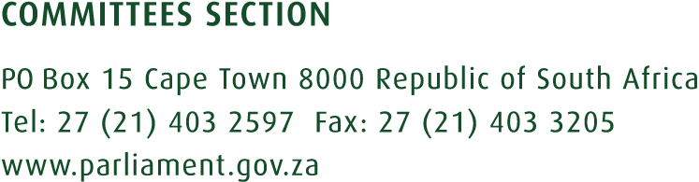
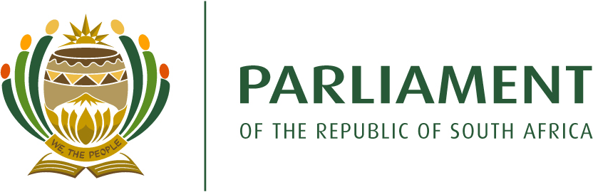

PORTFOLIO COMMITTEE ON WATER AND SANITATION

DRAFT PROGRAMME OF THE PORTFOLIO COMMITTEE ON WATER AND SANITATION OF THE SIXTH (6TH) PARLIAMENT,2ND TERM OF 2022
DATE | TIME | AGENDA | VENUE
TUESDAY,19 April 2022 | 09h30-13h00 | Briefing the Department of Water and Sanitation and SALGA on the proposed water tariffs determinations by Water Boards for the 2022/23 financial year.  Consideration and adoption of minutes.
 |  | NA Leave Period: 25 – 29 April
TUESDAY,3 May 2022 | 09h30-13h00 | Briefing by the Department of Water and Sanitation on Budget Vote 41 and Annual Performance Plan for the 2022/23 financial year.  Briefing by the Entities undertaking work on behalf of the Department of Water and Sanitation on their appropriated budgets and Annual Performance Plans for 2022/23 financial year.  - Breede-Gouritz Catchment Management Agency  - Inkomati-Usuthu Catchment Management Agency  - Water Research Commission  - Trans-Caledon Tunnel Authority | Virtual Meeting
TUESDAY, 10 May 2022 | 09h30-13h00 | Consideration and adoption of the Report of the Committee on the Budget Vote 41, revised APP and Strategic Plan of the Department of Water and Sanitation and Entities, 2022/23. | Virtual Meeting.
TUESDAY, 24 May 2022 | 09h30-13h00 | Briefing by the Department of Water and Sanitation on the Fourth Quarter Expenditure and Performance Report 2021/2022 financial year.  Consideration and adoption of minutes. | Virtual Meeting
TUESDAY, 31 May 2022 | 09h30-13h00 | Assessment, evaluation and analysis of the work of water boards for the period 2019 to date, in respect of mandate, institutional arrangements, governance, budget, operations, instituting directives and work of board members as prescribed through Chapter 6 of the Water Services Act, 1997.  Consideration and adoption of minutes. | Virtual Meeting
TUESDAY, 7 June 2022 | 09h30-13h00 | Briefing on the 2022 Green Drop Report and progress report of work undertaken to date by the Anti-Pollution Task Team.  Consideration and adoption of minutes. | Virtual Meeting
TUESDAY, 14 June 2022 | 09h30-13h00 | Workshop on legislation, policies and regulations in the water and sanitation sector – effectiveness and challenges in the water and sanitation sector  Consideration and adoption of minutes. | Virtual Meeting
Constituency period: 20 June-15 August 2022

