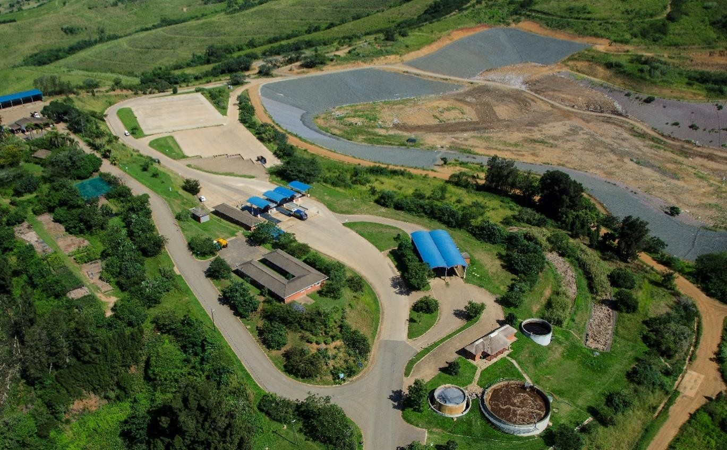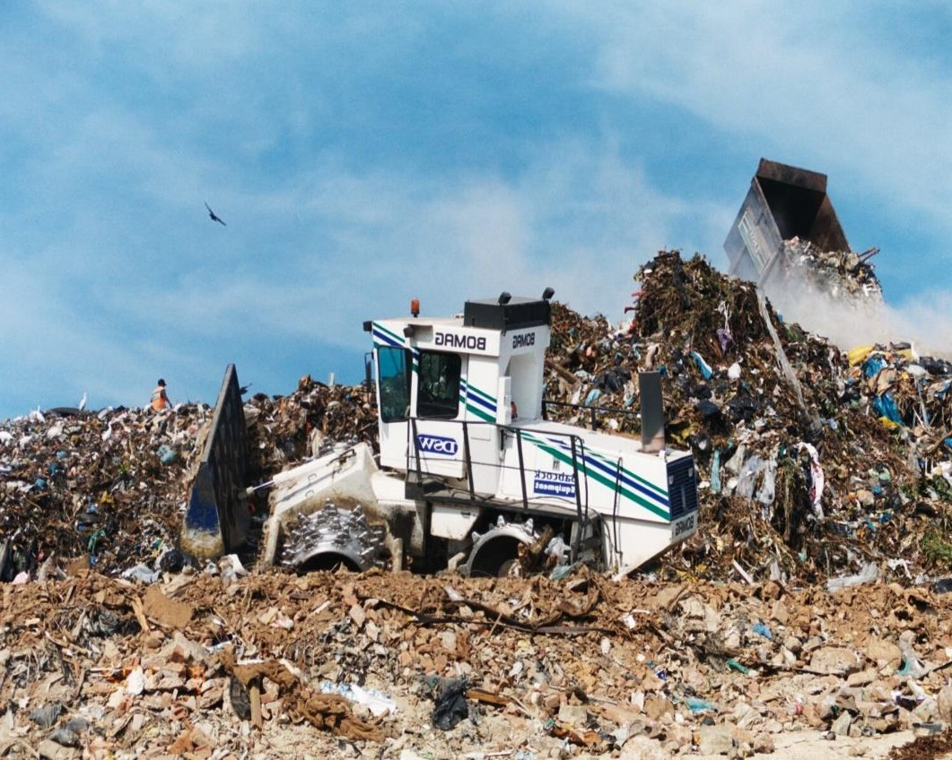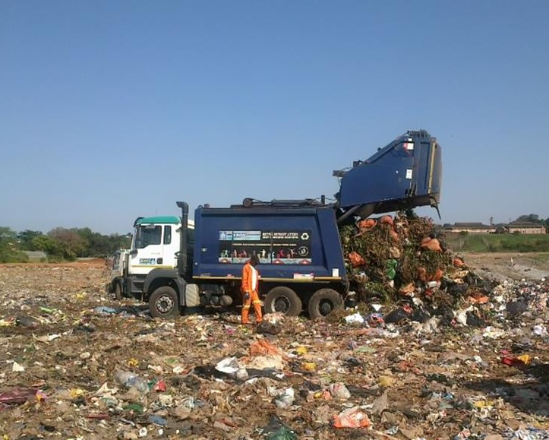

PORTFOLIO COMMITTEE ON ENVIRONMENT, FORESTRY AND
CLEANSING & SOLID WASTE
FISHERIES – eThekwini Waste Management 2022-02-18

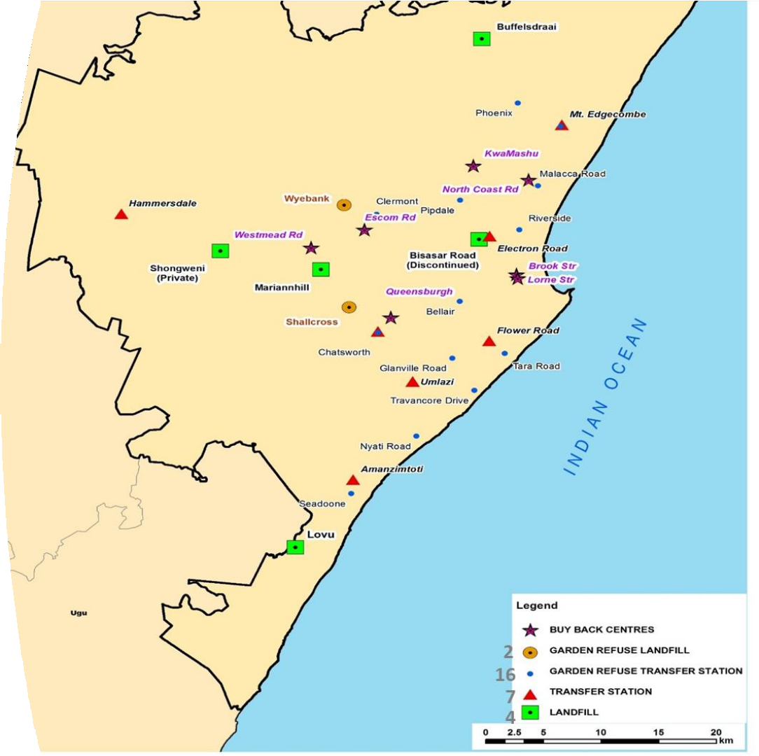

~1 400 000 tons per year

- 4 Landfill Sites

- 16 Garden Refuse Transfer Stations

7 Transfer Stations

- 2 Garden Refuse Landfills

WASTE COLLECTION STATUS

DESCRIPTION | HOUSEHOLDS
 | 2019/2020
Solid Waste Removal: (Minimum level) | Once a week
Removed at least once a week | 1 039 757
Solid Waste Removal: (Below minimum level)
Backlog | 218 000
Total number of households | 1 125 767
Breakdown:
Formal Settlements – households | 411 468
Informal Settlements –households | 628 289

Waste Management Context

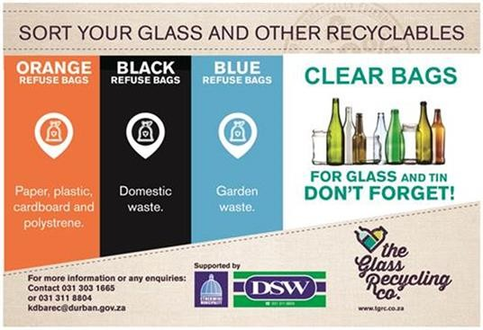EST. SOURCE SEGREGATION

I

NTEGRATED WASTE MANAGEMENT PLAN: BEEN ENDORSED

Durban
~1 400 000 t/a

95%
ESTIMATED
COLLECTION RATE

3400 t/d
ESTIMATED SOLID WASTE GENERATION

15%
TYPE OF SEG. 3 WAY: PAPER&PLASTIC / BOTTLES&CANS/

0.60 kg/d
EST. PER CAPITA
MSW GENERATION
RESIDUAL

SCARCE
DIVERSION FROM
LANDFILL

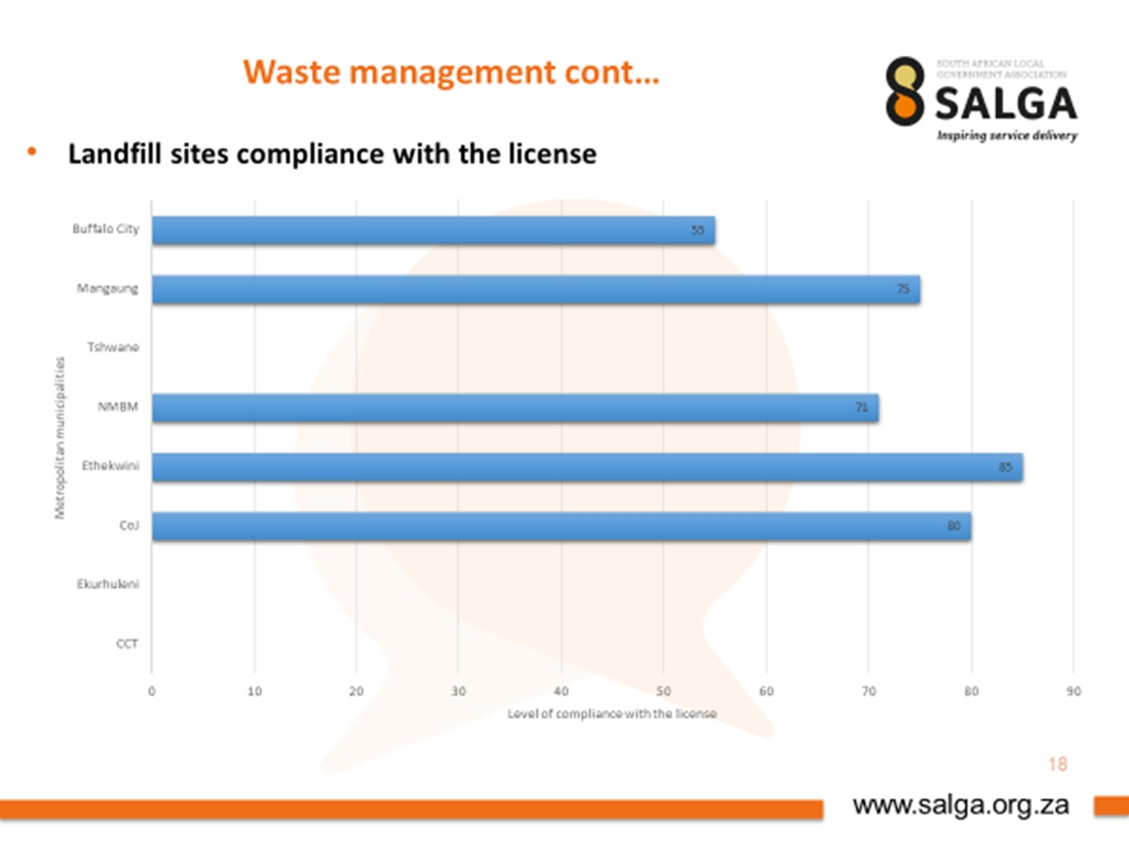
Landfill Sites

eThekwini Catchment Area | Central | West | North | South | New West
Landfill Site | Bisasar Road | Mariannhill | Buffelsdraai | Lovu | Shongweni
Focus Area
Design Airspace Capacity (m3) | 25,000,000 | 4,400,000 | 45,000,000 | 8,694,000 | 54,800,000
Remaining Airspace (m3) - Approx | 32,900 | 290,000 | 42,000,000 | 8,144,000 | 54,800,000
Tonnage Received (t/day) - Average | 1100 | ~1700 | 850 | 420 | 3000
5Year Airspace Development | 150,000 | 0 | 3,300,000 | 2,100,000 | 4,000,000
10Year Airspace Development | 0 | 0 | 4,100,000 | 6,200,000 | 7,000,000
Remaining Useful Life (Years) | 0.3 | 2.0 | 64 | 26 | 90
Closure Expansion New

Waste Routing

Clermont TS

Electron TS

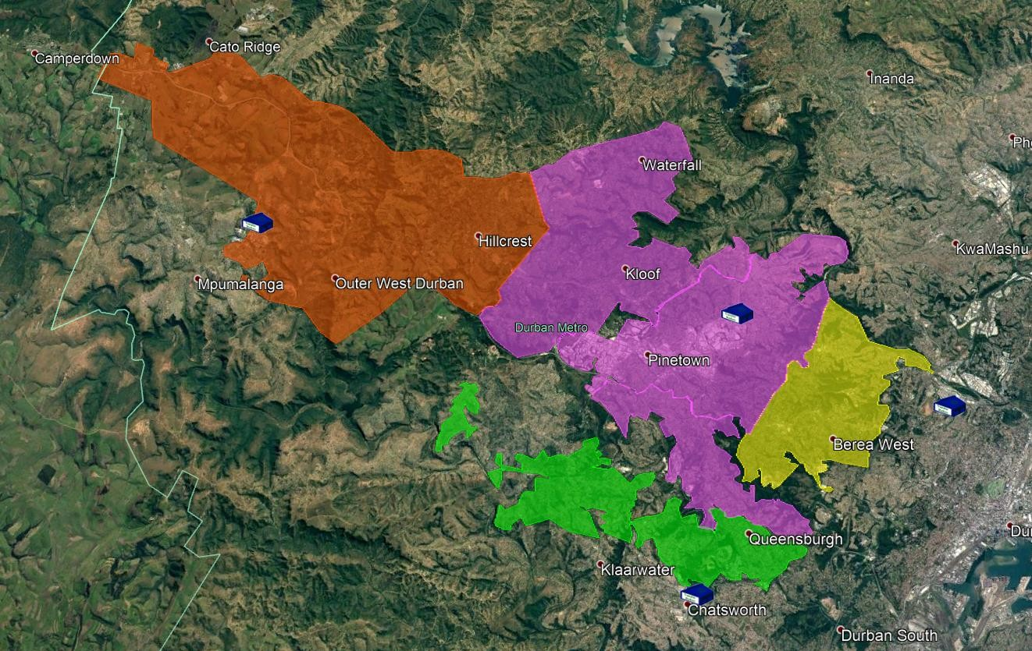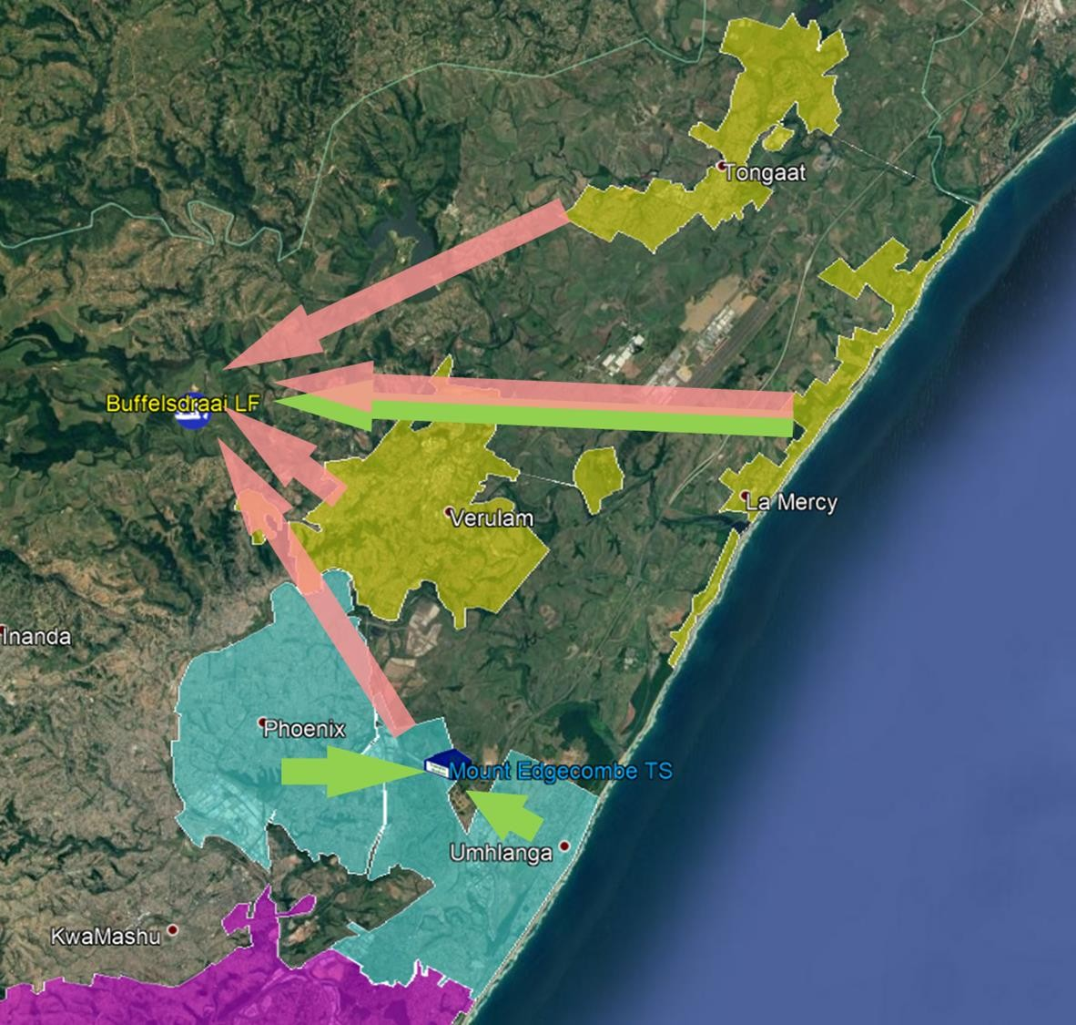Hammarsdale TS Chatsworth TS
- Overall Cost of WM has increased
  - Overtime
  - Maintenance
  - Hire
- Shongweni Waste Management Facility CRITICAL! To reduce OPEX

CHALLENGES & INTROSPECTION

LANDFILL AIRSPACE
- Imminent Landfill Site Closures
- New Landfill Delays with Authorities, Appeals
- 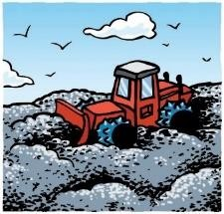Public Uprising – NIMBY, BANANA Syndrome
- Poor Market Uptake for Alternative
Waste Treatment

INFRASTRUCTURE STRAIN
- Asset Management Required
- Depot Degradation / Capacity
- Refurbishment / Upgrade Attention
- Equitable Provision for Female Staff
- Occupational Health & Safety Non- Compliances

Head: CSW

FLEET & HEAVY PLANT
- Aging Fleet with “Fleet Creep”
- Moratorium, Budget Cuts?
- Replacement Programme Backlog

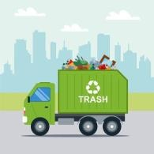TOUGH ECONOMIC TIMES
- City Competing Interest – Water, Electricity, Housing…Waste ?
- True Cost of Waste Management Vs Waste
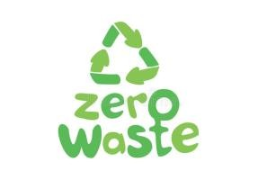Revenue?
- Resource Utilisation – Need to Optimise Big Cost Drivers
- COVID After Math Impact

ALTERNATIVE WASTE MANAGMENT
- Separation at Source (S@S) Roll Out
- Recycling, Waste Minimsation Model
- General Poor Market Uptake for Alternative Waste Model
- Lost Opportunities – Institutional Limitations

The Financial Model
Total Cost = Collection + Landfilling + Transfer Station

0 – 12.8 % of total cost 3
Landfilling

Transfer Station
Waste is processed in the transfer station and transported using 8x4 Hook-lifts to landfill.

Processing and final ₂
disposal of waste.

42.4 – 60.7 % of total cost
34.6 – 45.3 % of total cost

Collection
Waste is collected from
1
source and transportated to
either a transfer station or landfill. Collection is conducted with 4x2 & 6x4 REL’s.
34

OPTIMISATION AND RESOURCE UTILISATION

Job creation potential
GHG reduction potential Other operational
Budget increase

considerations (e.g. level
Pyrolysis Incineration
- Objectives of Solid Waste Management in eThekwini
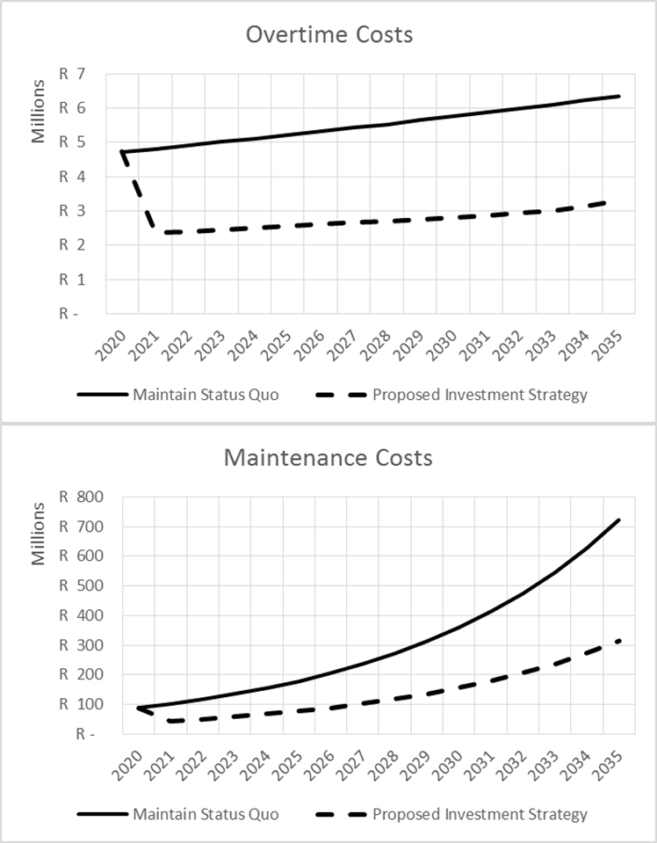
- Reduction of cost

- Increase of revenues

and type of segregation, waste composition, access roads, etc.)

Informal sector
Anaerobic Digestion Windrow composting

  - Creation of jobs

  - Diversion from landfill

  - Reduction of greenhouse gas emissions

  - Collection service for all residents

Technological sophistication

  - Proposed Scenarios

    - Scenario 1: Improvement of cost efficienc
    - Scenario 2: Comprehensive recycling
    - Scenario 3: Energy-from-waste strategy

PRESENTATION HEADING

TURN-AROUND?

LANDFILL AIRSPACE
- Existing Landfill Airspace Acceleration
- Closure Preparations – Legislative Compliance
- New Shongweni Landfill Development

FLEET & HEAVY PLANT
- Capital Investment Support
- Long Term (3Year) Contracts – City Fleet
- Replacement Programme Modelling
- Refurbishments & Maintenance Improvements

  - Waste Beneficiation TOUGH ECONOMIC TIMES
    - Cost Drivers – Reduction/Optimisation
      - Overtime
      - Maintenance

INFRASTRUCTURE STRAIN
  - CIDMS – Infrastructure Asset Mang
  - Depot Improvements – Architecture
  - Life Cycle & Maintenance Planning
  - Equitable Provision for Female Staff
  - Conditional Assessments
  - Change Management & Project Management – Focus on Development

Head: CSW
    - Hiring
  - Business Recovery Modeling – Revised Tariff
  - Efficiencies & Better Resource Utilization
    - Round Balancing, Shifts?
  - Waste as a Resource – Decrease City Expenditure

ALTERNATIVE WASTE
MANAGMENT
  - Separation at Source (S@S) Intensification
  - Recycling, Waste Minimisation Re-Model
  - Education & Awareness Drives
  - Integrated Waste Management Planning
  - Beneficiation of Waste – Changing Mindset
  - Institutional Review

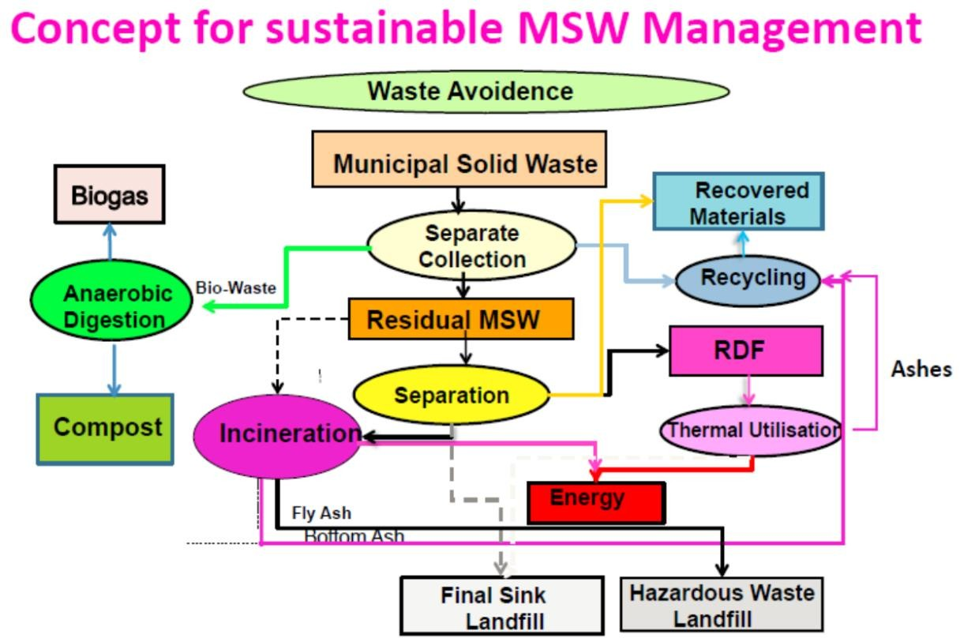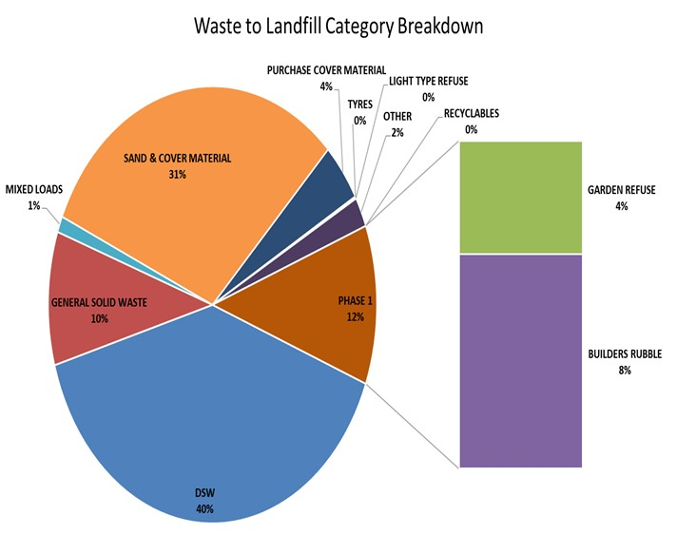DURBAN’S PROPOSED IWMP
OUTLOOK
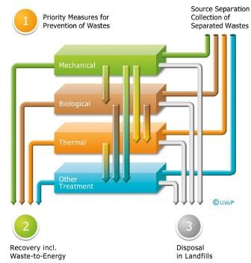

INVESTMENT, JOBS AND INCLUSIVE GROWTH
NOT BUSINESS AS USUAL & TRANSITION TOWARDS WASTE AS A RESOURCE

“We must give priority to the urgent and necessary work required to ensure the stability of electricity supply. This means that we must both accelerate the introduction of new electricity generation”

“We need to take decisive measures to reduce our carbon footprint, in line with our international commitments, in a manner that is
sustainable and ensures a just transition for workers and communities that may be affected by a shift to a lower carbon economy.”

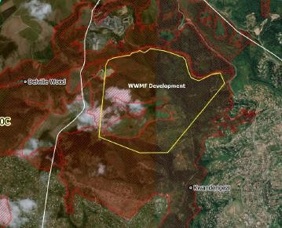LVE IT!
…WE CAN SO

CHECK LIST

LAND

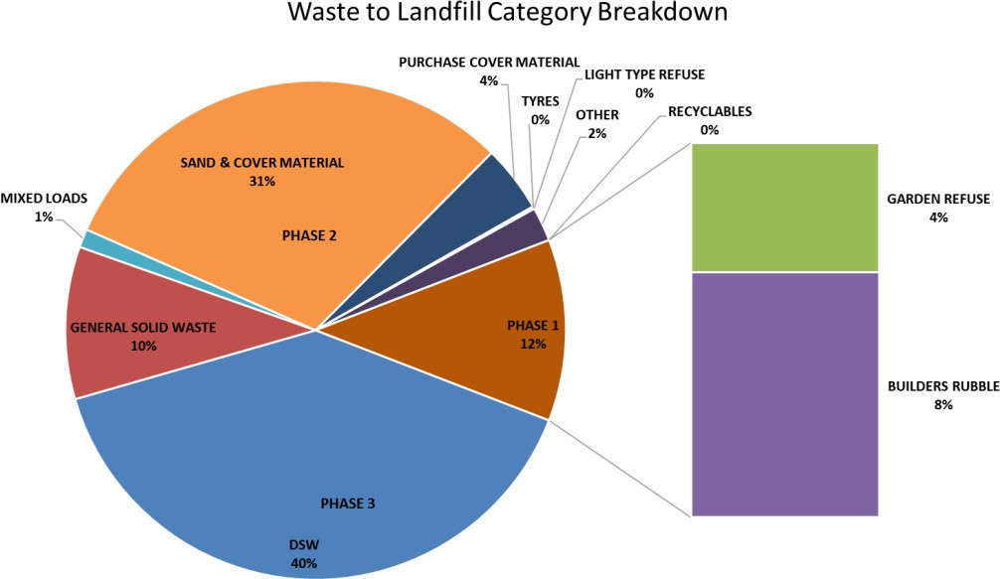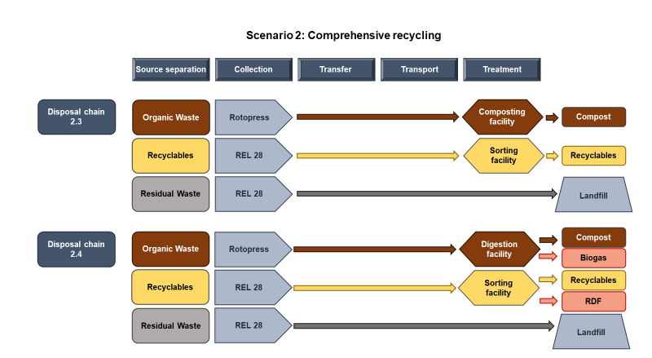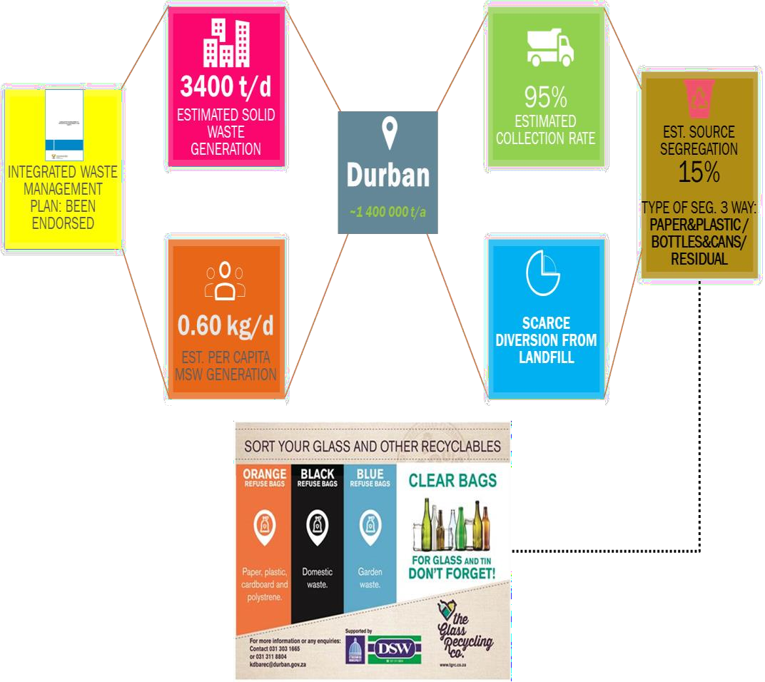

550Ha

FEEDSTOCK
- MARKET OFF TAKE

Project Status: Landfill Design Underway 75Years Airspace Capacity
- Due Diligence & Gaps Done

Local Confidence Data

Composting
- 36 000-75 000ton/annum
Future Integrated Opportunities

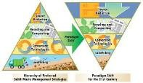
Potentials

- Compost / Soil Amelioration - Agriculture
- Emissions Trading ~ SA Carbon Tax

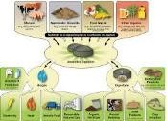
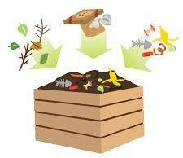
Construction & Demolition Waste
- 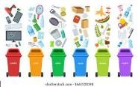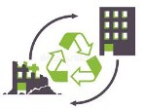170 000 ton/annum
- Recycled Aggregate for Green Applications
- PPP Potential

Anaerobic Digestion 150 000 tons/annum Organics
- 40 000 Nm3/day Biogas
- Contract Participation Goals: Compliance to PPPFA – 30%. Vehicle through normal structures (Ward Councillor – ward etc)
- Job Creation
- Climate resilience and environmental protection
- An alternative circular economy from waste
as a resource and Carbon Offset Model Market value increase with an opportunity for land value capture
- Health Improvements to Citizens
- Bufferzone model as per other landfills for ECA and CBA

Materials Recovery
  - 8-12% of Total Waste
  - Paper, Plastic, Cardboard, Cans & Bottles
SCHEDULE
- Master Plan and Conceptual design completed
- Detailed Design – 2021
- Construction – 2023-2025 Phase 1 Landfill

