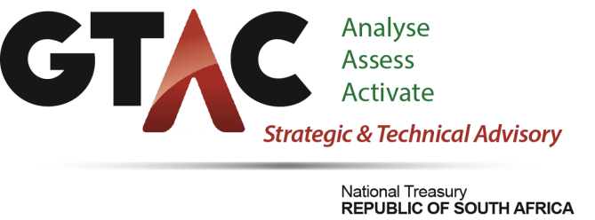
Financial Year
AGSA Audit Outcome for 2020-21

Overall Audit Outcome
- The audit outcome of GTAC for the 2020-21 financial year is an ‘unqualified audit with findings’
- This remains unchanged from the unqualified audit with findings that was achieved in the prior year.
- GTAC was able to achieve most of the strategic objectives, a marked improvements from prior year audit.
- There were no material misstatements on the submitted annual financial statements.
- Note must be taken that there was about 83% reduction in irregular expenditure compared to the prior year i.e. (2020-21: R1.4 million and 2019-20: R8.2 million).
- The findings were in the following areas:
  - Usefulness and reliability of reported performance information i.e. one (1) key performance indicator was not well defined to adhere to the SMART criteria.
  - Non-compliance with the SCM legislation that resulted in irregular expenditure.

Summary of the key root causes identified
- Lack of strict monitoring of useful and reliable performance information.
- Insufficient preventative controls to ensure compliance with SCM legislation.
- Accounting officer position is vacant and currently appointed on an acting capacity.

Management actions implemented
- Audit action plans were reviewed by Internal Audit and the Audit Committee to ensure that they address the root cause with specific focus on compliance with SCM legislation. The internal audit unit independently monitor the action plans and the audit committee exercises oversight. Preventative controls on SCM compliance have been strengthened and SCM training improved.
- A policy and standard operating procedures were put in place to ensure that performance indicators are well defined and adhere to the SMART criteria. Consultations are also made with the DPME and Internal Audit before the APP is finalised to ensure adequate performance indicators. The audit committee also exercises monitoring and oversight.
- Investigations of all reported irregular expenditure were finalised by the Internal Audit unit and the process of determining the breakdown in internal control, to initiate disciplinary actions, is underway. Submission to request OCPO to condone the irregular expenditure will be instituted thereafter. Consequence management processes have been prioritised by management and the audit committee tracks consequence management on a quarterly basis.

