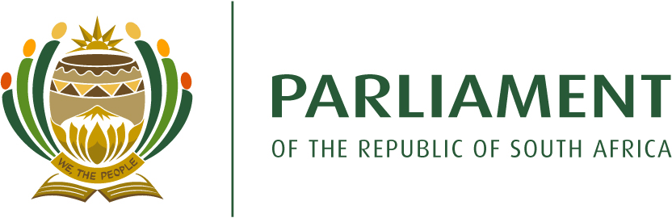

PORTFOLIO COMMITTEE ON TRADE AND INDUSTRY
SIXTH PARLIAMENT
PROGRAMME FOR 4th QUARTER FOR 2021
(dated 26 November 2021)
Committee Business
Legislation
Budgetary oversight
Oversight

Date | Venue | Time | Agenda
Constituency period

13 – 24 December 2021

Leave period

27 December 2021 – 7 January 2022

Constituency period

10 - 24 January 2022

Tuesday, 25 January 2022 |  | 09:00 – 12:00 | Briefing by the NRCS on its 2020/21 Annual Report, including first and second quarter financial and non-financial performance for the 2021/22 financial year
Wednesday, 26 January 2022 |  | 09:00 – 12:00 | Briefing by the DTIC and the B-BBEE Commission on the Equity Equivalent Investment Programme as well as on the BBBEE Commission’s activity over the past financial year
Tuesday, 1 February 2022 |  | 09:00 – 12:00 | Briefing by the DTIC on Trade Policy and an update on trade negotiations as well as implementation of trade agreements
Wednesday, 2 February 2022 |  | 09:00 – 12:00 | Briefing by the DTIC on its 2nd and 3rd quarter financial and non-financial performance for the 2021/22 financial year
Tuesday, 8 February 2022 |  |  | Briefing by the Competition Commission and Competition Tribunal on outcomes on matters considered by the Tribunal
Thursday, 10 February 2022

State of the Nation Address
Tuesday, 15 February 2022 |  | 09:00 – 13:00 | Response from the DTIC and Adv vd Merwe on submissions received wrt the Copyright Amendment Bill
Wednesday, 16 February 2022 |  | 09:00 – 12:00  12:00 – 13:00 | Deliberations on submissions received wrt the Copyright Amendment Bill
 |  |  | Consideration of the first draft report on the 2nd and 3rd quarter financial and non-financial performance of the DTIC
Friday, 18 February 2022 |  | 09:00 - 12:00  12:00 – 13:00 | Deliberations on submissions received wrt the Copyright Amendment Bill
 |  |  | Formal consideration of the report on the 2nd and 3rd quarter financial and non-financial performance of the DTIC
Tuesday, 22 February 2022 |  | 09:00 – 12:00 | Deliberations on submissions received wrt the Copyright Amendment Bill
Wednesday, 23 February 2022 |  |  | Deliberation on / consideration of the Copyright and the Performers’ Protection A/Bs
Wednesday, 23 February 2022

Budget Speech
Friday, 25 February 2022 |  |  | Deliberation on / consideration of the Copyright and the Performers’ Protection A/Bs
Tuesday, 1 March 2022 |  |  | Deliberation on / consideration of the Copyright and the Performers’ Protection A/Bs
Wednesday, 2 March 2022 |  |  | Consideration of the C and D Bills of the Copyright and the Performers’ Protection A/Bs
Tuesday, 8 March 2022 |  |  | Formal consideration of the Copyright and the Performers’ Protection A/Bs
Wednesday, 9 March 2022 |  |  | Briefing by the DTIC, NRCS and SABS on the Public Protector’s Report regarding the illegal conversion of goods carrying Toyota Quantum Vans into passenger carrying minibus taxis
Tuesday, 15 March 2022 |  |  | Briefing by the DTIC on Covid-19 initiatives
Wednesday, 16 March 2022 |  |  | Briefing by the DTIC on the 2020/21 Annual Incentive Report
Monday, 21 March 2021

Human Rights Day
Tuesday, 22 March 2022 |  |  | Engagement with stakeholders wrt the implementation of the Retail Clothing, Textiles, Footwear and Leather Value Chain Master Plan
Wednesday, 23 March 2022 |  |  | Engagement with stakeholders wrt the implementation of the South African Sugar Value Chain Master Plan
Tuesday, 29 March 2022 |  |  | Briefing by the DTIC on its Strategic and Annual Performance Plans, which will reflect on SONA and Budget as it relates to its  Consideration of Committee’s 2nd Quarter Programme
Constituency Period: 4 – 14 April 2022

