National Treasury & SARS
Per email:
2020AnnexCProp@treasury.gov.za
acollins@sars.gov.za
Ulreich Tromp
Director External Affairs
e: ulreich.tromp@pmi.com
t: +27 82 294 7600

31 March 2021

COMMENTS ON DRAFT RATES AND MONETARY AMOUNTS AND AMENDMENT OF REVENUE LAWS BILL 2021

Your invitation of 24 February 2021 for written comments on the contents of the above draft publication (“the Draft Bill”) refers.

Our comments below relate specifically to Schedule II Part I (Section 5) of the Draft Bill, with heading Amendment of Part 2A of Schedule No. 1 to the Customs and Excise Act, 1964’. More specifically, our comments relate to the Rate of Excise Duty (“ROD”) and the base for calculation for Tariff Item 104.35.14 / Tariff Subheading 2403.99.05 of R7.05/10 sticks.

Rate of Excise Duty

We are not contesting the fact that an excise tax has been imposed for heated tobacco products (“HTPs”). We do however wish to highlight that the current ROD for HTPs, being 25% less than that of cigarettes, is significantly below the excise tax differential in most of the other countries where these products are now available and where switching out of cigarettes, as the most harmful way of consuming nicotine, is being partly driven through excise tax policy.

Please see Table 1 below, as published in public databases, that shows the excise tax for HTPs in the European Union (“EU”) being on average 72% less than the excise tax on cigarettes. A low excise tax differential, as is the case in South Africa, could be viewed as de facto support for cigarettes and other combusted tobacco products.

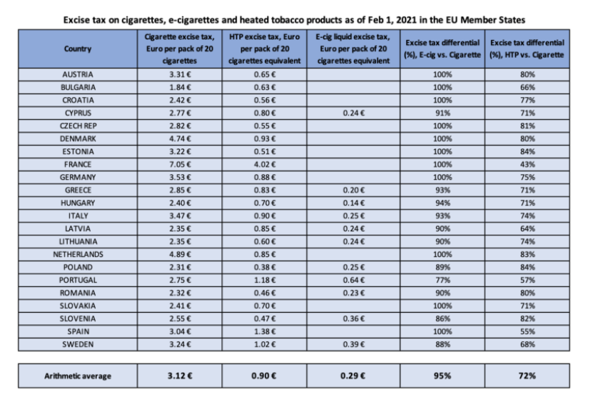
Table: Excise tax differential between HTPs and cigarettes in the EU

In the area of tobacco taxation, the promotion of public health goals has been articulated into two key priorities: preventing smoking initiation and encouraging cessation.

The tobacco and nicotine market has changed greatly in recent times with a new and different category of products, including electronic cigarettes and HTPs (together “Non-Combusted Tobacco and Nicotine Products”) appearing on the market and growing in demand.

The defining feature of this new category of products is that unlike combusted tobacco products (i.e. cigarettes, cigarette tobacco, pipe tobacco, cigars and cigarillos), they operate by heating a liquid (electronic cigarettes) or by heating a specially prepared tobacco mixture as is the case with HTPs to deliver a vapour that is not smoke, as no combustion take place.

As there is no combustion and no smoke being produced, these Non-Combusted Tobacco and Nicotine Products generate significantly lower yields of harmful and potentially harmful constituents compared to combusted tobacco products, such as cigarettes. This technological development offers an unprecedented opportunity to improve public health by offering better alternatives to adult smokers who would otherwise continue to smoke.

Regulatory and fiscal policies play a crucial role in ensuring that such an opportunity is realised, including making Non-Combusted Tobacco and Nicotine Products available to adult smokers, who would otherwise continue to smoke, as some of the leading scholars have stated in an article published in the New England Journal of Medicine:

“Policymakers should consider an approach that differentially taxes nicotine products in order to maximize incentives for tobacco users to switch from the most harmful products to the least harmful ones.”

The framework could be further enhanced with product standards for scientifically substantiated Non-Combusted Tobacco and Nicotine Products. These products should be subject to lower taxation than higher risk products according to the principle of risk-based taxation (i.e. higher risk-higher tax / lower risk-lower tax).

Scientific evidence is already available today to conclude that these products are vastly different from combusted tobacco products. For reference, the U.S. Food and Drug Administration’s (“FDA”) modified risk tobacco product authorization (“MRTPA”) of IQOS (our Non-Combusted Tobacco product available in South Africa) confirms that IQOS is fundamentally different from cigarettes. The FDA concluded that the issuing of exposure modification orders for the IQOS tobacco heating system is “appropriate to promote the public health” and “scientific studies have shown that switching completely from conventional cigarettes to the IQOS system significantly reduces your body’s exposure to harmful or potentially harmful chemicals”.

Considering the vastly different characteristics and risk profiles of Non-Combusted Tobacco and Nicotine Products compared to combusted tobacco products, significantly different tax policies on these products (i.e. combusted tobacco products taxed significantly higher than Non-Combusted Tobacco and Nicotine Products) would accelerate a complete switch out from cigarettes and other combusted tobacco products.

Recommendation

If countries decide to levy excise tax on Non-Combusted Tobacco and Nicotine Products, PMI recommends that their excise tax level should be below the lowest excise tax level applied to any combusted tobacco product.

Base for Excise Duty Calculation

In the United Kingdom (“UK”), the Government ran a public consultation on the tax treatment of HTPs from 20 March 2017 to 12 June 2017 and published the Government’s response to the public consultation on March 2018.

In response to the public consultation questions on the appropriate tax base for HTPs, the UK Government said:

“2.41 The government notes the consensus among respondents that weight is the best way to calculate the duty on heated tobacco products.” [p.8]

“2.42 The government has therefore decided that the duty on heated tobacco should be calculated based on weight as this will provide flexibility and ensure that the duty will be based on the amount of tobacco in the product.” [p.8]

In the Next Steps Section of the same document, the UK Government mentioned:

“3.7 The duty on heated tobacco will be calculated based on the weight of the tobacco as this will provide flexibility and ensure that the duty will be based on the amount of tobacco in the product rather than the weight of the total capsule.” [p.12]

Following the UK Government’s response to the public consultation, a new HTP excise tax category was created effective July 1st, 2019 and the tax base changed from full product weight to tobacco mixture weight resulting in an approximately 80% differential between the excise tax for HTPs compared to cigarettes.

We support the above view from the UK as HTPs come in many different formats with different amounts of tobacco content applying per use to different technologies. Thus, a practical and equitable tax base would be the net weight of the tobacco mixture, rather than per stick or the gross weight of the consumable, which are both currently options in South Africa and open to possible tax loopholes and excise tax collection / administration difficulties. A system based on the weight of the tobacco mixture would also not necessitate changes to the tariff schedule each time a new format of HTP is introduced to the South African market.

Recommendation

Our recommendation is that (i) Tariff Subheading 2403.99.90 be deleted; (ii) that Tariff Subheading 2403.99.05 remain but be amended to read “Products intended for inhalation without combustion” (removing the reference to “put up for retail sale in the form of sticks”) as it will capture the whole heated tobacco product category; and (iii) that excise tax be levied on a /kg net basis to ensure a level playing field.

----------

Thank you for the opportunity to comment on the Draft Bill. We look forward to engaging further on the above matters and remain at your disposal for any further queries or information you may require.

Yours sincerely,

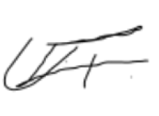

Ulreich Tromp
Director External Affairs

https://vaporproductstax.com/european-commission-expected-to-revise-tobacco-excise-directive/
Frank J. Chaloupka, Ph.D., David Sweanor, J.D., and Kenneth E. Warner, Ph.D., Differential Taxes for Differential Risks — Toward Reduced Harm from Nicotine-Yielding Products, n engl j med 373;7
https://www.fda.gov/media/139796/download
https://www.gov.uk/government/consultations/tax-treatment-of-heated-tobacco-products
https://assets.publishing.service.gov.uk/government/uploads/system/uploads/attachment_data/file/688858/heated_tobacco_consultation_response_web.pdf
https://www.gov.uk/government/publications/rates-and-allowances-excise-duty-tobacco-duty/excise-duty-tobacco-duty-rates

