Question
Reference made to the investment in private healthcare infrastructure or private healthcare providers
Response
This question was raised in relation to this slide with dealt with the segregation of the duties between the state as the funder and the state as a healthcare provider:
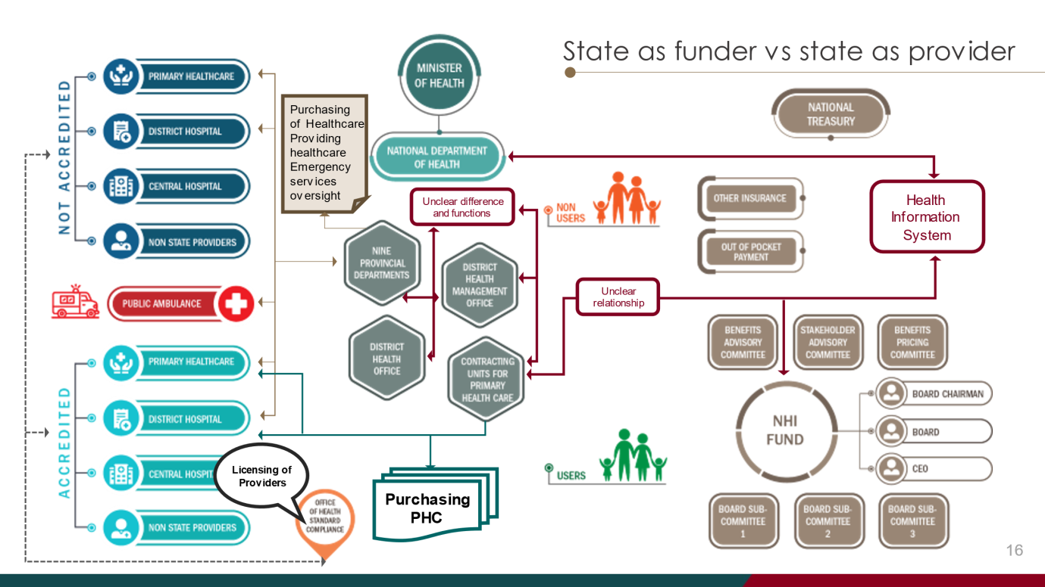
We raised the issue that the NHI Fund provided the opportunity for the segregation between the state as the provider of health care services and the state as the funder of health care via the NHI Fund. We mentioned that this segregation would provide an opportunity for improved accountability and governance but at the same time would enable the NHI Fund to leverage the private sector infrastructure and resources. We did however stipulate that we believed that there should be a restriction on investment in private health care facilities. The question was where this was permitted in terms of the NHI Bill.
Section 11(1)(d) stipulates that the fund "may in the prescribed manner and subject to national legislation, invest any money not immediately required for the conduct of its business and realise, alter or reinvest such investments or otherwise manage such funds or investments."
We would suggest that section 11(1)(d) is narrowly construed by regulations to limit the types of assets which the NHI Fund can invest in and to specifically exclude investment in any healthcare delivery infrastructure or organisation including in the public and private sectors to maintain the accountability between the funder and the health care provider.
This is also specifically dealt with in paragraph 19 of the executive summary of our submission at paragraph 85.
Question
Reference in the Bill that excludes parliamentary oversight
Response
The question seems to relate to the following slide:
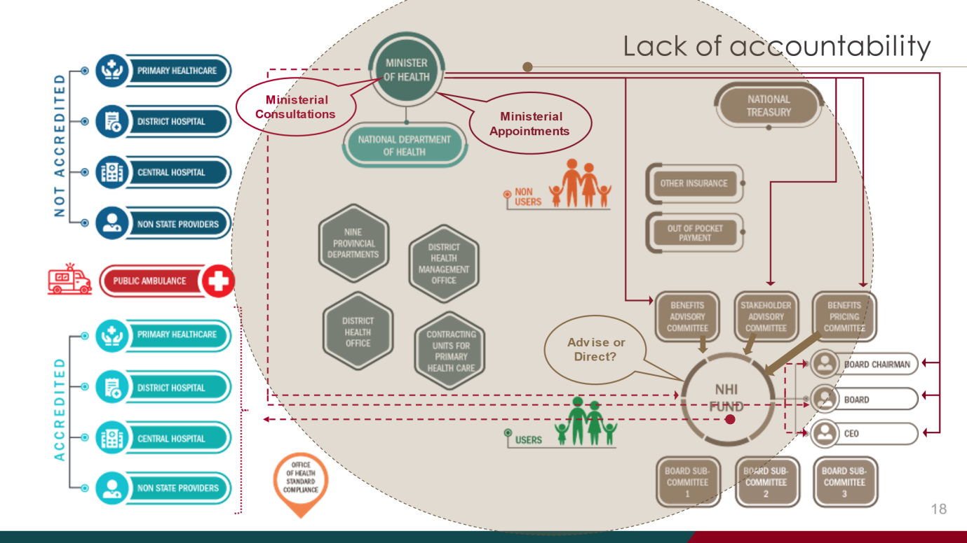
What we raised from a lack of accountability perspective were our concerns firstly regarding the proposed governance structures of the NHI Fund board in that the role of the Minister of Health was substantial in that the NHI Bill grants the Minister the powers to hire and fire the CEO and to determine the benefits provided by the NHI Fund. Effectively what this means is that power is concentrated in an individual and not in the board which should be the governing body of the NHI Fund. Our comment was that legislators should consider, when drafting, that they bear in mind office bearers with dubious objectives and not only draft it in favour of a "good" Minister who has the best interests of the NHI Fund at heart.
Although the PFMA and similar legislation would apply to the fund, the PFMA and similar legislation applies to the Road Accident Fund, for instance, which is well-publicized to not be in a financially stable state currently. Given the financial decimation of the RAF, currently unless a party has individual life insurance or disability insurance, him or his dependants are completely at risk should he be injured or die in a road accident. The poor are even far worse off given the fact that they do not have the means to procure life or disability insurance independently of the cover provided by the RAF. Accordingly, although the PFMA would apply to the NHI Fund, we do not believe that, in a public sector environment with significant audit findings, that the ordinary South African is protected in the event that funds are misappropriated from the NHI Fund despite the existence of the PFMA.
The Board of the NHI Fund should report to the Minister of Health, but appointments to the Board should be made, not by the Minister, but by Parliament as the elected representatives of the people to ensure that the vulnerable are not exposed without any recourse when they need that health care the most.
Section 13 grants the power of the appointment and dismissal of board members by the Minister and not by Parliament. Our in-depth comments in this regard are provided in the section entitled "Corporate Governance of the NHI Fund" set out in paragraphs 56 to 68 of our submission and in paragraphs 12 and 13 of the executive summary to our submission.
Question / statement
Medical schemes reinforce apartheid system of medical schemes
Response
Although the concept of medical aid funds pre-date the Constitution of the Republic of South Africa, 1996, it should be noted that the Medical Schemes Act constituted a complete revision of the legal framework and came into effect on 1 February1999. Currently one of the largest medical schemes in South Africa is the Government Employees Medical Scheme; whose membership is predominantly "black", as that term is defined in the Broad-Based Black Economic Empowerment Act 53 of 2003. Ultimately a person who requires health care should receive that health care in the best facilities available in the country regardless of their socio-economic conditions and this is precisely the view that the BHF is expounding i.e. that the NHI Fund can exist in parallel with medical schemes, that more individuals who are currently a burden on the state are accommodated through low-cost benefit options in the private sector to alleviate the pressure on the state so that the state can concentrate on providing cover for the poor. Nothing stops the NHI Fund from procuring those services from the private sector and the public sector could, through public-private partnerships or concession arrangements reach agreements with private healthcare funders to provide care to the level provided in the private sector by the private sector to public sector patients. That is precisely the view expressed in relation to the following slide:
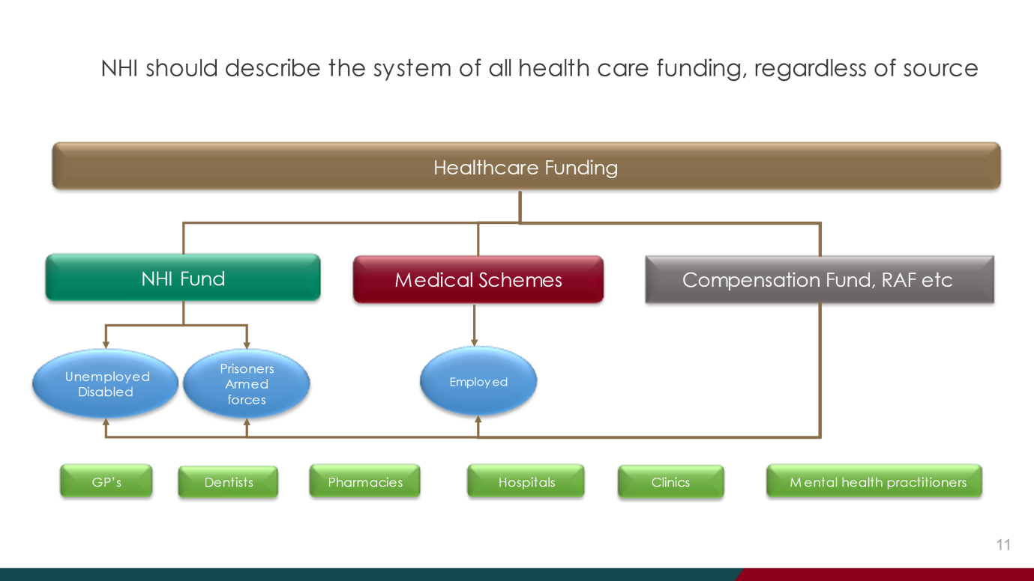
As we reiterated throughout our presentation, healthcare funding versus healthcare service provision must be separated so that just as a person receiving a disability pension from SASSA applies those same funds to buy groceries at Shoprite as compared to a person who receives a salary from an employer in the private and/or public sector does, the funds from the NHI Fund (which could operate as a medical scheme) may be applied to the purchase of health care services whether in the public or the private sector.
Question
Right of access to health care and specifically in light of the provisions of section 27(2) of the Constitution
Response
The relevant provisions of section 27(1) of the Constitution of the Republic of South Africa, 1996 (Constitution) states that "Everyone has the right to have access to health care services, including reproductive health" (our emphasis).
Section 27(2) of the Constitution states that "The state must take reasonable legislative and other measures, within available resources, to achieve the progressive realisation of each of these rights". (our emphasis)
The first point is that section 27(1) refers to "everyone" i.e. not only the poor and vulnerable, but the more well-heeled as well. This is line with the judgment of the Constitutional Court in Government of the Republic of South Africa & Others v Grootboom & others 2001 (1) SA 46 (CC). In that judgment, the Constitutional Court held the following:
In this regard, there is a difference between the position of those who can afford to pay for housing, even if it is only basis though adequate housing, and those who cannot. For those or can afford to pay for adequate housing, the State's primary obligation lies in unlocking the system, providing access to housing stock and a legislative framework to facilitate self-built houses through planning laws and access to finance. Issues of development and social welfare are raised in respect of those who cannot afford to provide themselves with housing. State policy needs to address both these groups.
This does not exclude the person who can afford to pay for health care to source that health care independently of the health care provided by the State but places an obligation on the State to "unlock the system" and provide a "legislative framework to facilitate" this right of access.
Our view therefore is that the State needs to provide that access to healthcare together with a legislative framework which is provided in the Medical Schemes Act 131 of 1998 (MSA).
Section 27(2) of the Constitution requires the State must progressively realise the right to access to health care "within its available resources" and this is understandable given that the State does not have unlimited resources. Our view though is that the "progressive realisation" contemplated in section 27(2) should apply to "everyone" as set out in section 27(1) and not only the indigent at the expense of those that can afford private health care funding. Ultimately the BHF has throughout reiterated its support of universal health care coverage and, recognising the "within its available resources" in section 27(2), has suggested that the State conserve and apply its resources to the vulnerable and that people with the means to access private health care funding, should do so. We have furthermore suggested that the State is unnecessarily assuming a burden of funding people in the public sector that could, through medical scheme reform, be funded in the private sector; thereby alleviating the financial burden on the state and the public and private funding environment can co-exist with the aim ultimately through socio-economic upliftment, transferring more people from public funded health care to private funded health care. Importantly, we do not see that the access to the health care (where funding is provided in the public sector) should be restricted to the public sector. In fact (outside the scope of this submission) our view is that the burden of funding public health care facilities can be managed through public-private partnerships so that a person who accesses that funding can do so either in the public or the private sector (to the extent that government wishes to continue to operate public health care facilities) and there is no differentiation on health care service delivery other than the source of funding. We believe that this approach is more in line with the progressive imperative of section 27(2) of the Constitution but believe that the easiest way of doing this is to reduce the burden on the State. This was what was intended by the following slides:
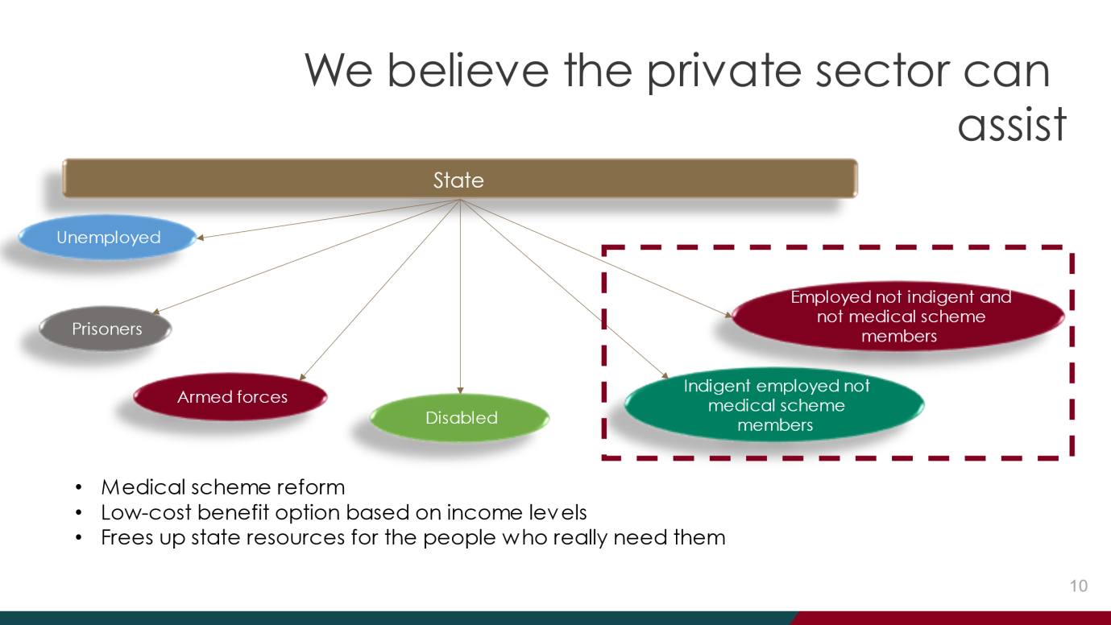

Our submission canvasses the constitutional issues associated with the right of access to health care in some detail in paragraphs 10 to 55 and in paragraph 5 of the executive summary to our submission.

