CORPORATE PLAN
TABLE OF CONTENTS
•
INTRODUCTION AND STRATEGIC OVERVIEW
•
SABC SERVICES
•
DELIVERY ON STRATEGY
•
BUDGET FY2021/22
–
2023/24
•
PREDETERMINED OBJECTIVES

INTRODUCTION AND STRATEGIC OVERVIEW
- As the national public broadcaster the SABC must offer, in all South Africa’s official languages, a range of informative, educational and entertainment programmes that showcase South African attitudes, opinions, ideas, values, talent and artistic creativity;
- Through its programming the SABC reflects South African attitudes, opinions, ideas, values and artistic creativity and talent.
- The SABC offers a plurality of views and a variety of news, information and analysis from a South African point of view whilst at the same time advancing the national and public interest.
- Like every other public broadcaster, the SABC is facing a world in transition, and has to devise and implement a set of strategic responses to the challenges facing the delivery of public service broadcasting.

INTRODUCTION AND STRATEGIC OVERVIEW (cont.)
The SABC is expected to fulfil its mandate within a very challenging context. In terms of the economic context:
- Continued subdued economic performance, following a year of significant contraction. It will take time to get back to pre-pandemic levels;
- The continuing effects of the COVID-19 pandemic – unknown impact of anticipated subsequent waves, and the success of the vaccination programme;
- Tax revenues can be expected to remain subdued in line with the national economic activity;
- Debt levels (national, corporate and consumer) will remain high;
- The reduced levels of industry-wide spend by multinational and local advertisers is expected to continue;
- The country’s overall economic performance will have a negative effect on the SABC’s revenue generation efforts, both in terms of advertising revenue and TV licence revenue.

INTRODUCTION AND STRATEGIC OVERVIEW (cont.)
In terms of the competitive landscape:
- New entrants to the media sector and strategic partnerships will continue to compete for audiences and advertising revenue.
- Entry barriers are high for new broadcasters but relatively low for additional stations. As a result new licensees focus on the most commercially valuable audiences, thereby impacting the SABC's margins.
- Non-linear and OTT broadcast technology make it easier for content providers to reach audiences in a cost effective manner in a largely unregulated environment while generating revenue in the process.
- South Africa’s pay TV broadcasters continue to enjoy limited regulation which creates monopolies in the market place particularly around sporting events, local content offerings without mandate, pricing of bouquets and control of revenue through the fragmentation of advertising revenue.
- The SABC also faces competition for the best content and talent. The increasing number of licensed radio and television channels has increased the cost of keeping talent, driven up the cost of local production and the acquisition of content rights, particularly sports rights.

INTRODUCTION AND STRATEGIC OVERVIEW (cont.)
In terms of the regulatory landscape, the SABC, while recognising the efforts underway, has to contend with a regulatory/ legislative framework that has not kept pace with the growth of digital technology, the convergence of media, technology and telecommunications.
The SABC will continue to be involved in various policy and regulatory processes that are intended to culminate in new legislation that will have implications on the Corporation’s revenue generation capabilities and business operations in 2021 and future years. Some of these are:
Ban on Alcohol Advertising | Audio and Audiovisual Policy
Review of Must Carry Regulations | Review of Sports Broadcasting Rights Regulations
Digital Terrestrial Television –  Broadcasting Digital Migration | Review of Advertising Sponsorships and Infomercials Regulations
Broadcasting Amendment Bill | FPB Online Content Regulation/Policy
Subscription Broadcasting Services Regulations | ICASA Digital Licensing Framework
The strategies planned by the SABC, painted in broad strokes in the SABC
2021/22-2023/24 Corporate Plan, represent the SABC’s efforts to remain relevant, fulfil its public broadcasting mandate, and be able to do it in a self-sustaining way.
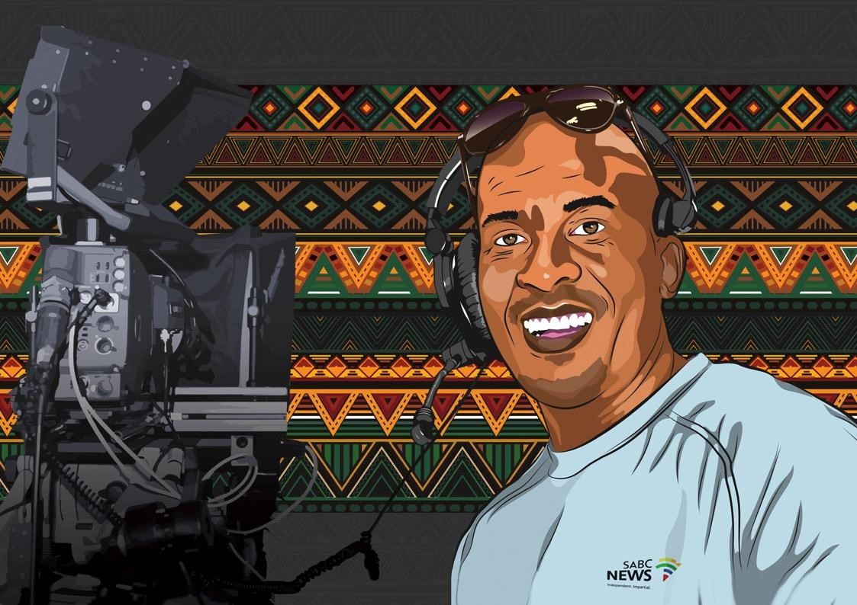
SABC Services
our Platforms

The SABC’s bouquet of services includes 18 Radio Stations, five Television Channels as well as a digital media offering. A 19th Radio Station, Channel Africa, is managed by the SABC on behalf of the Department of International Relations and Cooperation.
To many who have limited access to information technology and other more advanced media platforms, radio remains a critical source of information, current affairs and entertainment. SABC Radio commands a healthy 73% share of all adult radio listening in South Africa. This translates to 29 million adults who choose SABC radio stations as their source of news and information every week.
Television remains the medium of choice for most South Africans. The public broadcaster’s five television channels attract, on average, 29 million South African adults (15+) in a typical month. The SABC News channel and SABC Encore channel are delivered through the satellite platform and reach 5 million viewers and 6.1 million viewers respectively in a typical month.
The SABC has a digital media presence across the internet including social media, online video, podcasts and streaming media. SABC television channels and shows, radio stations, news, education and other brands have some of the most popular and engaged audiences in the South African social
media landscape. ⁹
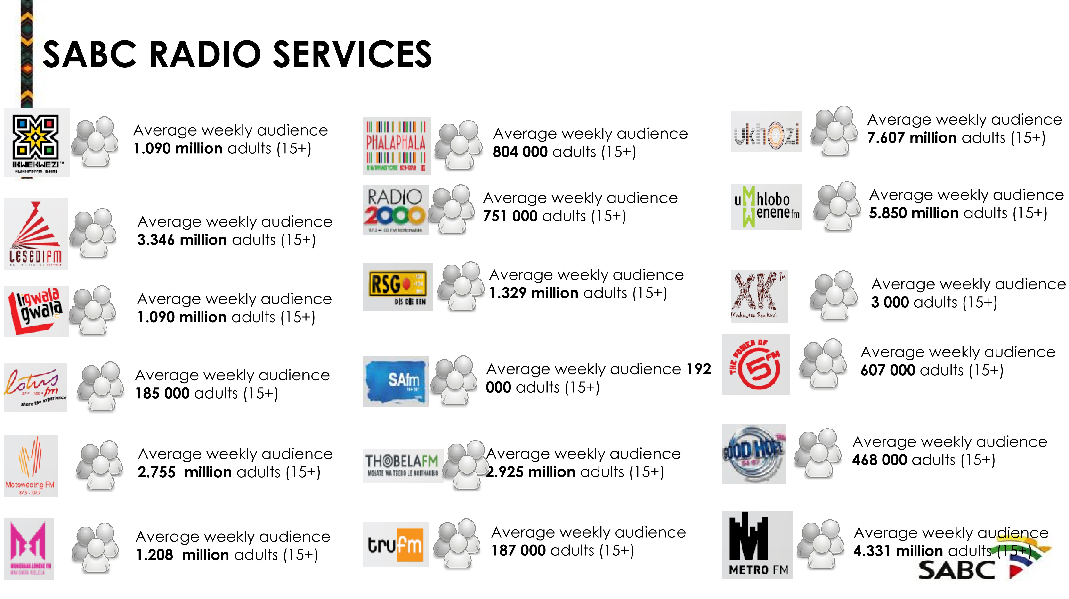
SABC TELEVISION SERVICES
Average weekly audience
22
million
Average weekly audience
23.9
million
Average weekly audience
17.4
million
Coming (back) soon!
Average weekly audience
7.4
million
DELIVERY ON STRATEGY
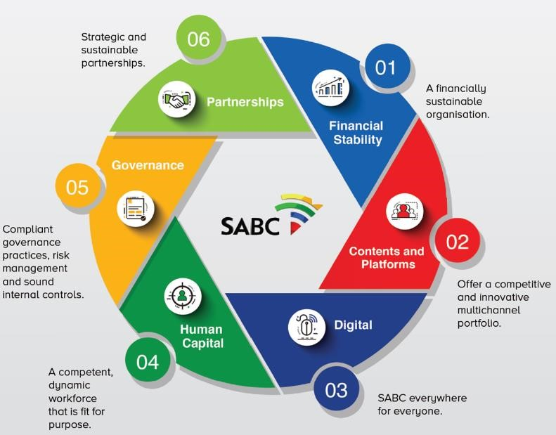
STRATEGIC PILLARS AND GOALS
The SABC’s FY2021/22
–
2023/24

Corporate Plan continues to focus on
implementing the SABC Turnaround Plan
which is anchored on the six strategic
pillars that make up the SABC Strategic
Roadmap:
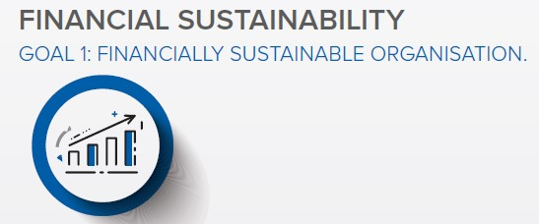
Increase commercial revenue
Enhance television licence fee collection
Control cash management
Leverage asset portfolio
Pursue policy and regulatory changes to
ensure SABC’s sustainability
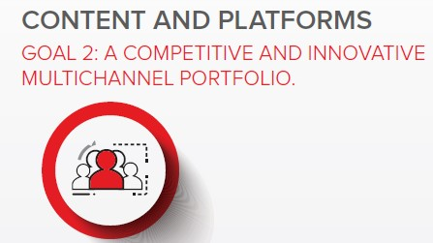
Know the audience
Obtain compelling content
Monetise local content
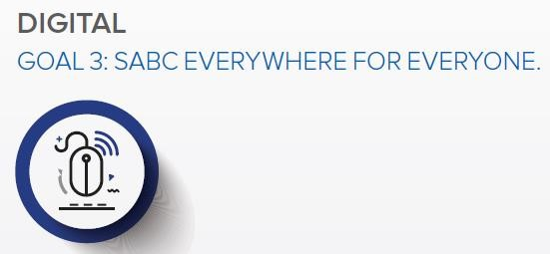
Broadcast and transmission initiatives
Digital migration initiatives
OTT and multi
-
channel environment
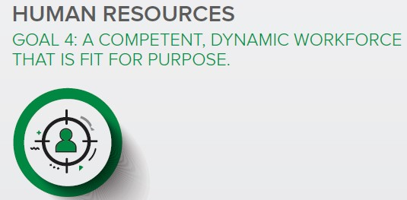
Providing leading edge guidance on
organisational structuring imperatives
Elevating Talent Management interventions to
ensure leadership bench
-
strength
Inculcating a culture of superior performance
across all business divisions
Embedding organisational values and related
behaviours to elevate the culture to a level of
acceptance and alignment by all employees
Continuously engaging with all stakeholders to
ensure unity of purpose
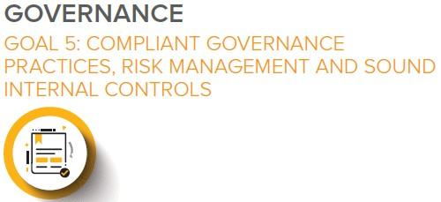
Leadership stability
Enterprise
-
wide risk management
Compliance, monitoring and evaluation
Internal control environment
Business continuity management
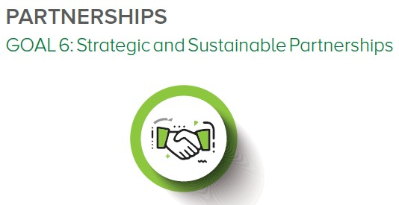
Alignment with SABC strategic goals
Revenue generation
Cost reduction
BUDGET FY2021/22
–
2023/24
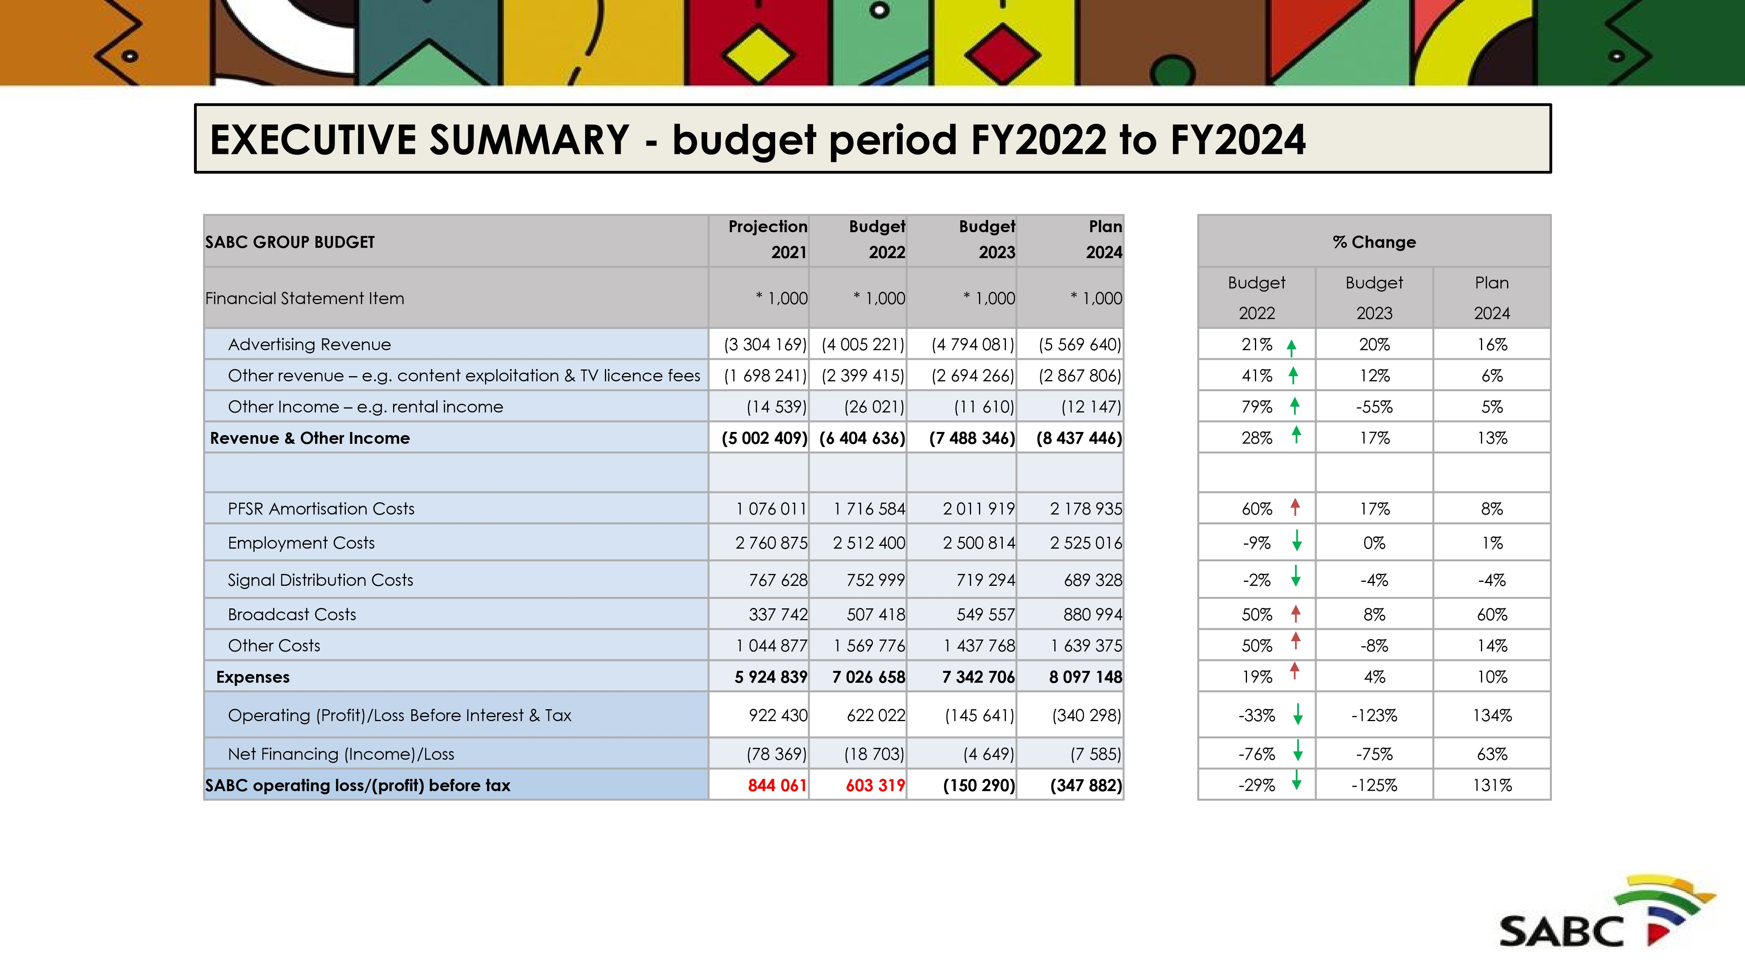
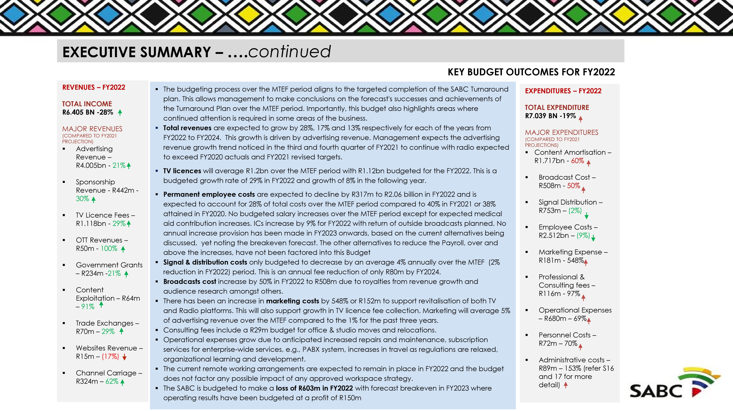
Factors not included in the budget and possible risks
1
•
The impact of any legislative support being requested such as the must carry provisions and
review of licensing conditions on some of our Radio Stations
2
•
Review of the signal transmission costs with Sentech including the analogue switch off as the
pace of the process cannot be reliably forecast
3
•
Any possible return from additional TV channels that are under consideration for
implementations as discussions are at their infancy. However, there is a chance that
developments in this area may be quick.
4
•
The impact of any TV Licence fee amnesty programme that may be implemented if approval
is obtained from both DCDT & National Treasury
5
•
Impact of further COVID waves continues to cause a level of unpredictability but the
Corporation and its Customers and Service providers have largely adapted to the current
circumstances though financial implications will depend on the conditions in further
lockdowns levels
EXECUTIVE SUMMARY….
continued
KEY CHALLENGES AND RISKS
1
•
Budgeted
advertising revenue growth
for 2022 at 20% is high which may not be attainable with the
current economic climate and the second
wave
of Covid
-
19
infections
2
•
Ability to turn around
SABC 3 and key
Radio
platforms
(
SAFM, Radio 2000 & Lotus FM)
–
these remain loss
making through out the MTEF period
3
•
Stagnating or maturing linear
TV advertising market
–
stiffer competition or increased cost for every
additional advertising rand gained
4
•
Limited forays into continental markets and volatility of the emerging OTT market in RSA
5
•
Achieving significant efficiencies in the
signal distribution costs
is key for sustained financial
improvement
6
•
Slow pace of
legislative and regulatory
required to secure and sustain the SABC’s turnaround
7
•
Focus on
digital
needs to be magnified
–
revenue from OTT platforms & websites averaging only 3%
of commercial advertising revenues. Online marketing is 13.1% of total advertising market in SA &
50
% in global market. Possibility for a
3
-
5
% growth in paid internet advertising
(
Internet Advertising
Revenue Report, PwC 2020)
.
8
•
Constrained
commercial viability of Sports
and alternative distribution platforms.
Return to profitability
Sustaining the execution of the
Turnaround Strategy
•
Budgeted amounts should be linked to
strategic initiatives.
•
All capex investments planned towards
the implementation of the strategic
initiatives to be tracked and reported on
in detail
Declining Audiences
•
Increase content investment, to
acquire quality content that will attract
audiences back to the SABC.
•
We need a tool for tracking of
audience performance vs target and
financial performance, planned vs
actual per property and timeslot in real
time
Digital and OTT Strategy
Detailed digital media strategy.
New Carriage and OTT deals in
place and more anticipated
imminently but not yet incorporated
in this budget
.
Sports Offering
•
Smart investment in sports rights
•
Increase the quantum and
quality of sporting codes on offer,
migrate to digital offering
Declining revenues and growth
•
Improving on the trade exchange transactions
•
Defend Classic revenue through proactive
deals
•
Win back lapsed business
•
Gain more New Business through increased
value proposition
•
Maximize Sellouts
•
Partner to grow OTT including Audio on
Demand
•
Expedite OTT implementation and SABC and
3
rd Party OTT exploitation, digitisation in all
areas of business and DTH alternatives.
STRATEGIC INITIATIVES TO ADDRESS KEY CHALLENGES
(
)
...to be tracked and reported on
VIDEO ENTERTAINMENT BUDGET SUMMARY
•
SABC 3 revenue
is budgeted to grow by 48% in FY2022 and an average of 16% over the following two years but the channel
remains loss making over the MTEF period.
•
Investment in content is being made, though it is not yet possible to accurately predict the success of the properties and th
e r
esultant financial reward, but the business cases did anticipate positive ROI.
Projections will be reviewed in the course of Q2.
•
Sourcing of content, assessment criteria, performance evaluations and contracting models are all in the process of being revi
ewe
d and enhanced to ensure fresh and compelling content that meets and
exceeds criteria towards amongst others financial sustainability if not profitability.
•
SABC 2
carries any presidential, ministerial briefings. This will unfortunately continue to inhibit its profitability.
•
SABC 1
remains the ‘’cash cow’’ with continued solid performance from long standing popular properties.
•
Amortisation
budgets will allow channels to deliver on the second year of a 3
-
year strategy, noting the challenges on S3.
•
Year 1 of the Turnaround strategy was hampered by the delays in receiving the bailout funding compounded with the destruction
s o
f COVID19
RADIO BUDGET SUMMARY
•
Metro,
Ukhozi
,
Umhlobo
Wenene
, Lesedi FM, RSG & Thobela FMs will drive revenue growth from growth in the audience
•
Though SAFM, Radio 2000 & Lotus FM will continue making losses over the MTEF period, initiatives are underway to stem the los
ses
noting that some factors outside the control of the Corporation contributes
towards the situation being, licensing conditions and the Transmitter costs. It must also be noted that Radio 2000 has been t
he
top performing station in recent months in terms of growth in audiences.
•
Other ALS stations are anticipated to return to profitability around FY2024.
•
The PCS stations are all anticipated to be profitable over the MTEF period.
•
The
budgeted revenue numbers
indicated an average annual growth rate of 18% over the MTEF. These are aggressive forecast to levels higher than any histori
cal
peak in the last 5 years.
•
The SABC is
finalising
a
transmitter audit
that is expected to yield some cost efficiencies. These cannot be quantified currently.
BUSINESS UNIT KEY INSIGTHS
NEWS BUDGET SUMMARY
•
Elections Budget R 30 million FY2022
•
Events of Special interests R5million FY2022
•
Total Budget FY2022 R 710 million
BUSINESS UNIT KEY INSIGTHS ….continued
SPORT BUDGET SUMMARY
- The foreign exchange rate has significant impact on the Rand cost of Sports Rights.
- Continental Events carries an enormous negative ROI
- Marketing & Sales Restrictions of Headline Sponsors and Advertisers are barriers for the Sales Teams
- The Sport Rights Market is operating in a manner where the SABC becomes a Price Taker due to the Public Mandate.
- There is not sufficient space available for scheduling on the Linear Channels. • The limited space impacts on the commercialization efforts
- There is a risk of displacement that comes at a cost and the instability in the schedule of the channels negatively impact audiences and advertisers.
- The business unit continues to deliver a negative RoI over the MTEF period due to the above amongst others.
- Total Budget for Sports amount to nearly R300million in FY2022.
- Investment in Sports Rights budgeted over the MTEF period amounts to more than R 1.1 billion with more than R 250m in FY2022 alone.
- 100% of the rights budgeted for FY2022 may be considered public mandate events.
- There is also a significant number of properties not yet budgeted for, though these can be argued to be Sports of National Interest and there will thus be pressure to acquire the associated rights.
- Special Events e.g. Olympics, FIFA World Cup, AFCON and ICC World Cup requires significant investment with prepayments and yet these typically return substantial negative ROI.
TV Licenses
- Collection evasion assumed to continue to average 75% over the MTEF period.
- It costs the SABC R0.25c for each R1.00 collected which equates to a 75% efficiency.
- After the initial 29% growth in FY2022, annual growth rates decline to 8% in FY2023 and 5% in FY2024.
- The actual cash collected is therefore expected to approximate 90% of revenues at R1.006bn in FY2022
- The legislative support around TV licence compliances that is being sought has not been factored in the budget.
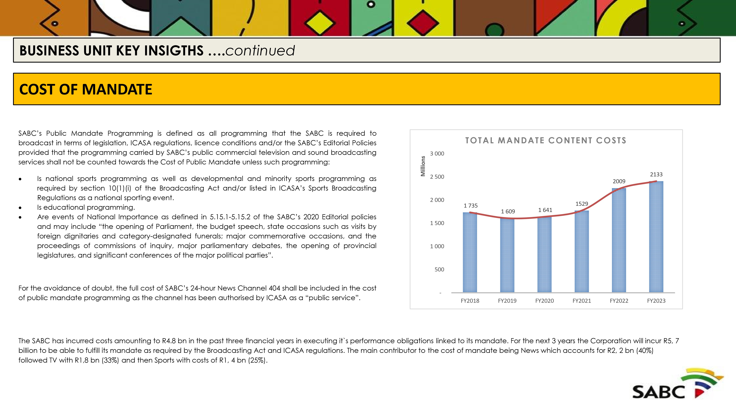
CASHFLOW
RATIOS
FY 21/22
FY 21/23
FY 22/24
Debtors Days
45
51
56
Creditors days
159
117
60
•
The
cash position is expected to deteriorate
in the FY2022 due to the expected operating losses and planned Capex spend.
•
This will see creditors days increasing. Noting that there is typically a few major creditors that are affected and thus enga
ged
when there are
constraints on the cash reserves.
•
Creditor payment terms are typically 30 days from invoice or as
otherwise
negotiated. Payments to small to medium sized entities are as a rule
prioritized and executed within 30 days from invoice
•
Debtors days is anticipated to increase subject to the implementation of alternative mechanisms being established to encourag
e e
arly payment.
•
The
budgete
d
Capex spend has been limited to NT funding allocated and proceeds from the disposal of
assets, however the planned spent subject
to funding and risk
–
noting the state of the facilities and infrastructure in the Corporation
–
is significantly more.
•
Following consultations with the Business Units
–
and taking note of capacity and SCM issues
–
it was agreed that there is curr
ently no need for
borrowing envisaged, particularly while there is still a significant unspent portion of the Bailout funding. While there is
no
specific burning platform to
secure external funding, the Corporation will however continue to establish relationships with possible future funders and id
ent
ify opportunities for
future exploration
.
•
Bailout Balance 31 March 2022
estimated at R 500 million by heavily influenced by the pace of Content and Capex spent.
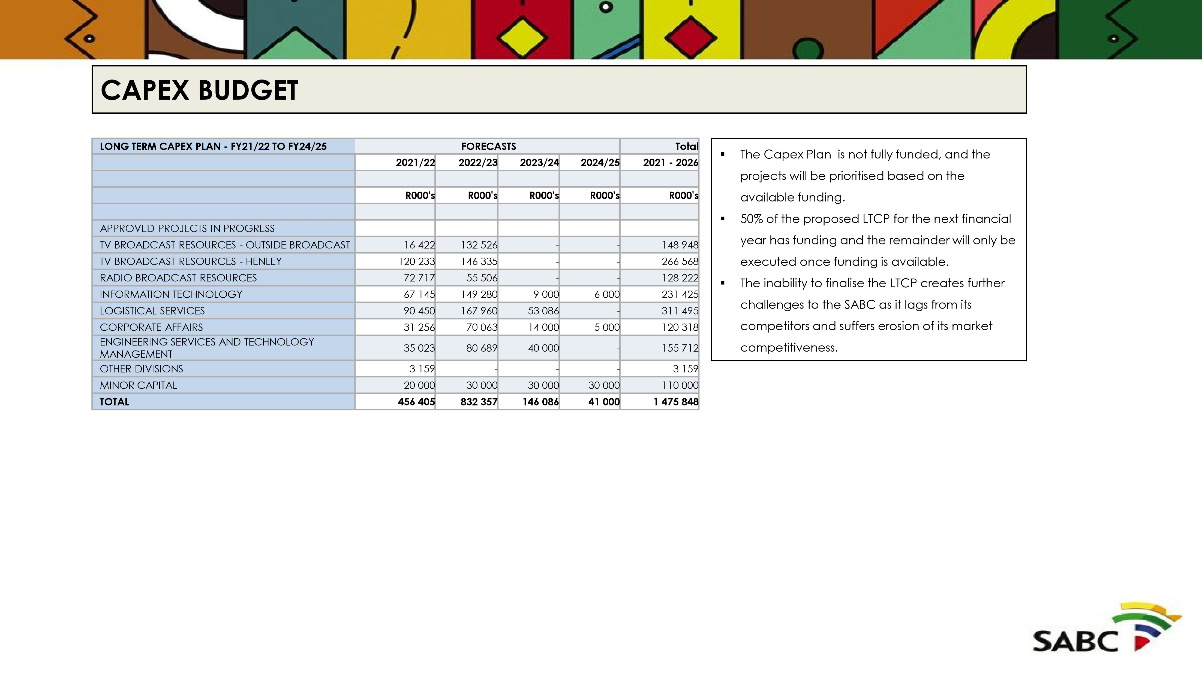
PREDETERMINED
OBJECTIVES
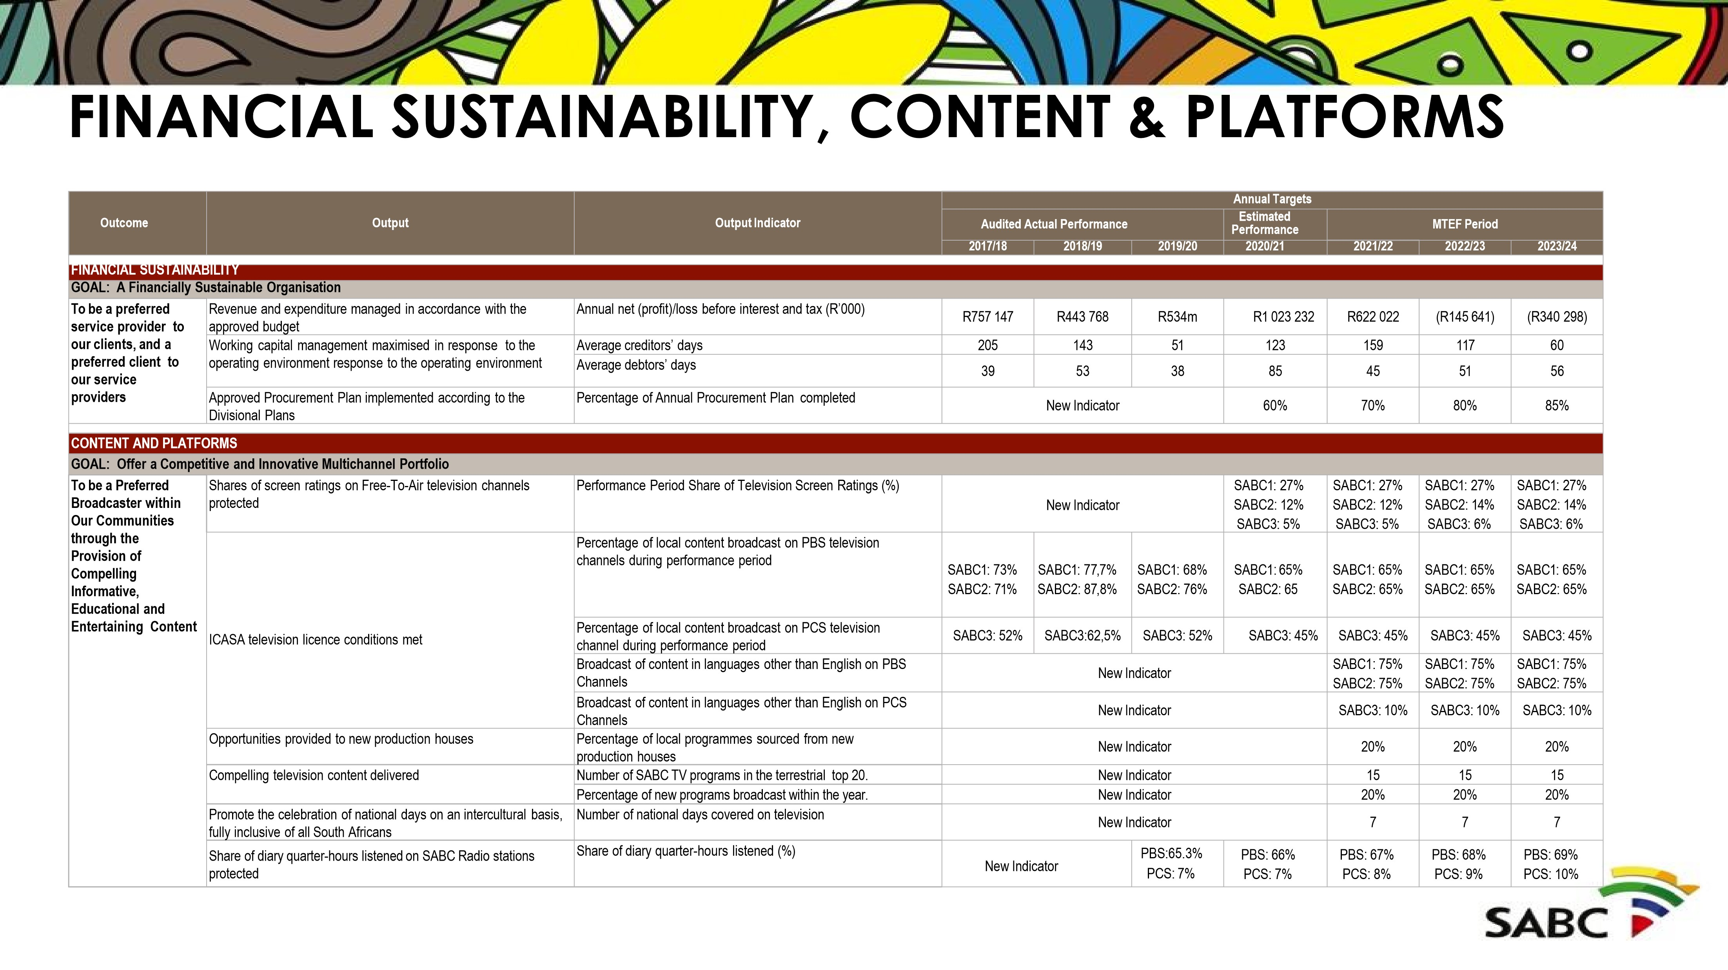

Outcome | Output | Output Indicator | Annual Targets
 |  |  | Audited Actual Performance |  |  | Estimated Performance | MTEF Period
 |  |  | 2017/18 | 2018/19 | 2019/20 | 2020/21 | 2021/22 | 2022/23 | 2023/24
CONTENT AND PLATFORMS
GOAL: Offer a Competitive and Innovative Multichannel Portfolio
To be a Preferred  Broadcaster within Our Communities through the Provision of Compelling Informative,  Educational and  Entertaining Content | ICASA licence conditions met | Percentage of local music broadcast on PBS radio stations during performance period | N/A | 75% | 73% | 70% | 70% | 70% | 70%
 |  | Percentage of local music broadcast on PCS radio stations and Lotus FM during performance period | N/A | 39% | 38% | 35% | 35% | 35% | 35%
 |  | Number of PBS radio stations (excluding Radio 2000) that achieved full compliance with ICASAspecified genre quotas | 14/14 radio stations | 14/14 radio stations | 14/14 radio stations | 14/14 radio stations | 14/14 radio stations | 14/14 radio stations | 14/14 radio stations
 | Promote the celebration of national days on an  intercultural basis, fully inclusive of all South Africans | Number of national days covered on Radio. | New Indicator |  |  |  | 7 | 7 | 7
 | Compelling sports contentdelivered | Number of live sports events broadcast on SABC terrestrial TV channels | New Indicator |  |  |  | 250 | 175 | 100
 |  | Number of live sports events broadcast on SABC terrestrial Radio stations | New Indicator |  |  |  | 300 | 500 | 750
 |  | Number of sports events broadcast on OTT Digital Platforms (Wireless and Mobile) | New  Indicator |  |  |  | 210 | 275 | 400
 |  | Percentage of sports events broadcast in marginalised languages | New Indicator |  |  |  | 25% | 50% | 90%
 |  | Number of new sports rights acquired. | New Indicator |  |  |  | 3 | 5 | 6
 | Public news service mandate fulfilled | Number of dedicated African language news channels introduced on Digital platforms. | New Indicator |  |  |  | 2 | 3 | 3
 |  | Percentage of Marginalised languages with dedicated news channels on the digital platforms | New Indicator |  |  |  | 45% | 73% | 100%
 |  | Number of annual news calendar events broadcast on free to air channels. | New Indicator |  |  |  | 16 | 15 | 15
DIGITAL
GOAL: SABC Everywhere for Everyone
To be a preferred broadcaster within our communities through the provision of compelling informative, educational and entertaining content that is accessibleon all platforms | DIGITALISATION: Digital workflows and infrastructurefor SABC contentimplemented | Operational SABC Enterprise Digital Library | New Indicator |  |  | Business Requirements  Specification document completed | Contracting completed with  appointed service provider/s | Project complete | Maintenance and Support
 |  | Number of additional sites with functional new Radio playout systems installations | New Indicator |  |  | 8 | 6 | Maintenanceand Support
 |  | Digitise Scheduling and Advertising Processes | New Indicator |  |  | Business Case Approved | Service Provider appointed for the  replacement of the  Scheduling and  Advertising  Management System | Project Implementation | Project complete
 |  | Capex projects implementedfor TV News | New Indicator |  |  | Business Cases Approved  Tenders Advertised Evaluation of Tender for News Branding and  Graphic Playout System | Operational News  Production System  Operational Newsroom  Computer System  Operational News  Branding and Graphic | Maintenanceand Support 33

CONTENT & PLATFORMS (cont.), DIGITAL

DIGITAL (cont.), HUMAN RESOURCES
Outcome | Output | Output Indicator | Annual Targets
 |  |  | Audited Actual Performance |  |  | Estimated Performance | MTEF Period
 |  |  | 2017/18 | 2018/19 | 2019/20 | 2020/21 | 2021/22 | 2022/23 | 2023/24
DIGITAL
GOAL: SABC Everywhere for Everyone
To be a preferred broadcaster within our communities through the provision of compelling informative, educational and entertaining content that is accessibleon all platforms | DIGITISATION:Conversion/transition from analogue to digital | Number of hours of TV content digitised | New Indicator |  |  | Business Requirements  Specification document completed | 500hrs | 70,000hrs | 70,000hrs
 |  | Percentage of analogue TV transmitters switched- off (in collaborationwith SENTECH) | New Indicator |  | 1 Analogue  Transmitter  Switched-Off  (Senekal) | 1% | 80% | 100% | N/A
 |  | Digitisation of Radio facilities and infrastructure | New  Indicator |  |  | - Completion of D3 and D1  Drama Studio upgrade in Auckland Park  - Appointment of suppliers for  KZN, Bloem, PE, North  West,A1 (JHB) studio projects | •7 Studio upgrade and infrastructure projects  •3 Radio Equipment and  Facilities Projects | Continuation of  4 Radio  Facilities and  Infrastructure projects | Completion of  2 Radio  Facilities and  Infrastructure projects
 |  | Operational Unified Collaboration and Video  Conferencing system | New Indicator |  |  | Business Requirements  Specification document completed. | Contracting  Completed with appointed service provider/s | Project complete | Maintenance and Support
 | DIGITAL TRANSFORMATION  - Emerging Technologies  - OTT Platforms  - New Business Models | SABC Radio and TV stations websites and Apps development project milestones completed | New Indicator |  |  | Business Case Approved | Contract/s signed with Service Provider/s | Redevelopment of 23 websites and Apps completed | Maintenance and Support
 |  | Operational SABC OTT Digital Platform – SABC++ | New Indicator |  |  | Partner with Telkom TelkomOne  Partner with Vodacom | Website and App Streaming  Pilot and Launch of  Radio Web and App EcoSystem  Launch SABC OTT  Platform – SABC++ | Maintenance and Support | Maintenance and Support
HUMAN RESOURCES
GOAL: A Competent, Dynamic Workforce that is Fit for Purpose
To be a preferred employer with employees who are  our brand ambassadors | Performance management implemented | Percentage of employees with signed, reviewed and evaluated performance contracts | New Indicator |  | 68% | 100% | 90% | 90% | 90%
 | Workplace Skills Plan implemented | Percentage of Workplace Skills Plan implemented | 1,3% | 46% | 10% | 80% | 75% | 75% | 75%
 | Talent Management Implementation | Percentage of Organisational Talent bench strength reviewed and initiatives approved | New Indicator |  |  | 100% | 100% | 100% | 100%  34
GOVERNANCE, PARTNERSHIPS
Outcome
Output
Output
Indicator
Annual
Targets
Audited
Actual
Performance
Estimated
Performance
MTEF
Period
2017/18
2018/19
2019/20
2020/21
2021/22
2022/23
2023/24
GOVERNANCE
GOAL:
overnance
Compliant g
practices,
risk management
and
nd
sou
internal
controls
To
be a preferred
broadcaster
within
our
communities
while
adhering
to the prevailing
policies, legislative
and
regulatory
framework
Internal
control
environment
strengthened
Percentage
o
f
previou
s
financia
l
years
’
Auditor
-
General
findings
resolved
49
%
81
%
61
%
90
%
90
%
%
90
90
%
Percentage
of policies
reviewed that
are current in
terms
of
the
2
-
year
review
cycle
New
Indicator
%
50
%
65
%
75
85
%
Turnaround
Plan
implemented
Percentage
of
key
actions
‘completed/in
place’
New
Indicator
%
54
%
90
%
100
PARTNERSHIPS
GOAL:
Strategic
d
an
Sustainable
Partnerships
T
o be the preferred
brands for our
audiences
SABC
content
distribution
partnership
s
established
Number
of
television
content generation
partnership
agreement/MOUs
signed
New
Indicator
5
7
11
14
SABC
content
distribution
partnerships
established
Number
of
content
distribution
partnership
agreements/MOU
s
signed
New
Indicator
3
4
5
5
SABC
strategic
relationship
building projects
implemented
Number
of strategic
relationship
-
building
projects
completed
New
Indicator
4
4
5
7
35
ALIGNMENT
WITH DCDT
PRIORITIES
36

ALIGNMENT WITH DCDT 2021/22 PRIORITIES
SOE targets for 2021/22  (Only key targets aligned to the  DCDT priorities) | Alignment with DCDT 2021/22 targets  (as appearing in draft DCDT 2021/22 APP) | Confirmation of available resources to deliver target  (Financial & HR) | Required institutional mechanisms & partnerships to deliver on target | Required support from DCDT
Collaborate with SENTECH on the switch-off of 176 analogue television transmitters | Implement the BDM Programme by  March 2023 | SABC resources are available | Collaboration with DCDT and SENTECH | Continued management of the project by DCDT
Implement a year-long GBV and anti-violence against children awareness and education drive | Departmental and SOCs Gender,  Disability, Youth and Children (GDYC) Responsiveness programmes monitored in line National targets | SABC resources are available | Campaign will be carried out in collaboration with various NGOs that are active in terms of education and support related to GBV and violence against children | Additional funding support for the  campaign (should the  Department have access to any)
Participate in policy and regulatory change processes | - South African Broadcasting Corporation SOC Ltd Bill submitted to Cabinet for approval to introduce to Parliament  - White Paper on the Audio and Audio-visual Content Services Policy submitted to Cabinet for approval | SABC resources are available | Continued engagement with DCDT,  PCC, SCOPA, ICASA | Facilitation of engagements with other stakeholders
Timely submission of statutory documents | - Tabling of submitted Annual Performance Plans of SOEs facilitated  - Tabling of Annual Reports of SOEs in accordance to section  65 of the PFMA facilitated | SABC resources are available | Continuous engagement with DCDT | Continuous engagement with  DCDT
Coverage of national days on our radio and television platforms | • Promote the celebration of  national days on an intercultural basis, fully inclusive of all South  Africans | SABC resources are available | Continuous engagements with various lead government entities, civil society organisations, public | Continuous engagement with  DCDT
Reduction of irregular, fruitless and wasteful expenditure | • Measures taken to eliminate  wasteful, fruitless and irregular expenditure in the public sector | SABC resources are available | Loss Control Committee established to address occurrences and ensure appropriate consequence management measures are implemented | Continuous engagement with  DCDT
37
CORPORATE PLAN

