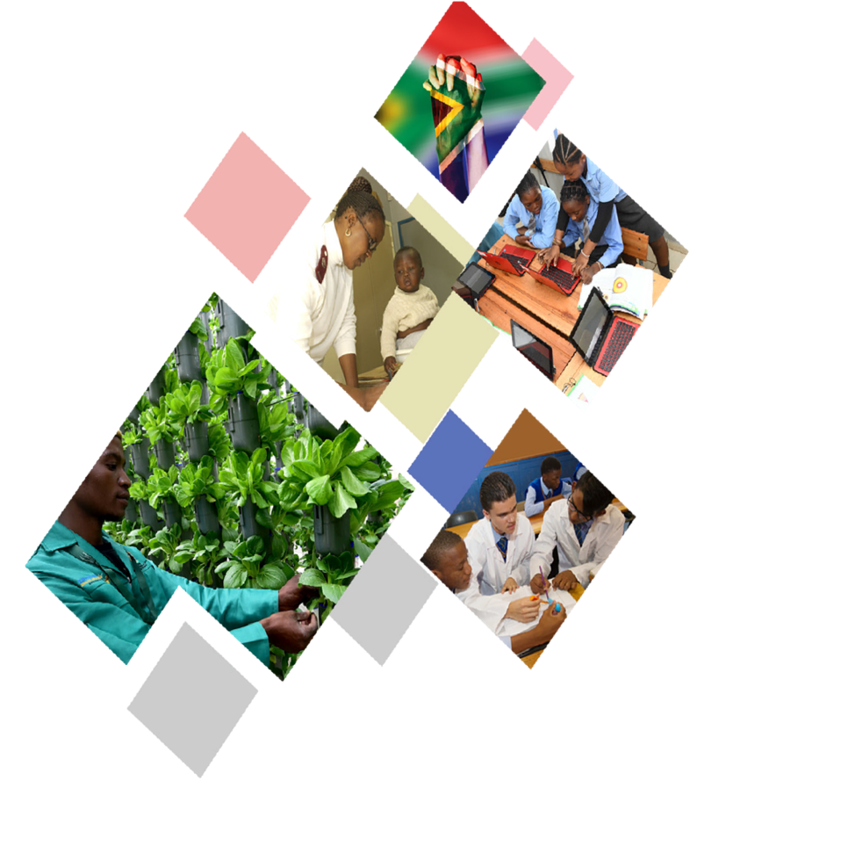

Implementation of the District Development Model
A report on lessons learnt from the piloting phase

July 2020

Table of Contents
1. Introduction 3
2. Purpose of the report 4
3. The Implementation DDM Process 5
4. The Piloting Phase 5
4.1 Defining the piloting phase 6
4.1.1 The development profiles 6
4.1.2 Government and private sector investment in the pilots (districts and metro) 7
4.1.3 The DDM launch events 8
4.1.4 Post launch implementation plan 9
5. Lessons learnt from the piloting phase 11
5.1 Lessons on intergovernmental coordination and institutional arrangements 11
5.2 Content lessons 12
5.3 Lessons learnt from engagements with stakeholders 14
6. Conclusion 15

Introduction

The 6th Administration is focusing on building a coherent State that can enable inclusive economic growth, spatial transformation, strategic infrastructure investment and reliable service delivery for all.

In this vein, the District/Metropolitan Development Model was adopted by cabinet on the 21st August 2019. As part of the cabinet adoption, it was agreed that the District Development Model will be piloted in two district municipalities and one metropolitan municipality.

The district/metropolitan focus emanating from the Cabinet Lekgotla has a bearing on the Department of Cooperative Governance’s mandate which includes a district (and metro) based approach to speed up delivery ensuring that municipalities are properly supported and adequately resourced. In giving effect to the vision of Joined-Up government positively impacting lives at local level, the district coordination model is premised on institutionalising a programmatic approach to IGR having four (4) key strategic objectives:

- To improve integrated planning across government through formulation and implementation of Single Joined-Up Plans for each of the 44 District and 8 Metropolitan geographic spaces or (52 IGR Impact Zones).

- To enable streamlined and effective Local Government capacity building by consolidating and strategically coordinating capacity building initiatives and programmes at district level.

- To ensure that municipalities are enabled to perform their mandated functions and duties effectively and efficiently by mobilising and making available expertise, key skilled personnel and systems that can be shared between district and local municipalities as needed.

- To monitor the effectiveness of government and the spatial and developmental impact on communities in the 52 IGR Impact Zones.

These objectives are to be realised through:

- A focus on the District/Metropolitan spaces as the appropriate scale and arena for intergovernmental planning and coordination.

- A focus on the 44 Districts + 8 Metros as developmental spaces (IGR Impact Zones) that will be strategic alignment platforms for all three spheres of government.

- Producing a Spatially Integrated Single Government Plan (One Plan - as an Intergovernmental Compact) for each of these spaces that guides and directs all strategic investment spending and project delivery across government, and forms the basis for accountability.

- Reinforcing an outcomes-based IGR system where there is a systematic IGR programme and process associated with the formulation and implementation of a single government plan. This signifies a shift from highly negotiated Alignment of Plans to a regulated cooperative governance One Plan.

- Taking development to our communities as key beneficiaries of what government does, and where they have a stake.

The purpose of enhancing cooperative governance through a new district development model is to improve the coherence and spatial targeting impact of all three spheres of government working together in unison.
This unison is achieved when there is a common appreciation and understanding by all three spheres of government of the service delivery and development dynamics, challenges and opportunities in various communities calibrated for practical purposes at a district/metropolitan spatial scale.
The district/metropolitan scale enables national and provincial government to have sufficient consideration of local conditions and contexts so that policies, plans, programmes and projects can be made more responsive to the needs of localities and communities. It also enables municipalities to articulate the strategic support and unlocking required by national and provincial government to improve prioritization, spatial alignment of investment, and implementation.
The Department of Cooperative Governance (DCoG) is mandated to coordinate the implementation of the District Development Model. As such it has to capacitate and organize itself better to focus rigorously and intensively on driving Government Coherence and Compliance. This has to be done in a focused, mission-directed manner and in a way that provides leadership within government to the rest of government.
It is in this context that DCoG will urgently fix the wasteful fragmentation in government and drive a new intergovernmental planning and delivery model centred around district/metropolitan geographical spaces as focal points as a way of re-establishing the foundation of coherent governance.

Purpose of the report

The first phase of the implementation of the DDM was to pilot the approach in two district municipalities and one metropolitan municipality. The aim of the report is to reflect on the lessons that emerged from the Implementation Plan of the District Development Model in the two pilot district municipalities and the metropolitan municipality.
It envisaged that some of the lessons that have been learnt from the pilot districts will be used to inform and guide the roll out phase of the implementation of the DDM, where this is possible and practical. The report also provides an overview of the implementation approach that was adopted during the pilot phase.

The Implementation DDM Process

In order to ensure the successful implementation of the District Development Model. It is crucial to have a clear implementation plan and process. This implementation plan will ensure that the whole of government and its partners understands what the process entails and what their roles would be in this process. The implementation plan also provides guidance on what would be required from various role players and in some instances how they can support the District Development Model. The implementation plan is also important because it will bring predictability on the process that needs to be followed.
The District Development Model is currently being implemented in three phases, namely:
- The Establishment phase,
- The Piloting Phase, and
- The Roll-Out Phase

September/October 2019 onwards
21 August 2019 –
26 November 2019
Cabinet Adoption
21 August 2019
Local Government Stabilization

The diagram above provides an overview of the implementation plan for the DDM. The Local Government stabilisation phase runs in parallel and in tandem with the piloting and roll out phases indicated above. Due to the urgency to implement the DDM, in all likelihood, the three phases will be implemented in parallel. Due to the aim of this report, the next sections will focus on the piloting phase.

The Piloting Phase

When cabinet adopted the District Development Model, it was agreed that the model will be piloted in three areas namely, OR Tambo District Municipality, eThekwini Metropolitan Municipality and Waterberg District Municipality. The three areas were chosen due to their uniqueness.
While OR Tambo District Municipality is one of the poorest rural districts in the country, eThekwini metropolitan municipality is a coastal metro with rural and urban spatial characteristics and Waterberg District is unique in a sense that it is a rural district that consists of a lot of mining houses that ideally should translate into a district that has a high economic potential. The map below shows the location of the three pilot sites.
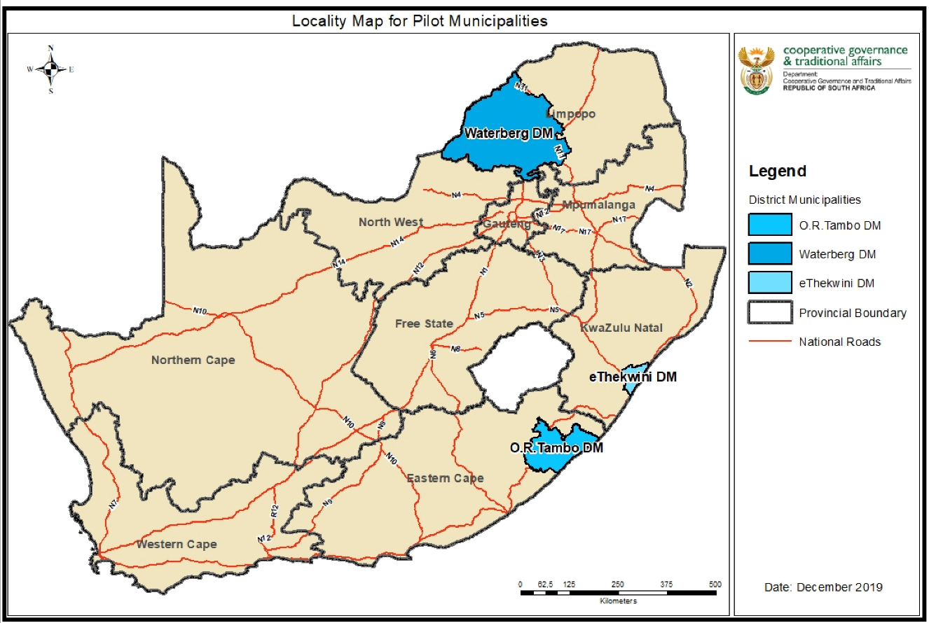

Defining the piloting phase

The piloting phase comprised mainly of five areas of work. The piloting phase comprised of the following areas of work:
- The development of profiles for the three pilots,
- Soliciting government (national, province and local) and parastatal projects, programmes and expenditure in the three pilots,
- Soliciting private sector investment where possible,
- Hosting an event where the pilot is launched,
- Implementing post launch programmes such as, conducting a skills gap analysis, establishing district and metro hubs, developing the one,
- Establishing district hubs, and
- Development of the One Plan

The development profiles

The district development profiles were developed through a collaborative intergovernmental process. The district profiles were developed based on information collected from:
- Statistics South Africa,
- National Treasury and the Auditor General (AG) Report,
- Provincial plans such as the Provincial Growth and Development Plans (PGDP), Provincial Spatial Development Frameworks (PSDFs), relevant provincial sector plans and reports,
- Municipal plans such as the Integrated Development Plans (IDPs), Spatial Development Framework (SDFs), Built Environmental Performance Plans (BEPPs), Capital Expenditure Frameworks (CEFs)
- National and provincial sector departmental projects and budgets
- Other national reports that are available
- Back to Basic Reports from the Department of Cooperative Governance and Traditional Affairs,
- District/Metro institutional and governance profiles
- Any other useful information

The profiles provided a comprehensive the status quo with regard to the following:
- Development Situation
  - Demographic and Population Profile
  - Socio-Economic Development
  - Spatial Development & Environmental
  - Infrastructure Development
  - Service Delivery (Access, quality and reliability)
- Projects & Spending Situation
  - National government projects and budgets spatially referenced
  - Provincial government projects and budgets spatially referenced
  - Local Government projects and budgets spatially referenced
- Institutional and Local Governance Situation

The development profiles also sought to provide the whole of government a comprehensive overview of development issues within the district/metro area. Key development challenges and potentials were also highlighted in the pilot sites. In addition, catalytic projects were also identified as part of the development profiles

Government and private sector investment in the pilots (districts and metro)

As part of the piloting phase, national and provincial sector departments were requested to provide projects they are implementing in these spaces together with the location of the projects and the associated budgets. This information was critical to start painting a picture of government projects and budgets in the pilot sites.
For the first time, government was able to quantify the estimated government expenditure in the three pilot sites. For instance, the estimated government expenditure in OR Tambo amounted to R11.2 billion whereas government expenditure in eThekwini metro was estimated to the tune of R35.3 billion and the estimated government expenditure for Waterberg was R55.81 billion.

eThekwini Metropolitan Municipality
Sphere of Government | Budget | Financial Year
National sectors | R17.1 billion | 2019/20 –2023/24 FY
Provincial sectors | R10.4 billion | 2019/20 FY
Local government | R7.8 billion | 2019/20 FY
Parastatals (SANRAL, PRASA, TRANSNET) | R56 billion
TOTAL | R35.3 billion

Waterberg District Municipality
Spheres of Government | Budget | Financial Year
National Government | R18.1 billion | 2019/2020 – 2024/2025
Provincial Government | R922 million | 2019/2020
Local Government | R6.1 billion | 2019/2020
Private sector (SLPs of mining houses) | R580.3 million | 2019/2020
Future investments by mining companies | R30.1 billion
TOTAL | R55.81 billion

The DDM launch events

All three launches took place as envisaged. For each of the pilots, district/metro development profiles were used to guide content issues that guided the launches. The launch of the DDM in the pilot sites took place on the following dates:
Pilot site | Date of the launch
OR Tambo District Municipality | 17 September 2019
eThekwini Metropolitan Municipality | 18 October 2019
Waterberg District Municipality | 26 November 2019

As part of the build up to the launch, consultations took place with key stakeholders, to introduce the Model and understand the key issues within the area. Some of the stakeholders consulted include:
- Stakeholder representatives comprising of religious leaders, NGOs, youth and women groups and community organizations,
- Traditional leaders,
- The business communities, and
- Political leaders within the district/metro
The consultations culminated into government Imbizos where the President launched the District Model. The government Imbizos were attended by national Ministers, Provincial MECs, the district or metro Mayor and MMCs, community members in the area, traditional leaders and other invited guests. At the Imbizos, the President also pronounced on the key development issues in the area informed by the development profile. The President further pronounced on government expenditure in the area and some of the catalytic projects that have the potential to improve the economy of the area including the lives of communities in the area.

Post launch implementation plan

After the launches of the pilots, work still continued. The main areas of that are currently underway in the pilot municipalities include:
- conducting a skills gap analysis: this process entails an assessment of the required skills that would be critical to implement the DDM in the districts,
- establishing district and metro hubs: to assist with the coordination of government planning, budgeting and implementation within the district/regional space.
- development of the One Plan: which is a long-term intergovernmental plan of government in the district that is compiled by the three spheres of government through a collaborative process.
- implementation of any urgent programmes that would address challenges in the pilots.

Conducting a skills gap analysis

The primary aim of the skills gap analysis is to determine the type, and level of skills that exists within a family of municipalities in the district in order to fulfill their functions, deliver services and manage their administrations. The skills gap analysis will also assist the Department to determine the type of support that are required in the immediate term so the Department can provide this support through a shared services model. The framework for the skills gap analysis can be explained by the diagram below
LM
DM
Agencies
&
Regional offices
Community
Academia
Regional Partners
& International Agencies
Private Sector

Some of the key issues that needs to inform the skills gap analysis for the three pilot municipalities are:
- What are the actual skills that currently exist within the district area?
- Are there officials below management level with the necessary skills?
- Assess the required skills in relation to the district/metro profile.
- Assess how development agencies where they exist can assist to close the skills gap within the district or metro area.

Establishing district and metro hubs

The key institutional mechanism to give effect to the coordination model and programmatic IGR is the establishment of District/Metropolitan Coordination Hubs at district/metropolitan municipality level. These Hubs will be established in a phased manner across the various districts and metros by DCoG in consultation with provinces and municipalities. They will be made up of a set of high-level experts constituting the core team who are appointed and contracted directly by DCoG:
- District Hub Manager
  - Strategic function
  - Operational (Project management, contract management, logistics etc. supported by PIU)
- Development Planner
- Infrastructure Specialist
- Economist
- Financial Management Specialist
- Capacity Building Coordinator
- Shared Resources Facilitator
- Monitoring Specialist
- Information Management (Linked into the Information Management system designed and operated in the PIU)

The core personnel will be responsible for developing a Business Plan based on the district needs and circumstances. The Business Plan will inform the appointment of any additional resources within the hub and/or resources to be made available to the district and/or local municipalities for fulfilling their core functions.

The Hubs will be set up on a differentiated needs basis. In Gauteng, there could be one Hub for the three metropolitan municipalities. Similarly, Hubs could be set up on a shared basis between certain districts or between neighbouring districts and metros.

Developing the One Plan

The profiles, diagnostic reports and reprioritisation reports make up the first step and feed into the formulation of the One Plan which is a Long-Term plan containing short, medium-term and long-term priorities, strategies and actions. The One Plan consists of the following phases and components:
- Deep Dive Diagnostic
- Vision Setting
- Strategy Formulation
- Implementation Planning
- Drafting
- Adoption (Intergovernmental)
- Implementation & Review

The implementation includes:
- Project Preparation
- Funding Mobilisation
- Project Implementation
- Monitoring and Evaluation
- Plan Review

The process for formulating, adopting and implementing the One Plan including content requirements and time frames will be regulated in terms of the Intergovernmental Relations Framework (IGRF) Act. Thus will enable the full institutionalisation of the District Development Model into the system of government.
This regulatory process will run in parallel to the process of formulation of the One Plan which DCoG will be supporting through interim specialist teams and the District/Metro Hubs.

Lessons learnt from the piloting phase

The implementation of the District Development Model started as soon as cabinet approved the concept document. The process to implement the DDM was undertaken with the understanding that it will be a process of learning by doing. This meant that the piloting would be a first important step of the process but that on the whole, the entire implementation process would be a reiterative one where refinements take place as and when we implement and learn. Thus, it became important that we understand that the implementation of the DDM will not be perfect, that there will be mistakes but that these mistakes and imperfections will assist with to improve the process as the system matures.
The lessons from the piloting phase can be this be categories into three key areas; namely:
- Intergovernmental coordination and institutional arrangements lessons
- Content lessons
- Lessons learned from stakeholder engagement

The three lessons learnt from the pilot municipalities will be discussed in the following sections.

Lessons on intergovernmental coordination and institutional arrangements

The introduction of the DDM takes place at a time when the intergovernmental coordination landscape has been in place for over two decades. The piloting process took place in three different provinces with varying strengths in as far as intergovernmental coordination is concerned. This is the first important precondition that needs to be taken into account.
First lesson: During the pilot phase, it became clear that the partnership between the provincial Departments of Cooperative Governance and Traditional Affairs, the Offices of the Premier and Provincial Treasures are critical to any intergovernmental programme of government. These three departments are that their centre of any collaboration that is required horizontally within the provincial sphere and vertically between the three spheres of government.
In this regard, in instances where the provincial COGTAs were able to work closely with the Offices of the premier, the piloting process was well coordinated. Some of the specific lessons are an agreement and understanding on the roles of the two departments with clear political and administrative leadership and accountability. In cases where these roles and responsibilities were unclear there was often confusion, communication breakdown and slow progress.
In all three pilot municipalities, the close working relationship between the Office of the Premier, Provincial COGTA proved to be a successful formula to coordinate government programmes. This is one of the valuable lessons that could boost coordination within the provincial space.
Second lesson: the establishment of intergovernmental task teams led by national COGTA resulted in an efficient and effective process to manage the implementation of the pilot process. In the case of eThekwini, three work-streams were established, namely the content work-stream, the communications work-stream and the logistic work-stream, while in Waterberg, the content work-stream was further sub-divided into focal areas. In both Waterberg and eThekwini, the work-streams accounted to a larger coordinating forum co-chaired by the DG of the province and the DDG within the DCOG. All the work-streams comprised of officials from national (DCOG, the Presidency, key sector departments and municipalities).
During the eThekwini pilot process, the IGR structures were further used to provide an update on progress in preparation for the pilot.
Third lesson: at national level, coordination took place through the Inter-Ministerial Committee (IMC) on Integrated Service Delivery. In addition, the Minister for DCOG played a very active role to personally ensure that national sector departments cooperated and provided information that was required.
Fourth lesson: In South Africa, intergovernmental planning and coordination is informed by a set planning and budgeting processes across the three spheres. During the pilot phase, we learned that in order for national and provincial sector departments to speedily/immediately respond to pertinent challenges on the ground, the current cycle of planning does not always permits this to be done. In most instances, if the synchronization process is incorrect and budgets are already committed to specific projects, there is little room in the system to reprioritize.
This lesson is important because there were instances where we found that there is a no link between the challenges that communities have in districts and the programmes that national and provincial sector departments are implementing.

Content lessons

While most of the trends that emerged from lessons learned regarding content issues from the three pilots were similar, the eThekwini metropolitan municipality was slightly different. The metropolitan municipality was able to provide additional content information based on research and studies that they had conducted, i.e. human settlement, tourism, etc. The fact that the metropolitan municipality is part of the City Support Programme (CSP) in the National Treasury, contributed to setting the metro apart, especially with the development of the Built Environment Performance Plan (BEPP) that metros were required to prepare. This lesson lay a good foundation for a differentiated approach on how some aspects of the DDM roll out would need to be approached.

As part of preparing the profiles for the three pilots, the Department decided to collate all national, provincial and local projects and budgets in order to cost government investment in each pilot site. Given the scale of this exercise and the fact that it was being done for the first time at this scale within such as short period of time, it was encouraging to see the overwhelming response, especially from national sector departments.

The main lessons from this segment of the pilot is that with leadership, starting with the political head, accompanied by persistence, and dedication, it is possible to achieve such challenging tasks. Because of this exercise, we were able, for the first time, to:
  - Provide a total quantum of government expenditure in each district space,
  - Determine which departments have a district footprint, i.e. projects and programmes within the district and which departments do not localize their projects and programmes within the district, and
  - Conduct a high-level analysis of duplication in national government projects and programmes in the same district space.
While the lessons are clear in this instance, the pilot phase of the DDM implementation pointed to the need to discuss how national and in some cases provincial sector departments are organized in relation to how the delivery services.

One of the main concerns on content issues was access to and the reliability of some of the statistical data. There were instances where some of this data and information was outdated. While this was the case, the key development issues remained credible and clear in all three pilots. In terms of a socio-economic assessment across the three districts, the main lessons that emerged pointed to:
  - High poverty levels. In fact, we learned that OR Tambo District was one of the top ten poorest districts in the country as indicated in the image below.
  - High numbers of women and child headed households.
  - Low skills levels, with a high number of unemployable youth and little to no training institutions
  - Weak coordination of infrastructure delivery across various national departments.
  - Untapped economic potential to grow local/regional economies (OR Tambo in the areas of agriculture, tourism, oceans economy, eThekwini in the areas of agriculture, tourism, oceans economy, and Waterberg in the areas of mining, agriculture and tourism), and
  - No long-term planning to address the socio-economic challenges in the districts.
It was also found that there is weak integration and coordination of programmes and projects both vertically and horizontally potentially because some sector departments do not collaborate when developing and implementing their projects and programmes leading to potential duplication and diluted impact at district level. In some instances, it was challenging to determine a rationale of the projects that government was implemented in the districts, i.e. schools built in villages with no enrolment of learners.

One of the most criteria to determine the impact and integration of government investment districts is to be able to know where (the location) government is investing. During the pilot phase, there were some national projects that were not spatially mapped. While this is also a fairly new practice in government, it became clear that spatial mapping of national and government projects is critical and would need to be enhanced as the DDM is rolled out.

The development of profiles for the three pilots served as a very important basis for the three spheres of government to jointly agree on the challenges and opportunities that exists in these spaces. For the first time, the whole of government was able to jointly agree and obtain an appreciation of the challenges facing local communities. This step of the DDM laid a solid foundation and proved to be a valuable lesson to anchor an intergovernmental approach to planning, budgeting and implementation.

Lessons learnt from engagements with stakeholders

During the launches, the Minister for Cooperative Governance and Traditional Affairs and the President took time to engage with a variety of stakeholders on the DDM. These engagement sessions demonstrated the willingness of all stakeholders to collaborate with and support government and in particular the DDM roll our process. While there were concerns raised, most stakeholders were eager to provide support and partner with government as it implements the DDM.

Conclusion
The decision by Cabinet to pilot the implementation of the District Development Model in the three sites has provided valuable lessons that would enrich the overall roll out of the DDM. While some of the lessons may appear negative, they make a clear case and motivation for the need to implement the DDM.
The majority lessons learnt from the piloting process points to a greater need for collaboration across the three spheres of government. The lessons from the piloting process exposes faultiness of how government plans, budgets and implements. The lessons also demonstrate challenges on some of the tools that are critical to enable the roll out of the DDM.
The pilot process of the DDM have provided a litmus test to the level of buy-in across government. This is perhaps one of the most important lessons and it became clear that there is overwhelming buy-in on the introduction and implementation of the DDM both in the public sector and from other stakeholders.
The leadership provided by the President and the Minister for Cooperative Government and Traditional Affairs was one of the areas that set the piloting of the DDM apart from previous programmes. This leadership was critical in mobilizing all of government and all of society towards a journey that will improve the lives of poor communities, especially women, children and young people.

The BEPPs will only be used in metropolitan municipalities
CEFs can only be used in some Intermediate Cities
This challenge was concerning but required in-depth investigation to determine the real issues and factors that would be leading to this tendency.

