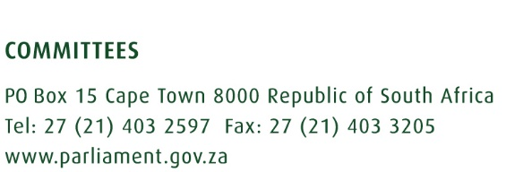
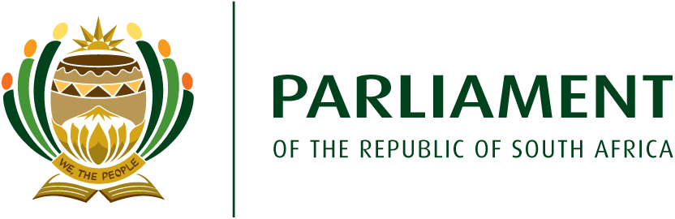
CONTENT ADVISORY NOTE

Committee : Portfolio Committee on Tourism

Content Advisor : Dr Sibusiso Khuzwayo

Date : 16 February 2021

Topic and purpose for discussion

This briefing note provides strategic and policy advice on the interaction with the Department of Tourism and Small Enterprise Finance Agency (SEFA) on the Tourism Equity Fund. Two presentations will be made. The Department will provide the contextual background and SEFA will clarify technical issues.

Policy and strategic issues

The Committee may engage the Department and SEFA on the following issues:

- Bias towards VTSDs
Central to the approach of the Committee is tourism transformation with a bias towards the Villages, Townships and Small Dorpies (VTSDs). The presentation by the Department mentions this inclination, albeit without any details. The technical presentation by SEFA is totally silent on this matter. The qualifying criteria, funding requirements and application process do not provide any information on how he TEF will prioritise emerging enterprises from these designated areas. The Committee should solicit clarity oh how the TEF will benefit the VTSDs.

- Indebtedness to the banks
The TEF has a grant and a loan element. Given the current economic situation and slump in the tourism economy, some beneficiaries might struggle to repay the loan element. This is a possible risk, particularly for the enterprises in the VTSDs. The Department and SEFA should explicitly outline the process to be followed when beneficiaries default on loan repayments. This is important to avoid a possibility of the banks repossessing properties that have been partly funded through tax payers’ money.

- Implementation and oversight
Some of the qualifying criteria by SEFA seem to be designed for a normal funding facility that is not earmarked for transformation. The Committee should get clarity on the oversight role to be played by the Department in ensuring that government priorities are achieved, especially transformation.

- Assistance with qualifying criteria
The Committee would note that there has been a slow uptake for a number of government funding facilities due to non-compliance with the qualifying criteria. This is true for departmental programmes, including the Tourism Transformation Fund. The Department should also clarify how they will assist prospective applicants to qualify instead of rejecting them out of hand due to non-compliance with the qualifying criteria. Assistance by the Department will ensure a high uptake level of the TEF. The presentation alludes to the Technical Committee that will be set up by the Department. More details are needed.

- Continuation of a gap with funding start-up businesses
The TEF seems to be geared towards tourism business expansion as compared to start-ups. This perpetuates the challenge of difficulty to enter the tourism industry as experienced mainly by the aspirant tourism entrepreneurs in the VTSDs. The Department should clarify what is being planned to plug the gap in tourism business start-ups. If the tourism start-ups continue to be neglected, the rate of transformation in the sector will continue to be pedantic.

- Threat for litigation
It is reported that the Minister of Tourism has suspended the implementation of the Tourism Equity Fund as a response to a threat of a legal action from two civil organisations. The reports indicate that the Afrikaner rights groups AfriForum and the trade union, Solidarity, wrote to the Minister of Tourism threatening legal action on the basis of what they term the “racist” criteria for the fund. Both groups are concerned that the TEF is “exclusive on the basis of race, and discriminates without any legal or justifiable basis”. This is their response to the 51 percent black-owner/managed qualification criterion of the fund.

This is the second instance that these two organisations have taken the Minister of Tourism to court. The Committee would recall that a legal action was taken against the Minister in April 2020 when the Tourism Relief Fund was introduced to cushion the tourism sector from the effects of COVID-19. The outcome of that litigation was that the Constitutional Court upheld the Judge Kollapen that “At the level of principle it can hardly be contended that the minister acted outside of her powers …”

The Minister should take the Committee into confidence about the details of the threat of legal action by these two organisations. The Minister should update the Committee about her discussions with the two organisations and the possible delays to the implementation of the TEF should the litigation go ahead.

- The possible challenge with the grant and SEFA loan

The Department should provide more clarity on the R20 million grant and the R15 million loan. There is a possible challenge that might be experienced by the applicants based on the cash requirement for the loan. The presentation alludes that the term of the funding will be determined by the business cash flows up to a maximum of 120 months per enterprise with a maximum moratorium of 12 months. This might pose a challenge as there has been a slow-down in the tourism industry in the past year due to COVID-19 and other factors before the pandemic, some enterprises might not meet the qualifying criteria. The Department and SEFA should indicate how will this requirement take into account the effects of the pandemic and other teething challenges on the cash flow of applicants.

Policy and strategic Advice
At a policy level, the Committee may engage the Department and SEFA with regard to:
- TEF compliance with the Tourism BBBEE Sector codes.
- Redress in the sector in response to the Apartheid laws.

Possible questions to the Department and SEFA

- How is the TEF aligned to the Committee oversight approach on villages, townships and small towns?

- How will the beneficiaries who default on loan repayment be treated?

- What process will be followed by the Department in conducting oversight over SEFA as an implementing agent?

- How will the Technical Team in the Department assist the applicants with meeting the qualifying criteria?

- How will the Department address the gap in funding the tourism businesses start-ups?

- What are the pertinent details of the threat of legal action by AfriForum and Solidarity?

- What lessons did the Minister and the Department learn from the 2020 legal action by AfriForum and Solidarity in order to avoid similar litigations in future?

- How did the Department and SEFA factor in the impact of COVID 19 to the qualifying criteria given that the cash flow is a serious consideration?

