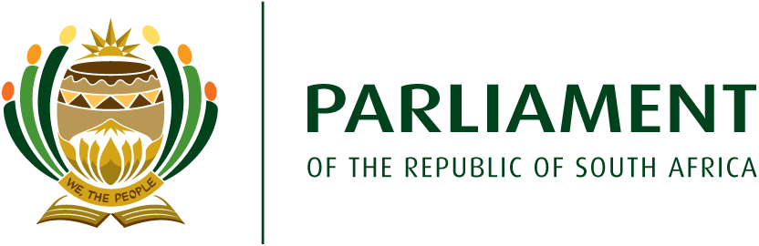

SUBCOMMITTEE ON REVIEW OF THE ASSEMBLY RULES

Please note that the Subcommittee on the Review of the National Assembly Rules will meet on the following date -

Date: Friday, 5 February 2021

Time: 10H00 (the platform will open at 09H30 for testing)

Agenda: Matters before Subcommittee on Rules

Agenda Items

1. Opening
2. Consideration of Minutes (9 November 2019)
3. Composition of the Chief Whips Forum
4. Consideration of Principle of ruling by Mr Dyantyi (29 July 2020)
5. Time for Declarations of Vote
6. Discussion on Questions to the Deputy President
7. Opportunities for Debates for Smaller Parties
8. Discussion on Questions to the Executive not responded to
9. Way Forward and Closing.

Attached are -

- A briefing document on the matters referred to the Subcommittee
- Annexures, which include the –

- Letter from the Speaker referring matters to the Subcommittee
- Unrevised Hansard of the National Assembly for 29 July 2020
- ATC of 15 July 2019, which lists functions of the Deputy President.

Apologies:

Please submit apologies to the Secretariat: Perran Hahndiek at (021) 4032499 or phahndiek@parliament.gov.za; or Victor Ngaleka at vngaleka@parliament.gov.za.

