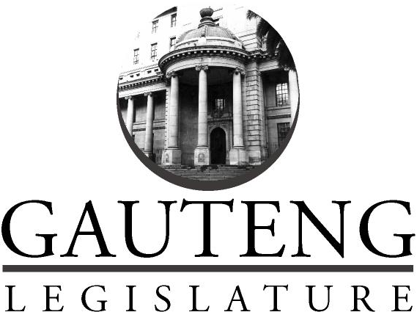
CoGTA AND HUMAN SETTLEMENTS PORTFOLIO COMMITTEE

FINAL VOTINGMANDATE

ON THE:

CUSTOMARY INITIATION BILL [B7D-2018]

19 November 2020

- INTRODUCTION

The Chairperson of the CoGTA and Human Settlements Portfolio Committee, Hon. Kedibone Diale, tables the Committee’s Final Voting Mandate on theon the Customary Initiation Bill [B7D-2018].

- PROCESS FOLLOWED

The Speaker, Hon N Mekgwe, formally referred the further amendments to Customary Initiation Bill [B7D-2018]Section 76 to the Portfolio Committee on CoGTA and Human Settlements for consideration and reporting in terms of GPL Rules 245(1) read with 246, 247 and 248 on Thursday 19 November 2020.

After duly processing the Bill in accordance with the Constitution of the Republic of South Africa, the Committee, on Thursday, 20 August 2020, deliberated and adopted its Negotiating Mandate on the Bill wherein it voted in favour of the said Bill with proposed amendments.

On Thursday, 19 November 2020 the Committee convened a meeting to deliberate on further amendments and the Minutes from the NCOP Select Committee on Cooperative Governance and Traditional Affairs to adopted the Final Voting Mandates on the Customary Initiation Bill [B7D-2018].

- PRINCIPLES AND DETAILS OF THE BILL

The Bill seeks to provide for the effective regulation of customary initiation practices; to provide for the establishment of a National Initiation Oversight Committee and Provincial Initiation; Coordinating Committees and their functions; to provide for the responsibilities, roles and functions of the various role-players involved in initiation practices as such or in the governance aspects thereof; to provide for the effective regulation of initiation schools; to provide for regulatory powers of the Minister and Premiers; to provide for the monitoring of the implementation of this Act; to provide for provincial peculiarities; and to provide for matters connected therewith.

- OBJECTIVES OF THE BILL

The objects of the Bill are as follows:
The aim of the Customary Initiation Bill [B7B-2018] (‘‘the Bill’’), is:

- To protect, promote and regulate initiation and for this purpose to-
- provide acceptable norms and standards; and
- provide for structures at national and provincial levels with a view to ensure that initiation takes place in a controlled and safe environment.
(b) To provide for the protection of life and the prevention of any abuse.
(c) To provide clarity on the various responsibilities, roles and functions of the key role-players in customary initiation.
(d) To make provision for the effective regulation of initiation schools.

- FINANCIAL IMPLICATIONS
The Committee noted the following regarding the financial implications of the Bill:

- No financial implications (no additional expenditure),
- However, the Department will make provisions for travel allowances and accommodation for the work of the members.
- Limited to initiation seasons.

- FINAL VOTING POSITION ADOPTED BY THE COMMITTEE

In terms of thesection 65 of Constitution, the Portfolio on CoGTA and Human Settlements confer authority on the Gauteng Provincial Delegate/s to the National Council of Provinces to vote in favour of Customary Initiation Bill [B7D-2018].

