11 Display Gardens Postnet Suite #22

Sarel Baardt Street Private Bag X2
Gateway Industrial Park RASLOUW
CENTURION 0109

BROADCASTING ELECTRONIC MEDIA & ALLIED WORKERS UNION

Tuesday, 20 October 2020

RESPONSE TO QUESTIONS BY THE PORTFOLIO COMMITTEE

We have been directed to respond to inter alia the following issues, as we hereby do:
“must respond in writing to the Committee their understanding of differences between commercial and public mandates of the SABC;”

BACKGROUND
- The SABC was established in terms of an Act of Parliament, the
Broadcasting Act No. 22 of 1936, which replaced the previous state-

controlled African Broadcasting Corporation, formed in 1927 and included the South West African Broadcasting Corporation, which later became the Namibia Broadcasting Corporation.
- The 1936 Act was subsequently replaced by the Broadcasting Act No. 73 of 1976, as amended, that was repealed by the Broadcasting Act No. 4 of 1999 (‘the Broadcasting Act’), as amended.
- The abolition of apartheid in South Africa introduced extensive changes in the South African Broadcasting Corporation’s (SABC) funding model.
- Then the SABC consisted of two public service stations (SABC 1 and
SABC 2) and one commercial station (SABC 3).
- The transformation of the SABC from a state broadcaster to a public broadcaster began in 1993 with the appointment of the first independent board of the Corporation.

- The 1998 White Paper on Broadcasting took these transformation
processes further.
- Among other things, it:
  - Introduced a legislated Charter for Public Broadcasting outlining the
SABC’s mandate,
  - Clarified the relationship between the public broadcaster and the regulator.
  - Considered how the SABC mandate should be funded; and
  - Separated the broadcaster into two divisions – public and public commercial.

RADIO
- SABC Radio currently includes:
  - 18 Radio Stations and Channel Africa.
  - SABC Radio Stations are widely accessible and they are a core platform for the Public Broadcaster to deliver on its public service mandate.
  - SABC Radio commands a share of 72.6% audiences; the
share increased by 1.5% year on year.
  - The all adult share target for the period under review
(2019/20) is 71.5%.
- Radio Public Commercial Services (PCS) comprise of three (3) radio
stations :
  - 5FMis the entertainment powerhouse for South African youth, offering the most popular contemporary hit music and entertainment on radio. The station has the biggest social media following in South African media with more than a million Facebook and Twitter followers.
  - Good Hope FM is focused on the fun, energy and funkiness of urban Cape Town in the Western Cape Province. The

station is well positioned to meet the lifestyle needs of its audience through showcasing high quality events and highlighting public concerns.
  - METRO FM is the most influential radio brand for youthful urban adults that embrace a pragmatic and successful lifestyle. It is the largest commercial radio station in South Africa with listeners in excess of four million. Though primarily a music station, METRO FM also delivers credible and impartial news reporting that keeps its listeners engaged and informed. Due to its reach, the station plays a critical role in the development of music talent in South Africa through its various initiatives.
  - CHANNEL AFRICA is a radio station managed by the SABC on behalf of the DoC. The station broadcasts on shortwave spectrum to the Southern, Eastern and Western African audiences. The broadcasts are done in English, French,
Chinyanja, Portuguese, Silozi and Swahili

TELEVISION
- SABC TV consists of three free-to-air (FTA) channels and two other channels carried on a subscription digital satellite network.
- The channels deliver local and international content in all South
Africa’s languages.
- SABC 1, SABC 2 and SABC 3 attract on average 27.9 million South
African viewers in a typical month.
a. SABC 3 is operated as a public commercial television service.
- A further two regional SABC licences (SABC 4 & 5) were granted by ICASA in 2005 but the licences were never issued pending
confirmation of sufficient funding for these services.

DIGITAL SATELLITE NETWORK
- SABC ENCORE is a retro channel showcasing and celebrating SABC programming from the 1980s and 1990s. The channel, which forms an integral part of the SABC’s strategy moving into a multi-channel

environment, is currently available in HD and carried on DStv channel 156, a subscription digital satellite network channel.
- SABCNews is available in HD and is broadcast on DStv channel 404 and offers breaking news and continuous news updates. The channel broadcasts in English and reaches 51 African countries as it aspires to be a Pan African channel. It has the second highest number of viewers on the DStv news block and continues to display impressive growth. It offers a seamless fusion of rolling news and current affairs programming, boasting 18 hours of live daily coverage.

MIGRATION TO DIGITAL
- The migration from analogue to digital television will change the structure of the SABC and enable it to air many more television channels.
- With analogue, each spectrum channel or multiplex delivers a single analogue television channel.
- In the digital television environment, the multiplex can deliver up to eight channels. This will enable the public broadcaster to better meet
its public mandate across its television services as, for example, it has been restricted by the number of channels in ensuring all languages are treated equitably.
- In many countries around the world it is recognised that public broadcasting services play a critical role in a democracy and in ensuring that society’s social and cultural needs and objectives are met.
- Post-apartheid SABC has however been plagued by scandals and
poor financial decisions, resulting in a deep crisis at the broadcaster in terms of its precarious financial state and the quality of its content.

MANDATES
- The mandate, powers and functions, as well as the SABC’s rights and obligations, are derived from a number of sources:
    - legislation,
    - the Charter,
    - the license conditions of each SABC station and channel, and
    - regulations issued by ICASA from time to time, including the Code of Conduct for Broadcasters set by the BCCSA,
- Programming must be in all the country’s official languages, offer a plurality of views and a variety of news, information and analyses from a South African perspective, and advance the national and public
interest.
- As a custodian of the country’s diverse cultural heritage and expressions, the SABC is a platform for the expression of the hopes, dreams and aspirations of South Africans, be these past, present or in the future.
- The object of the Broadcasting Act is to establish and develop a broadcasting policy in the Republic in the public interest and for that purpose, inter alia to:
    - contribute to democracy, development of society, gender
equality, nation building,

    - safeguard, enrich and strengthen the cultural, political, social and economic fabric of South Africa;
    - ensure plurality of news, views and information and provide a wide range of entertainment and education programmes;
    - cater for a broad range of services and specifically for the programming needs in respect of children, women, the youth and the disabled;
    - encourage the development of human resources and
training, and capacity building within the broadcasting sector especially amongst historically disadvantaged groups;
    - be a strong and committed public broadcasting service which will service the needs of all South African society;
- South Africa's broadcasting legislation provides for a three-tier licensing structure for broadcasting services: public, commercial and community.
- The SABC is South Africa's only public broadcaster, and for public accountability purposes consists of two separate divisions controlled
by the Board: a public service division and a commercial service division, in each of which the SABC runs a number of radio stations and television channels.
- Each has a set of license conditions that imposes obligations, including quotas for local content, and requirements for geographical coverage and language services.
- These are laid down by ICASA, which is responsible for monitoring compliance with the license conditions and with the objectives of the Charter.
- Broadcasting licences are categorised in the following classes:
    - Free-to-air radio service;
    - free-to-air television service;
    - satellite-free-to-air radio service;
    - satellite-free-to-air television service;
    - satellite-subscription television service;
    - terrestrial-subscription television service;
    - direct-to-home delivery service, including multi-channel
satellite distribution;
    - local delivery service;
    - cable television subscription service;
    - low power radio service; and
    - any other class of licence as determined from time to time.
- TheSouth African broadcasting system:
    - serves to safeguard, enrich and strengthen the cultural,
political, social and economic fabric of South Africa;
    - operates in the public interest and strengthens the spiritual and moral fibre of society;
    - ensures that the broadcasting system is controlled by persons or groups of persons from a diverse range of communities in South Africa and within each element promotes ownership, control and management of broadcasting services by persons from historically disadvantaged groups;
    - encourages fair competition in the provision of programmes and services.
- The Minister is ultimately responsible to develop policy that is required from time to time.
- Public and commercial broadcasting services must comply with international technical standards and the broadcasting system must be readily adaptable to scientific and technological advances.
- The broadcasting system, as a whole, must provide educational programming, and where such programming is provided by a dedicated education service, must be extended throughout the Republic within the financial resources.
- The programming provided by the South African broadcasting system must:
    - be varied and comprehensive,
    - providing a balance of information, education and entertainment, meeting the broadcasting needs of the entire South African population in terms of age, race, gender, interests and backgrounds;
    - be varied and offer a range of South African content and analysis from a South African perspective;
    - must be drawn from local, regional, national and international sources;
    - provide a reasonable, balanced opportunity for the public to receive a variety of points of view on matters of public concern;
    - provide a significant place for programmes produced by the independent production sector;
    - comply with the code of conduct for broadcasting services as prescribed in Schedule 1 of the IBA Act.
- A range of programming in the Republic's official languages must be extended to all South Africans as circumstances permit.
- The human resources development strategy for the broadcasting
sector must be viewed holistically in terms of qualification standards, skills development, teaching, inter-relationships with the complementary sectors and the funding of the training system.
- According to the revised edition of Toby Mendel’s Public Service Broadcasting: A Comparative Legal Survey (2011), which examines the public broadcasters of Australia, Canada, France, Japan, Poland, Thailand, the United Kingdom and South Africa, all public
broadcasters strive to serve the broadest public possible, by:
    - establishing and maintaining a national identity and culture,
    - upholding democracy and freedom of expression, and
    - furthering a plurality and diversity of voices.
- To this end a public broadcaster needs to be both free of political interference and economically independent.
- The SABC is said to meet all these criteria of what defines a public broadcaster, except in the area of funding.
- Whereas most public broadcasters are heavily funded by their national governments, the SABC is dependent on commercial funding and licence fees.
- The objectives of the Corporation are:
  - to make its services available throughout the Republic,
  - to provide sound and television broadcasting services, whether by analogue or digital means,
  - and to provide sound and television programmes of information, education and entertainment funded byadvertisements, subscription, sponsorship, licence fees or any other means of finance;
  - to acquire from time to time a licence or licences for such period and subject to such regulations, provisions and licence conditions as may be prescribed by the Authority;
  - to provide, in its public broadcasting services, radio and television programming that informs, educates and
entertains;
  - to be responsive to audience needs and account on how to meet those needs;
  - to provide other services, whether or not broadcasting or programme supply services, such services being ancillary services;
  - to provide television and radio programmes and any other material to be transmitted or distributed by the common carrier for free to air reception by the public subject to section 33 of this Act;
  - to provide to other bodies by such means and methods as may be convenient, services, programmes and materials to be transmitted or distributed by such bodies and to receive from such other bodies services, programmes and materials to be transmitted by stations of the Corporation for reception as above;
  - to commission, compile, prepare, edit, make, print, publish, issue, circulate and distribute, with or without charge, such books, magazines, periodicals, journals, printed matter,
records, cassettes, compact disks, video tapes, audio-visual and interactive material, whether analogue or digital and whether on media now known or hereafter invented, as may be conducive to any of the objects of the Corporation;
  - to establish and maintain libraries and archives containing materials relevant to the objects of the Corporation and to make available to the public such libraries and archives with or without charge;
  - to organise, present, produce, provide or subsidise concerts, shows, variety performances, revues, musical and other productions and performances and other entertainment whether live or recorded in connection with the broadcasting and programme supply services of the Corporation or for any purpose incidental thereto;
  - to collect news and information in any part of the world and in any manner that may be thought fit and to establish andsubscribe to news agencies;
  - to carry out research and development work in relation to any technology relevant to the objects of the Corporation and to acquire by operation of law, registration, purchase, assignment, licence or otherwise copyright and designs, trade marks, trade names and any other intellectual, industrial and commercial property rights;
  - to nurture South African talent and train people in production skills and carry out research and development for the benefit of audiences;
  - to develop, produce, manufacture, purchase, acquire, use, display, sell, rent or dispose of sound recordings and films and materials and apparatus for use in connection with such sound recordings and films;
  - to develop and extend the services of the Corporation
beyond the borders of South Africa.
- Revenue which comes from the state budget or other public funds, or from mandatory fees paid by viewers and listeners (broadcasting licence fees), is generally referred to as "public revenue".
- In contrast, income from contractual transactions on the market (advertising, sponsorship, programme sales, etc.) is generally referred to as "commercial revenue".
- The fact that such commercial revenue is derived from a broadcasting service, or is used to fund it, does not, however, mean that the broadcasting service itself is of a commercial nature. This is often a cause of misunderstandings.
- In Europe the predominant funding model for public service broadcasting is mixed funding, where a combination of public and commercial revenue is used to fund the public service activities.
- Whether a programme service is of a public service nature or a commercial nature depends solely on whether it falls within the public service remit as legally defined and specified by the competent bodies in a given State.
- Commercial revenue is the primary enabler of the South African Broadcasting Corporation to meet its mandate to deliver widespread public value.
- Revenue is generated through the sale of classic advertising, programme and sports sponsorships across SABC Television, radio and website platforms.
- The public service provided by the Corporation must—
    - make services available to South Africans in all the officiallanguages;
    - reflect both the unity and diverse cultural and multilingual nature of South Africa and all of its cultures and regions to audiences;
    - strive to be of high quality in all of the languages served;
    - provide significant news and public affairs programming which meets the highest standards of journalism, as well as fair and unbiased coverage, impartiality, balance and independence from government, commercial and other interests;
    - include significant amountsof educational programming, both curriculum based and informal educative topics from a wide range of social, political and economic issues, including, but not
limited to, human rights, health, early childhood development, agriculture, culture, justice and commerce and contributing to a shared South African consciousness and identity;
    - enrich the cultural heritage of South Africa by providing support for traditional and contemporary artistic expression;
    - strive to offer a broad range of services targeting, particularly, children, women, the youth and the disabled;
    - include programmes made by the Corporation as well as those commissioned from the independent production sector; and
    - include national sports programming as well as developmental and minority sports.
- The public service provided by the Corporation may draw revenues from advertising and sponsorships, grants and donations, as well as licence fees levied in respect of the licensing of persons in relation to television sets, and may receive grants from the State.
- The commercial services provided by the Corporation must:
    - be subject to the same policy and regulatory structures as outlined in this Act for commercial broadcasting services;
    - comply with the values of the public broadcasting service in the provision of programmes and service;
    - commission a significant amount of their programming from the independent sector;
    - subsidise the public services to the extent recommended bythe Board and approved by the Minister; and
    - be operated in an efficient manner so as to maximise the revenues provided to its shareholder.
- Television license fee collection is controlled by the S.A. Broadcasting
Act, No. 4 of 1999 (Section 27) as amended.
- In terms of the Act, Television license fees should be used to provide funding for the SABC’s PBS mandate.
- According to the SABC Corporate plan 2014–2017, PBS Radio Stations command the highest audiences in South Africa.
- However, revenue realisation does not equate to the audience share.
- PBS radio stations depend solely on advertising revenue, whilst other sources of advertising are not exploited. PBS radio station license conditions stipulate that the station must meet mandatory programming deliverables which are sometimes not attractive for advertisers to invest
in.
- Broadcasting in a vernacular language as per its licence conditions is aimed at niche audiences.
- This creates a challenge for public broadcasting radio stations - to meet licence conditions and at the same time remain financially sustainable.
- Internationally, Britain led the way in public broadcasting.
- Established in the 1920’s the BBC organisation was extensively respected as a source of reliable information, education and entertainment.
- Public broadcasting systems are basically an application of the British Broadcasting Corporation, which was adopted by some countries (BBC,
2015).
- McKinsey, a financial consulting firm, in a study identified four types of funding models applicable to public broadcasting services (Bora, 2011).
    - PBS broadcasters that are financed solely or almost purely by revenue that is collected through a license fees system, in countries such as Japan, Norway, Sweden, Australia and
Denmark;
    - PBS Broadcasters financed by a mixed system, in countries such as Germany, Turkey, Belgium, Netherlands, France,
Czech Republic and Italy;
    - PBS broadcasters financed by license fees that are essential but not primary; such as France, Poland, Denmark and South Africa. For these countries, the major source of revenue is either government grants or commercial revenues; and
    - PBS broadcasters not collecting any license fees but are funded by government grants and/or advertisements only, such as Portugal, Spain and New Zealand.
- A number of studies have been conducted on the SABC.
- Masenyama (2006) held the view that the SABC plays an important role in promoting a sense of national unity in South Africa, through diversity in its programming.
- Furthermore, that hindering the SABC’s role is its hybrid model of broadcasting, which comprises of characteristics of both public and commercial broadcasting.
- Berger and Jjuuko (2007) present a similar argument, stating that the SABC is in many respects run as a commercial broadcaster, which produces implications for its programming, independence and public accountability.
- Eastman (2003) contends that the SABC’s over reliance on advertising is problematic and results in the goal to enlarge audiences, and thus the pressure to expand advertising sales, reduce programming costs and attract bigger audiences. That this goal directly counters the SABC’s mandate to serve multiple ethnic groups through local programming.
- This according to (Eastman 2003; Berger and Jjuuko 2007) also results in English language programming dominating programming and compromising the SABC’s broadcasting in all eleven official languages mandate.
- In an evaluation of SABC news, Roseborough and Bird (2007) argue that the SABC’S over reliance on advertising impacts on the SABC news by limiting the news airtime and news budget.
- Although these findings seems to be aged, the SABC’s funding model, and its composition has not significantly changed since then.

PUBLIC MANDATE
- Public service broadcasting can be loosely defined as broadcasting solely for the bettering of society, as opposed to broadcasting for financial gain (Tracey, 1998)
- Public Service Broadcasting (PSB) generally implies the following
characteristics:
  - Public ownership, usually involving a large degree of financial autonomy;
  - accountable to the public through parliament (which does not imply state control, i.e. not a state broadcaster).
  - Universal availability through open broadcasts (i.e. unconditional access), irrespective of geographical location;
  - the coverage area is therefore national (countrywide), or regional when directed at a specific interest and/or cultural group.
  - PSB caters for all interests and tastes, with commitment to a balanced schedule across the different programme genres, which incorporate elements of information, education, and entertainment.
  - PSB also caters for minorities; this means that every member of the viewing or listening public will, at some time or another, find something of interest in its programmes.
  - PSB programme content should be independent of vested interests and government;
  - It should be politically impartial, which means political output should be impartial and balanced.
  - PSB should be funded mainly by its users from licences and/or fiscal funds; licence fee funding is a form of (poll) tax levied on the owners of television receivers.
  - In most cases, with the notable exception of the BBC and Australian ABC, advertising is a common supplement to the licence fee income.
  - The emphasis in PSB is on programming rather than on audience numbers.
- Commercial Broadcasting, by contrast, is typically characterised by the following criteria:
    - Privately owned, usually accountable only to its shareholders.
    - Profit driven: the aim of commercial broadcasting is to make a profit, and funding is derived from commercial sources.
    - It does not claim any licence fee income, but is funded by either subscription fees or advertising or sponsorship, or a combination of these.
    - Limited geographical coverage: commercial services are normally targeted at profitable areas, often using conditional areas (e.g. encoded broadcasts).
    - There is a selected spectrum of affordable and popular programmes (mainly entertainment and recreational).
- Generally speaking, commercial broadcasters are liable to have fewer commitments to provide specific levels of balanced output, domestic origination, and impartiality than their public service counterparts.
- The programming focus is normally on broad market needs.
- Commercial broadcasters are usually regulated on foreign and cross-media ownership
- The aim is to attract the maximum number of viewers and listeners.
- As part of the broadcasting "licence fee", an obligation to comply with requirements regarding local content, language diversity, and news.
- It is an integral part of a funding regime where a government partially funds a PSB, and the rest of revenue comes from other streams.
- SABC FUNDING At the insistence of Parliament's Portfolio Committee on Communications committee's a skills audit was conducted by PricewaterhouseCoopers (PWC) in 2014.

- The SABC is partially funded by the South African government.
- Less than 5% of its revenue comes from government, for educational programmes.
- About 80% of its revenue comes from advertising and private sponsorship and about 12% comes from TV licenses fees.
- The SABC’s revenue is under pressure due to the fact that the SABC is not enforcing the Broadcasting Act to pursue, by means of a fine and civil prosecution defaulters who does not pay licence fees.
- Furthermore, the bad publicity and irregularities at the SABC has caused advertiser to look elsewhere, and created an excuse, to an extend legitimately so, to withhold their licence fees.
- Additionally, instead of lowering TV licence fees, to make it more affordable and to get more people to pay their licences, the SABC wants to increase fees, to burden those who already pay, even more.
- It is proposed that the SABC embark upon a campaign where early payers be given a discount, whilst defaulters be warned they will, and in fact be issued with a fine and civil action as per the Act.

“must respond in writing to the Committee on its understanding of the relevance of the Skills Audit to the
Section 189 process;”

THE IMPORTANCE OF THE SKILLS AUDIT TO THE S189 PROCESS
- On exactly the 18th of June 2020 the SABC served the following
S189 Notice on all of its employees:
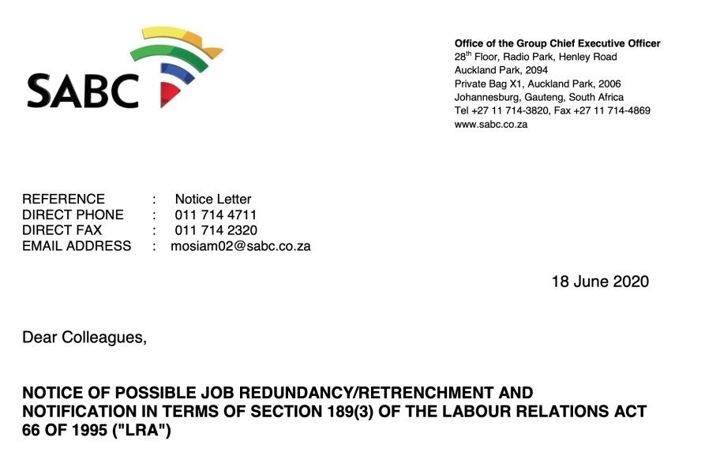
- Contained in this notice, the selection criteria proposed by the
SABC:
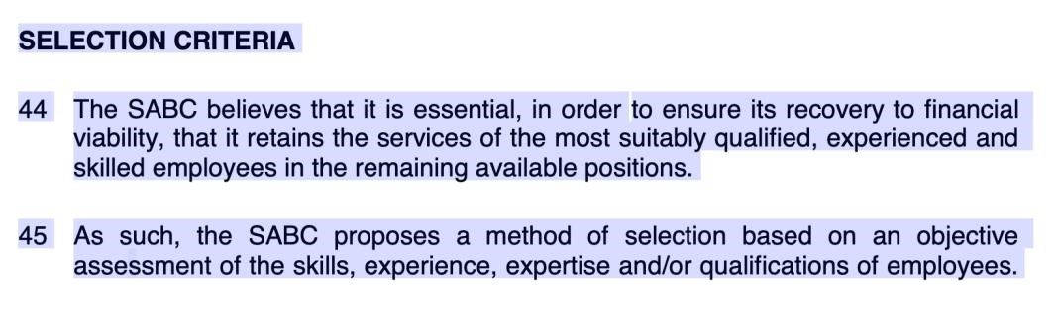

- Clearly, the selection criteria proposed by the SABC will be based on an objective assessment of skills expertise and qualifications – a skills audit.
- Jonathan Thekiso, the HR Director at the time described it as fair, legitimate and correct.
- Seven (7) days later, on 25 June 2020 the SABC denied what is contained in their own S189 notice, saying;
“The SABC says the current skills audit has nothing to do with its intention to retrench staff but rather a bloated workforce necessitates the need for job cuts.
On Wednesday, the SABC Board and Executives tried to make its case before Parliament’s Communications Portfolio Committee to begin the section 189 process to retrench staff on the 1st of July.
SABC COO Ian Plaatjies says the current management inherited a bloated workforce and it is imperative to ensure that those employed have the necessary skills to perform their jobs.
Plaatjies says, “We have inherited a bloated work structure, now it is important to differentiate between a bloated structure and incorrect skills or lack of skills. No matter how much we reskill people we will still have a bloated structure…”
“So when we look at the skills audit it is not a prerequisite to a 189 process, the skills audit will enable us to develop an adequate talent management process and certainly a skills development plan andretrenchment plan,” added Plaatjies.
- One needs to carefully analyse what the SABC COO said, playing with words.
- It is correct that the Skills Audit has nothing to do with the SABC’s intention to retrench staff. It however has everything to do with the selection criteria proposed by the SABC.
- It then makes it absolute relevant and necessary to have a proper and authentic skills audit.
- This then also deals with the SABC’s answer hereunder.
“The conclusion of the skills audit process is not a statutory or governance pre-requisite for the approval of the Target Operating Model, or the issuance of the Section 189 notice to employees”
- Once again true, but playing with words. It is proposed selection criteria, making it absolute relevant.
- Another reply from SABC:
“However, during Section 189 engagements, parties will collectively explore, consider and decide how the results of the skills audit could be utilised while upholding the principle of fairness.”
- This never happened!
- What is a skills Audit?
“Skills audit is a process in which the skills of individuals or groups are being measured. The basic intent behind any skills audit is to identify the existing set of skills within the organization and the skills and knowledge the organization will need in the future.
A skills audit is more than simply collecting qualifications information. A good skills audit enables organizational leaders to build a comprehensive skills matrix and see whether each employee within the company possesses the competencies and actual skills to fulfill his/her workplace role.
The audit data can also be used to detect skill deficiencies, improve skill levels, and prevent critical skill losses. Each person who works in the organization has a set of skills. Not only is it important for the organization to know what each person’s skill set and skill levels are, but it is also important to know how these skills are utilized as part of his/her work role.
Skills audit always involve documenting the skills the organization needs to become successful, and the skills the workers already have; and at the end of the day comparing these two data sets.
In the end the skills audit provides a snapshot of the organizations skills base that allows identification of specific training needs, prioritization of training, job role matching, and the meeting of employee desires and aspirations.”
- Downfall of not conducting a skills audit:

“Organizations, which do not engage in skills audits, usually face the following problems:
Having the wrong people in the wrong job roles.
Inhibited job growth for your employees.
Not recruiting the right applicants for both the organizations’ current and future strategic needs.
Expensive and non-effective training.
Training plans that are too general to bring valid results.
Failure to align training priorities with the goals and priorities of the organization.
Little or no commitment to training & development by management and staff, as plans are not seen as value adding.”
- Additional to the fact that the SABC is proposing skills, competencies, experience and expertise it simply cannot afford to
not have, and use an objective skills audit as basis should there be consensus on the proposes selection criteria.
- The consultant, who did the skills audit on behalf of the SABC has confirmed the skills audit will not be able to capture employee’s competencies and skills correctly.
- Furthermore, that they, the consultants informed the SABC about this, but that the SABC persisted with the skills audit.
- Just some history to the entire skills audit issue, and how it came about that the SABC stopped the previous S189 process to first do a skills audit.
- It needs to be noted that, if the SABC was of the view the Skills Audit was not relevant to the S189 process, why did they stop the S189 process to do skills audit?
- During or about 2013 and at the instance and insistence of the Parliament's Portfolio Committee on Communications, an independent skills audit was conducted by
PricewaterhouseCoopers (PWC) which revealed that the SABC does
not have the appropriate skill levels to successfully transition to digital broadcasting before the international deadline of June 2015.
- From the 2013 Skills Audit:
Aligned to its mandate, the SABC has, over the past year, implemented various turnaround initiatives aimed at improving thedelivery of public value, operating more efficiently and preparingchannels and stations for the digital age.
As part of this important journey to embedding changes and ensuring sustainability, the broadcaster embarked on a re-design ofthe operating model and an organisational structure that is efficient,assigns accountability to those charged with execution, andsupported by the adequate skills to effectively implement the migration to digitisation.
In view of the above, the Skills Assessment Project Report is aimedat directing and prioritising areas of significant improvement and enhancement of processes, structure, people and change, with the following strategic objectives:
  - Ensure that the SBC has the correct staffing numbers acrossits divisions to effectively operationalize the new structureand processes;
  - Ensure alignment between structure and processes;
  - Eliminate duplicate processes between divisions anddepartments;
  - Develop a skills and competency framework for all workforce segments;
  - Determine skills and competency gaps between future skillrequirements and current employee skill sets;
  - Determine scarce and critical skills for the entire SABC;
  - Determine personal development plans;
  - Develop a training plan based on the outcomes of the skills and competency assessment process; and
  - Verify authenticity of employee qualifications.
The findings, conclusions and recommendations of the 2013 Skills
Assessment ProjectReport will further assist and enable the Executive Leadership Team of the SABC to continue embracing transformational change thus enabling the SABC with a high performing culture with the right people with the right skills tousher a whole new broadcasting environment for the entity.
The envisaged outcomes of the Skills Audit Project were thefollowing:
  - List of critical and scarce skills per division and workforce segment
  - Development of personal development plans (PDPs);
  - Organisational training plan to address the skills gaps identified for digitisation and current needs;
  - Skills and competency assessment report for the entire organisation;
- Some committee members described the outcome of the skills audit as a "shocking state of skill availability at the South African
Broadcasting Corporation (SABC) - from executive management down"
- The independent audit report also revealed the following:
      - 60% of executive and senior managers do not meet the minimum strategic thinking skills for executives;
      - 56% were unable to demonstrate adequate levels in solving problems and making decisions;
      - 15% demonstrated only marginal competence in strategic thinking; and
      - 35% of the group did not consider the financial information provided to them as a skills test during the audit.
- The Mail & Guardian reported that Members of Parliament came down hard on the South African Broadcasting Corporation (SABC) and questioned whether the public broadcaster was capable of asuccessful transformation to digital broadcasting scheduled to take off in June 2015.
- On or about 30 October 2018 the Democratic Alliance expressed its serious concern about the intended retrenchment of “up to 2200 staff, effective 1 February 2019.”
- “Of serious concern is that this is to take place without the SABChaving conducted a proper employee audit, which means staff who should not lose their jobs might end up doing so. Beforeconsidering retrenching staff, the SABC ought to have conducted aproper independent skills audit to asses which staff it still needs, and those that are no longer needed, similar to the one conducted by PricewaterhouseCoopers for the SABC in 2013.” the DA Shadow Minister of Communications said in a media release.
- It furthermore said “The DA will not allow the SABC to play Russian Roulette with the jobs of its staff. Therefore, we will be writing to the SABC’s CEO requesting that an independent HR audit be conducted, and the results thereof tabled in Parliament and made public.”
- During or about 25 September 2018 the SABC made a presentation to this committee.
- The Power Point presentation was entitled SABC STRATEGIC
ROADMAP and the SABC presented the following (Slide 102):
“HUMAN RESOURCES – STRATEGIC POSITIONING
We will become a Preferred Employer with Employees who are our brand ambassadors.

• Talent attraction and retention, learning and development are highpriorities and so is having the right people in the right job - highly skilled,motivated, engaged, and passionate people
- On 13 November 2018 the SABC made another presentation to this
Committee.
- Mr Bongumusa Makhathini, Board Chairperson: SABC, thanked the Committee for the opportunity to give an update on the progress made in the implementation of the turnaround strategy.
- The SABC’s slide 41dealt with proposed selection criteria.
THE PROPOSED METHOD FOR SELECTING WHICH EMPLOYEES TO
RETRENCH
        - The SABC proposes a method of selection based on an objectiveassessment of the skills, experience, expertise and/or qualifications ofemployees.

        - The Corporation is confident that the above selection process is fair, legitimate and correct.

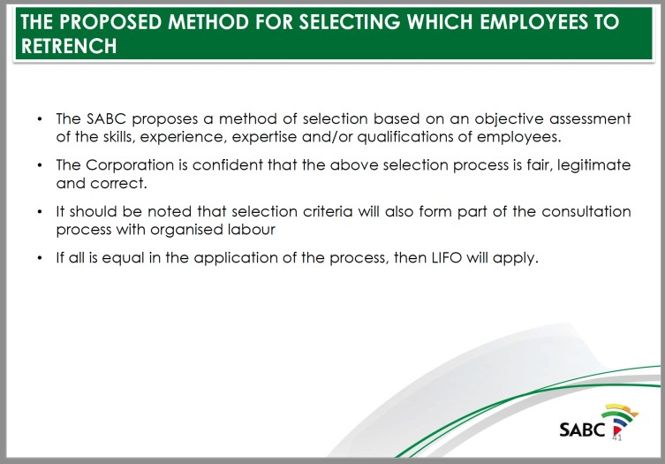

- In his presentation, Mr Jonathan Thekiso, Group Executive, Human
Resources (as he was then) told this Committee:
“… the implementation of section 189 would affect all employees, from top senior management to the bottom, and all divisions within the SABC and all provinces across the country. It would be based onan objective assessment of the skills, experience, expertise and/orqualifications of employees. The method of selection would be fair,legitimate and correct and added that the selection criteria would form part of the consultation process.”
- MrMadoda Mxakwe, Group Chief Executive Officer (CEO): SABC, said that the decision to utilise section 189 formed part of the cost cutting measures being implemented.
“As part of the turnaround strategy, the SABC was also reviewing its wage bill. The wage bill took 43% of the overall revenue. Thebiggest cost driver of the wage bill was senior management. The SABC had 495 senior managers and their total bill was R630million.”
- Yet, in its presentation on Friday, 16 October 2020 the SABCpresented a structure at Commercial Enterprises where the numberof senior managers (scale 120) will be increased from two (2) to(five) 5.
- Mr M Kalako (ANC) expressed his gratitude that the SABC was not going to CCMA with a conclusion to retrench its employees, but to engage with the organised labour unions. He asked if it had
conducted a skills audit. Would the implementation of section 189 affect the SABC executives?
- Mr B Bongo (ANC) said he was not convinced by what the SABC had reported, as it seemed as if the section 189 was already being implemented. He wanted to find out if SABC had done any auditsbefore engaging in consultation with the labour unions. He said the retrenchment was focusing on lower level employees, yet the SABC’s top executive structure was heavily staffed. He did not understand why the SABC was employing more people, while at the same time it was working towards retrenching 981 of its employees. Mr Bongo said that the Board had been quick to arrive at a decision to retrench its employees. It should have started byevaluating the skills that could be used internally before employing a legal adviser whose salary would be very high.
- He suggested that the reduction in costs should start by reducing the salaries of the executives.
- Ms Van Damme expressed her displeasure at the SABC Board’s attitude. She felt that the executives were arrogant and that their
attitude should be addressed. The executives thought that they were bigger than the Parliament that had oversight over the SABC.
- She stressed the need to employ an independent organisation toconduct the skills and salary audits.
- Ms M Matsoba (ANC) also expressed her unhappiness about the decision to retrench workers, and said she could not accept the entire report.
“Allowing the SABC to retrench its workers would be a brutal act.”
- In reply, Mr Mxakwe said the functional competences, qualificationsand expertise of employees were being looked at. All theseprocesses were being incorporated in the implementation of section189 and the consultation process.
- Ms Van Damme said that the PWC skills audit which had been done in 2013 had focused on qualifications, expertise and skills.
However, it had not included the salaries of all SABC employees. The PWC audit was now outdated because five years was a long time and many things had changed within the SABC.
- On 27 November 2018 another meeting of this Committee took
place.
- Mr Bongo agreed with Mr Tseli that the report is not addressing what Members want. Members requested a skills audit of the SABCstaff, who is there and their qualifications.
- Ms van Damme agreed with Mr Bongo.The presentation is telling us the same information and SABC should have come to the Committee with a skills and salaries audit. The Committee will notsupport retrenchment until SABC provides a skills and salary audit.
It will not allow SABC staff to lose their jobs.
- On 31 January 2019 the SABC announced that is has halted the
S189 process.
“The SABC announced on Thursday that it is halting moves to retrench more than 2,000 permanent staff and freelancers, pendinga skills audit.”
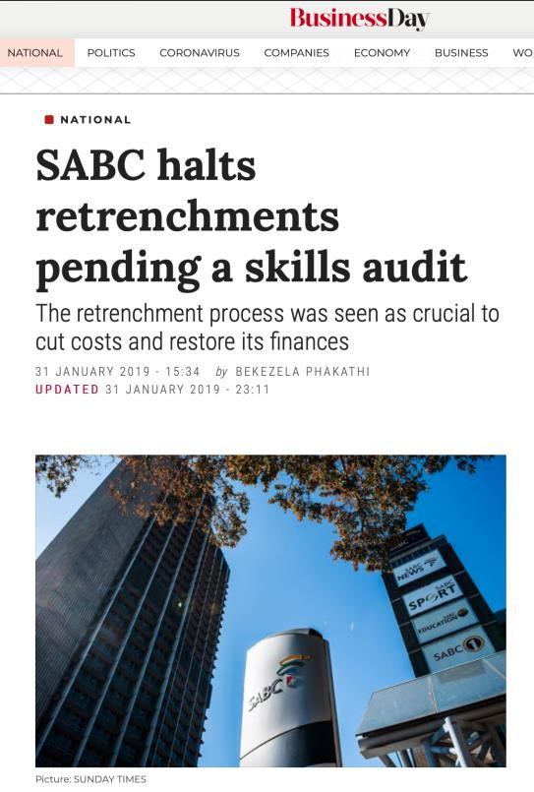

- Per the SABC’s 2019 Annual Report, p.32
“The organisational structure is being adapted to ensure alignmentto the new operating model and will be implemented in alignmentwith the outcomes of the Skills Audit.”
- “The SABC is busy conducting a Skills Audit. Once the results havebeen received and processed the operating model and structureswill be finalised and implemented.”
- “For the period under review, the SABC commenced with a Skills Audit to ensure alignment between its available and future skillsrequirements.”
- “The SABC’s headcount has been on a downward trend over the past year. It is, however, important to retain core skills and talent.”
- The review of the operating model in order to identify cost efficiencies and ensure a fit for purpose staff complement willcommence in the next nine months once the Skills Audit has beenconcluded
- Fast forward to 2020.
- As per the GCEO, in the SABC’s Corporate Plan dated 29 April
2020:

“Concurrently, we are finalising the skills audit process which willhelp us in defining the future structure and capabilities of the
SABC.”
- Paragraph 4 of the SABC’s S189 Retrenchment Notice:
“… Added to this, a need to improve our efficiency, simplify our structures, as well as align the level of staff to the newoperating model is a matter of urgency if we are to begin the journey towards rediscovery and financial viability.”
- This makes the Operating Model extremely relevant to the S189 process.
- Paragraph 8.3.6 of it’s Notice:
“..attract new digital skills in information communication technologies and business processes, …”
- Paragraph18.3.8 of it’s Notice:
“implement a fit-for-purpose organisational structure”
.

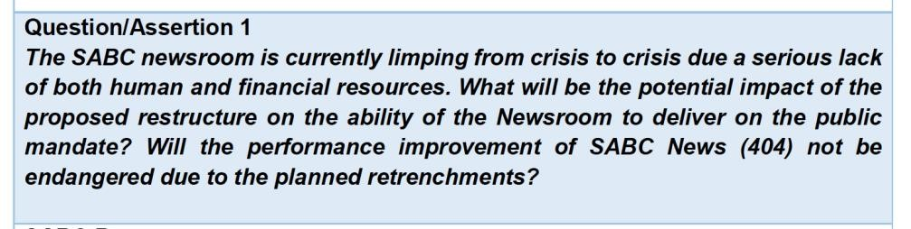

The review also seeks to ensure that the newsroom is equipped not only from the point of human resource capacity, but also from a content perspective. Part of the consideration is the introduction of specialist coverage areas that are currently nonexistent or not properly resourced, such as investigative journalism, health, education, science, technology and innovation, as well as crime and courts coverage.

The public news service cannot do justice to the coverage of the country without the correct expertise to do so.

Besides the focus on skills capacity, the review also deals with news technology infrastructure to enable efficient off-site newsgathering and processing.

Since the SABC News Division is not expected to be profitable, there is no basis for a commercial model.

Regions have not been reduced. What is being pursued is the reconfiguration of two provincial offices.

However, during Section 189 engagements, parties will collectively explore, consider and decide how the results of the skills audit could be utilised while upholding the principle of fairness.

The skills audit questionnaires were derived from division/function/discipline specific competencies which were identified and approved by respective Group Executives and were generic enough to cover various levels within the same ‘job family’.

Regarding the skills audit process, the SABC management consulted with Organised
Labour on the approach. No concerns were raised. A request was made by Organised Labour to have a separate session with the service provider only. This was granted. The feedback received following that session was that no concerns were raised regarding the approach to be taken.

The SABC cannot utilise the Skills Audit as a precondition for a Section 189 process or as a basis for who to retrench and who not to retrench as this is an issue to be determined by the employer in consultation with the relevant consulting parties as per section 189 of the LRA.
The SABC has noted the Committee’s reference to the events in 2018, including calls then for a Skills Audit and a halt to that section 189 process. The SABC further notes that the Section 189 process was only suspended in January 2019 because the Board had become inquorate.
It is important to reiterate here that the Skills Audit is not part of the retrenchment process. Instead, it is a process that can be undertaken by an employer with no intention of retrenching employees, but rather as part of the employees’ personal development plans and the organisation’s talent management strategy. A Skills Audit process cannot be relied upon as being a requirement in a retrenchment process. Section 189 of the LRA already provides that the employer, in conjunction with the employees and Organised Labour must determine the selection process and criteria to be adopted. As such, if the SABC decided to use the Skills Audit as part of the retrenchment process, it would amount to nothing more than a fait accompli and undermine the consultation process itself.
The Skills Audit cannot be relied on in a Section 189 process because an employer is still required to allow employees and/or their respective trade union representatives to make representations so that the appropriate selection criteria may be determined and agreed upon.

"[69] It is trite that fairness requires that employees who are selected for retrenchment on the basis of lack of skills or qualifications, should be afforded an opportunity to make representations on that. In casu the Respondent’s retrenched the Applicant, using the skills audit, conducted by outside consultants, as the basis for retrenchment. The skills audit indicated a tertiary qualification as a requirement, without considering the workplace specific requirements. It cannot be a fair basis to deny an existing employee her job security, more so where she had been performing payroll functions for more than four years"

The import of the above is clear: a Skills Audit process cannot be a basis for selecting who to retrench and who not to retrench. It is also not a requirement for determining the selection criteria to be applied in the retrenchment process. This is an issue to be determined by the employer in consultation with the relevant consulting parties as per Section 189 of the LRA.

It is for the above reasons, that the Board has not utilised the Skills Audit as a condition for a Section 189 process. Nonetheless the results of the Skills Audit are included as annexures for the Committee’s information as requested (see Annexures A and B).

It is important to note that the Skills Audit is not part of the Section 189 process. Instead, it is a process that can be undertaken by an employer with no intention of retrenching employees, but rather as part of the employees’ personal development plans and the organisation’s talent management strategy.

A Skills Audit process cannot be relied upon as being a requirement in a Section 189 process. Section 189 of the LRA already provides that the employer, in conjunction with the employees and Organised Labour must determine the selection process and criteria to be adopted. As such, if the SABC unilaterally decided to use the Skills Audit as part of the Section 189 process, it would amount to nothing more than a fait accompli and undermine the consultation process itself.

The Skills Audit cannot be relied on in a Section 189 process because an employer is still required to allow employees and/or their respective trade union representatives to make representations so that the appropriate selection criteria may be determined and agreed upon.

The SABC skills audit is not flawed. It is based on a proven methodology that has been used by various private and public institutions.
The skills audit questionnaires were derived from proven industry related models and division/function/discipline specific competencies which were identified and approved by respective Group Executives.

Regarding the skills audit process, the SABC management consulted with Organised
Labour on the approach. No concerns were raised. A request was made by
Organised Labour to have a separate session with the service provider only. This was granted. The feedback received following that session was that all concerns raised were incorporated into the amended approach that was taken.

The SABC did not mislead Parliament when it last responded to this matter. Following an outcome of the internal investigation, the implicated employees were charged and disciplined accordingly. Employees were charged as per the SABC Disciplinary Code. The most appropriate charges based on the outcome of the investigation were issued. In total, 4 employees were involved, 1 employee was dismissed, 1 employee got a final written warning and is back at work, 1 employee was cleared and is back at work, and 1 freelancer was unscheduled immediately after the incident.

From this process, one employee has instituted a defamation case against the SABC, which the Corporation is defending itself against. Any further comments on this matter could prejudice the SABC’s ability to successfully defend its case. The intent of the SABC, as stated in the Corporation’s response when this matter was raised, has always been to furnish the Committee with a full report upon conclusion of the matter currently before the Court.

Regarding the audio clip played for the PCC on 22 July 2020 (and recorded without the knowledge and approval of the SABC’s Service Provider), we have since engaged the Service Provider for a formal response to what their consultant is alleged to have said. Their formal response is attached as Annexure R.

4. ( I ) Any person. other than a law enforcement officer, may intercept any
communication if he or she is a party to the communication. unless such communication 20 is intercepted by such person for purposes of committing an offence.

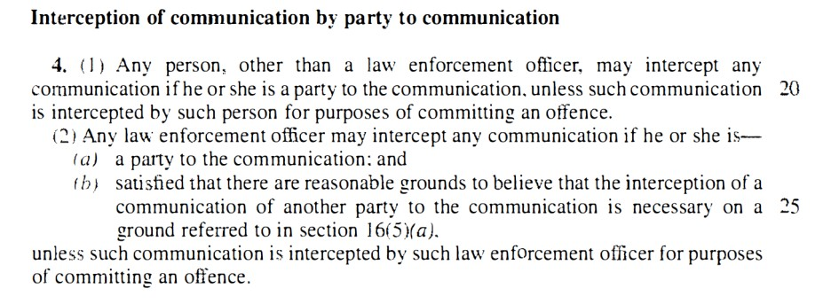
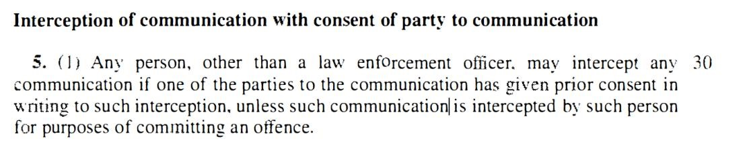

The SABC’s Employee Relations (ER) Unit within Human Resources consists of three (3) employees (one an administrator and the other two are ER practitioners), all of whom are not practicing attorneys. The ER Unit is primarily responsible for advising on internal disciplinary matters, as well as representing the SABC at the CCMA. They cannot also initiate, chair and advise on the same cases.
Based on the evidence of the past 5 years, many of the cases that included disciplinary hearings, involved senior and executive staff. Accordingly, as per the SABC policy, it was not possible to appoint an internal Chairperson, Initiator and Panel, since those implicated were often at the highest levels of the Corporation. It is accepted practice that both the Chair & Initiator of a particular disciplinary hearing cannot be junior to the positions occupied by those being charged. Furthermore, over the past five to ten years, the SABC suffered a number of irregular and unlawful activities within Human Resources and Supply Chain Management. Both these divisions included persons who were expected to enable and enforce controls at the implementation level. For example, almost all irregular appointments at the SABC went through the same Human Resources Executives. This revealed a complete breakdown of governance and ethical conduct in these positions of trust. It would have been irresponsible for the SIU and Interim Board to have delegated these sensitive matters to the same internal staff.
The newly appointed Group Executive HR will appoint the Head of ER who will be tasked with ensuring that more cases are handled internally. Since proper governance and controls are now restored, the future plan is to have the majority of cases handled by our internal staff.

The SABC did not mislead Parliament when it last responded to this matter. Following an outcome of the internal investigation, the implicated employees were charged and disciplined accordingly. Employees were charged as per the SABC Disciplinary Code. The most appropriate charges based on the outcome of the investigation were issued. In total, 4 employees were involved, 1 employee was dismissed, 1 employee got a final written warning and is back at work, 1 employee was cleared and is back at work, and 1 freelancer was unscheduled immediately after the incident.
From this process, a defamation case has since been instituted against the SABC, which the Corporation is defending itself against. Any further comments on this matter could prejudice the SABC’s ability to successfully defend its case. The intent of the SABC, as stated in the Corporation’s response when this matter was last asked, has always been to furnish the Committee with a full report upon conclusion of the matter currently before the Court.
146.Having so many positions filled by employees in an acting capacity, especially at middle and senior management levels, has adverse implications on decision-making, stability and the ability of the organisation to sustain the momentum of strategic plan implementation.
147.
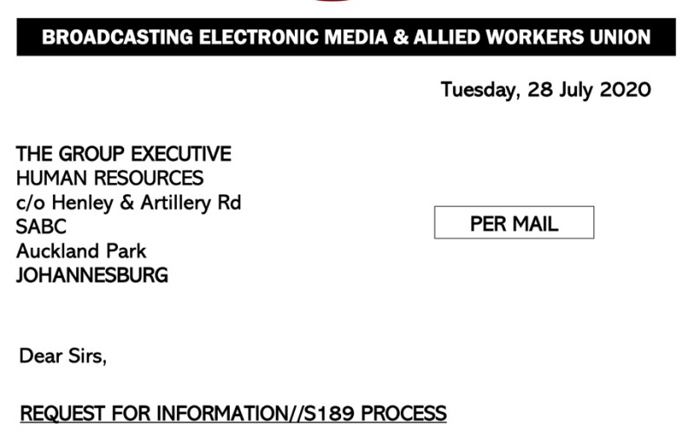

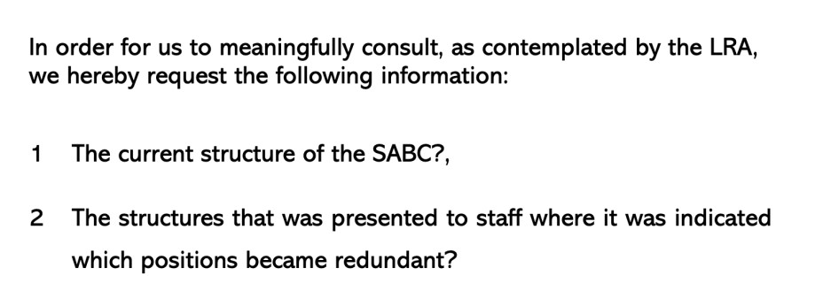
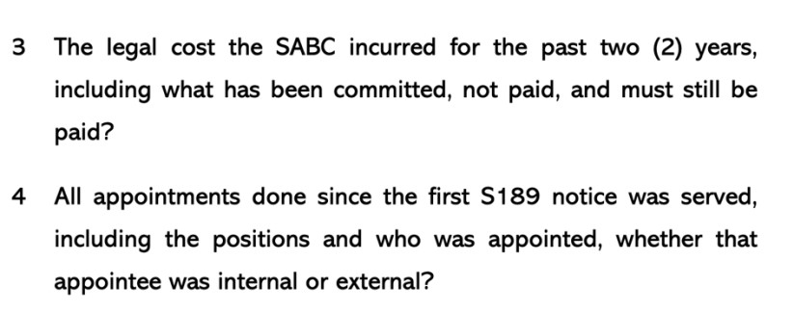
148. 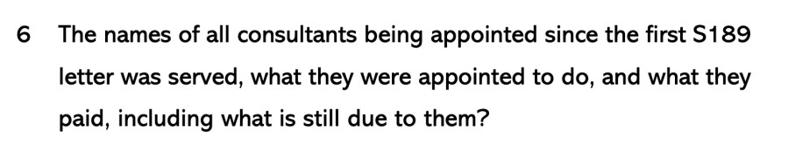

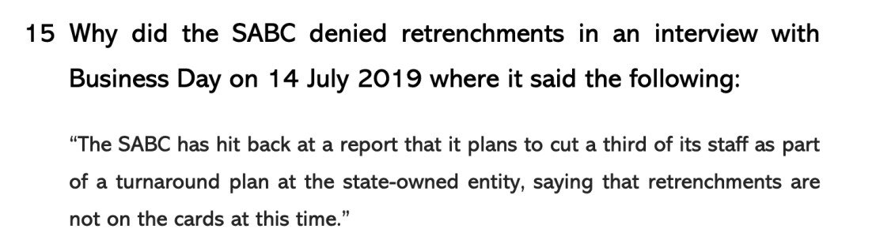
149.
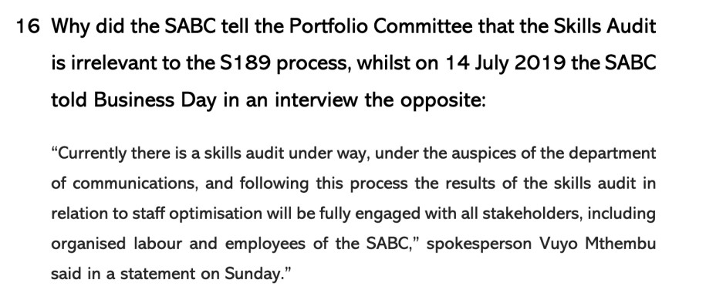
150. Staff optimisation is de facto and de jure retrenchments.

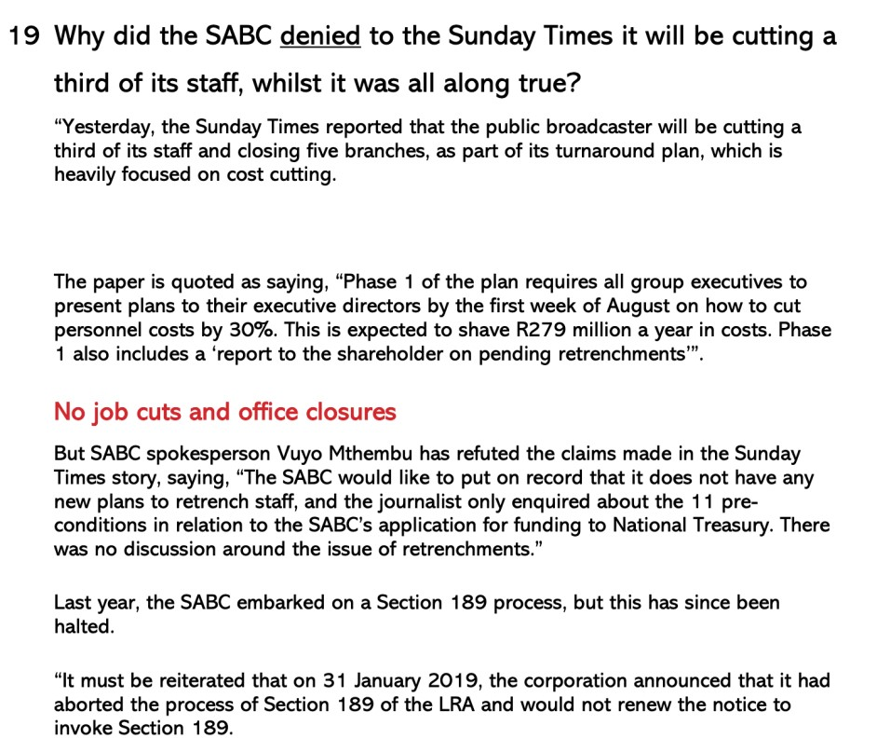

Similarly, a salary audit would have revealed where inflated salaries that need to be reduced exist, which would have resulted in savings, particularly at mid- and top-level management level.

- must respond in writing and in detail reports on claims of sabotage about
President Ramaphosa’s address to the nation;

- should provide to the Committee their expectation of reskilling and upskilling of employees in anticipation of digital broadcasting platforms;
a. provide concrete plans on how the SABC can deal with the matter of a bloated staff;

- must share with the Committee the list of its members that have contracted or tested positive for COVID-19;

- must provide explanations on the outsourcing of certain job functions at the
SABC;
a. further provide an extensive list of all companies contracted to the SABC as well as the monies associated to the contracts; and

- must provide a report to the Committee on any other non-core expenditure outside the litigations that the labour unions and Editors Forum are aware of.

The SABC received qualified outcomes with findings for the 2013/14, 2014/15 and 2015/16 financial years. A qualified opinion refers to an outcome where the entity failed to produce credible and reliable financial statements, and had material misstatements on specific areas in their financial statements which could not be corrected before the financial statements were published.

6.1.2 In 2015/16 the areas of qualification had been reduced but irregular, fruitless and wasteful expenditure—which had escalated considerably—remains an area requiring urgent intervention.

The SABC Provincial Offices represent the Corporation in all corners of the country and are managed by Provincial General Managers (PGM’s).
The Provincial Offices are a mirror of the Head Office, although on a much smaller scale and include staff from Radio Stations, Logistics, Finance, Sales, Technology and Human Resources.
These offices bring about provincial relevance in news and other programming, as well as playing the important role of reflecting the life and culture of people of different geographical areas.
During the 2018/19 financial year, the focus of the Provincial Offices centEred around monthly themes such as Human Rights Day in March, Youth Month in June, Heritage Month in September, World Aids Day and International Day of No Violence against Women and Children in December. January focused on matric results announcements and back to school campaigns.
Provincial Offices were actively involved in a range of developmental and social projects across the country, aligning the SABC Corporate Social Investment (CSI) activities with those of its core business. This allowed the Public Broadcaster to leverage its national footprint, resources and expertise, when partnering with NGO’s and other institutions.

- The SABC has also faced many internal challenges, including a decline in audience and revenue, some decisions that were taken were detrimental to the SABC’s revenue and reputation, and leadership instability that prevented the timely implementation of policy and business decisions to stabilise the institution.
- The SABC’s dire financial situation worsened during the fourth quarter and the Corporation ended the last Quarter with a cash balance of only R72 million. The Corporation’s cash flow was depleted and therefore could not fulfil its obligations including payments to service providers, adhere to its committed contracts, and commission local content productions.
(Spent millions on litigation)

Various Executive appointments were made during the year under review including that of the Group
Chief Executive Officer, Chief Financial Officer, Group Executive: Media Technology Infrastructure, Group Executive: Corporate Affairs and Head of Legal. These appointments provided the SABC with the necessary stability from a leadership perspective.

Human Resources
Goal 3: To develop a dynamic and motivated fit-for-purpose workforce that embraces learning and is sufficiently adaptable to migrate into the digital age.
Operating Model and Structure Review
The SABC embarked on a review of its Operating Model and structure to ensure that the Corporation would be able to deliver on its revised strategic direction. The revised Operating Model will ensure an agile organisation, able to respond to challenges of the dinamic media environment. The organisational structure is being adapted to ensure alignment to the new Operating Model and will be aligned with the outcomes of the Skills Audit.
Achieve ICASA PBS local content quotas as per SABC broadcast licence
PBS
- SABC1: 55% • SABC2: 55%
PBS
- SABC1: 77.7% • SABC2: 2:80%
Achieve ICASA
PCS local content quotas as per SABC broadcast licence.
PCS
- SABC3: 35%
PCS
- SABC3: 62.5%

Achieve ICASA PBS local music quotas as per SABC Broadcast licence.
PBS Stations: 70% achieved 74.5%
Achieve ICASA PBS Radio genre quotas as per SABC Broadcast licence excluding Radio 2000, XK FM, Lotus and Tru FM.
- News: 60 min/day;
- Current Affairs: 60 min/ day;
- Informal Knowledge build- ing: 180 min/week;
- Education: 300 min/week;
- Children: 60 min/week
- Drama: 150 min/week

Achieved
- News :76 min/day:
- Current Affairs: 99 min/day
- Informal Knowledge building:1 498 min/week
- Education:358 min/week
- Children: 133 min/week
- Drama: 198 min/week

Not achieved.
Career Progression Framework was approved by EXCO. Consultation sessions still to be held with Organised Labour on the Career Progression Policy prior to approval.
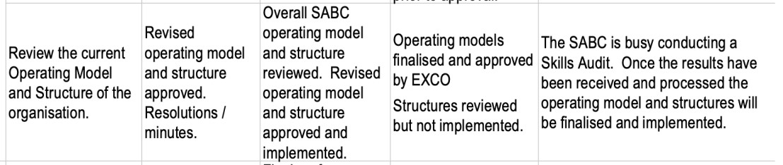
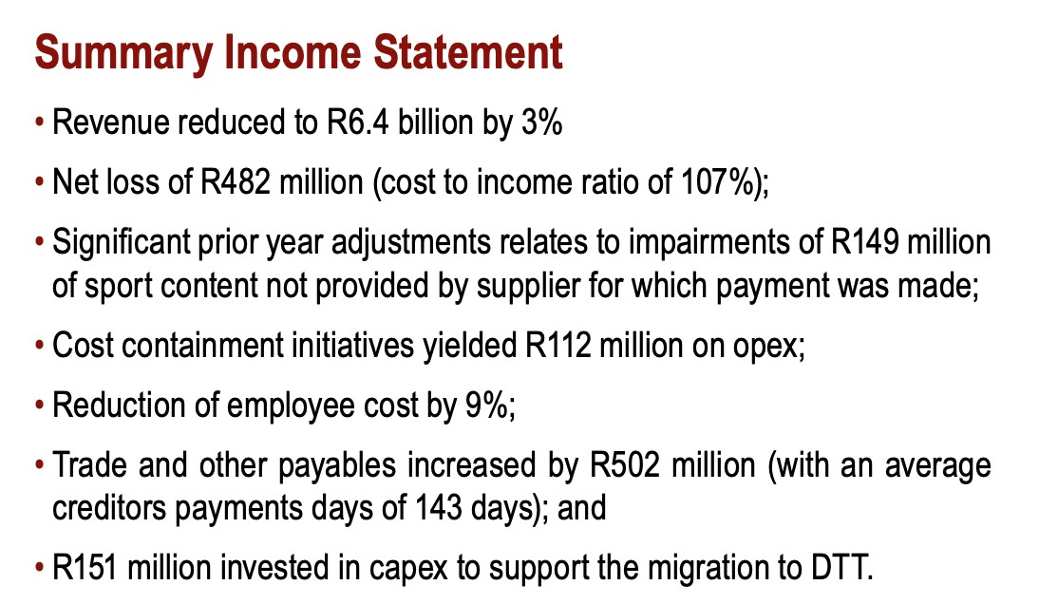

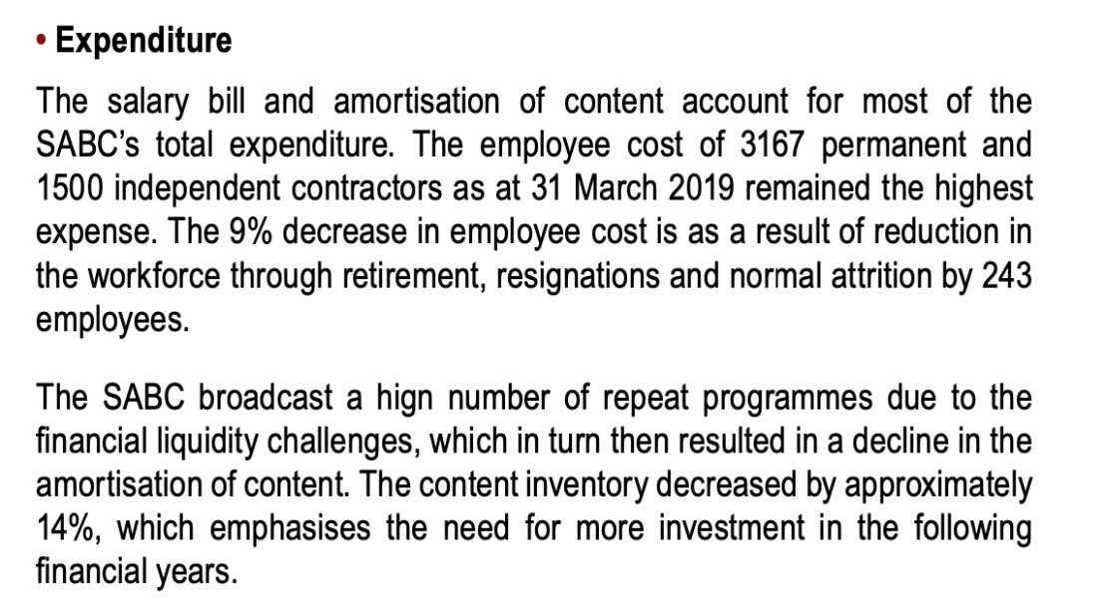
- Expenditure
The salary bill and amortisation of content account for most of the SABC’s total expenditure. The employee cost of 3167 permanent and 1500 independent contractors as at 31 March 2019 remained the highest expense. The 9% decrease in employee cost is as a result of reduction in the workforce through retirement, resignations and normal attrition by 243 employees.
The SABC broadcast a hign number of repeat programmes due to the financial liquidity challenges, which in turn then resulted in a decline in the amortisation of content. The content inventory decreased by approximately 14%, which emphasises the need for more investment in the following financial years.
The SABC was able to realise only 31% of the total licence fees billed during the 2018/19 financial year, which was lower than the prior financial year. The absence of the bulk mailing services contributed to depressed collection rates. The collection cost was on par with the annual trend of 13%. 401 321 new television licence holders paid for their first licence during the period under review. Only 2.9 million licence holder made an effort to pay their television licence fees in full or in part against a known database of 9.4 million television licence holders.
SAfm | 68 | 60 | 68 | 70 | Principal language English
Tru FM | 76 | 60 | 73 | 70 | Principal languages English (60%) and isiXhosa (40%)
Lotus FM | 61 | 60 | 61 | 70 | Principal languages English with specialist programmes in Hindi, Tamil, Urdu, Gujurati and Telegu
RSG | 68 | 60 | 70 | 70 | Principal language Afrikaans
Munghana Lonene FM | 76 | 60 | 74 | 70 | Principal language XiTsonga
Lesedi FM | 78 | 60 | 77 | 70 | Principal language Sesotho
Radio 2000 | 70 | 60 | 71 | 70 | Principal language English
XK FM | 89 | 60 | 89 | 70 | Principal languages !Xintali and Khwedam
Umhlobo Wenene FM | 76 | 60 | 79 | 70 | Principal language isiXhosa
Ligwalagwala FM | 79 | 60 | 82 | 70 | Principal language isiSwazi
Motsweding FM | 68 | 60 | 73 | 70 | Principal language Setswana
Phalaphala FM | 63 | 60 | 71 | 70 | Principal language tshiVenda
Thobela FM | 78 | 60 | 71 | 70 | Principal language Sepedi
Ukhozi FM | 81 | 60 | 82 | 70 | Principal language isiZulu
Ikwekwezi FM | 88 | 60 | 84 | 70 | Principal language isiNdebele

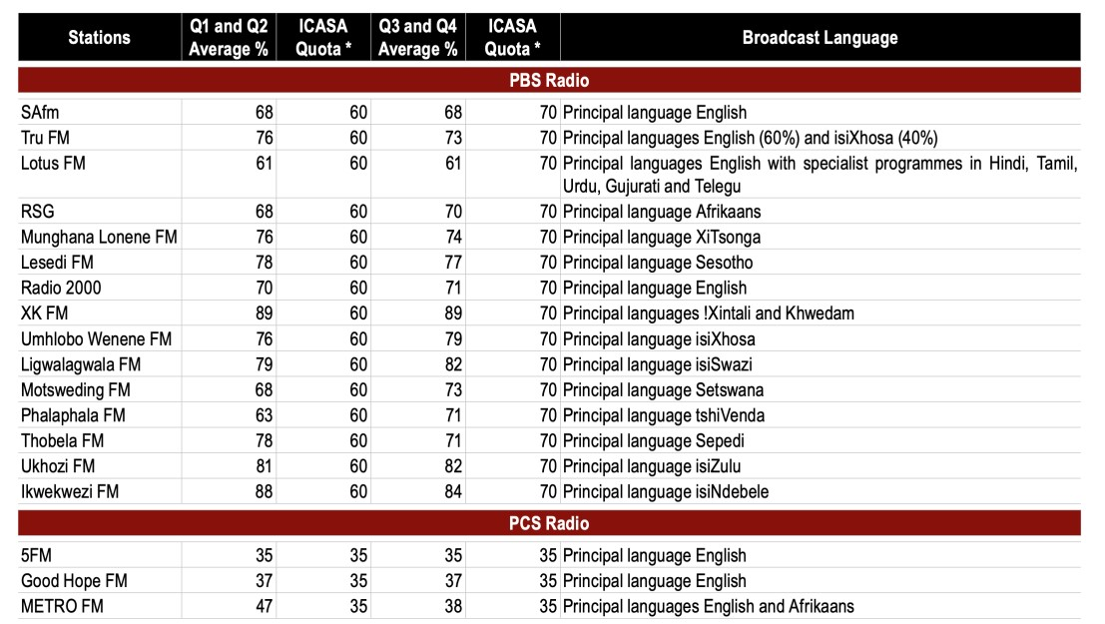

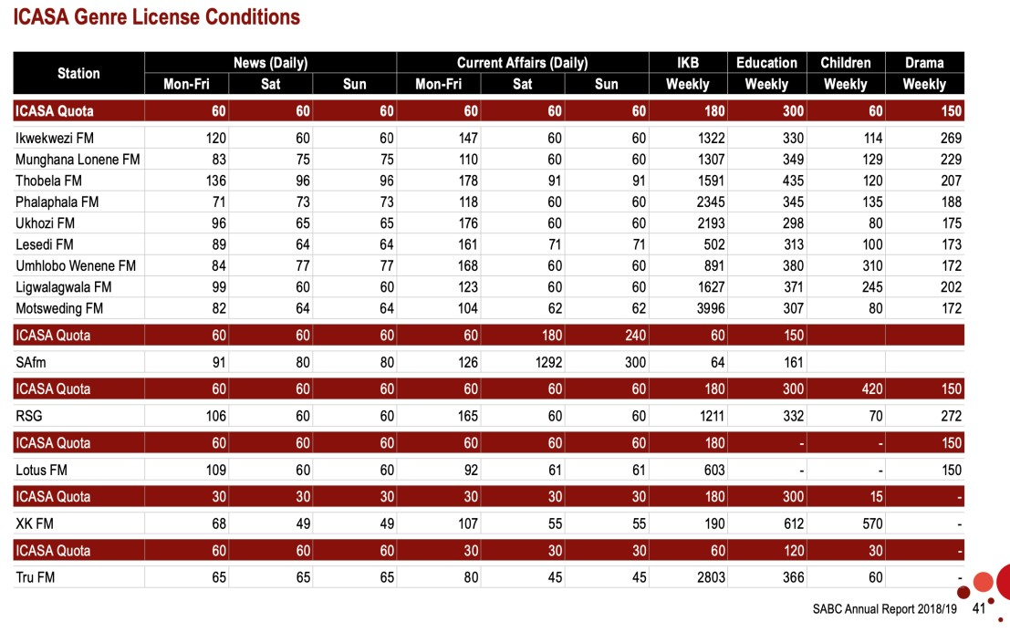
____________________
Per: Hannes du Buisson
BEMAWU
Signed electronically

AND TO:
Ms Hajiera Salie
Telephone: (021) 403 8264
Cell: 061 472 9191
Email: hsalie@parliament.gov.za

Mr Thembinkosi Ngoma
Telephone: (021) 403 3733
Cell: 083 709 8407
Email: tngoma@parliament.gov.za

Furthermore, the Operating Model of the SABC was reviewed to ensure alignment between the new strategic direction of the Corporation and the structure. For the period under review, the SABC commenced with a Skills Audit to ensure alignment between its available and future skills requirements.

0
500000
1000000
1500000
2000000
2500000
3000000
3500000
4000000
Top
Management
Senior
Management
Middle
Management
Junior
Management
Supervisory
Levels
Rest of Staff

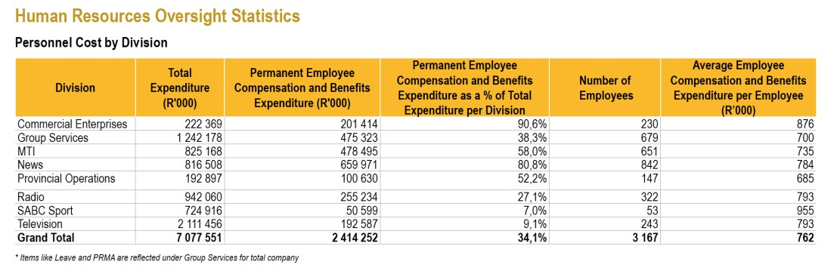

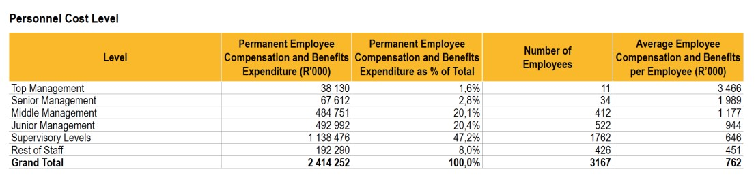

SABC Annual Report, 2019/20
SABC Annual Report, 2019/20
SABC Annual Report, 2019/20
SABC Annual Report, 2019/20
SABC Annual Report, 2019/20
https://skillsdbpro.com/necessity-skills-audit/

