GRIVIANCE 1: Assets / Audits
Why did the mun. Never handed in the financials for audit? Despite that the mun. is under administration why did the team administrators not act to get the audits to the Auditor-General? The last audit that was done is 2016 and it still had outstanding documentation? Why are the audits outstanding since 2016?
MLM RESPONSE:
The Municipality struggled with the following
- Incomplete of Fixed Asset Register,
- Missing Records
- Challenges with Finance System
- Capex Challenges
AFS set for 2017/18 has been completed and are busy with the two outstanding sets.
Administration has been withdrawn
How do the mun. gain revenue if there is no financial soundness, service delivery or order in the mun. as there is NO REVENUE COLLECTION at his stage.
MLM RESPONSE:
The Municipality is in the process of implementing the Finance Recovery Plan employing among others, the following means to raise revenue:
- Municipality has initiated an Operation Patala for effective implementation of credit control
- All Major debtors are being such as Mines, Senwes, OK stores, Spar etc are being engaged on their municipal debts
- Issuing of accounts,
- Data Cleansing Project ( 4000 accounts completed to date)
- Correction of tariffs (NERSA and ESKOM offering assistance)
- Attend to the Disputes

Why there is NO By-laws to gain revenue? (No action against illegal dumping, traffic fines,..)

MLM RESPONSE:
The following By laws have promulgated and we are in the process of determining the correct fines through the office of AdvMantsho from COGTA for purposes of re gazetting.
- Standard Refuse removal By Laws,
- Standard Environmental Health By Laws
- Standard Dumding and Littering By Laws
- Standard Waste Management By Laws
On the other hand the municipality is experiencing the shortage of personnel, we however will be augmenting the number with the six trainees.
Why did the National Gov. not ensure the mun gets evaluated on performance according to Chapter 7 Section 155(7) OF THE CONSTITUTION STIPULATE THE NATIONAL GOVERNMENT SUBJECT TO SESTION 44 AND THE PROVINCIAL GOVERNMENT HAVE THE LEGISLATIVE AND EXECUTIVE AUTHORITY TO SEE TO THE EFFECTIVE PERFORMANCE BY MUNICIPALITIES OF THEIR FUNCTION? Committee Section 18 plays a vital role in the municipality as well why is there NO COMMUNICATION BETWEEN MUN AND THE SECTION 18 COMMITTEE (No zoom, no whattsupp, no emails nothing) so the mun. top management runs the mun. Independent for months? That’s for sure not a safe action due to outstanding audits already proof there’s a red light?
How many staff on pay roll and how many of them is ghost workers and how many of them get overtime paid (please note work don’t get done to gain revenue but still overtime gets charged/ paid out)
MLM RESPONSE:
- 543 staff workers are on the payroll,
- We do not have ghost workers
- The number varies monthly around 150

GRIEVIENCE 2 Water and Sanitation
Why do the mun charge full service charges to the community for non service delivery? And for no clean water?
MLM RESPONSE:
- The municipality is fully reliant on the service charges for effective service delivery,
- Every effort is being made to ensure that consumers realise value for money in terms of services, our focus was initially on water and sanitation, serious strides have since been registered in this regard. Next focus will be on refuse removal, roads and electricity,
- Whilst this concern is noted, we need tom hasten to indicate that on the other hand, in most instances the municipality is also providing full services to consumers who are not paying anything at all.

Why is there no actual human serving as security at the water plans and where there is very expensive equipment?
MLM RESPONSE:
All our water plants have are secured 24/7 Chair please assist with specific case.
Why don’t the mun. Pay the service providers?
MLM RESPONSE:
When cash flow allows, service providers are indeed paid, mainly we enter into payment arrangements with service providers.
Why do they keep on changing service providers for chemical?
MLM RESPONSE:
The municipality does not keep on changing service providers on chemicals, a necessary change was effected only in October 2019 and to date, the water supply disruption due non delivery of chemicals is now history.
Why do the mun. Violate the community human right and constitutional right Bill of right Section 27(1) (b)? According to the reports the above new water dam (photo) was build about 3 years ago with grant money of R14.5 million rand but is this dam again charged for even if the current contractor didn’t build the dam? Was the contractors investigated en research to ensure they are the perfect contractors for the improvements because with the court case (see end of petition) it doesn’t look like it as they already fail the requirements by the judge many times.
MLM RESPONSE:
Service Providers are appointed through SCM processes, the court order in this regard is something else and the consultant is aware of such.
MLM RESPONSE:
If the budget according to court case for the project was R20 million then why do the mayor say in the budget speech R33 million was allocated? Where are the other funds and what happen to it?
MLM RESPONSE:
The Mayoral Budget speech alluded not only to the plant but to another water related project as well.
The mun. Used R24 million rand for 3 boreholes (the boreholes was drilled prior to 1994 and was dry but still the mun. Claim to have drilled the boreholes and they only put pumps on but was stolen due to no security of property) what happened to the funds?
MLM RESPONSE:
More details are requested in this regard.
The mun. Received a budget for R90 million for pipeline from Sedibeng to Winburg and now again adisional R153 064 000 still nothing in place. The mun. Received R14.5 million for upgrade of water works and above dam was also build with the money but DWS minister’s office was not happy with the way the money was spent and granted a forensic audit on the funds and still it was not done. Mun. Received 82,2 million from DWS to upgrade the waterworks at Brandfort but still the contractors was not researched or investigated before hand and services fail year after year because the service provider also could not give a full on warrantee/ guarantee on the work. The mun. Received funds for JoJo tanks in all areas but still they fail to provide JoJo’s to all areas and most of the JoJo’s was provided by Covid funding recently.
MLM RESPONSE:
Water
Regional Bulk Infrastructure Grant (RBIG)
A grant for bulk infrastructure through the Department of Water and Sanitation(DWS) the municipality had an initial allocation of R153 million for 2020/21FY and due to processes of Assessment through a Consultant appointed by the municipality, by the end of 2019/20FY the process of Assessment was still not complete. As a result; the allocation was then reduced to R31 000 000 for the 20/21 Financial Year. From the Assessment, two phases were identified. Phase 1 being the Refurbishment of Winburg Water Treatment Works and Phase 2 being Construction of Sedibeng- Winburg bulk water pipeline. The plant refurbishments resumed in 2019/20 FY to be completed in the current financial year. The 20/21FY allocation will be utilised for consulting fees on the phase 2: Construction of Sedibeng – Winburg water pipeline and completion of the phase 1: Winburg refurbishment and rehabilitation of the water treatment works.
Phase 1: The progress on plant refurbishment project is at 67%. Currently; at the WolwasPumpstation Construction progress is underway with the electrical works is 100% completed. The contractor is currently busy with preparation for installation of new pumps and motors. The plan is to have Wolwaspumpstation completed by end October 2020, which will assist with water storage in Wolwas dams during the rainy season which will deal with both water shortages and quality.
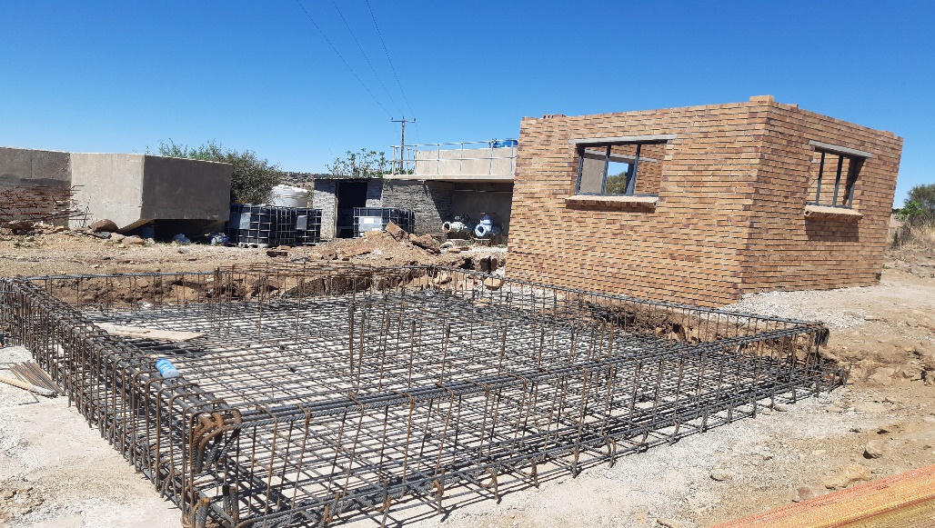
The construction of the new dosing room

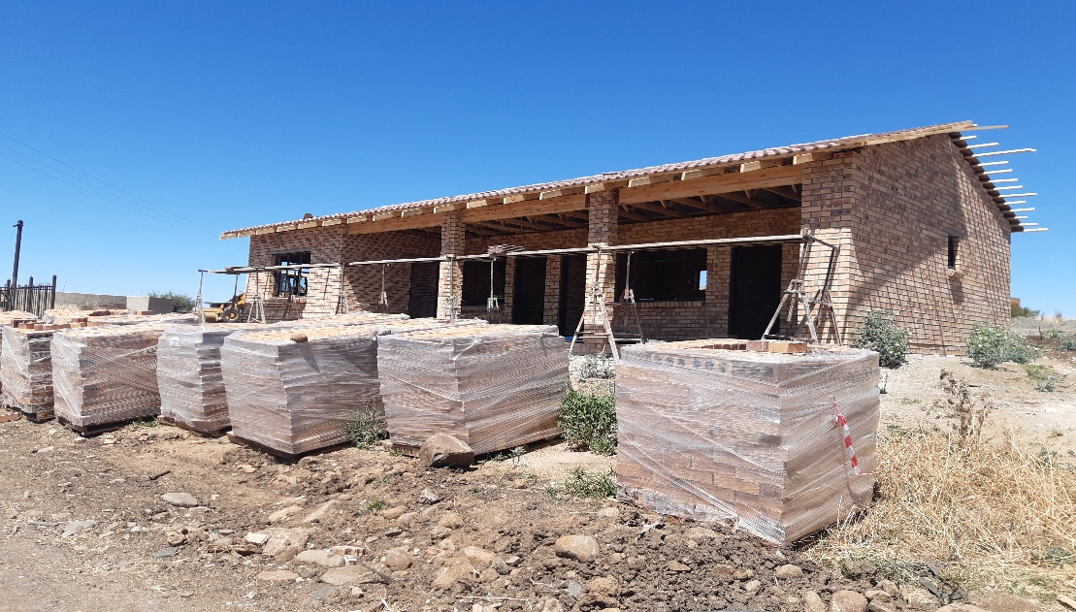
The Construction of the administration building
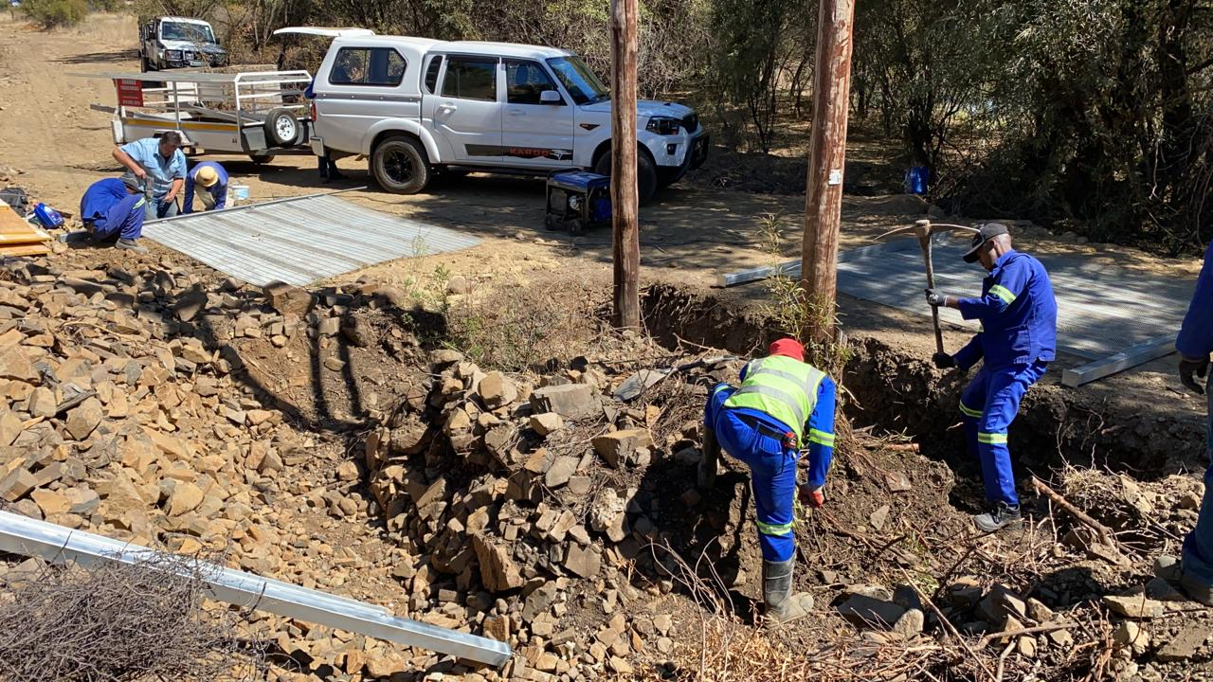
The removal of the existing fence, and to follow is the installation of the new fence at the Wolwaspumpstation.

Phase 2: The Construction of Sedibeng – Winburg water pipeline is on preliminary stage; however, there are contractual discussions underway between the Municipality and the appointed Consultants which will be resolved by end of the week next week, and progress will be underway to finalise the Detailed designs and advertise for the Contractor.
Operationally; Currently there is insufficient raw water due to a dry season; as a result, the dam is full of sludge due to the sluice gate which is non-operational, and as a result water quality is compromised. The Municipality has started with investigations to source funding for the dam desludging process. This will assist with the quality of the raw water. As part of the process of addressing the water quality challenges, investigations are underway to resolve the challenges. One of the planned activities as a way of dealing with the quality issue, is to flush the main line that supplies water to the community, and also clean the reservoirs. These activities will be completed by mid-October 2020. The Municipality is closely monitoring the water through frequent sampling and testing, to ensure that the water complies with SANS standards. Currently water samples have been sent for analysis at the accredited laboratory and the results will assist the Municipality in determining the exact deficiencies with water and the plan to resolve such will be implemented. To augment the water shortage and water quality, the Municipality supplies potable water through the water tankers from the Sibanye Mine.
Sanitation
Water Infrastructure Service Grant (WSIG)
The municipality had R5.1 million allocated for the 2020/21FY to the Winburg/Makeleketla refurbishment of sewer pump stations & Waste Water Treatment Works project from the WSIG grant. The project is on construction phase and overall progress is at 64%.

Waste water Treatment works
The plant is 100% desludged and cleaned as it was full of sludge to the plant being non-operational for a long period.
The mechanical works components e.g. pumps at the plant were removed for refurbishments. The new mechanicals items are being procured and to be delivered on site before the end of October 2020. The contractor has started with installation on Electrical works and these will be completed end of October 2020. The plant will be fully operational by Mid November 2020. Once the plant is fully operational, the effluent will have better quality that meet the required standards.
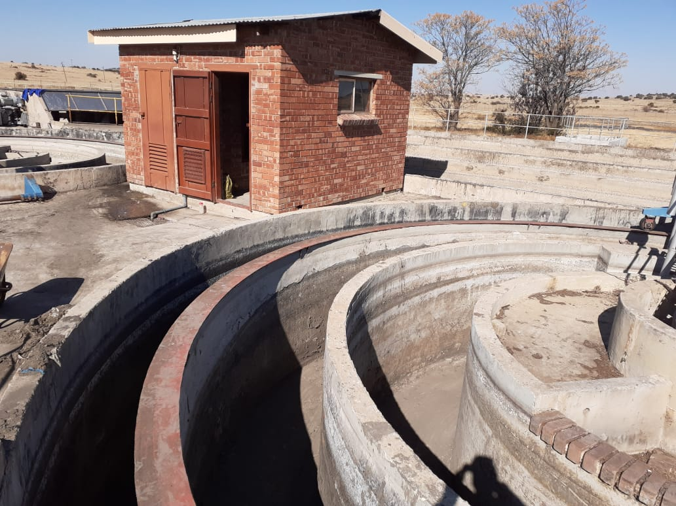
The desludged works at the waste water works.
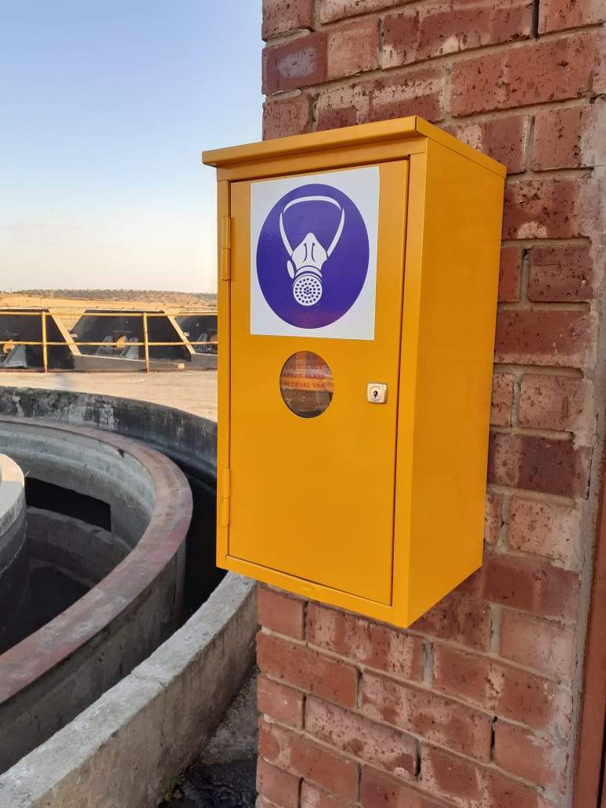
The newly installed electrical control panel

Pumpstation 1 at Disco Section
The construction of the new sump is almost completed, what is outstanding is the cover slab. New 2 pumps and 2 motors have been installed (One being the stand-by pump). The new transformer and electrical line is to be installed, the progress is underway. The control panel is also being refurbished. The items will be finished end of October 2020.
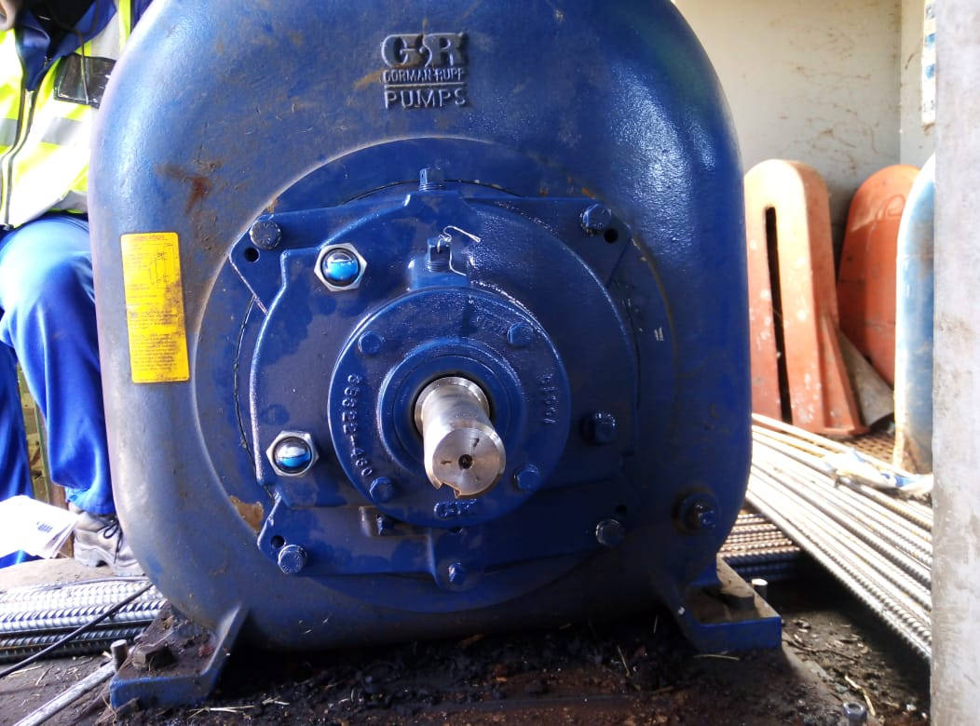
The newly installed pump at Pumpstaion 1.
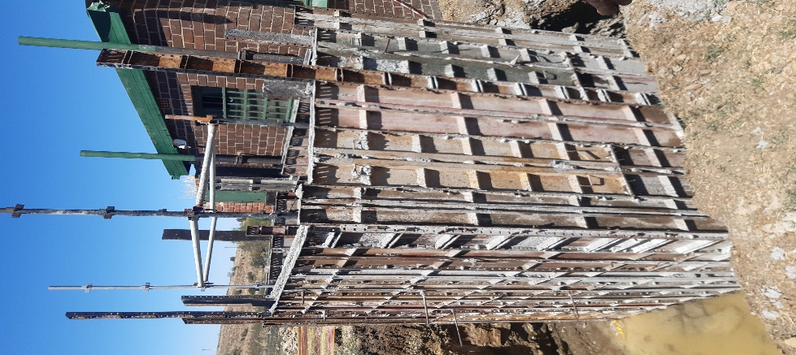
The construction of the sump.
Pumpstation 2 at Boitumelo Section
The construction of new pump station sumps is underway. The repair pump station inlet works almost complete. The repair of the existing operating pump is completed with the installation of new motors. On the Electrical component, the motors connected to the pumps are being serviced and tested. The DB components such as main switch, pilots, lights, voltmeter and ammeter should be tested for proper functionality. Repair electrical motor on operating pump is completed. The new generator still to be installed.
Pumpstation 3 at Fora Section
The construct bund wall is completed which assist in case of spillages not to spill to the houses. The replace submersible pumps with Gorman Rupp (both duty and standby) is underway. On electrical; two induction motors serviced and tested for operation. The panel is being refurbished. These items will be completed by mid-November 2020.
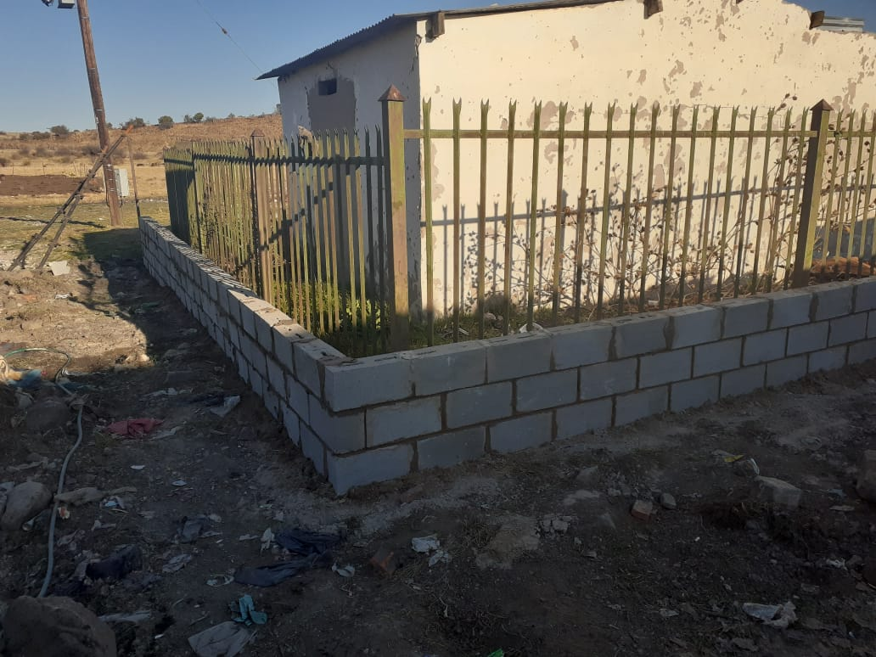
The constructed wall at Pumpstation 3.

GRIVIANCE 3: Landfill
Where did the funds came from to build the landfill fence so fast? Why do the community or an organisation first need to take the mun. To court before they comply with the standard to provide a service?

MLM RESPONSE:
More details are sought on the above.
The security staff at landfill are they still on payroll and why because they don’t work there anymore.
MLM RESPONSE:
Security is deployed to the land fill site in Winburg, perhaps the more details on the matter would assist. Day shift is also taken care of.
Why is there no up to standard recycle waste management?
MLM RESPONSE:
Director for Community Services Me Michele Sello is in talks with a group of youths from Winburg to start recycling project, a container has been donated through SLP by Harmony mine in this regard.
Why are there no funds from the mun. For fuel to collect the refuge and maintain the trucks but the community needs to pay for services?
MLM RESPONSE:
The lack of funds is once in a while incident that occurs when there was a delay in submission and processing of payments towards fuel.

GRIVIANCE 4: Electricity
March 2017 the mun. Received 80 million for the pre-paid meters in portions
why is there still no pre-paid meters installed in Winburg areas? What happen
to the funds?
MLM RESPONSE
The municipality never received such an amount of money
Instead we went out on tender and have subsequently appointed a service that will install smart and prepaid meters and currently have registered the following progress:
- To date 20 Smart meters has been installed for large Power Users (LPU) and billed throughout the municipality. Such customers cannot be placed on prepaid meters as they consume more power as compared to domestic consumers.
- An application has been sent through to Eskom to provide the municipality with a supply group code once that has been finalized and approved then installation will take place of pre-paid meters for all four Towns.
We are now at a point where we are to start with small businesses and residences.
For the record, the municipality embarked on Public Participation as to the installation of the meters, like we said LPU will be using smart and all else prepaid, its misleading to say the MM took unilaterllly concluded on the matter.
Business forum attempted to have ESKOM take over the electricity in our areas of supply, ESKOM, SALGA office of the MEC for Finance made it clear in the meeting that the license in those areas belong to Masilonyana.
In our tender advert to attract service providers, the municipality had stipulated a condition that says
“ Without the municipality incurring costs”
DBSA was then engaged and the application has been to their Investment Committee that is awaiting Legal Advice to make a final decision.
Mun. Still still have an outstanding R73 million debt with Eskom why don’t the
mun. Pay Eskom and why do the mun. Not stick to the agreements they make
with Eskom?
MLM RESPONSE
Municipality is still in talks with Eskom on a payment plan and have also sourced in the services of DBSA in this regard.
Why do Eskom cut the electricity to towns then the people don’t have water as
the mun is violating the human rights and violate the constitutional rights.
Once again no service delivery no revenue.
MLM RESPONSE
The municipality is working very hard to ensure payments are made regularly to ESKOM, non payers are ones violating any right of paying consumers.
The mun. Paid R3 million rand into wrong account instead of Eskom why is
there no feedback in writing or media release about the findings? It needs to
be investigated and the person/s who did the transaction needs to be held
accountable for lost of revenue and mismanagement. They should also be
legally charge. It shows that there’s is no financial security in place with
systems
MLM RESPONSE:
- The actual amount paid in wrong account was R3.7m
- Rampai Attorneys has been appointed to recover the money.
- The case was moved fro Bloemfontein to Johannesburg High Court due to challenge by merchants
The application is currently opposed by various merchants from whom substantial purchases were made using the fraudulent Nedbank account facility at Standard Bank’s points of sale located at the merchants’ various establishments. Apart from Standard Bank, a total number of 6 merchants cited in the application are as follows;
- 2nd Respondent: Kosak (Pty) Ltd – amount of R305 000.00 in dispute. Entity had issued application against Standard Bank and has since indicated an intention to join Masilonyana Local Municipality (MLM). However, no joinder application has been served on our office as we had previously advised the entity to do so at our office. Entity has also not filed any answering papers in the application issued by MLM.
- 3rdRespondent :J A Freman Trading Cc – an amount of R420 000.00 is in dispute. The entity had launched an application under case number 32792/17 in an attempt to force Standard Bank to release payment of the amount in its favour. This application was removed from the roll. The entity has been advised to file its answering papers in the application issued by MLM.
- 4th Respondent: Ozykamo Group (Pty) Ltd – amounts of R486 745.90 and R392 893.68 in dispute. Summons issued by the entity against Standard Bank under case number 46650/17 for payment of the above-mentioned amounts. The claim is still pending before court, subject to finalization of the MLM application and entity has been advised to file answering papers in the application issued by MLM.
- 5th Respondent: Come Today Trading & Projects183 – amount of R165 000.00 in dispute. The entity has been advised to file answering affidavit in the application by MLM. This entity claimed not to have legal representation in previous court appearance and was advised to secure legal representation if it still intends to oppose the application by MLM. No answering affidavit has been filed by the entity.
- 6th Respondent: L& H Classic Panelbeaters – amount of R440 000.00 in dispute. Entity had indicated that it is in the process of filing a legal claim against Standard Bank and MLM. Entity was advised deliver its legal claim at our address for handling thereof upon receipt, however no claim has been received from the entity as yet.
- 7thRespondent:Kelvano Group/ Kelvano Fashion Traders – amount of R184 600.00 in dispute. The entity was served with papers and no reaction from the entity. From our searches, the entity was in the process of deregistration by the CIPC and could possibly be de-registered by now. No opposition is anticipated from this entity.
There is ZERO SERVICE DELIVERY because ALL VECHILES OF MUN. NOT
ROADWORTHY as they don’t get maintain and all the vehicles including the
trucks, tractors, cherry picker and more don’t have valid licenses.
ONLY HAVE ONE OF THE FOLLOWING TO SERVICE ALL TOWNS:
1 x TLB (we had covid funerals daily and one TLB had to cover 4 towns)
1x Grader (needs to cover 4 towns)
1 x Sherry Picker (can’t fix lights as it needs to be used in 4 towns)
Above out of fuel so they can’t do the work as the mun. Don’t buy or pay the
fuel. The vehicles are NOT ROADWOORTHY and are a danger to community
and to the drivers themselves.
MLM RESPONSE:
Corrections
- Graders X 2
- Cherry picker X 2
- Not all vehicles are unroad worthy. Process of getting vehicles roadworthy was delayed by systemic challenges at the testing stations in Winburg.
The municipality has however appointed a service provider that will supply the municipality with service delivery fleet and submitted a business plan to COGTA through MIG to procure yellow fleet.
Everyone in the Masilonyana towns needs to pay the same rate for electricity.
All streetlights to work and be on at night.

MLM RESPONSE:
It is impractically impossible that every individual in Masilonyana can be charged the same rate, as business customers cannot be compared to normal household customers due to power differences that they draw and that will have variances in bills being charged for these customers.
All streetlights to work and be on at night.
MLM RESPONSE:
The municipality has embarked on street and High Mast repair projects
Theunissen was the 1st town, this, due to high crime including murders registered.
To date the municipality has fixed a total number of 683 street lights and 31 high mast lights throughout all four towns and the maintenance is ongoing for both street lights and high mast lights.
Why is the mun. Neglecting the safety of the staff and the community?
MLM RESPONSE:
Municipal employees are being provided with adequate PPE for the works they are executing and the post of the Health and Safety Officer with requisite qualifications and skill has been advertised and is due to close on the 12thOctyober 2020. We are on the other hand not neglecting that of the communities.

GRIEVIANCE NO.5
Indigent tariffs advertised –
MLM RESPONSE:
refer to 20/21 tariff book as tariffs are correct as per DORA, advert could’ve been an oversight
The mun. Increase DORA service charges prior to the set legal dates and in some cases increased it twice in one year –
MLM RESPONSE:
There’s has never been an incident where the service charges were increased twice in one year, make available such.
MLM RESPONSE:
We currently still waiting for accounts to be printed (then there is no cartridge or paper to print accounts or they don’t pay the service providers for using the system then they keep changing the service providers) or the latest they move offices as well.–
MLM RESPONSE:
The current machine can’t handle the pressure during printing of accounts. Talks to resume with service providers for a specialized machine for printing of accounts. It is difficult to keep up with the expenditure when we are not collecting for services delivered
The mun. Fail to provide accounts on date and then community needs to pay interest on account as well they don’t charge every household to gain revenue. Also the mun. Send out demand letters for accounts but they don’t deliver services and it’s more than a battle to get account sorted. –

MLM RESPONSE:
It is the consumer’s responsibility to pay their account for services rendered, as much as it is of the Municipality to issue accounts, and the matter is being looked into to acquire a machine specifically for accounts. Consumers who wants to pay account always request accounts at municipal office and pays.

Payments don’t get deducted from accounts – payments don’t reflect. BIG CONCERN –
MLM RESPONSE:
Backlog on allocation of accounts was due to lockdown of offices and COVID-19 regulation, however the backlog has been addressed and will reflect on the next accounts

Why do the community need to pay for services not delivered?- Services are rendered daily to communities, except where there technical challenges which are addressed ASAP
Why is there no deduction of accounts once payments made to account?-
MLM RESPONSE:
The allocation of payments is an ongoing process, however there was backlog on allocation of accounts, this was due to lockdown of offices and COVID-19 regulation, however the backlog has been addressed and will reflect on the next accounts
Why do the mun. Stay in bad debt and assets needs to be claimed on auction? – non-payment of service rendered by the municipality.
MLM RESPONSE
Every effort has been employed to stop opportunistic elements from putting municipal assets to auction, this is not a regular occurrence
Why is there no proper system to do the accounts and on time? –
MLM RESPONSE:
The system is man-made and we experience challenges every now and then but most times accounts are prepared on time, the challenge then becomes printing and sending them out
Why is there no financial soundness to gain revenue? –
MLM RESPONSE
results of non-payment of services, the Municipality can’t sustain itself
Why do areas have to pay more for non-service delivery than others? –
MLM RESPONSE
tariffs are the same for all towns of Masilonyana, and payments are influenced by how we consume the services
Why do the people need to wait endless and take the mun. To court to get clearance certificates on accounts? –
MLM RESPONSE:
this was due to Lockdown, backlog of paid clearance certificates requests have been addressed, and those awaiting figures is currently underway as we were waiting for August billing to e complete
Why is the medical aid and pensions not paid of the staff? Why don’t the mun. Gain revenue to fill its obligation to staff –
MLM RESPONSE:
Non-payment of services result in the Municipality being over-burdened with debt, and as a result don’t afford to pay 3rd parties and rely on payment arrangements

Grievance No.6
Why is there so many meetings regarding this matter but nothing gets done?
Why do the mun. Overcharge the community on property rates if they mun. Fail the community and the economic in Winburg is finish/ exhausted / depleted.
Why the community do needs to beg for minutes of meetings and we don’t get the minutes of meetings.
Why is there such a big delay in re-evaluation of property?
Once again no revenue coming in due to mun. Refuse to co-operate and be fair.
MLM RESPONSE:
The previous Valuation Roll had challenges and COGTA even assisted with handling of process to ensure that issues were mostly addressed. The advert for the new Valuation will be going out on tender before the end of October 2020 to ensure its implementation by 01 July 2021

GRIVIANCE 7: Farmers
Why are farmers not paying fredges toward the mun.? It’s again lost of revenue?
MLM RESPONSE:
The municipality and the farmers have entered into a payment agreement that is intended to address matters of dispute, the arrangement is in the final stage and about to be implemented.
Why is there no pound active for animals in the street damaging property, storm water pipes and more?
MLM RESPONSE:
Currently the municipality does not conform to pound prescripts, however a municipal pound is planned for in the long term once the legal prescripts are completed.
Why do the mun. Allow the farmers to over use the land with overstock livestock? Why is there no co-operation in protecting the animals where many starve of hunger? Why are there no by-law protecting animals as well? Why can farmers slaughter animals at any given place? Why do farmers farm on tourist attraction properties where the mun. Could gain revenue?
MLM RESPONSE:
- The municipality has embarked on the following:
- Live stockaudit is in progress,
- Commonage occupancy is also being assessed,
- Provincial Department of Agriculture have been initiated,
- Tender on Land Audit was issued and has closed, Bid processes are unfolding.
- Commonage tarrif was discussed and accepted by Commonages’
- COGTA has been engaged to assist with the by laws on animals,
- Draft Tourism Sector Plan has been compiled and will serve before Council soon, this will address the destruction of tourist attraction centres.

