DHET COMPLAINT - Select Committee in Parliament

SUBJECT: CONSIDERATION OF THE EOH PETITION

Introduction
The CETA received a complaint through DHET which was brought to the CETA’s attention through a petition submitted by Mr John Maropeng Cholo (the petitioner) on behalf of learners that went through the EOH Learnership Training. The petition largely talks to events that took place between the petitioner and the Services SETA and it is therefore important to note that the CETA can only comment on those matters that directly involved or affected the CETA.

Background of the Project
The project was funded by the Services SETA and was facilitated by EOH Abantu (Pty) Ltd who are FASSET registered levy paying stakeholders, as per the below screenshot from the DHET levy payer portal.
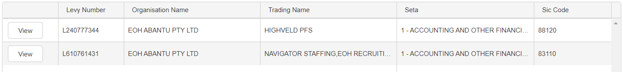
A total of 125 learners started the project and the CETA was able to certify 106 of the original complement of learners that commenced the programme.

Review of the Project Implementation
InTouch Community Development & Project Managers is an accredited skills development provider with the CETA and they have confirmed that the said project was funded by the Services SETA and awarded to EOH. The learnership on which the learners were enrolled, has been identified as NC: Construction Road Works (Level 2). The learnership therefore falls within the scope of the CETA and so too does the quality assurance function with regards to accreditation of skills development providers and certification of learners.

InTouch has since provided the update below with regards to the implementation of the project in question:
- The workplace report provided to the CETA indicates that workplace training took place from 03 January 2017 to 31 July 2017.
- The project started with workplace training and InTouch came on board to facilitate the institutional learning from 31 July 2017, with induction, and concluded on 03 November 2017 – the duration of which was 04 months’ classroom training.
- We are further informed that the workplace training continued after the institutional training from 06 November 2017 until 14 December 2017.
- In summary, the duration of the workplace training was 08.5 months versus 03 months for the classroom training.

Role of the CETA
As this was a Services SETA funded project, the role of the CETA was to provided support through quality assurance.
According to the CETA policy, stakeholders implementing projects where the quality assurance function is performed by the CETA are required to initiate the project with institutional/classroom training. Training implementation for programmes such as learnerships are implemented on a 30% classroom and 70% workplace basis. For this project, it is noted that this method was not adopted on implementation of the project.
On 07 May 2018, the CETA performed external moderation for this project at the offices of InTouch. This is a normal process conducted by the CETA to conduct visits of this nature within the premises of the skills development provider.
According to the external moderation report, a total of 125 learners are said to have been recruited for this project and the team were furnished with only 106 samples of Portfolios of Evidence (POE’s) as a sample for moderation. The CETA samples a minimum of 10% of the total population which resulted in a total of 11 POE’s that were considered. Important to note is that the complainant’s POE was not sampled but confirmation can be provided that the 11 learners and the complainant were part of the same group of 106.

The outcome of the external moderation indicated after moderation of the sampled POE’s, the learners were found to be competent.

The CETA has in total certificated 106 learners including the complainant. We further note the duration of the project from 03 January 2017 to 14 December 2017 and that the project was non-CETA funded.

