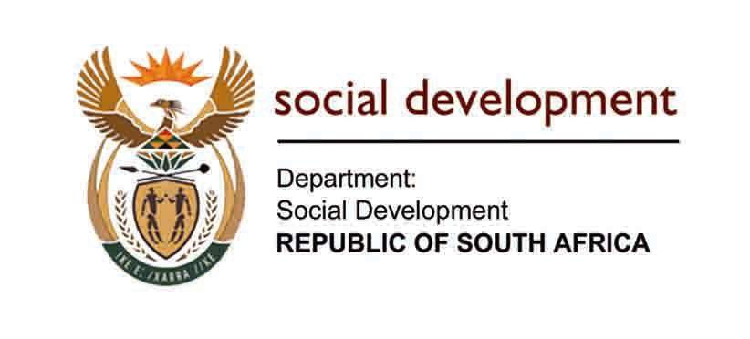

SOCIAL ASSISTANCE AMENDMENT BILL, [B8-2018]
PRESENTATION TO NATIONAL COUNCIL OF PROVINCES, 2020

INTRODUCTION
The Social Assistance Amendment Bill was introduced to the National Assembly on 13 April 2018, but the Amendment Bill unfortunately lapsed in May 2019 due to the change in administration. It was then revived in October 2019 and subsequently considered by the Portfolio Committee on Social Development.
The Committee held public hearings and received written comments on the Amendment Bill. The vast majority of these comments supported the proposed Amendment Bill, and the Committee approved it on t11 March 2020, with minor amendments. The Amendment Bill was then sent to the National Assembly, who passed it and referred it to the National Council of Provinces (NCOP) for concurrence. The NCOP is now seeking mandates from all the provinces to enable the Council to respond to the National Assembly’s request for concurrence. The provincial legislature is thus conducting public hearings to obtain the views of their constituencies so that they can then take forward their provincial mandates to the NCOP.
OBJECTIVES OF THE BILL
In addition to providing a few minor amendments to definitions, the Amendment Bill has three main objectives.
The first objective is to empower the Minister of Social Development, with the concurrence of the Minister of Finance, to make additional amounts payable on top of existing social grants. This will enable the Department of Social Development and the South African Social Security Agency (SASSA or 'the Agency') to implement the extended child support grant policy, which seeks to pay an additional amount for orphans living with family members, on top of the existing child support grant.
South Africa has a large number of orphans. Most orphans are raised by grandparents or other family members. However, due to high levels of poverty in the country, the foster child grant became the default grant for supporting orphans. However, the majority of families taking care of orphans could not access the foster care system owing to overwhelming numbers and the limited resources within government to place children in foster care.
The foster child grant and the foster care system were originally designed for children in need of care and protection. These are children who have been abused or neglected and removed from their caregivers. Most orphans do not fit into this category and are safe in extended family environments. This resulted in many vulnerable children not being able to access the foster care system.
The aim of this policy is to provide extra income support to orphans living with family members so that they do not have to go through the foster care system. This will relieve the burden on the foster care system and allow the Department to utilise their social workers more effectively while providing additional income support to orphans without them needing to go through the cumbersome foster care system.
Applicants will not require a court process nor the associated social work process before being able to apply for the additional financial support. However, once the grant is allocated, they will be referred to the Department for social services and support.

The second objective of the Amendment Bill seeks to streamline the appeals process.
The process at present is made up of two parts. If someone applies for a social grant and SASSA rejects the application, the applicant has a right to appeal. However, before they may appeal, they first need to go back to SASSA and request SASSA to reconsider their application. In the principal Act, the Social Assistance Act, 2004 (Act 13 of 2004), this process is called 'reconsideration of decision by Agency'. SASSA has 90 days to reconsider the applicant’s appeal and, in the vast majority of cases, they still reject the application, as SASSA does not consider the merits of the case – they just check whether they have complied with all the administrative requirements provided for in the legislation. Only after an application has been reconsidered by SASSA may the applicant, if s/he is still in disagreement with SASSA’s reconsidered decision, approach the Appeals Tribunal to lodge an appeal. The appeals process itself also takes 90 days. The full process thus takes 180 days or six months.
The internal reconsideration process causes significant delays for persons accessing their right to appeal relating to social grants, without adding any substantial value. The Amendment Bill therefore proposes to remove this process and allow an applicant the right to lodge an appeal for social assistance directly with the Independent Tribunal if s/he is dissatisfied or aggrieved with the outcome of a grant application or a decision made during the review of a grant by SASSA. This would reduce the appeals time frame from 180 days to 90 days.
The third objective is to change the organisational structure of the proposed Inspectorate for Social Assistance from that of a national department to that of a government component.
Section 24 of the Social Assistance Act, 2004, provides for the establishment of an Inspectorate for Social Assistance; however, this section has not yet been promulgated, as it provides for the Inspectorate to be a national department. Given the number of national departments South Africa currently has and the significant costs involved in establishing national departments, another Department is not needed. Hence this Amendment Bill seeks to change the structure of the Inspectorate to that of a government component within the Department of Social Development. The proposed Inspectorate, however, must be able to maintain its independence and carry out its functions without interference from the Department or SASSA.
Establishing the Inspectorate will assist in ensuring that the issues of fraud and corruption are adequately addressed. As provided, the key functions of the Inspectorate are to investigate fraud, corruption and theft; investigate forms of financial and service mismanagement; conduct financial and compliance audits; investigate any criminal activity within SASSA and in connection with their functions, duties and operations; as well as maintain the integrity of the social assistance frameworks and systems. It must also combat social assistance abuse and develop a complaints mechanism.
In conclusion, these objectives are aimed at improving the efficiency of the social grants system, enabling improved benefits for orphans and quicker access to the Appeals Tribunal, and reducing the potential for fraud and corruption within the social grants system.

