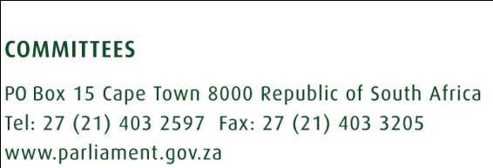
JUNE 2020
LINKING THE MULT- PARTY WOMEN’S CAUCUS MANDATE WITH THE NATIONAL STRATEGIC PLAN ON GENDER BASED VIOLENCE AND FEMICIDE
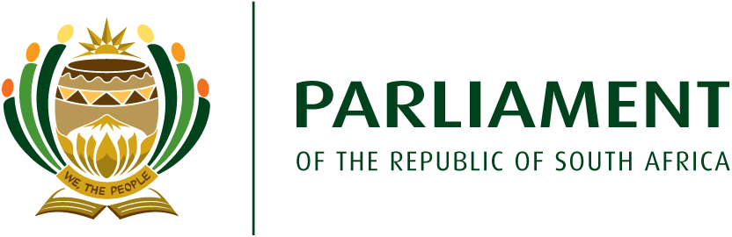
- Introduction
The purpose of this brief is to link the Multi- Party Women’s Caucus (MPWC) identified focus areas, with activities outlined in the National Strategic Plan on Gender Based Violence and Femicide (NSP).
The NSP is a framework developed to respond to gender-based violence and femicide (GBVF) in the country. It is aimed at providing a national, cohesive, coordinated, and strategic response to GBVF. The NSP is centred around six pillars, giving effect to the articles articulated in the Presidential Summit Declaration on GBVF. These six pillars have built in key strategies to achieve desired outcomes at stated periods (five and ten years).
The pillars are:
- Pillar one: Accountability, Coordination and Leadership
This pillar relates to strengthening of overall accountability of the state and society at large, towards bold leadership and heightened commitment towards eradication of GBVF.
- Pillar two: Prevention and Rebuilding Social Cohesion
This pillar is about development and implementation of programmes to eliminate and address harmful social and gender norms, while working towards healing and rebuilding the social fabric.
- Pillar three: Protection, Safety and Justice
This pillar is about strengthening the justice system to be responsive and accessible to all victims of GBVF.
- Pillar four: Response, Care, Support and Healing
This is about enhancing support services offered by the state and other partners to effectively respond to the needs of all survivors and victims.
- Pillar five: Economic Power
This pillar is about strengthening the economic power of women, through creation of economic opportunities to lessen vulnerabilities to abuse and victimisation.
- Pillar six: Research and Information Systems
This pillar is about increasing the knowledge base towards better understanding of the GBVF concepts, leading to adoption and implementation of evidence-based programs and laws.
- The role of the Multi Party Women’s Caucus in implementation of the NSP
The President of the RSA has called on everyone to play a part in implementation of the NSP. The MPWC has been forward thinking in planning for the sixth parliamentary term, as some of the identified focus areas correspond to some activities detailed in the NSP. Gender based violence and femicide is an identified priority focus area for the MPWC. In addition to that, the MPWC identified vulnerabilities of certain groups of women, like sex workers, hence resolving to continue lobbying for decriminalisation of sex work, as inherited from the fifth Parliamentary term.
The corresponding activities are detailed below.
  - Gender based violence and femicide

    - Lobbying for a Multi- Party Parliamentary Committee to oversee the implementation of the National Strategic Plan
During the identification of activities, the MPWC agreed on importance of having a dedicated parliamentary committee to oversee GBVF related matters. A decision was reached to engage Parliament Presiding Officers about establishment of a multi-party parliamentary committee to oversee the implementation of the NSP, and to partner and support the National Council on Gender Based Violence and Femicide (once established). The NSP also identifies the importance of establishment of a Parliamentary oversight Committee as an important activity that will contribute to increased accountability, coordination, and leadership (pillar one).

      - Suggested areas of clarity
- Progress in constitution of the National Council on Gender Based Violence and Femicide (NCGBVF).
- Progress in drafting legislation establishing the NCGBVF (setting out its powers and functions).
- Commencement date for the implementation of NSP (whether implementation of the NSP will be after constitution of the NCGBVF).
- Process towards recruitment of members of the NCGBVF (how members will be recruited).
- Possibility of involvement of members of the MPWC in recruitment process (form part of recruitment panel).
- Support and training programs to provincial and local government for constitution of GBVF councils.

    - Educational and social behaviour change programs
The fifth Parliament National Assembly (NA) referred a motion to the MPWC, about implementation of an educational and support program, relating to violence against women within religious, cultural, and spiritual settings. Pillar two (02) of the NSP is about implementation of prevention and awareness raising initiatives, to sensitise and mobilise communities about GBVF. The facilitation of community prevention interventions as detailed in the NSP is in alignment with the MPWC’s implementation of an educational and social behaviour change program.

The NSP also mentions establishment of a regulatory framework for functioning of religious and cultural institutions by the Ministry of Cooperative Governance and Traditional Affairs (COGTA). The establishment of a regulatory framework for religious and cultural institutions will be a powerful and helpful tool to utilise during the implementation of the NA motion by the MPWC.
      - Suggested areas of clarity
- The role to be played by Commission for the Promotion and Protection of the Rights of Cultural, Religious and Linguistic Communities (CRL Commission) in implementation of NSP.
- One of the identified outcomes under Pillar 2 is a strengthened ability for the roll out of evidence-based prevention programs, then:
- Responsibility for developing these evidence-based programs, whether it will be NCGBVF or the Department of Women.
- Whether programs to be developed will cover every conceivable structural root cause of GBVF.
- Whether there will be programs developed for offenders and perpetrators of GBVF (rehabilitation programs).
- Whether programs developed will also be about reducing vulnerabilities of certain people, for example, ensuring access to gender transforming surgery for Trans people.

    - Partnership and collaboration with GBVF stakeholders.
One of the identified challenges with previous responses to GBVF was the fragmentation and uncoordinated response by various service providers, which the current NSP is planning to address. The importance of building and partnering with common interest stakeholders is crucial for the MPWC, and for the successful implementation of the NSP, as these give voices to women, and a platform to influence program implementation.
      - Suggested areas of clarity
- Plans in place to ensure effective coordination for all spheres of government.
- Measures in place to empower provincial and local government spheres on the implementation of the NSP in line with their roles and responsibilities.
- Plans in place to address current challenges faced by the national gender machinery to enhance effective response to GBVF.

    - State of shelters- funding
The standardisation approach to sheltering for funding and services outlined in the NSP framework, corresponds with the MPWC’s intention to assist in addressing challenges experienced by shelters.
      - Suggested areas of clarity.
- Measures in place to improve access to places of safety especially for rural communities.
- Capacity and empowerment programs for existing shelters to increase responsiveness and access to support services by all victims including LGBTQIA+ and persons with disabilities.
    - Other related activities
Other identified common activities between the NSP and MPWC, include,
- implementation of programs aimed at eliminating gender wage disparity.
- intervention programs to address GBV vulnerabilities of farm workers, mine workers, and domestic workers, and
- adherence to minimum wage.

  - Decriminalisation of sex work
Decriminalisation of sex work is a legacy project inherited from fifth parliament MPWC. The fifth term MPWC was mandated by women in various women’s parliament sessions to lobby and advocate for decriminalisation of sex work. Various engagement with Ministry of Justice and Correctional Services, led to release of adult prostitution report by South African Law Reform Commission (SALRC), and an undertaking by the Ministry of Justice to table legislative reforms relating to sex work by second half of year 2018, which never happened.

The current MPWC, resolved to continue with lobbying for decriminalisation of sex work, an activity which corresponds with one of the activities outlined in the NSP framework. Finalisation of legislative process to decriminalise sex work is mentioned under pillar three of the NSP, with annual targets starting on March 2021. The stated indicator is promulgation of legislation on decriminalisation of sex work.

    - Suggested areas of clarity.
- Confirmation whether the NSP framework supports decriminalisation of sex work.
- Progress in tabling legislative reforms in relation to gender-based violence areas including decriminalisation of sex work.

- Additional suggested areas for clarity
- Progress in implementation of the emergence response action plan (with six months duration from October 2019- March 2020 with an R1.6 Billion allocation) as announced by the President in a Joint Parliament session convened on 18 September 2019.
- Alignment of 2019-2024 MTSF with outlined NSP departmental responsibilities (whether various ministries have taken into consideration the NSP responsibilities when drafting their strategic and annual plans).
- Measures in place to empower the private sector about the NSP (private sector is identified as a stakeholder with a role to play in the roll out of the NSP, including investing).
- Whether the Department would consider training members of parliament on GBVF oversight and concepts.
- Whether the Department is capacitated to conduct evidence-based research as mentioned in Pillar 6; role to be played by academic and research institutions in GBVF research, availability of support and/or incentives for these institutions in terms of funding.

- Conclusion and proposed way forward
The suggested way forward will not only contribute to successful execution of the MPWC mandate but will also greatly enhance the implementation of the NSP framework. It is suggested that the MPWC consider and undertake the following:
- Engage Parliament Presiding Officers about establishment of a Parliamentary Committee to oversee the implementation of the NSP.
- Engage the CRL Commission about violence against women and children in religious, cultural, and spiritual settings.
- Engage COGTA about introduction of regulatory framework for religious, cultural, and spiritual institutions.
- Engage Ministry of Justice about legislation related to decriminalisation of sex work and other GBVF legislation, including the law establishing the NCGBVF.

