**PRODUCTIVITY SA RESPONSES TO THE ISSUES RAISED DURING THE TABLING OF QUARTER 3 & QUARTER 4 PERFORMANCE INFORMATION REPORT TO THE PORTFOLIO COMMITTEE ON EMPLOYMENT AND LABOUR HELD ON 19 AUGUST INCLUDING THE ANC STUDY GROUP WHICH WAS HELD ON THE 18 AUGUST 2020:**

1. **QUESTION/COMMENT:** The CCMA and Productivity SA should work together on the issues of job preservation (section 7 of the Employment Services Act and section 189A of the Labour Relations Act) to give effect to the Presidential Jobs Summit Framework Agreement (TERS) and enhancing the capacity of Productivity SA to deliver on its mandate.

**RESPONSE:** The CCMA and Productivity SA work together on the issues of job preservation (section 7 of the Employment Services Act and section 189A of the Labour Relations Act) to give effect to the Presidential Jobs Summit Framework Agreement (TERS) and enhancing the capacity of Productivity SA to deliver on its mandate as can be evidenced by the attached MOA between the two entities.

1. **QUESTION/COMMENT:** Productivity SA reports should include the statistics on strategic objectives, in particular Enterprise Support Programmes (Enterprises supported to improve their competitiveness and sustainability to create decent jobs, Enterprises facing economic distress supported to preserve jobs, Productivity Champions and Future Forums, etc.)
2. **QUESTION/COMMENT:** Provide information on the number of jobs created and preserved through our interventions. Where possible, this should be split per Province per Economic Sector, Gender, Race and Youth.

**RESPONSE 2&3**: Breakdown of Productivity SA Enterprise Support Programmes statistics which are Productivity Organisational Solutions (POS) and Workplace Challenge (POS) Programmes) per Province, Economic Sector, Gender, Race and Youth is as follows:

**Quarter 3 Information:**

**Strategic Objective: To support government programmes aimed at sustainable employment and income growth.**

*I****NDICATOR: Number of enterprises capacitated to improve productivity and business efficiency***

Provincial Breakdown: Q3 Accumulative YTD 3261 Enterprises Capacitated (Incl. POS & WPC)

|  |  |
| --- | --- |
| EC | 154 |
| FS | 40 |
| GP | 1268 |
| KZN | 668 |
| LP | 239 |
| MP | 112 |
| NC | 0 |
| NW | 173 |
| WC | 607 |
| **TOTAL** | **3261** |

Productivity Organisational Solutions Programme:

|  |  |  |  |  |  |
| --- | --- | --- | --- | --- | --- |
| **SMME Owners** | **BLACK** | | **WHITE** | | **YOUTH** |
| **Male** | **Female** | **Male** | **Female** |
| 3 194 | 1 050 | 1 300 | 14 | 12 | 931 |

Workplace Challenge Programme: Accumulative 67 Enterprises supported (94% Black Owned)

**Sectors Supported**:

|  |  |
| --- | --- |
| Agriculture | 15% |
| Construction and Steel | 11% |
| Clothing & Textile | 3% |
| Footwear & Leather | 5% |
| Furniture | 2% |
| Services | 16% |
| Manufacturing | 47% |

**Quarter 3 Accumulative (67 Enterprises) No. of Jobs retained: 3196 Jobs Retained**

**INDICATOR: *Number of Education, Training and Development (ETD) practitioners and Skills Development Facilitators (SDF) trained***

Provincial Breakdown: Q3 Actual = 142 Accumulative YTD 281

|  |  |  |  |  |
| --- | --- | --- | --- | --- |
| **Q3** | **Actual** |  | **YTD** | **Actual** |
| EC | 3 | EC | 28 |
| FS | 0 | FS | 0 |
| GP | 69 | GP | 170 |
| KZN | 45 | KZN | 47 |
| LP | - | LP | 2 |
| MP | - | MP | 5 |
| NC | - | NC | 0 |
| NW | - | NW | 4 |
| WC | 25 | WC | 25 |
| **Total** | **142** | **Total** | **281** |

|  |  |  |  |  |
| --- | --- | --- | --- | --- |
| **Champions** | **BLACK** | | **WHITE** | |
| **Male** | **Female** | **Male** | **Female** |
| 281 | 126 | 72 | 25 | 10 |

**Quarter 4 Information:**

**Strategic Objective: To support government programmes aimed at sustainable employment and income growth**

***INDICATOR: Number of enterprises capacitated to improve productivity and business efficiency***

Provincial Breakdown: Q4 Accumulative YTD 3686 Enterprises Capacitated (Incl. POS & WPC)

|  |  |
| --- | --- |
| EC | 158 |
| FS | 40 |
| GP | 1416 |
| KZN | 744 |
| LP | 418 |
| MP | 121 |
| NC | 5 |
| NW | 173 |
| WC | 611 |

Productivity Organisational Solutions Programme:

|  |  |  |  |  |  |
| --- | --- | --- | --- | --- | --- |
| **SMME Owners** | **BLACK** | | **WHITE** | | **YOUTH** |
| Male | Female | Male | Female |
| 3 586 | 1 075 | 1 314 | 14 | 12 | 1039 |

Workplace Challenge Programme: Accumulative 100 Enterprises supported (93% Black Owned)

**Sectors Supported:**

|  |  |
| --- | --- |
| Agriculture | 14% |
| Construction and Steel | 10% |
| Clothing & Textile | 3% |
| Footwear & Leather | 5% |
| Furniture | 2% |
| Services | 15% |
| Manufacturing | 51% |

**Quarter 4 Accumulative (100 enterprises) No. of Jobs retained: 4460 Jobs Retained**

**INDICATOR: *Number of Productivity Champions, Education, Training and Development (ETD) practitioners and Skills Development Facilitators (SDF) trained***

Provincial Breakdown: Q4 Actual = 64 / YTD 345

|  |  |
| --- | --- |
| **Q4** | **Actual** |
| EC | 0 |
| FS | 0 |
| GP | 14 |
| KZN | 5 |
| LP | 10 |
| MP | 11 |
| NC | 0 |
| NW | 0 |
| WC | 24 |
| **Total** | 64 |

|  |  |
| --- | --- |
| **YTD** | **Actual** |
| EC | 28 |
| FS | 0 |
| GP | 184 |
| KZN | 52 |
| LP | 12 |
| MP | 16 |
| NC | 0 |
| NW | 4 |
| WC | 49 |
| **Total** | 64 |

|  |  |  |  |  |
| --- | --- | --- | --- | --- |
| **Champions** | **BLACK** | | **WHITE** | |
| **Male** | **Female** | **Male** | **Female** |
| 345 | 147 | 84 | 25 | 10 |

1. **QUESTION/COMMENT:** Provide information on how we respond to the “New Normal” in terms of our products and services offering, as well as improved access to our services (The Productivity SA Way of doing business and how we leverage technology (digital platforms) to improve access to our services/expand our footprint.

**RESPONSE:** Covid-19 Pandemic has speed up the need to transform in order to adapt to these changing organisational and environmental demands. The use of technology in service delivery will have to become more prevalent. Productivity SA’s strategy is twofold:

* Review of Products and Service Offerings
* Revise the delivery strategy/ Develop a digital strategy
  1. **Products and Services Innovation**

**4.1.1. The Productivity Enterprise Development Ecosystem**

The Productivity Enterprise Development Ecosystem was developed to improve the competitiveness & sustainability of enterprises, with a focus on SMMEs. (a) creating an environment conducive to sustainable enterprises, (b) encouraging the application of decent and productive workplace practices, (c) addressing sector-specific challenges through value chain and cluster upgrading which is linked to training and skills development along the value chain, and (d) promoting technology & ways of doing business that are environmentally friendly.

The Ecosystem contains, a structure to support in the goal to support SMME’s. The Productivity Enterprise development Ecosystem comprises of three productivity implementation models illustrated below i.e. Enterprise and Supplier Development model, Clustering Model and the District implementation Model. The models illustrate the offerings (the what) and will be implemented using the Productivity SA way of doing business (the how).

**4.1.2** **The Productivity SA Way of Doing Business Framework**

The Productivity SA Way of Doing Business Framework is an operational framework used to explain how Productivity SA Practitioners provide productivity and competitiveness improvement solutions that will enhance the productive capacity and operational efficiency.

The Productivity SA way of doing business framework is built on a body of knowledge. Body of knowledge (BOK) is the complete set of concepts, terms and activities that make up a professional domain. The BOK is more than simply a collection of terms. It is the skills, expertise, and tools that are used by Productivity Practitioners.

**Basic Process Steps Diagram: Process Steps**

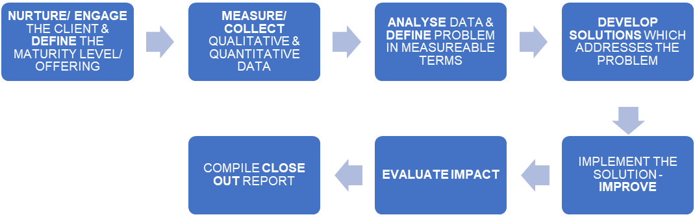

**Step 1**

**Step 2**

**Step 3**

**Step 4**

**Step 5**

**Step 6**

The Enterprise Development Ecosystems defines the ‘what’ we offer and the Productivity SA Way of doing business the ‘How’, the methodology it follows.

* 1. **Digital Strategy**

The Digital strategy focuses on using technology to improve business performance, aligned to the review of products or design of new products. The strategy looks at the delivery of current relevant offerings or the re-configuration of the processes, it specifies the direction the organization is taking to create new competitive advantages with technology, as well as outlining how it would be done.

1. **QUESTION/COMMENT:** The financial report should reflect overall budget and expenditure organisation-wide and reflect Financial Performance per Programme and per Strategic Objective.

**RESPONSE:**  The Financial Performance per Programme and per Strategic Objective for quarter 3 and 4 is as follows:

**Quarter 3 Financial Performance per program:**



**Quarter 3 Financial Performance per Strategic Objective:**



**Quarter 4 Financial Performance per program:**



**Quarter 4 Financial Performance per Strategic Objective:**

