Summary of applications
- Purpose
The purpose of this document is to summarise the list of applications received by the Ad-Hoc Committee on the appointment of the Auditor-General (the Committee) following its invite for the public to apply for the position of the Auditor-General of South Africa. It further guides the Committee on its shortlisting of suitable candidates.
- Background and Introduction
On the 9th of June 2020, the National Assembly resolved to establish an Ad Hoc Committee on the appointment of the Auditor-General of South Africa. The Committee was mandated to nominate a person in terms of section 193 of the Constitution for appointment as Auditor-General. It was further mandated to report to the House on the nomination of the Auditor-General by 31 August 2020.
Flowing from the above, the Committee held its first meeting on 24 July 2020, subsequently, Honouarble Sisi Tolashe was elected as the Chairperson of the Committee. On the same day, the Committee further considered and adopted its programme aiming to achieve its mandate, that is, to nominate a person for the appointment of the Auditor-General. Moreover, a draft proposed job advert was given to members for their consideration. It was resolved that the Members will give their inputs and submit such to the Secretariat of the Committee for consideration. Indeed, the Members submitted their inputs and comments and they were considered and adjusted accordingly. This culminated in a final draft of advertisement signed by the Chairperson of the Committee and later placed in national newspapers and local radio stations.
Pursuant to the job advert, suitable candidates from the public, who meet the stipulated requirements were invited to submit their applications. The advert was made to run for two weeks, started from 3 July 2020 to 17 July 2020. By the end of closing date, which was, 17 July 2020, the Committee received 71 applications. In line with the programme of the Committee, the Committee support staff sorted the list of applications according to the requirements of the position as stipulated from the advert. Consequently, two (2) different lists of candidates were developed and marked A and B. The A list contains the list of applications, who met the requirements. On the other hand, the B list is made up of applicants, whom their Curriculum Vitae (qualifications and experience) do not meet the requirements as stipulated.
In spite of the applications received, this brief summarizes them according to their profile, such as gender, age, qualification and experience. This brief will also rank/sort applications in terms of relevance to the requirements of the advertised position. The following sections give an overview of the applications and the summary as indicated in the last paragraph.

- Overview of the applications received by the Committee
As alluded in the previous paragraphs of this Brief, that the Committee received 71 applications after the closing date. These applications were received from people of all walks of life, ranging from Stock Packers, Cashiers, Interns, no experience to Chief Executive Officers (CEOs) and Managing Directors. In terms of the qualifications they possess, were ranging from Grade 12, National Diplomas, Bachelor Degrees up to PhDs. Even though the majority of these qualifications are on the field of Commerce, there is a significant number of applicants who are in possession of qualifications from the fields of engineering, science, law and philosophy for instance.
Importantly, there is a significant number of applicants who possess the required qualifications, but with no relevant experience as per required for this position or vice versa. Further, there are some few applicants, who possess the required qualifications, but difficult to track its knowledge of state finances and public administration. Such applicants for instance, are qualified and registered Chartered Accountants or in possession of a Master’s degree in Accounting, and designated as CEOs of their Accounting and Auditing firms with no previous track of knowledge of the public sector. These are the applicants who worked in the private sector and later started their own businesses, which they claim to have clients in the public sector.
Lastly, there is a small number of applicants, who are highly qualified with no trace of practical knowledge of state finances and public administration. They work in the Academic field, but claim to do consulting and advisory work in the public sector, in particular in the field of accounting and auditing.
- Summary of the key profiles of applicants

4.1 Figure 1: Gender

Figure 1 shows that out of the total number of 71 applications received, more than a half (54.9 percent) or 39 were from male applicants, while female applicants only accounts (30.9 percent) or 22. In addition, Figure 1 also reveals that there are applicants (10 or 14.1percent) who did not specify their gender in their Curriculum Vitae. They also not attached their Identity Documents (ID) for the ease reference of their gender.

4.2. Figure 2: Age
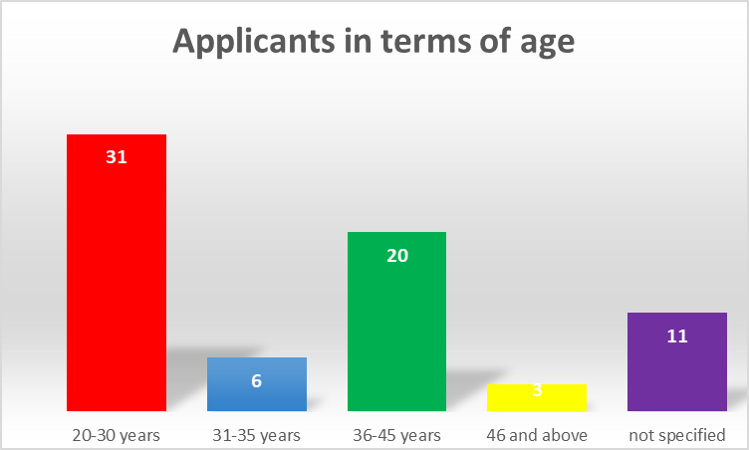
Figure 2 reveals that the majority of applicants who responded to the advert were very young applicants between the ages of 20-30 years. They were followed by the middle age applicants who are between the ages of 36-45 years. Importantly, both applicants between the ages of 20-30 years, and between 31-35 years constitute more than half (52.1 percent) of the total 71 applicants. This means that the majority of applicants who applied for the position of Auditor-General of South Africa is youth. Moreover, Figure 2 shows that there were 11 applicants who did not specify their age in their applications.
4.3 Figure 3: Qualifications in Accounting/Auditing

Figure 3 above indicates the number of applicants who possess qualifications in Accounting and/or Auditing. As seen in Figure 3, a significant number of applicants, about 17 percent or 12 are in possession of Bachelor Degree in Accounting and/or Auditing. Importantly, one of the two applicants who possess a Master’s degree and above, in Accounting and/or Auditing is also accounted under applicants who qualified as Chartered Accountants. Basically, applicants, who meet the requirements in terms of qualifications, are those who possess a Master’s degree and above, and those who are registered as Chartered Accountants, meaning that they are 10 or constitute 14.1 percent of the total 71 applicants. It is worth noting that out of these 10 applicants, 3 (three) of them could not meet the requirements in term of experience, meaning that they only meet requirements in terms of qualifications. Moreover, as shown in Figure 3 above, the majority of applicants (32 or 45 percent) are in possession of qualification from other fields of study such as engineering, science, law, information technology, retail management, business administration, philosophy and other fields. The “other” qualifications also include an applicant who recorded Grade 12 as her highest qualification.

4.4 Experience as required in terms of this position

Figure 4, shows that out of 71 applications received by the Committee, only 10 applications met the required experience. Importantly, 3 of these 10 applicants could not meet the requirement for qualifications because, they possess an Honors degree. The 61 applications received fall below the minimum requirements in terms of experience, some do possess irrelevant experience or no experience at all. This includes amongst others, applicants who have an experience in law, internships, cashiers, stock packers, boilermakers, driver/general worker financial managers in the private sector, quantity surveyor and others.

- Sorting of the applications
On the 22 July 2020, the support staff of the Committee met with the aim of sorting applications so as to make it easy for the Members of the Committee to shortlist the suitable candidates. It is noteworthy to highlight that the support staff with the guidance of an expert from Parliament Human Resources, agreed on the criteria to follow in sorting of the applications. The criteria agreed upon was to sort applications according to the requirements of the position as stipulated in the job advert, which are, the applicant must be a registered Chartered Accountant or possess equivalent qualifications, with a specialized knowledge of or experience in Auditing, State Finances and Public Administration.
Subsequent to the above, the support staff categorized the applications into two. The first category is termed “A List”, which constitutes applicants who meet all the requirements of the position (see Annexure A as attached). The second category, which is termed as “B List”, includes applications who could not meet the requirements of this position (see Annexure B as attached). There were various reasons, which led to applicants included in “B list’. The reasons vary from no experience at all coupled with irrelevant qualifications, or qualifications, which are below the requirements; relevant qualifications coupled with irrelevant experience and vice versa.

- Conclusion
After the closing date for applications, 71 applications were received from the people of walks of life, ranging from a stock packer, cashier up to the CEOs and managing directors. The majority of the applicants were male, of which more than half (52.1 percent) were young applicants below the age of 35. Further, the majority of applications received do possess a Bachelor degree in Accounting and/or Auditing, of which only 10 applicants who possess a Master’s degree and above in Accounting and Auditing; and registered as Chartered Accountants, which means they met the requirement in terms of qualifications. Importantly, 3 of those 10 applicants could not meet the requirements in terms of experience.
Lastly, the support staff has assisted the Members of the Committee in preparation by sorting the applications according the requirements of the positions as stipulated in the job advert. Subsequently, two lists were produced by the support staff, the first list (A list) is made up of applicants who meet all the necessary requirements, while the second list (B list) constitutes applicants who do not satisfy the requirements as stipulated in the job advert.

