**REPORT ON PETITION FROM WARD 52 SUBMITTED BY THE PORTFOLIO COMMITTEE OF CO-OPERATIVE GOVERNANCE AND TRADITIONAL AFFAIRS**

1. **PURPOSE**

To table eThekwini Municipality’s responses to a petition from ward 52, submitted by the Portfolio Committee of Cooperative Governance & Traditional Affairs

1. **STRATEGIC OBJECTIVE**

Good Governance and Responsive Local Government

1. **PETITION FROM WARD 52 RESIDENTS OF BHAMBHAYI, EMAMBA, EMAOTI AND BROOKSFARM**

* 1. Housing
  2. Roads
  3. Drainages
  4. Food parcels are given to well-known people of African National Congress members and poor don’t receive the food parcels
  5. Vouchers are only given to African National Congress members
  6. Satellite Primary Health facility
  7. Satellite Police Station facility
  8. There was an Electricity contractor we were hoping the company would help us with electricity but suddenly they left, they only installed electricity in about 20 houses a minimum of 14 million was paid to this contractor
  9. Main Contractor called GLX under paying members of the community
  10. Multi-Purpose Centre worth 30 million
  11. Wards committees having 2 wages such as Jabu Sithole, Pule Chamane, Mhlabunzima Gazu and Lindani Mkhize
  12. Only members of the African National Congress are employed in Bhambayi ward 52
  13. Only members of the African National Congress can be a sub-contractor if there is a project in Bhambayi ward 52
  14. Ward councillor Sthembiso Boxer Zulu is very rude and arrogant, he puts himself first before the community

**It must be noted that the following responses will be in sections as indicated in the above order of petition.**

1. **RESPONSE TO HOUSING**

**This item is providing a response to petition number 3.1**

* 1. **BHAMBAYI PHASE 1 EXTENSION HOUSING PROJECT STATUS**

**PROJECT DETAILS**

No. of Sites : 479

Project Type : Greenfield Housing Project

Ward : 57 & 52

**BACKGROUND**

The project site is approximately 21 km from Durban Central Business District (CBD). The parcels of land are located within Ward 52 & 57. Bhambayi Phase 1 Extension comprise parcel of land within Bhambayi Phase 1 (erf 259 & 315) i.e. Pat Marshal with an extent of 23 hectares. Erf 259 was reserved as a school site and erf 315 as open space owned by eThekwini municipality.

Stage 1 application was submitted to Department of Human Settlements and assessment was received indicating outstanding information which included socio economic study and other related information. Resubmission of the application has been sent to the KZN Department of Human Settlements in March 2020. The application is being assessed for the preparation of submission to TEC Department of Human Settlements.

**PROJECT VALUE AND PAYMENTS MADE**

PROJECT VALUE AND PAYMENTS : Not yet Approved

DOHS APPROVED VALUE (STAGE 1) : Not yet approved

TOTAL AMOUNT CLAIMED : 9/20: R5 000 000

ETHEKWINI BUDGET : 20/21: R 5 000 000

**PROGRESS TO DATE**

Phase 1 Extension (Pat Marshal) (Ward 52 & 57)

Professional team was appointed to undertake outstanding scope of work to obtain Spatial Planning and Land Use Management Act approval (SPLUMA). SPLUMA pre-application was submitted to Public Sector Housing for comments in July 2019. Comments raised by Public Sector Housing and the line departments were as follows:

Comments raised as follows:

* Amendment of the Record of Decision to reflect correct project name to be submitted to KwaZulu Natal Department of Economic Development, Tourism and Environmental Affairs (EDTEA) for approval
* Amendment of Department of Education letter to reflect correct site number. The letter issued is an authorization letter to utilize school site for housing development purpose.
* Development of Conditions of Establishment
* Closure of Public open space application

Number of comments have been addressed. Conditions of Establishment drafted and completed in December. The amended Record of Decision (ROD) was obtained in December 2019 and Department of Education (DOE) letter for authorization has been obtained in March 2020. The town planner prepared and submitted application for closure of public open space to Public Sector Housing (PSH). The application is being assessed by Real Estate. After final assessment, public participation will proceed for the period of 30 days.

**DEVELOPMENT PROGRAMME**

* SPLUMA advert **: Completed**
* Real Estate process and Public Participation **: May 2020-November 2020**
* Submission to JAC and MPT (if there are no objections) : **December 2020**
* Decision Notice : **January 2021**

**CHALLENGES**

* Waiting for Stage 1 approval from Department of Human Settlements (DOHS)
* Obtaining amended letters from Department of Education
* Closure of Public open space application process

**WAY FORWARD**

Await Real Estate to assess and complete closure of public space application process which the line department anticipated 3 to 6 months. In parallel, line department to submit to JAC a request of SPLUMA approval while process of closure of open space process is being undertaken by Real Estate. Bhambayi Housing project will be presented at JAC on 28th of July 2020 for SPLUMA approval. Once SPLUMA approval is obtained, tender for services will be advertised.

**SHOW HOUSE**

One double story house was built through storm disaster program in 2015 at Bhambayi. It was not a show house for Bhambayi housing project since planning processes have not been finalized.

**STORM DISASTER PROGRAMME AT WARD 52**

There were 27 informal houses affected during 2017 storm at ward 52. Contractor was appointed in February 2019 and is on site. 9 units have been completed and 5 slabs completed. Outstanding 13 units to be completed by end of September 2020. In April 2019, there was a storm disaster that affected 8 informal houses at ward 52. Geotechnical investigation is currently underway so that houses can been enrolled with National Home Builders Registration Council (NHBRC). The contractor has been appointed and anticipated to start on the ground by mid-August 2020.

* 1. **BROOKSFARM RECTIFICATION HOUSING PROJECT**

**CURRENT STATUS**

Total yield : 465

Houses completed : 405

Houses to be constructed : 05

Project has 55 substantial structures where beneficiaries are not willing to demolish and will not benefit for new 40m2 units. These houses were extended over the years. All 55 beneficiaries were issued notice letters about their situation.

The first item that was raised about the project is Community Liaison Officer - Mr. Mhlabunzima Gazu who was employed by eThekwini housing project to deal with the social issues to the project. He was recruited through interview during recruitment process.

Second item raised was the houses as follows:

* **House no.1640** – The site was not enough to fit 40m2 unit and the beneficiary refused to demolish the existing house. House can only be positioned as per approved layout plan.
* **House no.1738**- The beneficiary refused to allow the contractor to demolish the portion of the existing house so to fit 40m2 unit. House can only be positioned as per approved layout plan.
* **House no.1621**- the beneficiary has extended the existing house and she refused to demolish but she was demanding the units to be connected. Home Builders Registration Council **(**NHBRC) regulations state that government can’t alter private structures hence the existing house must be demolished first and then a new house can be built.
* **House no.1676**- the beneficiary has extended the existing house and she refused to demolish but she was demanding the units to be connected. Based NHBRC regulations government can’t alter private structure hence existing house to be demolish first and then new house can be built.
* **House no.1810**- the beneficiary refused to demolish big existing structure to fit 40m2 unit, but she wanted to benefit to get 40m2 unit. House can only be positioned as per approved layout plan.
* **House no.1830** - the beneficiary refused to get 40m2 unit.
* **House no.1659** - This house was built.
* **Allocation issues** – Since this project was a rectification so all beneficiaries were already approved on the Housing Subsidy System (HSS). During construction allocation issues came where some beneficiaries claim back their houses to the occupants. This has created tension to community where some occupants were kicked out by approved beneficiaries regardless of how many years they have stayed there. This allocation issue will fall under verification Programme. All houses will be verified in terms of ownership verses occupant then do advert on the new paper. When they no approved beneficiary coming forward, will then deregister approved beneficiary and replace with occupants.
  1. **GREATER AMAOTI/AMAMBA HOUSING PROJECT STATUS**

**PROJECT DETAILS**

Project Name : **GREATER AMAOTI HOUSING PROJECT**

Project Number : **K17090015**

No. of Sites : 20000

Project Type : In-situ Upgrading/Brownfield Housing Project

Ward : 52, 53, 56, 57, 59, and 102

No. of Beneficiaries : 20000

Start Date : April 2015

End Date : June 2025

**BACKGROUND**

The project area being the Greater Amaoti is located within the INK (Inanda, Ntuzuma, and KwaMashu) area, approximately 20 kilometres North of Durban. It comprises a mix of residential townships and informal settlements. Greater Amaoti, is one of the largest informal settlements in eThekwini and South Africa, comprising 12 sub-areas, and is one of a series of communities forming the Greater Inanda Area. The project area is approximately 1235.59 hectares(Ha)in extent is located on a portion of Wards 52, 53, 56, 57, 59 and 102 of the eThekwini Metropolitan Municipality. The project aims to yield 20000 housing units. Amaoti Cuba consist of 345 units is a pilot project under Greater Amaoti. Construction is in progress. The project was granted approval for Stage 1 planning and implementation in August 2018 by MEC Human Settlements and Public Works.

**PROGRESS TO DATE**

* Stage 1 approval completed
* Geotech Phase 1 is completed
* Top survey is completed
* Construction of Amaoti Cuba (Pilot project of Greater Amaoti) is in progress. To date 340 units have been completed.
* Overall planning is in progress.
* Environmental Impact Assessment (EIA) is in progress and anticipated to be completed by February 2022.
* SPLUMA approval by July 2022.
* Construction will commence once SPLUMA approval is obtained

**COVID 19 MATTERS**

* 4000 soaps have been distributed at Amaoti on the 04th of April 2020.
* There is a planned disinfection/cleaning program to take place in August 2020 to cover the settlement.
* Fast track incremental services (water, sanitation, footpath etc)
* Identify land to relocate people on the way of service to unlock Amaoti Cuba project.

1. **RESPONSE TO ROADS AND RELATED ISSUES IN WARD 52**

**This item is providing a response to petition number 3.2**

**PAST ROADS RELATED PROJECTS IN THE AREA**

The following is a list of past roads related construction projects that have been undertaken in the area:

|  |  |  |
| --- | --- | --- |
| **Year** | **Description of works** | **Estimated value** |
| 15-16 | Lenham Drive Sidewalk | R175,000 |
| 17-18 | Stoneham Sidewalk | R615,000 |
| 17-18 | Fernham Sidewalk | R140,000 |
| 17-18 | Westham Sidewalk | R320,000 |
| 17-18 | Fernham/Ntuzuma Road Sidewalk | R2,150,000 |
| 17-18 | Preventative maintenance and Re-seal of various roads | R13,000 000 |
| 18-19 | Preventative maintenance and Re-seal of various roads | R1,000,000 |
| 19-20 | Rehabilitation works on D403  (Arterial road serving Wars 52, 53, 57 & 59) | R20 358 311 |
| 19 -20 | Two footbridges completed 2019 - 6m stream crossings   * Pedestrian crossing between Dudu village and Bhambayi, * Pedestrian structure near Kwa- Mashu Highway. | R173 340.00  R149 657.50 |

**PLANNED ROADS RELATED PROJECTS IN THE AREA**

The following is a list of planned road construction projects to be undertaken in the area:

|  |  |  |  |
| --- | --- | --- | --- |
| **Year** | **Type** | **Detail** | **Status** |
| 20/21 | Passages   * Lenham area * Brookfarm area * Chris Hani Intersection * Dudu Shangase Road * Sidewalks   - Jobe Blose Road  Roads  Bhambayi | To be done via Community Infrastructure Programme or alternatively, through application for capital via adjustment budget process. | Target 20-21 / 21/22 via CIP contract.  The North CIP contract is currently in SCM process. Anticipate construction for 20/21 FY. Roads To be undertaken as per ward councillor requests. Funding shortfall also to be addressed through application for capital budget when available. |
| 21/22 | Dudu Shangase Walk Ped Bridge – 36m long pedestrian bridge | Estimated value, R3m | On track – Planned for 21/22 implementation.  Prelim design complete, EIA process complete, design and SCM process to follow in 20/21.  Construction +- July 2021. |

**TYPICAL WORKS UNDERTAKEN**

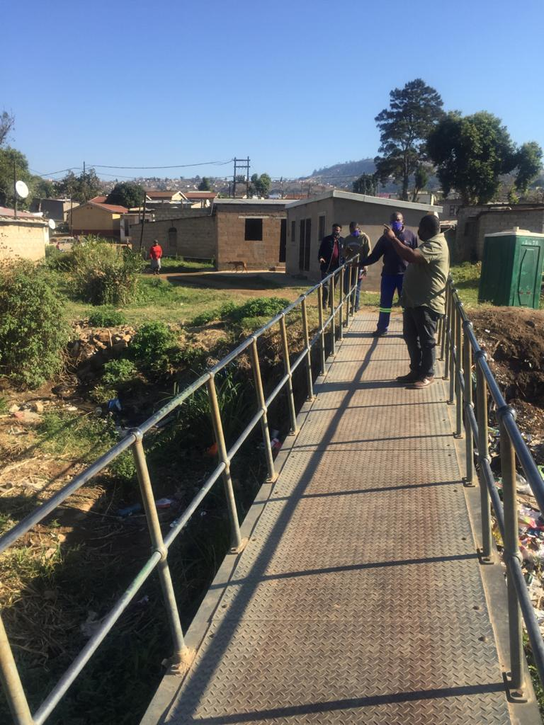

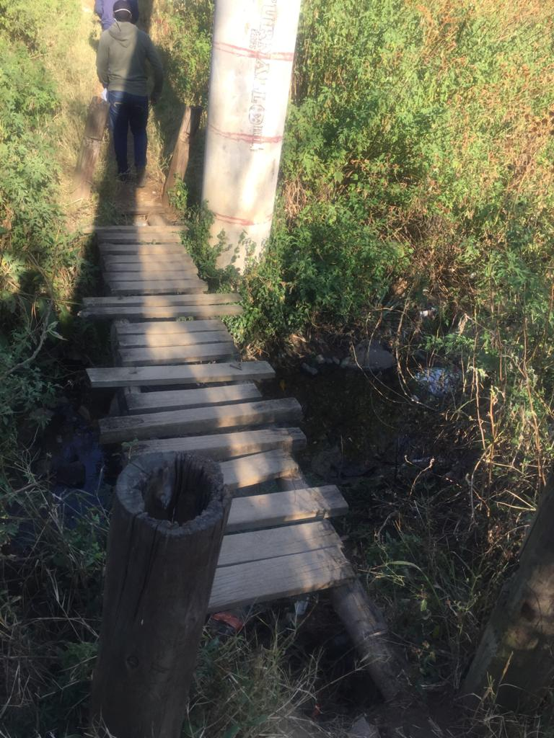

Current access that Unit proposes to upgrade – Brooks Farm area

**OTHER ROADS RELATED MAINTENANCE ISSUES**

An additional maintenance item, pertaining to pedestrian access has been noted. A steel bridge crossing is required where the river has altered course; this work will require an additional 12m span added to the existing bridge, which also needs to be re-seated. Investigations for the works are in progress.

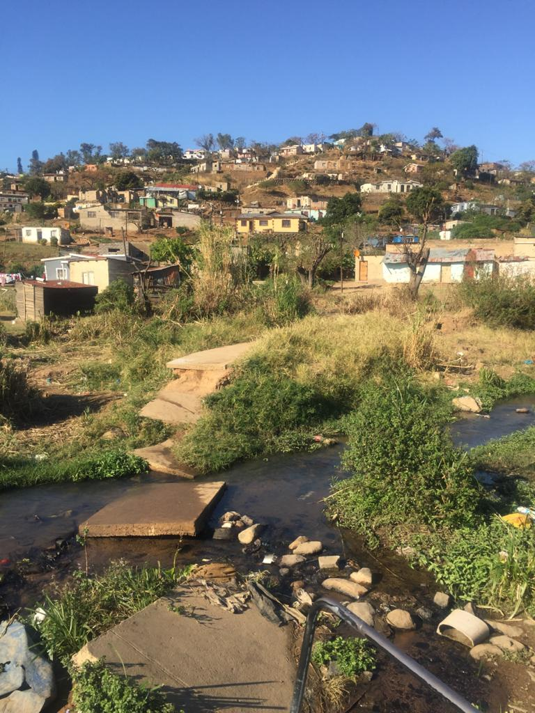

**STORMWATER RESPONSES**

**Past projects**

The following is a list of past stormwater related construction projects that have been undertaken in the area:

**STORMWATER UPGRADES AND REHABILITATION**

|  |  |  |  |
| --- | --- | --- | --- |
| **Project name** | **Description of works** | **Project status** | **Completion date** |
| 7D-17417 | 110 Phaphama Avenue | Stormwater upgrade | 15 September 2016 |
| 7D-31433 | no 10 Ntombi Mbiko Street | Stormwater upgrade | 10 March 2017 |
| 7D-34055 | 03 Ntombi Mbiko Street | Stormwater Upgrade | 31 May 2019 |
| 1D-9849 | SIPHOSIWELA RD: AMAOTI S/WATER | Extension of Stormwater | October 2019 |
| 7D-33932 | Machwane Road | Stormwater Rehabilitation | 6 November 2017 |
| 7D- 33933 | Pat Marshall Road | Stormwater Rehabilitation | 7 November 2017 |

**STORMWATER REPAIRS**

|  |  |  |  |
| --- | --- | --- | --- |
| **Project name** | **Description of works** | **Project status** | **Completion date** |
| 7D-35636 | 6 Buyani Lane | Stormwater repairs | 25 January 2018 |
| 7D-35469 | 610320 Street | Stormwater repairs | 9 February 2018 |
| 7D-35637 | Phaphama Avenue | Stormwater repairs | 2 May 2018 |
| 7D-36372 | 41 Vika Crescent | Stormwater repairs | 2 May 2018 |
| 7D-38198 | 41 Siyavuma Crescent | Stormwater repairs | 15 June 2018 |
| 7D-38260 | 19 Vika Crescent | Stormwater repairs | 22 June 2018 |
| 7D-39551 | No 27 Street 108827 | Stormwater repairs | 11 October 2018 |
| 7D-39552 | No 29 Street 108827 | Stormwater repairs | 17 October 2018 |
| 7D-34055 | 03 Ntombi Mbiko Street | Stormwater Upgrade | 1. ay 2019 |

**PLANNED STORMWATER RELATED PROJECTS IN AREA**

The following is a list of planned stormwater construction projects to be undertaken in the area:

|  |  |  |  |
| --- | --- | --- | --- |
| **Year** | **Type** | **Detail** | **Status** |
| 20/21 | V drains - Bhambayi | Stormwater Upgrade | Going out to tender  End Aug 2020 |
| 20/21 | 48 Heysham Pl – Stormwater Upgrade – Wall Collapse | Storm damage | Award stage; estimated that contractor on site by 18 August 2020 |

**UNFUNDED STORMWATER RELATED PROJECTS IN WARD 52**

The following is a list of unfunded stormwater related works requiring attention.

|  |  |  |  |  |
| --- | --- | --- | --- | --- |
| **Project Name** | **Description of Works** | **Project Status** | **Estimated Value** | **Commencement Date** |
| Ntombi Mbiko Street  (opp Dube Village)  Stormwater Upgrade | Extension of Stormwater pipe from MR25 discharge | Funding required  (design and documentation will be ready by 28 Aug 2020) | R1 200 000 | Dependent on funding availability |

**TYPICAL WORKS UNDERTAKEN**

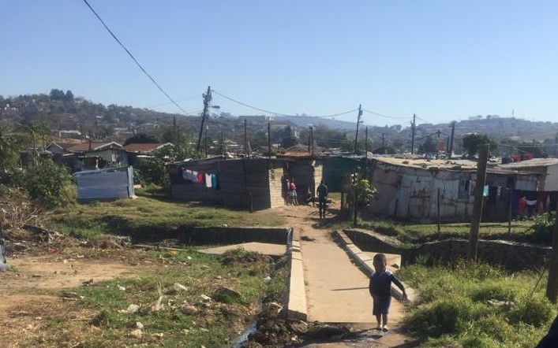

Stream crossing improvement – Ward 52

Typical gravel road improvement using wrap material in neighboring ward 53

Type of low-level structures provided by Municipality to provide pedestrian mobility

**MAYORAL OPERATION SUKUMA SAKHE (OSS) OUTREACH PROGRAMME**

The following items, pertaining to roads and stormwater were noted during the recent Mayoral OSS Outreach programme, (21 Feb 2020):

|  |  |  |  |  |
| --- | --- | --- | --- | --- |
| **Ward/ Area** | **Date** | **Issue Raised** | **Source of Concern** | **Dept Update / Status** |
| Bhambayi area (Chris Hani sub-area) | 21/02/2020 | Pedestrian bridge not completed | Observation by the Mayoral and war room delegations | Roads Provision – Structures Dept investigating; Final report by Engineers in Aug. Funding to be sought via adjustment budget process |
| Brooksfarm area | 21/02/2020 | Storm water blockage,  Incomplete sidewalks and lack of pedestrian bridges at Brooksfarm area. | Observation by the Mayoral and war room delegations. | Ward councillor advised that this could be a sewer blockage; Depot superintendent is liaising with Councillor to inspect on 21-07-2020.  Stormwater infrastructure is inspected on a routine basis and matters requiring attention is dealt with accordingly using existing resources.  Geneva sidewalk noted by the ward Cllr)  Roads Provision – Structures investigating |
| Amaoti area (Tanzania sub-area) | 21/02/2020 | Pedestrian bridge damaged. | Observation by the Mayoral and war room delegations. | Roads Provision – Structures Dept investigating; Final report by Engineers in Aug. Funding to be sought via adjustment budget process |
| Inanda Newtown Comprehensive High School (Bhambayi) | 21/02/2020 | Damaged wall next to the stream, at the school. | Observation by the Mayoral and war room delegations. | This has been re-inspected between Roads and Stormwater Maintenance Dept. and Coastal, Stormwater and Catchment Management Dept. (CSCM);  To be addressed via CSCM – Erosion protection (out to tender  21 Aug 2020) |
| Bhambayi area | 21 February 2020 | House flooded next to Jobe Blose road. | Observation by the Mayoral and war room delegations | 2 x storm water blockages in this area; (caused by illegal dumping).  Both locations will be attended to within week 20/7/20 – 25/7/20; to be undertaken on Friday 24-07-2020 |

1. **RESPONSE TO DRAINAGE RELATED ISSUES IN WARD 52**

**This item is providing a response to petition number 3.3**

**Background**

Ward 52 is largely informal in nature with only a small portion of Phoenix (formal township) included within its boundary. The ward also includes the areas of Brooks farm, Mamba and part of Amaoti. Being largely informal, there have been ongoing requests for infrastructure development to improve the level of service delivery in the area. Due to the lack of infrastructure, especially in-between the densely populated informal dwellings, ongoing maintenance is a real challenge. There are a few gravel / main roads/ taxi routes that service~~s~~ both wards.

There have been **Reconstruction and Development Programme (RDP)** houses built over the past 10 years in both these wards, although the road and storm water infrastructure are awaiting construction. Some roads that have been constructed to date, whilst other requests are pending construction. (Such works are pending due to budget related constraints). Community members of Bhambayi, Mamba, Brooksfarm and Amaoti (Ward 52) submitted a petition to address service delivery issues.

Issues raised in the petition pertained to the lack of service delivery in their area, and focused on the following service delivery areas:

* Houses
* Roads
* Drainage systems

This report aims to respond on issues raised by communities in relation to Engineering Unit functions.

**Response to petition**

This section covers the roads and stormwater related responses to the petition received, and is dealt with under the following headings:

* Roads and storm water Maintenance (RSWM) initiatives undertaken to date
* Roads responses
  + Past roads related initiatives
  + Planned roads related initiatives
  + Other Maintenance issues
* Stormwater responses
  + Past stormwater related initiatives
  + Planned stormwater related initiatives
  + Unfunded Stormwater related projects in Ward 52
* Mayoral OSS Outreach programme items

**ROADS AND STORM WATER MAINTENANCE (RSWM) INITIATIVES UNDERTAKEN TO DATE**

The following maintenance related initiatives have been undertaken recently:

* Eight (8) short narrow roads running in-between the informal dwellings in ward 52 have over the past twenty-four (24) months been improved, using a cement stabilized crushed stone layer to improve vehicular and pedestrian movement.
* Unconventional construction methods were used to complete the work done due to severe restrictions regarding access widths, underlying ground conditions and the continuous flow of grey water.
* Over the last 18 months one section of the main concrete road has been extended using concrete and one section removed and replaced.
* One concrete road has been constructed in the past two months; this entailed the construction of narrow concrete access-ways in Bhambayi. Similar approaches are planned to be implemented in ward 52.
* The intention is to construct two new concrete roads, traversing in-between informal dwellings, over the next 2- 3 months; the first project will commence by no later than 15 August 2020 and the second by 01 October 2020
* Blading of gravel roads is undertaken as the need arises/ calls from the ward Councillor; such is done via in-house team. Blading is due to start on 22/7/2020.
* Re-gravelling under our current annual contract is due to take place in this ward in Sept/Oct this year; Re-gravelling is due to commence 01/10/2020. The ward Councillor has been updated regarding the programme in this regard.
* Requests for stream canalization are being addressed and engagements being held with the Ward Councillor.
* Roads and Stormwater Maintenance Department stream cleaning programme has been in operation in this area, using co-operatives.
* The annual Inlet repairs contract is being used as and when required in ward 52; activities are based on job requests and storm water inspection reports.
* Annual Stormwater Inspections contract: Inspections are undertaken on a cyclic basis; Bhambayi and Redfern areas, within ward 52, are listed as cyclic area for inspection. Storm water inspections commenced on 20/07/2020; the next inspection cycle is due to commence on 01/09/2020.
* Annual Stormwater cleaning contract: Works commenced from 20 July 2020. (Such works were originally planned to commence just prior to Lockdown 5, in March 2020).
* Previous storm water inlet cleaning was successfully undertaken in September 2019.

**CONSTRUCTION OF ACCESS PASSAGES**

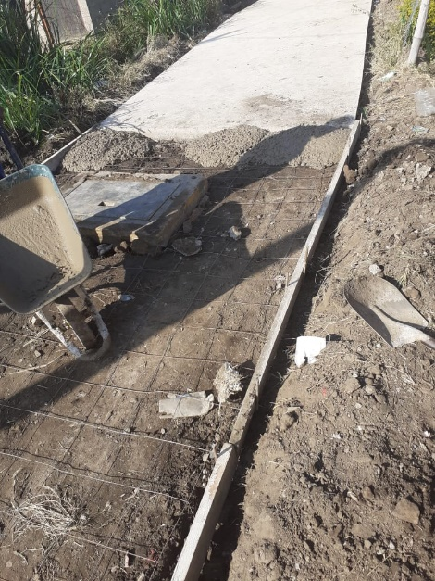 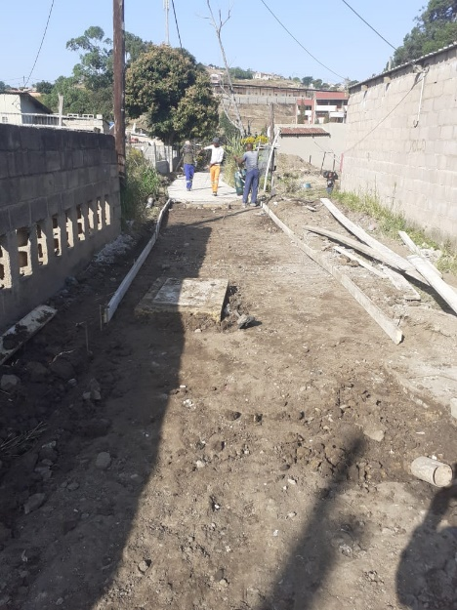 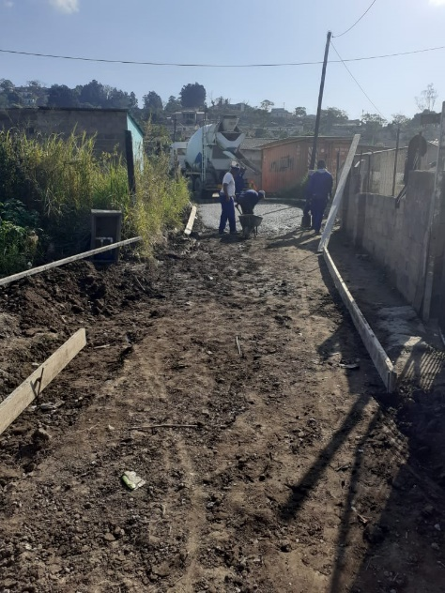

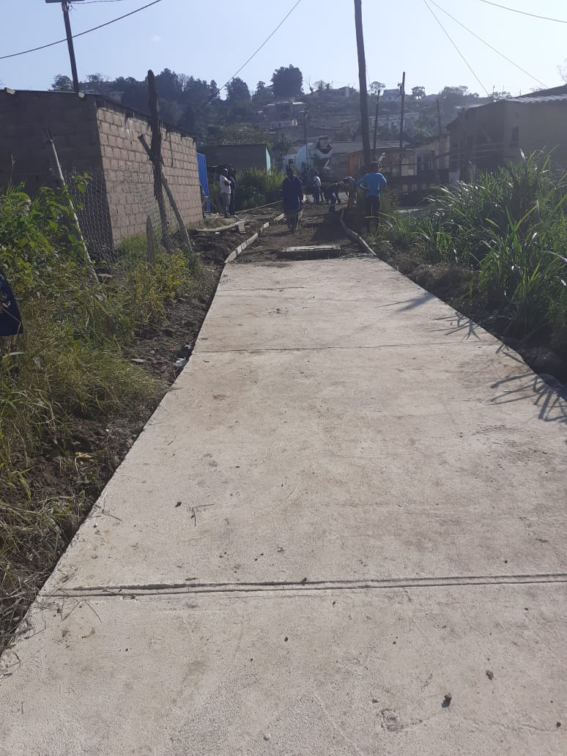 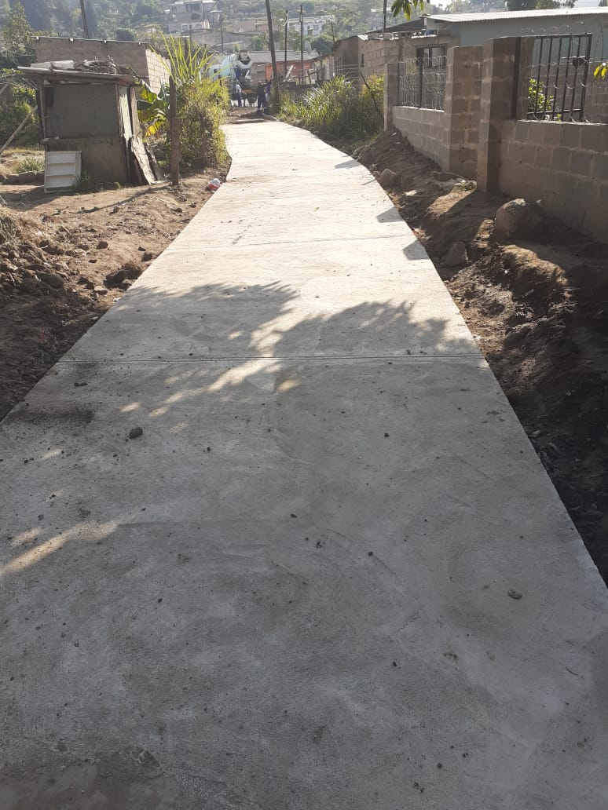

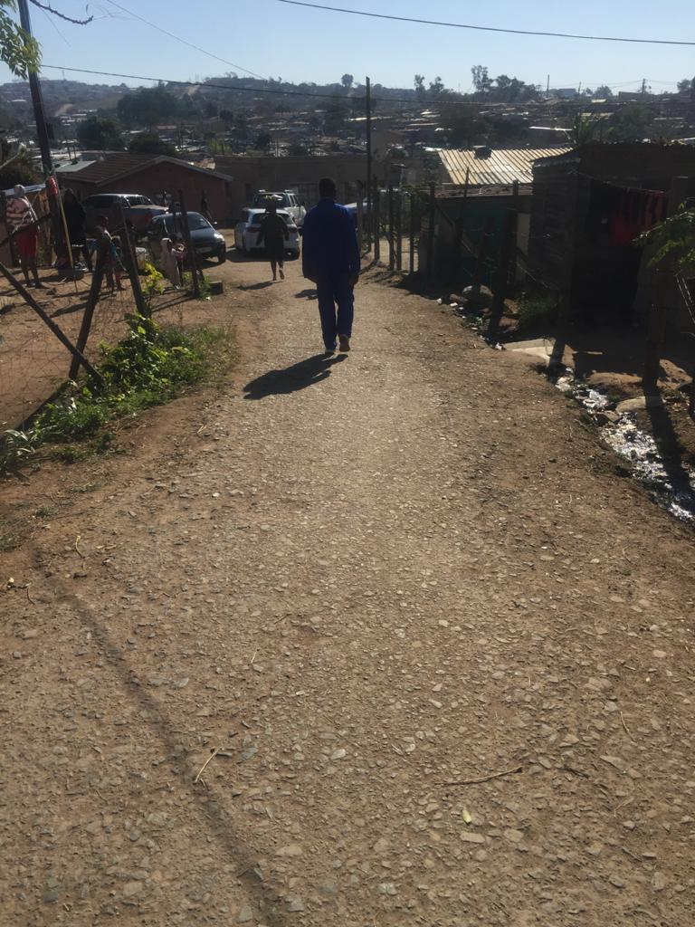

Narrow roads improved using cement stabilized crushed stone to provide all weather access in Ward 52

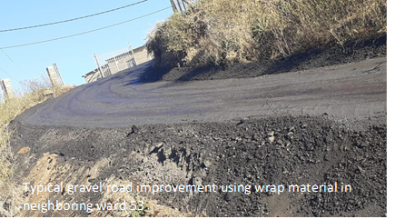

**STORMWATER MAINTENANCE IN PROGRESS**

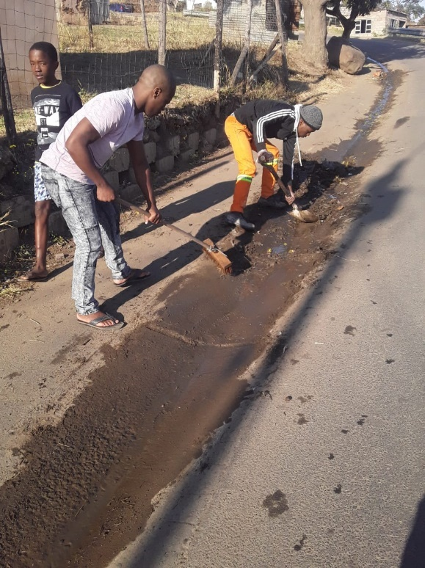 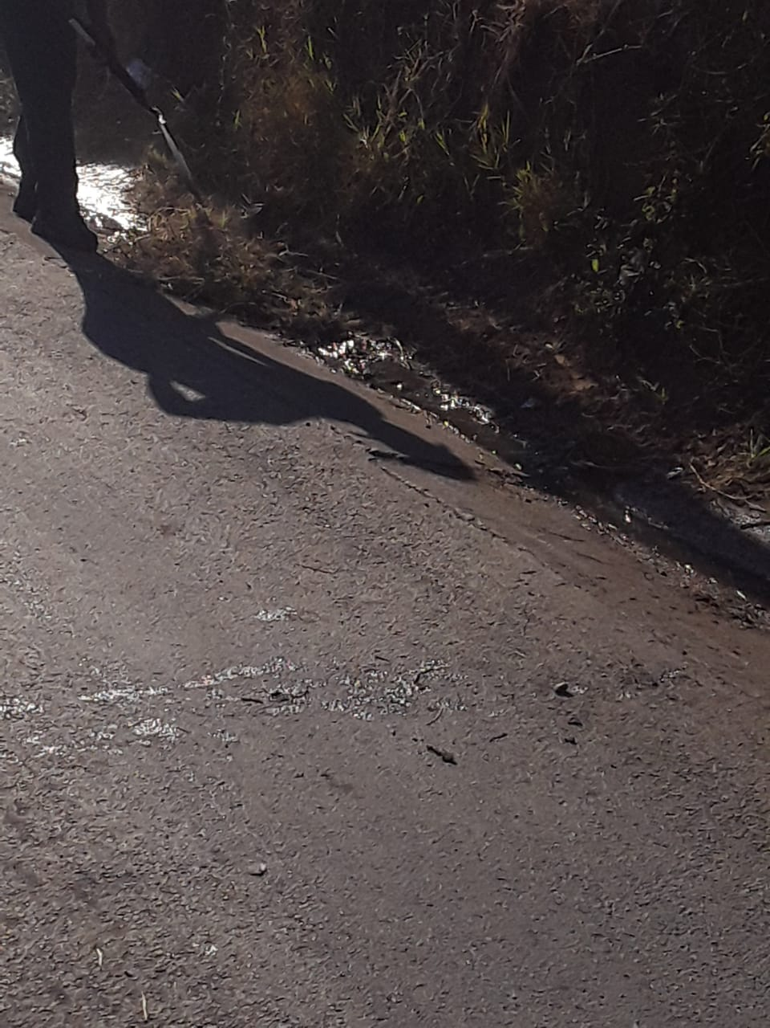

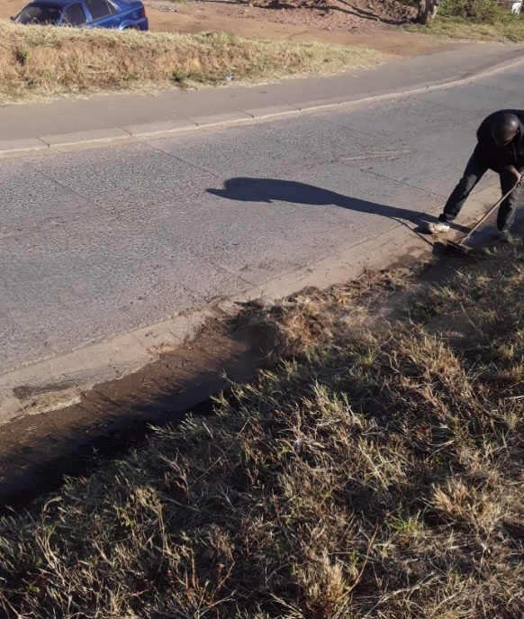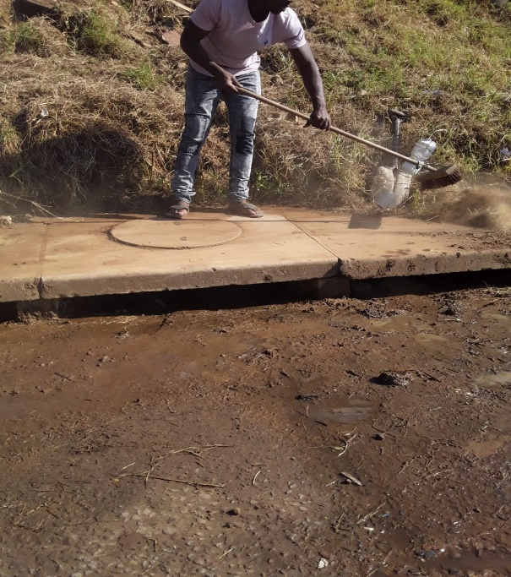

1. **RESPONSE TO FOOD PARCELS /VOUCHERS**

**This item is providing a response to petition number 3.4 and 3.5**

| **NATURE OF THE CONCERN** | **RESPONSE FROM OFFICE OF THE SPEAKER** |
| --- | --- |
| 1. Food parcels are given to well-known people of African National Congress members and poor don’t receive the food parcels 2. Vouchers are only given to African National Congress members | * The Municipality’s food relief programme (that is food parcels/ vouchers) was a Council programme, and not politically driven. * As the Municipality we strongly condemn “politicking” at the expense of our needy communities, because as elected community leaders, regardless of political affiliation, we subscribe to a notion that says, we’re here to improve lives of all our citizens. * Therefore prior to the programme being implemented, Councillors were engaged by His Worship the Mayor, Cllr Mxolisi Kaunda and the Speaker, Cllr Weziwe Thusi through the respective Political Party Whips on this food relief programme. * At the said engagement the Councillors were advised of the programme, and the beneficiary identification criteria to be used; which comprised mainly of Soup kitchen beneficiaries; destitute families; and any other needy member of a ward. This was done for uniformity purposes. * It will be noted that only 1000 food hampers/vouchers were distributed in a ward. * At the completion of the programme, Ward Councillors had to submit to the Office of the Speaker list of all 1000 beneficiaries from the respective Wards. * Given the above it becomes a challenge to accept that in a Ward, only members affiliating to a particular party would benefit from the 1000 food vouchers. * As the Municipality we acknowledge that a 1000 allocation within a ward doesn’t go a long way, but we are certain that it does make a difference to our needy communities. * Having stated the above, any information which proves that indeed only a particular group of community members benefited from the programme, that information will bewelcomed and highly appreciated so that such behaviour is nipped at its bud. |

1. **RESPONSE TO SATELLITE PRIMARY HEALTH FACILITY**

**This item is responding to petition number 3.6**

**BACKGROUND**

The Clinics in the Municipality are operated based on a Service Level Agreement signed between the eThekwini Municipality and the KZN Department of Health. Funds received to operate Services cover Salaries of specified employees and pharmaceuticals. The needs for additional fixed clinic facilities are determined based on needs and current guidelines.

The Provincial Department of Health does have identified prioritised fixed clinic building plans that are capture in the eThekwini District Health Plan (attached see page 134). With regards to the building of new Clinics, The eThekwini Municipality has made limited budget available to build clinics over a medium term which therefore assists in clinic building and upgrades of identified clinics within allocated budget.

Currently in the Amaoti area there is a fixed clinic operated by Provincial Department of Health. The community closer to Caneside are served by Caneside Municipal Clinic which is operational and patients from ward 52 who can access this clinic do so.

Furthermore, a mobile clinic service is provided by the Provincial Department of Health eThekwini District Health Services once a month at the hall in Amaoti. It has been reported that the mobile services were interrupted in July due to staff being in quarantine and that services are expected to resume in August.

**RECOMMENDATION**

The KZN Department of Health eThekwini District Office, should be further engaged to undertake a feasibility assessment regarding the request made by the community

1. **RESPONSE TO SATELLITE POLICE STATION FACILITY**

**This item is responding to petition number 3.7**

In response to the above- petition which relates to Satellite Police Station facility, the response is as follows:

# 9.1 Bhambayi

* + - * The area of Bhambayi is policed by both SAPS Inanda and SAPS Phoenix.
      * SAPS Phoenix polices a small area called Geneva within the area of Bhambayi, falling within the geographical block number 7499.
      * Majority of the area is policed by SAPS Inanda and serviced by the Vela Satellite Police Station.
      * Bhambayi is approximately 5km from the Vela Satellite Police Station and is accessible to the community.
      * The Satellite Police Station is situated approximately 10km from SAPS Inanda.
      * Thirteen (13) operational posts were allocated for the functioning of Vela Satellite Police Station.

# Brooks Farm

* The area of Brooks Farm is policed by SAPS Phoenix which is 08km from the Police Station and is accessible by both Police and community.
  1. **Mamba**
* The area of Mamba is policed by both SAPS Inanda and SAPS Phoenix.
* SAPS Phoenix polices a smaller portion of Mamba which mainly comprises of a shopping area called White City. This area is 8 km away from SAPS Phoenix and is accessible by the Police.
* Most of the area is policed by SAPS Inanda and serviced by the Amaoti Satellite Police Station which is accessible by the community.
* The Satellite Police Station is situated approximately 05km from SAPS Inanda.
* Thirteen (13) operational posts were allocated for the functioning of Amaoti Satellite Police Station.

1. **RESPONSE TO ELECTRICITY CONTRACTOR**

**This item is responding to petition number 3.8**

Regarding the continuation of the Electrification project in Bhambayi, Ward 52, the work has been re-issued to the Contractor. The Contractor is busy sorting out the paperwork as well as the materials so that house connections will continue smoothly. The project will commence next week.

1. **RESPONSE TO MAIN CONTRACTOR CALLED GLX UNDER PAYING MEMBERS OF THE COMMUNITY**

**This item is responding to petition number 3.9**

Under the point 3.9 stated the “*Main Contractor called GLX under paying members of the community*’, the municipality have no knowledge of this company, nor the work they are doing.

The Target groups for sub-contracting, in accordance with City’s Radical Economic Transformation (RET) Framework and the Preferential Procurement Policy Framework Act and its Regulations are:

(a) Priority population groups

(b) Women

(c) Youth

(d) Disabled

(e) Co-operatives

(f) Military Veterans

1. **RESPONSE TO COMMUNITY MULTI-PURPOSE CENTRE WORTH 30 MILLION**

**This item is responding to petition number 3.10**

Economic Development Unit has developed one Multi-Purpose Centre in Umnini and is in the process of implementing others in Bridge City, Hammersdale and Magabheni. These are meant to be sub-regional centres servicing multiple wards in those areas. Please further note that sports related Multi-purpose facilities are facilitated by Parks, Recreation and Cemeteries Unit. The Unit is working with Parks Culture and Recreation Unit to deliver a SAFA SAFE Hub in Bridge City which will service ward 52 and several neighbouring wards.

It must also be noted that due to the current financial constraints imposed by COVID 19 related economic contraction resulting in reduction in the capital budget there are no multi-purpose centres envisaged in the nearby future until the City’s revenue collection has fully recovered this recovery is not foreseen in the current MTRF.

When conducting a basic application of the access modelling (see attached PDF) you will see that at a 10 km radius majority of Ward 52 can access app facilities available in Bridge City as a Sub-regional Node. Also, with the development of the Multi-purpose Library in ward 53 one can see how much of ward 52 is covered in terms of access to that facility.

Please see Architectural Design Report with a response from Economic Development Unit.

1. **RESPONSES TO WARD COMMITTEES**

**This item is responding to petition number 3.11**

| **NATURE OF THE CONCERN** | **RESPONSE FROM OFFICE OF THE SPEAKER** |
| --- | --- |
| Wards committees having 2 wages such as Jabu Sithole, Pule Chamane, Mhlabunzima Gazu & Lindani Mkhize | * Elected Ward Committee Members are not employees of the Municipality, and as such they do not earn a salary and/or wage. * Ward Committee are paid merely an out of pocket expense to cover their costs when performing their duties. * Given the above Ward Committee members are not prohibited by the Municipality from engaging in other employment opportunities. You’ll note that there are other Ward Committees employed by Government such as Teachers; Police Officers; etc. * This practice is not outside of the Municipality’s Rules regulating the Establishment and Operation of Ward Committees. |

1. **RESPONSE TO RECRUITMENT PROCESSES**

**This item is responding to petition number 3.12 and 3.13**

The eThekwini Municipality recruitment and Supply Chain Management Policy respectively does not discriminate work seekers and entrepreneurs based on their affiliation to a political party. All vacant posts and tenders are advertised, and due process is followed so that qualifying candidates are appointed.

1. **RESPONSE TO MATTERS RELATED TO COUNCILLOR ZULU**

**This item is responding to petition number 3.14**

The matter has been escalated to the Speaker’s Office and during the discussion with the above-mentioned ward councillor, allegations were not proven.

1. **CONCLUSION**

The eThekwini Municipality views complaints from communities on service delivery and governance matters very seriously. We appreciate the oversight provided by the Provincial and National Portfolio Committees. We hope the responses provided in this report address the complaints raised. Where there are any outstanding concerns, we will continue to follow up to ensure matters are addressed.

Cllr Mxolisi Kaunda

Mayor