E A S T E R N C A P E P R O V I N C I A L L E G I S L A T U R E

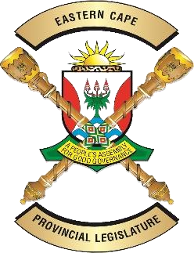
OFFICE OF THE SPEAKER
Tel: 040 608 0094 Enquiries: Qabane Mafuya
Fax: 040 609 2106 Date : 19 July 2020
E-mail: qmafuya@ecleg.gov.za Reference: DORB (SB) Final Mandate

FINAL MANDATE

To : The Chairperson:
National Council of Provinces

Name of Bill : Division of Revenue Amendment Bill

Number of Bill : [B9-2020]
Date of deliberation : 19 July 2020

______________________________________________________________________

Vote of the Legislature

The Legislature supports the Bill (B9 -2020) and mandates the Eastern Cape permanent delegate to the NCOP to vote in favour of the adoption of the Bill.

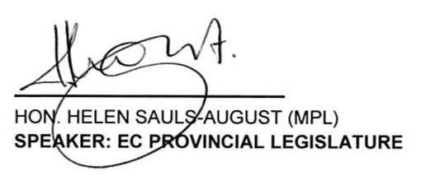
19 July 2020 DATE

