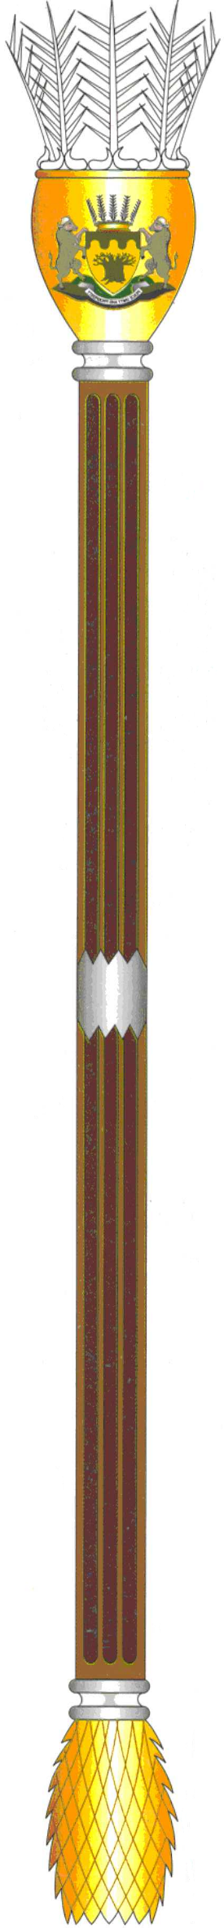

To : The Chairperson: Select Committee on
Appropriations

Name of Bill : Division of Revenue Amendment Bill

Number of the Bill : [B9-2020]

Date of Deliberation : 16 July 2020

Vote of the Legislature : Provincial NCOP Permanent Delegates to
negotiate in favour of the Bill with
recommendations as attached.

HON. K.A PHALA DATE: 17 JULY 2020
COMMITTEE CHAIRPERSON
(Consider it signed if submitted electronically)

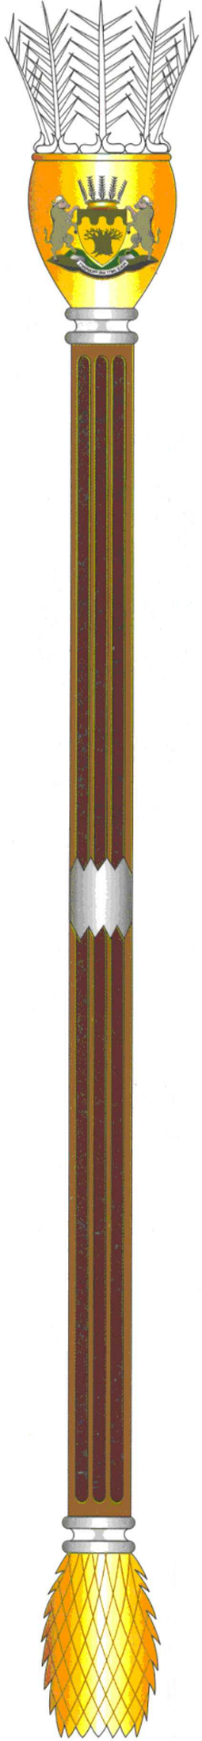
Tel: (015) 633 5071 – Fax: (015) 633 8185/ 633 8119

