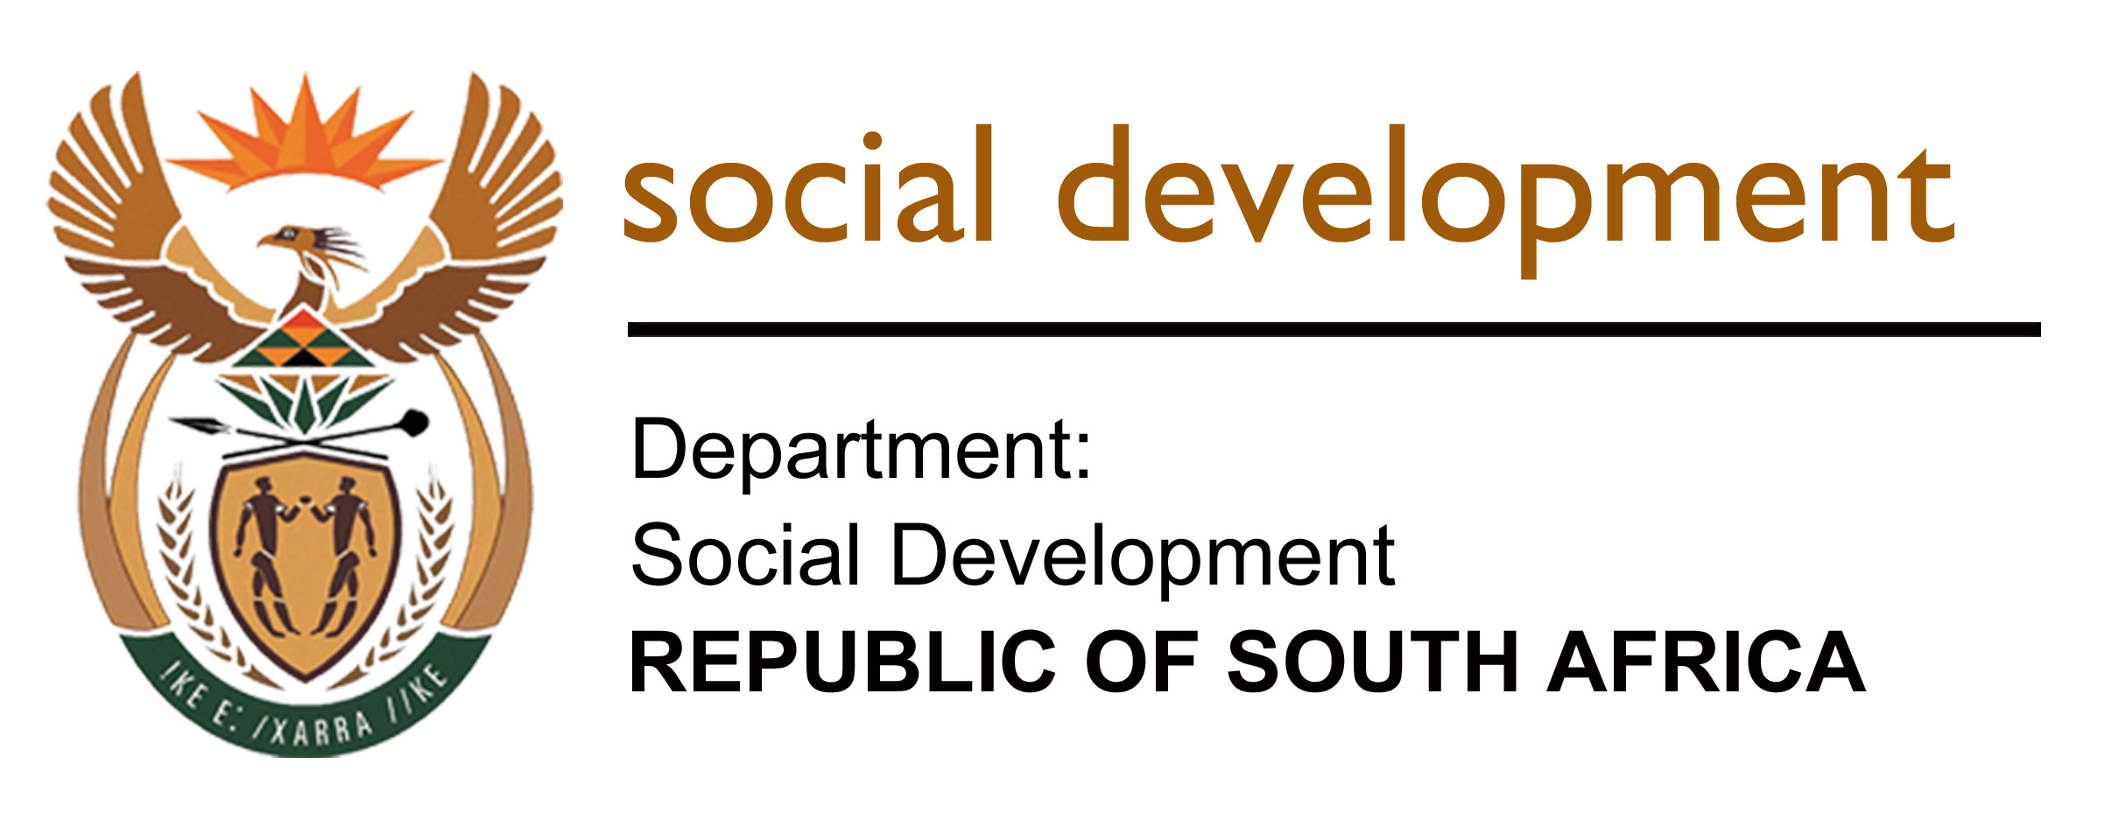

PARLIAMENTARY ENGAGEMENT ACTION NOTES

DATE:

08 July 2020

DELEGATION:

Virtual meeting

COMMITTEE/S:

Portfolio Committee on Social Development and Select Committee on Health and Social Development

ISSUE/S:
- Briefing by the Department of Social Development and its entities on their adjustment budget allocations (2020 -2021) and impact on delivery programmes
- Update on progress made to respond to COVID-19 pandemic issues

PRESENTATION COVERED:
- Introduction:

DISCUSSION:

Questions raised were:
- DSD:

  - How will DSD ensure that the Youth from deep rural areas will benefit and participate in the Siyakwazi Youth Network in the online advocacy campaign as rural youth don’t have access to technology?

The youth in the Siyakwazi Youth Network are connected to Social Media. They are a group of approximately 10 000 youth, who do outreach work within their communities on a voluntary basis to reach out to their peers to do advocacy on a range of issues on Sexual and Reproductive Health and Rights, assisting youth to get the correct information to make informed decision with respect to their health and wellbeing.

  - Under normal circumstances, where there is no pandemic, the youth in the Siyakwazi Youth Network would reach out to their peers, who are not connected on Social Media?

During the COVID19 Pandemic, they can still reach out to the youth who are not connected on the technology of social media, but they reach out to fewer youth as they must observe social distancing and they cannot gather in large groups.

  - Whether the proposed target for 17 400 work opportunities for EPWP has considered what we could obtain from working with other sectors of government and social partners? Is 17 400 all that we can do as there are many people that are unemployed because of COVID-19?

The DSD is already working together with the Social Sector which also includes the departments of Basic Education, Health, Sports and Recreation and Community Safety. Together the Sector plans to achieve 875 000 work opportunities over this five-year Phase Four period of the EPWP. This target is achievable through collaborative efforts and sharing of resources especially budgetary allocations for contributing programmes to the EPWP. DSD plays a role of coordinating the sector towards successful attainment of these targets.

  - Honourable Member Sukers asked about the Digital M&E System in terms of what is actually planned, some key deliverables and who will develop it?

As a policy department with oversight and concurrent functions, real time quality data is key to have an understanding of how effective our efforts are and if the service delivery interventions are working or not working.

  - What is actually planned?

The Digital M&E System will improve the data management and reporting function on all the Social Development Sector programmes. It will be a centralised data management system that will ensure the standardization of information for better decision-making. The Digital M&E system will be managed by National DSD, in close collaboration with Provincial counterparts. The data will be collected across all nine Provinces at a District level.

  - What are some key deliverables?

The development of the Digital M&E system will be conducted over a three (3) year period in a phased approach. Some of the key deliverables:

To develop a comprehensive Monitoring & Evaluation (M&E) Framework and Theories of Change for the Social Development Sector. Develop a user-friendly electronic M&E system that can be implemented at a Provincial and District level to collect real time data, improve data management and timely decision making using an automated standardized and centralized database. This system and database should incorporate existing data and key project performance indicators. To develop a dashboard with GIS information.

  - Who will deliver it?

The development of the Digital M&E System will be done by a preferred Service Provider, the advert will appear in the Government Tender Bulleting on Friday 10 July 2020.

  - Can the Department provide the Committee with statistics of graduates who had been absorbed since the bursary scheme started?

The total number of scholarship graduates who have been absorbed since the scheme started in 2007/08 is 8 220.

  - Parenting programmes training, is it continuing or not? It’s not clear on the targets.

Parenting programmes are not included in the APP targets, however DSD intends to partner with SABC on a programme that empowers parents and caregivers on parenting.

  - How are the social workers going to be trained? 500 vs 180, Why is the situation like this? What informed the numbers?

VIRTUAL Training will be conducted. The reduction is as a result of face to face training which is still prohibited by the Lockdown restrictions of gatherings to maintain social distancing. 20 Social workers per 9 training are anticipated to be accommodated during VIRTUAL Trainings.
  - Which targets talk to fighting the scourge of GBV on Programme 4?

Direct and indirect targets in the revised APP targeting GBV are as follows:

Revised white paper on families; Policy on GBV psychosocial services; Policy on GBV sheltering services; Audit of parenting programmes; Training on social behaviour change programmes; Monitoring tools for the implementation of protocol on the management of child abuse, neglect and exploitation; Monitoring tool for community based prevention and early intervention services for vulnerable children; Service delivery model for ECD; Quality assurance framework for ECD

  - What will happen to the case of a two year old raped at George Mkhari hospital while in quarantine/isolation? Will the perpetrator be arrested or what?

Children’s Act 38/2005 section 110, indicates measures to reporting of abused or neglected child and child in need of care and protection. An email has been sent to the Provincial Head of GP to determine whether the case has been reported to them by the Department of Health, if so, what services were provided and action or steps taken to ensure the safety and well-being of the child and to provide psychosocial services to the family. If not reported, what actions has been taken to ensure that the case receives attention, National DSD will continuously monitor the matter. Furthermore National DSD has referred the matter to The National Emergency Response team to provide further intervention.

  - Is the department aware of the social work veterans’ programme in NW that was stopped? What can be done in this case?

The Social Work Veterans Programme is being implemented in the North West. There is an active Veterans Forum in the province and two of its members are serving in the National Social Work Veterans Forum. The NW Veterans Forum also established the NW Veterans Organisations, an NPO registered in terms of the NPO Act. The NW Veterans Organisations is being funded by NW- PDSD under Services to Families programme. The veterans Programme in NW is still active in that both Forum and Organisation are functional. Their activities may have scaled down due to COVID-19 and its impact on the health of the elderly (all are above (age) 55 years.

  - Which provinces are affected by the cuts made to public treatment centres to Implement the Universal Treatment Curriculum and substance abuse forums?

No cuts made to public treatment centre for operational budget.

  - Can the department come to brief the Committee on the programmes such as GBV, Gangsterism in light of the adjustments?

Yes.

  - What has been the outcome with regard to discussions with Treasury about the additional budget allocation that is needed to cover the shortfall in the SRD grant payments?

At the start of the financial year, SASSA received an allocation of R407 million for SRD, and this is the budget that was used to provide food parcels. After the lockdown, National Treasury allocated a total of R29 billion for the top-up grants, which is adequate for this purpose. The serious budget constraint that SASSA is facing is with respect to the allocation for the COVID-19 Special SRD Grant, and the administration budget to implement the grant. Initially only R3.4 billion was allocated for this, and DSD engaged National Treasury to provide additional budget. During the Supplementary Budget announcement, Treasury allocated an additional R6 billion for the COVID-19 Special SRD Grant. The Department will continue to engage Treasury for additional funding, as the increase is still not sufficient to meet the demand.

  - Is the funds prioritized for CSG top up in line with the solutions to address the Foster Care crisis set aside?
No. The CSG top-up was only provided in May 2020. The funding for the extended child support grant to mitigate the foster care crisis requires a separate allocation, and will only be implemented once the regulations for the Social Assistance Amendment Act have been gazetted. The Department will approach Treasury for this funding.

  - Why there is no food budget at national in the programmes presented?

The budget for the food security programme is part of equitable share and has been appropriated to provinces as part of provincial equitable share.

  - What is the status of food parcels, food voucher and R350 COVID-19 Grant?

The programme of food parcels distribution is going on and as of 30 June 2020 the department has distributed over 800 968 feeding over 4 004 840 individuals throughout the nine provinces with Gauteng having the highest number of food distributed. Currently the department (all nine Provinces) has spent over R440, 9million.

- On NDA

  - Has the NDA taken into consideration the IT and connectivity challenges related to digitisation of the capacity building CSO development intervention?

The NDA has taken into consideration the IT and connectivity challenges related to digitisation of the CSO development interventions including capacity building, hence the focus on development of a Mobile Application which will utilise all platforms that are accessible to communities such as WhatsApp, USSD bulk emails and data subsidisation options. The platforms will not be confined to web-based applications which may be difficult to access due to connectivity and data challenges. The NDA will not only rely on digital platforms for capacity building, where permissible in line with Covid-19 regulations, contact sessions will be undertaken to reach CSOs that have access challenges to the digital platform.

  - How many volunteers have been appointed to participate in the Volunteers Programme per Province?

Two- thousand (2000) volunteers have been appointed to participate in the NDA Volunteers Programme. Two-hundred and twenty (220) Volunteers have been appointed per Province.

  - How is the NDA going to ensure proper utilisation of the grant funding distributed to CSOs?

The NDA implements a Project Monitoring Framework which assists CSOs to meet their development goals as well as enable the CSOs and NDA to review activities against plans, assess risks and provide support for improvement. To this end the NDA Development Practitioners conduct monthly monitoring and support interactions to ensure that CSOs are supported to meet grant requirements and compliance.

  - What process was used for the recruitment of volunteers?
The Volunteers participating in the Volunteers Programme were not directly recruited by the NDA. The NDA selected CSOs from its database as well as from youth-led organisations that already provide poverty eradication interventions within their local communities. The CSOs in turn selected and screened the Volunteers drawn from their own lists of community workers and field workers. Through the grant funding intervention, the NDA provides management fee to the CSOs and the stipends for the Volunteers enlisted to reach almost all Districts within the country. The volunteers facilitated various programmes, including DSD Portfolio programmes and those from organisations outside the Portfolio during the lockdown period.

  - On R32 million set aside for Civil Society Organizations – has NDA strengthened accountability measures by CSO? Plus breakdown of CSOs to be capacitated?

No, R32 million is not enough for the Programme but this is all what the Organisation could reprioritise from the allocated budget.

  - What process was used for the recruitment of volunteers?
The Volunteers participating in the Volunteers Programme were not directly recruited by the NDA. The NDA selected CSOs from its database as well as from youth-led organisations that already provide poverty eradication interventions within their local communities. The CSOs in turn selected and screened the Volunteers drawn from their own lists of community workers and field workers. Through the grant funding intervention, the NDA provides management fee to the CSOs and the stipends for the Volunteers enlisted to reach almost all Districts within the country. The volunteers facilitated various programmes, including DSD Portfolio programmes and those from organisations outside the Portfolio during the lockdown period.

  - How many women participate in the NDA Volunteers Programme?

Seventy percent (70%) of the Volunteers are women.

Decisions:

The Committee requested that the questions be responded to in writing and be submitted to the Portfolio Committee Secretariat; by Friday 10 July 2020 at 12:00.

ACTION PLAN (Time-frame is Friday – 10 July 2020 for all replies to questions)

ISSUE | FURTHER ACTION NEEDED | RESPONSIBLE PERSON |  | TIMEFRAME
 |  |  |  | 10 July 2020
Absorption of graduates who received bursaries to be social workers. | The Department to provide the Committee on statistics of graduates who had been absorbed since the bursary scheme started | Welfare Services Transformation

