H Mostert
Directorate Land and Asset Management
E-mail: heinrich.mostert@westerncape.gov.za
Tel.: 021 483 3684

13 September 2018
THE ACQUISITION OF ERF 35163 - 35176, 35148 AND REMAINDER ERF 38368, MILNERTON
PROGRESS UPDATE
The HDA, via the Department of Human Settlements, investigated the purchase of the above properties near Dunoon with a combined total extent of 17.4128 ha.
On 10 July 2018 the Seller excepted an offer of R66 000 000.00 Excluding VAT in writing for the 17.4128 ha of land.
Subsequent to the go ahead from the DHS, HDA Board approval was received on 27 August 2018 to purchase the land.
Prior to entering into a Deed of Sale with the Seller, the Seller informed that Erf 35175, measuring is 0.2059ha, cannot be included in the sale as it is part of a settlement agreement with a former partner. This led to the exclusion of Erf 25175 and 35176, with the net result of a revised land portion measuring 17.0454ha.
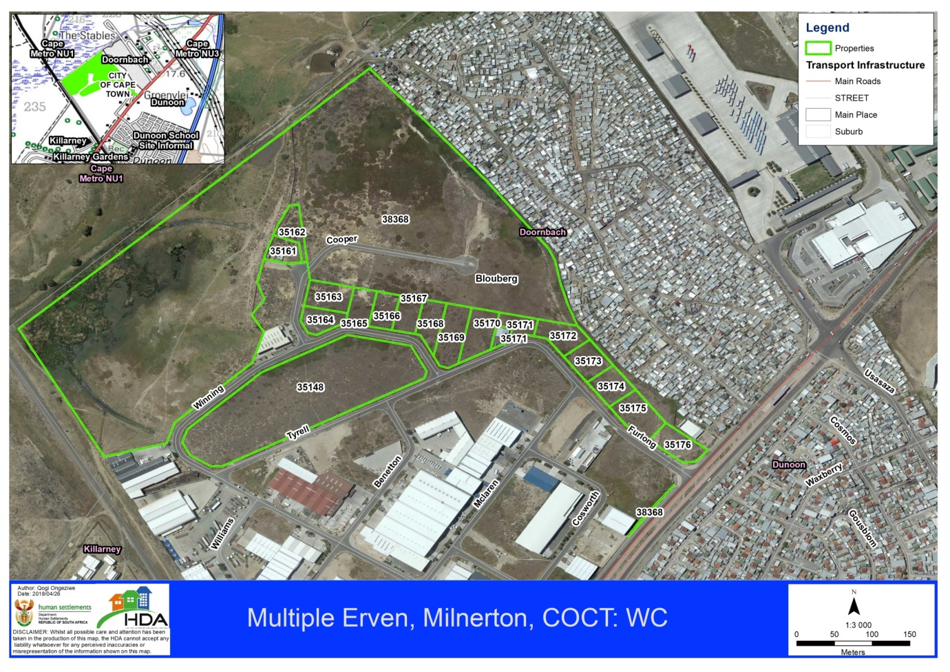
Excluded
Potential additional
The Seller has agreed on a revised purchase price of R64 600 000,00 excluding VAT, which excludes Erf 35175 and Erf 35176.
The Seller has not yet signed the agreement.
However, discussions continue with the view of still obtaining these two land parcels. In addition, discussions also continue with the view of purchasing Erf 35161 and 35162 measuring 0,1112ha and 0,1227ha in extent.
New land negotiations will be entered into in respect of Erven 35175, 35176, 35161 and 35162 once an agreement can be reached.

DEVELOPMENT POTENTIAL
Of the 17ha of land to be bought, approximately 5 ha is located below the 1:100 year floodline (north-westernmost corner), implying that only about 12 ha is available for development.
At a conservative estimated flat rate of 100 units per ha, the purchased land could accommodate approximately 1200 units.
However, it should be noted that the properties need to be rezoned to allow for a residential development, even for a temporary relocation area.

