**REPORT OF THE SELECT COMMITTEE ON HEALTH AND SOCIAL SERVICES ON THE STRATEGIC PLAN, THE ANNUAL PERFORMANCE PLAN AND BUDGET OF THE DEPARTMENT OF SOCIAL DEVELOPMENT;DATED 03 JUNE 2020**

The Select Committee on Health and Social Services(hereinafter the Department) having considered and deliberated on Budget Vote 19, the2020/21-2024/25 Strategic Plan and 2020/21 Annual Performance Plan (APP) of the Department of Social Development (the Department), together with the Portfolio Committee on Social Development, reports as follows:

1. **INTRODUCTION**

Section 5(2) of the Constitution of South Africa (No. 108 of 1996) and section 27(4) of the Public Finance Management Act (No.1 of 1999) sets out the role of Parliamentary committees in overseeing the performance of government departments and entities.

The Committees’ mandate as prescribed by the Constitution of South Africa and the Rules of Parliament is to build an oversight process that ensures a quality process of scrutinising and overseeing government’s action that is driven by the ideal of realising a better quality of life for all people of South Africa.

This report summarises a presentation received from the Department focusing on its 2020/21-2024/25 Strategic Plan, Annual Performance Plan and Budget for 2020/21 and allocations over the MTEF period. The report entails the deliberations, observations and recommendations made by the Committees relating to Budget Vote 19 on 7 May 2020.

1. **AUDITOR-GENERAL OF SOUTH AFRICA INPUT**

Prior to the Committees receiving a presentation of the Department’s plans, it received a briefing from the office of the Auditor-General of South Africa (AGSA). The briefing was on the review AGSA conducted on the social development sector.

The briefing emphasized the importance in the planning stage to set measurable targets and sufficient budget to implement the targets. Adequate controls and effective monitoring measures, including consequence management, should be in place to ensure effective implementation of targets. These adequate plans would enable the department and its entities to be in a position to address any implementation challenges that may arise.

The reviewwas only limited to the measurability of the indicators and not on their relevancy. It also did not review the plans against all the Medium-Term Strategic Framework (MTSF) priorities because the MTSF was not yet available at the time of the review, and did not include a review on the strategic plan and APP of the Department. The Department missed the deadline of 31 January 2020 to submit the plans.

The AGSA reported on the recurring findings that it made for the 2019/2020 financial year. The key findings included lack of oversight and monitoring and filling of vacant posts, including the Director–General positionat the Department.

1. **OVERVIEW OF KEY POLICIES AND STRATEGIES**
   1. **Mandate, Vision and the Mission of the Department**

The mandate of the Department of Social Development is to provide social protection services and lead government efforts to forge partnerships through which vulnerable individuals, groups and communities become capable and self-reliant participants on their own.

The Department derives its mandate from several pieces of legislation and policies that are aligned to the Constitution. These include the White Paper for Social Welfare (1997) and the Population Policy (1998), which set out the principles, guidelines, policies and programmes for developmental social welfare in South Africa. The White Paper for Social Welfare has provided the foundation for social welfare in the post-1994 era. The White Paper on Social Welfare is being reviewed to expand to make it more inclusive of a wide variety of social welfare services.

The vision of the Department is a to promote a caring and self-reliant society. The Department’s mission is to transform society by building conscious and capable citizens through the provision of comprehensive, integrated and sustainable social development services.

* 1. **Key Focus Areas of the Department**

The key focus areas of the Department in delivering social security and protection involve programmes to address gender-based violence and femicide (GBVF), poverty alleviation, income support, unemployment, substance abuse, child protection services, services to older persons, people with disabilities and HIV and AIDS. The department thus implements these interventions to address the aforementioned, through the following:

* Victim Empowerment Programmes - psychosocial services,skills development and sheltering for victims of GBV.
* Food security and nutrition programmes provided by both the Department and the National Development Agency (NDA).
* Social assistance programme administered by the South African Social Security Agency (SASSA).
* Income generation and skills development programmes implemented by the NDA.
* Prevention, early intervention and treatment of substance abuse programmesprovided at treatment centres and through outpatient programmes.
* Prevention and early intervention and alternative care programmes for children - early childhood development (ECD) programmes for 0-4 years (ECD centres), children’s homes, Child and Youth Care Centres, drop in centres, foster care and adoption services,
* Employment, capacity building and leadership programmes for youth, women and persons with disabilities.
* Support to old age homes,active ageing programmes, and community-based programmes.
* Support HIV and AIDSsocial and behaviour change programmes which are aimed at reducing risky sexual behaviours among young people, men and women.
  1. **Policy Priorities for MTSF**

The Department derives its priorities from the government’s wide Medium Term Strategic Framework priorities. The department responds to the following priorities:

* *Priority 1: A capable, ethical and developmental State*: This priority calls for improved governance, functionality, coordination between national, provincial and district spheres, accountability and productivity in the public sector. It also calls for elimination of wasteful and fruitless expenditure.

The Department plans to professionalise the Not-for-Profit (NPO) sector, the Social Services Professionals and standardise norms and standards and ensure compliance.

* *Priority 2: Economic transformation and job creation:*All government Departments are required to create a conducive environment that enables industrialisation and localisation that leads to increased exports, employment, youth and women owned SMMEs participation. Departments are also required to develop, implement, support and monitor programmes for equitable job creation, representation and ownership by women, youth and persons with disabilities. They must expand access to finance, incentives and opportunities for women, youth and persons with disabilities including those in the informal sector.

The Department will contribute towards the achievement of this priority by increasing the absorption of Social Workers and expand social services professionals, pay social grants, link graduates to economic opportunities and continue to support NPOs and co-operatives.

* *Priority 3: Education, skills and health:*The Departments of Social Development, in partnership with the Department of Basic Education, Community-Based Organisations (CBOs) and Non-Profit Organisations (NPOs) have to work on the migration of early childhood development (ECD) services. This will require amendments to the existing legislation and regulations. Further, these two Departments together with the Departments of Health; Higher Education and Training; and Women, Youth and Persons with Disabilities have to develop programmes targeted at adolescent sexual and reproductive health and rights including addressing teenage pregnancies and risky behaviours.

The Department of Social Development will ensure universal access ECD services for children aged younger than 5 years as this remains itskey priorityover the medium term. The Department also contributes to this priority by providing HIV and reproductive health programmes, social worker scholarship programme and training.

* *Priority 4: Consolidating the social wage through reliable and quality basic services:*The whole chapter on this priority speaks to the provision of comprehensive, inclusive and responsive social protection. Interventions listed under this priority area encompass the five-year strategic plan of the Department.
* *Priority 5: Spatial integration, human settlement and local government:*This priority calls for improved and integrated provision of housing, access to public transport, access to land, and improved rural economy. Even though it does not directly apply to the Department of Social Development, it will contribute through the provision of ECD centres, shelters for victims of GBV and shelters for child protectionprogrammes.
* *Priority 6: Social cohesion and safe communities:*This priority area calls for the implementation of the below interventions:
* Establishment of the gender-based violence and femicide (GBVF) Council.
* Development and coordination of the implementation of the National Strategic Plan (NSP) to end GBVF,
* Development of a system to ensure consistent barrier free access for people with disabilities to justice across the justice value chain,
* Strengthening and expansion of protection measures to protect children and adults with disabilities in institutionalized settings such as school boarding facilities, mental health care facilities and residential facilities,

The Department will contribute towards the achievement of this priority area by scaling up provision of shelters, expanded and reformed social welfare services in line with the Revised White Paper on Social Welfare.

* *Priority 7: A better Africa and world*: This priority area calls for the following interventions:
* Contribution to the implementation of the identified Agenda 2063 flagship projects.
* Advancement of, and compliance to South Africa’s obligations towards the United Nations (UN), African Union (AU) and the Southern African Development Community (SADC), including institutions hosted in South Africa – Pan African Parliament, New Partnership for Africa’s Development (NEPAD), African Peer Review Mechanism (APRM), African Commission on Nuclear Energy (AFCONE).

Further, the department has an obligation to compile progress reports on interventions and priorities set by the aforementioned bodies.

* 1. **The Department’s Five Year Strategy**

The Department identified three key outcomes for the MTSF period, which are in line with the above mentioned priorities:

* Reduced levels of poverty, inequality, vulnerability and social ills,
* Empowered, resilient individuals, families and sustainable communities,
* Functional, efficient and integrated sector.

1. **BUDGET ANALYSIS AND** **ALLOCATIONS FOR 2020/21**

**4.1 National Department of Social Development Budget**

The budget of the Department is shared amongst five programmes as indicated in Table 1.

Table 1 indicates that the department receives a total budget of R197.7 billion for 2020/21. This is a real increase of 2.54% from the adjusted allocation of R184.7 billion in 2019/20 financial year. It is worth noting that about 95% of the Departmental budget goes to social grants transfers under Programme 2: Social Assistance to the value of R187.8 billion.

**Table 1: Budget allocation by programme for the 2020/21 financial year**



In terms of economic classification, R537.9 million is allocated to compensation of employees (COE) for 2020/21 financial year. This represents a real increase of 0.6% from R512.1 million allocated to COE in 2019/20.

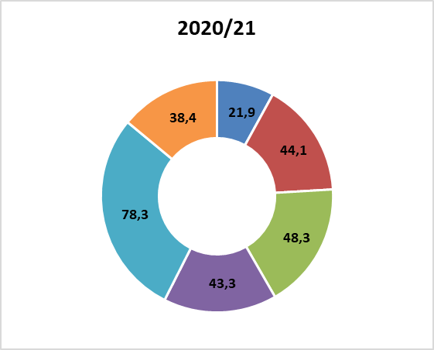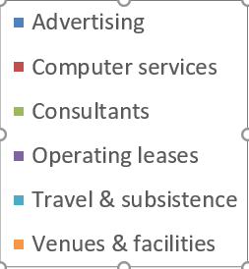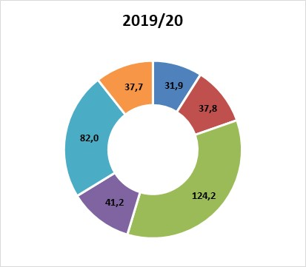**Figure 1: Selected goods and services (R’ million)**

Expenditure on goods and services decreases from R497.2 million in 2019/20, to R401.7 million in the current financial year. This represents a 22.6% decline in real terms from the previous year. The biggest shift is recorded for consultants: business and advisory services, which decreases from R124.2 million previously to R48.3 million in 2020/19. This is a real decrease of 62.75%.

Departmental travel and subsistence also declines from R82 million in 2019/20, to R78.3 million in the current financial year. Advertising also decreases in real terms with 34.2% from the previous year; down from R31.9 million previously to R21.9 million in the current year.

## Programme 1: Administrationprovides leadership, management and support services to the department and the sector.COE for the programme increases from R208.4 million to R221.9 million – staying above inflation. Furthermore, travel and subsistence (S&T) also increases from R24.3 million previously to R25.9 million in 2020/21- staying above inflation with 2.1%.

## Programme 2: Social Assistanceprovides for the payment of social assistance grants to beneficiaries who qualify for social assistance in terms of the Social Assistance Act (No. 13 of 2004).Expenditure under this programme is dominated by the Old Age and Child Support grants, which are allocated R83.1 billion and R69.8 billion, respectively. Both grant-types record above-inflation increases, i.e. 3.45% and 2.86% real growth, respectively. The strongest growth in expenditure is projected for the Grant-in-Aid (i.e. 26.34% real growth). Grant-in-Aid is an additional grant to recipients of the Old Age, Disability or War Veterans grants, who require regular care from another person due to their physical or mental status.

## Programme 3: Social Security Policy and Administrationprovides for social security policy development, administrative justice, administration of social grants and the reduction of incorrect benefits payments. The Social Grants Administration sub-programme provides for SASSA operational costs related to administering social grants, the management information systems and the reimbursement of payment contractors.

## 

## Programme 4: Welfare Services Policy Development and Implementation Supportcreates an enabling environment for the delivery of equitable developmental welfare services through the formulation of policies, norms and standards and best practices.Government has to ensure and make sure that it meets its obligations to observe, protect, realise and safeguard all children’s rights. Hence, the Department plans to promote, coordinate, facilitate and monitor the implementation of children’s constitutional rights through the Office on the Rights of the Child by March 2023.

Some of the developmental-social welfare issues identified in the 2020 State of the Nation Address are located in this programme. These include: Gender-Based Violence and Disability. However, the voted allocations to the Social Crime Prevention and Victim sub-programmes is below inflation, that is, it isdeclines by 56.23% in real terms.

## Programme 5: Social Policy and Integrated Service Deliveryprovides support to community development and promotes evidence based policy making in the department and the social development sector.The NDA, is located within this programme. Programme 5 is designated to the entity to support sustainable, community-driven programmes that serves poor and vulnerable communities.

*\*\*\*\*The detailed budget analysis per programme is included in the Portfolio Committee on Social Development budget vote report, dated 22 May 2020.*

**4.2 Allocation to provincial Departments**

The total equitable share to provincial social development Departments amounts to R24.1 billion for 2020/21, as compared to the allocation of R22.4 billion in 2019/20. This shows a nominal increase of R1.6 billion (or 7.5%), but when the inflation rate is considered this allocation shows a real increase of R670.1 million (or 2.99%).

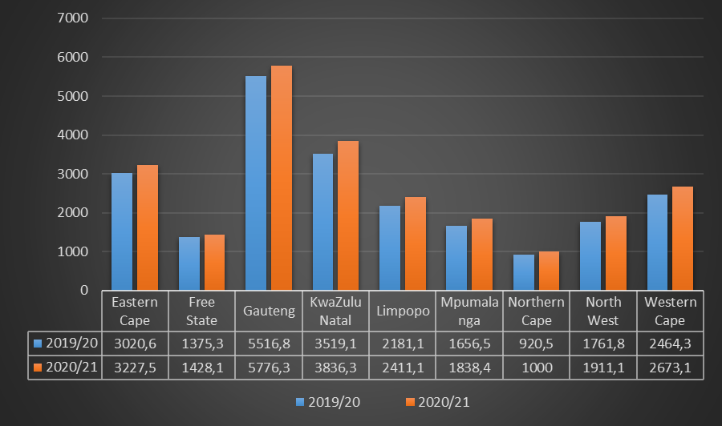*Figure 2: The proportion of the equitable share budget allocations for provincial social development departments for the 2020/21 financial year*

All the provincial social development Departments show increases in both nominal and real terms. Gauteng, Eastern Cape, KwaZulu-Natal and Western Cape receive the biggest share of the provincial social development budget allocation than other provinces. After inflation, the following real increases/decreases are recorded per province:

* Eastern Cape: 2.35%
* Free State: -0.54%
* Gauteng: 0.9%
* KwaZulu-Natal: 4.42%
* Limpopo: 5.89%
* Mpumalanga: 6.30%
* Northern Cape: 4.06%
* North West: 3.90%
* Western Cape: 3.90%

**4.3 Direct Grant Allocation**

In recognising that a good foundation of learning and capacity development forms part of a long-term solution to reducing inequality, ensuring universal access to ECD services for children younger than 5 remain a key priority for the Department of Social Development over the medium-term, as indicated earlier.

An estimated 70.4% (R3.2 billion) of spending in the Welfare Services Policy Development and Implementation Support programme over the medium-term is allocated to the ECD Grant, to provinces. This results in an increase in spending in the programme from R1.0 billion in 2019/20 to R1.5 billion in 2022/23 at an average annual rate of 14.2%[1].

**Table 2: Early Childhood Development Grant allocation over the MTEF**

|  |  |  |  |
| --- | --- | --- | --- |
| **Conditional grants** | **2020/21** | **2021/22** | **2022/23** |
|  | **R’ million** | | |
| ECD | R552.9 | R583.3 | R609.9 |

As can be seen from Table 2, the national Department of Social Development allocates an amount of R552.9 million for ECD Grant in the 2020/21 financial year. This shows a nominal increase of R37.4 million compared to the R518.2 million allocated in 2019/20 financial year. The ECD Grant is directed towards ECD subsidy expansion and ECD centre maintenance.

The increase in allocation of the ECD Grant over the MTEF will enable the Department to increase the subsidy rate per child from R15 in 2019/20 to R18.57 in 2022/23, and provide access to ECD services to an estimated 692 469 children by 2022/23.

It must be kept in mind that, in the midst of the Covid-19 pandemic, Government will have to reprioritise the allocation of resources. To this end, the budget of the Department of Social Development and that of provincial health departments may also be affected.

1. **COMMITTEE FINDINGS, OBSERVATIONS AND RECOMMENDATIONS**

Having considered the Strategic Plan, APP and the budget of the Department, this section summarizes the Committees’ findings, observations and recommendations.

**5.1 Findings and Observations**

* The Committees commended the Department for improvement in the language of reporting and accountability. The strides the Department has taken were also noted as they will strengthen governance and oversight in the sector.
* The Committees expressed concern that the Department failed to meet the deadline of 31 January 2020 to submit its APP to the AGSA for a review. Further, the Committees raised concerns over the repeat audit findings, with the key findings being lack of oversight by the department over its entities.
* The Committee reiterated its concern over the AGSA’s 2017/2018 finding that senior management failed to respond to the internal audit unit reports. It maintained that this unit is important as it provides early warning signs of weaknesses in the implementation of internal controls and non-compliance.
* The Committees were concerned that the Department’s APP and Five Year Strategic Plan were silent on GBVF issues. It strongly felt that the Department needs to prioritize this area.
* The Committees wanted to know the total number of trained Social Workers are, and if the Department will absorb the 1809 temporary Social Workers it will employ as a response to the Covid-19 pandemic. *The Department explained that there were 4 597 unemployed social worker graduates. The budget for the social work scholarship would be cut to finance the employment of Social Workers. The Department needs 7 1 00 Social Workers.*
* The Committees were concerned that anti-gangsterism and anti-substance abuse programmes or campaigns are not focused on family strengthening interventions and youth skills development.
* The Committees were concerned over the lack of clear communication on the application requirements and processes for the Social Relief of Distress Grant. It was also concerned that the WhatsApp number for application for this Grant was not working. It was stated that applications *via* the email were not responded to with regard acknowledgement of receipt.

**5.2 Recommendations**

Having considered the strategic plans and the annual performance plans of the Department and its entities the Committee makes the following recommendations:

* *Strengthening good governance and accountability:*The Minister should ensure that the Department submits its APP to the office of the AGSA for a review within the prescribed or agreed deadline. This is in spirit of upholding good governance and effective planning, improvement of accountability and transparency.
* *GBVF:*The Minister should ensure that the department in its annual plans set clear targets aimed at addressing issues of GBVF and violence and murder of children.
* *Internal controls:*The Minister should ensure that the Department’s senior management effectively use reports of the internal audit units. This will ensure that the Department responds timeously to any issues identified by these units. Any weaknesses to the internal controls and systems and non-compliance to legislation and policies can be addressed on time.
* *Gangsterism and Substance Abuse*: The Minister should ensure that the Department in its anti-gangsterism and anti-substance abuse campaigns have clear emphasis on family strengthening interventions and youth skills development.
* *Collaboration with civil society:*The Minister should ensure that the Department within this financial year develops clear guidelines that will direct its collaboration with CBOs, Faith-Based Organisations (FBOs) andnon-government organizations (NGOs) and corporate organizations in the distribution of food parcels or cooked meals. This will ensure better coordination and the strategy should be bottom up.
* *Monitoring and reporting*: The Department should strengthen its monitoring and reporting systems.
* Greater care should be taken in the spending theECD Grant. The Department should report more regularly to Parliament in order to ensure transparency and accountability.

1. **CONCLUSION**

Overall, the Committees noted a number of areas that require strengthening in the Department’s plans and response to the Covid-19 pandemic, but commended its hunger alleviation efforts.

Unless otherwise indicated, the Department should respond to the Committees’ recommendations in three months, from the day the report is adopted in the House.

**Report to be considered.**

1. National Treasury (2020).