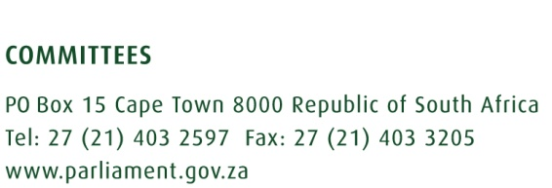

Draft Report of the Select Committee on Security and Justice on the Declaration of Amnesty in terms of section 139(2)(a) of the Firearms Control Act, 2000 (Act No. 60 of 2000), dated 11 June 2020.
The Select Committee on Security and Justice, having considered the Declaration of Amnesty in terms of section 139(2)(a) of the Firearms Control Act, 2000 (Act No. 60 of 2000) referred to the Select Committee on 5 June 2020, reports as follows:
Background:
The Minister for Police, on 28 August 2019, tabled a Notice for Parliament’s consideration of a Declaration of Amnesty in terms of section 139(2)(a) of the Firearms Control Act, 2000 (Act No. 60 of 2000) and the Council referred the matter to the Select Committee on 29 August 2019. The Select Committee recommended the Council approve the Amnesty for the period 1 December 2019 to 31 May 2020.
During the amnesty period the Government of the Republic of South Africa declared a National State of Disaster due to a Corona virus outbreak that was declared a pandemic by the World Health Organisation. The Regulations to the National State of Disaster Act, 2005 (Act No 53 of 2005), prohibited the movement of people to stem the outbreak of the pandemic. This had a negative impact on persons applying for amnesty.
The Minister for Police tabled a further Notice for Parliament’s consideration of a Declaration of Amnesty in terms of section 139(2)(a) of the Firearms Control Act, 2000 (Act No. 60 of 2000) that was referred to the Committee on 25 May 2020. This Notice indicated the period as 1 June 2020 – 30 November 2020.
The Select Committee met on 3 June 2020 and received a briefing from the Deputy Minister for Police and the South African Police Service (SAPS) on the amnesty. The Deputy Minister indicated a new Notice would be tabled with a revised period of 1 August 2020 - 31 January 2021.
The Notice with the revised date was referred to the Select Committee on 5 June 2020.

Committee decision
The Select Committee, after due consideration, approved the Minister’s request for an amnesty period and recommends the National Council of Provinces approve the amnesty period as tabled for 1 August 2020 to 31 January 2021.

Report to be considered.

