

PFMA audit outcomes of the 2014-15 financial year
Department of Sport and Recreation South Africa

13 October 2015

PC

CONTENTS
1. Introduction 3
2. Audit opinion history 5
3. Key focus areas 6
4. Drivers of internal control 11
5. Combined Assurance on Risk Management in the Public Sector 12
6. Minister commitments and progress on these commitments 13

7. Commitments from the former Standing Committee on Finance 14

- Introduction
1.1 Reputation promise of the Auditor-General of South Africa
The Auditor-General has a constitutional mandate and, as the Supreme Audit Institution (SAI) of South Africa, it exists to strengthen our country’s democracy by enabling oversight, accountability and governance in the public sector through auditing, thereby building public confidence.
1.2 Purpose of document
The purpose of this briefing document is for the Auditor-General of South Africa (AGSA) to provide an overview of the audit outcomes and other findings in respect of the Department of Sport and Recreation South Africa and its entities for the 2014/15 financial year to enable oversight of the portfolio committee.
1.3 Overview
Legislative mandate
To provide for the promotion and development of sport and recreation and the co-ordination of the relationships between the Department of Sport and Recreation South Africa and the Sport Confederation, National Federations and other agencies; to provide for measures aimed at correcting imbalances in sport and recreation; to provide for dispute resolution mechanisms in sport and recreation; to empower the Minister to make regulations; and to provide for matters connected therewith.
Vision
The vision of Sport and Recreation South Africa (SRSA) is ‘An active nation and winning nation’.
Mission and objectives
The mission of SRSA is to transform the delivery of sport and recreation by ensuring equitable access, development and excellence at all levels of participation and to harness the socio-economic contributions that can create a better life for all South Africans.
The following are the objectives of the department:
- Citizens access sport and recreation activities
- Sport and recreation sector adequately transformed
- Athletes achieve international success
- Enabling mechanisms to support sport and recreation
- Sport used as a tool to support SA government and global activities
- An efficient and effective organisations

Entities reporting to the Minister
- Boxing South Africa (BSA)
- South African Institute for Drug-Free Sport(SAIDS)
1.4 Organisational structure

Minister
Mr F Mbalula

Deputy Minister Mr Oosthuizen

Director General
Mr A Moemi

Corporate Services
Mr T Lejaka
Chief Director: School Mass Participation
Ms O Mjo
Chief Director: Client Support, Liaison, Events and Facilities
Mr C Singh
Chief Director: Strategic Management, Monitoring and Evaluation
Mr B van der Spuy

Chief Financial Officer:
Mr Lesedi Mere

Chief Operating officer
Ms Khan Sumaya

- Audit opinion history

Audit opinions |  | 14/15 |  | 13/14 | 12/13 | 11/12 | 10/11
- Department of Sport and Recreation
- South African Institute for Drug- Free Sport
- Boxing South Africa
Qualification areas |  | 14/15 |  | 13/14 | 12/13 | 11/12 | 10/11
- Revenue |  | ü
- Payables |  | ü |  |  |  | ü
- Receivables |  | ü |  |  |  | ü | ü
Predetermined objectives |  | 14/15 |  | 13/14 | 12/13 | 11/12 | 10/11
- Department of Sport and Recreation |  |  |  |  | ü | ü | ü
- Boxing SA |  | ü |  | ü | ü | ü | ü
- SAIDS |  |  |  |  | ü | ü | ü
Compliance with laws and regulations |  | 14/15 |  | 13/14 | 12/13 | 11/12 | 10/11
- Department of Sport and Recreation |  |  |  |  | ü | ü | ü
- Boxing SA |  | ü |  | ü | ü | ü | ü
- SAIDS |  | ü |  | ü | ü | ü | ü
AUDIT OPINION LEGEND
 | CLEAN AUDIT OPINION: No findings on PDO and Compliance
 | UNQUALIFIED with findings on PDO and Compliance
 | QUALIFIED AUDIT OPINION (with/without findings)
 | DISCLAIMER/ADVERSE AUDIT OPINION
 | ENTITY NOT YET ESTABLISHED
ü | DEPARTMENT/ENTITY HAD FINDINGS (in the related matter)

2.1 Significant emphasis of matters
Department/Entity | Emphasis of matter raised
Sport and Recreation South Africa(SRSA) | The corresponding figures for March 2014 have been restated as a result of errors discovered during 2014/15 financial year.
Boxing South Africa (BSA) | Boxing South Africa is a defendant in various lawsuits. The outcome of these lawsuits cannot be determined at the time of the audit report.  Irregular expenditure to the amount of R1 920 772(2013/14:R924 312) for non-compliance with SCM prescripts and Human Resource Policies.  Fruitless and wasteful expenditure amounting to R386 343(2013/14:R182 622) was incurred main due to payments to suspended officials.
SA Institute for Drug Free Sport(SAIDS) | There was no emphasis of matter raised in the Audit Report.

- Key focus areas

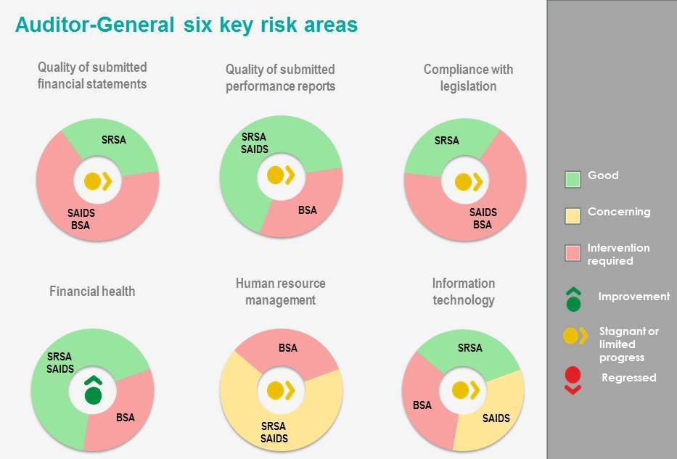

  - Material errors/omissions in submitted annual financial statements

Department/Entity | Finding | Root cause | Recommendation
SRSA | The departments financial statements did not contain any material misstatments
BSA | Material misstatements were identified in the areas of provisions, trade receivables, pre-paid expenditure, accruals, revenue, expenses, irregular expenditure, fruitless and wasteful expenditure, related parties and contingent liabilities. | The suspension of the CEO and CFO resulted in a lack of review on the financial statments | The CEO and CFO suspended cases should be resolved and the following posts must be filled with skilled officials
SAIDS | Material misstatements were identified in the areas of assets, employee costs and commitments | Lack of adequate review due to lack of skills | Officials should be trained on technical matters that change in the enviroment, a skills review of officials in the entity should be performed.

3.1.1 Comments on additional AGSA interactions to help improve financial outcomes
Department/Entity | Additional interaction/ add service (eg. Workshops etc) | Impact / outcome
SRSA | An interim audit was performed and findings submitted to management before the financial year end | Maintained the clean audit outcomes

  - Predetermined objectives
Department/Entity | Finding | Root cause | Recommendation
BSA | Auditors were unable to obtain the information and explanations considered necessary to satisfy themselves as to the reliability of the reported performance information on objective Marketing, Branding, Communication and Event Coordination. | Lack of understanding of the FMPPI  The suspension of the CEO lead to a lack of leadership in the entity, which impacted on accountability to ensure that supporting evidence is filled and submitted for audit | The CEO and CFO suspended cases must be resolved and the following posts must be filled

3.2.1 Comments on additional AGSA interactions to help improve AOPO outcomes
Department/Entity | Additional interaction/ add service (eg. Workshops etc) | Impact / outcome
SRSA | Reviewed the 2014/15 Annual performance plan before tabling and provided management with the findings before tabling | Maintained the clean audit outcomes

  - Compliance with legislation
Department/Entity | Finding | Root cause | Recommendation
SRSA | No findings
BSA | Procurement and Contract Management  Awarding contracts to suppliers who did not submit tax clearance certificates or who did not declare their interest in the client.  Procurement of goods and services with the value between 10 000 and 200 000.00 was made without obtaining at least three quotations  Contracts and quotations were awarded to bidders who did not submit a declaration on whether they are employed by the state or connected to any person employed by the state | Lack of review that all supply chain regulations are adhered to when contracting  Lack of consequence management of officials when transgression are identified due to lack of leasdership. | Consequence management should be implemented
BSA | Performance Information  Non-submission of the strategic plan covering the period 2012/13-2016/17 for approval by CEO and the Board. | There was no CEO to prepare the trategic plan for approval to the board | Stabilise leadership. Designate an official to develop the strategic plan for approval by the board and CEO.
BSA | Human Resources  No approved HR plan. | Lack of proper monitoring and review of compliance with laws and regulation | Management should ensure development and approval of the HR plan.
BSA | Audit committee  Internal audit did not evaluate the financial statements and performance information  Audit committee did not review the compliance with legal and regulatory requirements. | Due to the suspension of the CEO and CFO, reports were not available for review by Audit committee. | The Executive Authority should ensure that the audit committee discharge its duties and review the compliance with legal and regulatory requirements affecting the entity  Audit committee should ensure that the internal audit discharge its responsibilities as prescribed by PFMA.
BSA | Revenue  The entity did not take effective and appropriate steps to collect revenue. | Inadequate controls around revenue collection to ensure that revenue is collected timeously | The CFO should implement debt collection measures
SAIDS | Financial statements.  The financial statements submitted for auditing contained various misstatements corrected by management | Lack of adequate review of financial statements | Management should ensure that financial statements submiteed for audit purposes have been reviewed thouroghly.  Internal audit should assist management to review the AFS.
SAIDS | Procurement and Contract Management  Awarding contracts to suppliers who did not submit tax clearance certificates or who did not declare their interest in the client.  Contracts and quotations were awarded to bidders who did not submit a declaration on whether they are employed by the state or connected to any person employed by the state | Lack of review to ensure that all supply chain regulations are adhered to when contracting | A checklist should be developed, officials must ensure that before contracting they complete the checklist.  Consequence management must be implemented for transgressors

  - Human resource management and consequence management
There were no significant findings for the department and SAIDS. The following findings for BSA were raised on Human resourc management
Department/Entity | Finding | Root cause | Recommendation
BSA | No approved HR plan. | Absence of CEO and CFO to have the HR plan developed | Stability of leadership is required to ensure that necessary policies are in place

  - Information technology (control environment)
BSA does not have edequately designed formal controls over information technology systems to ensure the reliability of the systems and the availability, accuracy and protection of information.

- Other matters of interest
- Irregular expenditure: Expenditure incurred in contravention of key legislation
Department/ Entity |  | Irregular expenditure
 |  | Movement | Amount  R  2014/15 | Amount  R  2013/14 | Root cause | Recommendation
1 | SRSA |  | 0 | R165 000  (100% identified by the auditee) | N/A- None was identified in the current year
2 | BSA |  | R1 920 772  (89% identified by the auditors) | R 924 312  (38% identified by the auditors) | Lack of monitoring controls for compliance with procurement processes | Management monitoring compliance using procurement checklist;  Include compliance with SCM in individual performance contracts for SCM officials.  The officials who incurred/permitted the irregular expenditure should be held accountable.
3 | SAIDS |  | R995 000  (100% identified by the auditors) | R935 982  (100% identified by the auditors) | No unit responsible for procurement | SCM unit should be established within the office of CFO.  The officials who incurred/permitted the irregular expenditure should be held accountable.

- Fruitless and wasteful expenmditure: Expenditure that should not have been incurred (incurred in vain that could have been avoided and no value for money received)
Department/ Entity |  | Fruitless and wasteful expenditure
 |  | Movement | Amount  R  2014/15 | Amount  R  2013/14 | Root cause | Recommendation
1 | SRSA |  | R143 000  (100% identified by the auditee) | 0 | The payment of penalties was due to dispute of amount owed by SRSA | Implement adequate contract management to ensure that payments due are valid for services rendered
2 | BSA |  | R386 343  (97% identified by the auditors) | R 182 622  (100% identified by the auditee) | Management overriding of controls around fruitless and wasteful expenditure | Management to adhere to policies and procedures of the organisation

- Drivers of internal controls
Drivers of internal control
Department & Entities | Leadership |  |  |  |  |  | Financial & performance management |  |  |  |  | Governance
Department & Entities | Effective leadership culture | Oversight responsibility | HR management | Policies and procedures | Action plans | IT governance | Proper record keeping | Processing and reconciling controls | Reporting | Compliance | IT systems controls | Risk management | Internal audit | Audit committee
Department of Sport and Recreation South Africa
South Africa Institute for Drug Free Sport
Boxing SA

- Combined Assurance on Risk Management in the Public Sector

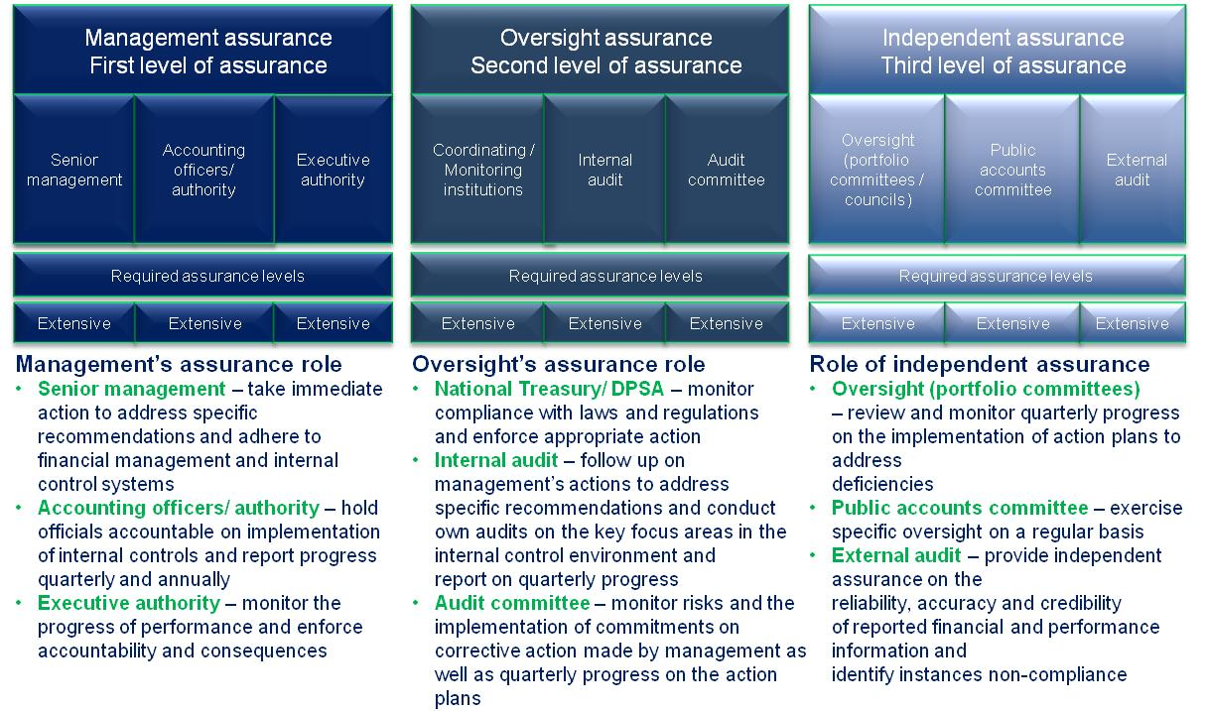
- Minister commitments and progress on these commitments

The following includes prior year commitments
Focus area | Commitment | Due date | Status
All focus areas | Obtain and review action plans to address internal and external audit findings | March 2014 | The minister is receiving action plans from the department, boxing SA did not have the action plans
STATUS LEGEND
Commitment has been implemented
Commitment in progress
Commitment has not been implemented
New commitment made in current year

- Commitments from the Portfolio committee / SCOPA
The following are proposed commitments for the portfolio committee to consider:

Department
- Follow- up on a quaterly basis on the progress and reporting on Performance information

Boxing SA
- Ensure that Boxing SA appoints a Chief Executive Officer
- Review the strategic plan for Boxing SA and ensure that it is aligned with the budget available.
- Obtain the action plan to address audit findings from Boxing SA

