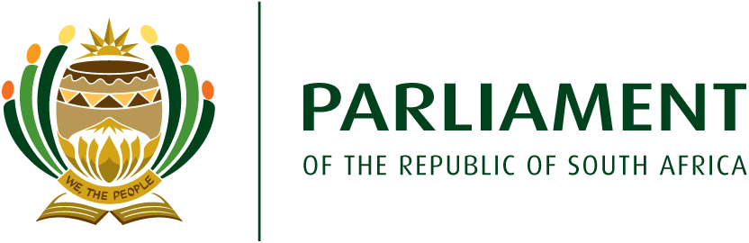
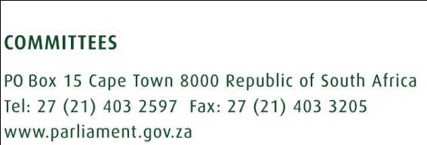
NOVEMBER 2019
- INTRODUCTION
This brief is about sharing the written inputs and proposals received from the members of the Multi- Party Women’s Caucus. The members of the MPWC were to provide comments in relation to focus areas (herein referred to, as suggested focus areas) which the Steering Committee has proposed for implementation by the sixth MPWC. The suggested focus areas are:
- Gender based Violence and femicide(GBVF)
- Strengthening of the national gender machinery
- Gender responsive planning and budgeting
- Sanitary dignity
- Women and health
- Women in politics
- Decriminalisation of sex work
- Building relations with stakeholders

- INPUTS FROM MEMBERS
Member Input | Comments | Overall analysis of member’s Input
2.1 Input number one
1.Focus to include plight of women in rural areas  2.Focus to include plight of women in farms (as workers and/or owners)  3.Vulnerabilities and support mechanisms to female learners in schools and tertiary institutions  4.Protection of the LGBTQIA+  5.Uniform implementation of gender sensitive and budgeting through the implementation of framework | - The suggested focus areas will also benefit the women in rural areas for example; the NA motion referred to the MPWC, is specifically speaking to implementation of education programmes reaching to women in rural areas.  - The input does not specify which plight of women in farms. The MPWC can focus on violence and health issues experienced by women in farms under the focus areas (gender-based violence and femicide and women and health)  - Safety of women and girls in schools is an activity under the GBVF focus area.  - The LGBTQIA+ comprise persons who are not women or identify as women e.g. gay men  - Gender responsive planning and budgeting is a suggested focus area and members will be empowered on the principles and framework of GRPB. | The Member’s inputs point towards support of the suggested focus areas.
2.2 Input Number two
1. The MPWC should focus on three areas, which are, Gender based Violence and femicide, Decriminalisation of sex work and sanitary dignity.  2. Capacity building programmes for women Members to include respect, equality, protocol, anti-sexism and harassment, how to support rape victims | - The proposed areas include some of suggested focus areas for implementation by the sixth MPWC.  - The suggested capacity building programmes can be taken in consideration under the focus area of women in politics as it is also about empowerment of current Members of the MPWC | The Member is of the view that focussing on three areas is likely to yield better results, but is in support of the suggested focus areas as her chosen three, form part of the suggested focus areas.
2.3 Input number three
1.Use of the term “adult sex worker” instead of just sex worker  2. Gender responsive budgeting (GRB and national gender machinery (NGM) should not be stand-alone focus areas but to form part of the GBVF focus area.  3.The Member has suggested that the sixth MPWC should focus on improving women’s access to productive work; reduce the burden of reproductive work; environmental issues, violence against women, Sexual and reproductive Health, women in politics, social cohesion and national building.  4. Suggested capacity-building priorities (basic economics, progressive campaigning, protocol, monitoring and evaluation, public speaking, self-defence classes).  5.The MPWC to engage with chapter nine institutions, academic institutions, hosting dialogues with different stakeholders  6.The MPWC to be involved in the 365 days of activism | 1. The MPWC can emphasise the use of the term “adult sex work” when dealing with decriminalisation of sex work.  2. GRB and NGM are critical components in the fight against gender based violence and femicide but are also relevant in all other areas of government planning, intervention and programming to ensure gender mainstreaming in all programmes and interventions.  - Planned activities under GRPB include empowering Members about its principles for Members to apply during oversight in ensuring gender responsiveness of budgets, programmes and interventions of Government Departments.  - Planned activities under NGM include assisting towards strengthening of NGM structures.  3. Some of the focus areas suggested by the Member (violence against women and women in politics) form part of the suggested focus areas.  - The sexual and reproductive health issue falls under the focus area of women and health.  - Under the sanitary dignity focus area there is plan to engage with the Department of Small Business Development in order to empower women owned businesses to manufacture and /or distribute sanitary dignity products. This can cater for the Member’s proposal for access to productive work.  4. Proposed capacity building courses can be taken into consideration under women in politics focus area.  5. One of the suggested focus area is building of relations with stakeholder so engagement with chapter nine institutions, academic and research institutions including hosting dialogues with different stakeholders will form part of activities.  6. The sixth MPWC will also as part of the GBVF implement a comprehensive education programme on abuse of women under religious, cultural and spiritual institutions. The education programme to be implemented is a prevention programme like the 365 days of activism. | The Member is proposing additional focus areas, but some of the proposals can be addressed under some of the suggested focus areas.
2.4 Input number four
1.Focus on three areas:  - women’s health, safety and security: will include focus on GBV, sanitary dignity and decriminalisation of sex work);  - Strengthening the gender machinery  - Economic empowerment of women  2. Refer decriminalisation of sex work to PC on SAPS and Justice and Correctional Services for further consideration.  3.Ensure priorities are aligned to NDP, ensure implementation of regional and African protocols  4.Focus on understanding the correlation between women, poverty and GBVF  5.Members to fight for Parliament that caters to the needs of young mothers  6.Members to lobby for measures to ensure women representation in politics  7.MPWC to be support structure for all women | 1. The Member is suggesting grouping together GBVF, sanitary dignity and decriminalisation of sex work as one broad area called women’s health, safety and security. The Member is also in support of the strengthening of the NGM and proposing economic empowerment of women as an additional focus area.  2. On the issue of referring the decriminalisation of sex work to Portfolio Committee on SAPS and PC on Justice and Correctional Services, the MPWC can instead regularly schedule joint meetings with these committees to work on areas that are specific and relevant to those Committees.  3. The relevant legislative framework taken into consideration when suggesting focus areas.  4. The proposal to focus on understanding the correlation between women, poverty and GBVF can be addressed by requesting relevant stakeholders like research institutions to empower Members on the correlation as an activity under GBVF.  5. The input is about lobbying for a gender sensitive Parliament that is family friend which falls under women in politics focus area.  6. Women in politics as a suggested focus area will focus on adopting measures to ensure increase in number of women represented in politics.  7. The focus area, women in politics is also about supporting women Members and the MPWC is a support structure for all women Members across party political lines. | Although proposing grouping of some of the focus areas to form one broad priority area but areas of focus within the broader areas are the same as suggested focus areas.
2.5 Input number 5
1.Gender responsive planning and budgeting and National Gender Machinery to be under GBVF  2. Annual review of focus areas to ensure relevance, consistency and accountability. | 1. Already addressed above under input number three (2.3 above).  2. Annual reviews can be done at the beginning of each financial year to track progress and/or relevance | Member in support of suggested focus areas.
2.6 Input number six
1.Gender based violence should also focus on boy child through socialisation  2. To focus on equal pay and on unpaid care work  3. Focus on plight of domestic workers and farm workers  4. Input related to gender responsive planning and budgeting | 1. The MPWC can also engage with organisations working with men and boys as part of activity under GBVF.  2. A decision to be taken on additional focus area of equal pay and unpaid care work  3. The input by Member does not specify programmes for domestic workers and farm workers, but the MPWC can ensure that GBVF initiatives include vulnerabilities experienced by women in farms and also build relations with stakeholders working with these vulnerable women. | The input by Members seems in support of the suggested focus areas.
2.7 Input number seven
1.Support all focus areas except decriminalisation of sex work  2. Annual monitoring and evaluation to ensure  3. Focus to include women in economy | 1. Member input support all other suggested focus areas except decriminalisation of sex work  2. Annual evaluation can be part of annual planning at the beginning of each financial year.  3. Proposing an additional focus area to include women in economy | In support of suggested focus areas except decriminalisation of sex work
2.8 Input number 8
1.Members to be trained on financial management, project management and policy making, gender equity, self-defence classes and health and wellness  2. Women and education aimed at encouraging women MP to further their education while in Parliament  3.Support all focus areas except decriminalisation of sex work | - The suggested capacity-building areas fall under focus area women in politics.  - Encouragement of current women Members to further their education can be addressed under the focus area on women in politics as it is also about assisting and empowering current women Members | Member’s input points towards support of suggested focus areas except decriminalisation of sex work
2.9 Input number 9
1.The Members is in support of all the eight suggested focus areas but also proposing annual review to determine relevance  2.Proposing training on how to interact with stakeholders | Input supporting all the suggested focus areas, and the proposed training area can be looked at under women in politics . | Support all the suggested focus areas.
2.10 Input number 10
1. Integrated programmes that have a common approach in implementation of policies in all three spheres of government  2. Interactions with departments or committees on seeking solutions on reoccurring or burning issues in the country and abroad and that are in the public eye for example; the Basic education matter of the Comprehensive Sexuality Education that has been misinterpreted in the society and media and others. | Proposing integration, working together and collaboration between various spheres of government as well as different committees and Departments. | Member seems in support of the suggested focus areas and proposing integration across the different spheres of government.
- Conclusion
The majority of inputs from Members are in support of all the focus areas as suggested by the Steering Committee. Only three inputs voiced an objection with regards to decriminalisation of sex work as a focus area, two of those suggesting that decriminalisation should not be a focus area at all, while the third input proposing referring it to Portfolio committees on SAPS and Justice and Correctional Services for further consideration.
A number of inputs propose conducting annual reviews of the focus areas to ensure relevance and/or track progress.
  - Additional focus areas proposed
The written inputs from Members also include proposals for additional focus areas for implementation by the MPWC as follows:
- Focus to include persons from the LGBTQIA+
- Focus on programmes aimed at reducing the burden of reproductive work;
- Focus on environmental issues
- Focus on social cohesion and national building
- Focus on economic empowerment of women
- Focus on fighting for equal pay and recognition of unpaid care work
- Focus on plight of domestic workers and farm workers

  - Fewer focus areas
There is an input that proposes focussing on three areas, which are gender based violence and femicide, decriminalisation of sex and sanitary dignity.

