Ref Number: 11/4/1/2/3

(Final Mandate Stage) Report of the Budget Committee on the Division of Revenue Amendment
Bill [B 15-2019] (S76) (NCOP), dated 26 November 2019.

The Budget Committee having considered the subject of the Division of Revenue Amendment
Bill [B 15-2019] (S76) (NCOP), referred to the Committee in terms of Standing Rule 217, recommends that the House confers on the Western Cape’s delegation in the National Council of Provinces the authority to not support the Bill.

Minority View

In terms of Standing Rule 90, the African National Congress expressed its minority view to support the Bill.
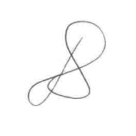

________________
ADV D BAARTMAN, MPP
CHAIRPERSON: BUDGET COMMITTEE
DATE: 26 November 2019

