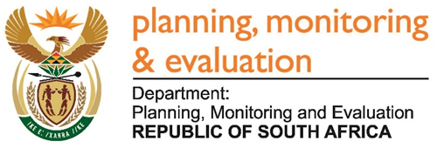 

______________________________________________________________________________

**BRIEFING FOR THE SELECT COMMITTEE ON COMMUNICATION AND PUBLIC ENTERPRISES**

1. **INTRODUCTION**

This briefing seeks to provide the Select Committee on Communication and Public Enterprises with a brief overview of the National Department of Communications (DOC) for 2016 to 2018 period. The information contained herein is based on a synoptic analysis and synthesis conducted by DPME using its monitoring and evaluation systems, including tools such as the Management Performance Assessment Tool (MPAT) as well as other information sources such as National Treasury’s Estimates of National Expenditure (ENES). Secondary analysis was done using sources such as the report of the Auditor General and annual performance information from the annual performance plan.

The department was disestablished after the 2019 general elections. The Department: Communications (DOC) was merged into the Department of Communications and Digital Technologies (DCDT) in June 2019. Information displayed here is historical information as it existed before the merger.

1. **MANDATE**

**2.1 Constitutional mandate**

Create an enabling environment for the provision of inclusive communication services to all South Africans in a manner that promotes socio-economic development and investment through broadcasting, new media, print media and other new technologies, and brand the country locally, regionally and internationally.

**2.2 Legislative Mandate:**

The DoC’s mandates are derived from the President’s proclamation when establishing the department, to:

* Develop an overarching communications and broadcasting policy and strategy.
* Provide information dissemination and publicity to promote an informed citizenry.
* Brand South Africa abroad to assist the country promote investments, economic growth and job creation.

**2.3 Furthermore, the legislative framework for the work of the DoC is contained primarily in the following legislation:**

* Broadcasting Act, 1999 (Act 4 of 1999)
* Electronic Communications Act (ECA), 2005 (Act 36 of 2005)
* Independent Communications Authority of South Africa (ICASA) Act, 2000 (Act 13 of 2000)
* Films and Publications Act, 1996 (Act 65 of 1996)
* Media Development and Diversity Agency Act, 2002 (Act 14 of 2002).

**2.4** **The department is also guided, among other things, by:**

* the Constitution of the Republic of South Africa of 1996
* the Public Service Act (PSA), 1994 (Act 103 of 1994), as amended
* the Public Finance Management Act (PFMA) of 1999, as amended
* the International Telecommunications Union (ITU)
* the World Intellectual Property Organisation (WIPO)

1. **ENTITIES REPORTING TO THE DEPARTMENT/MINISTER**

|  |  |  |  |
| --- | --- | --- | --- |
| **Name of the entity** | **Legislative mandate** | **Financial relation-ship** | **Nature of operations** |
| **Media Development & Diversity Agency (MDDA)** | The MDDA was set up in terms of the MDDA Act of 2002 to enable historically disadvantaged communities and individuals to gain access to the media. The mandate of the agency is to create an enabling environment for media development and diversity which reflects the needs and aspirations of all South Africans; redress the exclusion and marginalisation of disadvantaged communities and people from access to the media and the media industry; and promote media development and diversity by providing support primarily to community and small commercial media projects. The overall objective of the agency is to ensure that all citizens can access information in a language of their choice, and to transform media access, ownership and control patterns in South Africa. | **Transfer payment** | * Provision of technical, non-financial and financial support to diverse media platforms. * Provision of support to the increased participation of communities in ownership and control of community and small commercial media. * Provision of community media grants. * Promotion of ownership, control and access to information and content production by communities. * Enhancement of ownership, participation and control of print and digital media by independent media entrepreneurs. * Creation and enhancement of a body of knowledge of the media landscape. * Building of capacity for a diverse media industry. |
| **South African Broadcasting Corporation (SABC)** | The SABC is listed as a Schedule 2 public entity in terms of the PFMA of 1999. Its mandate is set out in its charter and in the Broadcasting Act of 1999, as amended, and requires it to provide radio and television broadcasting services to South Africa. | **Transfer payment** | * Radio broadcasting. * Television broadcasting. * Implementation of digital terrestrial migration and technology. * Programming and development of local content. * Expansion of commercial radio stations to increase the organisation’s audience share. * Digitisation of value chain and distribution platforms. |
| **Name of the entity** | **Legislative mandate** | **Financial relation-ship** | **Nature of operations** |
| **Independent Communications Authority of South Africa (ICASA)** | ICASA was established by the ICASA Act of 2000, as amended, to regulate the South African communications, broadcasting and postal services sectors. The regulator’s mandate is defined in the ECA of 2005 as licensing and regulating electronic communications and broadcasting services, and in the Postal Services Act, 1998 (Act 124 of 1998) as regulating the postal services sector. Enabling legislation also empowers the regulator to monitor licensee compliance with licence terms and conditions, develop regulations for the three sectors, plan and manage the radio frequency spectrum and protect consumers in relation to these services. | **Transfer payment** | * Conducting of advocacy and awareness campaigns. * Monitoring of spectrum interference. * Implementation of DTT projects. * Monitoring of the activities of postal and broadcasting licensees. * Implementation of customer relationship management. * Use of spectrum management tools to ensure the optimal use of the high-demand radio frequency spectrum by licence holders. |
| **Brand South Africa (BSA)** | Brand South Africa was established as a trust in 2002 and gazetted as a Schedule 3A public entity in 2006, in accordance with the PFMA of 1999. Its purpose is to develop and implement a proactive and coordinated international marketing and communications strategy for South Africa, to contribute to job creation and poverty reduction and to attract inward investment, trade and tourism. | **Transfer payment** | * Brand strategy development and management. * Rendering of assistance to government and private sector entities in aligning their communications strategies with national messaging. * Improvement of brand-ranking index. * Hosting of South African Competitiveness Forum. * Roll-out of *Play Your Part* television series. |
| **Film and Publication Board (FPB)** | The FPB regulates and controls the creation, production, possession, exhibition and distribution of films, interactive computer games and certain publications in terms of the Films and Publications Act of 1996. The board is also responsible for monitoring age-restricted business premises for compliance with their licence and registration terms. | **Transfer payment** | * Protection of children against premature exposure to adult experiences and harmful materials; particularly films, games and publications. * Conducting of awareness programmes that inform and educate the public about films, videos and games that are harmful to children. * Conducting of research on human trafficking. * Monitoring compliance with the Films and Publications Act of 1996. * Development and implementation of a content regulation framework that ensures 100% classification and labelling of classifiable content distributed on online, mobile and related platforms. * Implementation of programmes aimed at cyber-safety and child online protection. |

*Source AR 2018/19*

The following table displays key financial and human resource management information of the five entities for the 2017/18 and 2018/19 financial year. Its noted and commended that all entities achieved clean audits except for the SABC and Brand SA. The areas of Unauthorised, Irregular and Fruitless and Wasteful Expenditure as indicated per entity needs management intervention to eliminate these where they occurred. The entities managed with relatively high vacancy rates and the recruitment processes must be properly managed to lower these to within acceptable rates.



*Source: AR 2018/19 of Entities*

1. **MPAT ANNUAL ASSSESSMENTS ANALYSIS**

**4.1 Strategic Management**



The Strategic Management Key Performance Areas (KPA) seeks to assess the extent to which the annual performance drives the strategic plan agenda at it aligns to the government outcomes. It further assesses if the department has sound systems and processes in place to effectively monitor performance and conduct evaluations to inform future improvements.

The departments’ performance for Strategic Management KPA has been inconsistent for the three previous assessment cycles with 2018 results showing a decline for three of the standards. This is a concern since the department has been regressing to below compliance level for at least two standards from the 2017 assessment and on average now performs at below compliance level for the KPA. The department appears to be struggling in monitoring and evaluation areas. It is critical for the department to strengthen the area of monitoring and evaluation both for projects and programme. This will help promote the use of performance information for evidence based decision making in the department. There is also a clear need to institutionalise systems and processes in the department to ensure consistent improvements.

**4.2 Governance and Accountability**



Governance and Accountability KPA assesses whether a department has systems and policies in place to promote professional ethics, discourage unethical behaviour and combat corruption, including management of risk.

Performance for the KPA had remained below compliance level for all of the standards assessed in 2018*.* It is of concern that standards relating to ethics management have also regressed further from the previous assessment. The main reason for the regression can be attributed to the department failing to provide the correct evidence for all of the KPA 2 standards assessed. There is clearly a need for the department to prioritise development of policies and strategies to promote ethical behaviour and combat corruption and ensure that these are implemented and monitored.

**4.3 Human Resource Management**



The Human Resource Management KPA assess the extent to which the department is able to effectively manage and develop its human resources in terms of HR planning, recruitment and retention, performance management and the management of employee relations.

This KPA achieved an average score of 1.8 in the MPAT 1.8 assessment and regressed further from the average score of 2.4 which was achieved in the previous MPAT 1.7 assessment. In the MPAT 1.8 assessment most of the standards regressed further from the previous assessment in this KPA. The areas of concern raised in the Human Resource environment for the MPAT 1.8 assessment was that not all employees inclusive of SMS members signed and submitted their Performance Agreements by the required due dates and the department also did not afford evidence relating to any action taken for this non-compliance action. Secondary data also reflected that the department on average takes more than the required 90 days to complete disciplinary cases which resulted in them scoring a non-compliant score in this standard. Apart from this the department also did not provide any evidence for this standard to redress the allocated score.

Reflecting on the key Human Resource Indicators tracked by DPSA, the department registered an overall vacancy rate of 11.9% as at the end of the 2018/19 financial year. This is above the targeted public service vacancy requirement of 10%. It must be noted that the SMS vacancy rate is reported at 10.9% for the same period. The department’s percentage women in management registered at 46%, just below the 50% target and it employed 15.4% youth in management positions. Employment of persons with disabilities was at 0%.

**4.4 Financial Management**



Financial Management KPA assesses the extent to which a department has processes in place for effective and efficient managing of acquisition, logistics, disposal and cash flow. The assessment further reflects on the departments’ ability to prevent and detect unauthorised, irregular, fruitless and wasteful expenditure.

The Financial Management KPA has remained the overall best performing of the four KPAs for three consecutive years. The department is however struggling with paying suppliers on time as per Treasury Regulation 8.2.3 hence performance at partial compliance since 2017 (level 2) for the Payment of Suppliers standard. The department is therefore advised to ensure that this area is strengthened through sound invoice tracking systems.

**4.5 Audit Opinion**

The department obtained an **unqualified audit opinion with findings** from the Auditor General (AGSA) for the past 2018/19 financial year and **unqualified audit opinion without findings** for the 2016 and 2017 financial years. The finding for the 2018/19 financial year relates to insufficient audit evidence to support achievement of targets. The AG was unable to confirm the reported achievement of the indicator by alternative means

**4.6 Payment of Suppliers**

As at end of March 2019 the department reported an amount of R 101 378,00 on unpaid invoices. This was a decrease from a reported R 229 124 at the end of 2018 financial year. The number of invoices in comparison to the value also declined significantly from 37 at the end of the 2018 year to 01 at the end of 2019. The challenge with the non- payment of suppliers within prescribed time was also identified during MPAT assessments and associated non–compliance scores were awarded accordingly.

**4.7 Unauthorised, Irregular, Fruitless and Wasteful Expenditure**

The department managed to not register any Unauthorised, Irregular, Fruitless and Wasteful Expenditure during the 2018/19 and previous financial years

1. **2018/19 ANNUAL PERFORMANCE INFORMATION ANALYSIS PER PROGRAMME (NOT AUDITED)**

The department had 22 targets planned; 16 were achieved and six were not achieved. Programme 1 achieved eight targets, Programme 2 achieved one, Programme 3 achieved five of its targets and Programme 4 achieved two of its planned targets.

|  |  |  |  |  |
| --- | --- | --- | --- | --- |
| **Programmes** | **Planned** | **Achieved** | **Not achieved** | **% Achieved** |
| 1. Administration | 10 | 8 | 2 | 80% |
| 1. Communications Policy, Research and Development | 4 | 1 | 3 | 25% |
| 1. Industry and Capacity Development | 5 | 5 | 0 | 100% |
| 1. Entity Oversight | 3 | 2 | 1 | 67% |
| TOTAL | **22** | **16** | **6** | **73%** |

*Source: Annual Report 2018/19*

**5.1 Programme 1: Administration**

In the 2016/17 financial year, the department achieved 4 out of the 5 compliance-related targets, with the exception of the 30-day payment of suppliers which registered a deviation of -1.31% from the planned target of 100%. In 2017/18, the department achieved all the compliance-related targets. It is worth noting, however, that the 30-day payment of supplier’s target was not included as a predetermined objective for this financial year. In the 2018/19 financial year the majority of the targets which mainly involved improvement of business processes and systems were achieved but those not achieved were due to a Cabinet reshuffle and the financial reviews that were not conducted as planned.

**5.2 Programme 2: Communications Policy, Research and Development**

In the 2016/17 financial year, the department achieved only 1 of the 4 planned targets. It has been observed that the targets which were not achieved were dependent on the approval of Cabinet and / or Parliament, and in some cases, the approval of supporting policies and legislation, which was not within the direct control of the department. In the 2017/18 financial year, the department achieved both targets under Programme 2, as these focused more on the compilation of reports than the approval of legislation. During the 2018/19 financial year the planned legislative documents that were to be developed were not concluded due to the reconfiguration of the department as well as poor stakeholder involvement hence the department did not achieve all its targets in this programme.

**5.3 Programme 3: Industry and Capacity Development**

Programme 3 registered achievements in all planned targets for the financial years between 2016/17 and 2018/19, the main aim of which was to facilitate the digital broadcasting migration process through awareness raising, monitoring and stakeholder engagements.

**5.4 Programme 4: Entity Oversight**

In the 2016/17 financial year, the department achieved 2 out of the 3 planned targets under Programme 4. The target pertaining to the approval of entity oversight reports was only partially achieved, with the analysis reports and feedback letters to entities being compiled but not approved by the Executive Authority for further processing. The 2017/18 financial year saw a more concerted focus on entity oversight, with all 4 planned targets being achieved without deviations. During the 2018/19 financial year, the department failed to meet the planned target of conducting 20 QPR sessions of SOE’s for the year due to the change of the Accounting Officer, which impacted on the approval of the plans to conduct sessions with SOC on QPR.

1. **6. FOCUS AREAS**

This section highlights the relevant available information as informed by the various outcome areas in addressing the request received from the Select Committee.

* 1. **Outcome 4, 6 &14**

**Background**

Outcome 14 of the 2014-2019 Medium-Term Strategic Framework (MTSF) identifies nation building and social cohesion as important underpinnings of government’s socio-economic transformation to address poverty, unemployment and inequality in South Africa. This imperative is closely aligned with the work of the DoC, and over the reporting period the department continued to focus on overseeing the implementation of Outcome 14, and its sub-outcomes of Fostering Constitutional Values, Equal Opportunities, and Inclusion and Redress, amongst others.

However, to achieve these sub-outcomes, there has to be greater integration and coordination between the various Outcomes in the MTSF. The National Development Plan (NDP) recognises that the ongoing development of quality communications infrastructure, services, content and applications are key to the rapid economic, social and cultural development of the country. Accordingly, the 2014-2019 MTSF Outcome 4 (Decent employment through inclusive economic growth) and Outcome 6 (An efficient, competitive and responsive economic infrastructure network) have a meaningful role to play in harnessing the activities of the DoC to both Outcomes in order to contribute to economic growth, employment and infrastructure development.

It is in this context that this narrative provides a summary report of DoC’s contribution to both these Outcomes. The mandates of the DoC and the Department of Telecommunications and Postal Services (DTPS) have always been seen to be complementary, which may also explain the merger of the two as announced by the President in late 2018. Hence the summary report also refers to related performance information of the DTPS.

**Highlights and Challenges**

DoC’s mandate is to develop appropriate policies that will help to improve government communication and drive the communications sector to ensure universal access to all citizens. The DoC achieved 76% of its targets in 2016/17, 83% in 2017/18 and 73% for 2018/19. The unachieved targets were largely experienced in core functions of the department’s work on policy development and the roll-out and successful completion of the Broadcasting Digital Migration (BDM) Programme, limited human capacity and delays experienced during the implementation of the project, and impact on industry are cited as some of the challenges faced. Eighteen analogue transmitters were switched off in the core towns of the Square Kilometre Array (SKA) in the Northern Cape in 2016/17 and none in 2017/18.

The revised BDM delivery model and implementation plan approved by Cabinet in October 2018 provides opportunities to:

• Create certainty for both manufacturers and retailers.

• Ensure effective collaboration with all stakeholders.

• Heightened education, awareness and communication as key elements to inform the public about the end-to-end migration process.

The process of developing the White Paper on Audio-Visual and Digital Content Policy was finalised in 2018/19 and submitted to the Cabinet committee. The White paper was subsequently withdrawn to ensure alignment with the reconfigured department. The policy is meant to provide enabling mechanisms to facilitate ownership of the new audio-visual digital content value chain by previously disadvantaged communities and small, medium and micro enterprises (SMMEs), thus contributing to employment creation.

Access to internet is crucial and remains a precondition for participation in the digital economy. This is more pronounced in the age of Fourth Industrial Revolution(4IR). According to ICASA’s report on the 2018 State of ICT sector in South Africa, mobile broadband coverage for 3G stood at 99% of the population, and coverage for 4G/LTE at 77%. However, the cost of data in South Africa still remains very high, ranked 31st most expensive in Africa for 1G according to the recent Competition Commission’s market enquiry findings. Disturbingly, ICASA analysis shows that Vodacom and MTN prices in South Africa are considerably higher than the prices they charge in other countries in which they operate.

It seems to be common cause that the failure to release high demand spectrum due to delays in digital migration has left mobile operators with both insufficient spectrum and a lack of access to favourable low frequency bands, raising costs unnecessarily. Sector grew from R190 billion in 2016 to R229 billion in revenue in 2018. Telecommunications high growth, broadcasting and postal services stagnant (ICASA 2019). Employment in the three sectors increased from 50,899 in 2016 to 61,757 in 2018.

DTPS successfully hosted the BRICS Communication Ministers Meeting in 2018, which was largely focused on 4IR, resulting in the endorsement of partnerships in the electronics manufacturing industry. Furthermore, South Africa was also elected into the International Telecommunication Union (ITU) Council, thus confirming the country as an influential player in this global space.

**Current MTSF Priorities**

President Ramaphosa stated that the merger between DOC and DTPS “is going to ensure that we have better alignment and coordination on matters that are critical to the future of our economy in the context of the 4IR.” The Presidential Digital Industrial Revolution Commission has been established and work has already commenced. Policy on high-demand spectrum was published, 5G spectrum to follow in 2020.

An updated White Paper on Audio-Visual and Digital Content Policy for South Africa, which will form a cornerstone of the review of the department’s policies to enable the 4IR and the digital economy is being undertaken.

The current focus of the Broadcasting Digital Migration Programme is to migrate all citizens who are still relying on analogue television services to the digital broadcast platforms. The slow pace of digital migration has prompted the department to revise the delivery model to create demand to entice consumers to migrate. This includes cheaper decoding devices and more compelling content.

There is an urgent need to invest in Small, Medium and Micro Enterprises (SMMEs) as they are key drivers of economic growth and job creation. In response, the Department prioritised the implementation of the ICT SMME Development Strategy that seeks to accelerate the development, growth, and sustainability of SMME’s in the ICT sector with the objective of job creation and economic inclusion. The objective is also to improve SA’s WEF ranking on ICT adoption from 89th out of 141 countries in 2019 to top 50 countries in 2024.

* 1. **OUTCOME 5**

Unfortunately, DOC do not fall under the ambit of outcome 5. The overall performance of outcome 5 is available but not specifically that of the Department of Communication. In outcome 5 we have Departments of Basic Education, Agriculture, Correctional Services, and Employment and Labour. The following information table on Outcome was submitted:

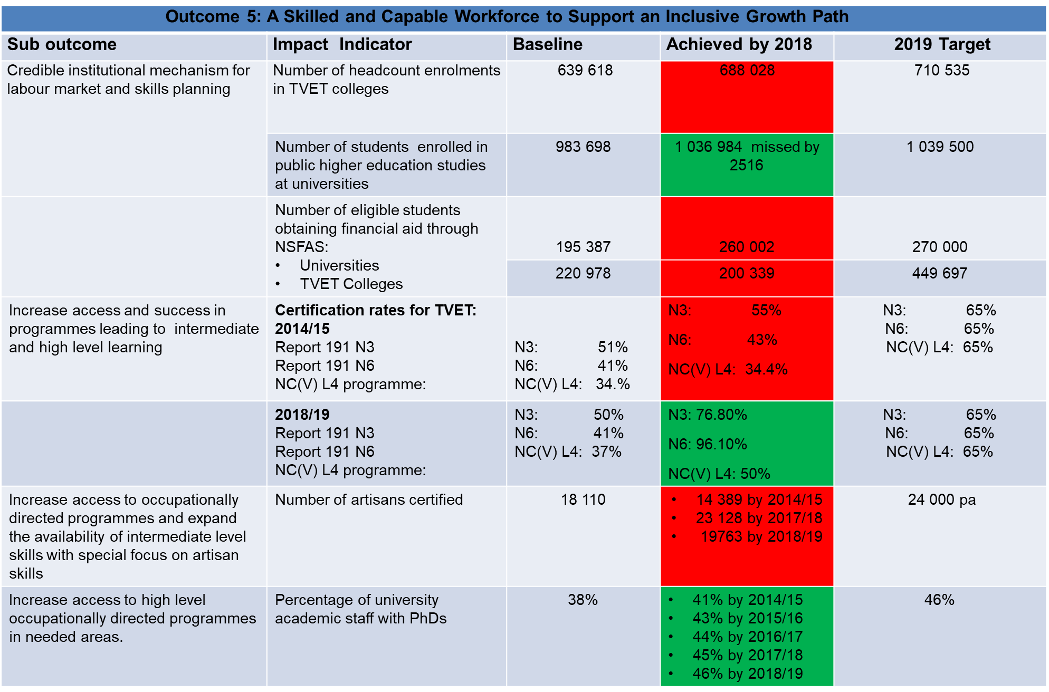

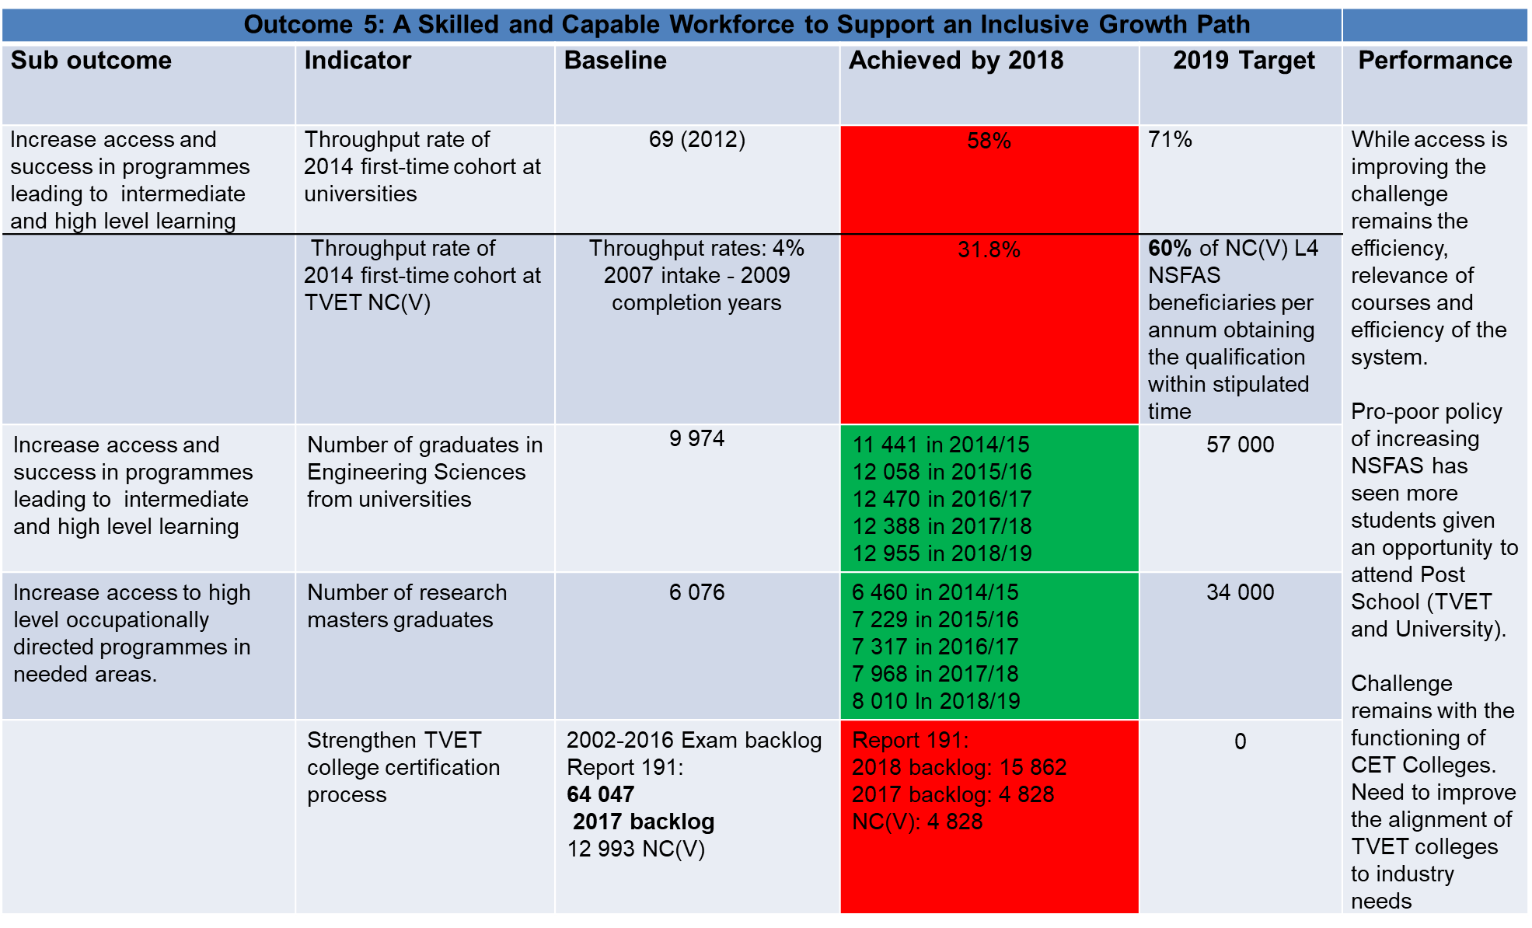

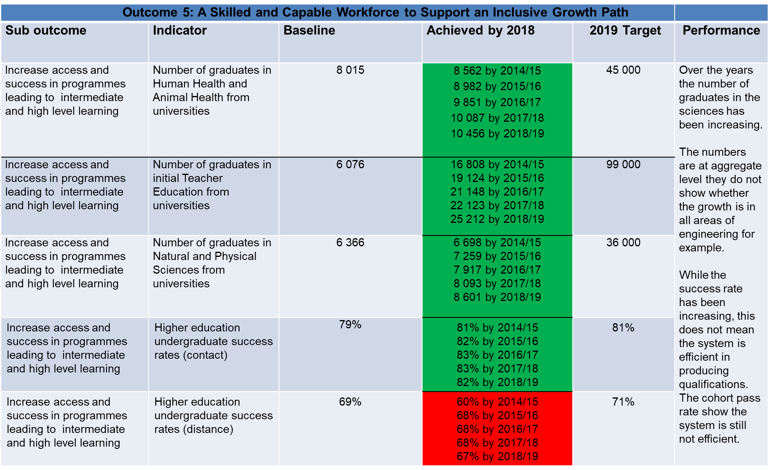

* 1. **OUTCOME 12**

The performance of the DOC over the 2016 to 2018 period in the realisation of the objectives of Outcome 12 is indicated and covered in the information around MPAT environment as outlined earlier in this brief.

1. **CONCLUSION**

The department should, as a good foundation, strive to maintain compliance to various prescribed legislations not only for financial management. Recent MPAT results have shown a decline in MPAT average scores across the various areas, which is a concern. It is however commendable that the departments’ audit opinion has been positive in the past two years. The department must also ensure that areas of slow progress on its institutional performance are timely addressed to ensure the achievement of targets at the end of the financial year. This is even more critical when one considers the outcomes of the Monitoring standard for the MPAT 2018 assessment. There is inadequate evidence that there are sound systems in place to facilitate effective organisational performance.

The DoC must develop appropriate policies that will help to improve government communication and drive the communications sector to ensure universal access to all citizens.

The department must strengthen its oversight role over its reporting entities and assist in the implementation of corrective measures to address the negative performance indicated in certain areas within each reporting entity.

1. **ANNEXURES**

For further detailed information in support of the narratives, the following annexures are included:

• Management Performance Assessment Tool (MPAT) score-card

• Trend analysis of Audit outcomes

• Trend analysis Unwanted expenditure

* FM&S Report
* Budget allocation: 2019
* Financial indicators: 2018 (budget summary and expenditure by economic classification)

**MANAGEMENT PERFORMANCE ASSESSMENT TOOL (MPAT) SCORE-CARD**



**AUDIT OUTCOMES 2017/18**

**Department of Communications Audit Outcomes and unlawful expenditures**



**Legend:**

|  |  |  |  |  |  |  |
| --- | --- | --- | --- | --- | --- | --- |
| **Unqualified with no findings** | **Unqualified with findings** | **Qualified with findings** | **Adverse with findings** | **Disclaimed with findings** | **Audit not finalised at legislated date** | **New auditee** |

|  |  |  |  |  |
| --- | --- | --- | --- | --- |
| **All Financial Values: R'000** | **2018/19** | **2017/18** | **2016/17** | **2015/16** |
| **AUDIT OUTCOME** | Clean Audit | Clean Audit | Clean Audit | Clean Audit |
|  | | | | |
| **APPROPRIATION STATEMENT** | | | | |
| Total Final Appropriation | 1 518 384 | 1 430 525 | 1 352 299 | 1 294 374 |
| Actual Expenditure | 1 488 121 | 1 418 954 | 1 335 742 | 1 288 042 |
| Employee Compensation | 73 643 | 64 484 | 65 482 | 47 592 |
| Goods and Services | 32 051 | 29 453 | 34 362 | 28 687 |
| Capital Assets | 638 | 2 088 | 3 784 | 1 558 |
|  | | | | |
| **UIFW EXPENDITURE** | | | | |
| Unauthorised Expenditure | - | - | - | - |
| Irregular Expenditure | 9 | - | - | - |
| Fruitless & Wasteful Expenditure | 2 | 17 | - | - |
|  | | | | |
| **HUMAN RESOURCES** | | | | |
| Posts Approved | 80 | 100 | 90 | 87 |
| Posts Filled | 70 | 73 | 76 | 65 |

**Budget summary: 2018/19**

|  |  |  |  |  |  |  |
| --- | --- | --- | --- | --- | --- | --- |
| R million | **2018/19** | | | | **2019/20** | **2020/21** |
| **Total** | **Current  payments** | **Transfers and  subsidies** | **Payments for  capital assets** | **Total** | **Total** |
| 1. Administration | 64,6 | 64,6 | – | – | 70,8 | 74,2 |
| 1. Communications Policy, Research and Development | 11,5 | 11,5 | – | – | 13,5 | 15,4 |
| 1. Industry and Capacity Development | 53,3 | 53,3 | – | 0,0 | 53,0 | 55,5 |
| 1. Entity Oversight | 1 383,7 | 6,1 | 1 377,5 | – | 1 451,8 | 1 538,5 |
| **Grand Total** | **1 513,1** | **135,6** | **1 377,5** | **0,0** | **1 589,1** | **1 683,6** |

**Financial indicators (Budget summary and expenditures): 2018/19**

|  |  |  |  |  |
| --- | --- | --- | --- | --- |
| **Expenditure by program** | | |  |  |
| R million | **2018/19** | **Prog as % of Total** | **2019/20** | **Prog as % of Total** |
| 1. Administration | 64,6 | 4,27% | 70,8 | 4,45% |
| 2. Communications Policy, Research and Development | 11,5 | 0,76% | 13,5 | 0,85% |
| 3. Industry and Capacity Development | 53,3 | 3,53% | 53,0 | 3,34% |
| 4. Entity Oversight | 1 383,7 | 91,44% | 1 451,8 | 91,36% |
| **Grand Total** | **1 513,1** | **100,00%** | **1 589,1** | **100,00%** |

|  |  |  |
| --- | --- | --- |
| **Economic classification** |  |  |
| R million | **2018/19** | **2019/20** |
| **Current payments** | **135,6** | **143,6** |
| Compensation of employees | 81,3 | 87,7 |
| Goods and services | 54,3 | 55,9 |
| **Transfers and subsidies** | **1 377,5** | **1 445,5** |
| Departmental agencies and accounts | 1 190,1 | 1 246,5 |
| Public corporations and private enterprises | 187,4 | 199,0 |
| Households | 0,0 | 0,0 |
| **Payments for capital assets** | **0,0** | **0,0** |
| Machinery and equipment | 0,0 | 0,0 |
| **Grand Total** | **1 513,1** | **1 589,1** |