COUNCIL FOR THE BUILT ENVIRONMENT AND THE COUNCILS FOR THE BUILT ENVIRONMENT PROFESSIONS IMPLEMENTATION OF SKILLS PIPELINE

Table of Contents

1. Introduction 4
2. Implementation of the skills pipeline in the built environment 4
2.1 Registration Status 4
2.1.1 The Importance of Professional Registration 4
2.1.2 Registration Trends since 2014/2015 5
2.1.3 Status of Registered Professionals 5
2.1.3.1 CBEP 2018/19 Comparison by Profession, Gender and Race 6
2.1.3.2 Number of Registered Professionals by Council and Registration Category 11
2.1.4 Registered Candidates 17
2.1.4.1 Number of Candidates by Council and Registration Category 20
3. Implementation of Skills Pipeline for Graduates to Reach Professional Status 28
3.1 The Skills Pipeline Stratey 28
3.2. Steps required for a graduate to reach professional status 29
3.3. Support and Interventions by CBE & CBEP 30
4.Challenges Encountered by Graduates, Candidates & SMME Employers 34
5. Conclusion 35

Introduction

The Department of Public Works and Infrastructure have transformation as one of the key areas of focus. The Council for the Built Environment (CBE) and the Councils for the Built Environment Professions (CBEPs) namely, the Built Environment Councils for Architects (SACAP), Engineering Council of South Africa (ECSA); South African Council for the Landscape Architectural Profession (SACLAP); South African Council for the Property Valuers Profession (SACPVP); South African Council for the Quantity Surveying Profession (SACQSP) and the South African Council for Project and Construction Management Professions (SACPCMP) promote professional registration of built environment professionals to ensure that there is accountability in terms of professional conduct.

The respective built environment professions Acts empower the CBEP amongst other functions to register persons in professional categories who have demonstrated competency against the standards determined by the council for the profession for the relevant categories and have passed any additional examination that may be determined by the council for the profession and to register persons who meet educational requirements in candidate categories.
The Council for the Built Environment informed by its National Built Environment Skills Audit report (NBESA) of 2008 developed a Skills Pipeline Strategy to support an integrated model in addressing skills gap in the industry. The interventions by the Councils for the Built Environment informed some of the interventions that were proposed in the Skills Pipeline Strategy. These interventions are discussed below.

Implementation of the skills pipeline in the built environment

  - Registration Status

The Importance of Professional Registration

- It’s an affirmation of competence in the field - recognised standard for competence and commitment, giving the public, employers and clients confidence in possessed professional skills
- It Allows registered persons to obtain Professional Indemnity Insurance that protects Clients in case things go wrong
- It demonstrates commitment to professional standards as set by the Councils through Code of Conduct.
- It provides opportunities for International competitiveness
- It provides the public and clients with recourse where they are grieved by substandard services, etc (CBEP & the CBE have no jurisdiction over unregistered persons)

Registration Trends since 2014/2015

Table 1: Registration Trends
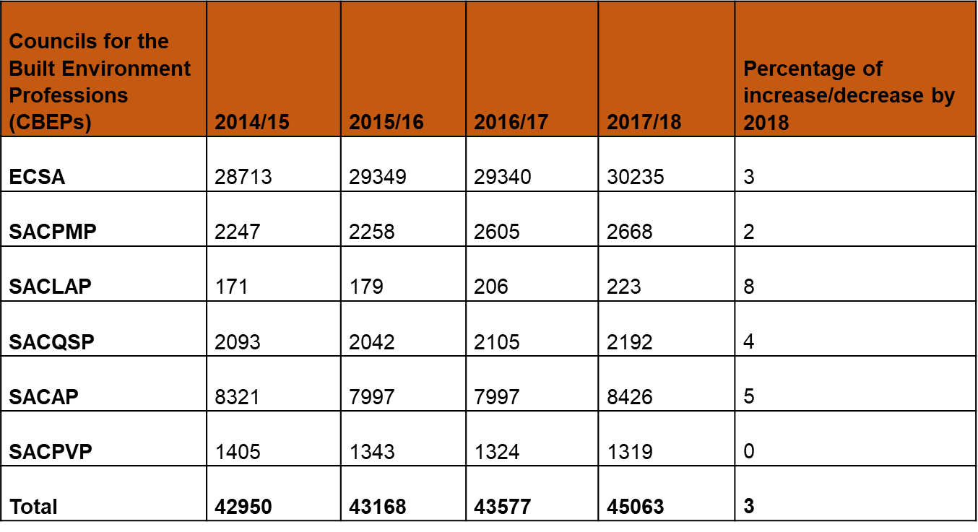

Status of Registered Professionals

2.1.3.1 CBEP 2018/19 Comparison by Profession, Gender and Race

Figure 1: CBEP 2018/19 Comparison by Profession Gender and Race

Source: CBEP Fourth Quarter Report 2018/19
Figure1 compares the demographic composition of each of the six professions by gender and race as at the end of the 2018/19 financial year. At ECSA, white males made up the bulk of registered professionals, followed by African males. These statistics show ECSA’s dominance in the CBEP, from a purely demographic perspective. Figure 1 demonstrates that there is an opportunity to improve performance regarding registration in the other CBEP. The contribution of SACLAP, SACQSP and SACPVP to the number of registered professions in the BE is relatively low. There is a need for career awareness drive to epxose learners to these professions.

Figure 2: CBEP 2018/19 composition by Profession

Source: CBEP Fourth Quarter Report 2018/19
Figure 2 demonstrates the percentage distribution of professionals across the six CBEP by the end of the 2018/19 financial year:
- Engineering Council of South Africa (ECSA) - 70%
- South African Council for Architectural Profession (SACAP) - 17%
- South African Council for the Project and Construction Management Professions (SACPCMP) - 5%
- The remaining three CBEP - South African Council for Landscape Architecture (SACLAP), South African Council for Quantity Surveying Profession (SACQSP) and the South African Council for Property Valuers Profession (SACPVP) - combined, made up less than 10% of registered professionals in the CBEP

Figure 3: CBEP 2018/19 Race profile

Source: CBEP Fourth Quarter Report 2018/19
Figure 3 shows that the white population group is the most prominent race in the BEPs, accounting for more than 70% of registered persons across the six professions. The African population group is a distant second, accounting for only 19% of BEPs followed by the Indian and coloured population groups, which account for 5% and 3% of the BEPs respectively. This is an opportunity for supporting career awareness programmes in the township areas to attract African learners to these professions.

Figure 4: CBEP 2018/19 Gender and Race profile

Source: CBEP Fourth Quarter Report 2018/19
Figure 4 compares the number of professionals registered with the CBEP according to their gender and race. It is evident that white males comprise the bulk of the registered professionals accounting for 34 010, followed by African males at 7 826 and white females at 3 121. Indian and coloured women are the least prominent groups in the CBEP membership.

Figure 5: CBEP 2018/19 Gender profile

Source: CBEP Fourth Quarter Report 2018/19
Figure 5 illustrates the gender percentage of the CBEP membership. By the end of the 2018/19 financial year, 89% of the individuals registered with the CBEP were male. Women make up more than half of the South Africa’s population; however, they are significantly underrepresented in the built environment professions - only 11% of registered persons are women. This demonstrates the need to implement further mechanisms to offer females the correct assistance and support to ensure their representation in the BEPs improves significantly. Enhancing the participation and leadership of women in the technically skilled workforce will generate a greater positive impact on our knowledge-based, technological and highly competitive global economy.

2.1.3.2 Number of Registered Professionals by Council and Registration Category

Figure 6: ECSA 2018/19 Professionals per Gender, Race and Discipline

Source: ECSA Fourth Quarter Report 2018/19
Figure 6 compares the number of registered engineers across the categories of race, gender and disciplines recognised by ECSA as at the end of the 2018/19 financial year. It is evident that white males account for the largest number of registered professionals across disciplines recognised by ECSA. All South Africans should have equal opportunity into engineering; however, accessibility and feasibility are not the same for all demographics - largely due to systemic barriers that disproportionately impact underrepresented groups. This inequality in access to engineering careers by other demographic groups in the country could lie in factors such as the Apartheid legacy. Nonetheless, it highlights the need for intervention to develop a more representative workforce in the engineering space.

Figure 7: SACAP 2018/19 Professionals per Gender, Race and Discipline

Source: SACAP Fourth Quarter Report 2018/19
Figure 7 compares SACAP’s number of registered professionals by race, gender and across disciplines. SACAP’s registered architects are largely whites - males make up the bulk of registered professions followed by females. Although the other demographic groups are present and accounted for, their numbers are marginal and do not significantly reflect the South African population.

Figure 8: SACPCMP 2018/19 Professionals per Gender, Race and Discipline

Source: SACPCMP Fourth Quarter Report 2018/19
Figure 8 compares the SACPCMP’s number of registered professionals by gender, race and discipline by the end of the 2018/19 financial year. White males are the most dominant group across all of the disciplines recognised by the SACPCMP; even more unsettling was the under-representation of women across the disciplines. Figure 9 reveals this profession as a white male dominated space. It also illustrates that registered professionals are concentrated in the Professional Construction Manager and Professional Construction Project Manager disciplines, whilst the Professional Construction Mentor and Professional Construction Health and Safety Agents disciplines remain well below these.

Figure 9: SACPVP 2018/19 Professionals per Gender, Race and Discipline

Source: SACPVP Fourth Quarter Report 2018/19
Figure 9 compares the SACPVP’s number of registered professionals across gender, race and discipline by the end of the 2018/19 financial year. It is evident that white males account for the largest group of registered individuals across the three disciplines, followed by white females - alluding to white dominance in this profession. Single Residential Property Assessor has the least number of registered professionals, whilst Professional Valuer had the most number of registered individuals of the three disciplines. It is noted that in the category of Professional Associated Valuer, there are more female Africans than whites.

Figure 10: SACQSP 2018/19 Professionals per Gender and Race

Source: SACQSP Fourth Quarter Report 2018/19
Figure 10 shows SACQSP’s number of registered professionals by race and gender. White males make up 1 259 registered professionals, followed by African males at 337 and white females at 253. As with most of the BE professions, the numbers of the Indian and coloured population groups indicate underrepresentation in this profession.

Figure 11: SACLAP 2018/19 Professionals per Gender, Race and Discipline

Source: SACLAP Fourth Quarter Report 2018/19
Figure 11 compares SACLAP’s registered professionals per gender, race and discipline by the end of the 2018/19 financial year. Whites dominated the number of registered professionals with 95 males and 82 females as registered Professional Landscape Architects. The other disciplines had comparatively lower numbers, with an average of three registered individuals per discipline.
From the data and analysis above, it is evident that white male professionals make up the majority of individuals in the six CBEP. African males were the second most prominent demographic group in the CBEP space. The coloured and Indian population groups, regardless of gender, were in the minority overall and regarding registration with specific professional bodies.

2.1.4 Registered Candidates

2.1.4.1 Number of registered candidates in 2018/2019
This section analyses the demographic composition (race and gender) of registered candidates per registration category in the CBEP, and highlights areas of improvement for transformational change.
Percentage number of registered candidates by race

Figure 12: CBEP 2018/19 Candidates Race profile

Source: CBEP Fourth Quarter Report 2018/19
Figure 12 represents the demographic composition of candidates in the six CBEP by the end of the 2018/19 financial year. Sixty percent of candidates in the CBEP were African, whites accounted for 28%, whilst Indians and coloureds combined accounted for 12% of CBEP candidates. The 60% of African candidates demonstrates efforts towards transformation, compared to the 19% of registered professionals across the six CBEP. There are also indications of improvement in access to CBEP by both Coloured and Indian population groups - from a combined representation of 8% of registered professionals to 12% of candidates. If the current crop of candidates all convert to registered professionals, the demographic composition of the CBEP will become more representative of the South African population.

Figure 13: CBEP 2018/19 Candidates Gender profile

Source: CBEP Fourth Quarter Reports 2018/19
Figure 13 shows the demographic composition of the CBEP candidates by gender at the end of the 2018/19 financial year. Males dominated, accounting for nearly three quarters of all candidates. Females only accounted for 27% of CBEP candidates. Although there is slight improvement of access for females from the 11% of registered professionals, there is room for improvement to increase this statistic and make it more representative of South African society.

Figure 14: CBEP 2018/19 Candidates profile per Gender and Race

Source: CBEP Fourth Quarter Report 2018/19
Figure 14 compares the numbers of CBEP candidates by race and gender, by the end of 2018/19 financial year. The bulk of CBEP candidates were African male, followed by white males and African females. As illustrated by the two graphs, there is noticeable improvement when comparing registered professionals versus candidates in terms of race, though not as much on gender.

Figure 15: CBEP 2018/19 Candidates profile by Profession, Gender and Race

Source: CBEP Fourth Quarter Report 2018/19
Figure 15 compares the number of candidates per profession by race and gender by the end of the 2018/19 financial year. At ECSA, African males dominated at almost 10 000, followed by white males at 5 200 and African females 3 797. These statistics demonstrate improved access to ECSA careers by African people, whilst there has been less dramatic improvement on race and gender demographics in the other CBEP. It is noteworthy that white male candidates were the most dominant group at SACAP (802), not a good indicator for transformation in an industry, which has been dominated by white males.

2.1.4.1 Number of Candidates by Council and Registration Category

Figure 16: ECSA 2018/19 Candidates profile by Profession, Gender and Race

Source: ECSA Fourth Quarter Report 2018/19
This graph depicts the number of candidates at ECSA by race, gender and skills type by the end of the 2018/19 financial year. Comparisons with the number of ECSA registered professionals in the same period indicate that there will be a change in the demographic composition of ECSA’s professionals. The graph demonstrates that white males dominate the Candidate Engineer category, whilst African males dominate the Technologist and Technician fields. The inference from this statistic is that white male candidates are more likely to occupy a senior role in the ECSA landscape, whilst the African male will occupy the Technologist and Technician roles. The low numbers of female candidates across the board is alarming; more interventions are needed not only to transform candidates holistically, but also to be cognisant of the disparities between genders in this field.

Figure 17: SACAP 2018/19 Candidates profile by Profession, Gender and Race

Source: SACAP Fourth Quarter Report 2018/19
Figure 17 shows the number of candidates in the Architectural field by race, gender and category by the end of the 2018/19 financial year. White male candidates are the most prominent group in three of the four categories. African male candidates follow, with white females close behind. Comparisons with the number of registered professionals in the same period indicate that SACAP’s demographic profile will remain as is. This highlights a huge need to include females in this male dominated industry, especially of the African population group, to strive towards a more equitable Architectural landscape.

Figure 18: SACPCMP 2018/19 Candidates profile by Gender and Race

Source: SACPCMP Fourth Quarter Report: 2018/19
Figure 18 compares SACPCMP candidates across gender, race and discipline by the end of the 2018/19 financial year. African males accounted for the largest number of SACPCMP candidates, followed by white males. Representation of female candidates in the SACPCMP remained non- existent in all but one discipline (Candidate Construction Health and Safety Officer). Comparisons with registered professions in the same period indicate the participation of Africans will improve in most of the disciplines, resulting in a more demographically transformed SACPCMP.

Figure 19: SACPVP 2018/19 Candidates profile by Profession, Gender and Race

Source: SACPVP Fourth Quarter Report 2018/19
Figure 19 compares the number of SACPVP candidates by gender, race and discipline by the end of the 2018/19 financial year. White males accounted for largest share of SACPVP, followed by African males and females. Despite the large inclusion of females into the SACPVP candidate programmes, there is room for improvement towards a more inclusive sector. Compared with the number of registered SACPVP professionals, there is a notable improvement in the representation of the African population group, particularly in the “Valuer” discipline, which, hopefully, will lead to a more equitable and demographically transformed SACPVP.

Figure 20: SACQSP 2018/19 Candidates profile by Gender and Race

Source: SACQSP Fourth Quarter Report 2018/19
Figure 20 compares the number of SACQSP candidates by gender and race by the end of the 2018/19 financial year. Males accounted for most of the SACQSP candidates, and the number of African candidates drastically improved. This highlights the need to improve female access to SACQSP candidate opportunities to ensure a more demographically transformed profile.

Figure 21: SACLAP 2018/19 Candidates profile by Profession Gender and Race

Source: SACLAP Fourth Quarter Report 2018/19
Figure 21 compares the gender, race and disciplines of SACLAP candidates by the end of the 2018/19 financial year. As has been the trend across SACLAP registered professionals, the white population group accounted for the largest share of candidates by the end of 2018/19; however, a standout feature is that white females accounted for the largest group of candidates followed by white males.
The overall number of registered candidates by the end of 2018/19 highlight two salient points:
- the CBEP’ demographic composition was more transformed when compared with registered individuals in the CBEP space. However, it is important to note there are some professions where there is no distinguished difference in the demographic composition of registered professionals and candidates - such institutions remain largely white male dominated.
- is the pace at which the CBEP are transforming acceptable or is there a need to develop interventions to accelerate transformation?

    - South African Professionals Abroad
Table 2: South African Professionals Abroad
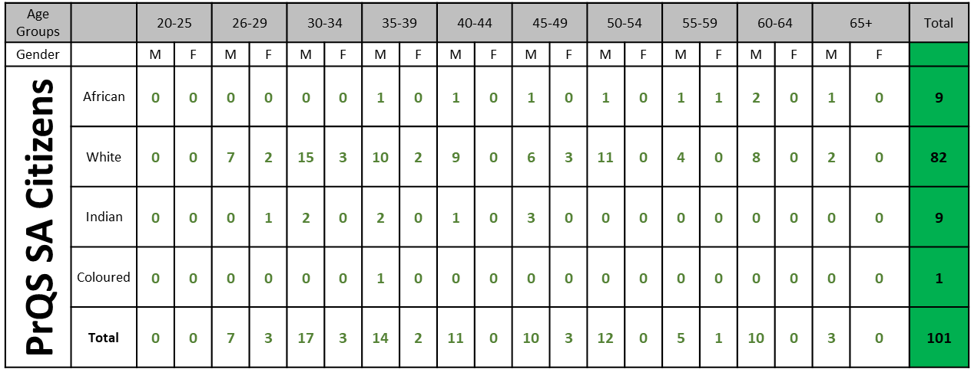

    - Stats of Professional Foreign Nationality

Table 3: Stats of Professionals of Foreign Nationality
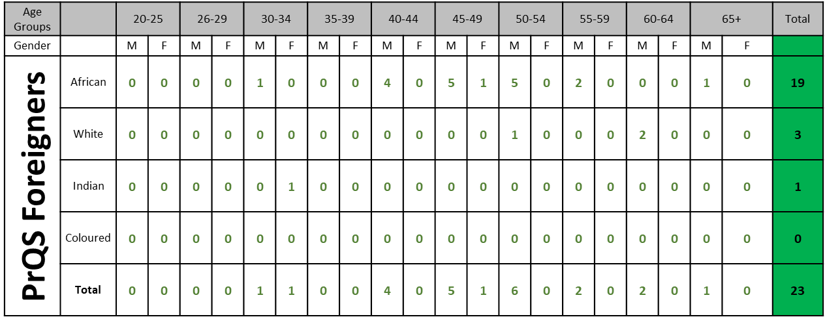

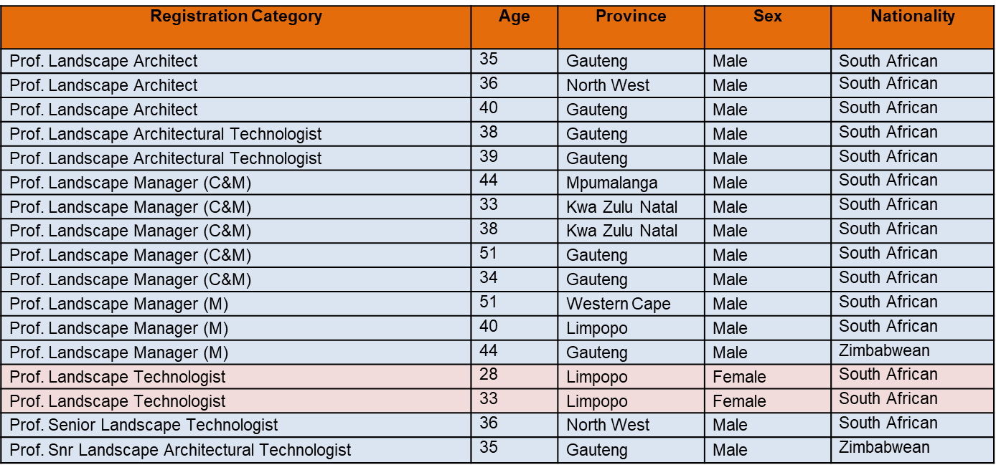

- Implementation of Skills Pipeline for Graduates to Reach Professional Status

3.1 The Skills Pipeline Stratey
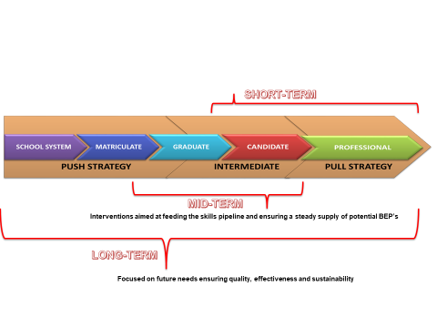
The Skills Pipeline programme is articulated in the following key three strategies:
- The push strategy
- The Intermediate strategy
- The Pull strategy.
The Push Strategy
This strategy aims to provide enough competent and skilled professionals in the built environment through supported and funded secondary and tertiary education programmes. This strategy pushes graduates into the built environment professions from secondary and tertiary education levels.

The Intermediate Strategy
The Intermediate strategy is aimed at providing assistance to the newly graduated built environment graduates and ensuring their ongoing development into fully registered built environment professionals.

The Pull Strategy
The Pull strategy aims at addressing the shortage of skilled professionals in the built environment. The two strategies discussed above address the flow of new and potential entrants into the built environment through ongoing support at school level, tertiary levels and during the early year of registration as a professional. The pull strategy deals primarily with making it attractive for professionals to remain in the built environment, whist still attracting new entrants. It is a retention strategy aimed at alleviating the migration of built environment skills.

3.2. Steps required for a graduate to reach professional status

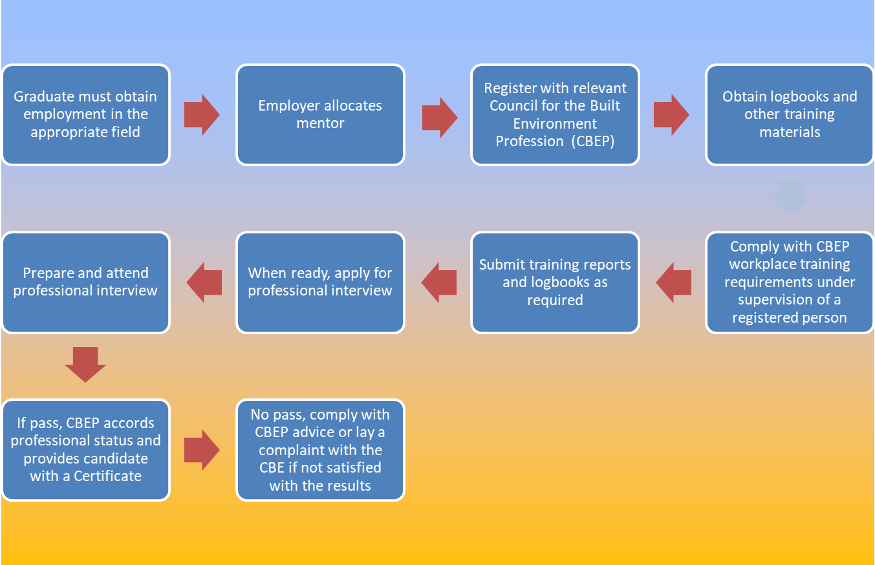

3.3. Support and Interventions by CBE & CBEP

Table 4: Support and Interventions by CBE and CBEP
CBE | CBEP
- Implementation of the CETA Candidacy Programme | - Implementation of the CETA Candidacy Programme
- Employment of mentors to support candidates | - Conduct Roadshows
- Establishment of a detailed training plan per candidate in alignment with the CBEP’s competency profile | - Conduct Candidate Workshops
- Face to face contact sessions between mentor and candidates | - Provision for Mature route to registration
- Conducting workplace assessments | - Amnesty route to candidates registered over 10 years (once-off)
- Reporting on progress as required | - Recommend mentors where required

Table 5: CBE CETA Funded Programme
Number of Candidates | Services Rendered | Number of Mentors | Contract Amount  2016/2017 – 2019/2020
18 | Mentorship Of Candidacy Programme (Construction And Project Management) | 4 companies | R988 380
5 | Mentorship Of Candidacy Programme (Quantity Surveyor) | 1 company | R249,660
5 | Mentorship Of Candidacy Programme (Civil Engineering) | 1 companies | R279,000
21 | Mentorship Of Candidacy Programme (Electrical, Mechanical And Architecture) | 1 company | R304 392.57

Number of Candidates | Services Rendered | Number of Mentors | Contract Amount  2017/2018 – 2020/2021
8 | Mentorship Of Candidacy Programme (Civil Engineering) | 1 company | R414 000
6 | Mentorship Of Candidacy Programme (Electrical, Mechanical And Architecture) | 1 company | R324,000
15 | Mentorship Of Candidacy Programme (Quantity Surveying) | 3 companies | R625 000
8 | Mentorship Of Candidacy Programme (Civil Engineering) | 3 companies | R468 000
3 | Mentorship Of Candidacy Programme (Architecture) | 1 | R162,000

SACPCMP CETA Funded Programme

SACPCMP received funding from services seta in 2018 to embark on internship programmes for purposes of unemployed graduates from accredited universities to obtain workplace learning experience. The programme failed because the stipend R2500 was construed by graduates as not being adequate, therefore they pulled out of the programme. The normal amount paid in the private sector is R7500. The support received by the private sector, but they could not augment the support.

Other Interventions by CBEP to retain and attract registered persons in their registers

Recognition of Prior Learning

Recognition of Prior Learning (RPL) considers practising individuals in the professions who do not have a formal qualification, which will nevertheless enable them to be recognised as either professionals or candidate professionals under the statutory-determined professional designations. Their recognition is based on a demonstration of competence against learning outcomes required for a National Qualifications Framework (NQF)-aligned qualification.

Continuous Professional Development
The purpose of Continuous Professional Development (CPD) is to ensure that BEPs’ knowledge and competencies are continuously developed, and to keep abreast of new developments in their respective fields.
Another purpose is to assist BEPs maintain and acquire new and updated levels of knowledge, skills and ethical attitudes that will be of measurable benefit in professional practice, and to enhance and promote professional integrity. The client will ultimately be the beneficiary.

Agreements and partnerships
In terms of section 13(e) of the built environment professions Act of 2000, the CBEP may establish mechanisms for registered persons to gain recognition for their qualifications and professional status in other countries. Section 13(h) states that councils for the professions may enter into an agreement with any person or body of persons, within or outside the Republic, with regard to the recognition of any examination or qualification for the purpose of this Act.
Arrangements for agreements and partnerships should be consistent with the following principles:
- international movement of professionals is in the interests of increasing trade, investment and knowledge flows between the council for the profession and its trading partners
- needs of the South African community are served according to the highest professional standards
- assessment processes ensure applicants meet standards consistent with the standards applying to local applicants

Regulating the built environment throught the Identification of Work
The CBE is compelled by section 20(2) of the CBE Act to identify the scope of work for each category of registered persons - referred to as IDoW. The scoping of the work is determined after consultation with the Competition Commission (CC) and in consultation with the six CBEP.
The objective of the IDoW is to enhance the protection and safety of the public and the environment by ensuring that only persons registered in the relevant category of registration (and thus demonstrated the required competence and academic qualifications), perform work in the built environment or take responsibility for work so performed.

Guideline Professional Fees
Section 4(k)(v) of the CBE Act, empowers it to ensure the consistent application of policy by the councils for the professions with regards to the principles upon which the councils for the professions must base the determination of fees which registered persons are entitled to charge in terms of any of the professions’ Acts, and in accordance with any legislation relating to the promotion of competition.
In terms of section 34(1) of the built environment professions Acts of 2000, “The Council must, in consultation with the voluntary associations, representatives of service providers and clients in the public and private sector, formulate recommendations with regard to the principles referred to in section 4(k) (v) of the Council for the Built Environment Act, 2000.”
Section 34(2) of the built environment professions Act 2000 provides that “he council must annually after consultation with the voluntary associations, representatives of service providers and clients in the public and private sector, determine guideline professional fees and publish those fees in the Gazette.”

4.Challenges Encountered by Graduates, Candidates and SMME Employers

Table 6: Challenges encountered by Graduates, Candidates and SMMEs
Graduates | Candidates | Employers
Unemployment | Skewed training due to limited type of project required to meet training requirements | Limited access to projects
SOEs and other entities don’t require professional registration | Inadequate employer support | Lack of monitoring on the implementation of procurement legislation and policies
Employment exposure in irrelevant field of work | Difficulty in securing mentors | Unfair tendering environment for SMME sector (unbalanced competition with those not rendering in the private sector – resulting in anti-transformation).
SACPCMP received funding from services seta in 2018 to embark on internship programmes for purposes of unemployed graduates from accredited universities to obtain workplace learning experience.  The programme did not succeed because the stipend R2500 was construed by graduates as not being adequate, therefore they pulled out of the programme.  The normal amount paid in the private sector is R7500. The support received by the private sector but they could not augment the support | Incomplete reporting and supporting documentation on experience | BBBEE legislation that allows level 1 to companies with no black ownership, thus giving them competitive advantage
 | SACPCMP received grant funding for a period of 3 years for the 75 candidates employed by municipalities countrywide to embark on a structured candidature programme. And this ended on the 31 August 2019. Challenges encountered included the dropping off of a number of the selected candidates once they received other alternative employments. There was no support of the municipalities. Only 16 candidates managed to upgrade to professional status. SACPCMP have received grant funding for 50 candidates to embark on a structured programme countrywide.  SACPCMP has applied for grant funding for seta to embark on a structured candidature programme for 300 candidates, to utilise candidate from the private sector. The Council is also supporting other organisations in sourcing candidates for their programmes. Future funding from government for additional candidacy programmes is being explored. | Some public entities are not utilsing registered professionals. CBEPs have engaged government departments on this matter.

Conclusion

There has been an increase in the number of registered professionals but not at the pace expected and desired by the industry. Engagements with the roleplayers indicate that there are challenges outside the control of the CBEP and other regulatory bodies that require interventions at various levels. Transformation of the built environment should start at a very early stage of the development of learners, key to this process is the Department of Basic Education and other spheres of government. Collaboration of stakeholders is critical, this accompanied by monitoring and evaluation of every intervention aimed at improving registration numbers of the built environment professionals.

