RESPONSE TO UNDERTAKING MADE AT THE NCOP PLENARY OF 07 JUNE 2017 BY MINISTER O SOCIAL DEVELOPMENT

(d) “I would like to inform the house that we have been allocated a conditional grant of R181 million to absorb 556 social work graduates in this financial year”

Response:
During the 2017 Medium Term Strategic Framework a conditional grant to the value of R591 269 million was approved to be implemented over the three year period commencing 2017/18 to 2019/20. Funds would therefore be spent as follows during the MTEF period
- 2017/18 = R181 million
- 2018/19 = R196 million
- 2019/20 = R212 million
The grant was as a result of the suspension of recruitment of new students in the scholarship programme over the same period, which resulted in funds being allocated towards employment of graduates. This grant prioritised social work graduates who benefitted from the departmental scholarship programme.
Provincial departments of Social Development commenced with implementation of the grant and therefore had the responsibility to recruit and place graduates based on their needs assessment. All graduates were employed during the 2017/18 financial year with full entry level salary packages. All other provinces appointed graduates on permanent basis Only Western Cape employed graduates on contract (due to the unavailability of vacant funded posts in the staff establishment). The same number of graduates employed in 2017 were carried over, implying that no other graduates were employed in 2018/19.
As at end March 2019, a total of 746 social work graduates were employed through the grant, an increase of 82 more graduates from the initially targeted number of 566. Limpopo province was able to increase its target to 209 due to savings accrued from the implementation in 2017/18. The savings were as a result of some graduates not taking all benefits in their salary packages. The financial year 2019/20 is the last year of the three year cycle of implementation of this grant. Approval was therefore granted that the grant been transferred to provincial departments as part of the baseline budget for compensation of employees. This implies that funds are included in provincial departments’ personnel expenditure.

(e). “We will implement the recommendations of the Ministerial Committee on foster care. These include strengthening parental support for foster parents, prevention and early intervention, as well as exploring the feasibility of Specialised Foster Care Services”

Response:
1. Strengthening parental support for foster parents:

- The Department began to strengthen parental support for foster parents through the engagement of foster parents through intergenerational dialogues. The foster parents are being trained on parenting programmes to support them in their parenting roles and responsibilities. Parental programmes includes, parenting for teenagers and families matter programme amongst others.

2. Strengthening prevention and early intervention:
- The Department is engaged in processes that contribute toward strengthening the prevention and early intervention services and has increased access to social welfare support programmes that include parenting, Community Based Prevention and Early Intervention Programme, Yolo, Ezabasha programmes.
- The provinces are encouraged to elevate the Committee’s recommendation to establish child care and protection units;
- Inputs made to the Children’s Amendment Bill to make provision for the establishment of well-resourced child care and protection units with quality assurance units;
- A 365 days programme of action is being implemented in the provinces.

3. In relation to exploring the feasibility of establishing specialized foster care services:
National DSD encourages provinces to elevate the Committee’s recommendation to establish child care and protection units. Processes in provinces are at various stages in relation to the implementation of this recommendation. These include:
- Proposal for establishing specialized unit tabled at a Provincial Branch Strategic Planning Meetings.
- Provinces provided recommendations to Human Resources Units for revised human resource plans to incorporate the specialized units.
- Some provinces are testing the implementation of specialized Unit, particularly with Statutory Services Unit that quality assures recommendations for placement of children in alternative care and issuing of statutory administrative orders including foster care.
- Fully implemented Unit with social workers specializing on Foster Care is in at least one province, Mpumalanga.

(f) “Over the MTEF period, a conditional grant to the value of R812 million has been allocated for the expansion of ECD services, focusing on rural and informal settlements”

Response:
The conditional grant framework for ECD
The purpose of the grant is to:
- To increase the number of poor children accessing subsidised ECD services through partial care facilities
- To assist existing conditionally registered partial care facilities providing an ECD programme to meet basic requirements in order to attain full registration to increase the number of children accessing
The grant has two components which is a subsidy component and a maintenance component.
- Budget Allocation
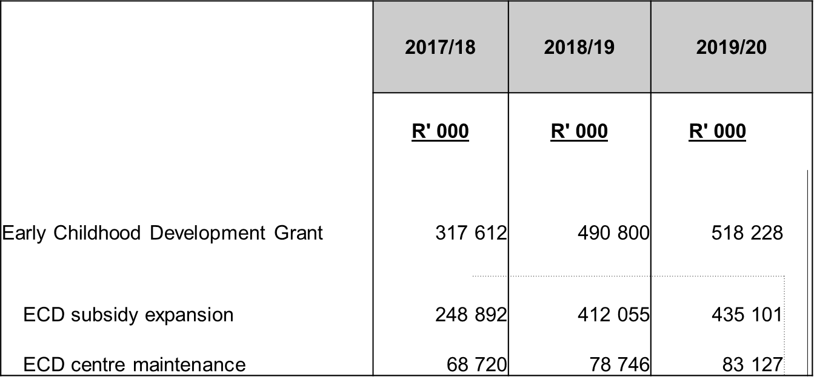
The total budget allocation for the grant was R808 412 000 for the two financial years namely 2017/18 and 2018/19.
The grant is extending over the MTEF from 2019/20 to 21/22
- Performance on the grant
The grant started in the 2017/18 financial year which was the first year of implementation. The conditional grant framework was published in the Division of Revenue Act which set the conditions for implementation of the grant by Provinces.
  - Overall Financial Performance for 2017/18
2017/18 Financial Performance
Province | Allocation | Transfer | Spent | Percentage
Eastern Cape | 56 365 000 | 56 365 000 | 27 238 000 | 48%
Free State | 18 398 000 | 18 398 000 | 12 937 000 | 70%
Gauteng | 34 489 000 | 34 489 000 | 35 938 000 | 93%
KwaZulu Natal | 71 879 000 | 71 879 000 | 71 870 000 | 100%
Limpopo | 41 085 000 | 41 085 000 | 36 034 000 | 88%
Mpumalanga | 25 799 000 | 25 799 000 | 23 645 000 | 92%
Northern Cape | 13 761 000 | 13 761 000 | 11 710 000 | 85%
North West | 32 686 000 | 32 686 000 | 20 344 000 | 62%
Western Cape | 19 150 000 | 19 150 000 | 18 770 000 | 98%
Total | 317 612 000 | 317 612 000 | 258 446 000 | 81%

4.2 Overall Financial Performance 2018/19
2018/19 Financial Performance
Province | Allocation | Transfer | Spent | Percentage
Eastern Cape | 78 715 000 | 78 715 000 | 76 556 024 | 97%
Free State | 21 656 000 | 21 656 000 | 26 115 733 | 121%
Gauteng | 62 777 000 | 62 777 000 | 44 336 397 | 71%
KwaZulu Natal | 109 519 000 | 109 519 000 | 109 519 000 | 100%
Limpopo | 68 561 000 | 68 561 000 | 67 216 987 | 98%
Mpumalanga | 41 998 000 | 41 998 000 | 41 094 837 | 98%
Northern Cape | 16 496 000 | 16 496 000 | 14 028 425 | 85%
North West | 52 185 000 | 52 185 000 | 61 214 239 | 117%
Western Cape | 38 893 000 | 38 893 000 | 38 312 214 | 99%
Total | 490 800 000 | 490 800 000 | 478 393 856 | 97%

  - Achievement of targets for 2017/18 and 2018/19
    - Overall Achievement of the Subsidy Component (2017/18 and 2018/19)
Years | Target | Actual performance
2017/18 | 72 388 | 62870
2018/19 | 103 078 | 107 153
Province | Target | Number of Children Benefiting
Eastern Cape | 14 035 | 8 420
Free State | 2 085 | 2 084
Gauteng | 8 135 | 9 079
KwaZulu-Natal | 14 615 | 14 615
Limpopo | 12 785 | 9 414
Mpumalanga | 4 625 | 4 625
Northern Cape | 1 221 | 1 221
North West | 6 592 | 9 147
Western Cape | 8 295 | 4 265
TOTALS | 72 388 | 62 870
    - Subsidy Component performance (2017/18) per province
The target achieved was 87% and there was an under-achievement of the target given that it was the first year of implementation and there was a lack of capacity to implement the grant.

    - Subsidy Component performance (2018/19) per province
Province | Target | Number of Children Benefiting
Eastern Cape | 20 472 | 20 429
Free State | 3 610 | 3 560
Gauteng | 14 570 | 11 543
KwaZulu-Natal | 24 622 | 24 622
Limpopo | 11 756 | 12 029
Mpumalanga | 8 425 | 8 440
Northern Cape | 1 640 | 1 640
North West | 10 983 | 17 616
Western Cape | 7 000 | 7 274
TOTALS | 103 078 | 107 153
There was a roller of funds of funds that was not spent in the 2017/18 financial year which allowed more children to be reached.
Maintenance Component
    - Overall achievement for the maintenance component for the period (2017/18 and 2018/19)
Years | Target | Actual performance
2017/18 | 593 | 459
2018/19 | 369 | 539

    - Maintenance Component performance (2017/18) per province
Province | Target | Achieved
EC | 96 | 0
FS | 79 | 79
GT | 15 | 15
KZN | 117 | 117
LP | 98 | 98
MP | 62 | 62
NC | 65 | 65
NW | 48 | 10
WC | 13 | 13
Total | 593 | 459
The target achieved was 77% because Provinces experienced challenges given that it was the first year of implementation with procurement processes and delays in appointing the required capacity to manage the grant.
3.4.2 Maintenance Component performance (2018/19) per province
Province | Target | Achieved
EC | 19 | 15
FS | 25 | 32
GT | 20 | 15
KZN | 52 | 63
LP | 99 | 184
MP | 35 | 35
NC | 40 | 38
NW | 33 | 38
WC | 46 | 119
Total | 369 | 539

There was an over-achievement of the target because there was a saving on the costing of each centre for maintenance which resulted in more centres being assisted. Furthermore, some centres in Limpopo only benefited from early learning material which allowed the province to assist more centres than planned.

(g) “We will introduce the Social Service Practitioners Draft Bill to Parliament. The Bill seeks to regulate all social service practitioners and includes measures to support emerging professionals in the sector”

Response:

The Social Service Practitioners Draft Bill was not introduced to parliament due to cabinet changes and the fact that it was an election year, which resulted in most cabinet matters set aside. The Bill is ready for cabinet consideration, therefore will be submitted to cabinet for consideration in order to gazette for public comments. This Bill will only be introduced to parliament in 2020/2021 financial year due to delays of processing it in 2018/19.
Draft input for commitments made at NCOP
- Utilisation of savings to promote local economic development through alternative pay points and local health shops

Since the period in which this commitment was made, the payment environment for social grant beneficiaries to access their money has changed significantly. The contract with CPS for social grant payments ended on 30 September 2018. This change brought with it the reduction in cash pay points – from approximately 10 000 in 2017/18, SASSA currently has 1 740 approved pay points. Work is underway to reduce this further as the number of citizens who continue to utilise this channel has reduced from over 3 million to less than 300 000 per month. The cash payment channel is also both expensive and inefficient, while at the same time being prone to serious security risks.
The changed environment resulted in SASSA abandoning its project to establish alternative pay points in locally owned shops. However, work is underway, together with SAPO, to identify alternative channels. This will include aspects such as mobile money; working with community based and South African owned spaza shops for them to become part of the network while not increasing their risk by having them handle large amounts of cash (looking at increasing the acceptance of electronic transactions); expanding the network of SAPO ATMs and other options which will be driven by technology. This will require an investment into local communities, but should also see social grant money remaining in local communities rather than taking flight to the large towns and cities.
The above innovations are aimed at reducing the dependence on cash, while at the same time improving security and convenience for the clients we serve.

- Addressing long queues, dilapidated buildings and promoting dignity
As explained above, SASSA, through the partnership with SAPO, currently services less than 300 000 social grant beneficiaries through the historic cash payment channels. There is a commitment to further reduce the number of cash pay points, while providing safe and convenient options to those beneficiaries who reside long distances from any national payment infrastructure.
Many of the pay points which were in the open have been discontinued. However, even within the remaining 1 740 approved pay points, there are still some which operate from less than ideal buildings and some which are still in the open. The intention is to move the beneficiaries who are serviced at these points to alternative channels, where these are within easy reach, or to look at other options, such as empowering the local spaza shop to become an alternative, where social grant beneficiaries can transact electronically.
Continuous beneficiary education is required, to strengthen the beneficiaries’ trust in electronic payments, and also to empower them to use the power of the debit card they now have, rather than withdrawing the total grant in cash and then transacting with cash.
SAPO, as part of their commitment to the contract for the payment of social grants, also has a medium to long term plan to upgrade post office outlets, to ensure that these meet minimum standards for dignified grant payment services. This will also encourage grant beneficiaries to voluntarily go to post offices to access cash, when cash is required.

