Recommendations of SASCOC Committee of Inquiry
- In the light of our findings we make the following recommendations, in the interest of sport:
- The Act:
  - We recommend that the Act should be amended to include:
    - the details of a revised structure of SASCOC, which is set out in detail in paragraph 42 below;
    - clarity about the roles of the Department, SASCOC and the entities that fall into the definition of a ‘sport and recreation body’, as well as their respective oversight roles;
    - SASCOC’s powers and duties, and its obligations to the Department, and to each and every sport and recreation body;
    - an external and independent dispute resolution body in terms of the Act, for disputes: between sport and recreation bodies and between the latter and SASCOC; and
    - the details of what should be contained in SASCOC’s Constitution, including: criteria for the eligibility of members to the Board; a prohibition on the receipt of commissions from other entities in prescribed circumstances, as well as other issues relevant to the principle of ‘conflict of interest’;
- SASCOC, the revised structure and mode of operation:
  - In the light of our findings it is our view that there should be an organizational structural and strategic review and change management process in order to ensure that SASCOC –
    - understands its vision, its mission and its role in the development of sport in South Africa;
    - delineates clearly its strategy for sport in general, and high performance sport in particular; and
    - understands its obligations in relation to corporate governance, financial governance and responsibility, and the development and administration of sport.
The Board
  - We recommend that the Board must be representative of sport and recreation bodies, and must include specialists in the field of corporate governance; company and commercial law; sports law; finance, accountancy and auditing; amongst others (‘the specialist members’). In particular:
    - the following three positions on the Board must be occupied by persons who are independent and who have no affiliation to any sport and recreation body:
      - the President of SASCOC;
      - an accountant; and
      - a commercial lawyer;
[Collectively referred to as the ‘independent and specialist members’]
    - the independent and specialist members of the Board should:
      - be appointed by an independent committee, pursuant to a fair and transparent process;
      - be persons of high stature and impeccable reputation; with appropriate experience and qualifications; and should demonstrate a passion or a love of sport;
      - be representative of the different genders and peoples of the country
    - members of the Board who are appointed in consequence of their membership or affiliation with any sport and recreation body, must relinquish such membership or affiliation upon their appointment;
    - members of the Board must serve no more than two 4 year terms in their respective posts on the Board; and
    - the President of the Board, because of the expected increase in responsibility should be paid a monthly retainer, and all other members of the Board should be paid for meetings that they attend, including Board and subcommittee meetings.
The Management Structure
  - The management structure of SASCOC, should consist of, amongst other things: a CEO, a CFO, a COO and a Director of Communications. In particular –
    - each of these posts must be advertised and must be filled pursuant to a fair and equitable recruitment process by an independent committee;
    - the appointees must not have any links with a sport or recreation body, or must relinquish such links, if any, upon appointment; and
    - the appointments must be confirmed in a contract of employment, on a fixed term basis and subject to a probationary period, job description and key performance areas;
CEO (Chief Executive Officer)
    - the CEO must be subject to the direction and control of the President of the Board and the chairperson of the Finance Committee;
CFO (Chief Financial Officer)
    - the CFO must be subject to the direction and control of the CEO and the chairperson of the Finance Committee;
COO
    - the COO must report to the CEO; and
Director of Communications
    - the Director of Communications must report to the President of the Board and to the CEO.
  - At the first meeting of the Board –
    - a process for the revision of all policies and procedures must be determined; and
    - travel benefits and allowances for the President, the members of the Board and the CEO should be discussed, and a process for the determination of such benefits should be decided, subject to the approval of an independent external auditor.
  - Administrative matters related to the operation of the Board, including the holding of meetings, agendas, the distribution of minutes and matters ancillary to the functioning of the Board should be determined on an urgent basis.
- Pending the implementation of the above recommendations, we make the following further recommendations:
  - SASCOC must, pending the process set out above:
    - read and consider the Pullinger Report, and any other Reports received pursuant to investigations conducted at its behest, and determine the appropriateness and the rationality of implementing some or all of its recommendations;
    - appoint a National Colours Board in terms of the Act, its Constitution and internal regulations, for the purposes of determining any and all issues relevant to the awarding of national colours to athletes;
    - ensure that there is complete transparency, accountability and consultation in relation to all decision-making processes;
    - ensure that international travel is limited and in line with a revised interim policy, and that the procurement of services is approved by a sub-committee of members of the Board specially constituted for this purpose;
    - undertake a complete and thorough audit of its financial transactions for at least the last five years, including travel and other benefits and the procurement of services, and that any irregular or wasteful and fruitless expenditure is dealt with, and if possible, recovered;
    - investigate the payments made to SS Griffin; and
    - ensure that all members of the Board, who receive commissions payable to them from other entities, declare the details thereof to the Board for further investigation.
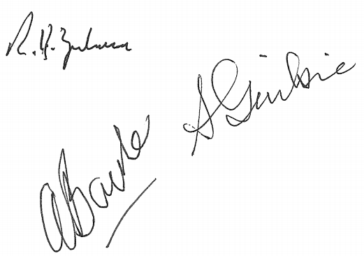
21 August 2018
R Zulman
A Bacher
S Gaibie

These positions will be in addition to those that already exist in the SASCOC Constitution.

