CEPPWAWU PRESNTATION TO THE PORTFOLIO COMMITTEE ON MINERAL RESOURCES AND ENERGY

Resource and Energy Sector
1. Introduction
This paper serves as CEPPWAWU’s submission to the Portfolio Committee on Mineral Resources and Energy as requested. Although it covers Mining and Energy broadly, it is largely towards petroleum sector in the economy of South Africa.

1.1 Executive Summary
In the Minister of Energy’s Budget Vote 29, 10th July 2019 three critical indicators were mentioned, i.e. the contraction of the economy by 3.2% in the first quarter of 2019, the declining of mining by 10,8% and the effects of load shedding and long strikes in the gold sector. These critical factors outlined by the Minister are a fundamental consideration in mapping out the response to the urgency of measures to deal with challenges facing the country. This situation gets even more frightening when we look at the Quarterly Labour Force released (QLFS, Q2:2019) which reported unemployment increase of 1.4% to 29% compared to the first quarter of 2019. Mining alone, lost 36 000 jobs and manufacturing 9 000 jobs. This economic contraction extends its effects affairs beyond employment to the building of skills based for the country. As we ponder where to find solutions from, certain sources need to be consulted i.e. the National Energy Plan, as directed by the National Energy Act (2008).
According to the plan, South Africa needs to grow the energy supply to support economic expansion. The Plan centres on a triple effect approach; economic, social and protection of the environment. Although there is economic contraction, the demand for energy resources continues to grow largely due to infrastructural challenges in South Africa. For example, the DoE’s projected demand for petroleum products had anticipated an increase between 2015 -2050 where in 2050 the Final Consumption (PJ) would be 8000. The LPG sector will also increase sharply due to growth in the residential sector. Furthermore, diesel consumption is projected to increase especially in the mining sector. In the generation of electricity, Eskom alone has already projected 1, 4 billion need for diesel just this financial year and this likely to continue until alternative sources of feedstock are secured. This will further be influenced by the demand for electricity and natural gas, where the latter is most needed in the industrial sector. These projects are in line with the Minister’s emphasis on finding solutions for sustainable supply of these hydrocarbons. There is however, a need to revisit the Integrated Energy Plan which some of its assumptions no longer hold. Take for example, it assumes availability of cheaper indigenous gas thus no need for crude oil concentration. The reality as demonstrated at PetroSA is that natural gas has diminished and therefore a need to drill more wells and consider crude oil for export.
1.2 Macro-environment issues in the Oil and Gas
The global liquid fuels demand is expected to increase by around 15 Mb/d, to reach 110 Mb/d by 2035. Most of the demand growth comes from the emerging economies, with China accounting for 50%. In contrast, OECD oil demand continues with its declining trend. Global liquid fuels supply is expected to increase by a little less than 13 Mb/d, reflecting the excess production of liquids in 2015. The global consumption petroleum and other liquid fuels averaged at 95.6 M b/d in 2016. Consumption growth is expected to increase by 1.6 Mb/d in 2017 and 1.5 Mb/d in 2018. Despite the rising gasoline production and high inventory levels, margins remain reasonable high on average. Input costs, market access (both export and domestic) and refinery configurations are key to higher refinery margins.

Given the lower oil prices environment, the Oil and Gas industry continues to respond by cutting costs, postponing or cancelling projects. The Brent crude oil prices recently increased by 20% to almost US$ 60 per barrel in late 2016 in response to the OPEC-brokered agreement to curb production. This has since reversed in 2019 but likely to return in less than two years. In contrast, the US shale producers have increased production in response to high prices. Prices have since moderated to current levels of around US$55 per barrels. The continuing global oil inventory builds contribute to crude oil price remaining below US$60 per barrel through the end of 2018. However, uncertainty remains future growth in the oil prices due to looming trade wars in Europe, geopolitical tensions in the Middle East, and nuclear threats by North Korea.

The new drive to adopt ultra-low sulphur diesel in countries like Asia, Africa, and the Middle East is gaining momentum, fuelled by stringent emission standards. Across Asia and the Middle East, new refineries have been built and older ones upgraded, creating a significant increase in the availability of ultra-low sulphur diesel. Simultaneously, the shutdown of unprofitable refineries in countries with high fuel-qualities standards has created larger demand in the Singapore hubs. To meet the domestic and export demand, Singapore upgraded three of the four of its refineries to produce 10 ppm sulphur diesel.

Members of Brics such as China and India have drawn up regulations to further tighten up sulphur standards in fuels in 2017. India has switched to 50 ppm sulphur diesel nationwide since 2017 and advanced in adopting Euro 6 compliant fuels by end of 2019. Three new refineries in the Middle East which were commissioned recently, two of those are owned by Saudi Aramco in joint partnership with Sinopec and Total, while a third is an expansion of Abu Dhabi National Co.’s Ruwais refinery. The total full capacity of these new refineries is estimated to be between 700 00 and 800 000 p/d of Ultra-Low Sulphur Diesel. In East Africa, Tanzania, Kenya, Rwanda, Uganda, and Burundi have all tightened their sulphur standards for diesel to 50 ppm since 2015.South Africa consumes both 50 ppm and 500 ppm sulphur gasoline, and there are no plans in place to shift to 10 ppm. The government is currently developing a 20-year liquid fuels infrastructure roadmap to ensure continued security of supply of liquid fuels. The roadmap will assist in determining a capability for local refining, storage, handling and logistics, this strengthened by plans to build a refinery in Richards bay in a joint venture between PetroSA and Saudi Aramco.

2. Background
According to the fundamental principles of the Mineral and petroleum Resource Development Act, South African government has an international right to exercise sovereignty over all the mineral and petroleum resources within the Republic. It has full custodianship, powers, liberties and privileges of the nation’s mineral and petroleum resources. In exercising these rights, the State has a duty to ensure that it exercises them with skill, care and diligence while ensuring it promotes economic growth and mineral and petroleum resources in the republic.
CEPPWAWU sees this as a dual responsibility (economic growth and employment creation). For the above to be achieved, security of supply of affordable Coal, Natural Gas and Crude Oil is needed to ensure economic growth and stability for the Nation. Energy is the economic backbone of not only South Africa but also the entire Southern African economic ecosystem and hydrocarbons are the bedrock on which this ecosystem is built. Without hydrocarbons, there will be no positive economic growth and thus no better life for all our people living within the Southern African Development Countries (SADC), the African continent and the world. For us to understand the impact of Minerals and Energy, the global view of the sector is necessary. At global level, Oil and Gas have become an important strategic commodity in the world where an estimated three billion dollars of petroleum traded worldwide a day. South Africa produces less than 2% of its fuel needs from gas, 35% from coal and 50% from crude oil; the remainder is imported. We import about 45% of fuel from Saudi Arabia, 23% comes from Nigeria, 18% from Angola, 4% from Ghana, and the balance comes from other sources.
The National Development Plan (NDP), aims to eliminate poverty by 2030 and this can only be achieved by constantly increasing the economic growth and reduce inequality in the country. To achieve the latter, the NDP recommends an investment in the economic infrastructure in order to support the country’s long term economic growth and social objectives. The NDP envisaged that the country should provide a reliable and efficient energy services at competitive rates and the aim is to expand access to energy at affordable tariffs whilst maintaining a sustaining the environment.

2.1 The Coal Sector Analysis
According to the Coal Market Sector Report of 2019, Coal is critical because it contributes 90% towards the country’s electricity generation and approximately 30% towards liquid fuel production. Its importance ranks highest in the energy sector which is at 72% of the total primary energy supply in South Africa. This demonstrates the impact it has on the full energy space and by virtue, the biggest contributor in the job creation space. If one looks at the full value chain, Coal sector creates jobs along resources reserves, exploration, mining, coal preparations, transportation, electricity, Coal-to-Liquids, metallurgical use, industrial and residential use, therefore means that although energy should be diversified, Coal should form centre of the energy plan. In 2018, the Coal sector contributed 86 919 jobs from which 253 million tons were mined. With R200 billion invested in land, machinery and transport, this is the sector that can bolster the economy strongly especially in the export category which recorded R139 billion in sales.
The Department of Mineral Resources has recently published a draft Integrated Resource Plan (IRP), which sets out the country’s energy mix until 2030 and this will inform the investment in energy infrastructure in the next decade. The IRP is considered as a “living document and is largely focusing on electricity infrastructure development plan which seeks to achieve the following objectives:
- Affordable electricity
- Reduce greenhouse gas (GHG)
- Reduce water consumption
- Diversify electricity generating sources
- Localisation and regional development
The draft plan proposed 11 930 MW or 15.7% for installed gas generation capacity and this will be used in conjunction with 7 958 MW (10.5%) for solar PV and 11 442 MW (15.1 %) for wind PV energy by 2030. The draft plan provides only 1000 MW for new coal generation beyond the Medupi and Kusile power stations and this is likely to be sourced from two Independent Power Producer programmes (IPP). According to draft plan about 75% or 30 000 MW of the Eskom’s current coal feet will be decommissioned by 2040.
The availability of wind and solar energy will depend on the weather conditions and time day. The sources of energy will include importing gas from Mozambique, fracking in the Karoo, and offshore imports (LNG). The IRP is currently reviewed at a time when some of the key assumptions have changed compared to the review done in 2011 due to the lacklustre of the SA economy in the past decade. Some of the key assumptions made in the IRP report:
- The Renewable Energy Independent Producers Programme (REIPPP), Eskom’s current capacity plus Kusile capacity will be sufficient to meet the forecasted demand.
- Coal will contribute less than 30% of the energy supplied by 2040 and down to 20% by 2050, from a significant contribution of 70% in 2015.
2.1.1 Decomposition Analysis
Based on the empirical evidence provided in the draft IRP report the South African economy is not yet ready to drastically switch from coal energy to renewable energy because this will be an expensive option unless it is done on an incremental basis.
2.1.2 The Economic Impact
To put things into perspective, over the past ten years on average the South African economy grew by 2.1% hence electricity demand projections for the IRP 2010-2030 which was reviewed in 2011 were not realized. As you can see in the graph below, since 2007 the GDP growth rate has been declining from 5.4% to 1.3% in 2017 whilst the population of the country has grown by 24% to 57 million in the past 10 years and this has put more pressure on the economy.

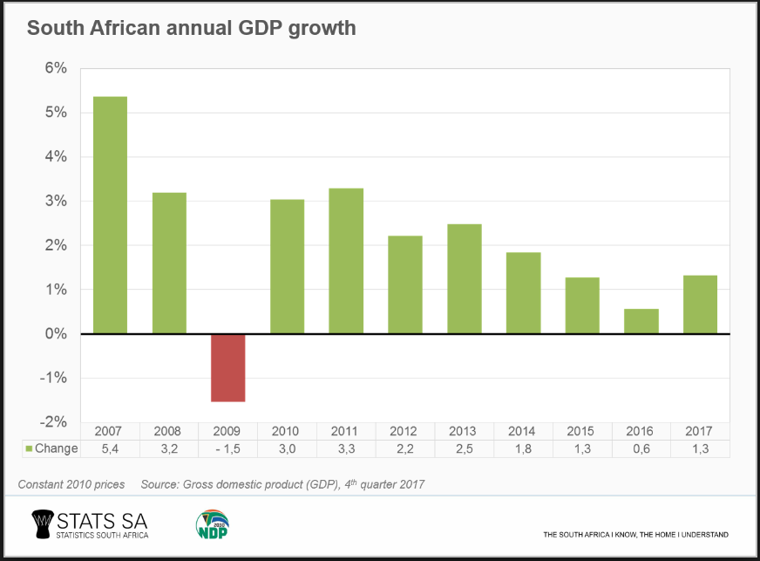
The table below show the real increases granted by South African companies over the last 15 years. A real increase is defined as the increase after inflation has been taken into account. The real salary increase has remained below 2% over the period of 15 years, however, in 2008 there was an erosion of value.
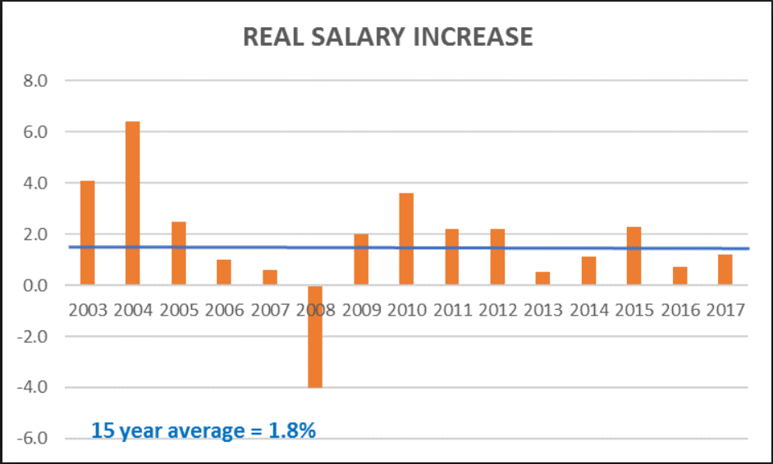

According to the World Bank report, nearly half of the population of South Africa is considered chronically poor at an upper bound-national poverty line of R992 per person per month. However, this number declined from 51% to 40% in 2017, measured by per person per month and that means close to 2.3 million South Africans escaped due to an increase in the number of people who are earning social grants. The income polarization in the country decelerates the growth of the middle class, who constituted 20% of the population. Only four percent of the population can be considered elite with living standards far above the average. Nonetheless, by any measure, South Africa is one of the most unequal countries in the world hence there is a strong need to grow the economy in order to reduce the unemployment rate in the country.

2.1.3 The Renewable Energy and electricity consumption
The renewable from independent power producers is currently procured in terms of a take-or-pay model, therefore, this seem to be an expensive transaction for SA economy. Even if the current debate is strongly suggesting that the renewable energy technology is becoming cheaper but there is a high probability that this will choke the economic recovery because the economy will not be able to carry all these costs. For the past decade, our economy has failed to perform and these added costs will put a lid on economic recovery. A case in point, initially Eskom has refused to sign the REIPPP agreement in order to protect its liquidity position; however, they end up signing it in April 2018. Even though Eskom can have a surplus of electricity due to the fact that the electricity demand in the country is flat, however, that is not translated to lower prices because Eskom is currently increasing generation capacity and this weighs heavily on the balance sheet of the company.
During the financial period of 2017, Eskom paid 214c/kWh for 7200 Gigawatt (GWh) of renewable energy at a total cost of R15.5 billion whilst Eskom can only sell it to the consumers at 83.6 cents/kWh and definitely, this erodes the company’s balance sheet. The Minister has recently signed about 27 projects of REIPPP at a weighted average price of 86 cents/kWh, which will costs R 52 billion. According to the IRP, Eskom’s plant performance is below the 80% availability factor. Eskom depends largely on coal-fired power stations to produce approximately 90% of its electricity and uses over 124 million tonnes of coal per annum in the process of producing electricity.
About 70% of the coal mined in the country is sold to Eskom, and 30% is exported. Eskom supplies more than 90% of the power used in the country and approximately 32 mining and industrial companies accounting for more than 40% of the country’s electrical energy consumption. Therefore, it’s no brainer the drastic increase renewable energy will have a major ramifications throughout the economy and a detrimental impact in the mining sector, especially the coal industry, which employs about 86 919 people. Coal mining in South Africa is relatively cheap compared to the rest of the world and these low costs have had a positive effect on the nation’s prosperity. The graph below stipulates these benefits in the employment space.
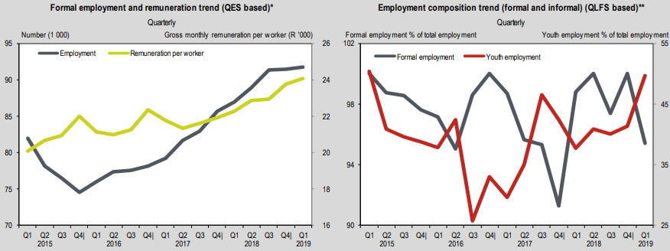

Based on Eskom’s 2017 opinion piece, the accumulative “school fees” required to craft the renewable energy technologies would approach R100 billion in 2021 and this costs will be passed through to the consumers. The argument put forward on this paper does not mean we are against clean energy initiatives that are aiming to avert climate change. South Africa has got to be innovative and creative when they endeavour to meet the climate change targets because we kill the goose that bear the golden eggs. To reduce the coal contribution from 70% to 30% of the energy supplied by 2040 that will definitely choke the economy and the unintended consequences might amplify the socio-political impact on the ground.
2.1.4 What can we learn from abroad?
Germany is considered as the country that has done more than any other to unleash the renewable energy industry, however, they are likely to fall short of goals for reducing harmful carbon dioxide after targeting to over USD 580 billion by 2025 to overhaul its energy system. Germany is currently close to replacing coal as a primary energy and the natural gas use is also declining, on top of that, they are also phasing out nuclear reactors. However, the current reductions that Germany has achieved so far has failed to make a bigger impact on the picture for global emissions due to the increase in emissions from developing countries. The general view is that if Germany can’t succeed after all efforts, with its economy which is largely driven by services that require less energy. This could be a signal that the other polluters, such as China, might encounter bigger challenges in making reductions because China has a larger share of its economy tied to the factories.
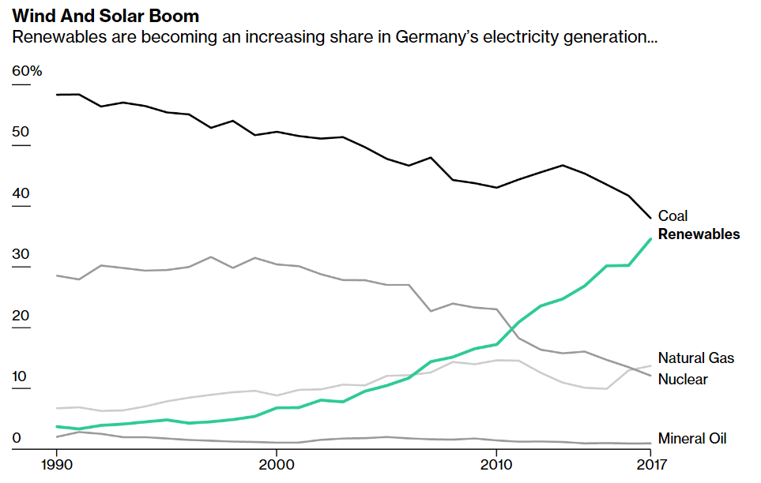
Africa contributes less than 3.8%, compared to the largest emitters such as China, United States and European Union which together contribute nearly 56% of the total global greenhouse emissions.

2.3. Upstream Sector Market Analysis
South Africa is a low oil resources country, therefore, it is heavily dependent on imports. The security of supply depends on the economic and political stability in the OPEC countries as well as the investment in the country’s capacity. Over 300 exploration wells including appraisal and production wells in South Africa by Soekor, the former State Owned Oil and Gas exploration company. In addition, 233 000 km of 2D seismic data and 10 200 km2 of D seismic data have been acquired since exploration. Exploration drilling was most active from 1981 to 1991, during the period, about 181 exploration wells were drilled. However, Soekor’s focus was oil, not natural gas. South Africa has proven reserves of 13.6 million barrels (bbl.) and 30.6 billion cubic meters. It is further a fact that the West Coast consist of billions of Oil reserves which remain un-tempted.

Research has shown that South Africa has an ample unconventional and deep water resource potential. Through project Pakisa, government believe that our coastal waters could contain as much as 9 billion barrels of oil crude and natural gas deposits that could amount to 11 billion barrels of equivalent. As a result Government has identified development of South Africa’s prospective resources as a key strategic focus for the next five years. Government is planning to drill 30 exploration wells in the next 10 years in order curb its reliance on imported oil through Project Pakisa. In the last five years, we have seen a significant increase in interest in South Africa’s offshore potential and this is driven by the technology advancement. About 20 exploration licenses have been awarded to a number of international companies (e.g. Sasol, ENI, Exxon Mobil, Total SA and Royal Dutch Shell etc.) including PetroSA.
However, the ongoing regulatory uncertainty around the amended MPRDA will have direct implications on potential investment in the country’s upstream sector.

3. Natural gas industry
Natural gas industry in South Africa is still at a stage of development with limited competition. It currently makes up 3% of the total primary energy mix in South Africa and this is expected to grow to around 10% over a decade. Natural gas is imported into South Africa (with the exception of PetroSA), by Sasol Gas Company, via 865-km pipeline from Temane and Pande gas fields in Mozambique. As the major player, Sasol sells its gas to the domestic and industrial sector. However, the gas feedstock challenges PetroSA is experiencing renders the South African government a major challenge as the security of supply cannot be guaranteed, this because of Sasol’s status of not being the national Oil and Gas Company of South Africa. Our view as CEPPWAWU, this role should be played by PetroSA.

4. Shale gas opportunities
The US Energy Information Administration (EIA) has previously estimated the potential shale gas resources in South Africa to be around 485 tcf. South Africa’s Karoo basin is still perceived as the largest shale gas reserves in the Sub-Sahara Africa. So far, exploration right applications have been received from five companies, such as: Shell International, Falcon Oil and Gas in partnership with Chevron, and Bundu Gas etc.. The Econometrix report estimates that 20tcf of gas could have an annual economic impact of ZAR80 billion. At 50tcf, which is 50% of the total resources, the impact on the South African economy could be high as ZAR200 billion. About 7000 sustainable jobs could be created and have a knock-on effect on producers, government and consumers. However, a significant investment in infrastructure will be required before South Africa becomes a major shale gas producer. CEPPWAWU’s view is that PetroSA, not Shell should be leading the charge in the exploration and successful production of shale gas with care to the environment. If this done successfully, South Africa can become the leading shale gas in Africa.

5. Downstream Analysis
In 2005, South Africa suffered a major fuel shortages crisis which promoted the then Minister of Minerals and Energy to establish the Moerane Commission to investigate the causes thereof. Among its findings, there were deeper problems in logistics infrastructure (pipelines, rail, road and storage), refining capacity and state of repair, refinery shut-down planning etc. The report in essence, painted a picture of a state that does not have full control and insight of the oil and gas players with multi-nationals dominating the space. It is CEPPWAWU’s view that only a designated national Oil and Gas company can secure the security of supply. There further revelation was a need for a new refinery as multi-nationals continue not to invest in their decaying refineries. Recommendation 25.5.1.1 of the Moerane Report provided for the role of a state-owned entity in expanding storage capacity. But why is the downstream sector critical?
Downstream sector is a one of the strategic sectors in terms of its wider impact on consumers, as it provides inputs into other productive sectors of the economy. South Africa consumed approximately 11.3 billion liters of petrol and 13.2 billion liters of diesel during 2014, increased by 1.7% and 11% respectively from the previous year. Diesel consumption has exceeded petrol for the first time in history. South African refineries are price-takers; prices are driven by supply and demand for fuel. Crude oil prices have a major effect on the fuel prices, given that crude oil forms the biggest input cost. As a result, when crude oil prices increase it follows that the domestic pump petrol prices should also increase to allow crude oil refineries to cover their input costs. Currently, there are six oil refineries in South Africa which are owned by the various oil companies with the total capacity of 703 000 barrels per day. However, the actual usage is below the total capacity (SAPIA, 2014).

Major oil companies are controlling the supply of fuel at the downstream level, through branded wholesalers and retailers to distribute fuel consumers. About 60% of fuel demand in South Africa is in inland regions such as Gauteng, while the remainder is coastal regions. Pipeline infrastructure operated by Transnet transport roughly 50% of the total demand in South Africa and the bulk of which is the inland regions. There are approximately 4200 service stations in South Africa and more than 6000 retail licenses have been issued. On the wholesale side, over 1000 licenses have been issued to potential entrants in fuel wholesaling, less than 10% are being used effectively by firms that have been able to enter the market. Independent wholesale firms currently distribute between 40% and 70% of fuel to commercial customers, including the rural areas

The importing of fuel has been mostly restricted to the major oil companies due to the lack of access to transport infrastructure and necessity of large balance sheet to hedge the risk involved. As a result the independent fuel suppliers find it difficult to access port infrastructure in South Africa because the landing fuel facility in Durban is owned and controlled by the major oil companies and availability of storage facility is limited. This has made the importing of fuel from other alternative sources almost impossible in South Africa. Furthermore, getting access to the inland markets is difficult for the independent fuel suppliers, given the fact that major companies’ control of access to the pipeline via refineries. PetroSA can assist government in terms of breaking this curtail by buying, one of the IOCs that has of at least 25% market share in order to stimulate fair competition in the industry which will trigger competitive pump prices. This will also strengthen government’s attainment for security of supply.
6. Key Market Players within Oil & Gas industry

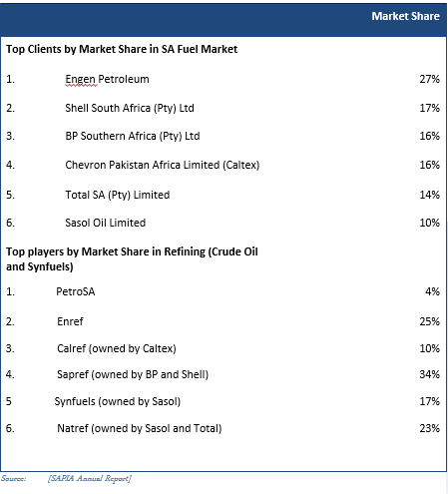

Notes:

The picture above demonstrate our government’s challenges in ensuring security of supply is managed within government. The fact that the only state owned entity in Oil and Gas is only 4% is embarrassing to CEPPWAWU and a major cause for concern. It is our belief that this market share has diminished to less than 3% due to our government’s focus on assiting PetroSA to prosper. For South Africa to fix this, a National Oil and Gas company status is required.

7. SWOT ANALYSIS OF THE SOUTH AFRICAN CONTEXT

Strengths | Weakness
- South Africa is leading in the synthetic oil industry  - South Africa has the second largest Gas-to-Liquid refinery in the world (Owned and operated by PetroSA).  - Second largest and most competitive downstream sector in Africa  - We are one of the most stable country, with low-risk investment environments in Africa  - Oil and gas sector is one of the driving forces of the economy, promotes massive job creation  - Domestic production helps to reduce the balance of trade deficit for the country  - The production of gas can be used to produce electricity and this is necessary to attract more foreign  Investment. | - Limited proven hydrocarbon reserves  - Inefficient downstream sector in need of considerable investment.  - Instability of the regulatory framework  - Integrated Energy Plan not reviewed timeously and frequently  - Misalignment between MPRDA and NDP on policy priorities  - Not utilising the Upstream Training Trust to its maximum effect in up skilling South Africans in Oil and Gas.
Opportunity | Threats
- Total gas find in block 9 (closer to PetroSA) poses an opportunity for a gas that can last the PetroSA G-T-L for the next 25 years.  - This find sits approximately 85km from PetroSA  - Considerable offshore exploration opportunities with major companies involved in upstream activity.  - Shale gas resources in the Karoo Basin are thought to be among the largest in the world  - Deep-water drilling experience (PetroSA) off our coastal line  - Coal-bed methane potential in the Karoo, with positive pilot production displaying upside potential.  - Rising demand for refined products and petrochemicals in South Africa | - Growing demand for refined fuels could lead to greater imports of petroleum productions and put pressure on balance of payments.  - Increasing pressure on refining margins and more stringent fuels standards could lead to some operators to exit downstream market.  - Public opposition to hydraulic fracturing could hinder the development of shale gas despite growing support from the government  - The absence of a designated NOC results in a lack of coordination in ensuring Security of Supply

8. South Africa Core Challenges
- No clear direction of policies within the energy sector and how these align to the NDP. MPRDA is still not yet promulgated
- There is no South African Act that recognizes PetroSA as a National Oil Company (NOC) hence no appropriate budget allocation to grow the company from National Treasury.
- The current shareholder structure hampers the company’s future plan because the interests of CEF and PetroSA are not aligned.
- Fragmented institutions all competing with each other for relevance CEF, PetroSA SFF and Transnet.
- Inter-ministerial alignment lacking with no coordinated approach to deal with energy projects or national energy philosophy e.g. Public enterprises; Nersa, CEF, and I-gas as relates to pricing and tariffs
- Too many boards and corporate red tape have been put in place e.g. CEF, PetroSA, and SFF. According to CEPPWAWU, the Boards of these company have dismally failed and left nothing in these parastatals. During this period, DoE as the shareholder disappeared when poor performance of these Board went unabated.
- SoE are meant to be enablers of governments agenda of social economic transformation yet are being asked to be commercial and are expected to compete against private sector. A case in point is PetroSA’s treatment on Oil and Gas exploration for license applications
- SoE are meant to create skills development opportunities for previously disadvantaged, promote transformation of the energy sector through BBBEE and stimulate employment growth, however we see SOE’s threatening to be amongst the largest to shed jobs due to maladministration and incompetence and corruption at the highest levels.
- Threats of privatisation of State assets by means of unbundling e.g. Eskom and PetroSA.
- Skills being lost not only to private sector but to better international prospects
- Dwindling investment by government and private sector into skill development and training of the workforce.

9. OPPORTUNITIES

South Africa must enact an act of parliament for PetroSA to be designated as an NOC with key powers which include;
- The entire ownership in, and the exclusive rights, powers,
liberties and privileges of exploring, exploiting, winning and
obtaining petroleum whether onshore or offshore of South Africa shall be
vested in a Corporation to be incorporated under the Companies Act 2017
- The vesting of the ownership, rights, powers, liberties and privileges referred to above shall take effect on the execution of an instrument in the form contained in the Schedule to this Act.
- Added to the Petroleum development Act there must be enablers to ensure success thereof. These enablers to include an establishment of the National Petroleum Advisory Council whose duty should be to advise the Minister on national policy, intersts and matters pertaining to petroleum, petroleum industries, energy resources and their utilisation. This will ensure that our Minister is not advised by the multi-nationals through SAPIA which is largely dominated by BP, Shells etc of this world.
- Establishment of a National Oil and Gas company with clearly defined powers. PetroSA can take the form of this NOC because it is already tried and tested and posses the full value chain as an integrated Oil and Gas company wholly owned by the State. This would also be in line with other countries in particular, Malysia through Petronas (Engen) where resources of the country are owned and controlled by Petronas on behalf of the State. It is on record that Malaysia would not have transformed its petroleum sector without establishing this Act and ensuring it receives full suupport from government. For unknown reason, South Africa has not protected PetroSA in that form. This despite ANC’s 54th National Congress in Mangaung resolutions. It is therefore important to take cognisance of the fact that PetroSA’s future depends on finding more reserves. Hence, it vitally important to view the addition of the reserves must be perceived as the core business of PetroSA.
- Effective, job oriented rehabilitation of mines and the creation of decent work opportunities from it.
- Reduce health and safety hazards
- Building technical excellence in the petroleum sector through effective usage of Upstream Training Trust. It is also crucial to build awareness and consensus among the stakeholders that PetroSA by its nature is a long-term business that consume a great deal of capital. On the other hand returns and benefits are enormous if we managed to hit the bull’s eyes. This can have a direct positive impact on the government’s revenue in the long run.
- The solution to Eskom challenges lies in the manner in which our government attends to the petroleum sector. If this sector receives the support, Eskom’s feedstock challenges can be resolved through among others, supplementing coal with Natural gas power generation and heating.
- Despite the Gas find by Total in the South Coast, which is a mere 85km way from blocks owned by the State through PetroSA, South Africa has proven Oil resevers in the West coast which can turn the economy of South Africa to the largest exporter of Oil and creator of massive jobs. This oil however, requires a strong NOC
- Suggestion is to supplement coal with Natural gas for Power generation and heating instead of the refined products such as diesel. New markets will be established in the production, storage, transmission/transportation and end user consumption. Thus resulting in job creation from these new entrants
- LPG to be introduced more aggressively in the automotive space as an alternative to petrol. Again new markets for the production, manufacturing, maintaining and converting of gas-powered vehicles will emerge. Net result will be creation of jobs
- Gasification of industry and homes, this will lead to new industries and trades manufacturing, distributing servicing of gas products and appliances and metering. Here again job creation will be achieved
- Exploration of hydrocarbons - Government to begin aggressively investing in hydrocarbon exploration
- Support the construction of new refining capacity within South Africa
- Support initiatives that assist fuels producers in upgrading existing refining capacity. On average South African Refineries are 40 years old
- Attract foreign investment through favourable terms on Acreage within South Africa via partnerships with the NOC
- Establish an ocean economy which will cater for ship building, ship repairs and refurbishment, dry docking facilities, Logistics support and vessel support services; deep water ports to handle large vessels and rigs
- Creation of industrial zones that will through free trade agreements make South Africa attractive to off shore drilling, subsea infrastructure manufacturers that will service both the East and West coast of Sub-Saharan Africa
- Leverage local expertise to provide training to neighbouring countries in the Geological and Geophysics disciplines. This can be achieved through coordination between government institutions PASA PetroSA and local universities (G to G)
Without this act, South Africa will not be able to maximise its prowess in its onshore and offshore opportunities.

10. Conclusion
The side effects of the very low economic growth for past 10 years are currently pose major challenge in the economy. The drastic increase of the renewable energy and the projected significant drop of the coal contribution in the energy will have far-reaching consequences on the green shoots that are prevailing in the economy, which may ultimately prolong the recovery process. A prudent investment on New High Efficiency Emission (HELE) such as the installation of the flue-gas desulphurisation (FGD) which will favour clean coal power stations will go a long way in reducing the pollution because South Africa is endowed will large coal reserves. Most importantly, bold actions needs to be taken in order to create more jobs in order to reduce poverty in country.

Based on the submission above, CEPPWAWU is of the view that South Africa’s challenges have low hanging fruits to resolve them and Energy is central to this revival. For Energy to play the role that is required, a decisive position by government is required and this starts with reviewing its support in ensuring the country’s resources are managed properly. In the petroleum space, South Africa will not ensure the protection of its resources without an Act of parliament that affirms an NOC status. South Africa needs to improve storage infrastructure to respond to security of supply, LPG opportunities which can be a solution to the automotive industry. PetroSA is already participating in this space a stronger coordination between government institutions, PASA and local universities will assist. About the NOC, our position as CEPPWAWU is clear, if South Africa wants to be counted, amongst the big players in the energy industry particularly that of Oil and Gas, the NOC status is required. This is same approach that taken by other countries such as Malesia, Norwegian etc. - where they have created their own NOCs within their borders. These companies have established themselves to be multinational companies. In South Africa we need to follow their route hence there is a need to Legislate PetroSA as a National Oil and Gas company to enable state participation in the hydrocarbon reserves of our land and beyond.

Finally, CEPPWAWU supports the deployment of one of the most able leadership in comrade Gwede Mantashe to lead this charge. With collaboration with all stakeholders, South Africa can turn the corner through Energy economy.

http://www.iea.org/ciab/South_Africa_Role_Coal_Energy_Security.pdf
http://www.axiomatic.co.za/news/salary-increases-for-2018/
Using 2015 prices
between 2008 and 2015
https://www.fin24.com/Opinion/matshela-koko-radebes-path-will-undermine-eskom-lead-to-job-losses-20180608
https://www.fin24.com/Opinion/matshela-koko-sa-must-still-have-capacity-to-pay-school-fees-for-renewables-20180904
https://www.bloomberg.com/graphics/2018-germany-emissions/
https://www.brookings.edu/wp-content/uploads/2016/08/global_20160818_cop21_africa.pdf

